My sketch is supposed to feel like a game where the user runs a first-person shop where potions can be made and sold to the Spirit-beings who can be seen browsing the berry selection in the ShopCounter scene. If more time was allowed for this assignment, the user would’ve been able to have a line of Spirit-beings who would have requests for the berries used in potions. The user would then go to the makingPotion scene to make said potions to give to the customer.

The style of this game is first-person within a 2D environment. There is a 4, 3D shapes that can be interacted with to change the direction they spin.

All artwork is drawn by me, nothing was created using AI. The same follows for the idea of creating a game as well as the narrative being a user owned shop.

“Potion Shop” is a game belonging to Rogue Pheasant Productions and the creator as well as the two pheasant who belong to this group would greatly appreciate being contacted to discuss distributions. Please do not steal, it makes the human and the pheasants sad.
Thank you,
~ Candace Bienert(Creator/Designer/Developer), Cornellius(Pheasant #1), Reginald (Pheasant #2)
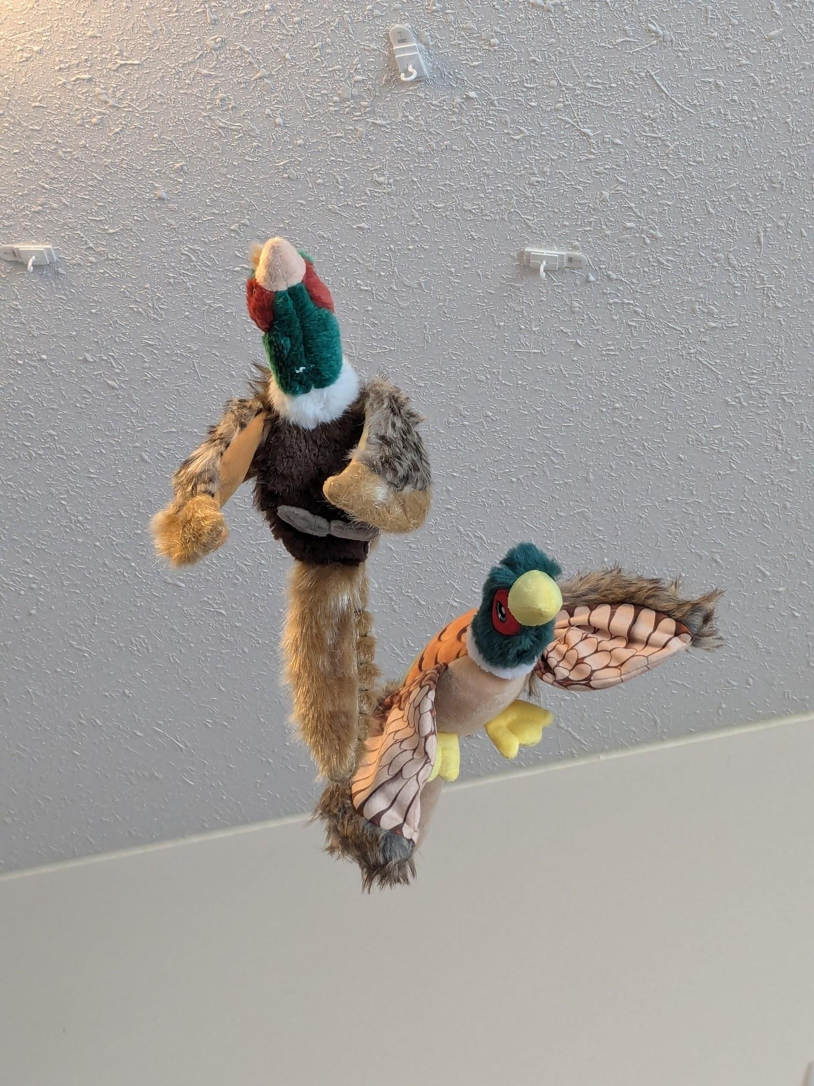
(The pheasants)

