Bi-Weekly Status Report        Name: Andrew Swayze        Project Title: LinkUp Community Board Ap  Score: 100

Github Sync

I just barely finished making some edits about an hour ago and pushed all the changes I’ve made since earlier today.

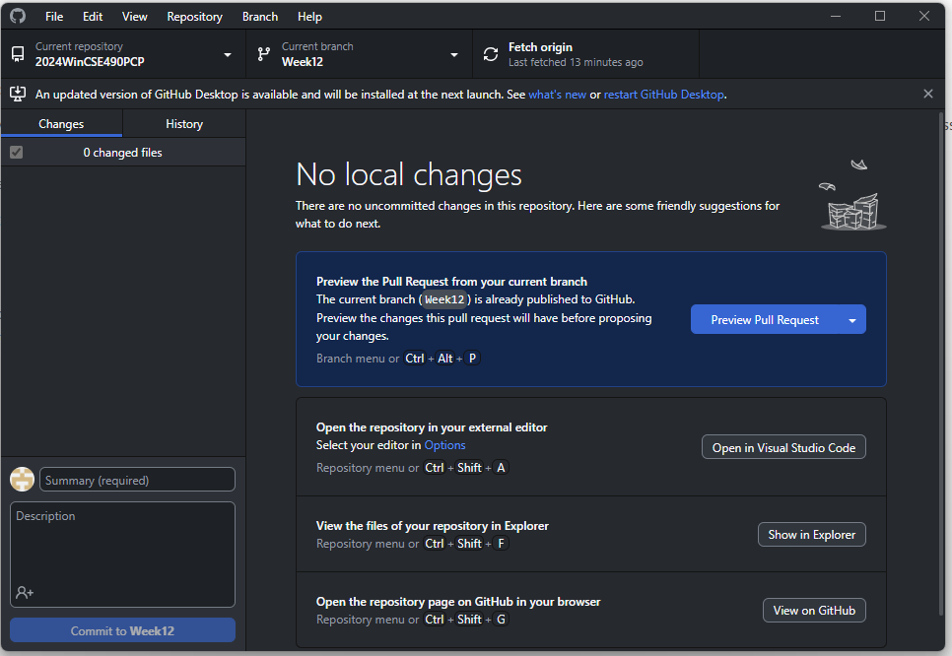

Tasking

* What I did:
  + UI:
    - I went through every page and redesigned the appearance to match my professional standards and what I believe the school would expect from an app that they run.
    - Each page was designed using hard values for spacing instead of making them automatically update based on screen size. I went through each item on each page and reformatted them to be positioned correctly within their containers, attached them to their containers instead of the outer edges of the app window, and removed the vast majority of all hard coded values for spacing.
    - I created and implemented the bottom navigation
    - I created and implemented the logo from scratch using Photoshop
  + Java:
    - I worked on this with Conner, but none of the buttons were working properly and so we went in and fixed the Java to correctly send people to new pages on button clicks.
    - I created and implemented the Hashing utility for password data protection
    - With the assistance of Brian and Allan, created and implemented the scripting to send data from the front to the backend.
    - Finished today setting up the script to pull the user_id from the backend and use that as a global variable for maintaining relevant information throughout the app.

Part one: Project Tasking

* Scrum Status
  + This scrum period, I updated every single page to have a more coherent and modern design. Almost nothing is the same from what it was before. I’ve also updated every java file that we have in order to function properly for button clicks and in connecting to the backend. In addition to that, I developed and implemented a hashing utility for password data protection.
  + I still plan on finishing the connection with the backend, there are some issues with it that I have to complete still. I also want to finish implementing the global user_id value.
  + The challenge has just been in that no one on my team really has a good understanding of the languages or programs that we’re using. We came into this at a 0 on the knowledge of Kotlin and Android Studio and I feel like there hasn’t been a lot of effort put into understanding how it actually works.

Part two: Project Artifacts

* Summary of Activities:
  + My team met multiple times throughout the week in order to prepare and practice for our presentation today. We also met a few times to finish some tasking that hadn’t been completed.
  + Here are some of the resources that I’ve been using to accomplish my tasks:
  + <https://stackoverflow.com/questions/35904633/show-logged-in-user-data-on-another-activity-in-android-studio>
  + <https://stackoverflow.com/questions/2091465/how-do-i-pass-data-between-activities-in-android-application>
  + <https://stackoverflow.com/questions/2091465/how-do-i-pass-data-between-activities-in-android-application/20584974#20584974>
  + <https://stackoverflow.com/questions/51893317/how-do-i-use-one-login-screen-activity-for-different-activities-in-android>
  + I made significant use of the Claude AI as well. It was incredibly useful in figuring out where I was having problems as they arose and troubleshooting solutions.

Part three: Project Metrics

* Time Tracking
  + This Week
    - Since the last time I sent this in earlier this week, I’ve probably worked on this for another 10-15 hours, so about 40 over the whole week.
  + Total to Date
    - * Altogether, I believe I’ve spent close to 130 hours on the project.