Dylan Bonis

HTML & CSS

Assignment 1

1/3/2023

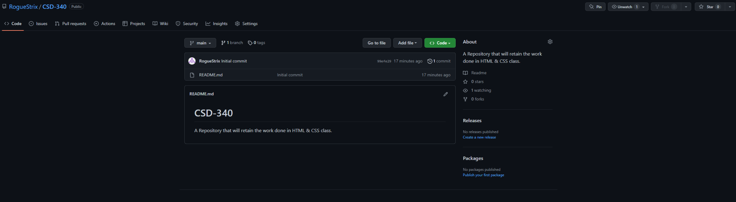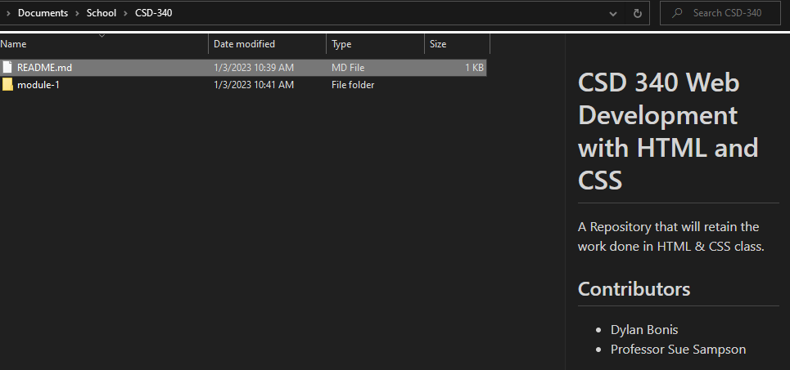

Link to Repository: <https://github.com/RogueStrix/CSD-340>