Dylan Bonis

HTML & CSS

Assignment 2

1/4/2023

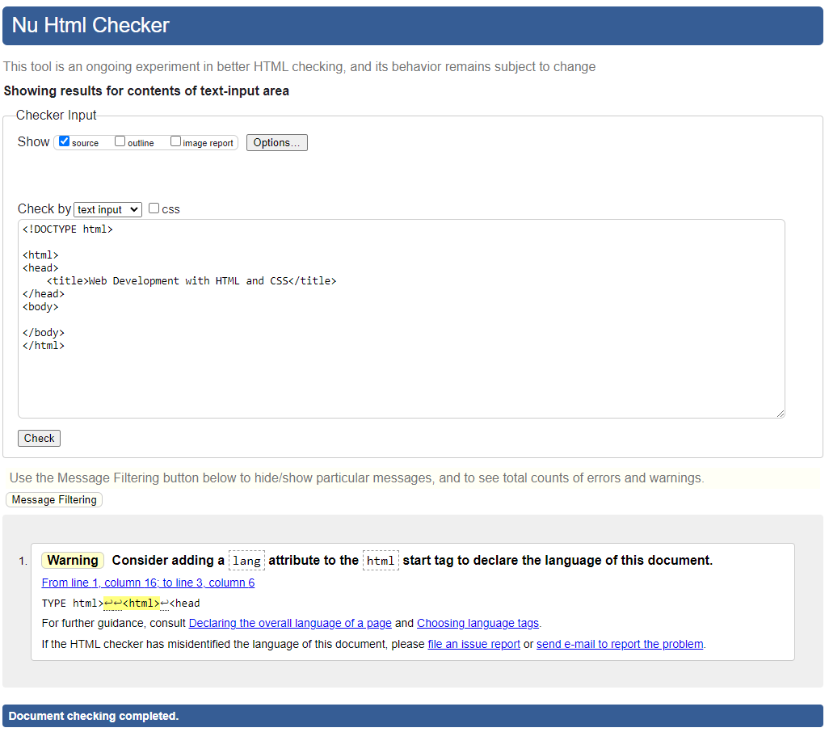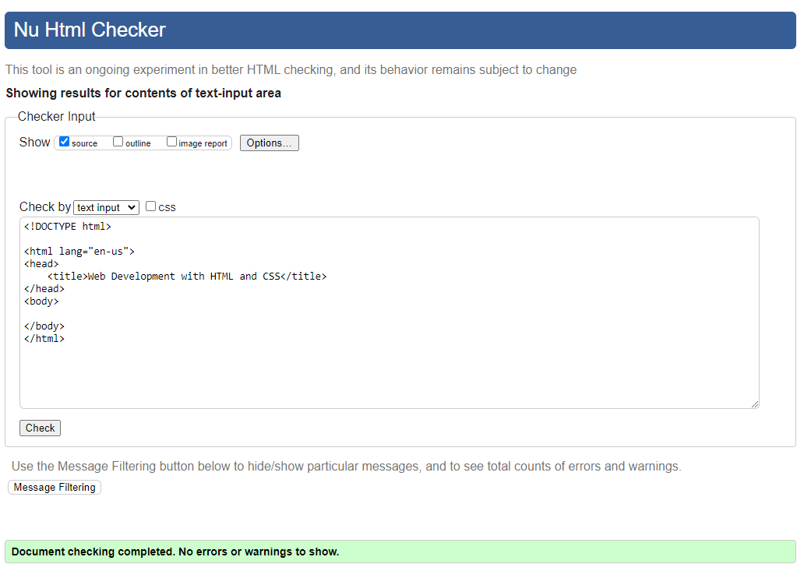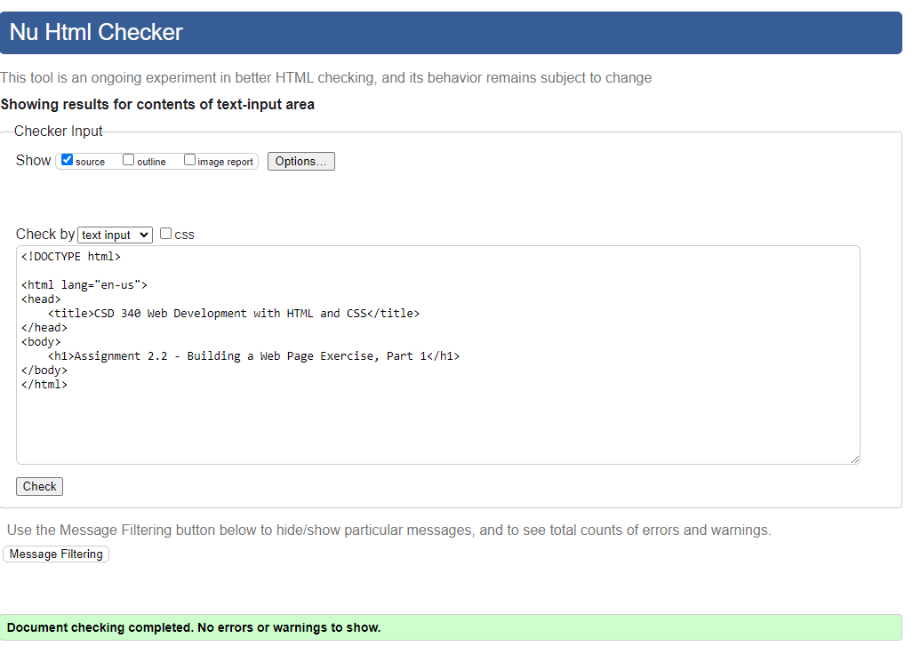

Link to Repository: <https://github.com/RogueStrix/CSD-340>