Dylan Bonis

HTML & CSS

Assignment 4.2

1/4/2023

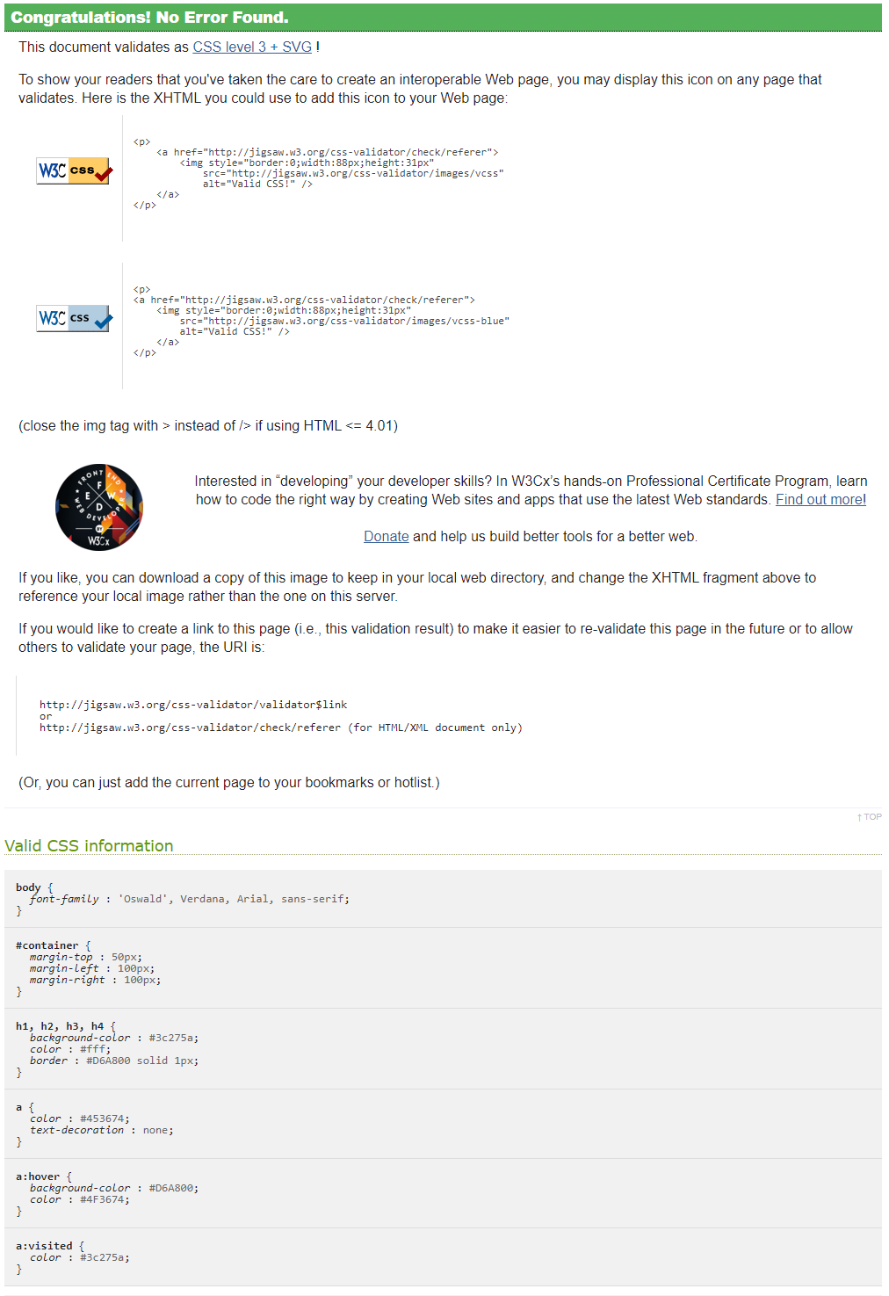CSS Validation

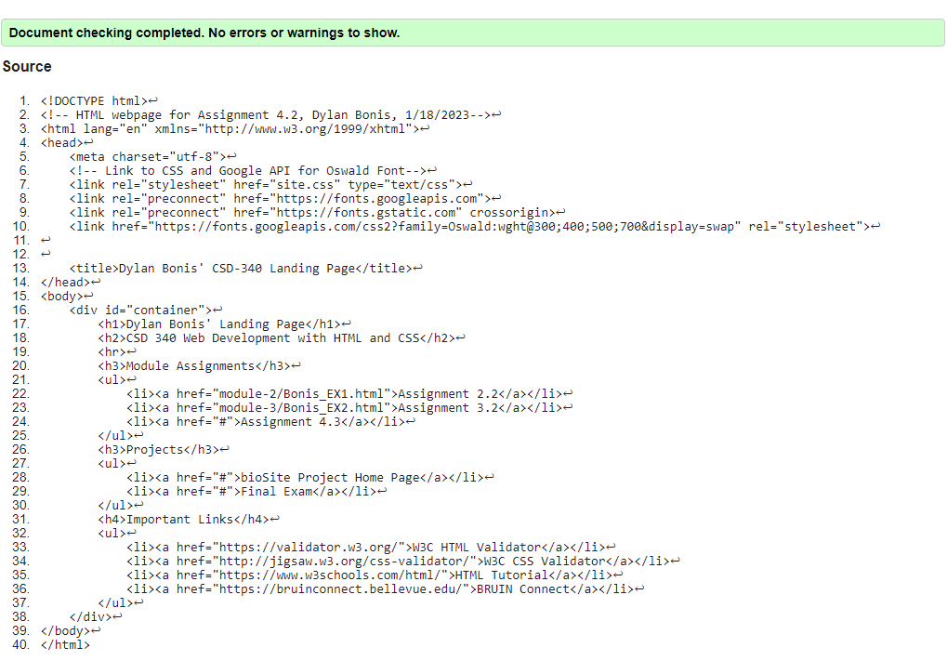

HTML Validation

Link to Repository: <https://github.com/RogueStrix/CSD-340>