**ESCUELA SUPERIOR POLITÉCNICA DEL LITORAL**

Facultad de Ingeniería en Electricidad y Computación

**Ingeniería en software 2**

Paralelo #3

**Taller#2:Code-insertion**

Grupo No: 5

**Miembros del grupo:**

Scarlet Angelina Espinoza Moreno

Nicole Gabriela Alvarez Di Luca

Rogwi Alexis Cajas Correa

**Fecha de entrega:**

10/2021

**Término Académico:**

2021-1S

**Repository link: https://github.com/RogwiCajas/CodeInspection**

**Part 1: Install Maven for Eclipse.**

1. For the first step. We need to install the plu-gin.

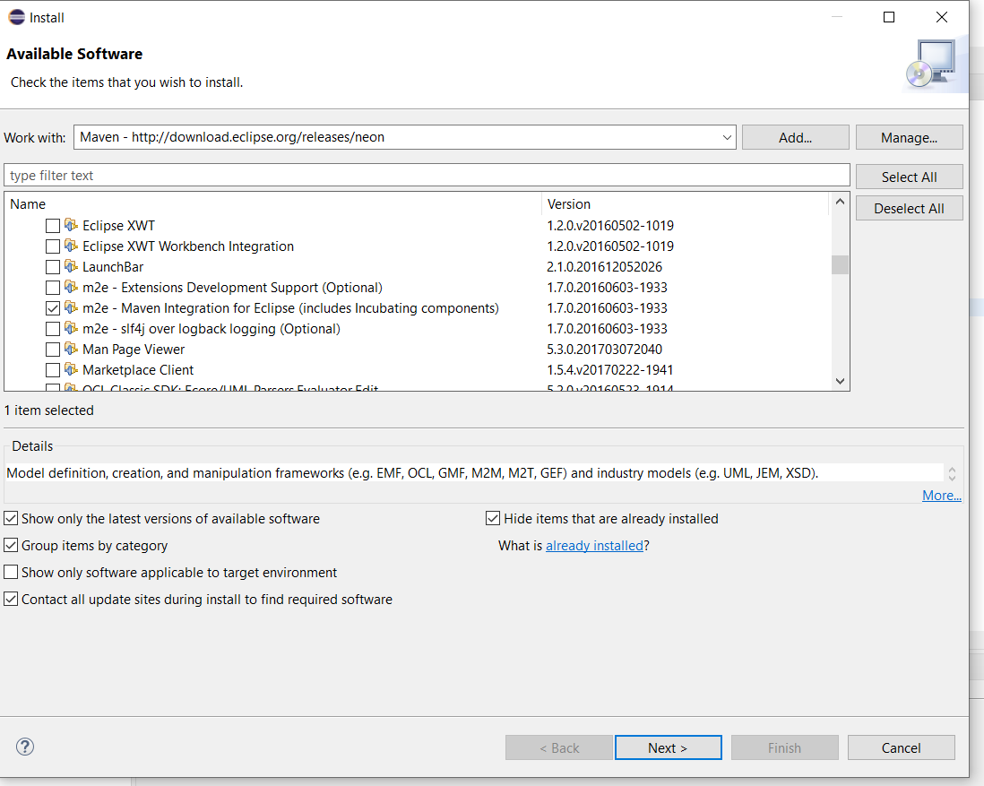

**Part 2: Install the Eclipse PDM plug-in**

1. In the eclipse market space we need to install PMD.

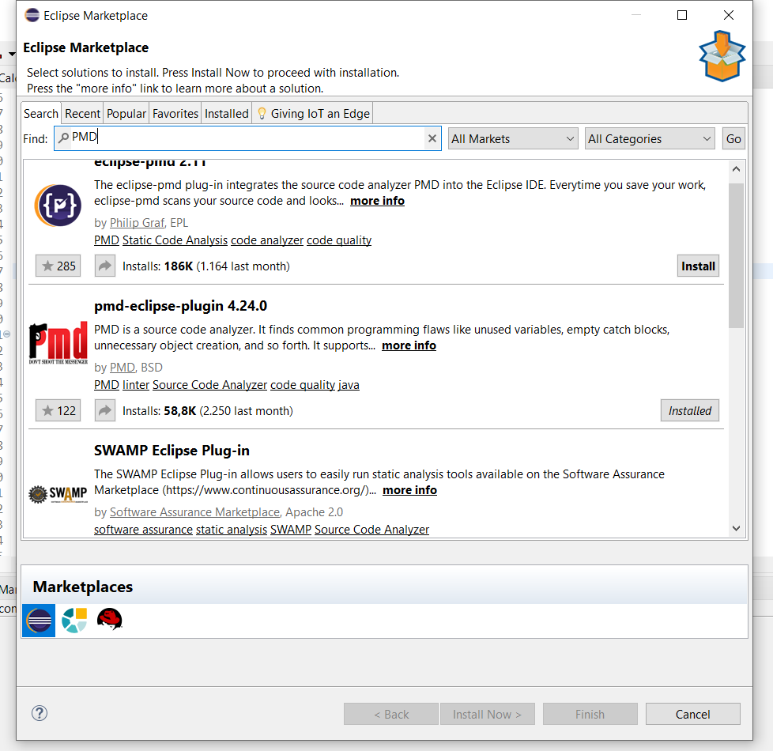

**Part 3: Download and configure the project.**

1. We need to fork the repository.

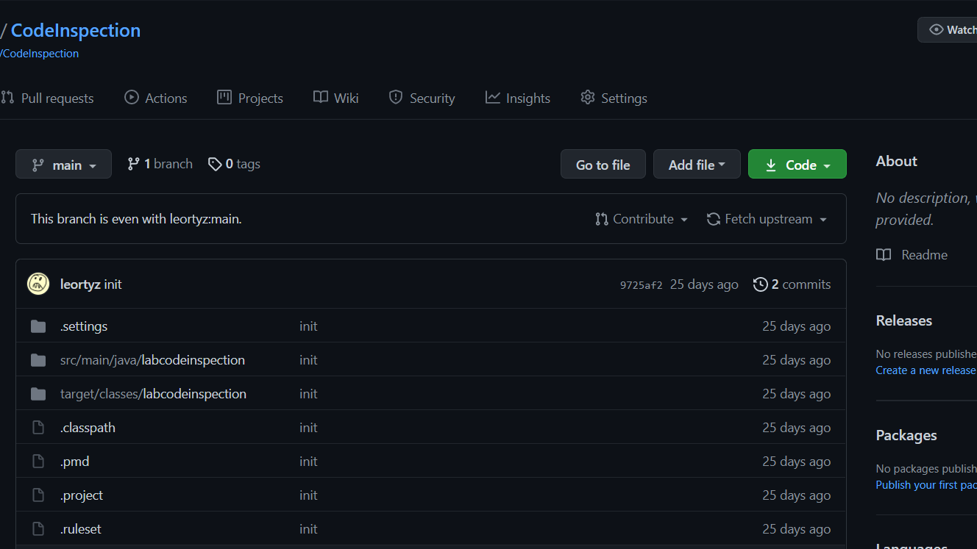

1. After that we need to activate de PMD for the project.

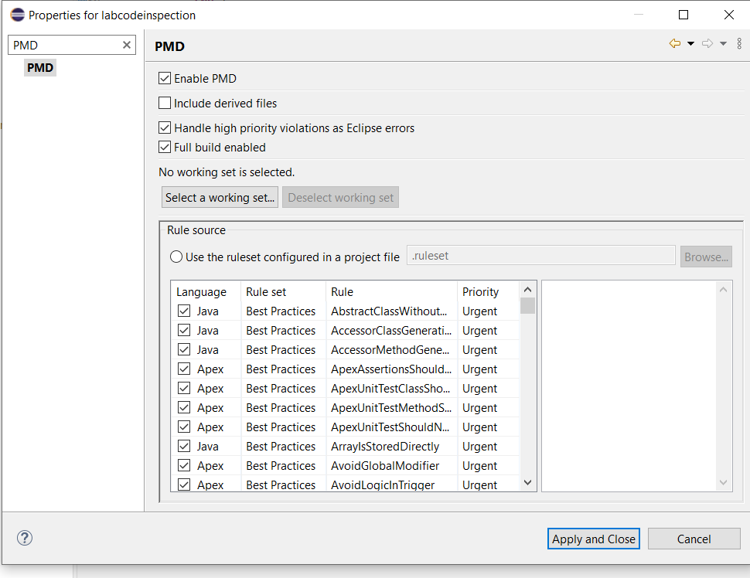

**Parte 4: Using PMD**

1. So Now we have to go to the option “Windows”, choose preferences and active the option “Check code after saving”.

1. In this part you must go to the folder project and right click

1. Two new windows are displayed with all violations. Each violation has its priority represented by a color and corresponding rule.

1. So, we also can filter de violations using the color indicators on the top right of Violations Overview window. After it only will appear the type of violation that you select and the ubication in the code. To know more detail click right and choose “Show details”

This option can give you more information of the violation and an example solution..

**Part 5: Creating PMD rulesets**

1. Now we need to create a XMfile so Right click on the project, then “New >> Other >> XML >> XML File”.

1. Name the XMfile like “_ ruleset “ and click in finish

1. Text

   Description automatically generatedEdit your XMfile adding this code. You have to replace <your name> and write obviously your name and in the other <your full name> also.
2. Let’s reference a complete ruleset. Add the following line below the description tag:

1. Graphical user interface, text, application

   Description automatically generatedNow, add another reference, but exclude some rules from the ruleset:
2. Graphical user interface, text, application

   Description automatically generatedWe can add rules from a specific ruleset as follow:
3. To use an external ruleset, we need to go to the PMD Configuration Window. Go to “Window >> Preferences choose PMD then Rule Configurations”.

1. Check “Use global rule management”, then group rules by “Rule Set” and Select all the rule sets and click in the “X” button to delete them.

1. Click "Import rule set..." (under the "x"), browse your file “_ruleset.xml” create before and Click “Ok”. The rules we added are not listed yet, press "Apply and close", then "Yes". Return to PMD configuration Window. Notice that the checkbox next to the rule names is unchecked.

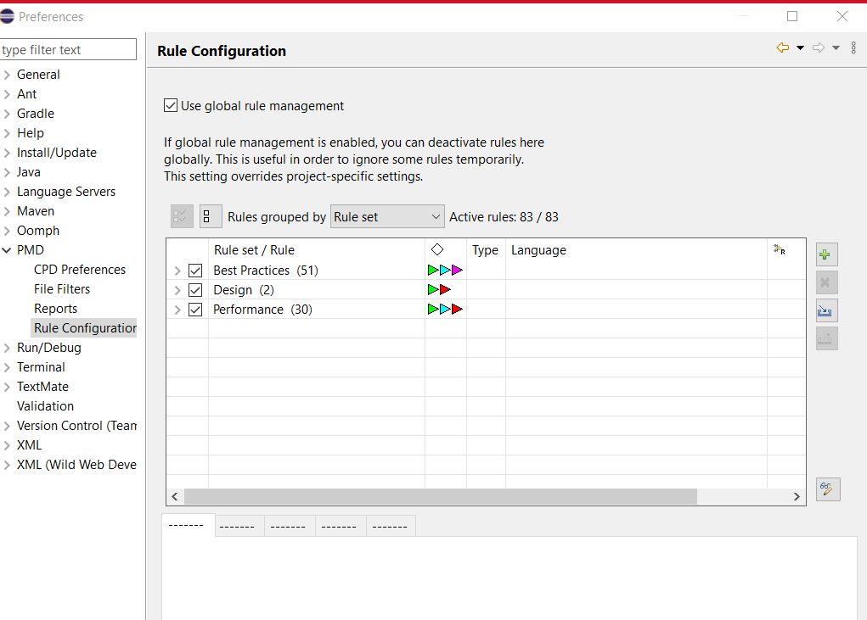

1. Right click on the project and select “PMD >> Clear Violations”. Then “PMD → Check Code.” Note that it is possible to configure the properties for each rule we add.

**Part 6: Generating a PMD report**

1. Open PMD configuration window, select Reports and check “html.”

1. Right-click the project then click “PMD and choose Generate Report.” After it will appear a new folder into your project named “reports”

1. Finally, you will see the report.

**Part 7: Suppressing PMD Rules**

Using NOPMD on email.java:

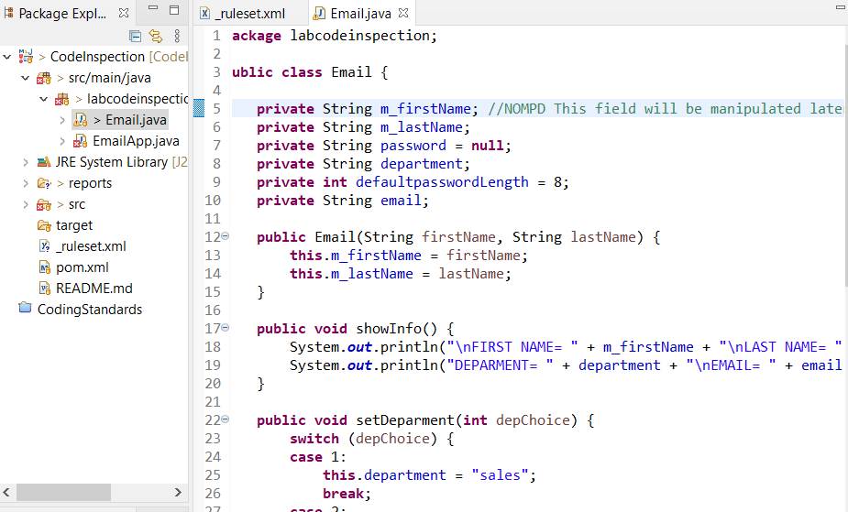

Go to EmailApp.java and check the violation. The rule violated is “UseUtilityClass”.

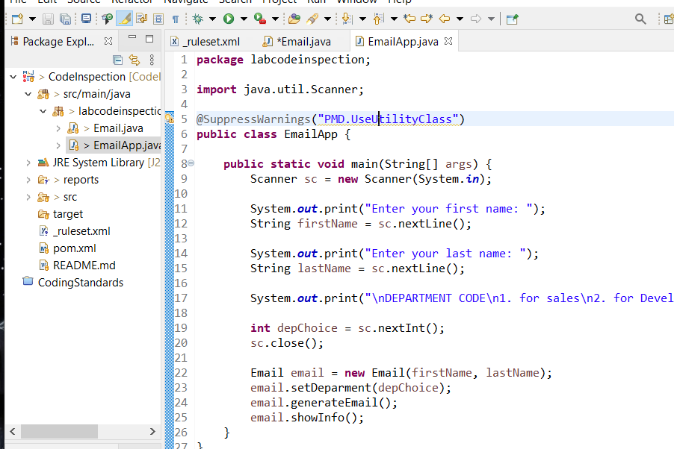

**Part 8: Detecting Cut-and-Paste with CPD**

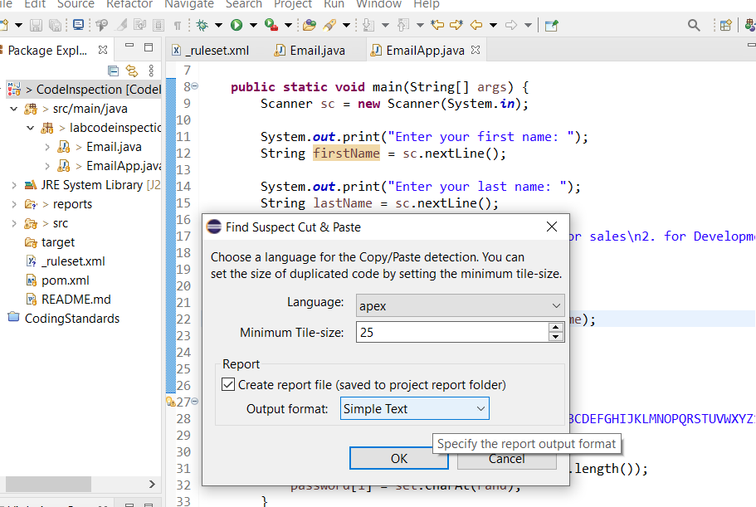

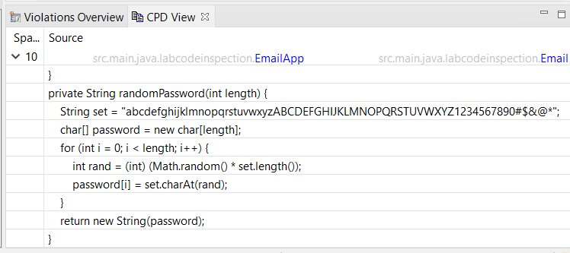

Report directory:

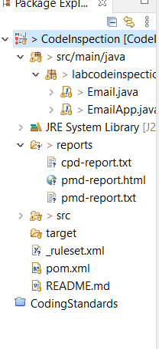

**Part 9: PMD and Maven**

New Pom.xml file:

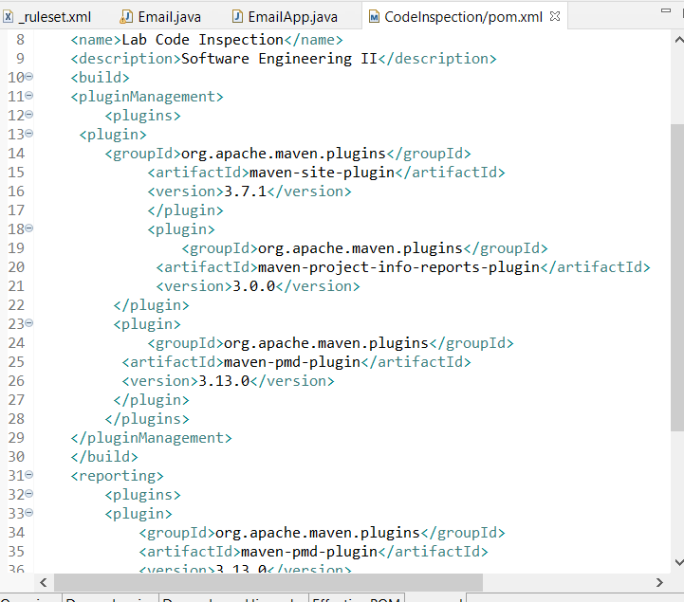

Creating the code inspector report:

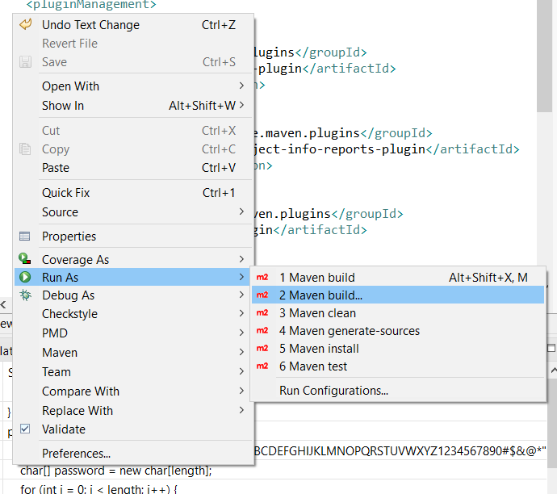

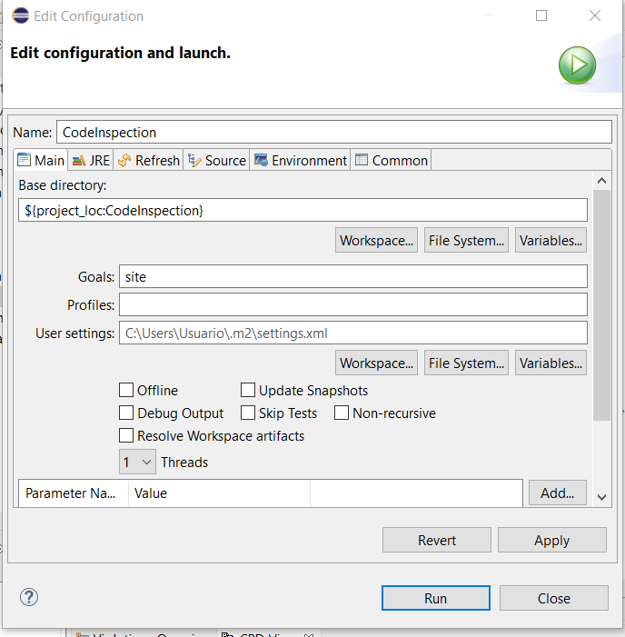

Succesful build generated:

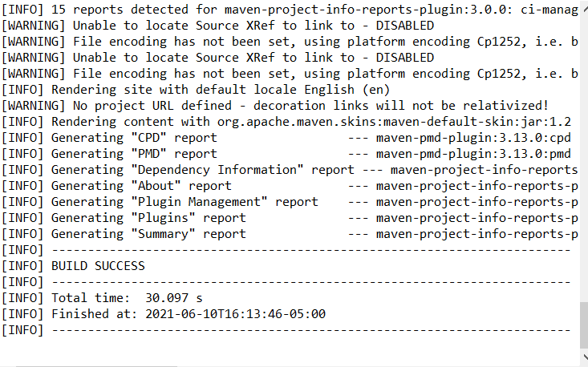

Report files on local directory and Browser report view:

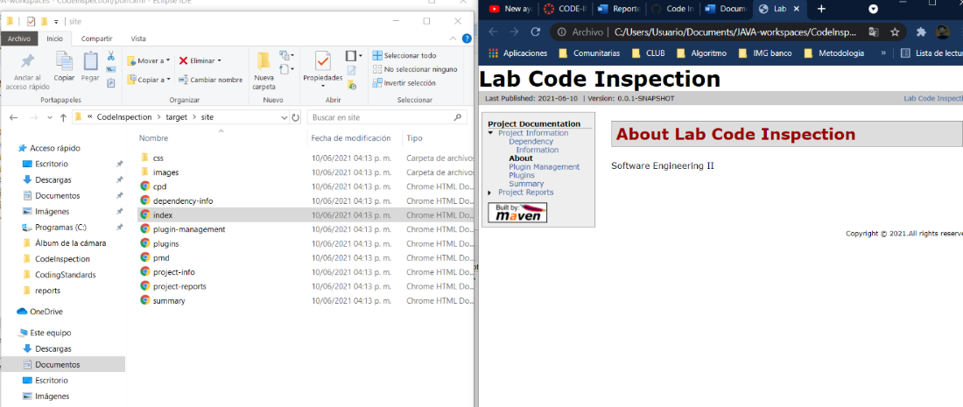

PMD Report document:

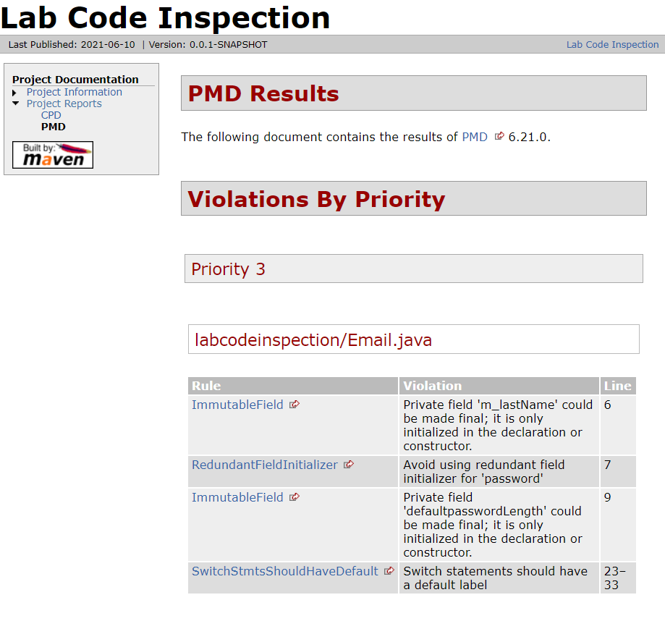

**Development**

New rules added to _rules.xml

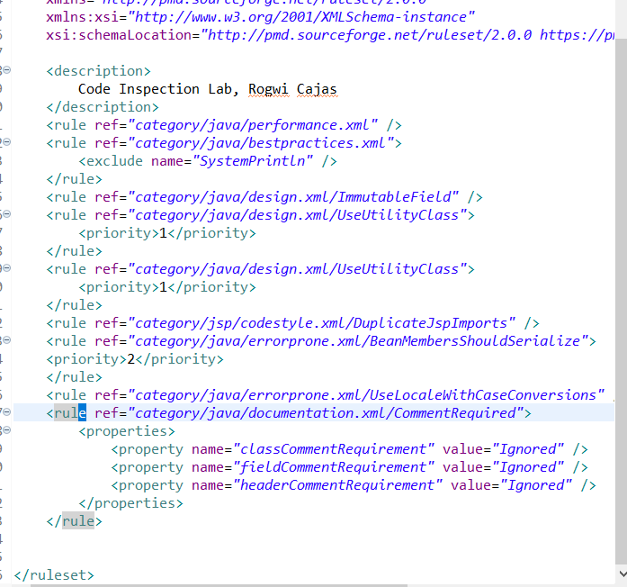

New report generated:

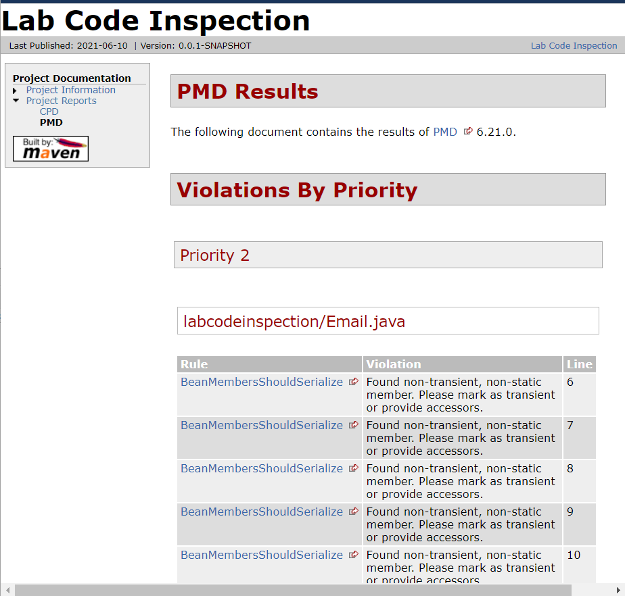

Final report output

