University Of Wollongong
Assignment 2:
Enterprise-2d
Rohit Panda
UOW ID: 8943060
Digital System Security
Advanced Programming

Content Page
How to run the program
(Interpreted)Requirement of Program
Challenges faced
Summary of each program module
Assumptions made
Additional Enhancements
Possible Enhancements
Learning Outcomes and Conclusion

How to run the program

NOTE: .app files can only work inside Ubuntu and Windows OS. If running on MacOS, do change .app to .run.
g++ Compile Mode: run the following code below:
g++ -std=c++11 main.cpp algorithms.cpp city_mapping.cpp cloud_mapping.cpp DisplayUserMenu.cpp pressure_mapping.cpp weather_report.cpp -o csci251_a2.app

./csci251_a2.app

MakeFile Compile Mode: run the following code below:
To compile and run:
make

To remove object files
make clean

(Interpreted)Requirement of Program

The Program is an Enterprise 2D program, intended to help in marine navigation. The user, likely to be the navigation officer will put in the coordinates and the program will read the data. Once read, navigation officer can compute the area, points inside the shapes, points on perimeter. Officer can print out the shape report on screen. He may also choose to sort the shapes based on the properties of the shapes. Once done, officer could delete the data that was provided. And finally, he can safely quit the program to prevent any unauthorized usage.

Challenges faced
The biggest challenge for me was figuring out how to begin coding the assignment.

I’ve broken down this challenge into smaller chucks.
1) Coding out the classes and constructors
2) Proper implementation and testing of the easiest shape
3) Calculation of the area of the shapes.
4) Getting the points in/on shape functions to show up with a Boolean variable
Here is a quick and short summary on how I overcame the 6 challenges:

Challenge 1: Coding out the classes and constructors
Solution: Review lectures and research on the internet
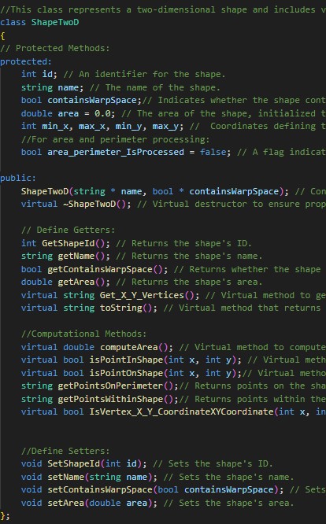
From what I gathered, it seems like the assignment’s objective was to get me comfortable with implementing classes and constructors. I started off with the file structures and focusing on understanding the appendix C of the assignment requirements. I started listing out the basic requirements that shapes should inherit from SuperClass ShapeTwoD. Once I added the destructors, ShapeID, vertex for X and Y coordinate, I moved on to implementing the square shape.
Challenge 2: Proper implementation and testing of the easiest shape
Solution: After practicing a few labs from Lecture 4 a-g, I copied the code for implementing child classes and then worked on rephrasing it. The properties and method that the square class had were the same for the Cross and Rectangle classes.
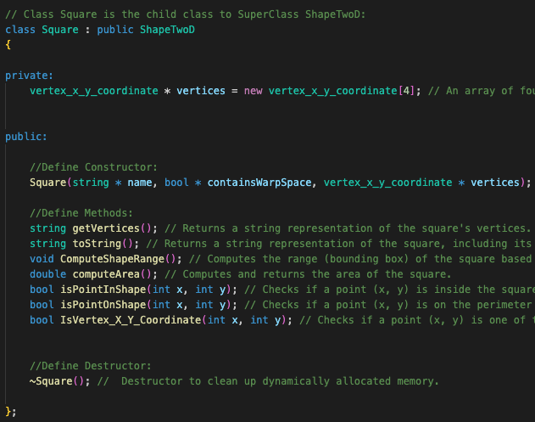

Challenge 3: Calculation of the area of the shapes
Solution: I particularly had to go through a lot of stackoverflow solutions to properly implement the computeArea() function.
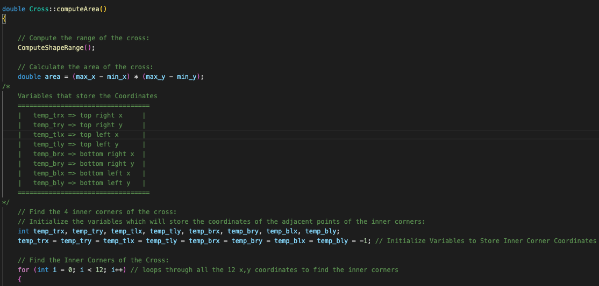
The calculation of area of cross and circle were particularly difficult. After coding the computeArea(), I realised that the calculations were wrong. It took quite some time to figure out why It was happening.
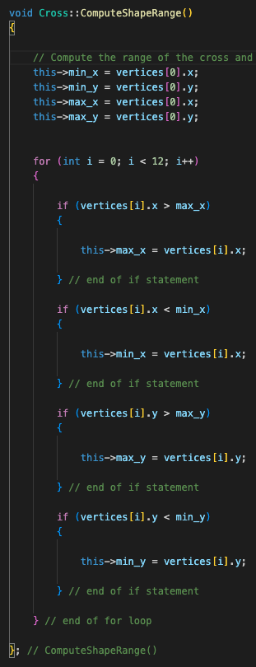
So I decided to break it down into two parts, ComputeShapeRange() and computeArea().

The ComputeShapeRange() method calculates the bounding box for the cross shape based on its vertices.
- Initialization: The method starts by initializing min_x, min_y, max_x, and max_y to the x and y values of the first vertex.
- Iteration: It then iterates over the rest of the vertices (total 12 vertices).
- Comparison: For each vertex, it updates the minimum and maximum x and y values accordingly:
  - If the current vertex's x value is greater than max_x, update max_x.
  - If the current vertex's x value is less than min_x, update min_x.
  - If the current vertex's y value is greater than max_y, update max_y.
  - If the current vertex's y value is less than min_y, update min_y.
At the end of this method, min_x, min_y, max_x, and max_y define the smallest rectangle that can contain the cross.

The computeArea method calculates the area of the cross shape.
- Compute Shape Range: It first calls ComputeShapeRange to determine the bounding box of the cross.
- Bounding Box Area: It calculates the area of the bounding box using the formula (max_x - min_x) * (max_y - min_y).
- Initialize Variables: It initializes variables to store the coordinates of the inner corners of the cross.
- Find Inner Corners: It iterates through the vertices to identify the inner corners of the cross. This is done by comparing the vertices' x and y values to min_x, min_y, max_x, and max_y.
- Store Inner Corners: It stores the coordinates of these inner corners in the object's properties.
- Subtraction Areas: It calculates the areas of the four smaller rectangles (squares) at the corners of the bounding box that are not part of the cross.
- Subtract Areas: It subtracts the areas of these four smaller rectangles from the bounding box area.
- Change Status: It updates the status of the object to indicate that the area has been processed.
- Return Area: It returns the computed area of the cross.

Challenge 4: Getting the points in/on shape functions to show up with a Boolean variable
Solution: Implemented a lot of if else statement and accurate logic to test, then implemented the logic into the functions.

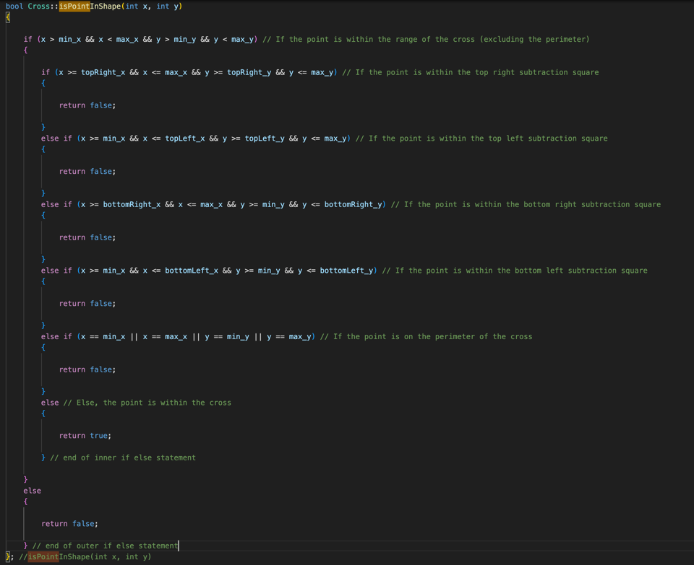

Through these challenges faced, on top of the time constraints and solving bugs, I have learnt to appreciate the std::cout function even more.

Summary of each program module
For each user’s choice, I have a program module, along with a cpp files with the logic of the program.

- Assn2.cpp Driver → Automates the build process of the program. Entry point of the system.
- ShapeTwoD.cpp → Contains the SuperClass. Contructors belonging to the SuperClass are defined here.
- Square.cpp → Contains the child class Square. Contructors solely belonging to Square are defined here. The rest like ( getId() , getName() containsWarpSpace() )are inherited from SuperClass ShapeTwoD.
- Rectangle.cpp → Contains the child class Rectangle. Contructors solely belonging to Rectangle are defined here. The rest like ( getId() , getName() containsWarpSpace() )are inherited from SuperClass ShapeTwoD.
- Circle.cpp → Contains the child class Circle. Contructors solely belonging to Circle are defined here. The rest like ( getId() , getName() containsWarpSpace() )are inherited from SuperClass ShapeTwoD.
- Cross.cpp → Contains the child class Cross. Contructors solely belonging to Cross are defined here. The rest like ( getId() , getName() containsWarpSpace() )are inherited from SuperClass ShapeTwoD. The calculations pertaining to the area is dividing the crosses into 5 square objects. The logic of the area of cross are inside computeRange() and computeArea() functions.
- userInputData.cpp → Handles user data. Gets and maps the ‘x’ and ‘y’ coordinates. Contains logic for user input functions and error handling.
- algorithms.cpp → contains UserPressEnter(), PauseProgram() and ClearScreen() functions for optimal user experience. Copied over from Assignment 1.

Each module is designed to handle specific aspect of the program, practicing file encapsulation and an organised structure of the program

Assumptions made

- Shapes are always square or rectangle, circle and cross.
- The first value of the grid range is always 0. There’s no negative value
- All points of the shape are whole number integers. E.g:(1,2,3,4….99). There cannot be decimal points for the coordinates.
- Coordinate Representation is always [x, y].
- All shapes are axis-aligned.
Additional Enhancements

- I have an additional feature where user can delete sensor data.
- Computing of points happens after user selects Option 2, hence computing of points happens with computing of area.
Possible Enhancements

- Prompting the user an option to save the shape report in a file

Learnings and Conclusion

Object Oriented Programming | Structures
Inheritance | Dynamic Memory Allocation
Default Constructors | Data Manipulation
Error Handling | Memory De-allocation

Among these learning outcomes, I have truly appreciated the importance of object-oriented programming, function overloading and overriding.

Object Oriented Programming focuses on using classes and objects, which can help make your code more modular, reusable, and maintainable.
Overall, I had a lot of difficulties to understand the problem statement of the assignment and the figure out how to link and inherit properties from the superclass to the child classes. I was able to progress faster once I had implemented and tested the Square class. This assignment was quite tough, but through the many times where the points on/in shapes and area were calculated wrongly, I learnt how to debug line by line and use the testing format from lab 1 and 2 frequently.

