K I L L S W I T C H
Software-Defined Directed Energy (SDDE)
A human-controlled targeting layer that lets a handful of operators defend against drone swarms for cents a shot.
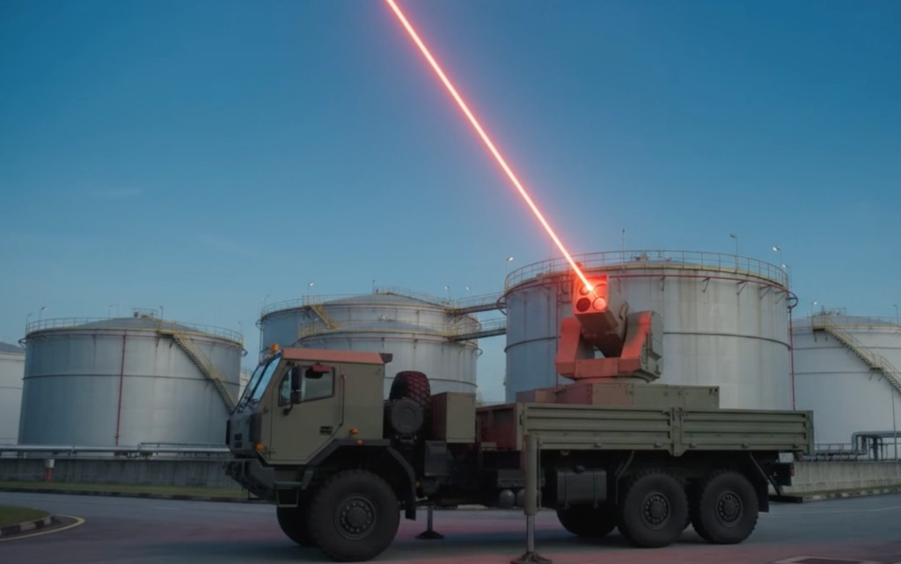
Concept render: how a production node could deploy on a tactical vehicle to screen petrochemical sites. Not built.

Team 49, Killswitch
Singapore Defence Tech Hackathon 2026
Counter-UAS Targeting & Fire-Control Layer
Track B: Autonomous Systems & Edge AI (Host Inference, Edge Actuation)
LOTR: Team Sentinal

1. What Exists Today, and Why It Breaks
Picture twelve launch sites releasing roughly 100 payload-carrying drones from a container yard in Johor. Small, low-flying and hard to pick up on radar, they converge on Jurong Island, Changi and the data-centre corridor. There is no single target to hit, and warning is measured in minutes.
Today the answer is kinetic interceptors, and they break in three ways against a swarm.
- Cost: a missile costing $1M or more is spent on a drone costing about $1,000, and the magazine empties long before the swarm does.
- Collateral: blowing drones apart over Jurong Island or a dense estate rains debris on exactly what we are protecting.
- Manpower: there are not enough soldiers to put one operator behind every weapon across 50 km of depth.
 | Kinetic missile | Attacker's drone | Killswitch laser node
Range | long, over 50 km | 10 to 20 km+ | ~350 m (modelled)
Magazine | low, finite | high, cheap | energy-bound
Cost per shot | $1M+ | ~$1k per drone | ~a quarter of a cent in power
Exchange | 1 : 1 | n/a | 1 : many
2. What Is New About Killswitch
Killswitch is a targeting brain, not another turret. The software does the searching, tracking and aiming; a human makes one decision per shot. Three things set it apart:
- 1:x decision layer. One operator supervises many turrets instead of crewing one, which answers the manpower ceiling directly.
- Safety lives in firmware. A cheap ESP32 microcontroller at each turret holds the deadman and burn limits, and the host computer cannot override them. If the laptop crashes, the laser shuts off on its own.
- Layered, not replacing. The laser takes the cheap, close-in drones so missiles are kept for the fast, long-range threats only they can reach. A 1.8 s shot from a 5 kW laser costs about a quarter of a cent in electricity (assuming ~30% efficiency and ~S$0.30/kWh). The real cost is the reusable node, about $200 of parts on our bench.
3. Who Uses It, and the Task It Changes
The user is an air-defence operator guarding critical infrastructure. Today that operator aims and fires one weapon. With Killswitch, the operator watches a shared map on which every turret report in. The software hands each inbound drone to the nearest free turret, ranked by time-to-impact, and the operator can override any assignment. Firing is different: every shot waits for the operator to press SPACE inside a 10 s window, or D to deny. The machine speeds up the work, but a human always owns the trigger and the legal responsibility that comes with it. Tracks also go out to ATAK-Civ, with simulated entities clearly tagged so no one mistakes a drill for the real picture.
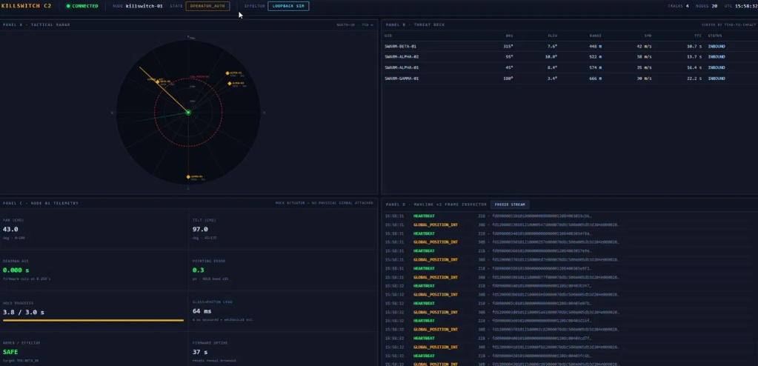
Figure 1: The Killswitch C2 during a simulated four-drone swarm. Every track sits on one radar, threats are ranked by time-to-impact, and Node 1 is paused in OPERATOR_AUTH, waiting on one human decision. Swarm tracks are simulated and the effector runs in loopback.
4. How It Works
Host inference, edge actuation. An OV5640 Wi-Fi camera streams to a laptop running YOLO11s. The laptop tracks the target, predicts where it will be, and sends aim commands over one serial link to an ESP32-S3. The ESP32 drives the pan/tilt servos and the laser gate, and it is the final safety authority.
Engagement sequence. SCAN in 20° steps, DETECT with YOLO, TRACK the target, HOLD it inside a 15 px band for 3 s, wait for OPERATOR_AUTH, then ENGAGE for 1.8 s and shut off automatically. The firmware hard-stops any burn at 2 s regardless of what the host asks for.
Wiring interlocks. The laser only fires when the ESP32 drives one pin HIGH. A pulldown resistor keeps it off during boot, reset or a crash, and actuator pins are kept clear of the camera bus after an early pin clash made the laser pulse on its own.
5. What We Built, and What the Results Show
A working bench rig on about $200 of off-the-shelf parts, with the full loop running in simulation and actuation plus firmware interlocks verified on hardware.
Result | Value | How we know
Deadman cutoff (host lost) | 254 ms | Measured on the physical ESP32 (firmware v2)
Maximum burn ceiling | 2002 ms | Measured on the physical ESP32 (firmware v2)
Firmware interlock checks | 13 of 13 passed | Physical board, firmware v3
Automated software tests | 337 passing | Offline test suite
Aim error, stationary target | 1.2 px | Closed-loop simulation
Aim error, crossing target (5 to 20°/s) | 3 to 6 px | Closed-loop simulation
Detection speed | 216 ms/frame (4.6 fps) | Measured on laptop CPU
Sensor-to-laser delay | ~414 to 514 ms | Estimated from measured stages
5 kW laser, melt onset at 350 m | ~1.1 s | Our thermal model, not a test
Detection accuracy | Not yet measured | Withheld until a proper held-out test

Along the way we fixed stale data winding up the control loop, frames smearing during fast scans, the camera stalling on dropped frames, and bad numbers freezing the dashboard.
6. Limits
- At 4.6 fps on a CPU, the tracker loses a target weaving ±15° at 0.2 Hz. This is a frame-rate limit, not a tuning problem.
- Tracking accuracy comes from simulation at 1280 px, not the 640 px rig. Live detection on hardware is still pending.
- The effector is a 5 mW visible laser standing in for a real one. A fielded laser also needs beam-path interlocks and key control we have not built.
- Only one node is physical; multi-turret assignment is shown with simulated turrets. The timing checks need re-running on firmware v3.
- Humidity, haze and rain weaken the beam, and melt onset in our model is not a confirmed kill. None of this has been tested outdoors.
7. Where It Goes Next
- Compute: move detection to a GPU or NPU for 15 fps or more, and measure accuracy on a held-out dataset.
- Hardware: brushless motors with absolute encoders, and hardware timestamps to correct for Wi-Fi delay.
- Security: encrypted, authenticated links (mTLS, signed serial frames) and secure boot on the ESP32.
- Live testing: CAAS-compliant range time with a Range Safety Officer, a rated laser behind the same firmware gates, and real payload and fixed-wing drones as targets.
ONE NETWORK. MULTIPLE NODES. HUMAN CONTROL.

