University Of Wollongong
Assignment 1:
Weather Processing System
Rohit Panda
UOW ID: 8943060
Digital System Security
Advanced Programming

Content Page
How to run the program
(Interpreted)Requirement of Program
Challenges faced
Summary of each program module
Assumptions made
Additional Enhancements
Possible Enhancements
Learning Outcomes and Conclusion

How to run the program
g++ Compile Mode: run the following code below:
g++ -std=c++11 main.cpp algorithms.cpp city_mapping.cpp cloud_mapping.cpp DisplayUserMenu.cpp pressure_mapping.cpp weather_report.cpp -o csci251_a1.app

./csci251_a1.app
Using Makefile:
make

(Interpreted)Requirement of Program

The Program is a Weather Processing System, intended to read weather data from a configuration file given by the user. The program will read the data connected to the configuration file and output in a form of a graphical format based of the user’s choice.

Challenges faced
The biggest challenge for me was generating the map in screen. As the preparatory workshop taught me know to generate a rectangle with space in it, I had to figure out a way to input data into those spaces.

I’ve broken down this challenge into smaller chucks.
1) Generating the border of the map.
2) Adding “#” borders around it.
3) Alignment of the coordinates
4) Removal of unwanted “#”
5) Printing out the X and Y axis onto screen
6) Removing characters from the coordinates

Combining codes from Lab Task 2 and the Workshop practice codes enabled me to get a rough understanding on how the code should look like for my map rendering function.

Here is a quick and short summary on how I overcame the 6 challenges:

Challenge 1: Generating the Border of the Map
Solution: Construct a border string by appending "#" symbols in a loop to create borders of the map.
The code above declares a border variable. The reason why I used width + 2 because I accommodated for the 2 columns which will include the additional borders on the left and right sides.

Challenge 2: Adding # Borders Around the Map
Solution: To create the top & bottom, left and right borders of the map, "#" symbols are printed at the start and end of each row. This ensures that each row of the map is enclosed within borders.
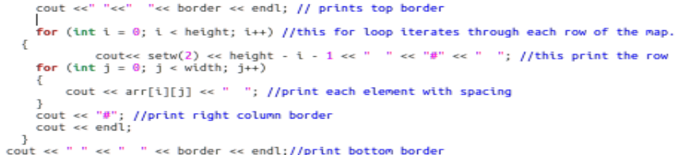
This code snippet shows the creation of the borders, the top and bottom borders are easy.
For the individual rows, I used a for loop inside a for loop. The first for loop iterates through the height and the second for loop iterates through each row, creating and displaying the ‘#’ symbol based the the GridRangeX and GridRangeY.

Challenge 3: Alignment of the coordinates
Solution: To ensure the borders are correctly aligned, initial spaces are added before printing the border string. This alignment helps maintain a consistent appearance across the entire map.
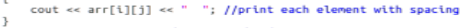

The code above prints the the coordinates with initial spaces for alignment

Challenge 4: Removal of Unwanted #
Solution: By carefully managing the loops and the construction of the border, extra "#" symbols are avoided. This ensures that the map has a clean and accurate border without any unwanted characters.

Challenge 5: Printing Out the X and Y Axis onto the Screen
Solution: The x-axis labels are printed below the map grid with appropriate spacing. This involves adding initial spaces before the labels to align them correctly under the map.
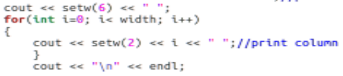
It ensures that the y-axis label is right aligned within a field of 2 characters.
Subtracting i from height - 1 ensures that the y-axis labels count downwards from height - 1 to 0 as you move from the top row to the bottom row of the map.

Challenge 6: Removing Characters from the Coordinates
Solution: A function is used to remove unwanted characters (like brackets and commas) from the coordinates string. This makes the coordinates easier to process and display.
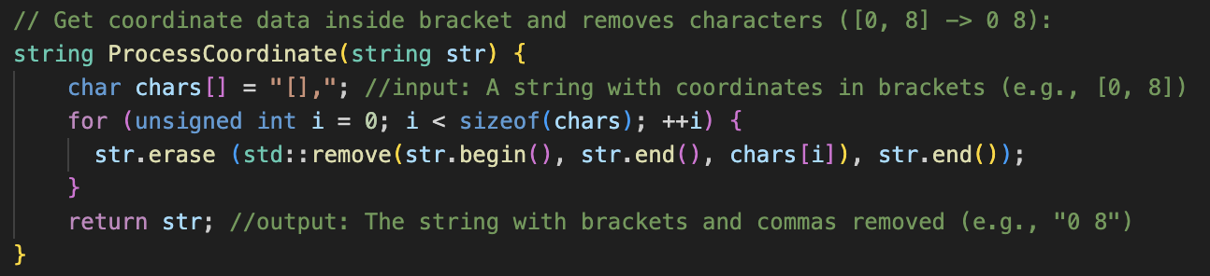
The function above shows the removal of character from the coordinates extracted from the txt files. char Chars are the characters [ ] , that will be going to be looped and erased. Here is a visual representation that may help:
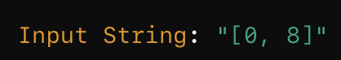
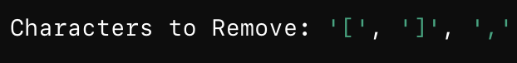
Step 1: (Removal of [ ) "[0, 8]" -> "0, 8]"
Step 2: (Removal of ] ) "0, 8]" -> "0, 8"
Step 3: (Removal of , ) "0, 8" -> "0 8"

Summary of each program module
For each user’s choice, I have a program module, along with a cpp files with the logic of the program.

- Makefile → Automates the build process of the assignment
- Algorithms.cpp → Contains utility functions and algos used throughout the program
- Main.cpp → The entry point of the program. Contains DisplayUserMenu() function.
- DisplayUserMenu.cpp → Manages the UI and menu display
- City_mapping.cpp → Handles the mapping of the City map onto a 2D Array
- Cloud_mapping.cpp → Handles the mapping of the Cloud map onto a 2D Array
- Pressure_mapping.cpp → Handles the mapping of the Pressure map onto a 2D Array
- weatherReport.cpp → Generates and display weather reports. It produces comprehensive weather reports.

Each module is designed to handle specific aspect of the program, ensuring a modular and organised structure of the program

Assumptions made

- Grid is always square or rectangle.
- The first value of the grid range is always 0.
- Cities are squares and rectangle
- Coordinate Representation is always [x, y].
Additional Enhancements

I have an additional feature where I sort the weather report data by city ID, in an increasing order. Although It was just the sort() function and all I had to do was write a line of code, It was fun to learn that sort data could be simple.
Possible Enhancements

- Maybe a Weather data statistics graph that shows total records, biggest/higher amount of pressure/cloud cover data and which city it belongs to. Least amount of pressure/cloud cover data and which city it belongs to.
- A bar graph that shows the cloud cover for a specific city. User can choose which city user want to view
- A bar graph to visualise data distribution and shows the most frequent data
- Sorting weather data by rainfall, or cloud or pressure index
- Allowing the user to choose how he/she wants to sort the weather report
- Prompting the user an option to save the weather report in a file

Learnings and Conclusion

Procedural Programming | Control Structures
Arrays | Dynamic Memory Allocation
Handling File Input/Output | Data Manipulation
Error Handling | Memory De-allocation

Among these learning outcomes, I have truly appreciated the importance of procedural programming and memory de-allocation.

Procedural Programming is simple and is like playing with Legos. I was coding function by function, block by block and attaching it to make bigger blocks. I would say, it’s a good starting point when learning to code C++.

Through multiple segmentation faults, bad memory allocations errors and program crashes, I learnt how important and crucial is allocating and deallocating memory.

Overall, I feel C++ is a very powerful tool with a lot of different applications to it. As I have had little prior knowledge of C++, this assignment has made me the importance of how crucial C++ is in the cyber security community. As we saw in the recent CrowdStrike outage, developers are still struggling with pointers. There are a lot of potential for C++ that this assignment is barely scratching the surface off. Maybe I would explore the secure coding side of C++ for my next assignment.

