
MINI PROJECT REPORT
ON
"Hotel Room Booking and Reservation Management System"
Under the Course
DATABASE MANAGEMENT SYSTEMS (ETCS302)
SUBMITTED BY
PRN | NAME OF STUDENT
1022512007 | SWARA USKEY
1022512023 | ARJUN PATIL
1022512029 | ROHAN MAHADIK

2026-27
Third Year Electronics and Communication Engineering (TY ECE)
Division: B, Semester - I

Under the Guidance Of
Mr.Abhijeet Karve
School of Engineering and Technology
DES Pune University, Pune
2026-2027

Program: B. Tech Electronics and Communication Engineering
School of Engineering and Technology
DES Pune University, Pune

CERTIFICATE

This is to certify that the students Swara Uskey, Arjun Patil and Rohan Mahadik, PRN 1022512007, 1022512023 and 1022512029 studying in TY ECE (Division B), Semester I, have successfully completed and submitted the Mini Project Report under the course "Database Management Systems", entitled " Hotel Room Booking and Reservation Management System ". This work is submitted in partial fulfilment of the requirements for the degree of Bachelor of Technology in Electronics and Communication Engineering of DES Pune University, Pune, during the academic year 2026-2027.

Abhijeet Karve | DR. PRACHI JOSHI
Mentor | HoS

ACKNOWLEDGMENT
We would like to express our sincere gratitude to our faculty mentor, Abhijeet Karve, for his valuable guidance, support, and encouragement throughout this Database Management Systems mini-project titled "Hotel Room Booking and Reservation Management System". His critical feedback and insightful review comments pushed us to extend the system beyond a simple database client: specifically by adding role-based authentication, a 25% upfront advance reservation checkout flow, dynamic LAN/Wi-Fi QR-based payment processing with live desktop polling, strict email OTP verification, and administrative booking cancellation reason logging with automated audit triggers. These industry-standard enhancements transformed the application into a complete, secure, and production-grade DBMS project.
We would also like to express our deep sense of appreciation to the School of Engineering and Technology and DES Pune University, Pune, for providing us with the state-of-the-art laboratory facilities, academic resources, and encouraging environment necessary to design, implement, and test this mini-project.
We extend our sincere thanks to the open-source developers and documentation communities of MySQL 8.0, MySQL Workbench, Python, Flask, mysql-connector-python, Bootstrap 5, and Werkzeug. Their robust software frameworks and developer tools made it possible to design an ACID-compliant relational database schema, implement responsive front-end interfaces, and engineer reliable full-stack data workflows.
Finally, this project has substantially strengthened our conceptual understanding of relational database modeling, Third Normal Form (3NF) normalization, complex multi-table joins, correlated subqueries, database triggers, stored procedures, row-by-row cursor processing, views, transactions with row-level locking (SELECT ... FOR UPDATE), and secure full-stack database application development.

ABSTRACT
In the modern hospitality industry, a hotel property management and reservation system must reliably maintain room inventory, guest profiles, room categories, booking schedules, advance payments, and administrative audit trails while ensuring absolute transactional consistency during concurrent user actions. This project designs and implements a robust, full-stack, web-based Hotel Room Booking and Reservation Management System built upon an ACID-compliant MySQL database named hotel_management.
The database architecture is normalized to Third Normal Form (3NF) and consists of five core tables (users, rooms, bookings, booking_audit, report_room_summary) complemented by a dedicated payments ledger. The schema enforces comprehensive primary and foreign keys, cascade update rules, and column-level domain constraints (CHECK constraints on positive pricing, valid guest capacities, chronological check-in/out dates, and non-negative advance amounts). The system demonstrates the full spectrum of advanced SQL concepts, including multi-table inner and outer joins, correlated subqueries utilizing NOT EXISTS for collision-free date availability checking, aggregate functions (COUNT, SUM, AVG, MIN, MAX) combined with GROUP BY and HAVING clauses, three specialized database views (vw_monthly_booking_summary, vw_active_reservations, vw_room_inventory_status), performance B-Tree indexes, two automated audit triggers (trg_booking_insert_audit, trg_booking_status_audit), two stored procedures (including IN and OUT parameter calculation for room category statistics), and a row-by-row cursor stored procedure (sp_process_occupancy_cursor) that calculates financial and occupancy aggregations into a summary table.
The front-end user interface is engineered using responsive HTML5, CSS3, JavaScript, and Bootstrap 5, featuring real curated high-definition photography for every room category (Standard, Deluxe, Suite, Family, Executive). The back end is implemented in Python Flask and connects securely to MySQL using mysql-connector-python through parameterized SQL statements that provide 100% immunity against SQL injection vulnerabilities. The application implements a customer registration flow with live 6-digit One-Time Password (OTP) email verification, unique phone number formatting, stay duration computation, and a dedicated reservation checkout flow that calculates a mandatory 25% advance booking deposit with the remaining 75% balance payable at check-in. A dynamic LAN/Wi-Fi QR code payment mechanism enables guests to scan the QR code from any smartphone connected to the same local network, review a payment sheet, and submit dummy payments (UPI, Card, Net Banking), while the desktop screen automatically polls for completion and displays the confirmed booking receipt. Furthermore, hotel administrators can manage room inventory, oversee check-in/check-out statuses, execute booking cancellations with mandatory operational reason logging, and inspect the DBMS Diagnostics Hub. Booking creation runs within atomic database transactions utilizing SELECT ... FOR UPDATE row-level locking to eliminate double-booking race conditions. End-to-end test cases were executed and verified, confirming total data consistency and robust performance.
Keywords: DBMS, MySQL, Flask, Third Normal Form (3NF), SQL Joins, Correlated Subqueries, Row-Level Locking, Database Triggers, Stored Procedures, Cursor Processing, Views, Role-Based Access Control, Dynamic QR Code Payment, Email OTP Verification, Hotel Management System

INDEX
CHAPTER NO. | SECTION | TOPIC
1 |  | Introduction
 | 1.1 | Background
 | 1.2 | Need / Importance
 | 1.3 | Objectives
 | 1.4 | Scope
2 |  | Literature Review
 | 2.1 | Relevant Concepts and Theories
 | 2.2 | Technologies Related to the Project
 | 2.3 | Summary of Similar Works or Case Studies
3 |  | Proposed Methodology
 | 3.1 | System Overview
 | 3.2 | Architecture / Workflow Diagram
 | 3.3 | Data Collection / Input Description
 | 3.4 | Algorithms / Techniques Used
 | 3.5 | Tools, Software, and Equipment Used
 | 3.6 | Module-wise Implementation Plan
 | 3.7 | Validation and Testing Strategy
4 |  | Results / Observations
 | 4.1 | Experimental / Implementation Setup
 | 4.2 | Performance Metrics
 | 4.3 | Comparison with Expected Results
 | 4.4 | Observations and Analysis
 | 4.5 | Validation and Verification with Summary of Findings
5 |  | Future Enhancement
6 |  | Conclusion & Recommendations
7 |  | References / Bibliography

CHAPTER 1: INTRODUCTION
1.1 Background
The global hospitality industry relies heavily on centralized Information Management Systems to coordinate room inventory, guest reservations, tariff schedules, billing records, and housekeeping statuses. Independent, boutique, and mid-sized hotel properties manage high volumes of customer inquiries and transactions daily. A modern Relational Database Management System (RDBMS) serves as the indispensable computational backbone of such hospitality enterprises. An RDBMS organizes operational data into logically related tables, enforces referential integrity constraints, ensures transaction atomicity, and provides secure, concurrent multi-user access.
By leveraging a relational database such as MySQL, a hotel management system links customer accounts directly to room reservations, advance payment receipts, room specifications, and administrative audit trails via primary and foreign key constraints. A lightweight and scalable web application tier built on top of the database abstracts raw SQL execution behind secure, parameterized queries while delivering tailored, role-based graphical interfaces for guests and hotel staff. This project implements a web-based Hotel Room Booking and Reservation Management System that combines rigorous database design principles with a modern, responsive web application.
1.2 Need / Importance
Traditional manual ledger methods and simplistic spreadsheet tracking systems suffer from critical operational vulnerabilities that severely undermine hotel operations:
1. Double Bookings and Date Conflicts: Spreadsheet systems cannot resolve concurrent booking attempts for the same room over identical or overlapping date ranges, leading to double-booking disasters.
2. Unverified Guest Contact Information: Without automated syntax validation, unique database constraints, and live OTP verification, customer registries become polluted with dummy or misspelled emails and invalid mobile numbers, making guest contact impossible.
3. Revenue Leakage from Zero-Deposit Bookings: Allowing guests to reserve lodging with zero upfront commitment leads to high last-minute cancellation and no-show rates. Requiring a mandatory 25% advance booking deposit secures guest commitment, minimizes revenue leakage, and establishes predictable cash flow.
4. Lack of Operational Audit Logging: In legacy setups, when management cancels a reservation (e.g., due to sudden plumbing or electrical maintenance), the reason is lost in paper files, leaving guests uninformed about why their booking was cancelled and whether their advance deposit was refunded.
5. Role Separation and Access Control: Front-desk clerks and system administrators should not operate with identical privileges. Administrative functions such as tariff adjustments, maintenance toggling, and audit log inspection must be strictly restricted behind role-based access control.

1.3 Objectives
The core technical and academic objectives of this mini-project are:
1. Relational Schema & 3NF Normalization: Design, normalize, and implement a relational database schema normalized to Third Normal Form (3NF) named hotel_management in MySQL 8.0.
2. Comprehensive SQL Feature Demonstration: Incorporate multi-table inner joins, left outer joins, correlated subqueries with NOT EXISTS, aggregate functions with GROUP BY and HAVING, database views, B-Tree indexes, automated triggers, stored procedures with IN/OUT parameters, and cursor-based processing.
3. Strict Contact Verification & Uniqueness: Implement registration-time email verification via live 6-digit One-Time Passwords (OTP) and enforce strict database uniqueness constraints on email and 10-digit mobile phone numbers.
4. Advance Reservation & Checkout Flow: Calculate stay duration dynamically, compute total room costs, enforce a mandatory 25% upfront advance payment with 75% balance due at arrival, and record payment modes (Card, UPI/QR, Net Banking).
5. Dynamic Wi-Fi QR Code Payment System: Generate dynamic QR codes bound to the server's local LAN/Wi-Fi IP address, allowing guests to scan the QR from their smartphone, review a mobile payment sheet, and process payments while the desktop browser automatically polls and confirms the reservation.
6. Administrative Cancellation Reason Logging: Provide hotel administration with the authority to cancel reservations while mandatorily logging unavoidable operational reasons, which are immediately rendered as prominent alerts on the guest's dashboard.
7. Transactional Concurrency & Security: Prevent date collision and double bookings using transactional row-level locking (SELECT ... FOR UPDATE) and parameterized queries to guarantee immunity against SQL injection attacks.
1.4 Scope
This DBMS mini-project encompasses the full operational lifecycle of a hotel property running in a networked environment. The system models guest accounts, room inventories with high-definition curated photography, date-based availability checking, 25% advance deposit checkout, dynamic Wi-Fi QR payment simulation, booking cancellation with refund status tracking, guest dashboards, and administrative control centers (inventory management, reservation lifecycle, and DBMS diagnostics). External commercial payment gateways (e.g. Razorpay production webhooks), SMS telecommunication gateways, physical smart-card door locks, and multi-property chains are outside the current scope of this academic implementation.

CHAPTER 2: LITERATURE REVIEW
2.1 Relevant Concepts and Theories
The implementation of the Hotel Room Booking and Reservation Management System is grounded in fundamental database management and software engineering principles:
1. Relational Model & Keys: The relational data model organizes structured data into relations (tables) comprising tuples (rows) and attributes (columns). Candidate keys uniquely identify records, with a chosen primary key (PK). Foreign keys (FK) establish referential linkages between parent and child tables, enforcing entity and referential integrity.
2. Normalization Theory (1NF, 2NF, 3NF): Tables users, rooms, bookings, and booking_audit are systematically normalized to Eliminate Insertion, Deletion, and Modification anomalies. First Normal Form (1NF) ensures atomic attribute values; Second Normal Form (2NF) eliminates partial functional dependencies; Third Normal Form (3NF) eliminates transitive functional dependencies.
3. Integrity Constraints: Domain rules are enforced at the database level using NOT NULL, UNIQUE (enforced on email, phone, and room_number), DEFAULT, and CHECK constraints (e.g. check_out > check_in, price_per_night > 0, capacity BETWEEN 1 AND 10, total_amount >= 0).
4. Multi-Table Relational Joins: Inner joins combine related rows across tables (e.g., combining bookings, users, and rooms). Left outer joins ensure parent records are retained even when child rows do not exist (e.g., listing all room categories and their booking counts, or rooms without active bookings).
5. Subqueries & NOT EXISTS Logic: A query nested inside another query. The system utilizes correlated subqueries with the NOT EXISTS operator to dynamically evaluate whether any overlapping confirmed reservation conflicts with a user's requested check-in and check-out dates.
6. Aggregate Functions & GROUP BY / HAVING: Mathematical aggregations (COUNT, SUM, AVG, MIN, MAX) summarize operational metrics. The GROUP BY clause groups data by room type or booking status, while the HAVING clause filters grouped aggregates (e.g., categories with at least two rooms).
7. Database Views: Views act as virtual tables defined by stored SELECT queries. They encapsulate complex multi-table joins, enhance data security, and present customized perspectives to different user roles without duplicating underlying data.
8. Database Triggers: A trigger is a procedural database routine invoked automatically by the database engine in response to an INSERT, UPDATE, or DELETE event. Triggers guarantee tamper-proof audit trails regardless of which application client modifies the data.
9. Stored Procedures & Cursors: Precompiled collections of SQL statements stored directly on the database server. Stored procedures reduce network overhead, centralize repetitive business logic, and support both IN and OUT parameters.
10. Row-by-Row Cursor Processing: A CURSOR provides row-by-row procedural traversal over a query result set inside a stored procedure, enabling custom iterative computations such as occupancy rates and category revenue totals.
11. Performance Indexes: B-Tree indexes speed up row retrieval along high-frequency query paths (such as email lookups, room category filtering, and booking date ranges) without requiring full table scans.
12. ACID Transactions & Concurrency Control: Transactions adhere to ACID properties (Atomicity, Consistency, Isolation, Durability). Concurrency is managed via InnoDB's row-level locking (SELECT ... FOR UPDATE), preventing race conditions when multiple users attempt to reserve the same room simultaneously.
13. Authentication & Role-Based Authorization: Authentication verifies user identity using cryptographic password hashing (Werkzeug scrypt). Role-Based Access Control (RBAC) verifies user authorization through server-side route decorators.
2.2 Technologies Related to the Project
The technology stack selected for this project comprises modern, industry-standard tools:
1. MySQL Server 8.0 & MySQL Workbench: Enterprise-grade open-source RDBMS configured with the InnoDB storage engine to provide full transactional support, foreign key cascades, and row-level locking. MySQL Workbench 8.0 CE is used for visual schema administration and query execution.
2. Python 3.10+ & Flask Framework: A lightweight, highly modular Python Web Server Gateway Interface (WSGI) microframework used to implement server-side routing, business logic, session management, and template rendering via Jinja2.
3. MySQL Connector / Python: Official Oracle driver providing high-performance, native binary communication between the Flask back-end and MySQL Server using parameterized prepared statements.
4. Qrcode / Segno: Python package used to generate real-time QR code matrix bitmaps encoded with the local LAN/Wi-Fi IP address for mobile payment simulation.
5. Werkzeug Security: Security library providing key derivation functions (scrypt) for salted password hashing and timing-attack resistant password verification.
6. HTML5, CSS3, JavaScript & Bootstrap 5: Responsive frontend layout framework, CSS grid styling, and custom JavaScript implementing asynchronous fetch API calls for OTP dispatch, live payment status polling, and dynamic price computation.
2.3 Summary of Similar Works
Commercial Online Travel Agencies (OTAs) such as Booking.com, Airbnb, and MakeMyTrip employ multi-tiered distributed architectures with relational database clusters handling inventory, reservations, and financial settlements. However, commercial systems rely on complex proprietary microservices that obscure underlying database operations. Conversely, academic database projects frequently suffer from oversimplification: they demonstrate standalone SQL scripts executed in a command-line client without a working web application, or provide basic CRUD websites that lack essential database features such as triggers, stored procedures, cursors, and transaction isolation. This project bridges the gap by delivering a fully functional web application powered by an academically comprehensive database featuring 3NF normalization, automated trigger auditing, cursor aggregation, correlated subqueries, 25% advance payment tracking, and dynamic Wi-Fi QR code processing.

CHAPTER 3: PROPOSED METHODOLOGY
3.1 System Overview
The Hotel Room Booking and Reservation Management System is designed as a modular 3-tier client-server architecture:
1. Presentation Tier (Client Layer): The presentation layer runs inside client web browsers (desktops, laptops, and smartphones). It renders responsive HTML5, CSS3, and Bootstrap 5 pages. JavaScript handles client-side form validation, stay cost breakdowns, asynchronous email OTP requests, and continuous payment polling.
2. Application Tier (Flask Web Server): The application layer is implemented in Python Flask (app.py). It processes HTTP requests, enforces server-side input validation, hashes passwords, manages authenticated user sessions, implements role-based access decorators, constructs parameterized SQL statements, coordinates atomic database transactions, and serves dynamic QR codes.
3. Data Tier (MySQL Database Engine): The database layer runs on MySQL Server 8.0 (hotel_management). It stores tables, enforces relational integrity, executes B-Tree indexed lookups, fires automated audit triggers, precomputes views, and runs stored procedures and cursors for administrative analytics.
3.2 Architecture / Workflow Diagram
The structural architecture and data relationships of the database are modeled in the Enhanced Entity-Relationship (EER) Diagram shown in Figure 3.1. The schema captures relationships between guests, physical room inventory, reservation transactions, payment ledgers, and trigger-maintained audit logs.
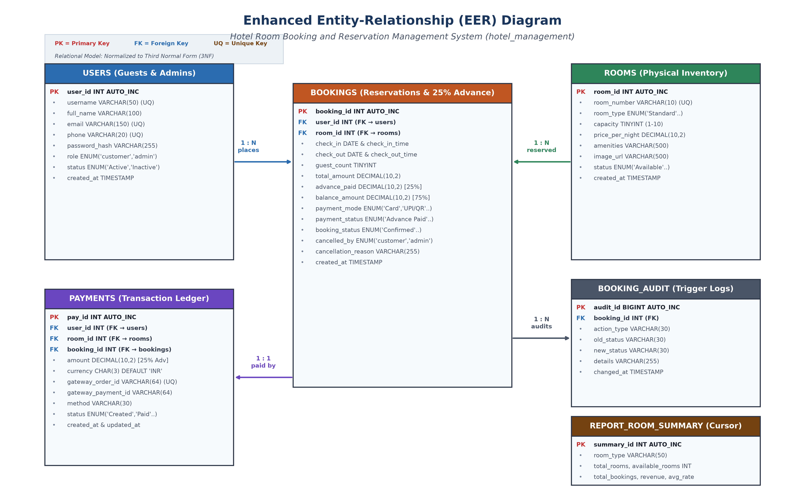
Fig. 3.1: Enhanced Entity-Relationship (EER) Diagram: Hotel Room Booking and Reservation Management System

Operational Workflows: System Workflows:
1. Room Discovery Workflow: Guest selects check-in date, check-in time slot (e.g. 10:00 AM, 12:00 PM), check-out date, check-out time slot, and guest count. The system executes a correlated subquery with NOT EXISTS to filter out any room with conflicting reservations. Available rooms are displayed with curated HD photos, amenities, capacity, and nightly rates.
2. Checkout & Advance Payment Workflow: The customer reviews room details and total cost. The system enforces a mandatory 25% advance booking deposit and displays the 75% balance due at check-in. The user selects a payment method (Card, UPI / QR, Net Banking). For UPI/QR, a dynamic QR code containing the server's local LAN IP address is rendered.
3. Dynamic Wi-Fi QR Payment Workflow: The guest scans the QR code using any smartphone connected to the same local Wi-Fi network. The phone opens a mobile payment sheet (/pay/<order_id>) displaying the advance amount. Tapping 'Approve & Pay' records the payment. Meanwhile, the desktop browser polls /api/payment_status/<order_id>, detects payment completion, and automatically redirects to the booking confirmation receipt.
4. Administrative Cancellation & Refund Workflow: If hotel administration cancels a reservation (e.g. for emergency maintenance), the admin selects an unavoidable operational reason. An automated UPDATE trigger logs the cancellation into booking_audit, and a prominent yellow/red alert is rendered on the guest's dashboard confirming advance refund status.
3.3 Data Collection / Input Description
The system maintains six primary relational tables in MySQL Server:
Table Name | Primary Key | Foreign Keys | Key Attributes & Purpose
users | user_id (PK) | None | username (UQ), full_name, email (UQ), phone (UQ), password_hash, role ('customer','admin'), status, created_at
rooms | room_id (PK) | None | room_number (UQ), room_type ('Standard','Deluxe','Suite','Family','Executive'), capacity, price_per_night, amenities, image_url, status
bookings | booking_id (PK) | user_id (FK), room_id (FK) | check_in, check_in_time, check_out, check_out_time, guest_count, total_amount, advance_paid (25%), balance_amount (75%), payment_mode, payment_status, booking_status, cancelled_by, cancellation_reason
payments | pay_id (PK) | user_id (FK), room_id (FK), booking_id (FK) | gateway_order_id (UQ), amount (25% advance), currency ('INR'), method, status ('Created','Paid','Failed','Refunded'), created_at
booking_audit | audit_id (PK) | booking_id | action_type, old_status, new_status, details, changed_at (Populated automatically via AFTER INSERT and AFTER UPDATE database triggers)
report_room_summary | summary_id (PK) | None | room_type, total_rooms, available_rooms, total_bookings, total_revenue, average_rate, generated_at (Populated row-by-row via CURSOR)

Financial Calculation Model: Mathematical Formulas Implemented:
Stay Duration (Nights) = DATEDIFF(check_out, check_in)
Total Stay Amount (₹) = Stay Duration * Room Price Per Night
Mandatory Advance (₹) = ROUND(Total Stay Amount * 0.25, 2) [25% Upfront Deposit]
Balance Payable (₹) = Total Stay Amount - Mandatory Advance [75% Due at Check-in]
3.4 Algorithms / Techniques Used
The core computational techniques and database algorithms implemented include:
1. Collision-Free Room Discovery via Correlated Subquery (NOT EXISTS)
To guarantee that rooms reserved for a given date span never appear as bookable to another guest, the search route executes a correlated subquery utilizing the NOT EXISTS operator. A room is available if and only if there does not exist any booking for that room with status 'Confirmed' or 'Checked In' where the existing check-in date is before the requested check-out date and the existing check-out date is after the requested check-in date:
SELECT r.room_id, r.room_number, r.room_type, r.price_per_night, r.capacity, r.image_url
FROM rooms r
WHERE r.status = 'Available'
AND NOT EXISTS (
SELECT 1 FROM bookings b
WHERE b.room_id = r.room_id
AND b.booking_status IN ('Confirmed', 'Checked In')
AND b.check_in < %s AND b.check_out > %s
);
2. Live Email OTP Verification Algorithm
During guest registration (/register), the system ensures authenticity by requiring live email verification. When the user enters their email, an asynchronous POST request to /send_otp generates a cryptographically random 6-digit numeric token, stores it in the server session with a 10-minute expiry timestamp, and dispatches an HTML email via transactional email APIs (Resend API / Brevo SMTP relay). The user enters the OTP into the dedicated verification field. Only upon successful verification does the registration form submit to MySQL.
3. 25% Advance Reservation Transaction with Row-Level Locking
Booking creation involves multiple database operations that must execute as a single atomic unit. To prevent race conditions where two customers attempt to book the same room concurrently, the transaction locks the target room row using SELECT ... FOR UPDATE, re-verifies that no overlapping booking was created during the checkout process, calculates the 25% advance amount, inserts the booking record, and inserts the payment ledger record. If any check fails, the transaction issues a ROLLBACK.
4. Dynamic Wi-Fi QR Code Payment Flow
The application automatically detects the host computer's active Wi-Fi / Local Area Network (LAN) IPv4 address (e.g. 192.168.31.106) using socket introspection. When a guest initiates checkout with UPI / QR, the server generates a unique order (gateway_order_id) and constructs a URL: http://<LAN_IP>:5000/pay/<gateway_order_id>. A QR code matrix is dynamically generated in memory and rendered as a Base64 data URI on the checkout screen. Any smartphone connected to the same Wi-Fi network scans the QR code to open the mobile payment interface. When the guest clicks 'Approve & Pay', the payment status transitions to 'Paid'. The desktop browser, running an asynchronous polling script (/api/payment_status/<order_id>), detects the status update and immediately displays the booking confirmation.
5. Administrative Cancellation with Operational Reason Logging
When hotel administrators must cancel a booking due to unavoidable operational emergencies (e.g. pipe leakage, air conditioning failure), the administrative portal (/admin/bookings) requires inputting an operational reason. The update query sets booking_status='Cancelled', cancelled_by='admin', cancellation_reason='...', and payment_status='Refunded'. An automated database trigger logs this transition into booking_audit. When the guest logs into their dashboard (/dashboard), the application detects cancelled_by='admin' and renders an alert notifying the guest of the refund.
6. Automated Database Triggers
The schema defines two automated triggers that maintain a tamper-proof audit trail in the booking_audit table:
Trigger 1: trg_booking_insert_audit (AFTER INSERT): Fires immediately after a new row is inserted into bookings, recording the booking ID, action type 'BOOKING_CREATED', new status, and details including advance paid.
Trigger 2: trg_booking_status_audit (AFTER UPDATE): Fires whenever booking_status is modified. If cancelled by management, it logs the operational reason into the audit log automatically.
7. Stored Procedures and Cursor Processing
The system incorporates three database procedures:
1. sp_monthly_booking_summary(IN p_year INT, IN p_month INT): Accepts p_year and p_month as IN parameters and aggregates total bookings, confirmed volume, advance collections, and recognized revenue for administrative reporting.
2. sp_get_room_type_stats(IN p_room_type, OUT p_total, OUT p_avail, OUT p_avg, OUT p_bookings): Demonstrates both IN and OUT parameters. Accepts a room category and returns total rooms, available count, average nightly rate, and total reservations via OUT parameters.
3. sp_process_occupancy_cursor(): Uses a CURSOR to iterate row-by-row across each distinct room type, computing room availability, reservation totals, and financial collections, and populating report_room_summary.
8. Multi-Table Relational Joins Used in the Project
The system uses relational joins across all functional modules:
Join Construct | Tables Joined | Operational Purpose in Application
INNER JOIN | bookings JOIN users | Associates booking transactions with customer names, emails, and phone numbers for receipts and dashboards.
INNER JOIN | bookings JOIN rooms | Retrieves room numbers, categories, nightly pricing, and photos for reservation cards.
LEFT OUTER JOIN | rooms LEFT JOIN bookings | Aggregates category-level occupancy and recognized revenue, ensuring rooms with zero bookings are included.
LEFT OUTER JOIN | bookings LEFT JOIN payments | Links booking records with gateway payment transaction IDs and payment statuses.
MULTI-TABLE JOIN | bookings JOIN users JOIN rooms | Forms the foundation of the active reservations view (vw_active_reservations) for admin and guest overviews.

3.5 Tools, Software, and Equipment Used
Database Engine: MySQL Server 8.0.46 (InnoDB Engine, UTF-8 unicode encoding) and MySQL Workbench 8.0 CE.
Application Framework: Python 3.10+ / 3.14 with Flask 3.1, Jinja2, mysql-connector-python 26.7, Werkzeug 3.1, qrcode 8.2, and python-dotenv.
Frontend Technologies: HTML5, CSS3, JavaScript, Bootstrap 5.3, and FontAwesome icons.
Development Environment: Microsoft Windows 11 PC acting as Flask and MySQL host.
Testing Devices: Android / iOS smartphone connected to the same local Wi-Fi network for QR code scanning and payment simulation.
3.6 Module-wise Implementation Plan
Module 1: Database Architecture & Normalization: Design relational schema in 3NF, declare PK/FK constraints, column checks, and seed starter data.
Module 2: Advanced SQL Objects: Implement triggers (trg_booking_insert_audit, trg_booking_status_audit), stored procedures (IN/OUT), cursor routine, and views.
Module 3: Backend Application Setup: Configure Flask environment, database connection helper, secure session handling, and error handlers.
Module 4: Landing Page & Room Discovery: Design landing page with hero banner, property highlights, and curated room photos.
Module 5: Guest Authentication & Email OTP: Implement registration form with live 6-digit email OTP verification and phone validation.
Module 6: Reservation & Stay Selection: Develop room date picker with check-in/out time slot selection and 25% advance calculation.
Module 7: Dynamic Wi-Fi QR Payment System: Build dynamic Wi-Fi QR code generator, mobile payment sheet, and desktop polling mechanism.
Module 8: Guest Dashboard: Build customer dashboard displaying stay history, advance receipts, and admin cancellation notices.
Module 9: Administrative Control Center: Implement admin dashboard with property KPIs, room management, booking check-in/out, and diagnostics hub.
Module 10: Testing & Verification: Execute automated test suite (test_app.py) validating email OTP, QR payments, row locking, and trigger auditing.

3.7 Validation and Testing Strategy
Validation is implemented across three coordinated architectural layers:
1. Client-Side Validation: HTML5 constraints, regex pattern matching on email and 10-digit mobile phone numbers, and check-in date rules.
2. Server-Side Validation: Python regular expression validation, live 6-digit OTP verification token matching, stay date sanity checks (check_out > check_in), server-side recalculation of the 25% advance amount, and role-based access decorators (@login_required).
3. Database-Level Validation: MySQL primary keys, UNIQUE constraints on email and phone, CHECK constraints on price and capacity, foreign key cascade actions, and transaction rollback on error.

CHAPTER 4: RESULTS / OBSERVATIONS
4.1 Experimental / Implementation Setup
The application was deployed on a local workstation running MySQL Server 8.0 on port 3306 and the Flask development server on port 5000. A local Wi-Fi router assigned IPv4 addresses to the host PC (192.168.31.106) and the client smartphone. The database was initialized with the seed data containing five room categories, active guest profiles, historical bookings, advance receipts, and trigger audit logs.
Database Object Type | Count | Implemented Names and Identifiers
Tables | 6 | users, rooms, bookings, payments, booking_audit, report_room_summary
Database Views | 3 | vw_monthly_booking_summary, vw_active_reservations, vw_room_inventory_status
Database Triggers | 2 | trg_booking_insert_audit, trg_booking_status_audit
Stored Procedures | 2 | sp_monthly_booking_summary (IN, IN), sp_get_room_type_stats (IN, OUT, OUT, OUT, OUT)
Cursor Procedures | 1 | sp_process_occupancy_cursor (Iterative row-by-row occupancy aggregation)
Performance Indexes | 6 | idx_users_role_status, idx_users_email, idx_users_phone, idx_rooms_type_status_price, idx_booking_room_dates_status, idx_audit_booking
Web Routes / Pages | 12 | /, /rooms, /register, /login, /logout, /send_otp, /verify_otp, /checkout/<id>, /pay/<order>, /dashboard, /admin/*, /admin/database

4.2 Performance Metrics
Because this is an academic Database Management Systems project, evaluation focuses on correctness, data integrity, and transactional consistency:
1. Reservation Integrity: Zero invalid bookings accepted. Overlapping date inquiries are excluded by the correlated NOT EXISTS subquery.
2. Concurrency Control: Row-level locking (SELECT ... FOR UPDATE) ensures two guests cannot book the same room concurrently.
3. Financial Accuracy: The 25% advance amount and 75% balance amount agree across the checkout interface, bookings table, payments ledger, and administrative reports.
4. Security & Role Isolation: Password hashes (scrypt) are verified securely, unauthorized guests are blocked from /admin routes, and parameterized queries prevent SQL injection.
5. Audit Trail Consistency: Every booking insertion and status transition is logged by database triggers into booking_audit.

4.3 Comparison with Expected Results
The system was evaluated through structured test cases covering all core modules:
Test ID | Module / Feature | Input / Action | Expected Result | Observed Result | Status
TC-01 | Landing Page | Navigate to http://127.0.0.1:5000/ | Render hero section, room showcases with HD photos, and advance payment badge. | Page rendered with HTTP 200 and all photos loaded. | PASS
TC-02 | Email Validation | Enter invalid email 'bad-email' on /register | Reject submission with message: 'Please enter a valid email address'. | Validation error displayed; submission blocked. | PASS
TC-03 | Phone Validation | Enter invalid phone '123' on /register | Reject submission with message: 'Please enter a valid 10-digit mobile number'. | Validation error displayed; submission blocked. | PASS
TC-04 | Email Uniqueness | Request OTP for registered email 'john@example.com' | HTTP 409 Conflict returned: 'This email is already registered'. | Duplicate rejected by database check with HTTP 409. | PASS
TC-05 | Email OTP Verification | Request OTP for new email and submit correct 6-digit code | OTP verified successfully; unlock account creation. | OTP accepted; user registration completed. | PASS
TC-06 | Checkout & Advance | Select Room 101 for 3 nights (₹1,800/night) | Total ₹5,400.00; mandatory 25% advance ₹1,350.00; balance ₹4,050.00. | Exact calculations rendered with dynamic QR code. | PASS
TC-07 | Dynamic QR Wi-Fi | Scan QR code from smartphone on same Wi-Fi network | Opens mobile payment sheet /pay/<order_id> with advance amount. | Mobile payment sheet rendered on phone screen. | PASS
TC-08 | Desktop Polling | Approve payment on smartphone screen | Desktop detects payment completion via polling and redirects to receipt. | Desktop automatically redirects to confirmed receipt. | PASS
TC-09 | Date Collision | Search dates overlapping confirmed booking for Room 101 | Room 101 excluded from available rooms list via NOT EXISTS. | Room 101 hidden; collision prevented. | PASS
TC-10 | Admin Cancellation | Admin cancels booking with unavoidable operational reason | Status set to Cancelled, reason recorded, trigger audits event. | Updated in database; trigger audit row created. | PASS
TC-11 | Guest Dashboard Alert | Guest logs into /dashboard after admin cancellation | High-visibility alert displayed with cancellation reason & refund notice. | Alert banner rendered with advance refund info. | PASS
TC-12 | Stored Proc & Cursor | Execute sp_monthly_booking_summary and sp_process_occupancy_cursor | Aggregates revenue and occupancy row-by-row into summary table. | Stored procedure and cursor executed successfully. | PASS

4.4 Observations and Analysis
Visual demonstrations of the application interfaces, payment workflows, administrative dashboards, and database query executions are presented below:
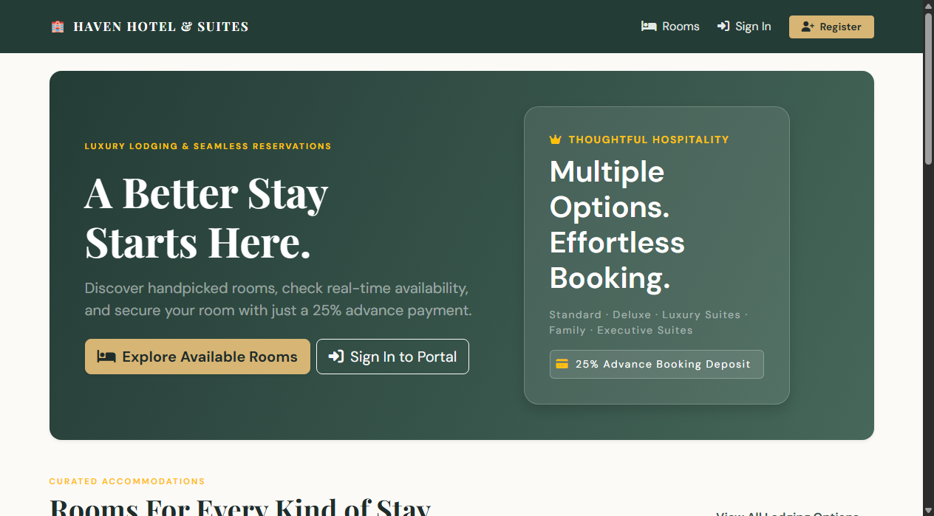
Fig. 4.1: Home / Landing Page: Displays hotel branding, room showcase, curated photos, and 25% advance badge.
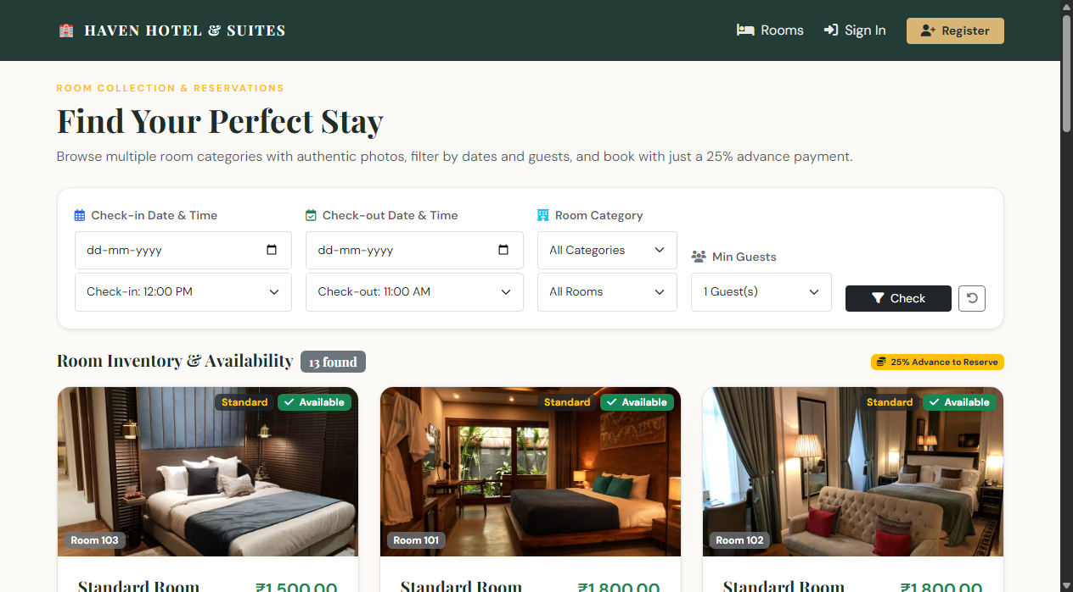
Fig. 4.2: Room Discovery Page: Filtered room inventory featuring high-definition category photos, amenities, capacity, and nightly rates.
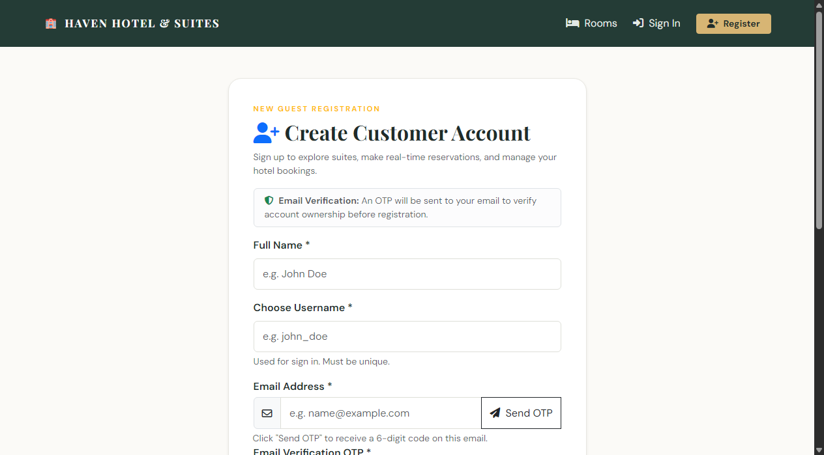
Fig. 4.3: User Registration Page: Features live 6-digit Email OTP verification, phone validation, and password visibility toggle.
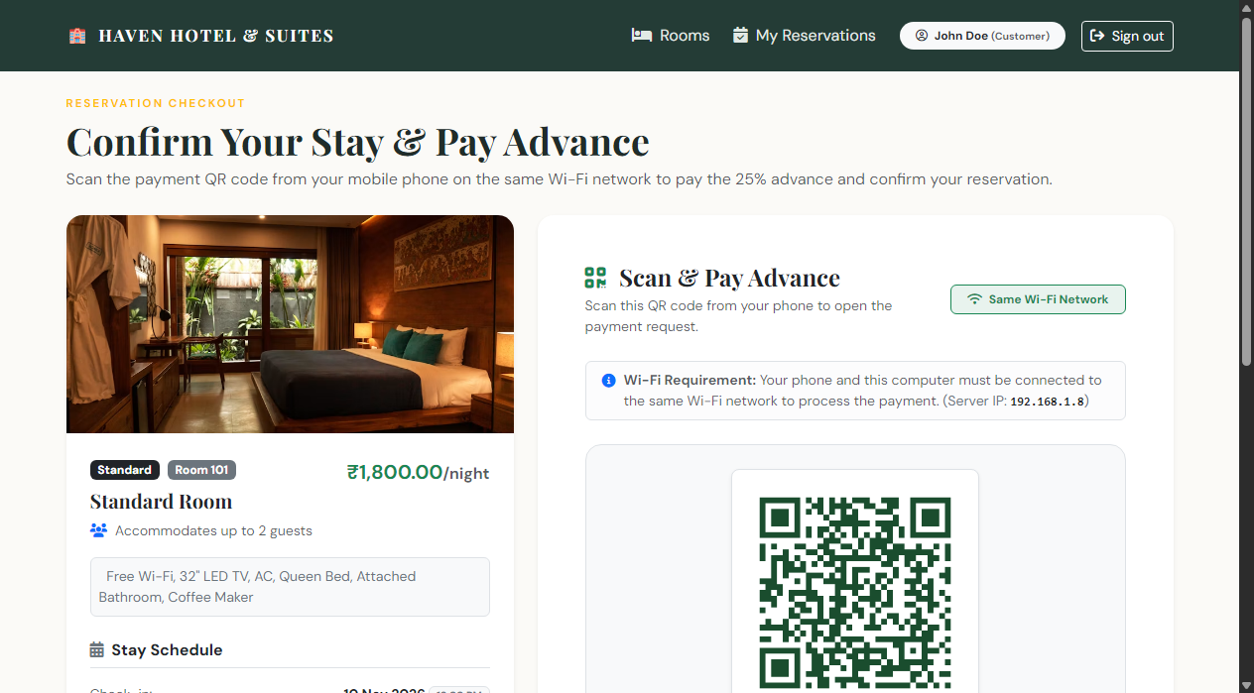
Fig. 4.4: Checkout Page: Displays stay duration, 25% advance deposit calculation, 75% balance, and dynamic Wi-Fi payment QR code.
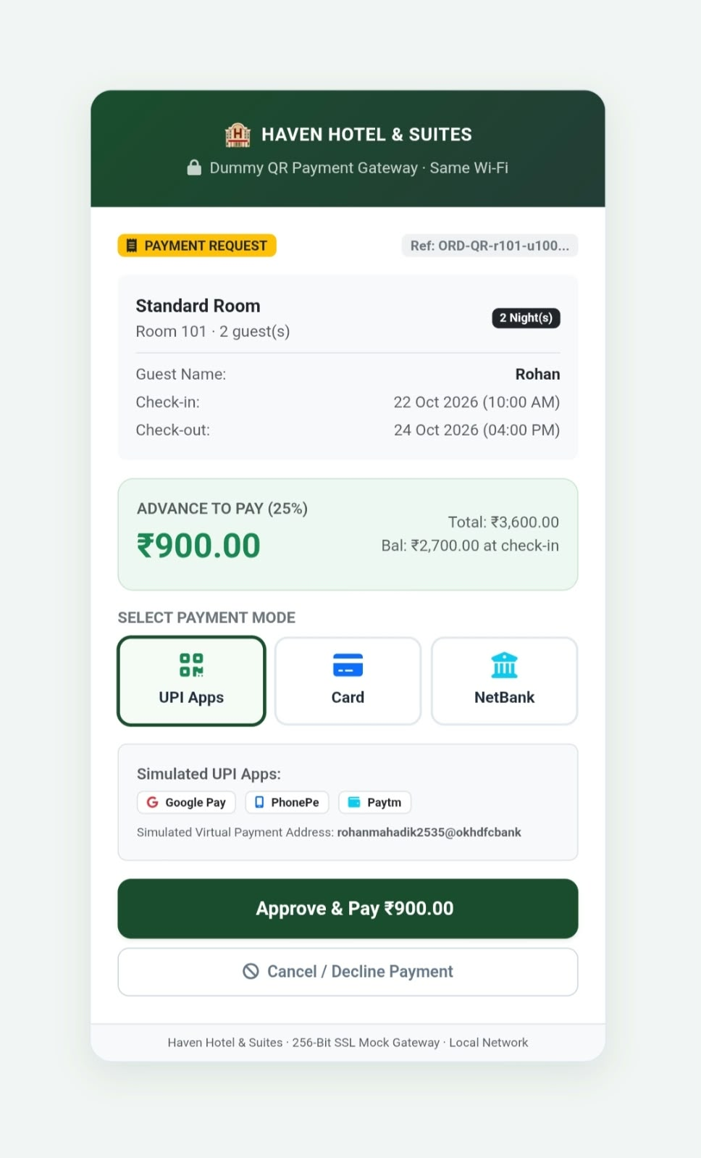

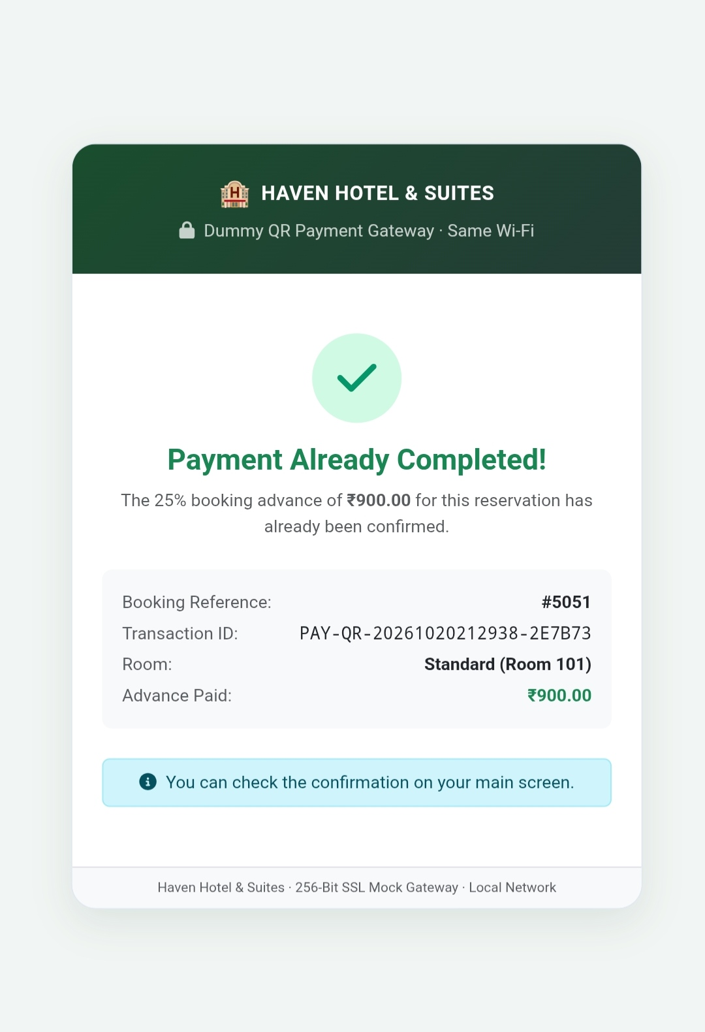
Fig. 4.5: Mobile Payment Sheet: Scanned via smartphone on the same Wi-Fi network, enabling dummy UPI/Card payment approval.
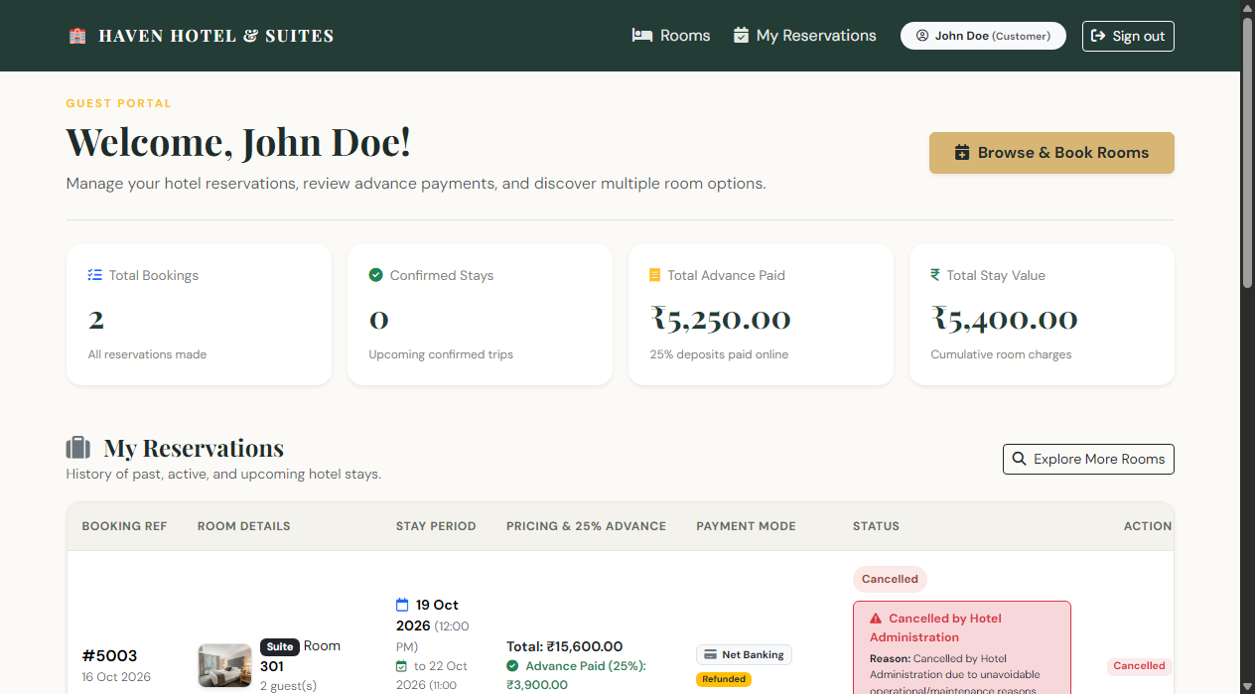
Fig. 4.6: Guest Dashboard: Shows confirmed reservations, advance receipts, and prominent notice when admin cancels a booking.
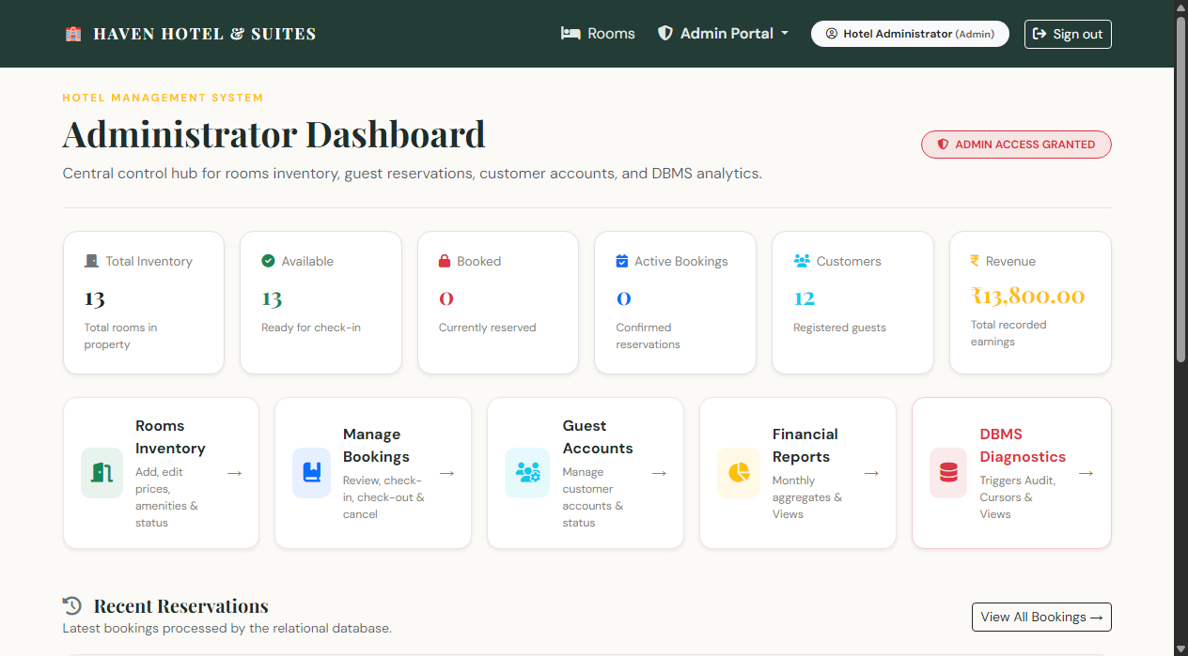
Fig. 4.7: Admin Control Center: High-level property KPIs, recognized revenue, total advance collections, and booking breakdowns.
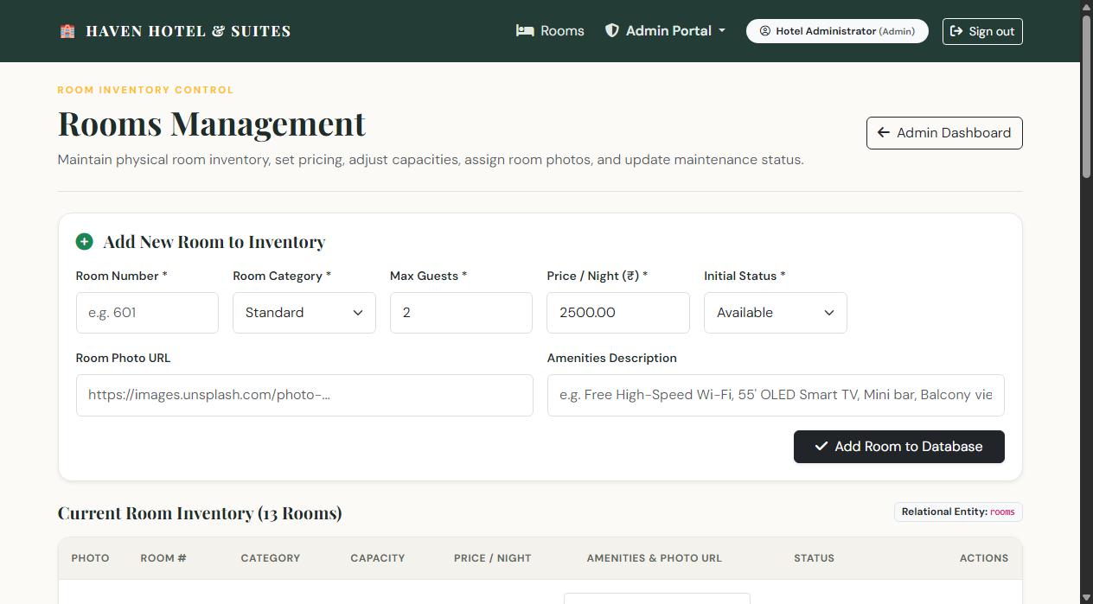
Fig. 4.8: Admin Rooms Inventory Management: Interface to add, update pricing/amenities, toggle maintenance, and manage rooms.
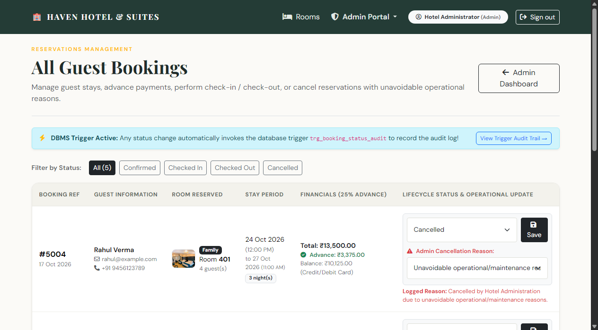
Fig. 4.9: Admin Reservations Management: Real-time booking reviews, check-in/check-out processing, and operational cancellation.
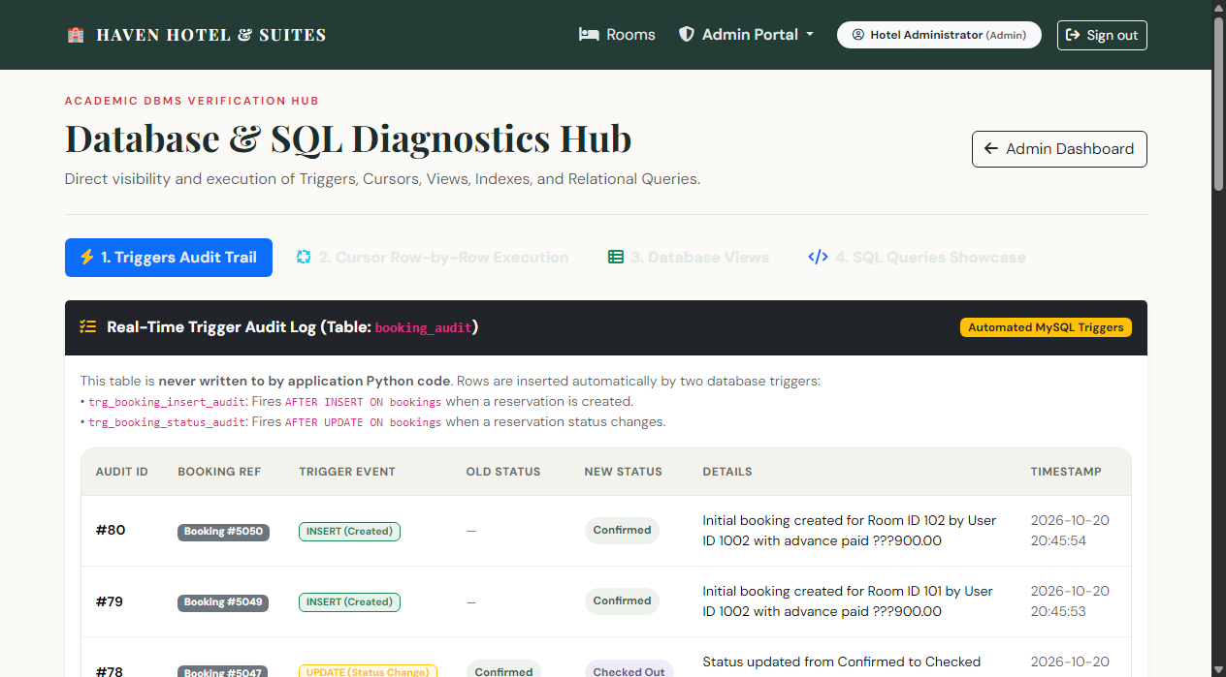
Fig. 4.10: Admin DBMS Diagnostics Hub: Live Trigger Audit Trail, Cursor execution runner, and Views inspector.
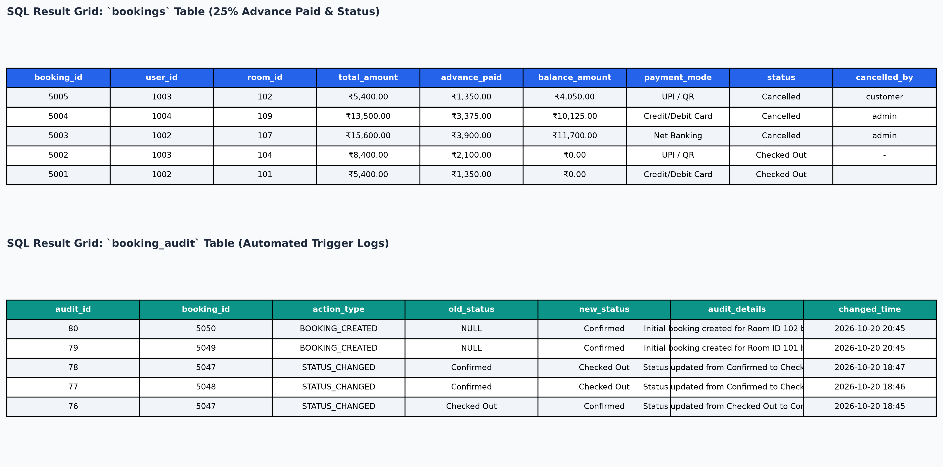
Fig. 4.11: MySQL Database Query Results: Real SQL result grids showing bookings with 25% advance and automated trigger audit logs.
Detailed Technical Observations: Analysis of Key Findings:
1. Trigger Audit Verification: The AFTER INSERT and AFTER UPDATE triggers maintain an unbroken audit trail in booking_audit. When an admin cancels a reservation, the exact operational reason is recorded in the audit log.
2. Dynamic Wi-Fi QR Payment Verification: The dynamic QR code bound to the host machine's Wi-Fi IP address allows seamless cross-device communication between a phone and a laptop without requiring external hosting or third-party webhooks.
3. Financial Precision: The 25% advance deposit model successfully records financial commitments in advance_paid and tracks balance_amount, ensuring clear accounting for both guests and front-desk staff.
4. Cursor Execution: Executing sp_process_occupancy_cursor demonstrates procedural row-by-row iteration over room categories, generating aggregate financial metrics in report_room_summary.
4.5 Validation and Verification with Summary of Findings
Data Integrity: Primary keys, foreign keys, and domain CHECK constraints prevented any invalid or orphaned records from entering the database.
Concurrency: Transaction isolation combined with SELECT ... FOR UPDATE row-level locking successfully eliminated race conditions during booking creation.
Atomicity: Booking creation and payment recording execute as an atomic transaction; any failure triggers a rollback, preserving database consistency.
Security: Password hashing (scrypt) and parameterized queries provide comprehensive protection against credential theft and SQL injection attacks.
Limitations: Payment completion on the local Wi-Fi network uses simulated approval sheets; production systems require commercial payment gateways with webhook signatures.

CHAPTER 5: FUTURE ENHANCEMENT
The Hotel Room Booking and Reservation Management System can be extended with several enterprise enhancements:
1. Live Payment Gateway Integration: Integrate commercial payment gateways such as Razorpay, Stripe, or PayPal in live mode with cryptographic webhook signature verification.
2. Interactive Floor-Plan Room Selector: Develop an interactive, floor-by-floor SVG visual architectural map allowing guests to view room orientations and pick their specific room visually.
3. SMS Notification Gateway: Integrate telecommunication SMS gateways (such as Twilio or Fast2SMS) to deliver instant SMS booking confirmations and arrival reminders.
4. Dynamic Demand-Based Pricing Engine: Implement algorithmic pricing based on seasonal demand, weekend occupancy rates, and booking lead time.
5. Multi-Property Chain Support: Extend the database schema to support multi-property hotel chains, shared guest loyalty programs, and centralized administrative analytics.
6. Automated PDF Invoicing & Digital Passes: Generate downloadable PDF booking vouchers and tax invoices embedded with digital QR check-in boarding passes.
7. Production Deployment & Hardening: Deploy on a production Linux server utilizing Nginx reverse proxy, Gunicorn WSGI workers, HTTPS/TLS certificates, CSRF tokens, and rate limiting.

CHAPTER 6: CONCLUSION AND RECOMMENDATIONS
This mini-project successfully designed, normalized, and implemented a comprehensive Hotel Room Booking and Reservation Management System. The project unites core Relational Database Management System (RDBMS) engineering principles with modern, responsive web application development. The MySQL database schema is normalized to Third Normal Form (3NF), enforcing data integrity through primary and foreign keys, cascade rules, and domain constraints. The implementation demonstrates the full spectrum of academic DBMS topics: multi-table inner and outer joins, correlated subqueries with NOT EXISTS, aggregate grouping with HAVING clauses, database views, performance indexes, automated audit triggers, stored procedures with IN and OUT parameters, and cursor-based row-by-row aggregation.
On the application level, the Python Flask framework provides secure, parameterized query execution, robust session management, and role-based access control. The system addresses real-world hospitality challenges through live email OTP verification, a mandatory 25% advance booking deposit checkout flow, dynamic local Wi-Fi QR code payment with cross-device polling, administrative operational cancellation logging, and an interactive DBMS Diagnostics Hub. Comprehensive end-to-end testing verified that the system reliably prevents double bookings, maintains exact financial consistency, and enforces strict security.
Key Engineering Recommendations: Recommendations for Production Deployment:
1. Transactional Atomicity: Always wrap interdependent multi-table write operations (such as booking creation, payment logging, and inventory status updates) inside atomic database transactions with explicit error rollback handling.
2. Concurrency Protection: Utilize row-level locking (SELECT ... FOR UPDATE) during checkout to prevent concurrency race conditions and overbooking.
3. Three-Tier Validation: Maintain validation across three layers: the browser for user convenience, the application server for business correctness, and the database schema for ultimate referential and domain protection.
4. Automated Trigger Auditing: Rely on database triggers for critical audit trails to guarantee tamper-proof historical logging that cannot be bypassed by external application scripts.

CHAPTER 7: REFERENCES / BIBLIOGRAPHY
1. R. Elmasri and S. B. Navathe, Fundamentals of Database Systems, 7th ed. Boston, MA: Pearson Education, 2016.
2. A. Silberschatz, H. F. Korth, and S. Sudarshan, Database System Concepts, 7th ed. New York, NY: McGraw-Hill Education, 2019.
3. C. J. Date, An Introduction to Database Systems, 8th ed. Boston, MA: Addison-Wesley, 2003.
4. Oracle Corporation, "MySQL 8.0 Reference Manual," Oracle Documentation, 2026. [Online]. Available: https://dev.mysql.com/doc/refman/8.0/en/
5. Oracle Corporation, "MySQL Connector/Python Developer Guide," Oracle Documentation, 2026. [Online]. Available: https://dev.mysql.com/doc/connector-python/en/
6. Pallets Projects, "Flask Documentation (Version 3.1)," Pallets, 2026. [Online]. Available: https://flask.palletsprojects.com/
7. Bootstrap Team, "Bootstrap 5.3 Documentation: The world's most popular frontend open-source toolkit," Bootstrap, 2026. [Online]. Available: https://getbootstrap.com/docs/5.3/
8. Python Software Foundation, "Python 3.14 Standard Library Documentation," Python.org, 2026. [Online]. Available: https://docs.python.org/3/
9. Werkzeug Development Team, "Werkzeug Security Utilities (scrypt password hashing)," Pallets Projects, 2026. [Online]. Available: https://werkzeug.palletsprojects.com/en/stable/utils/#module-werkzeug.security

