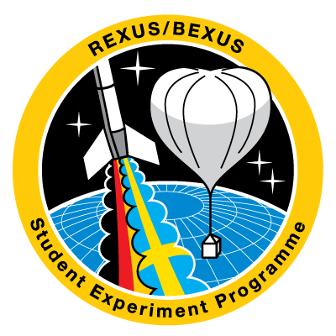 | REXUS/BEXUS Cycle 18  Experiment  Proposal Form |   
Your text should be understandable to scientists of various fields and engineers with a general scientific background.
Before you submit your proposal, please ensure that you have read the REXUS/BEXUS User Manuals and Esrange Safety Manual in detail.
To submit your proposal to ESA, please download this Experiment Proposal Form as a word file and ask your endorsing professor or academic supervisor to provide you with a formal Letter of Endorsement.
The forms and the documents are available at www.rexusbexus.net.
The completed Experiment Proposal Form and the Letter of Endorsement must be uploaded as separate pdf files to the ESA E-learning platform before the deadline. Instructions are available under https://www.esa.int/Education/Rexus_Bexus/How_to_apply
Please note that your team is responsible for all aspects needed to deliver the experiment, including the scientific rationale, experiment design, data handling, engineering, software, manufacturing, verification, safety, operations and outreach. These responsibilities may be distributed across team members with different backgrounds, and supported by professors, laboratories, senior scientists or technical staff where appropriate. The scientific scope and technical complexity of your proposed experiment shall match your team’s skills, available resources and expected support.
Team/Short experiment name | E.g. the acronym of the full experiment title
Full experiment title

REXUS
BEXUS

If you marked REXUS, please select one of the options below:

Spinning with 4 Hz

Despun with Yo-Yo to about 0.08 Hz
Note: if the experiment needs reduced gravity, you shall tick this box
Not important

Science & Organisation

Team Information
Student team leader: | Include name, nationality, university, the field of study, level of study (bachelor, master or PhD), academic year, date of birth and any additional team roles of the leader if applicable.
Contact information  of team leader: | Include at least the phone number, email address and postal address.
Members of your team:
Include name, nationality, gender, year of birth, university, the field of study, level of study (bachelor, master or PhD), academic year, and expected team role(s).

If your team composition does not match the conditions for participation, please describe which condition is not yet fulfilled and provide a clear and credible plan to meet it by the Selection Workshop.

Scientific/Technical background
What is the scientific and/or technical objective of your experiment? | This description should outline the scientific/technical question addressed, the assumptions made, and the research methods chosen to solve the question. Expected results should be stated.
Are you planning to fly an existing REXUS/BEXUS experiment? | If yes, what will be the improvements?
Why do you need a rocket / a balloon? | Clarify why your experiment cannot be done on ground and needs a rocket or balloon flight environment.  Provide a brief justification to implement this mission on a balloon or a rocket as opposed to other ground, air- or space-based platforms.
What flight characteristics do you require? | If you need a rocket:  - Does your experiment require a reduced gravity environment?  - What are the expected duration of the phenomenon and the minimally acceptable duration of the reduced gravity period?  Note: maximum of 120 seconds of reduced gravity conditions of approximately 10⁻² g may be available depending on the composition of the payload.  - What is the optimal altitude or altitude range for your experiment?  - Specify if you require any other flight characteristics.  If you need a balloon:  - What is the optimal altitude for your experiment?  - What is the minimum float time to perform your experiment?  - Does your experiment require daylight? If so, for what duration/part of the flight?  If part of the flight should be in the night/dawn/dusk, please also state this, but note that these flight conditions cannot be guaranteed.  - Specify if you require any other flight characteristics.  Note: Ejections from the BEXUS balloons are not allowed.
Where did you get the idea from? | E.g. research programme at your university, already performed a similar experiment, scientific publications, books…

Describe your experiment | This part should link the scientific objective(s) to the experiment. Explain how you are going to fulfil the scientific goal.
What data do you want to measure?
How do you want to take measurements?
Describe the process flow of your experiment.
What do you plan to do with your data after the flight?

Organisation of your project
How will you organise/distribute work within your team? | Please note that you are responsible for all aspects of your experiment (science, mechanical & electrical engineering, software, etc.)
Can your team members commit to the project for the duration of the programme cycle? If not, please indicate any plans for handing over the project/team roles.
Do institutes and/or senior scientists scientifically and technically support you? | Please indicate the name of the institute(s) and senior scientist(s). Every experiment must have an endorsing professor.
Do you have access to a workshop or a laboratory that meets your experiment's fabrication and testing needs?
Do you have all the material and equipment needed for your experiment? If not, how do you plan to obtain it?
How do you plan to finance your expenses?
Who else will support you (sponsors, others)?

Outreach Programme
Describe your outreach programme for before, during and after the REXUS/BEXUS flight campaign. | How are you planning to present your experiment to the public? E.g. newspaper, local radio, webpage, social media, presentation at the university…  The execution of an outreach programme is mandatory!

Experimental Set-up & Technical Information

Describe your experimental set-up. | Describe and outline the preliminary set-up of your experiment. Include at least a sketch or block diagram of the experiment (CAD drawings are optional).
Estimate the dimensions and the mass of your experiment (kg and m). | For REXUS: Do not include the rocket structure (module and bulkhead) into the mass budget.  For REXUS: State which module size is proposed (120, 220 or 300 mm) or if the experiment is located in the nosecone.
Indicate the preferred position of your experiment: | REXUS:  Indicate your experiment's orientation and the rocket's preferred position: module or nosecone section. Do you need access to the outside environment? Holes? Hatches?  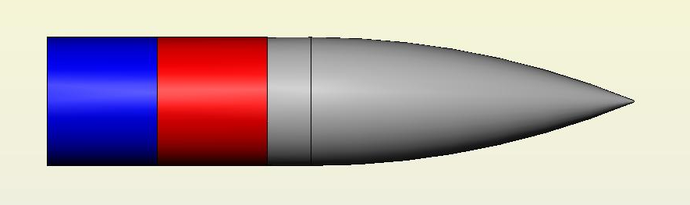  BEXUS:  Define the preferred position in the gondola, inside and external units. Do you need access to the outside environment?  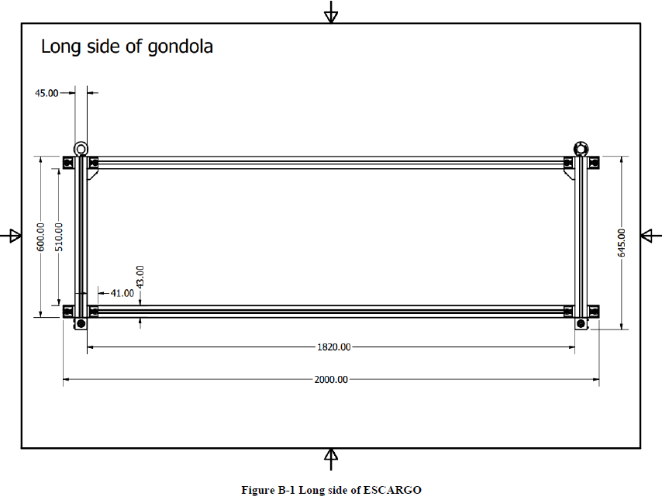  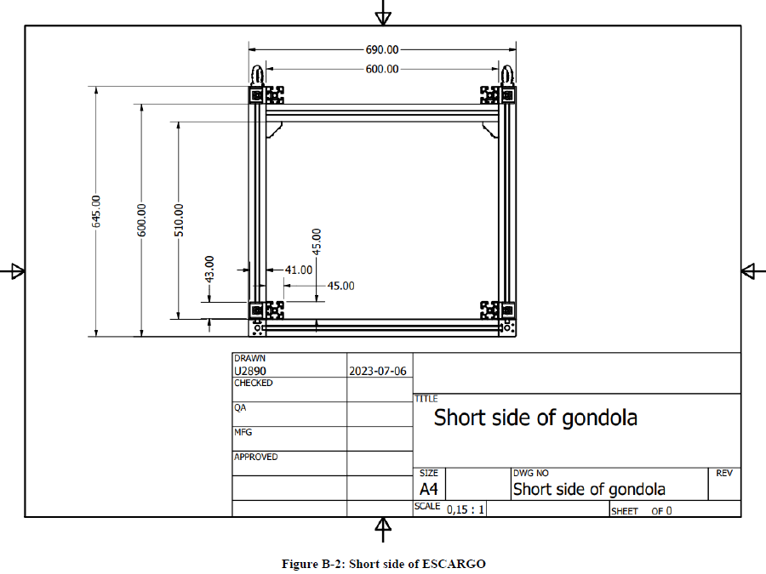

Will you need the 28 V DC power supply from the REXUS service system or power from the BEXUS gondola, respectively?
Will you need (additional) batteries? What do you need for charging? | Qualified batteries are listed in the REXUS and BEXUS User Manuals.
Estimate the electrical consumption of your experiment (Ah or Wh).
Do you use any equipment with high inrush currents? If so estimate the current (A). | E.g. Motors may need high inrush currents which exceed the nominal allowed current limit.
Do you need auxiliary power? Do you need a separate umbilical? | Auxiliary power for charging or consumption before launch is not standard.  Mention here whether you need auxiliary power and why.
Use of uplink and downlink: | Please indicate expected data rates for uplink and downlink.  Please note: In addition to onboard storage, it is mandatory that you downlink housekeeping/scientific data during the flight.  On BEXUS, an uplink is also available throughout the flight. On REXUS, an uplink is not normally available during the flight but should be used during ground testing.
REXUS only: Do you need to use the REXUS TV Channel? | There is only one TV channel available, so only one experiment can use it at any one time and a maximum of three experiments can be connected. Why should one be your experiment? At what stage of the flight do you need it and for how long?
Provide an event timeline, including the experiment actions during flight, such as timer or telecommand events. | Describe your event timeline from start of countdown.

Environmental Questions & Safety Issues
Please note that some of the aspects questioned below may require additional explicit approval from the organisers.
If you believe aspects of your design may cause safety or environmental concerns, you are invited to contact ESA before submitting your application.
Does the experiment use wireless devices? | E.g. Wifi (WLAN), Bluetooth, infrared, data transmitters. Describe the type of devices and frequencies used.
Does the experiment create any disturbing magnetic or electrical fields?
Do you expect to use high voltages in any part of your experiment? | Please indicate the voltage, its use within the experiment and any expected protection devices.
REXUS only: Does your experiment eject anything from the rocket? | Note: number and size of holes/hatches in a module are limited. Please refer to the REXUS User Manual.
Is the experiment sensitive to light?
Is the experiment sensitive to vibrations?
Does the experiment generate vibrations? | E.g. Vacuum pump, rotating devices…
Will you use any flammable, explosive, radioactive, corrosive, magnetic or organic products? | Specify any products you will use with any of these characteristics.
Will you use a laser? | Which class? Is the laser path securely contained?
Is your experiment airtight? Are parts of your experiment airtight? | Yields to a pressurized experiment (1 bar) when the vehicle reaches higher altitude with lower pressure values.  This question should remind you that there will be a very low ambient pressure environment for your experiment.
Are there any hot parts (> 60°C)? | Mention any parts besides electronics that heat up.
Are there any moving parts? Are the moving parts reachable? | This is important for the preparation before launch. Access to the experiment will be discussed with EuroLaunch. E.g. a tappet is used for a moving part.
Do you need any pressure systems from EuroLaunch before launch? | If you know that you need, for example, a pressurized nitrogen-bottle for your experiment before launch, please mention it here. All pressurized bottles will be handled by EuroLaunch personnel.
Is there any aspect in your experiment which you believe may be viewed as a safety risk by others (regardless of whether you will mitigate this risk in your design)?

End users | Identify any end users of the experiment data/technology, or any business applications. Where applicable, consider including team members with a relevant field of study and ensure they are reported under “members of your team”.
Additional comments | Is there any -information that is of importance for your proposal and not addressed above.

Drawings can be inserted below and referenced in the above table.

