1. **Write a program, in which you take 3 inputs from the user and apply the operations, Add, subtract, divide and multiply.**

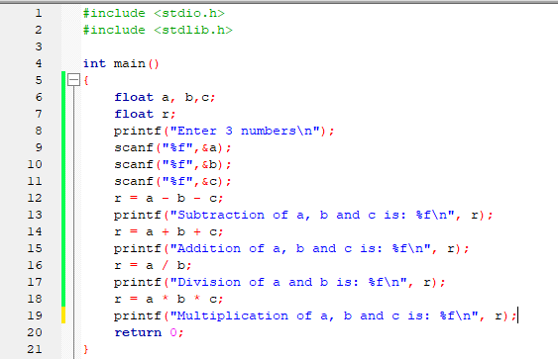

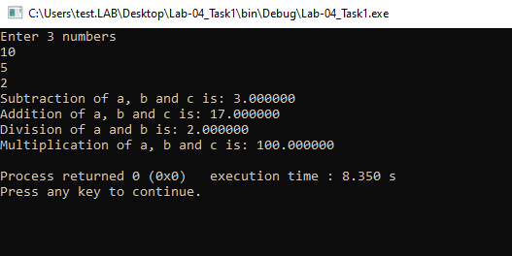

1. **Write a program to interchange values of two operands a and b.**

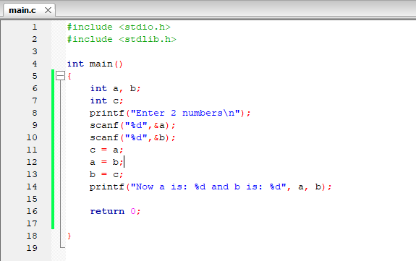

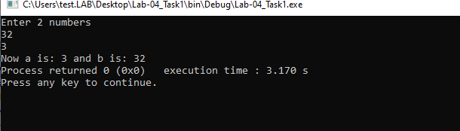

1. **Write a program for calculating the percentage of a student, by taking input of 5 subject’s marks and each course has max 100 marks.**

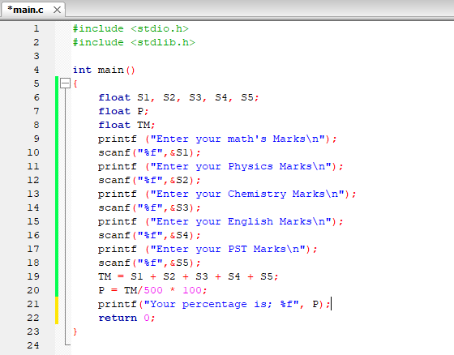

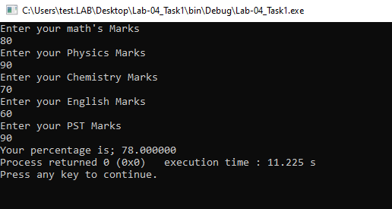

1. **Write a program to interchange two variable values without using a third variable.**

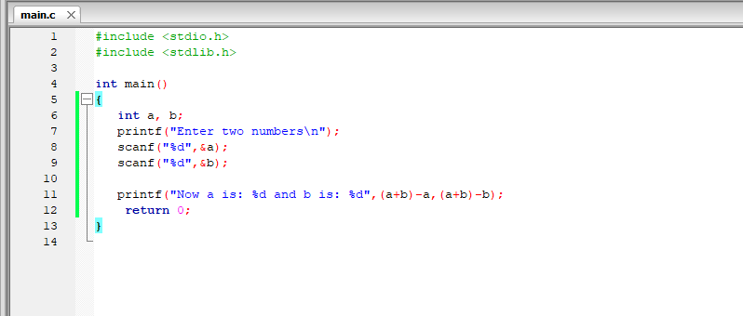

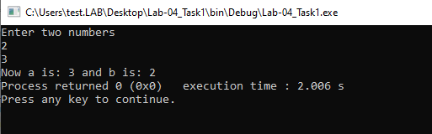

1. **Write a program to print the size of char, float, double and long double data types in C**.

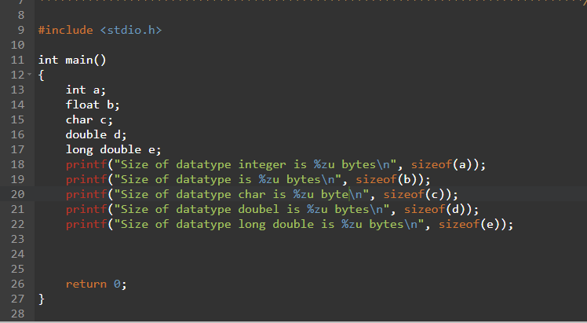

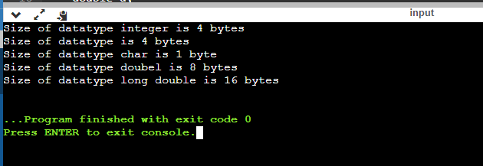

1. **Write a program to input two numbers and display the maximum number.**

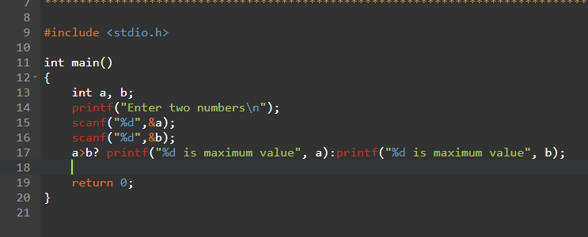

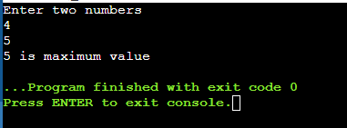

1. **Write a program to calculate the area and perimeter of a circle, triangle, and square. Input is dependent on the type shape.**

**Circle**

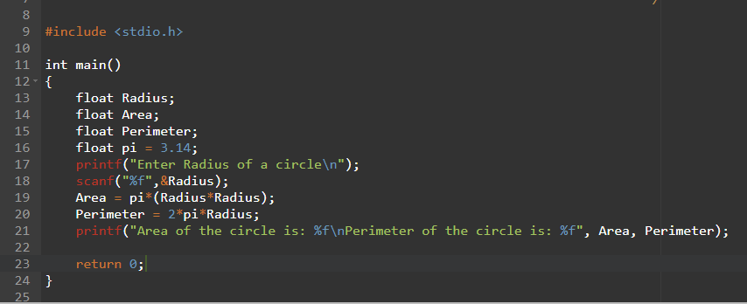

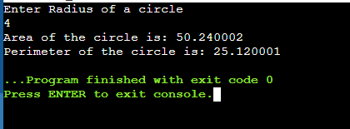

**Square**

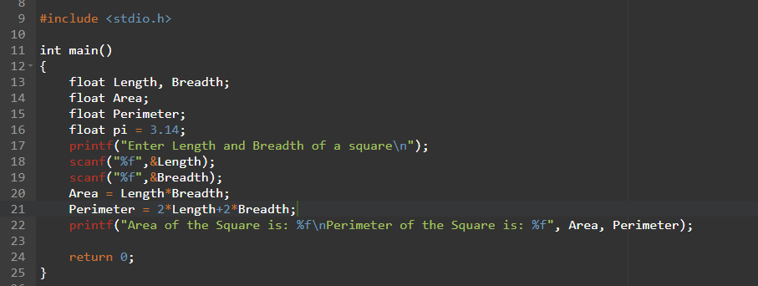

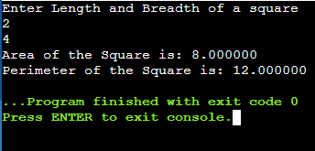

**Triangle**

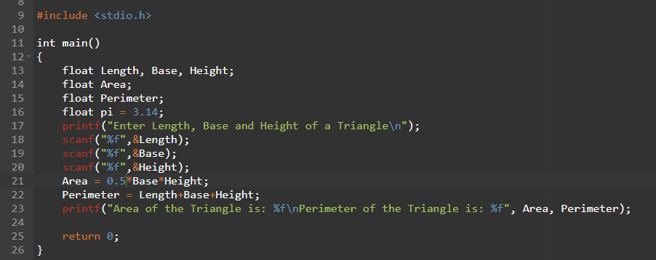

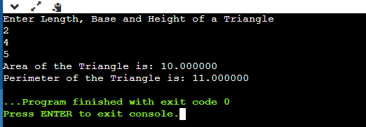

**All together**

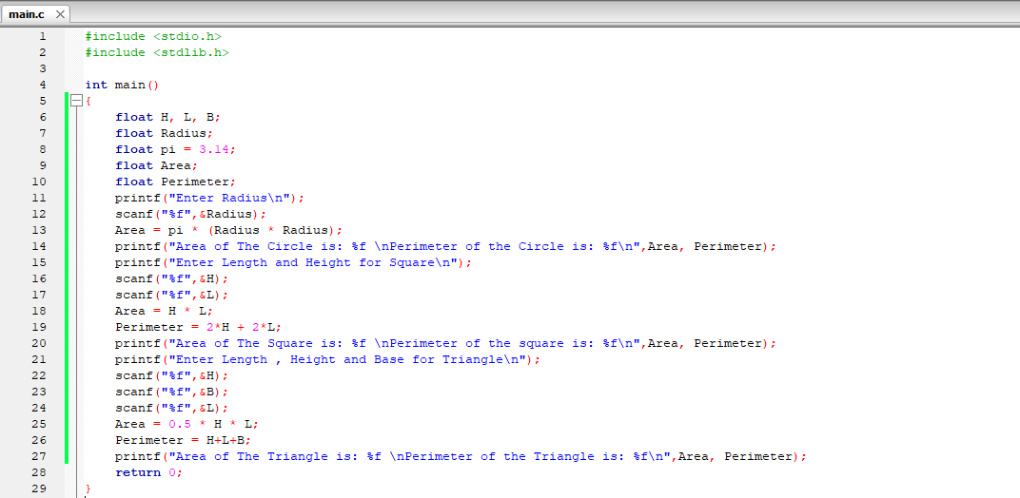

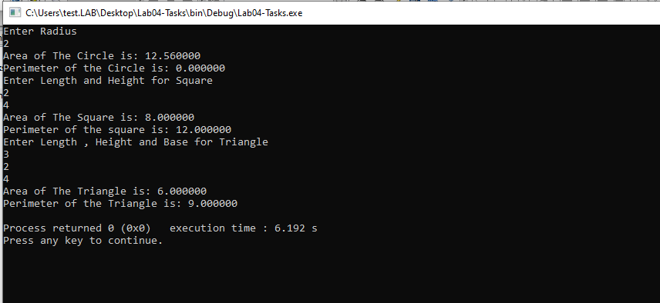

1. **Write a program to find unit , ten , hundred , and thousand values in a four digit number Example Number = 1234 Unit = 4 Ten = 3 Hundred = 2 Thousand = 1**

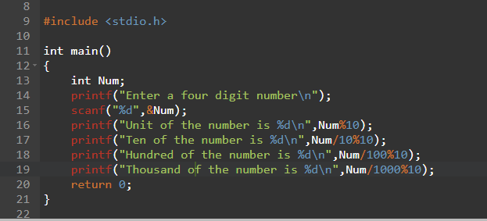

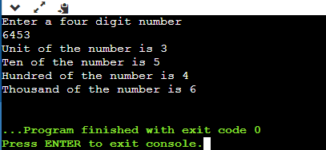

9. **Write a program to find the sum of individual digits of an integer**

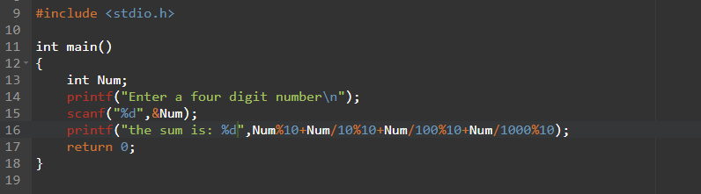

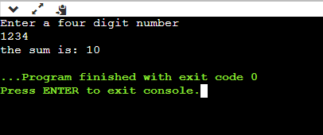

**10.Write a program to reverse a four digit number**

**Example**

**Number = 1234**

**Reverse = 4321**

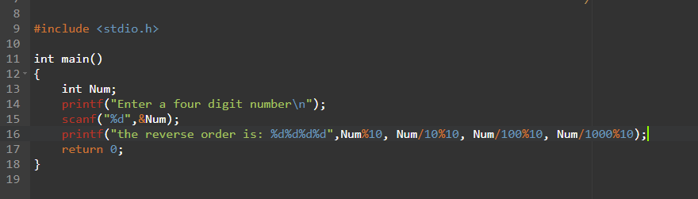

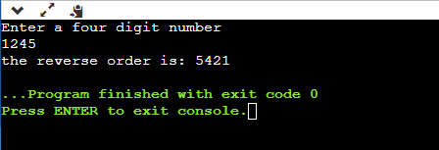

**11.What was the difference between a++, a= a+1? Discuss them?**

**There is a little difference between a + + and a = a = 1.**

**In a = a + 1 the computer use 3 steps to process:**

1. **It takes the “a” value**
2. **Add 1 in “a” variable**
3. **Add total in “a” variable**

**In a + + computer simply takes “a” variable and increments it by 1.**