1. Write a program for calculating the percentage and grade of a student by

taking input of 5 subjects marks (100 marks each course max).

* Less than 55 = fail
* 55 to 65 = C+
* 65 to 75 = B
* 75 to 85 = B+
* 85 to 95 = A
* 95 to 100 = A+

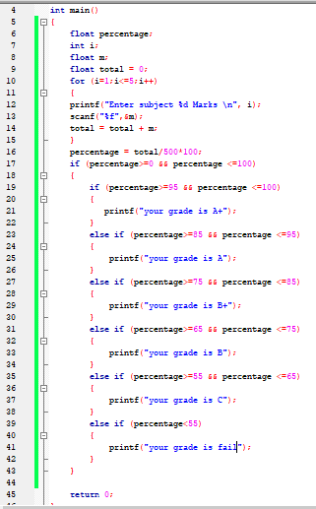

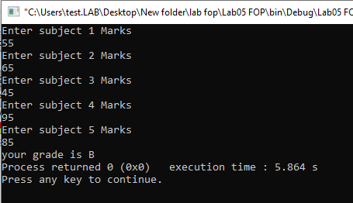

float percentage;

int i;

float m;

float total = 0;

for (i=1;i<=5;i++)

{

printf("Enter subject %d Marks \n", i);

scanf("%f",&m);

total = total + m;

}

percentage = total/500\*100;

if (percentage>=0 && percentage <=100)

{

if (percentage>=95 && percentage <=100)

{

printf("your grade is A+");

}

else if (percentage>=85 && percentage <=95)

{

printf("your grade is A");

}

else if (percentage>=75 && percentage <=85)

{

printf("your grade is B+");

}

else if (percentage>=65 && percentage <=75)

{

printf("your grade is B");

}

else if (percentage>=55 && percentage <=65)

{

printf("your grade is C");

}

else if (percentage<)

{

printf("your 5grade is fail");

}

}

return 0;

2. Write a program to make a calculator where the operator selection is dependent upon user input. Following are the requirements.

* two inputs numeric
* one selection for operation
* output with respect to user selection
* When selecting division operator handle ‘0’ in denominator.
* Operators (+,-,\*,/)

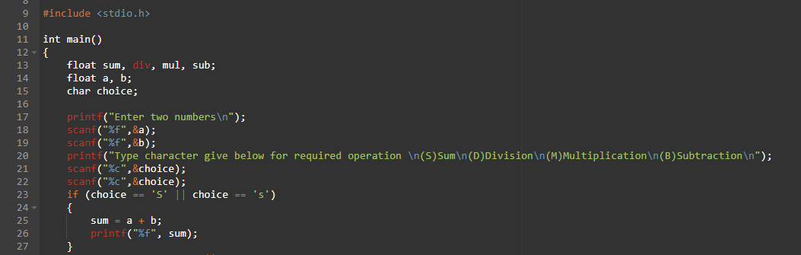

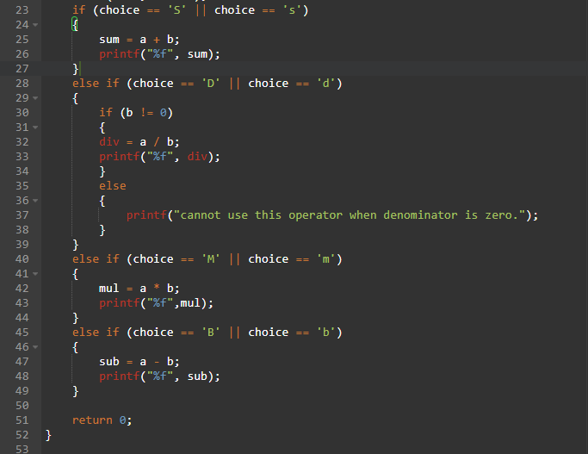

Output When input is 4 and 2. Operator multiplication:

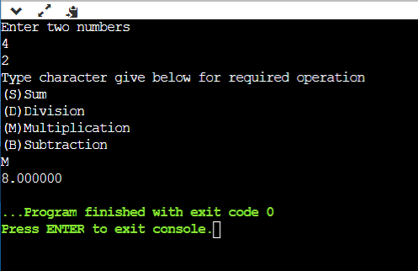

Output When input is 4 and0. Operator Division:

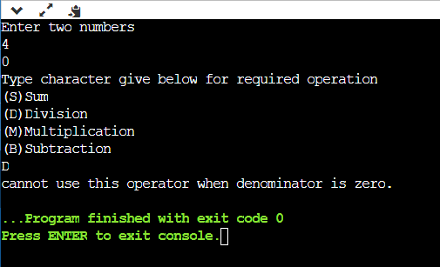

float sum, div, mul, sub;

float a, b;

char choice;

printf("Enter two numbers\n");

scanf("%f",&a);

scanf("%f",&b);

printf("Type character give below for required operation \n(S)Sum\n(D)Division\n(M)Multiplication\n(B)Subtraction\n");

scanf("%c",&choice);

if (choice == 'S' || choice == 's')

{

sum = a + b;

printf("%f", sum);

}

else if (choice == 'D' || choice == 'd')

{

div = a / b;

printf("%f", div);

}

else if (choice == 'M' || choice == 'm')

{

mul = a \* b;

printf("%f",mul);

}

else if (choice == 'B' || choice == 'b')

{

sub = a - b;

printf("%f", sub);

}

return 0;

3. Write a program to find whether the number entered by user is even or odd.

int num;

printf("enter any number\n");

scanf("%d",&num);

if (num%2==0)

{

printf("Number is even");

}

else

{

printf("Number is odd");

}

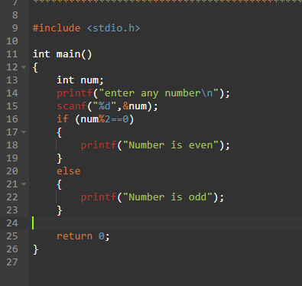

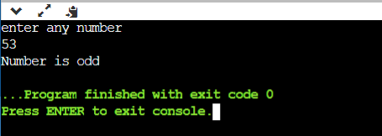

4. Write a program to check whether the number entered by the user is positive or negative.

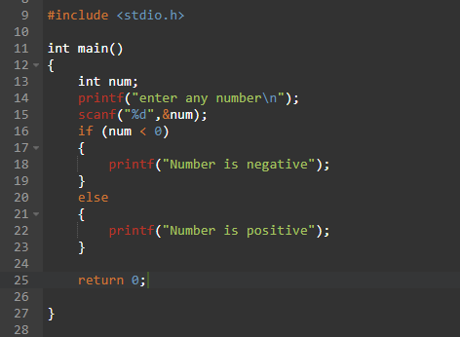

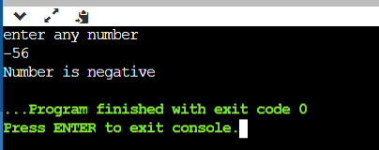

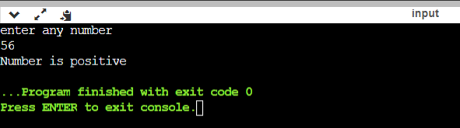

int num;

printf("enter any number\n");

scanf("%d",&num);

if (num < 0)

{

printf("Number is negative");

}

else

{

printf("Number is positive");

}

return 0;

6. Write a program to print “good morning” if time is less than 12 else print “good after noon”

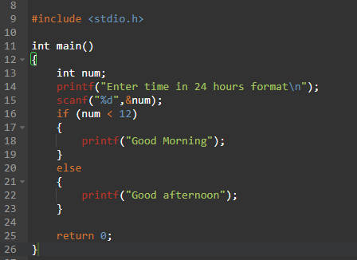

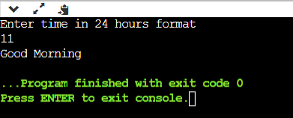

int main()

{

int num;

printf("Enter time in 24 hours format\n");

scanf("%d",&num);

if (num < 12)

{

printf("Good Morning");

}

else

{

printf("Good afternoon");

}

return 0;

}

7. Write a program to print “You can vote” if the voter’s age is 18, otherwise print “You are not eligible”

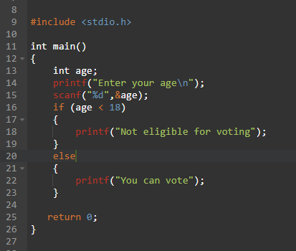

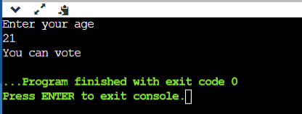

int main()

{

int num;

printf("Enter your age\n");

scanf("%d",&num);

if (num < 18)

{

printf("Not eligible for voting");

}

else

{

printf("You can vote");

}

return 0;

}

8. What is Ternary operator? Why we use them?

Excercidse 6

1. Write a program to design a calculator that performs all the arithmetic operations (by Switch case)

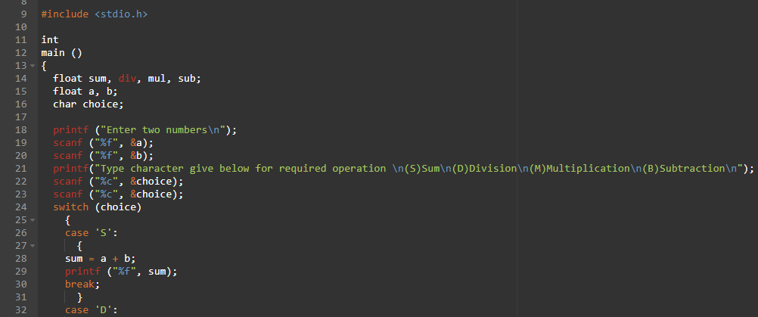

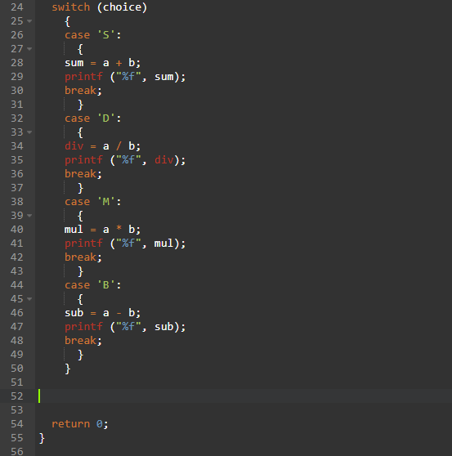

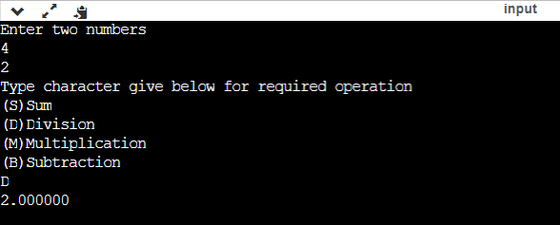

int main()

{

float sum, div, mul, sub;

float a, b;

char choice;

printf("Enter two numbers\n");

scanf("%f",&a);

scanf("%f",&b);

printf("Type character give below for required operation \n(S)Sum\n(D)Division\n(M)Multiplication\n(B)Subtraction\n");

scanf("%c",&choice);

scanf("%c",&choice);

switch(choice)

{

case 'S':

{

sum = a + b;

printf("%f", sum);

break;

}

case 'D':

{

div = a / b;

printf("%f", div);

break;

}

case 'M':

{

mul = a \* b;

printf("%f",mul);

break;

}

case 'B':

{

sub = a - b;

printf("%f", sub);

break;

}

}

return 0;

}