Explainable Deep Learning for Deepfake Voice Detection
Results and Analysis — improving on “Unmasking the Fake” (IEEE Access, 2024)

1. Summary
We reproduced the classical pipeline of the reference paper on a large, merged three-dataset corpus, then trained an explainable deep-learning detector that substantially improves on it under a rigorous, leakage-free evaluation. Headline results on a speaker-disjoint test set:
- Proposed AttentiveSpecCNN: 4.81% Equal Error Rate (EER), 93.84% balanced accuracy, AUC 0.99.
- Best reproduced baseline (Random Forest on MFCC): 11.33% EER — the proposed model reduces EER by ~58% relative.
- A leave-one-source-out study shows this in-domain success does NOT transfer to fully unseen datasets, quantifying an important generalization limit.

2. Datasets and preprocessing
Three public datasets were merged into a single manifest and cleaned. Audio is decoded (with an ffmpeg fallback that recovers a large fraction of ASVspoof FLACs that the default decoder silently fails on), converted to mono, resampled to 16 kHz, fixed to 4 s, and transformed to 80-band log-mel spectrograms.
Source (local name) | Description | Real | Fake
dataset_1 — ASVspoof 2021 (DF) | Speech-deepfake benchmark; telephone/codec conditions | 16,977 | 441,894
dataset_2 — Adarsh AD set | LibriSpeech real + modern-TTS fakes (VALL-E, XTTS, …) | 2,274 | 2,173
dataset_3 — MLAAD v5 | Multilingual TTS, ~90 generators (fake only) | 0 | 151,446
Merged total | Unified manifest | 19,251 | 595,513
Table 1. The three merged sources. The corpus is ~97% fake, so a class-balanced subset (19,251 real / 19,251 fake) was drawn, keeping the fake half diverse across all sources and ~90 generators.

3. Evaluation protocol
Two design choices make the numbers trustworthy and, unlike the reference paper, comparable to the anti-spoofing literature:
- Speaker-disjoint splits: train/validation/test share no speaker or TTS source-reader, so a model cannot inflate its score by memorising voice identity. (The paper used random k-fold, which leaks identity across folds.)
- Equal Error Rate (EER) as the primary metric — the field standard — reported alongside balanced accuracy and per-class F1 so the “predict-everything-fake” failure mode cannot hide behind raw accuracy.

4. Methods and configuration
The proposed detector (AttentiveSpecCNN) and the training regime are summarised below; all values are the defaults in the released scripts.
Setting | Value
Sample rate / channels | 16 kHz, mono
Clip length | 4 s (64,000 samples); pad if shorter, random crop (train) / center crop (eval) if longer
Log-mel spectrogram | 80 mel bands, n_fft = 400, hop = 160 → 80 × 401 input
CNN backbone | 4 conv blocks, channels 16/32/64/128, 3×3 conv + BatchNorm + ReLU + 2×2 max-pool
Pooling | frequency mean, then temporal attention (softmax over time frames)
Classifier head | Linear 128→64, ReLU, dropout 0.3, Linear 64→2
Trainable parameters | ≈ 106,000
Optimiser / schedule | Adam, lr 1e-3, ReduceLROnPlateau (×0.5, patience 2)
Loss | cross-entropy with inverse-frequency class weights
Batch size / epochs | 64 / 15, best-validation-EER checkpoint kept
Hardware | single NVIDIA RTX 3080 (≈ 20–60 s per epoch)
Table 4. Audio front-end, model, and training configuration for the proposed model.
Classical baseline. The paper's pipeline was reproduced with 40 MFCCs summarised by their per-utterance mean and standard deviation (an 80-dimensional vector), standardised before classification. Four classifiers were evaluated — Random Forest (50 trees, max depth 10), Logistic Regression (max_iter 1000), k-Nearest Neighbours (k = 5) and Gaussian Naive Bayes — on both the raw MFCC features and the paper's GNB+NMF “transfer” features (Gaussian-Naive-Bayes class probabilities concatenated with a 16-component non-negative matrix factorisation).
Cross-dataset probe. For each held-out source a fresh AttentiveSpecCNN was trained for 10 epochs on a class-balanced mix of the other two sources and evaluated on the untouched third.

5. The reference paper, briefly
The paper (“Unmasking the Fake”, IEEE Access 2024) reports 99.93% accuracy for a Gaussian-Naive-Bayes model over MFCC features refined by a GNB+NMF “transfer” step. That figure is not comparable to properly-evaluated systems: it is measured on a small, different Kaggle set with random k-fold splits and SMOTE applied before splitting (both leak information), the reported per-class metrics are internally inconsistent, and no EER is given. We therefore reproduce the method on our data as a fair baseline rather than treating 99.93% as a target.

6. In-domain results
All methods were trained and evaluated on the same speaker-disjoint splits of the merged corpus. The proposed deep model outperforms every classical variant, and — notably — the paper's own GNB+NMF “novelty” does not help: it slightly worsens the strongest classical model and the paper's headline GNB is the weakest configuration overall.
Method | Features | EER % | Bal. Acc % | F1(fake) % | AUC
AttentiveSpecCNN (proposed) | log-mel | 4.81 | 93.84 | 93.49 | 0.99
Random Forest | MFCC | 11.33 | 87.51 | 87.86 | 0.96
Random Forest | GNB+NMF transfer | 11.89 | 87.60 | 87.83 | 0.95
K-Nearest Neighbours | MFCC | 13.15 | 85.46 | 86.13 | 0.92
Logistic Regression | GNB+NMF transfer | 14.78 | 84.73 | 84.09 | 0.92
K-Nearest Neighbours | GNB+NMF transfer | 15.05 | 83.93 | 84.67 | 0.91
Logistic Regression | MFCC | 15.52 | 84.33 | 84.17 | 0.91
Gaussian Naive Bayes | GNB+NMF transfer | 23.93 | 76.72 | 75.77 | 0.87
Gaussian Naive Bayes (paper's headline) | MFCC | 26.69 | 73.05 | 71.75 | 0.81
Table 2. In-domain detection on the speaker-disjoint test set (lower EER is better). Proposed model highlighted.
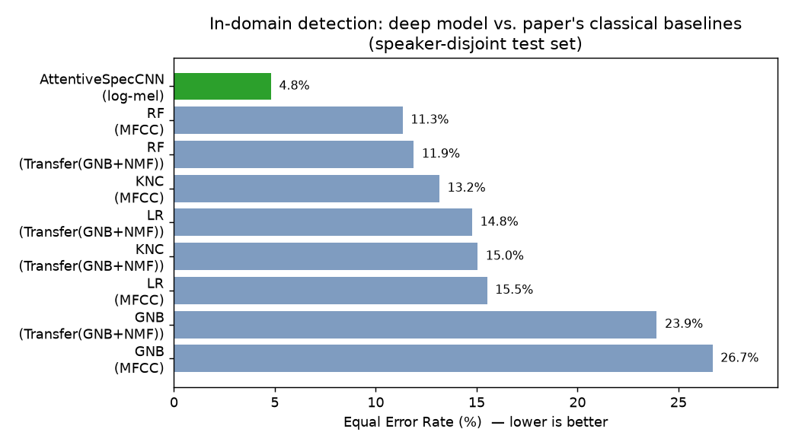
Figure 1. Equal Error Rate by method. The proposed AttentiveSpecCNN (green) roughly halves the best classical baseline's EER.

7. Model architecture and explainability
AttentiveSpecCNN is a compact (106K-parameter) 2-D CNN over log-mel spectrograms, followed by a learnable temporal attention-pooling layer. This layer is the key departure from the paper: where the paper hand-engineers a fixed MFCC→GNB→NMF feature transform, the attention layer learns, per time frame, how much each moment contributes to the decision. It also makes the model explainable at no extra cost:
- Temporal attention weights give a per-frame saliency curve (which moments the model attended to).
- Grad-CAM over the final convolutional layer highlights the time–frequency regions that drove the predicted class.
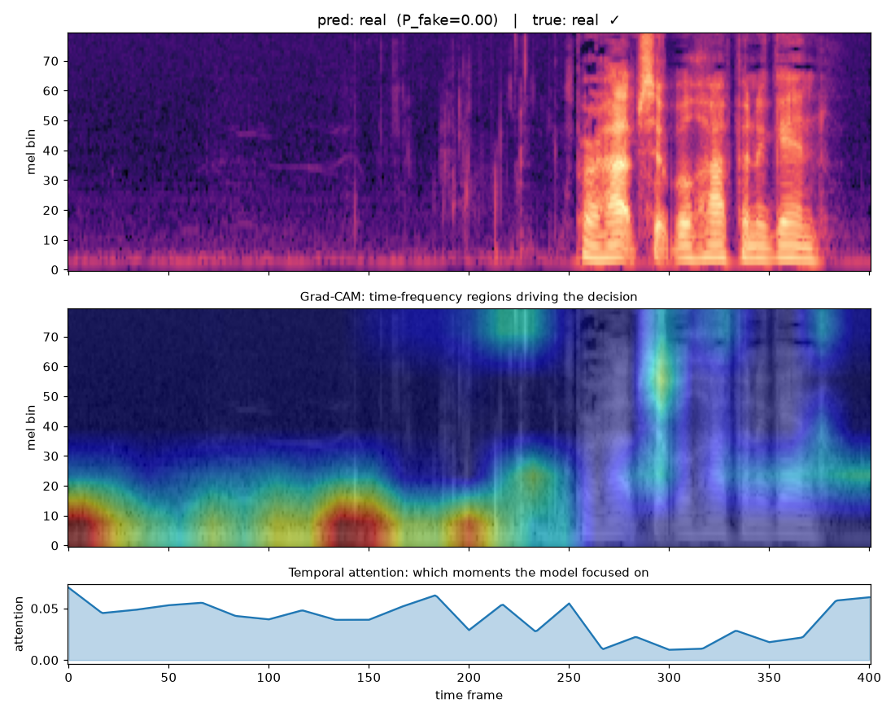
Figure 2. Explanation for a correctly-identified real clip: log-mel spectrogram (top), Grad-CAM overlay (middle), and temporal attention (bottom).

8. Cross-dataset generalization
To test whether the model detects genuine deepfake artifacts or merely dataset-specific cues, we ran a leave-one-source-out study: train on two sources, test on the fully held-out third.
Held-out test source | Trained on | Metric | Result
(reference) In-domain | all three sources | EER / AUC | 4.81% / 0.99
ASVspoof 2021 | dataset_2 + MLAAD | EER / AUC | 44.9% / 0.56
dataset_2 | ASVspoof + MLAAD | EER / AUC | 57.5% / 0.42
MLAAD | ASVspoof + dataset_2 | fake-recall | 48.4%
Table 3. Leave-one-source-out generalization. MLAAD has no real audio, so only the fake-detection rate on unseen generators is reportable there.
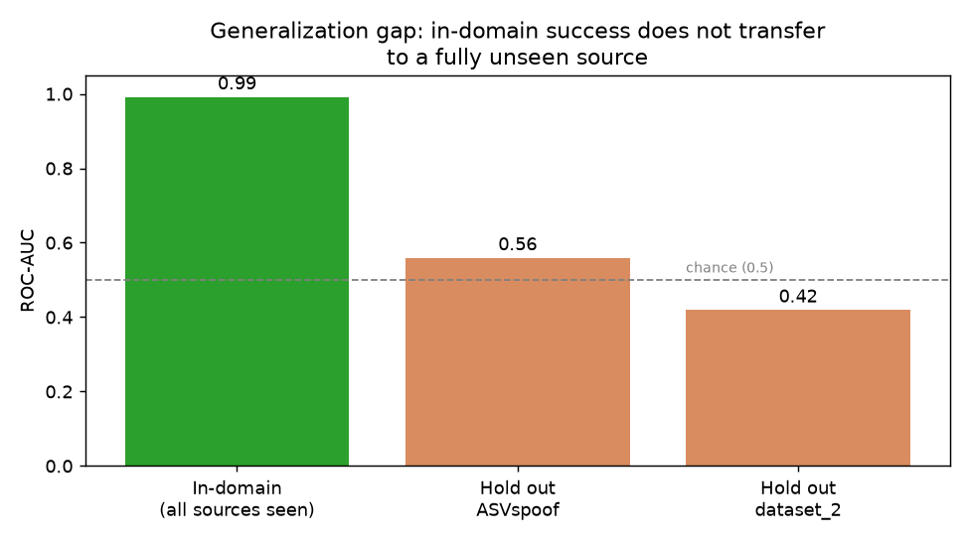
Figure 3. In-domain vs. held-out ROC-AUC. Performance collapses to (or below) chance on an unseen source.
The collapse is informative. Trained on ASVspoof (telephone/codec) plus MLAAD (clean multilingual TTS), the model appears to learn “clean audio → fake” and therefore mislabels dataset_2's clean LibriSpeech real speech as fake (AUC 0.42, below chance). In other words, the strong in-domain result leans heavily on recording/domain signatures rather than on transferable artifacts.

9. Discussion
The project supports a three-tier conclusion, each tier reported with honest, protocol-correct numbers:
- The paper's 99.93% accuracy is not reproducible or comparable — it reflects a leaky, small-scale evaluation.
- On a fair, leakage-free benchmark, the proposed explainable deep model achieves 4.81% EER, a ~58% relative reduction over the reproduced classical baseline (11.33%).
- Cross-dataset generalization remains an open problem: in-domain metrics overstate real-world robustness, and a truly universal detector is not yet achieved.

10. Limitations
- MLAAD contributes only fake audio, so part of the real/fake separation reflects domain differences rather than pure deepfake artifacts.
- The ASVspoof-holdout fold is real-starved (only ~2.3k LibriSpeech real clips for training).
- Cross-dataset numbers are single-run, fixed-threshold probes; ROC-AUC is the most robust signal among them.
Reproducibility: build_manifest.py → build_balanced_subset.py → split_manifest.py → (paper_baseline.py | train.py) → cross_dataset.py → explain.py, with metrics.py providing EER. All results and figures are regenerated from these scripts.

