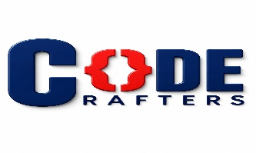
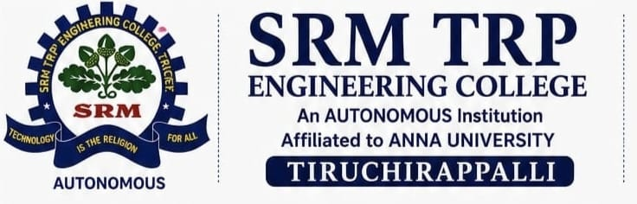
NEURAL FORGE HACKATHON 2026
OFFICIAL RULEBOOK · One Hackathon · Four Tracks · Common Judging
Built on NVIDIA open-source models (Nemotron, GR00T, Cosmos, Sonic) — format inspired by the Nebius x NVIDIA Global AI Hackathon.
1 · Event Schedule
Day | Time | Agenda
Day 1 | 1:00 PM – 4:00 PM | Opening · Rules & track briefing · Technology briefing (NVIDIA models & access) · Development
Day 2 | 9:00 AM – 4:00 PM | Final development · Submission · Judging · Demo/Q&A · Results
2 · Hackathon Structure & Tracks
A 2-day competition to build and demonstrate an AI-powered solution. Every team selects ONE track and follows common rules, submission process, and judging.
TRACK 1 — CODING & AGENTIC ENGINEERING  Focus: AI that meaningfully assists or automates software development — code generation/modification, debugging & testing, code review, repo analysis, dev/DevOps agents.  Powered by: Coding agents run in a live sandbox to write, run, and test code in real time.  Track rule: The AI must perform a genuine software-engineering task, not generic Q&A. | TRACK 2 — BEST APPS & AGENTS  Focus: A practical AI application or agent someone would actually use — assistants, research/education agents, productivity tools, business automation, multi-agent workflows.  Powered by: NVIDIA Nemotron models (Ultra for deep reasoning, Nano/Super for fast responses).  Track rule: Must show Problem → AI Capability → Solution → Outcome, with real reasoning, tool use, or workflow automation.
TRACK 3 — PERSONAL AI  Focus: Meaningful, personalized assistance for an individual user — personal assistants, personalized learning, productivity, memory-enabled AI, personal knowledge/workflow systems.  Powered by: At least one NVIDIA open-source model, assembled with agent frameworks and tools of the team's choice.  Track rule: Must show meaningful use of user context, preferences, memory, or goals. Private/sensitive user data must never be exposed. | TRACK 4 — PHYSICAL AI  Focus: AI that senses and acts in the physical world — robotics, IoT, sensors, edge AI, computer vision, smart/embedded systems.  Powered by: NVIDIA Nemotron, GR00T, Cosmos, and Sonic models, coordinated through an agent runtime.  Track rule: Must show Physical Input → AI Processing → Decision → Physical Output. Hardware demos must be safe; demo video needs ≥1 min of hardware actually operating (or key modules if no hardware).
3 · Competition Structure — 4 Rounds
Round | What happens
ROUND 0  Idea & Screening | Teams pick a track and a real-world problem, then submit Problem → Solution → Technology → Expected Impact via a Google Form. Judged on feasibility, technical relevance, innovation, and impact. Only shortlisted teams advance.
ROUND 1  Rapid Development | Build a working MVP: core functionality, AI/agent integration, UI, backend/API and database as needed (or, for Physical AI, sensing/control/edge logic, AI integration, hardware setup, monitoring interface, telemetry backend) plus a source repo. A mentor checkpoint in the last hour reviews progress, architecture, AI implementation, and remaining work. After Day 1, teams report progress in a shared Google Sheet by 9:00 PM.
ROUND 2  Surprise Engineering Challenge | Every team receives one new technical requirement — e.g. bilingual support, voice interaction, offline resilience, authentication, better AI reliability, a new external API, or accessibility — and gets 1 hour to adapt their solution. Tests engineering adaptability under constraints. Submissions are then screened; only shortlisted teams move to Round 3.
ROUND 3  Final Demo & Technical Q&A | 3-minute live demo of the working solution, followed by 5-minute Q&A on technology/model choices, how the AI component works, how the surprise challenge was implemented, failure handling, scalability, and each member's contribution.
4 · Technology Requirements
Every project must meaningfully use at least one eligible NVIDIA open-source model (e.g. Nemotron, GR00T, Cosmos, Sonic), accessed through any platform of the team's choice (NVIDIA API Catalog, Hugging Face, self-hosted, or similar). A submission that doesn't run on an eligible model is out of scope regardless of quality. Teams must be ready to demonstrate and explain their model usage live.
5 · Team & Project Requirements
Team rules | Project requirements
- Compete individually or in teams, within the announced team-size limit.  - Each team names one Team Leader and submits only one project on one track.  - All members must contribute meaningfully; registration details must be accurate. | - Relevant to the selected track, with a meaningful AI component.  - Functional, demonstrable, and original or legally usable by the team.  - Pre-existing projects need meaningful new work done during the event, following all third-party licenses.
6 · Final Submission Checklist
Required materials | Access & format
- Team & project details, selected track, problem & solution, key features.  - AI/model & technology details — which model(s) were used and how they were accessed.  - Working demo link and source-code repository with README/documentation. | - Repository must carry an open-source license (e.g. Apache 2.0, MIT, MPL 2.0), visible at the top of the repo.  - Demo video required where specified (Physical AI: ≥1 min of hardware/robot in action, or key modules if no hardware).  - All submitted links must be accessible to judges before the deadline.

7 · Judging Criteria
Criterion | Weight | What judges look for
Technological Implementation | 25% | Build quality and how effectively the project uses the required NVIDIA model(s).
Design | 25% | A complete, coherent product experience — not just a technical proof of concept.
Potential Impact | 25% | A credible, specific case for a real problem and audience, with evidence the demo actually addresses it.
Quality of Idea | 25% | Creative, non-obvious use of the platform/models and genuine understanding of the problem space.
TOTAL | 100% | Same criteria across all four tracks. Round 0 screens idea feasibility and impact; Round 3 scores the finished MVP against all four criteria, weighted equally.
8 · Prohibited Activities & Conduct
Prohibited | Conduct & safety
- Plagiarism, cheating, or submitting another person's work; fake demonstrations.  - Unauthorized access/hacking, malware, or attacking other teams' or college systems.  - Tampering with another team's project, IP violations, or exposing API keys/passwords/confidential data. | - Respect organizers, judges, mentors, and other participants; follow venue and safety rules.  - Unsafe hardware demonstrations may be stopped by organizers at any time.  - Rule violations may result in disqualification at the organizers' discretion.
Final decision: The judging panel's decision is final, subject to eligibility and rule verification. Organizers reserve the right to disqualify projects that violate the rules or fail mandatory requirements.
REGISTER → SELECT TRACK → R0 IDEA & SCREENING → R1 RAPID DEVELOPMENT → R2 SURPRISE CHALLENGE → R3 FINAL DEMO & Q&A → OVERALL & TRACK WINNERS

