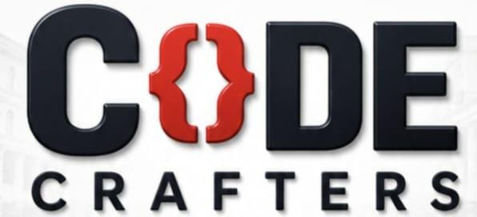
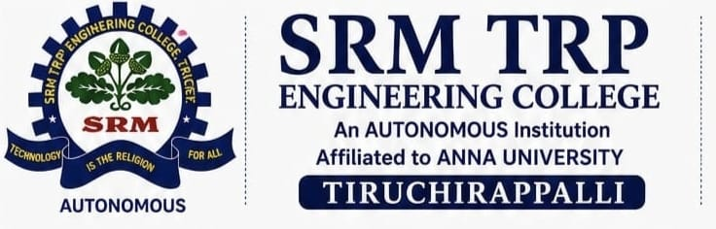
NURAL FORGE HACKATHON 2026
OFFICIAL RULEBOOK · One Hackathon · Four Tracks · Common Judging
Built on Nebius Token Factory / Nebius AI Cloud + NVIDIA Open-Source Models — format inspired by the Nebius x NVIDIA Global AI Hackathon
1 · EVENT SCHEDULE
Day | Time | Agenda
Day 1 | 1:00 PM – 4:00 PM | Opening · Rules & Track Briefing · Technology Briefing (Nebius Token Factory / NVIDIA models) · Development
Day 2 | 9:00 AM – 4:00 PM | Final Development · Submission · Judging · Demo/Q&A · Results
2 · HACKATHON STRUCTURE & TRACKS
A 2-day competition to build and demonstrate an AI-powered solution. Every team selects ONE track and follows common rules, submission process, and judging.

TRACK 1 — CODING & AGENTIC ENGINEERING  AI must meaningfully assist or automate software-development work.  Focus: code generation/modification, debugging & testing, code review, repository analysis, dev/DevOps agents.  Powered by: Coding agents run in Token Factory Sandboxes to write, run, and test code live.  Track rule: The AI must perform a genuine software-engineering task — not generic Q&A. | TRACK 2 — BEST APPS & AGENTS  A practical AI application or agent that someone would actually use.  Focus: assistants, research/education agents, productivity tools, business automation, multi-agent workflows.  Powered by: NVIDIA Nemotron models via Token Factory — Nemotron 3 Ultra for deep reasoning, Nano/Super for fast, responsive calls.  Track rule: Must show Problem → AI Capability → Solution → Outcome, with meaningful reasoning, tool use, or workflow automation.
TRACK 3 — PERSONAL AI  Meaningful, personalized assistance for an individual user.  Focus: personal assistants, personalized learning, productivity, memory-enabled AI, personal knowledge/workflow systems.  Powered by: At least one NVIDIA open-source model, assembled with tools such as NVIDIA NemoClaw, OpenShell, Hermes Agent, and Nebius Serverless.  Track rule: Must show meaningful use of user context, preferences, memory, or goals. Private/sensitive user data must never be exposed. | TRACK 4 — PHYSICAL AI  AI that senses and acts in the physical environment.  Focus: robotics, IoT, sensors, edge AI, computer vision, smart/embedded systems.  Powered by: NVIDIA Nemotron, GR00T, Cosmos, and Sonic models, coordinated through an agent runtime; Nebius Serverless Jobs/Endpoints for simulation and real-time inference.  Track rule: Must show Physical Input → AI Processing → Decision → Physical Output. All hardware demos must be safe; demo video needs ≥1 min of hardware actually operating (or key modules in action if no hardware).
3 · COMPETITION STRUCTURE — 4 ROUNDS
Round | What Happens
ROUND 0  Idea & Screening | Teams pick a track and a real-world problem, then submit Problem → Solution → Technology → Expected Impact via a Google Form. Judged on feasibility, technical relevance, innovation, and impact. Only shortlisted teams advance.
ROUND 1  Rapid Development | Build a working MVP. Software tracks: core functionality, AI/agent integration, UI, backend/API, and database as needed, plus a source repo. Physical AI: sensing/control/edge logic, AI integration, hardware setup, monitoring interface, telemetry backend, plus a source repo. A mentor checkpoint reviews progress, architecture, AI implementation, technology/hardware choices, and remaining work at last one hour. After Day 1 ends and participants head home, a Google Sheet will be shared for teams to report their progress, and it must be filled out by 9:00 PM.
ROUND 2  Surprise Engineering Challenge | At a set time, every team receives one new technical requirement — e.g. bilingual support, voice interaction, offline resilience, authentication, better AI reliability, a new external API, or accessibility features — and gets 1 hour to adapt their solution. Tests engineering adaptability under constraints.Submissions are then screened in a filtration round, where only the shortlisted teams move forward to Round 3.
ROUND 3  Final Demo & Technical Q&A | 3-minute live demo of the actual working solution, followed by a 5-minute technical Q&A: technology/model choices, how the AI component works, how the surprise challenge was implemented, failure handling, scalability, and each member's contribution.
4 · TECHNOLOGY REQUIREMENTS
Every project must meaningfully use Nebius Token Factory or Nebius AI Cloud AND at least one eligible NVIDIA open-source model (e.g. Nemotron, GR00T, Cosmos, Sonic). A submission that doesn't run on this stack is out of scope regardless of quality. Teams should also note any use of Nebius Serverless Endpoints/Jobs and must be ready to demonstrate and explain their usage live.

5 · TEAM & PROJECT REQUIREMENTS
Team rules  - Compete individually or in teams, within the announced team-size limit.  - Each team names one Team Leader and submits only one project on one track.  - All members must contribute meaningfully; registration details must be accurate. | Project requirements  - Relevant to the selected track, with a meaningful AI component.  - Functional, demonstrable, and original or legally usable by the team.  - Pre-existing projects need meaningful new work done during the event; follow all third-party licenses.
6 · FINAL SUBMISSION CHECKLIST
Required materials  - Team & project details, selected track, problem & solution, key features.  - AI/model & technology details (model + Nebius service used).  - Working demo link, source-code repository with README/documentation. | Access & format  - Repository must carry an open-source license (e.g. Apache 2.0, MIT, MPL 2.0), visible at the top of the repo.  - Demo video required where specified (Physical AI: ≥1 min of hardware/robot in action, or key modules if no hardware).  - All submitted links must be accessible to judges before the deadline.
7 · JUDGING CRITERIA
Criterion | Weight | What judges look for
Technological Implementation | 25% | Build quality, and how effectively the project uses Nebius Token Factory/AI Cloud and the required NVIDIA model(s).
Design | 25% | A complete, coherent product experience — not just a technical proof of concept.
Potential Impact | 25% | A credible, specific case for a real problem and real audience, and evidence the demo actually addresses it.
Quality of Idea | 25% | Creative, non-obvious use of the platform/models and genuine understanding of the problem space.
TOTAL | 100% | Same criteria across all four tracks; judges evaluate according to the nature of the selected track.
Applied at every scored stage: Round 0 screens idea feasibility and impact; Round 3 scores the finished MVP against all four criteria above, weighted equally regardless of track.
8 · PROHIBITED ACTIVITIES & CONDUCT
Prohibited  - Plagiarism, cheating, or submitting another person's work; fake demonstrations.  - Unauthorized access/hacking, malware, or attacking other teams' or college systems.  - Tampering with another team's project, IP violations, or exposing API keys/passwords/confidential data. | Conduct & safety  - Respect organizers, judges, mentors, and other participants; follow venue and safety rules.  - Unsafe hardware demonstrations may be stopped by the organizers at any time.  - Rule violations may result in disqualification at the organizers' discretion.
Final decision: The judging panel's decision is final, subject to eligibility and rule verification. Organizers reserve the right to disqualify projects that violate the rules or fail mandatory requirements.
REGISTER → SELECT TRACK → R0 IDEA & SCREENING → R1 RAPID DEVELOPMENT → R2 SURPRISE CHALLENGE → R3 FINAL DEMO & Q&A → OVERALL & TRACK WINNERS

