EXP: 2
Date : 10-07-2026
DDL Commands with Constraints – PRIMARY, FOREIGN KEY, UNIQUE, CHECK

AIM: To add the constraints like primary key, foreign key, unique key and check using DDL commands.
Description:
PROCEDURE:
Step 1: Create the Movies table with the required attributes.
Step 2: Add PRIMARY KEY constraint on the M_id column.
Step 3: Add a UNIQUE constraint on the Ott column.
Step 4: Verify the table structure and insert movie records.
Step 5: Attempt to update the OTT value of movie M_id = 103 to Netflix.
Step 6: Observe that MySQL displays a duplicate entry error because the UNIQUE constraint prevents duplicate values.
Step 7: Drop the UNIQUE index created on the Ott column.
Step 8: Modify the Ott column to ensure it remains NOT NULL.
Step 9: Update the OTT value of M_id = 103 to Netflix again.
Step 10: Display all records to verify that duplicate OTT values are now allowed after removing the UNIQUE constraint.
Query 1:
ALTER TABLE movies ADD PRIMARY KEY (M_id);
OUTPUT 1 :
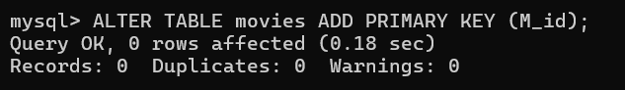

Query 2 :
ALTER TABLE movies MODIFY Ott VARCHAR(15) NOT NULL;
Output 2 :
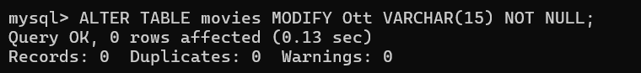

Query 3 :
ALTER TABLE movies ADD UNIQUE (Ott);
Output 3 :
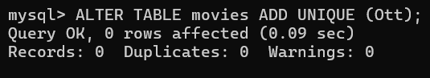
Query 4 :
ALTER TABLE movies ADD CONSTRAINT chk_mid CHECK (M_id >= 2);
Output 4 :

