EXP: 14
Date: 3-08-2026

TCL COMMANDS – COMMIT, SAVEPOINT, ROLLBACK

AIM:
To learn how to use various TCL commands such as COMMIT, SAVEPOINT and ROLLBACK.
PROCEDURE:
Step 1: Select the database containing the movies table.
Step 2: Verify the existing records in the movies table.
Step 3: Perform an UPDATE operation on a movie record.
Step 4: Create a SAVEPOINT after performing the update operation.
Step 5: Perform an INSERT operation after creating the savepoint.
Step 6: Create another SAVEPOINT after inserting the new record.
Step 7: Perform another UPDATE operation on the movies table.
Step 8: Use ROLLBACK TO SAVEPOINT to undo the changes made after the selected savepoint.
Step 9: Use COMMIT to permanently save the required changes.
Step 10: Display the final records and verify the transaction results.

SYNTAX
Query 1
UPDATE movies SET Ott='Hotstar' WHERE M_id=110;
Output
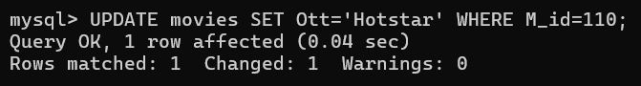

Query 2
SAVEPOINT A;
Output
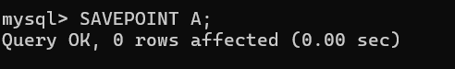
Query 3
INSERT INTO movies VALUES (111,'Retro','Suriya','Pooja Hegde','Karthik Subbaraj','Santhosh Narayanan','Netflix');
OUTPUT
Query 4
SAVEPOINT B;
OUTPUT
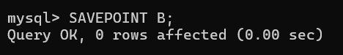
Query 5
UPDATE movies SET Ott='Prime Video' WHERE M_id=109;
Output
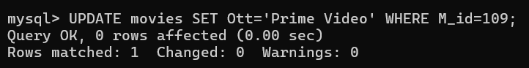
Query 6
ROLLBACK TO B;
Output
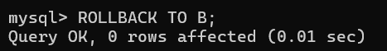

Query 7
SELECT * FROM movies;
Output
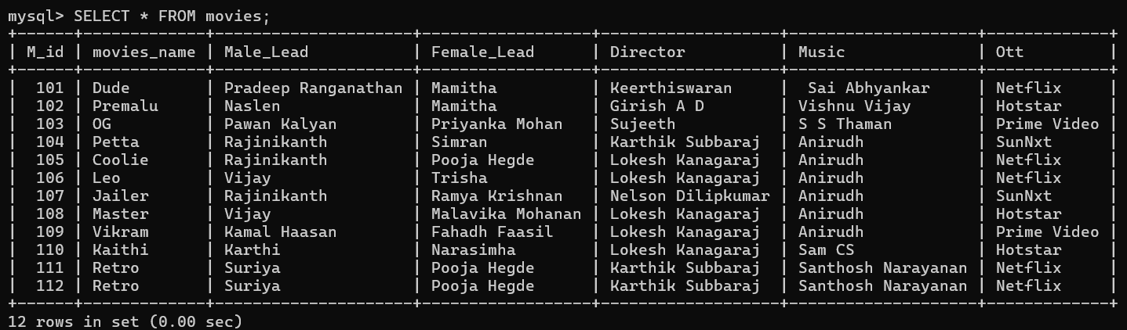
Query 8
COMMIT;
Output
