EXP: 15
Date: 5-8-2026

DCL COMMANDS – GRANT, REVOKE

AIM:
To learn how to use various DCL commands such as GRANT and REVOKE.
PROCEDURE:
Step 1: Open MySQL and select the required database.
Step 2: Create a separate MySQL user for performing the DCL operations.
Step 3: Grant the required privileges to the created user.
Step 4: Grant permission to perform SELECT operations on the movies table.
Step 5: Verify the privileges granted to the user.
Step 6: Revoke the previously granted privilege from the user.
Step 7: Verify that the privilege has been successfully revoked.
Step 8: Execute the required DCL commands and observe the results.
SYNTAX
Query 1
CREATE USER 'movieuser'@'localhost' IDENTIFIED BY 'movie123';
Output
Query 2
GRANT SELECT ON movies TO 'movieuser'@'localhost';
Output
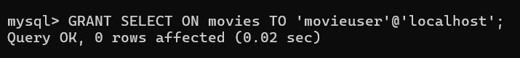

Query 3
GRANT INSERT ON movies TO 'movieuser'@'localhost';
Output
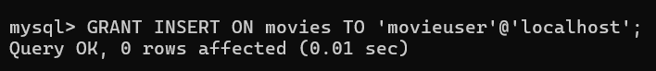
Query 4
SHOW GRANTS FOR 'movieuser'@'localhost';
Output
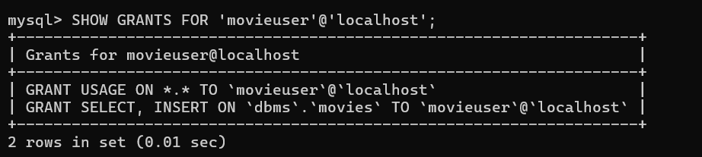
Query 5
REVOKE INSERT ON movies FROM 'movieuser'@'localhost';
OUTPUT

Query 6
SHOW GRANTS FOR 'movieuser'@'localhost';
Output
