EXP No.: 20

MYSQL STRING FUNCTIONS – REPLACE, REPEAT, REVERSE, RIGHT, LEFT, RPAD, LPAD
AIM:
To implement REPLACE, REPEAT, REVERSE, RIGHT, LEFT, RPAD and LPAD string functions using MySQL.
PROCEDURE:
- Select the database containing the movies table.
- Verify the records in the movies table.
- Use the REPLACE() function to replace characters in movie names.
- Use the REPEAT() function to repeat movie names.
- Use the REVERSE() function to reverse movie names.
- Use LEFT() and RIGHT() to extract characters from movie names.
- Use LPAD() and RPAD() to add padding to movie names.
- Execute the queries and verify the results.
SYNTAX
Query 1
SELECT REPLACE(movies_name,'a','A'), REPEAT(movies_name,2), REVERSE(movies_name) FROM movies;
Output
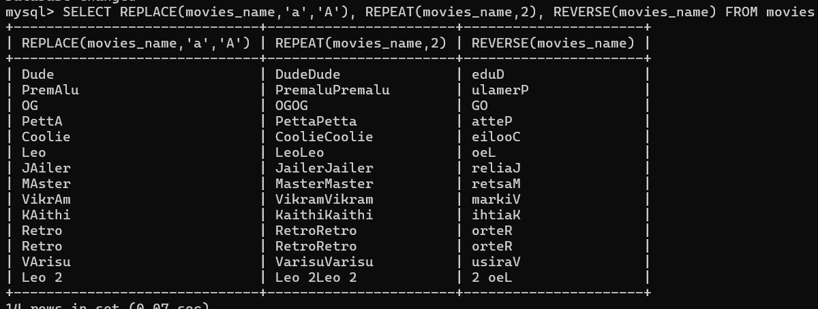
Query 2
SELECT movies_name, LEFT(movies_name,3), RIGHT(movies_name,3) FROM movies;
Output
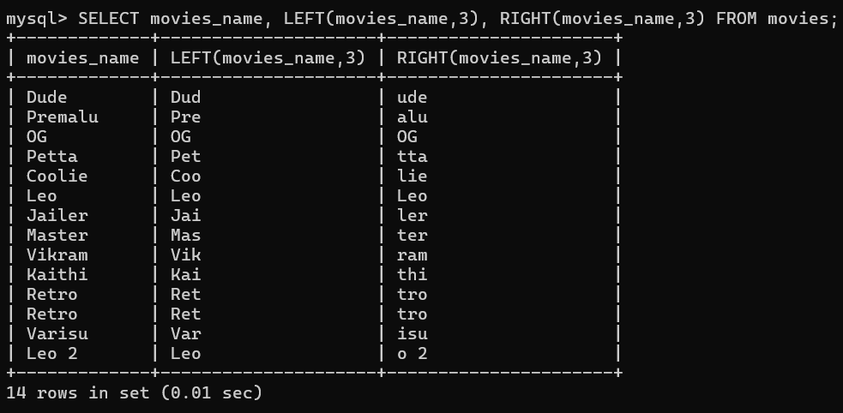
Query 3
SELECT movies_name, RPAD(movies_name,10,'*') FROM movies;
Output
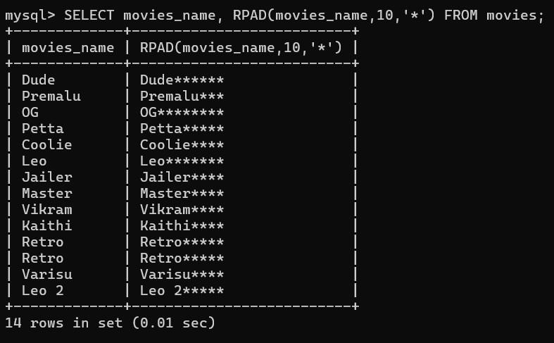

Query 4
SELECT movies_name, LPAD(movies_name,10,'*') FROM movies;
Output
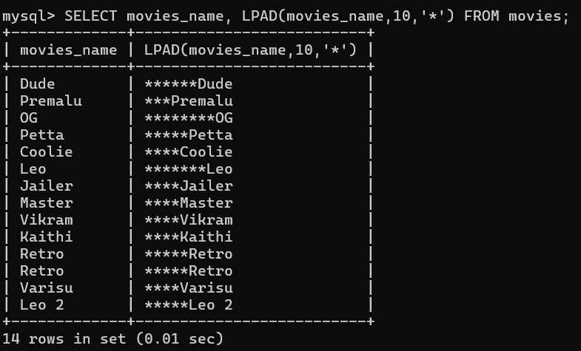

RESULT:
Thus, the MySQL string functions REPLACE, REPEAT, REVERSE, RIGHT, LEFT, RPAD and LPAD were successfully executed on the movies table.

