Contents
Twitter 1
Abusive Customer 1
Frustrated Customer 3
Customers seeking help 4
Youtube 5
Abusive Customer 5
Frustrated Customer 6
Customers seeking help 8
Instagram 9
Abusive Customer 9
Frustrated Customer 11
Customers seeking help 12
Facebook 14
Abusive Customer 14
Frustrated Customer 17
Customers seeking help 19
Maya Forums 21
Abusive Customer 21
Frustrated Customer 22
Customer seeking help 23
AutoCAD Forums 26
Frustrated Customer 26
Customers seeking help 28

Twitter

Abusive Customer
- https://twitter.com/MFiglarz/status/1299465240879431683?s=20 A
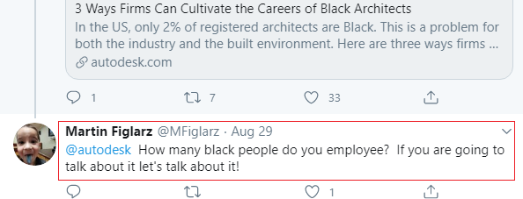

- https://twitter.com/EagleAscending/status/1294304219193921548?s=20 A
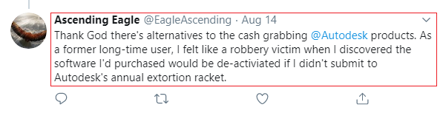

- https://twitter.com/AmeriCougar/status/1293230751228538881?s=20


- https://twitter.com/JoanieLemercier/status/1289176907095785473?s=20
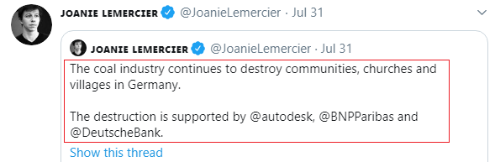

- https://twitter.com/chetfaliszek/status/1269329450967027712?s=20
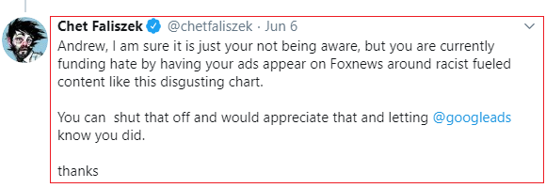

- https://twitter.com/JoanieLemercier/status/1269921409037488128?s=20
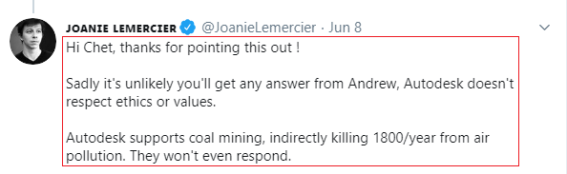

Frustrated Customer
- https://twitter.com/pulicitidur/status/1283564735594729473?s=20
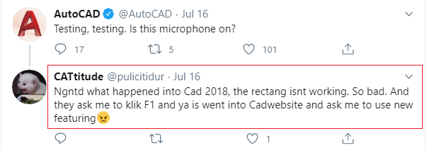

- https://twitter.com/Halaalg68640568/status/1304837456286580741?s=20
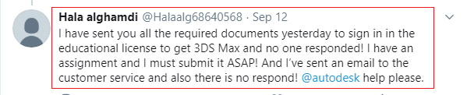

- https://twitter.com/JoanieLemercier/status/1304185101086068737?s=20
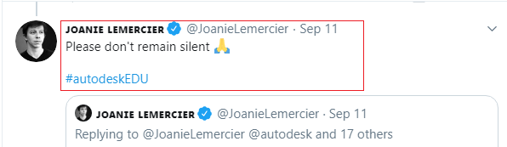

Customers seeking help
- https://twitter.com/JustinPamenter/status/1292948527228661760?s=20
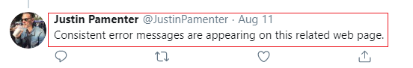

- https://twitter.com/glowingslab/status/1284157121144262657?s=20
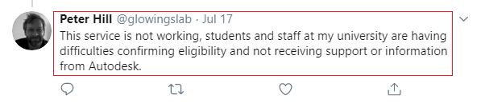

- https://twitter.com/0klizzy/status/1298024978630180868?s=20
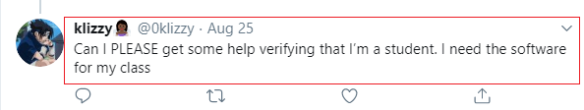

Youtube

Abusive Customer
- https://www.youtube.com/watch?v=9CbcF8KB0zQ&list=PL_6ApchKwjN_ujthF2hX6J4R_XcoYCgSV&index=2


- https://www.youtube.com/watch?v=RiQYitn5ock&list=PL_6ApchKwjN9uVq1XU7buYCrFeRxgE3Pa


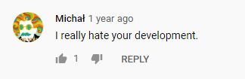

- https://www.youtube.com/watch?v=gOOHIAW8V2k&list=PL_6ApchKwjN9TksS_VzLQipgEa1u2kFG7



- https://www.youtube.com/watch?v=4421PPbAHLw&list=PL_6ApchKwjN9TksS_VzLQipgEa1u2kFG7&index=2


Frustrated Customer
- https://www.youtube.com/watch?v=GJM6TWEMMAA&list=PL_6ApchKwjN82liewh47pGosVWuEa6WNM
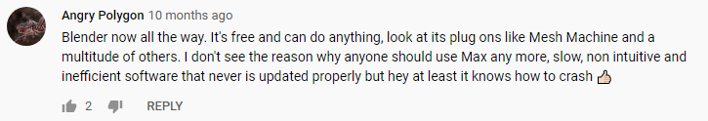
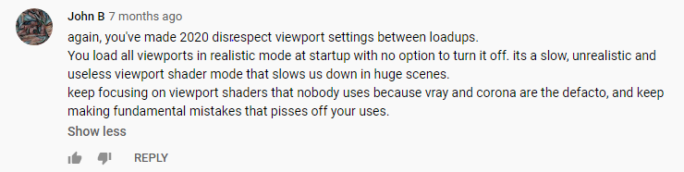


- https://www.youtube.com/watch?v=3rhAM8pSMCg&list=PL_6ApchKwjN9uVq1XU7buYCrFeRxgE3Pa&index=3

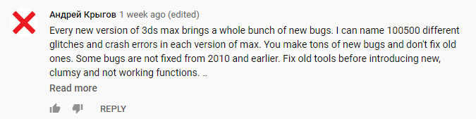

- https://www.youtube.com/watch?v=Nr-1AKZj408&list=PL_6ApchKwjN9TksS_VzLQipgEa1u2kFG7&index=3
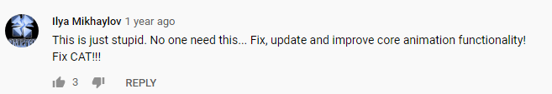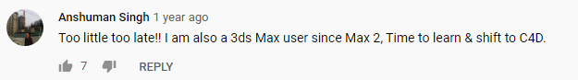

Customers seeking help
- https://www.youtube.com/watch?v=VkcYlcatYT4&list=PL_6ApchKwjN8wbejAE7i2XU22VHM1XV14&index=5
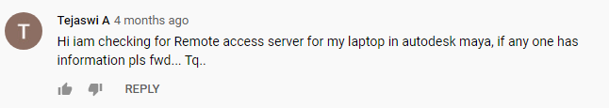

- https://www.youtube.com/watch?v=4D02lB-Tq4Y&list=PL_6ApchKwjN87752_oUnSddwJbS90Skfz&index=3

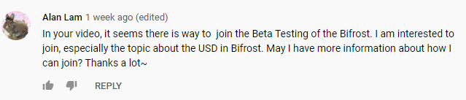

- https://www.youtube.com/watch?v=TgXxTvOwkuM&list=PL_6ApchKwjN8bhYyFcYO9BbiMqU1m6VFB&index=3

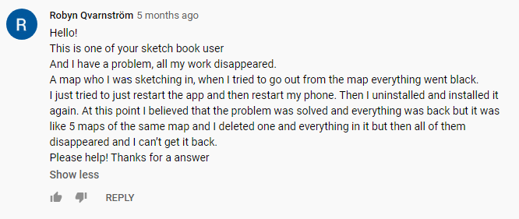


- https://www.youtube.com/watch?v=rJYIQ5R1EvU&list=PL_6ApchKwjN82liewh47pGosVWuEa6WNM&index=2
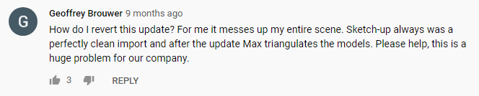

Instagram

Abusive Customer
- https://www.instagram.com/p/CEZ50iRF-oB/
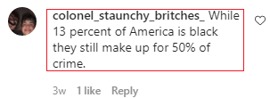

- https://www.instagram.com/p/CEAa5oWFpWO/
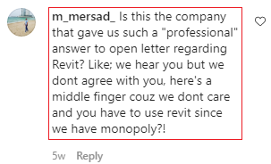

- https://www.instagram.com/p/CB9DKVvF9-K/
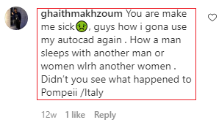

- https://www.instagram.com/p/CAD0BLcFK-Y/
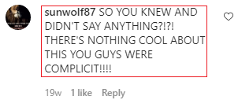

- https://www.instagram.com/p/B7_HVyhlZc5/
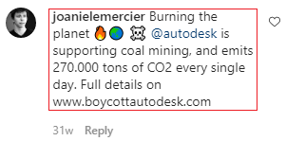

- https://www.instagram.com/p/CEAa5oWFpWO/
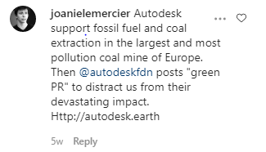

- https://www.instagram.com/p/CB9DKVvF9-K/


Frustrated Customer
- https://www.instagram.com/p/CDy4yseluU7/
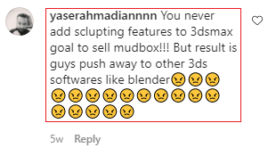

- https://www.instagram.com/p/CDj5kDPFsDv/
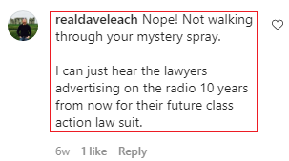

- https://www.instagram.com/p/CB6B_MDF81T/
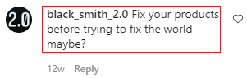

- https://www.instagram.com/p/B8uDYwQFZyP/
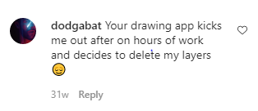

- https://www.instagram.com/p/B8ZmRbiFp29/
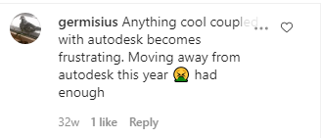

- https://www.instagram.com/p/B27gUBil3yI/


Customers seeking help
- https://www.instagram.com/p/CB9DKVvF9-K/


- https://www.instagram.com/p/CAMDsZdFGjF/
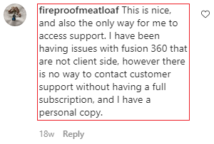

- https://www.instagram.com/p/B_qWgNylQRT/
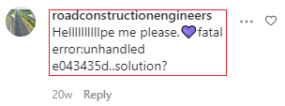

- https://www.instagram.com/p/B--S8QAlux_/
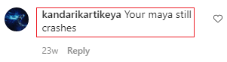
- https://www.instagram.com/p/B7MKiYnlWOd/
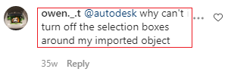

- https://www.instagram.com/p/B-NihwZlOO7/


- https://www.instagram.com/p/B8ZmRbiFp29/
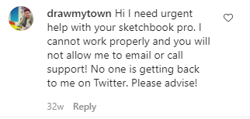

- https://www.instagram.com/p/B4AuzceFkEk/


Facebook

Abusive Customer
- https://www.facebook.com/autodesk/photos/a.181857988525502/2480683901976221
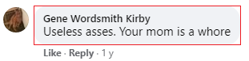

- https://www.facebook.com/autodesk/photos/a.181857988525502/2202045573173390
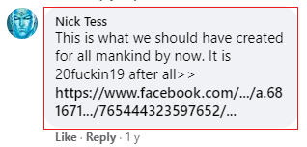

- https://www.facebook.com/autodesk/photos/a.181857988525502/2189003571144257
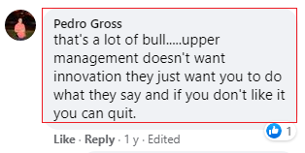

- https://www.facebook.com/autodesk/photos/a.181857988525502/2186023898108891
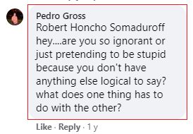
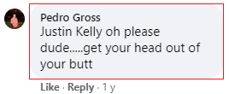
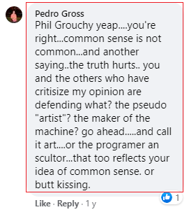
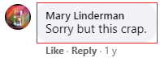

- https://www.facebook.com/autodesk/photos/a.181857988525502/3302931383084798
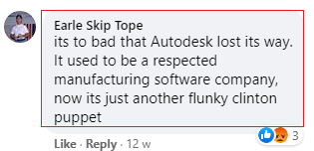
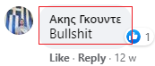
- https://www.facebook.com/autodesk/posts/3587251764652757?__tn__=-R
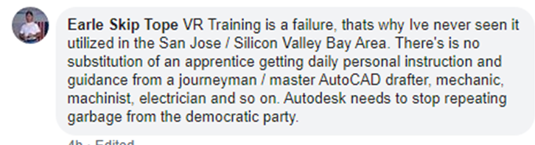

- https://www.facebook.com/autodesk/posts/3590188157692451?__tn__=-R
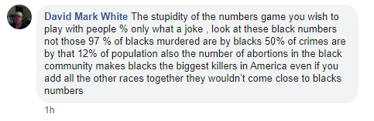

- https://www.facebook.com/autodesk/posts/3542421689135765?__tn__=-R


- https://www.facebook.com/autodesk/posts/3517118271666107?__tn__=-R


- https://www.facebook.com/autodesk/posts/3503836942994240?__tn__=-R
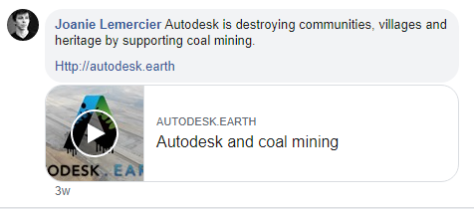

- https://www.facebook.com/autodesk/posts/3488329384544996?__tn__=-R


Frustrated Customer
- https://www.facebook.com/autodesk/photos/a.181857988525502/2249058545138759
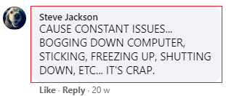
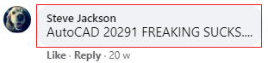

- https://www.facebook.com/autodesk/photos/a.181857988525502/2197830786928202
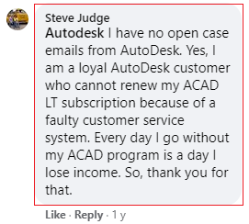

- https://www.facebook.com/AutodeskIndia/photos/a.259445400763518/3513433015364724
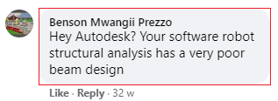

- https://www.facebook.com/autodesk/photos/a.181857988525502/3376100235767912
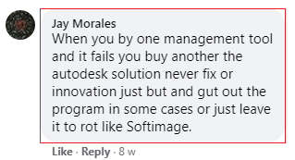

- https://www.facebook.com/autodesk/photos/a.181857988525502/2739452466099362
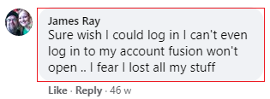

- https://www.facebook.com/autodesk/videos/vb.132081383503163/1642989229196314/?type=3&theater
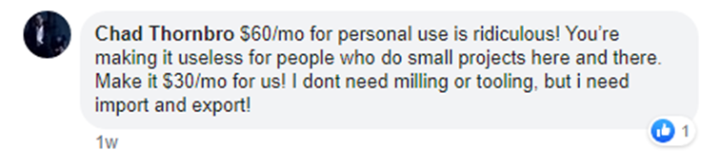

- https://www.facebook.com/autodesk/posts/3554634151247852?__tn__=-R
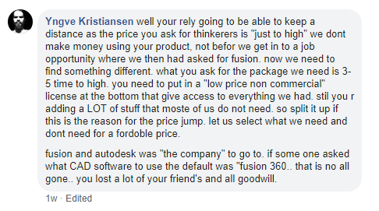
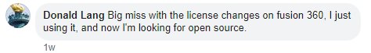

- https://www.facebook.com/autodesk/posts/3462070250504243?__tn__=-R
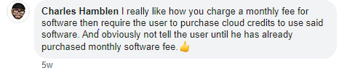

Customers seeking help
- https://www.facebook.com/AutodeskIndia/photos/a.259445400763518/3766539770054046
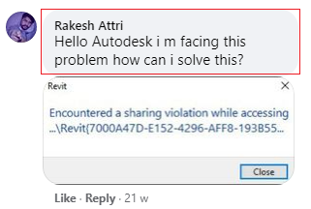

- https://www.facebook.com/autodesk/photos/a.181857988525502/3181080428603228
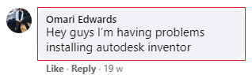

- https://www.facebook.com/autodesk/photos/a.181857988525502/2816340421743899
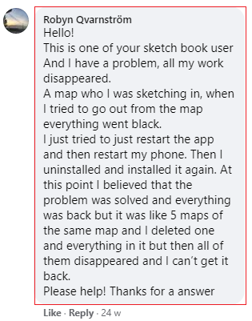

- https://www.facebook.com/autodesk/photos/a.181857988525502/2346421118735834
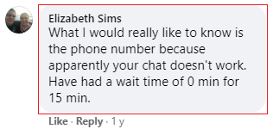

- https://www.facebook.com/autodesk/posts/3532227986821802?__tn__=-R
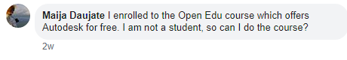

- https://www.facebook.com/autodesk/posts/3517118271666107?__tn__=-R

- https://www.facebook.com/autodesk/posts/3489093367801931?__tn__=-R

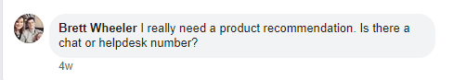

- https://www.facebook.com/autodesk/posts/3305807932797143?__tn__=-R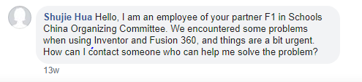

Maya Forums

Abusive Customer
- https://forums.autodesk.com/t5/maya-forum/maya-is-ty-piece-of-software/td-p/9714319
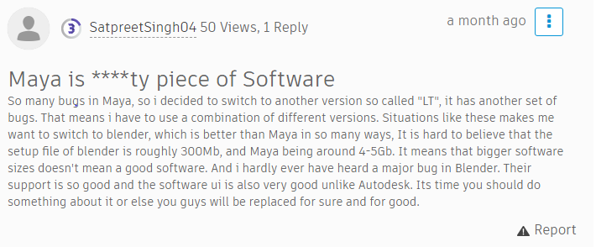

Frustrated Customer
- https://forums.autodesk.com/t5/maya-forum/xgen-nightmare/td-p/9585800
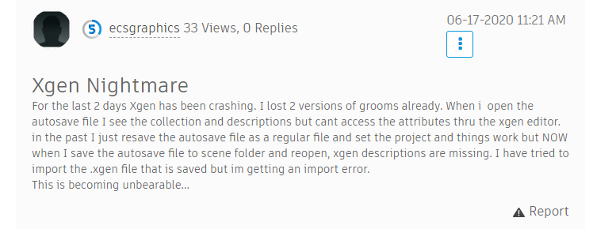

- https://forums.autodesk.com/t5/maya-forum/continuation-of-maya-2020-wont-stop-crashing/td-p/9762328
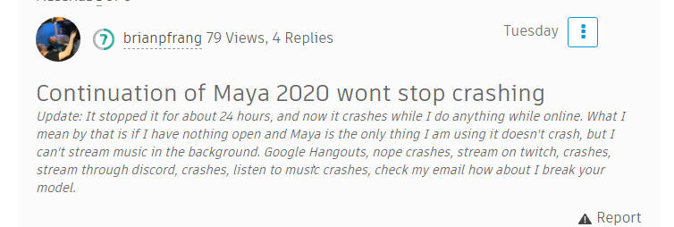

- https://forums.autodesk.com/t5/maya-forum/why-is-xgen-so-ineffective-in-production/td-p/9757121
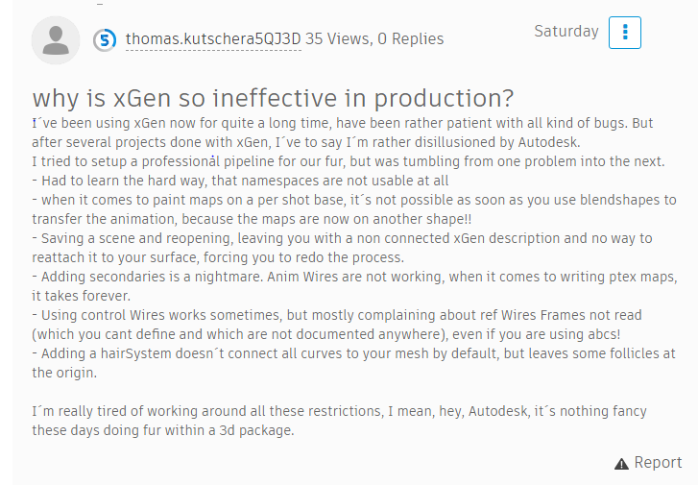

- https://forums.autodesk.com/t5/maya-modeling/boolean-hell/td-p/7350543
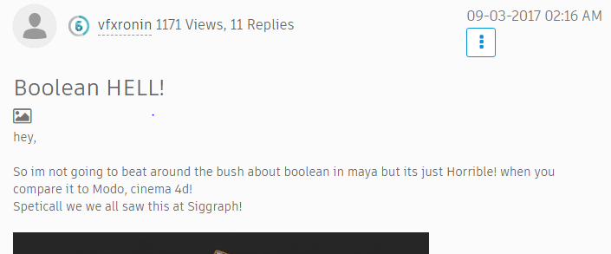

Customer seeking help
- https://forums.autodesk.com/t5/maya-forum/random-movements-between-keyframes-hik/td-p/9705292
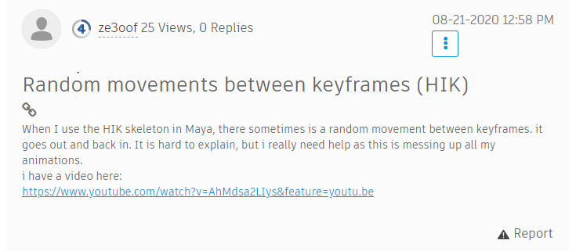

- https://forums.autodesk.com/t5/maya-forum/i-can-t-properly-install-the-free-maya-trial-help-please/td-p/9693421
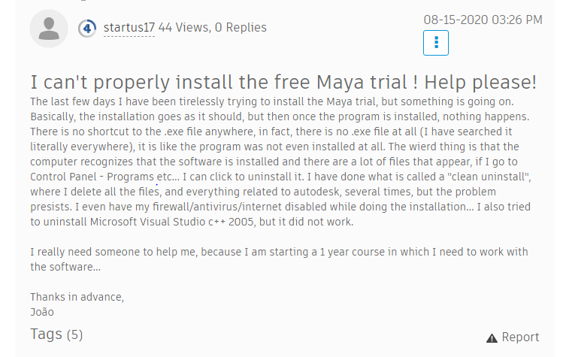

- https://forums.autodesk.com/t5/maya-forum/manipulator-isn-t-showing/td-p/9584080
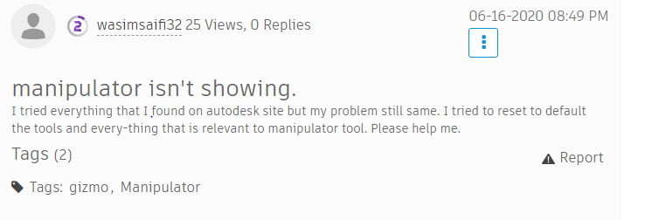

- https://forums.autodesk.com/t5/maya-forum/application-not-opening-on-mac/td-p/9544207
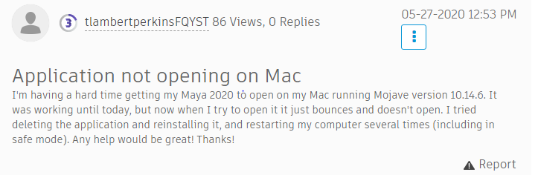

- https://forums.autodesk.com/t5/maya-forum/urgent-maya-control-rig-not-rotating/td-p/9461637
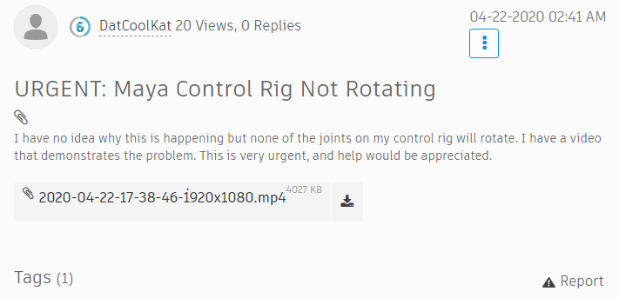

AutoCAD Forums

Frustrated Customer
- https://forums.autodesk.com/t5/autocad-forum/autocad-2019-vs-2020/td-p/9599778
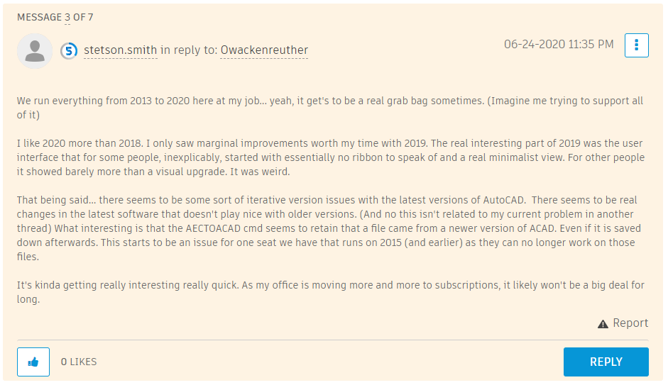

- https://forums.autodesk.com/t5/autocad-forum/going-crazy-versions-from-2019-and-on-has-problems-with-osnap/td-p/9447168
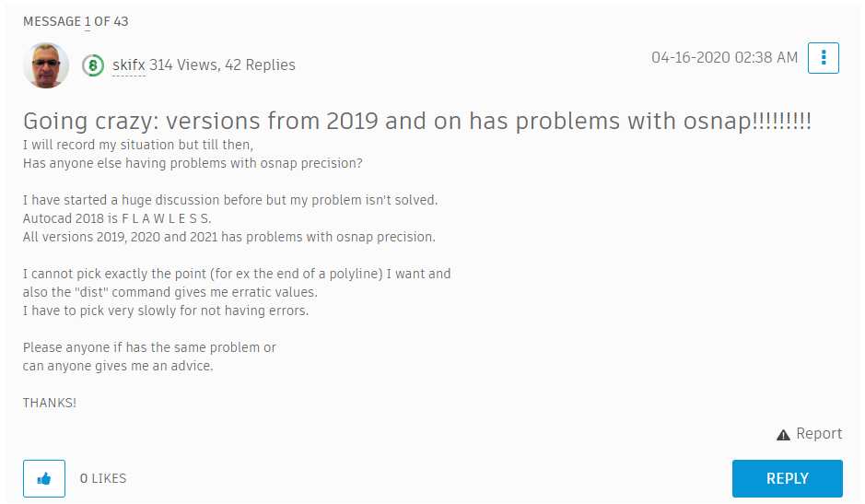

- https://forums.autodesk.com/t5/autocad-forum/go-back-to-2019/td-p/9557980
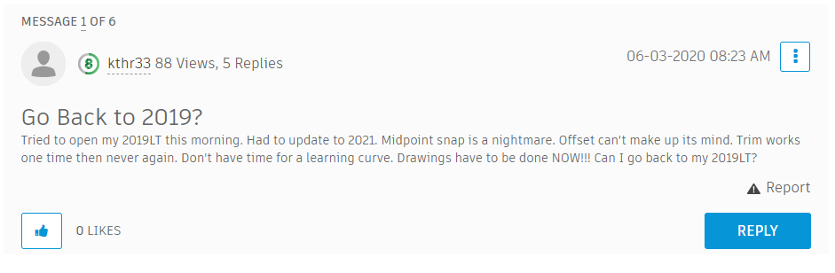

- https://forums.autodesk.com/t5/autocad-forum/why-is-autodesk-support-so-horrible/td-p/9496918
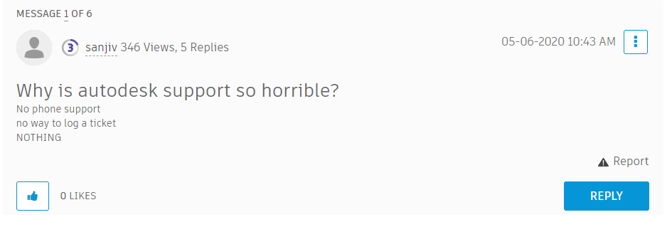
- https://forums.autodesk.com/t5/autocad-forum/does-anyone-else-hate-acad/td-p/2253465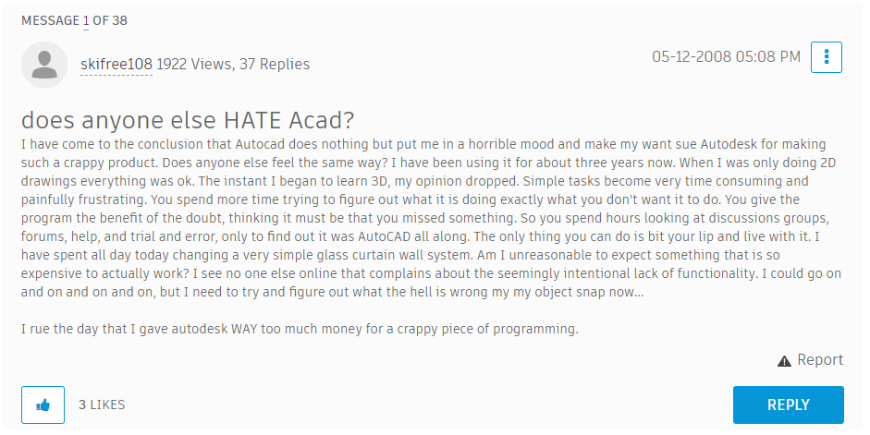

Customers seeking help
- https://forums.autodesk.com/t5/autocad-forum/tool-palettes/m-p/9767276/highlight/true#M1031669
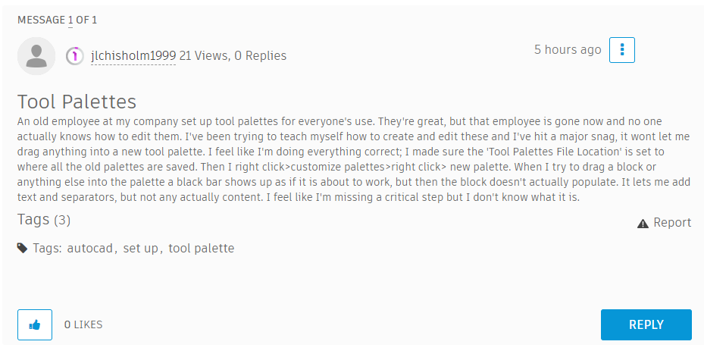

- https://forums.autodesk.com/t5/autocad-forum/creating-tool-palettes/td-p/9767279
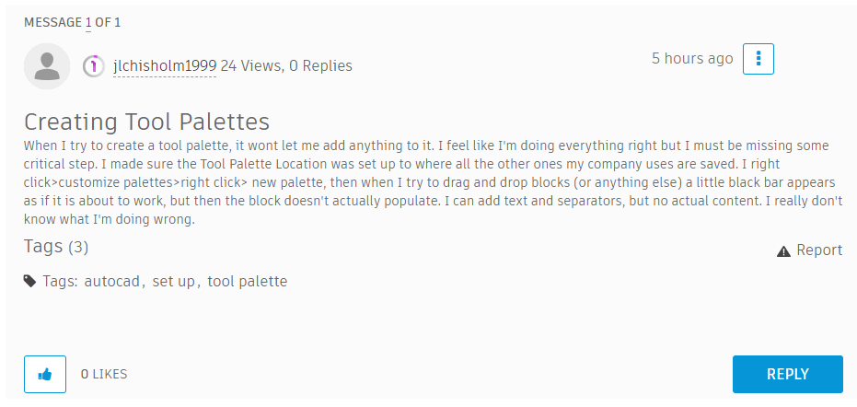
- https://forums.autodesk.com/t5/autocad-forum/autocad-spacebar-issue-and-hatch-set-origin-issue/td-p/9764920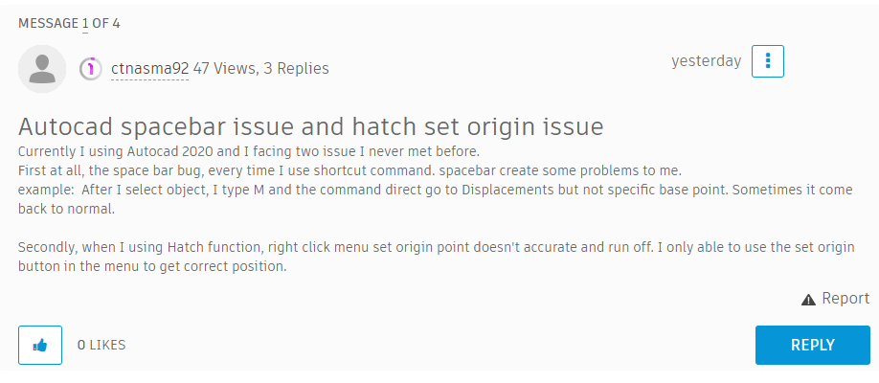

- https://forums.autodesk.com/t5/autocad-forum/email-verification-problem/td-p/9751996