5G Test Bed
Design Document
for
AMF in 5G Core (Version 0)
Version: 0
Prepared by:
IITB 5G core team

Jan 30, 2019
The information contained in this document is confidential and proprietary to IITB, IITM, CEWiT.
Table of Contents
1 Introduction 1
1.1 Purpose 1
1.2 Scope 1
1.3 Document Overview 1
2 System Design 2
3 Detailed Design 3
3.1 Design Guidelines 3
3.2 SCTP Interface. 3
3.3 Registration Procedure Call Flow 5
NRF Registration. 5
NF Discovery. 6
Callflow steps (Brief). 7
Authentication steps (Brief). 11
Security steps (Brief). 14
4 NAS Stack. 15
5 NGAP Stack. 15
6 SBA Interactions. 15
7 UE state and data structures. 15
8 AMF threading model. 16
9 Assumptions and Dependencies. 17

Revision History
Version | Date | Author(s) | Reason for Changes
0.1 | Dec 11 | Mythili | Initial draft
0.2 | Jan 30 | Kapil | Address Review Comments

Introduction

Purpose
This document describes the design for the 5G core components being built at IIT Bombay in version 0. The goal of version 0 is to come up with basic functionality of user registration.

Scope
The components involved in building and testing user registration are Network Repository Function (NRF), Access and Mobility Management function (AMF), Authentication Server Function (AUSF), Unified Data Management (UDM), User Data Repository (UDR) and Radio Access Network (RAN) Emulator.
Messages of the user registration procedure are primarily handled by AMF while authentication and security related steps are performed in AUSF, UDM and UDR; the other 5G core components are not expected to be needed for version 0. This functionality of 5G core will be tested using a RAN emulator, and is not expected to be integrated with the actual RAN.

Document Overview
The document is organized as follows. We first describe the system design and overall architecture of the 5G core in version 0. We then delve into the details of the specifics of the design of AMF.

System Design
The various protocol stacks implemented are as follows. UE communicates with AMF over NAS (N1) layer. NAS messages are encapsulated within NGAP messages by the RAN and sent over SCTP. The 5G Core VNFs NRF, AMF, AUSF, UDM and UDR communicate over HTTP as per the Service Based Interface (SBI).
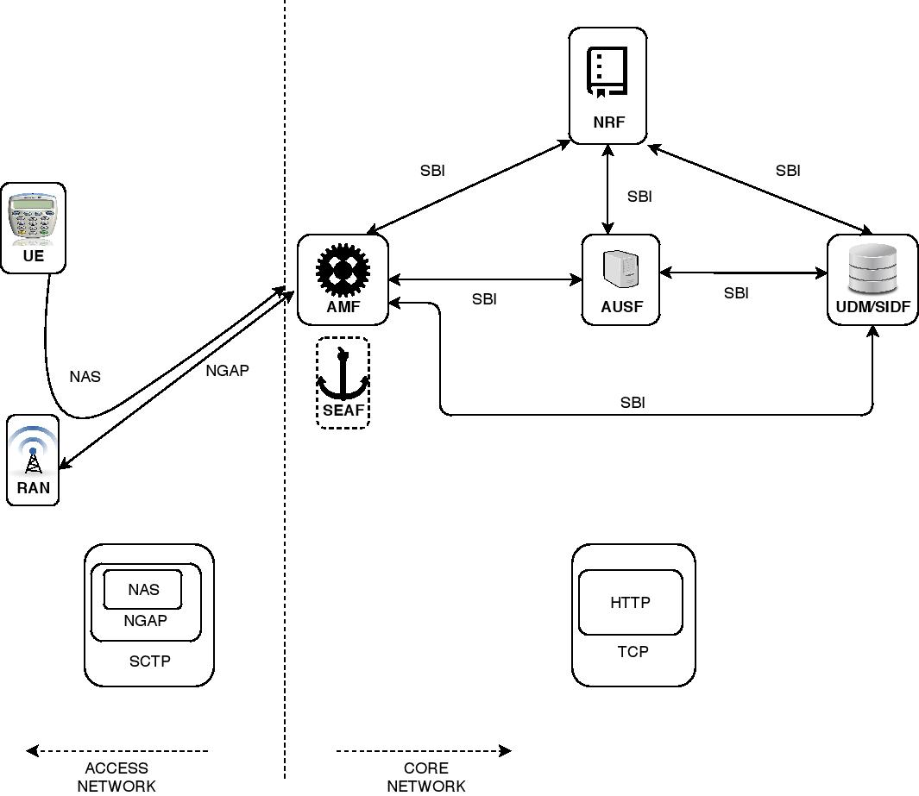
[
Rohan: Important diagram
SEAF?? SIDF??

Detailed Design

Design Guidelines
The AMF is built as a C++ software, to be run as a virtual network function (VNF) in the virtualized 5G core.
AMF has four sub-functionalities:
- It receives/sends SCTP messages from/to RAN.
- It decodes/encodes NGAP messages after/before receiving/sending from/to SCTP socket.
- It also takes care of decoding/encoding NAS messages.
- It interacts with other 5GC modules over SBI. It uses Casablanca library for RESTful APIs.

SCTP Interface.
AMF is SCTP server for RAN. RAN initiates SCTP association with AMF. AMF listens on standard specified port ‘38412’ and uses epoll_wait() to receieve SCTP messages.
SCTP association has at least two streams within it. AMF maintains two streams as of now. One stream is used exclusively for non-UE associated signalling and other is used for UE associated signalling.

Rohan: By non-UE/UE associated they mean NGAP with/without NAS
Check how AMF uses separate streams in SCTP socker code and where does it identifies type of signal in NGAP decoding code.
Check SCTP Server implementation
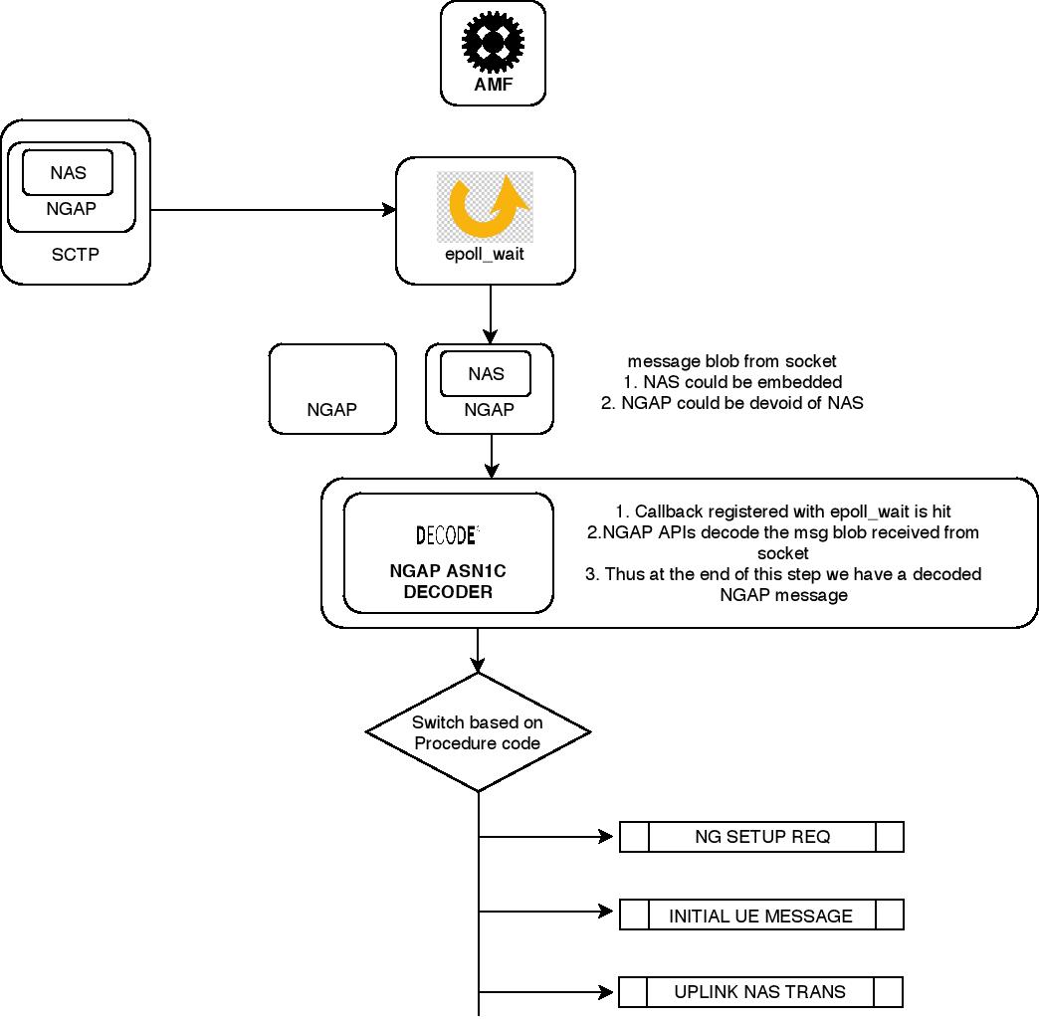

The first message that AMF expects from RAN is NG Setup Request. This message uses non-UE associated signalling. The purpose of the NG Setup is to exchange application level data needed for the NG-RAN node and the AMF to correctly interoperate on the NG-C (TO DO: Add abbreviations section) interface. If parameter-values sent in this Request message are not acceptable at AMF, subsequent NGAP messages are dropped. AMF intimates RAN with NG Setup Failure message. In the case that parameter-values are acceptable, AMF intitmates RAN with NG Setup Response. AMF then accepts subsequent NGAP messages.
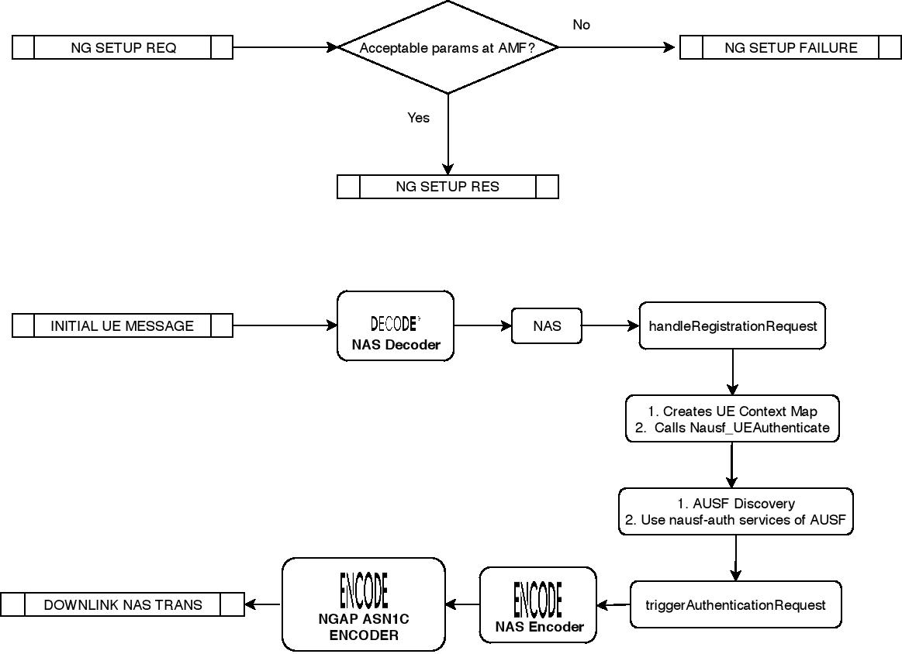
Initial UE Message is an example of NGAP message sent by RAN to AMF. Downlink NAS Transport has a direction from AMF to RAN.

Rohan: Example flow of how NGAP and NAS is handled at AMF (should be similar to 5G-UE and N3IWF)
Check structure used for UE_Context_Map and Http signalling (ausf discovery to NRF and ausf auth service to AUSF)

Registration Procedure Call Flow

NRF Registration.
As a first step, AMF registers its NFProfile with NRF. AMF provides three services, namely: namf-comm, namf-evts, namf-mt. None of these services will be used in version 0 and have not been implemented. NFProfile consists for example of nfInstanceId, nfType, nfStatus, ipv4Addresses, plmn, amf-region-id, amf-set-id ip parameters. It also consists of parameters required to offer the three services.
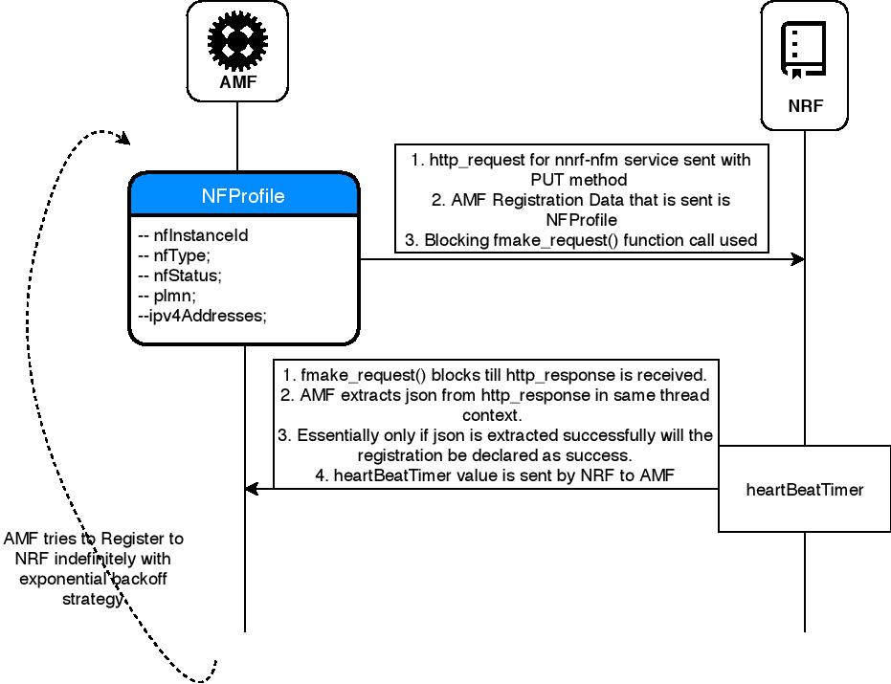
Rohan: Check code for sharing NFProfile with NRF using HTTP, refer above diagram. First place where we are using AMF’s Http signalling
More on SBI and RESTful APIs will be described in a section below. For now it suffices to say that AMF uses PUT method to register NFProfile with NRF. In case of failure AMF keeps retrying in exponential intervals. Without a successful NRF registration AMF does not proceed ahead.
Rohan: Check PUT and expo interval implementation
As a part of NRF response, NRF provides heartbeat Timer which should be used by AMF to send periodic keepalive messages to NRF. Heartbeat timer does not play any role as of now and is not used.
Rohan: Check heartbeat Timer implementation

NF Discovery.
Likewise, other NFs (AUSF, UDM, UDR) also register with NRF with their NFProfiles and a list of services offered. When AMF has to use services offered by AUSF or UDM then it ‘discovers’ them with help of NRF. This process is called ‘NF-discovery’. AMF discovers NFs based on nfType and service-name and then also caches the url of discovered NF to be used subsequently. Thus AMF does not need to connect to NRF everytime for discovery. [TO DO: More on caching will be explained in a section below]
Rohan: Check http signalling for discovery and caching implementation
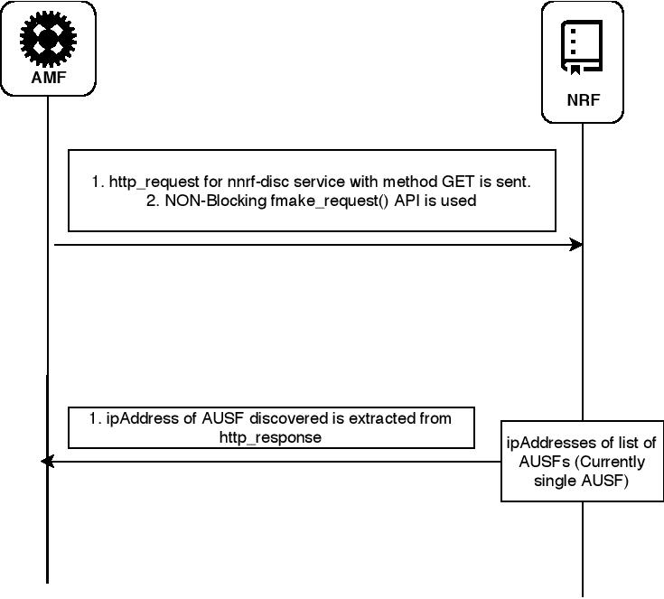

Rohan: Http get is used here

Callflow steps (Brief).
- Registration request is sent from UE to RAN.
  - The key arguments that Registration Request has are namely Registration type, 5GMobileId.
  - For version 0 Registration type supported is only Inital Registration and 5GMobileId supported is SUCI or 5G-GUTI. (5G-GUTI to be added after Phase 4 – available in dev_branch).
Rohan: List important Id, full forms and their uses in-short
- Initial UE message is sent from RAN to AMF.
  - After receiving Registration Request from UE, the RAN triggers Initial UE message. It is a NGAP message (a.k.a N2 message) and holds Registration Request as its NAS-PDU.
  - It has N2 parameters. The purpose of one of the parameters (UE Context Request) is to request AMF to send Initial Context Setup Request message so that RAN can establish an UE context at its end.
  - RAN assigns RAN UE NGAP ID to a UE by which it uniquely identifies that UE. This id is sent within Initial UE Message.
  - On receiving Initial UE Message, AMF assigns AMF UE NGAP ID to the UE to uniquely identify it. Both RAN UE NGAP ID and AMF UE NGAP ID are included in all subsequent NGAP messages.
  - The logic till version 0 phase 4 is such that when subsequent Initial UE Messages (for same UE) are received it prompts AMF to overwrite UE context generated from previous Initial UE Message. AMF finds AMF UE NGAP ID assigned previously to that UE based on the SUCI value and then reuses AMF UE NGAP ID. However it essentially forgets previous UE context. It restarts all Registration Procedure Steps for the new Initial UE Message as if this is the very first time it received this message.
  - However the logic post phase 4 will be improved. ‘Retries’ for same UE (identified either by SUCI or 5G-GUTI) will be handled correctly using Compare-And-Swap logic. Here ‘Retries’ mean while UE is being processed within AMF, a request for same UE is received from RAN as a ‘retry’. More on this will be explained in next version of design document.
- Authentication and Security
  - UE and network mutually authenticate each other. [Only 5G-AKA supported in version 0]
  - Ciphering and Integrity Keys are generated. These keys are used between UE and Serving Network in subsequent Security Procedures.
  - On receiving Security Mode Complete message, AMF connects to UDM and uses UECM service to store UE context in UDR. [TBD: What happens if Registration Accept fails; if UE has not moved to REGISTERED state; Should UDM be notified of deleting UE context?]
- Initial Context Setup between AMF and RAN
  - If RAN requested for UE Context then AMF triggers Initial Context Setup Request message. [TO DO: Add ‘if’ condition in code to trigger Initial Context Setup Request only when requested.]
  - GUAMI and UE security capabilities IE fields should be supported by this message in version 0. [Note: We support all except PDU Session Resouce List @ ROHAN crosscheck]
- Registration Accept from AMF to RAN
  - The AMF sends Registration Accept message to UE indicating that the Registration Request has been accepted.
  - AMF allocates new 5G-GUTI and it is included in this message.
Rohan: why new guti??
  - Timers (T3512, T3502) which run on UE can be assigned value by AMF using Registration Accept message. The values to be assigned are to be read from a config file. [TO DO: Only T3512 is being assigned.]
  - Apart from this no other IE field of this message is populated (in version 0). [@ GREESHMA crosscheck]
- Registration Complete from RAN to AMF
  - AMF handles Registration Complete message sent by UE. UE sends this message to ackowledge that it received new 5G-GUTI that AMF had assigned. UE state gets changed from RM-DEREGISTERED to RM-REGISTERED at both AMF and UE. [There are UE states maintained at AMF. E_UE_REGISTERED corresponds to RM-REGISTERED state. All others correspond to RM-DEREGISTERED state. The entire list of states is added in section below.]
The above steps highlight the positive working scenario. In case there are failures then UE should be notified of same. AMF sends Registration Reject and Authentication Reject messages for same. Registration Reject message is sent when NF Discovery fails, http response from NF fails, all timer retries are exhausted etc. Authentciation Reject is sent for authentication related failures like if verification of HRES and HXRES fails.
UE notifies failures observed at its end by sending Authentication Failure. AMF handles this message for three causes as of now, namely: Synch Failure, MAC failure and NGKSI- already-in-use. In case of Synch failure AMF uses Nausf_UEAuthenticate Service to send (POST) AUTS (synchronisation failure indication) parameter and receive new authentication vectors generated by UDM. In case of MAC failure AMF send Registration Reject to UE. In case of NGKSI-already-in-use failure AMF triggers Authentication Request after moving to a new NGKSI index. In 5G-AKA there is a need for only one index of NGKSI. [TO DO: Add reference where this is stated in specs. @ MANASI crosscheck]
Wherever Reject message is sent by AMF, UE context for that UE is deleted.
Rohan: Next diagram is very important
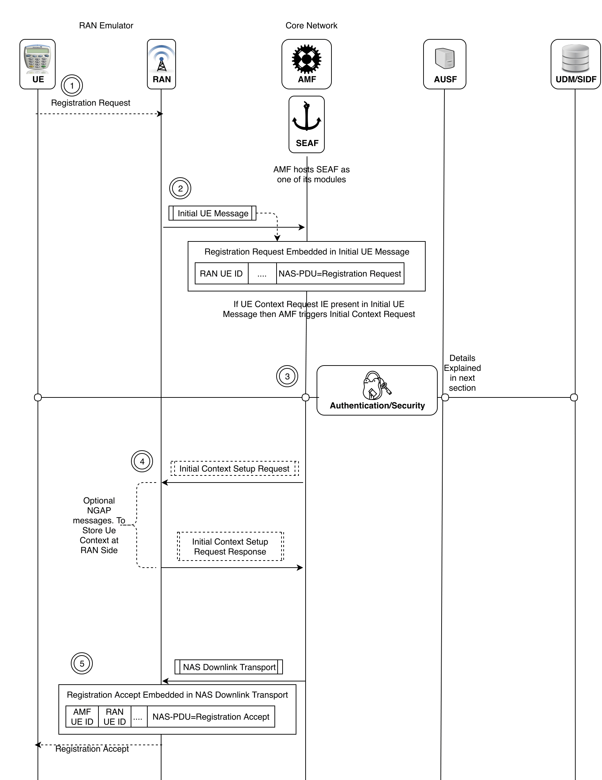

Authentication steps (Brief).
- Registration request is sent from UE to RAN. It contains SUCI.
- AMF extracts SUCI and passes it alongwith Serving Network Name (hardcoded to “amf” as of now) to AUSF. AMF uses Nausf_Ueauthenticate services with POST method.
- AUSF request for UDM services.
- Processing at UDM.
- AUSF gets response from UDM.
- AUSF stores XRES and calculates HXRES.
- AMF receives 5gAV from AUSF. HXRES is part of 5gAV.
- AMF triggers Authentication Request to UE. It sends ngKSI, RAND and AUTN to UE.
- UE calculates RES*.
- UE sends RES* in Authentication Response to AMF.
- AMF handles Authentication Response. Extracts RES*, calculates HRES* and verifies HRES* against HXRES(from 5gAV).
- AMF requests for Nausf_Ueauthenticate services with PUT method. AMF sends RES* to AUSF for its verification at AUSF.
- AUSF verifies RES* against XRES
- AMF receives response from AUSF and in this gets SUPI value deconcealed from SUCI.
[TO DO: Seaf as a separate library] [UECM : Supi is used. Details like which RAN etc.]
Rohan: Seaf?? Check Auth Vector in implementation and online tree diagram
Rohan: All this is done to deconceal SUPI from SUCI (check below diagram)
- Send SUCI to AUSF
- Cal XRES and HXRES at AUSF, Store HXRES at AMF in 5gAV (A1 A2) – a1 from suci?
- Send ngKSI,RAND,AUTN from AMF to UE (X Y Z) – xyz from ?
- Cal RES* at UE using above params and send it to AMF (A1*) --a1* from xyz
- Cal HRES* and Compare with HXRES in 5gAV at AMF (A2 == A2*)
- Send RES* to AUSF and Compare wtih XRES at AUSF (A1 == A1*)
- Deconceal SUPI from SUCI
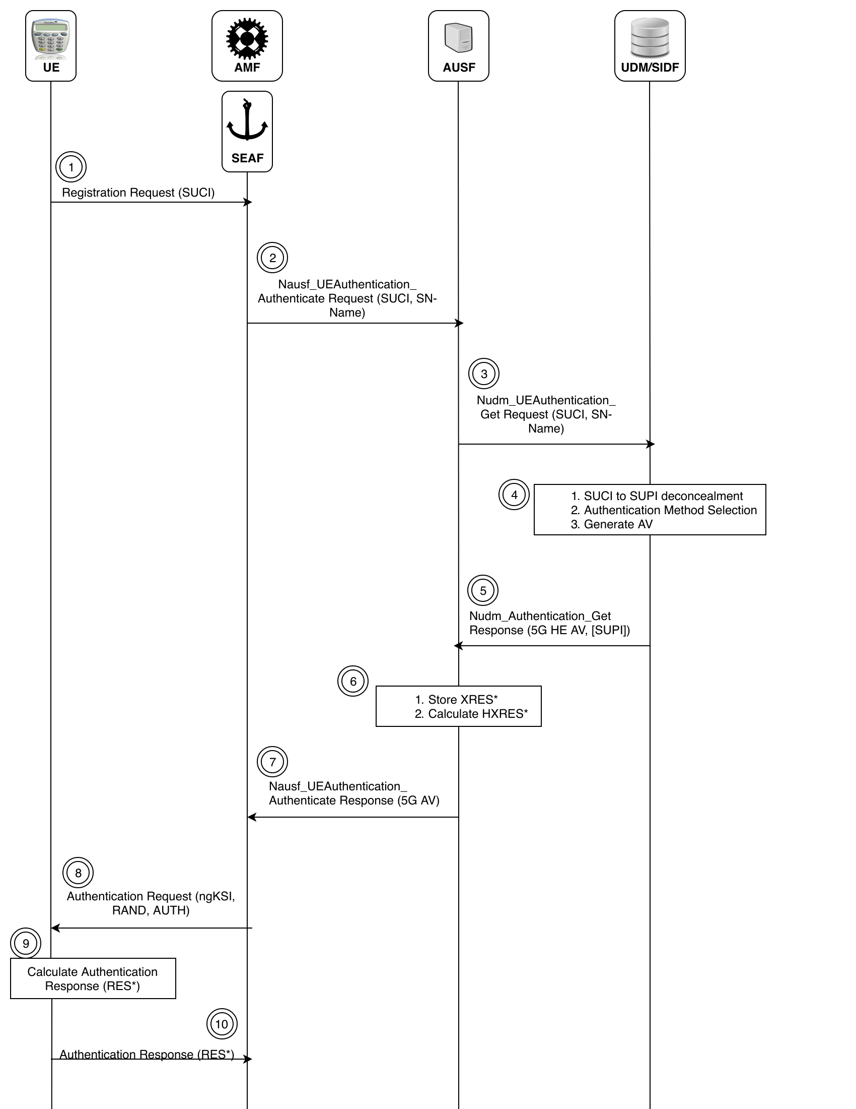
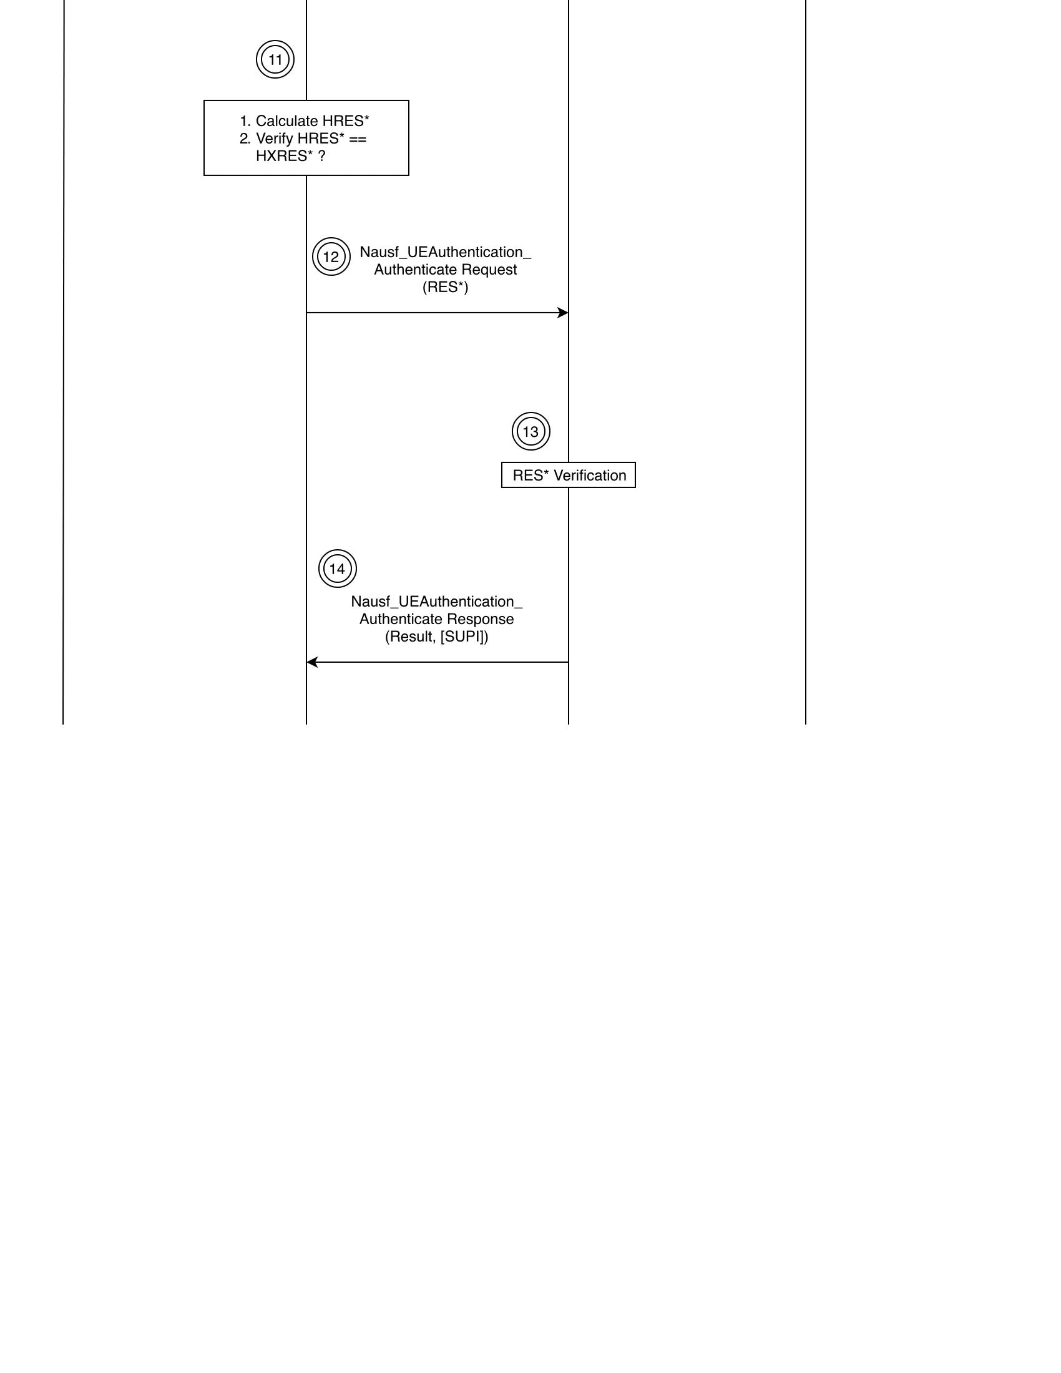

Security steps (Brief).
- After key generation, AMF can perform integrity protection. The NAS Security Mode Command message sent by AMF is the first integrity protected message.
- The AMF sends the NAS Security Mode Command message to the UE
- The AMF activates NAS uplink deciphering after sending the NAS Security Mode Command message.
- The UE verifies NAS Security Mode Command by matching Replayed UE Security Capabilties with ones stored in UE and by verifying integrity protection.
- UE sends Security Mode Complete which is ciphered and integrity protected. AMF receives same and then requests UDM’s UECM services to store UE context in UDR. [Add SUPI et al.]

Rohan: different than Authentication
Rohan: This happens after Authentication to setup the ciphering and integrity of NAS messages

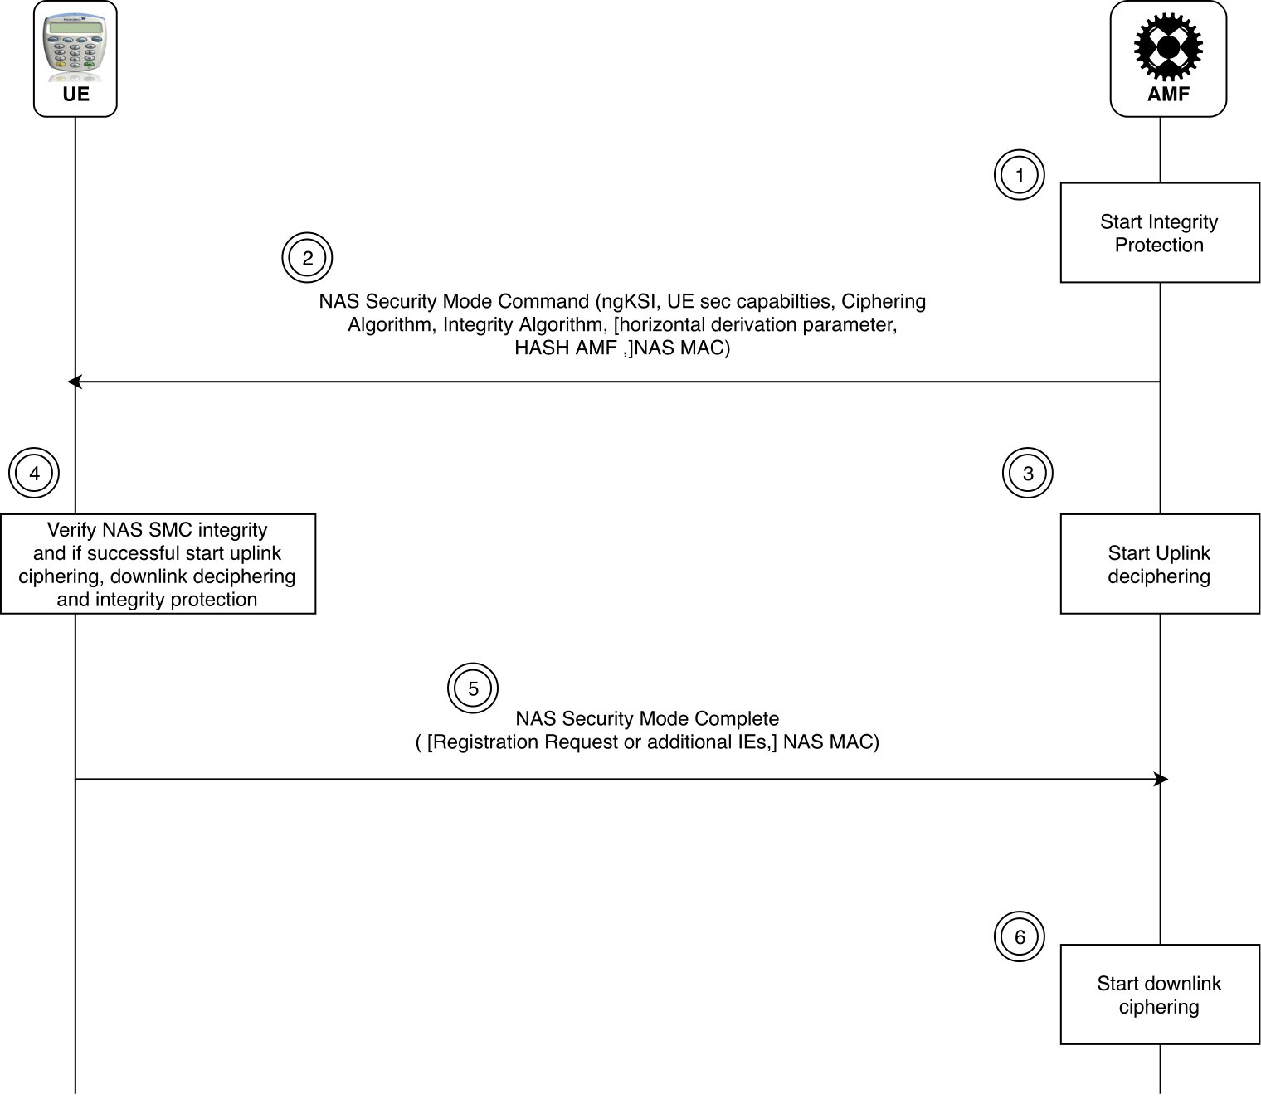

Rohan: Pt 5 contains Registration request again??
Rohan: In 3ggp reg, there is something called identity request used to request for SUCI in case of shifiting from old AMF to new AMF. Does that mean reg request nas has used GUTI instead of SUCI. And GUTI is used during handover scenarios??

NAS Stack.

NAS messages are exchanged between AMF to UE as NAS-PDU within NGAP messages. NAS-PDU are a stream of bytes. AMF stores NAS message within its main memory as a NAS message structure. This NAS message structure is a generic structure which should suppport storage of all NAS messages, be it plain or protected NAS message. Not all subfields of NAS messages are mandatory. Inclusion of optional fields vary as per requirements. NAS message generic structure supports storage of optional fields. However while exchanging it on wire we need to exchange a continous stream of bytes (NAS-PDU) for a particular NAS message. There has to be a process to convert NAS message generic structure to stream of bytes (encoding) and vice versa (decoding). Moreover there are instances where the layout of a field in main memory differs from what is sent over wire. For instance RAND field encoding/decoding is dictated by 10.5.3.1 in 3GPP TS 24.008 wherein bit 8 of octet 2 is MSB on wire while bit 1 of octet 17 is LSB. Also an encoder decoder verifies if the values of fields are within range.

Fields of Plain NAS message. Epd??,security/session,pti??,type,other IE’s

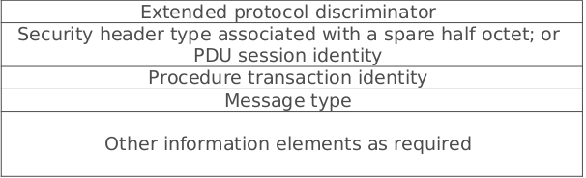
Fields of protected NAS message. Epd,security,auth,seqno,..above fields

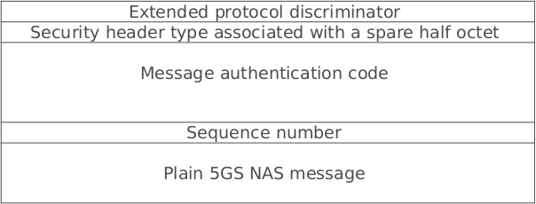

Encode:
- Encoding as mentioned above is process of converting values of fields stored NAS message structure into a stream of bytes.
- The encoding process follows calls to APIs in the form of layers. At top level only nasMessageEncode is called which decides whether to call only nasMessagePlainEncode or addtionally call nasMessageEncrypt. This layered approach is shown in Encode Flow diagram below.
- NasMessagePlainEncode API encodes mandatory for every message. Additionally it encodes optional fields by calling field-encode-APIs. The Presence mask indicates which optional fields should be encoded.
- Below snippet describes nasMessageEncode API and steps involved in encoding.
- [TO DO: Add snippet to sentences.]

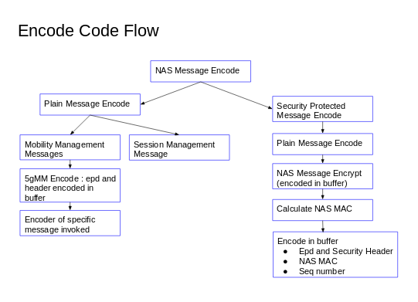

Reverse steps for decode are followed.

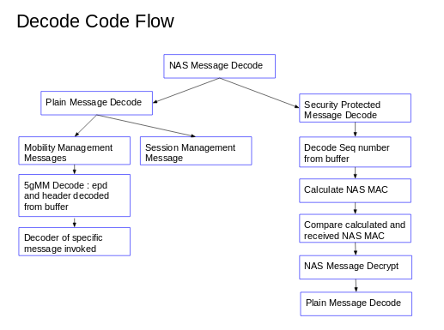

NGAP Stack.

SBA Interactions.
Interactions between NRF, AMF, AUSF, UDM and UDR happen over service based interface (SBI). AUSF and UDM provide services over http to AMF. As a first step we have decided to make use of Microsoft's Casablanca library for SBI. Casablanca is a library implemented in C++ which primarily offers two features. Firstly it supports creation of asynchronous tasks (no blocking). Secondly it supports RESTful services.

Asynchronous tasks in Casablanca work as follows.
- All long running or potentially blocking APIs in Casablanca are asynchronous, for example, any API which makes a call going across a network.
- Pplx tasks are used to represent the completion of some asynchronous work. A task represents an operation that may or may not have finished once a function producing it returns (in main thread).
- There is a '.then()' function associated with a pplx task object. This function takes in 'lambda' (lambda is inline function) as an argument. Lambda is essentially the function handler attached to the task.
- The handler gets invoked once task completes. The handler gets executed in a separate thread, while the main thread continues execution further. A '.wait()' function call is available to make the main thread wait till execution of task associated with '.then()' completes.
- A pool of threads executes the tasks created in an asynchronous non-blocking fashion.

Some points to note about RESTful services.
- JSON is used to represent a resource within RESTful services.
- Http protocol is used to exchange messages, which carry verbs GET POST PUT DELETE OPTIONS HEAD determining the action.
- In order that services are implemented in RESTful manner, it is important to keep the client requests stateless i.e. current client requests should be independent of previous requests.
- It is also important to understand the subtle difference between PUT and POST. Wherever AMF can specify complete URI of resource it is better to use PUT verb. If AMF is not able to guess the complete URI of the resource, then we have no option but to use POST.
- Consider AMF requests AUSF for service for a given 'supiOrSuci'. POST method is the first method which makes AUSF generate ueAuthContextId for this suci. Next time onwards AMF uses ueAuthContextId with PUT method.

UE state and data structures.
AMF assigns AMF UE NGAP ID for each UE and maintains a map of <AmfUeNgapId_t, ueContext>. The AMF also maintains a map mapping the SUCI to AMF UE NGAP ID, so that if the same user resends the initial UE message, it reuses the same AMF UE NGAP ID (resets the UE context).

For each UE which has requested AMF for registration, there is a state maintained for that UE in AMF. This state marks completion of sequence of steps and tracks the UE’s state machine. The application state helps AMF keep track of processing done till now for each UE. It thus helps AMF in expecting which NAS message should be received for particular UE. That way AMF can complain if it receives incorrect messages from UE. In other words AMF will not process NAS messages from UE in aribitrary incorrect order.

Note that for now, AMF is stateful and does not store its application state in persistent storage. If AMF restarts then application state for all UEs will be lost.
The UE context and UE state values are shown
Rohan: Storing UE context and state makes AMF stateful?? No AMF state is saved so why stateful??

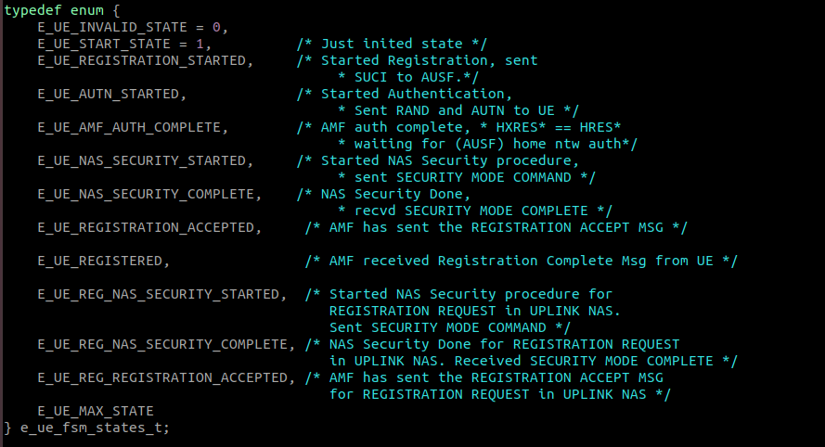
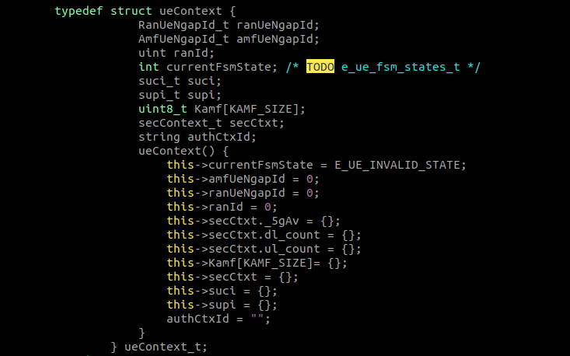

AMF threading model.
The AMF runs a single event-driven epoll thread. This thread waits for events from RAN. When an NGAP message is received from RAN, it processes this message. Thus all 'handle' methods for NGAP procedures like handleNGSetupRequest, handleInitialUEMessage, handleUplinkNASTransport are run in a single thread.
Processing an NGAP message may involve calls to AUSF/UDM over SBA, implemented using the Casablanca framework. AMF interacts with 5GCore in asynchronous manner. To communicate over SBA, a task is created for communication to AUSF/UDM and enqueued in the Casablanca framework. These tasks are handled by the Casablanca thread pool. Casablanca maintains a pool of thread. One of these threads receives messages (http response) from peer components (NRF, AUSF) on epoll_wait(), and the other threads execute the communication tasks. Once the task completes, the Casablanca thread handling the response will send a response back to the UE, which will trigger the next event from the RAN.
We may also wish to have multiple worker threads in AMF in order to better handle the NGAP/NAS processing load. In such a multi-threaded design, the main AMF thread uses a pool of worker threads. Once it receives messages from RAN, the NGAP/NAS processing will be handed over to a separate worker thread.
Note that the multiple threads in AMF must use locks to access the UE context and other maps.
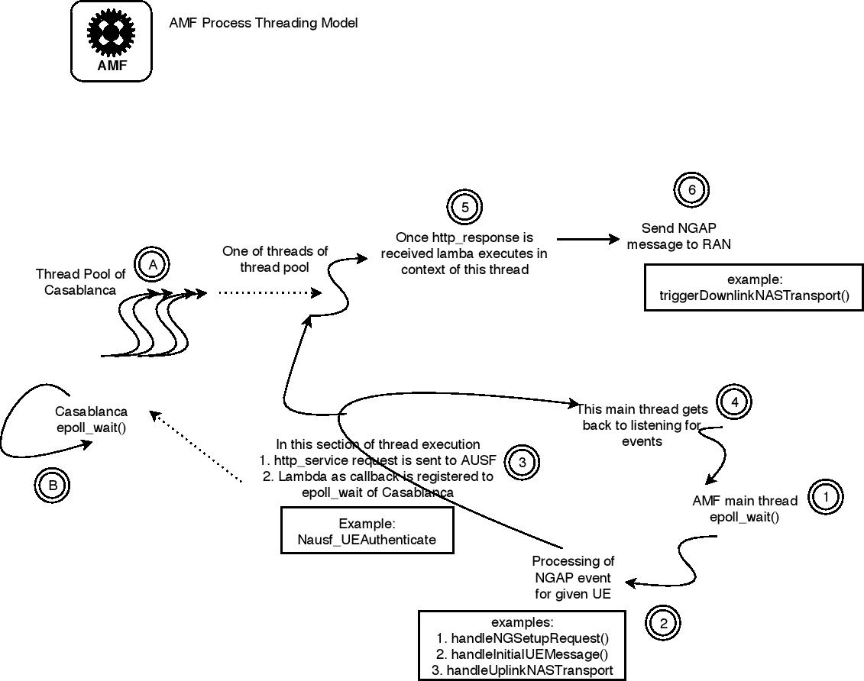

Assumptions and Dependencies.
- Only 5G-AKA will be supported in version 0.
- One NGAP message corresponds to one SCTP packet. Thus each trigger on epoll_wait() corresponds to an entire and only one NGAP packet.
- This version only handles functional failures and not node or network failures. Fault tolerance by storing AMF state in UDSF is out of scope of this version. Because AMF is stateful, AMF crash can lead to loss of state. In such cases, if the AMF restarts after a crash and loses state, the subsequent UE messages may appear out of sync with respect to the UE state machine at an AMF, and cause the AMF to send a authentication reject message.
- Also note that network failures (while AMF is alive) can result in UE retrying a registration request multiple times, leading to some consistency/concurrency issues within AMF (e.g., authentication repeated multiple times). Such cases are also not handled in the phase 4 version 0. But phase 5 will handle same using Compare and swap logic.
- Not handling endianness.

