
5G Test Bed

Design Document
for

PDU session management in 5G core
(Version 0)

Version: 0

Prepared by:

IITB 5G core team

Mar 31, 2019

The information contained in this document is confidential and proprietary to IITB, IITM, CEWiT.
Table of Contents
1. Introduction.....................................................................................................................................1
1.1 Purpose......................................................................................................................................1 1.2 Scope.........................................................................................................................................1 1.3 Document Overview.................................................................................................................1
2. System Design.................................................................................................................................2 3. Detailed Design...............................................................................................................................3
3.1 Design Guidelines.....................................................................................................................3 3.2 SBI and N4 Interface................................................................................................................3 3.3 PDU Session Establishment Procedure Call Flow...................................................................4
(a) NRF Registration..................................................................................................................4 (b) NF Discovery........................................................................................................................4 (c) Callflow steps (Brief)...........................................................................................................4
3.4 Data structures..........................................................................................................................7 3.5 SMF threading model...............................................................................................................8
4. Common design requirements.........................................................................................................9
4.1 Software Design........................................................................................................................9 4.2 Functional Requirements..........................................................................................................9 4.3 Performance Requirements.......................................................................................................9 4.4 API Design................................................................................................................................9 4.5 Diagnostics Design...................................................................................................................9 4.6 Management Interface..............................................................................................................9
5. Pitfalls............................................................................................................................................10 6. References......................................................................................................................................11 7. Glossary.........................................................................................................................................11

Revision History

Document Date Author(s) Reason for Changes
Version

0.1 Mar 31 Kapil Initial draft

[Type here]

1. Introduction

1.1 Purpose

This document describes the design for the 5G core components being built at IIT Bombay in version 1 to set up Protocol Data Unit (PDU) session which is a step prerequisite to transfer data. The goal of version 1 is to come up with basic functionality of session set up and data transfer.

1.2 Scope

The components involved in building and testing session setup are Network Repository Function (NRF), Access and Mobility Management function (AMF), Session Management Function (SMF), Unified Data Management (UDM), User Data Repository (UDR), Policy Control Function (PCF) and Radio Access Network (RAN) Emulator. RAN Emulator also emulates the User Equipment (UE). [It
might be decided to exclude PCF from version 1]

SMF plays the key role in managing session related procedures. SMF can not exchange messages with UE (RAN) directly. All communication between UE (RAN) happens through AMF. AMF acts as a gate keeper and thus a secured access to SMF is ensured. Thus setting up sessions also requires changes in AMF from what has been built in version 0.

Though version 1 also aims at data transfer, this document talks about managament of PDU sessions. As mentioned in the requirements document for version 1, only PDU sesssion establishment and release procedures will be implemented. These two procedures are sufficient to meet the basic requirement of data transfer.

1.3 Document Overview

The document is organized as follows. We first describe the system design and overall architecture of the 5G core in version 1. We then delve into the details of the specifics of the design of SMF. We also mention what changes AMF should undergo.

[Type here]
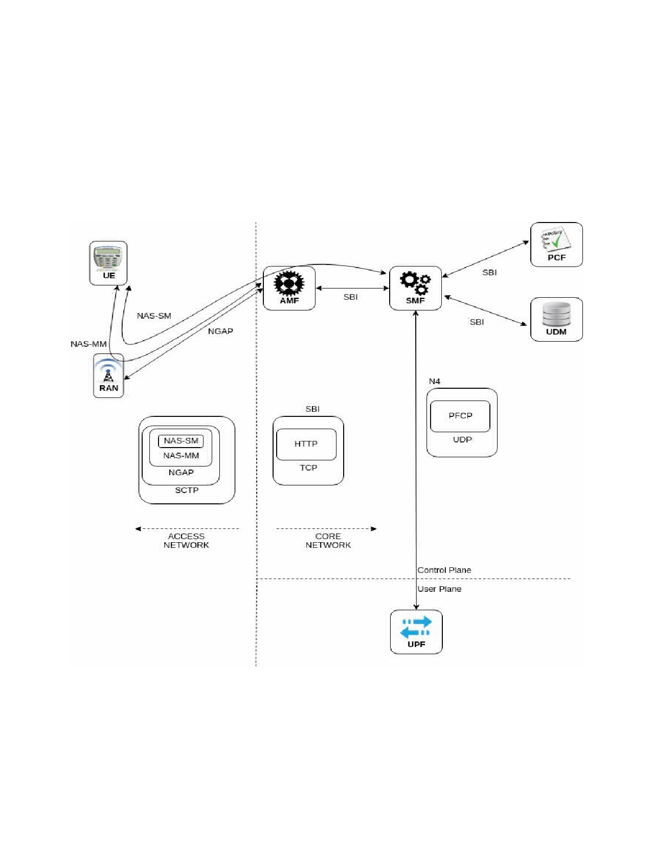
[Type here]

2. System Design
The various protocol stacks implemented are as follows. UE communicates with SMF over NAS-
SM (N1 SM) layer. NAS-SM messages are encapsulated within NAS-MM messages.. The 5G Core VNFs NRF, AMF, SMF, PCF, UDM and UDR communicate over HTTP as per the Service Based Interface (SBI). SMF communicates with UPF over N4 (PFCP) messages. The control plane part of PFCP messages (PFCP-c) are encapsulated within UDP. PFCP-u (user part of PFCP) use GTPv1-U protocol on top of UDP.

[Type here]
[Type here]

3. Detailed Design
3.1 Design Guidelines

The SMF is built as a C++ software, to be run as a virtual network function (VNF) in the virtualized 5G core.
The two functionalities of SMF which are of particular importance to use are:
• Session Management e.g. Session Establishment, modify and release, including tunnel
maintain between UPF and AN node.
• UE IP address allocation & management.

These two functionalities form the essence of session management. The reason being:
• The ultimate goal of 5GS is so that UE communicates with Data Network (DN).
• UE needs an IPv4 address (we support PDU session type of IPv4 only) to talk to an
appplication server running in DN.
• Moreover the PDU layer which encapsulates application data needs to reach UPF (PDU
session anchor) from UE and from UE to UPF. To enable the transfer of this information RAN and UPF need the peer tunnel addresses.
3.2 SBI and N4 Interface.
All communication to and from SMF with control-plane-5G-components is over SBI. The SMF acts
a producer for few services whereas consumer for others.
SBI messages are exchanged over Casablanca C++ REST SDK library developed by Microsoft.
The communication between SMF and UPF happens over PFCP. This document talks about PFCP-c only. [because PFCP-u study is pending]. SMF fetches PFCP-c messages over UDP socket when trigger events occur on epoll_wait().
AMF acts as a producer for SMF. Thus changes which let AMF be a server need to incorporated on top of version 0 code.

[Type here]
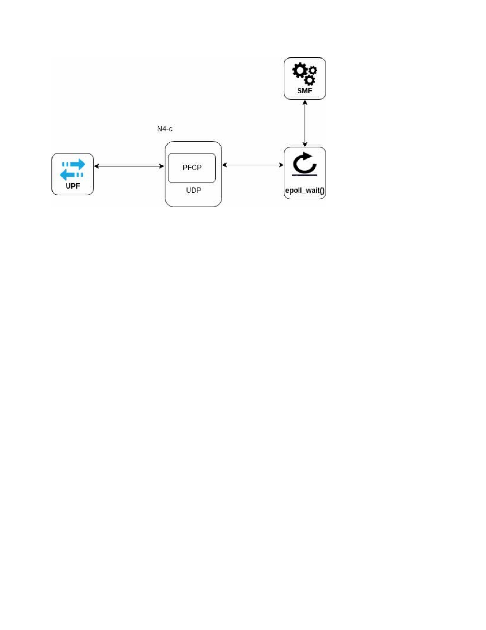
[Type here]

3.3 PDU Session Establishment Procedure Call Flow

(a) NRF Registration.

As a first step, SMF registers its NFProfile with NRF. The SMF provides two services, namely: Nsmf_PDUSession, Nsmf_EventExposure. Nsmf_PDUSession is the service that is important to us.

Namf_Communication service offered by AMF is employed so that SMF can exchane N1 N2 messages to from UE RAN using N1N2MessageTransfer service operation.

(b) NF Discovery.

AMF discovers SMF with help of NRF. Likewise, SMF can discover UPF from NRF

(c)

Callflow steps (Brief).

1. PDU Session Establishment Request is sent by UE as a NAS-SM message encapsulated
within UL NAS message. UL NAS message is encapsulated within Uplink NAS transport
NGAP message. The key arguments that these messages have are:

◦ PDU session ID. This ID is assigned by UE and is unique per UE.

◦ Request Type will be set to Initial.
Rohan: More?? Check 5G-UE

2. AMF discovers SMF with help of NRF.

3. AMF uses Nsmf_PDUSession_CreateSMContext service of SMF to create an association
between AMF and SMF for this PDU session.

[Type here]

[Type here]

4. SMF registers with the UDM using Nudm_UECM_Registration (SUPI, DNN, S-NSSAI,
PDU Session ID) for a given PDU Session. As a result, the UDM stores following information: SUPI, SMF identity and the associated DNN and PDU Session ID. The UDM may further store this information in UDR by Nudr_DM_Update (SUPI, Subscription Data, UE context in SMF data).
If Session Management Subscription data for corresponding SUPI, DNN and S-NSSAI is not available, then SMF retrieves the Session Management Subscription data using Nudm_SDM_Get (SUPI, Session Management Subscription data, DNN, S-NSSAI) and subscribes to be notified when this subscription data is modified using Nudm_SDM_Subscribe (SUPI, Session Management Subscription data, DNN, S-NSSAI). UDM may get this information from UDR by Nudr_DM_Query (SUPI, Subscription Data, Session Management Subscription data, DNN, S-NSSAI) and may subscribe to notifications from UDR for the same data by Nudr_DM_subscribe.

Rohan: where does it get SUPI from ??
Rohan: What is Sessioin Mgmt Subscription data?? where is it used??
Rohan: Last two highlights are udr equivalent of get and subscribe

5. AMF receives Nsmf_PDUSession_CreateSMContext Response(Cause, SM Context ID or
N1 SM container (PDU Session Reject (Cause))) from SMF.

6. Optional Secondary authorization/authentication step will be skipped.

7. SMF applies local policy. [If SMF should not use local policies then PCF comes into picture
when SMF has to talk to PCF for policies.]
Rohan:What Policy??

8. SMF selects SSC mode 1. SMF selects UPF. And then the key step of the SMF allocating an
IP address for the PDU Session.
Rohan: What is SSC mode??
Rohan: Select UPF based on what, previouse step policy??

9. In this step SMF performs an SMF initiated SM Policy Association Modification procedure.
[Skip this step?] [Study pending.]
Rohan: What is this ?? Policy wapas???

10. SMF sends an N4 Session Establishment and provides Packet detection, enforcement and
reporting rules to be installed on the UPF for this PDU Session. If CN Tunnel Info is allocated by the SMF, the CN Tunnel Info is provided to UPF in this step. The UPF acknowledges by sending an N4 Session Establishment Response. If CN Tunnel Info is allocated by the UPF, the CN Tunnel Info is provided to SMF in this step.
Rohan: wtf is cn tunnel??

If multiple UPFs are selected for the PDU Session, the SMF initiate N4 Session Establishment procedure with each UPF of the PDU Session in this step. [Multiple UPFs not applicable for us.]
Rohan: How are they managed then?? And kyu??

11. SMF uses Namf_Communication_N1N2MessageTransfer AMF service to let AMF know
about the CN tunnel info.

12. In this step AMF tells RAN how it should allocate resources for this PDU session, plus it
also informs RAN CN tunnel info so that RAN can send data to UPF.

13. The (R)AN may issue AN specific signalling exchange with the UE that is related with the
information received from SMF. For example, in case of a NG-RAN, an RRC Connection Reconfiguration may take place with the UE establishing the necessary NG-RAN resources related to the QoS Rules for the PDU Session request received in step 12.

14. In this step response to step 12 is sent from RAN to AMF. This response also carries AN
tunnel info which UPF should use to send downlink data.

15. AMF uses Nsmf_PDUSession_UpdateSMContext Request service of SMF to inform SMF
of AN tunnel info.

16. The SMF initiates an N4 Session Modification procedure with the UPF. The SMF provides
AN Tunnel Info to the UPF as well as the corresponding forwarding rules. After this UPF can send downlink data to RAN.

[Type here]
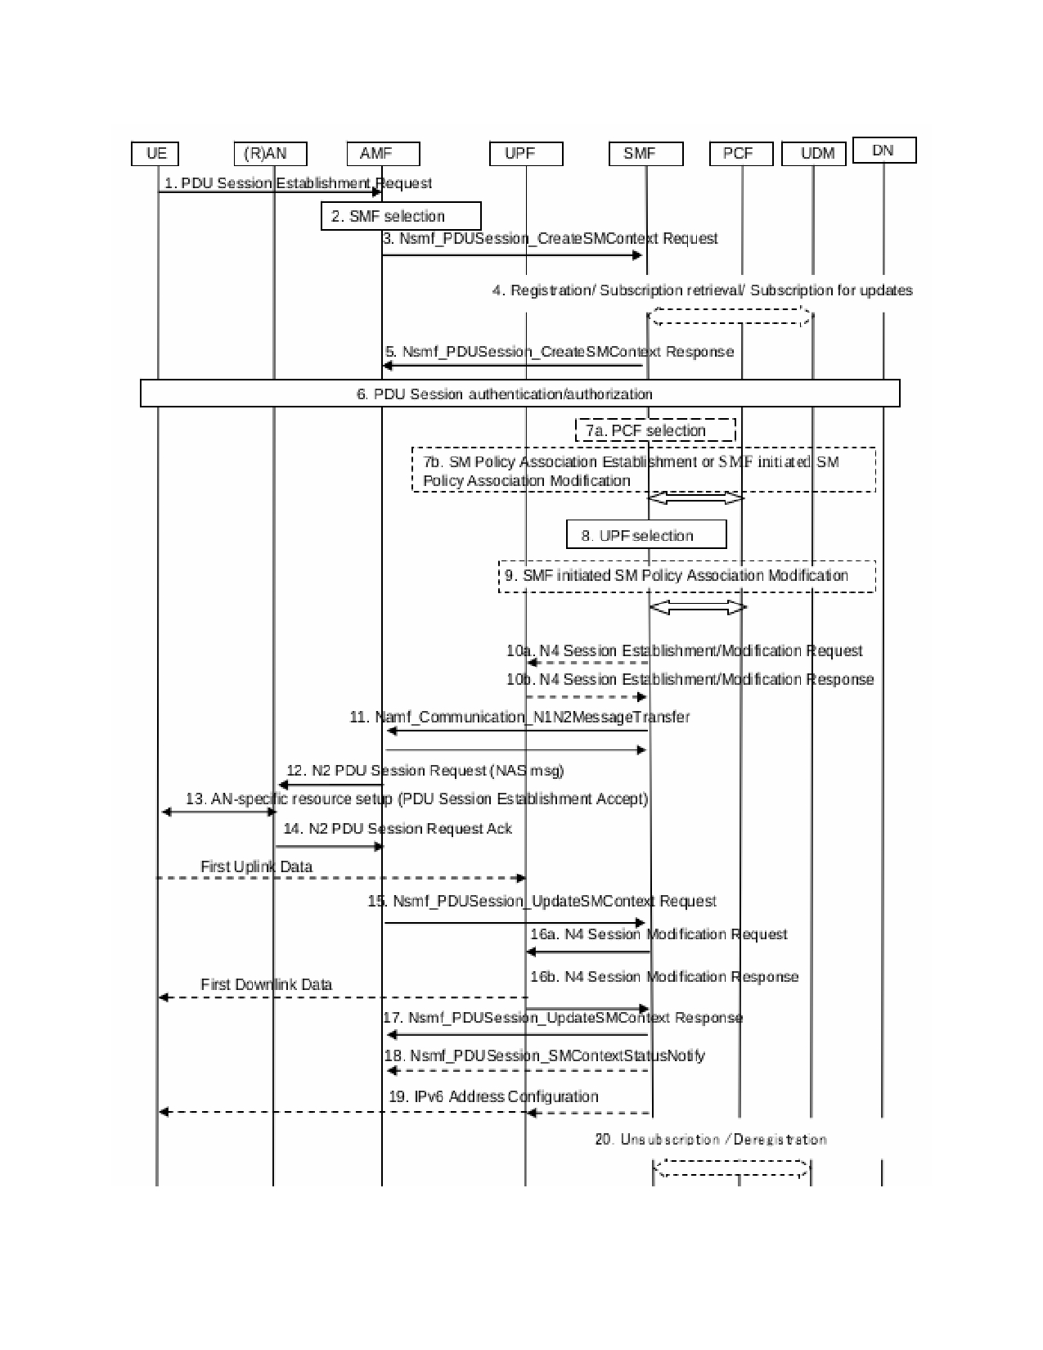

[Type here]
[Type here]

3.4 Data structures.
To be covered. Pending.

[Type here]
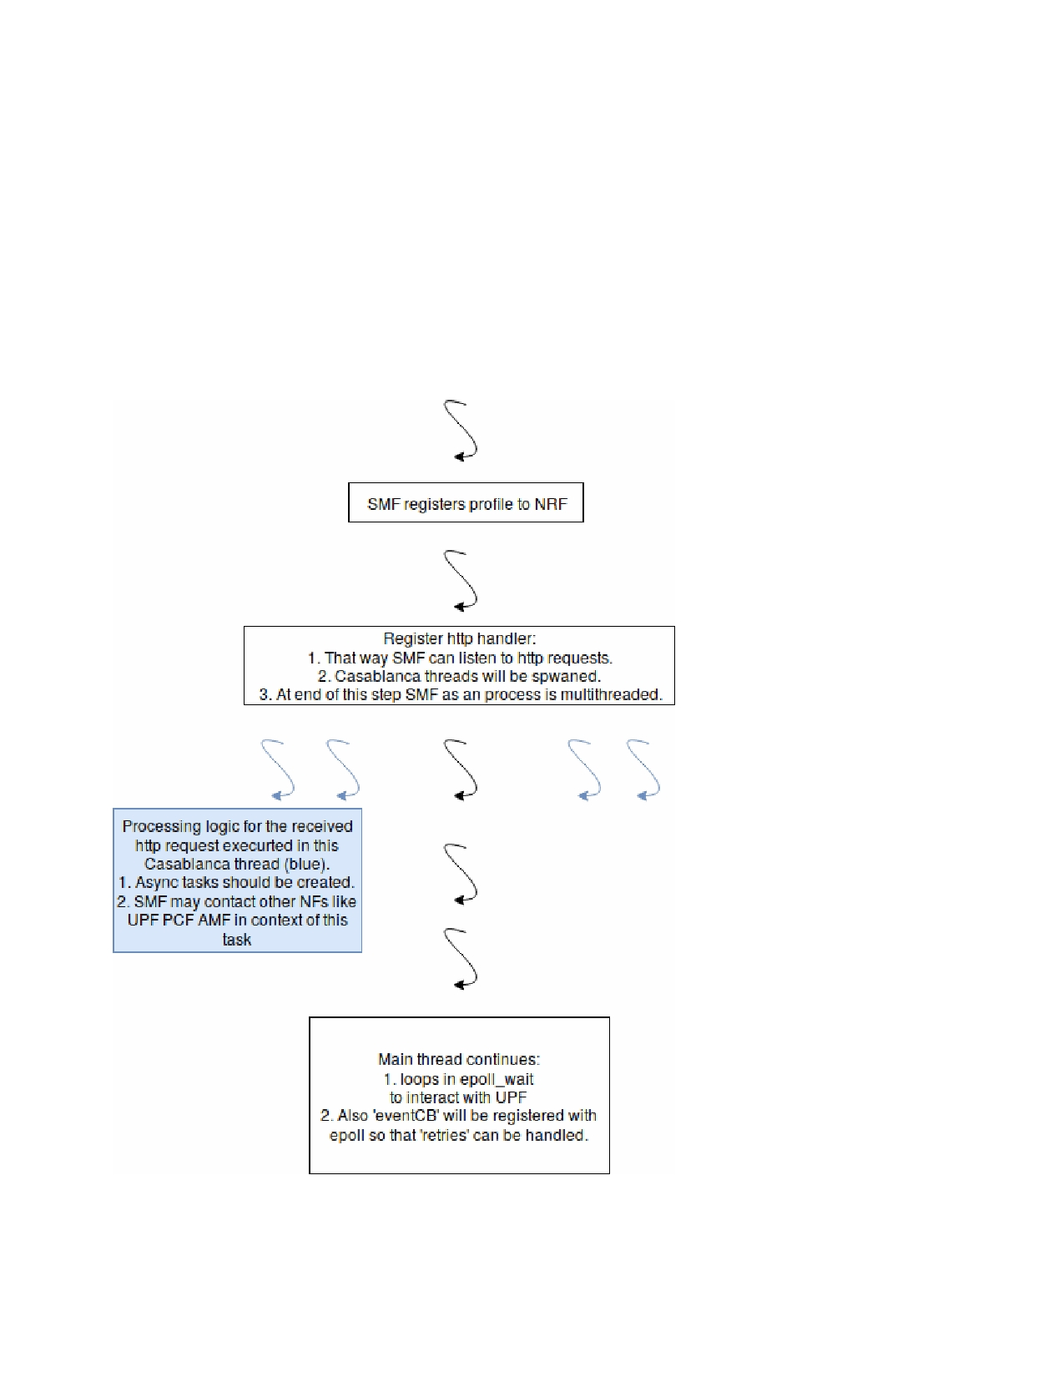
[Type here]

3.5

SMF threading model.
1. In SMF main thread, as a first step SMF registers profile to NRF.
2. SMF then registers http handlers so that it can listen to requests from AMF. Casablanca
threads are spawned in this step. Thus SMF is now a multithreaded process.
3. The processing logic of SMF (acting as producer for a service request) takes place in
Casablanca thread. Within context of this thread SMF may initiate service requests to UDM or send messages to UPF.
4. The main thread has epoll_wait() to read messages from UPF.

[Type here]
[Type here]

4. Common design requirements

4.1 Software Design

The SMF is implemented as a C++ network function. It uses Microsoft's open-source Casablanca framework for RESTful SBA interactions over HTTP. The NGAP stack is built over an open-source ASN to C framework.

4.2 Functional Requirements

Specified in the requirements document.

4.3 Performance Requirements

Specified in the requirements document.

4.4 API Design

Specified in the requirements document.

4.5 Diagnostics Design

None supported so far.

4.6 Management Interface

A configuration file is used to specify all the required parameters, details of which are in the requirements document.

[Type here]
[Type here]

5.

Pitfalls
1. SMF should not maintain Finite State Machine logic. SMF is a RESTful service and
accordingly it should be stateless from this perspective.
2. The use of .wait() should be completely avoided in Casablanca threads. The only place
where .wait() should be used is SMF Profile Registration to NRF. Otherwise all tasks should be asynchronous.

[Type here]
[Type here]

6.

7.

References
1. https://github.com/vlm/asn1c
2. 3GPP TS 24.501 V15.1.0 (2018-09) [Non-Access-Stratum (NAS) protocol for 5G System
(5GS)]
3. 3GPP TS 38.413 V15.0.0 (2018-06) [NG Application Protocol (NGAP)]
4. 3GPP TS 23.502 V15.2.0 (2018-06) [Procedures for the 5G System]
5. 3GPP TS 23.501 V15.2.0 (2018-06) [System Architecture for the 5G System]
Glossary

[Type here]

