
5G Test Bed

Design Document
for

UPF in 5G Core (Version 0)

Version: 0

Prepared by:

IITB 5G core team

May 28, 2019

The information contained in this document is confidential and proprietary to IITB, IITM, CEWiT.
Table of Contents
1. Introduction.....................................................................................................................................1
1.1 Purpose......................................................................................................................................1 1.2 Scope.........................................................................................................................................1 1.3 Document Overview.................................................................................................................1
2. System Design.................................................................................................................................2 3. Detailed Design...............................................................................................................................3
3.1 Design Guidelines.....................................................................................................................3 3.2 PFCP and GTP interface...........................................................................................................3 3.3 Control Plane Procedures..........................................................................................................4
(a) PFCP Association Setup.......................................................................................................4 (b) PFCP Session Establishment................................................................................................5 (c) PFCP Session Modification..................................................................................................5 (d) PFCP Session Release..........................................................................................................6
3.4 Data Plane Procedures..............................................................................................................7
(a) GTP Tunnels.........................................................................................................................7 (b) Packet Processing.................................................................................................................8 (c) Packet Flow, Routing via UPF..............................................................................................9
3.5 Threading Model.....................................................................................................................10 3.6 PFCP Library..........................................................................................................................10 3.7 UE and Test RAN Architecture...............................................................................................12
4. Common design requirements.......................................................................................................13
4.1 Software Design......................................................................................................................13 4.2 Functional Requirements........................................................................................................13 4.3 Performance Requirements.....................................................................................................13 4.4 API Design..............................................................................................................................13 4.5 Diagnostics Design.................................................................................................................13 4.6 Management Interface............................................................................................................13
5. Assumptions and Dependencies....................................................................................................14 6. References.....................................................................................................................................15 7. Glossary.........................................................................................................................................15
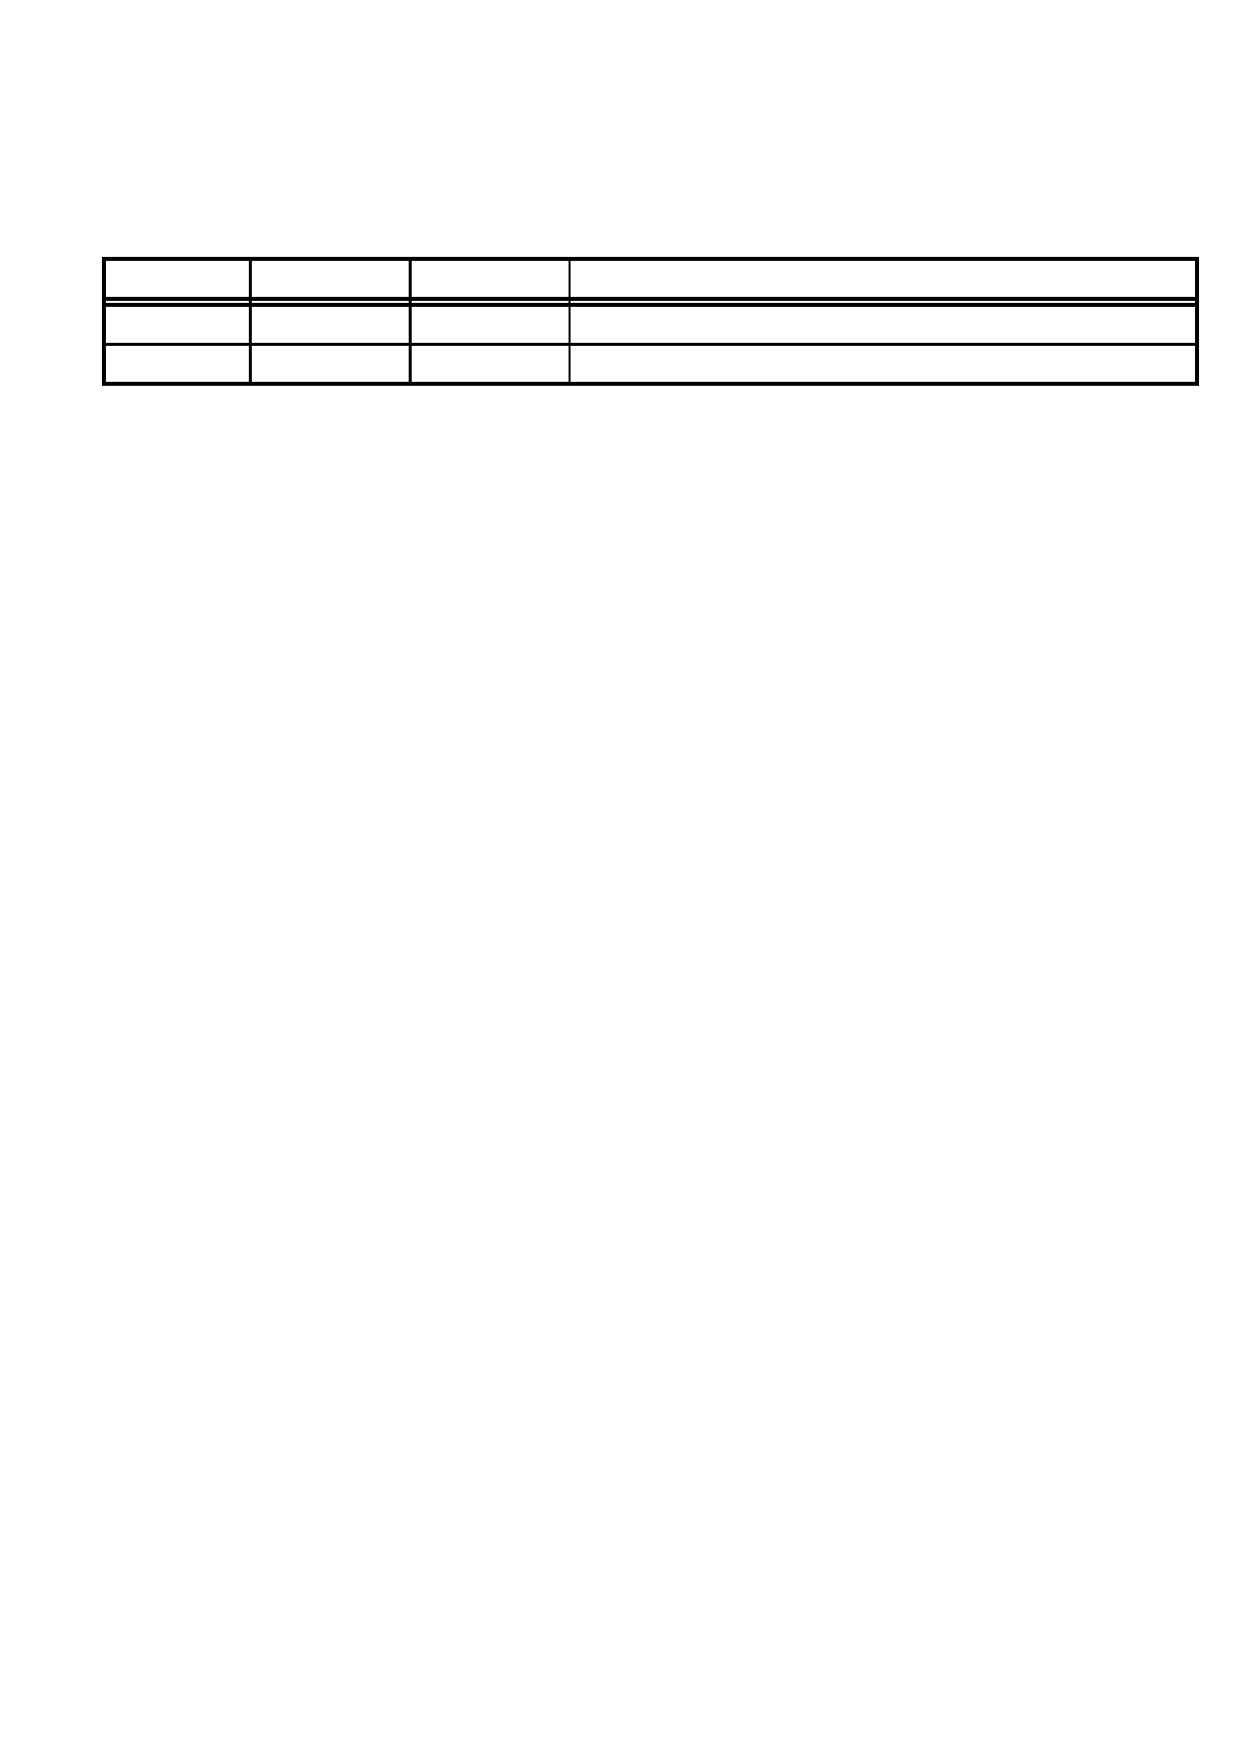
Revision History

Version Date Author(s) Reason for Changes
0.1 Dec 11 Mythili Initial draft
0.2 Jan 30 Kapil Address Review Comments

[Type here]

1. Introduction

1.1 Purpose

This document describes the design for the 5G core components being built at IIT Bombay in version 0. The goal of version 0 is to come up with basic functionality of user session establishment.

1.2 Scope

The components involved in building and testing session establishment are Network Repository Function (NRF), Access and Mobility Management function (AMF), Session Management Function (SMF), User Plane Function (UPF), Unified Data Management (UDM), User Data Repository (UDR) and Radio Access Network (RAN) Emulator.

Messages of the session establishment procedure are primarily handled by SMF, which the AMF transparently forwards. SMF then sets up rules in the RAN and UPF necessary for data flow. UPF processes data plane packets based on the rules installed by SMF. This functionality of 5G core will be tested using a RAN emulator.

1.3 Document Overview

The document is organized as follows. We first describe the system design and overall architecture
of the 5G core in version 0. We then delve into the details of the specifics of the design of UPF.

[Type here]
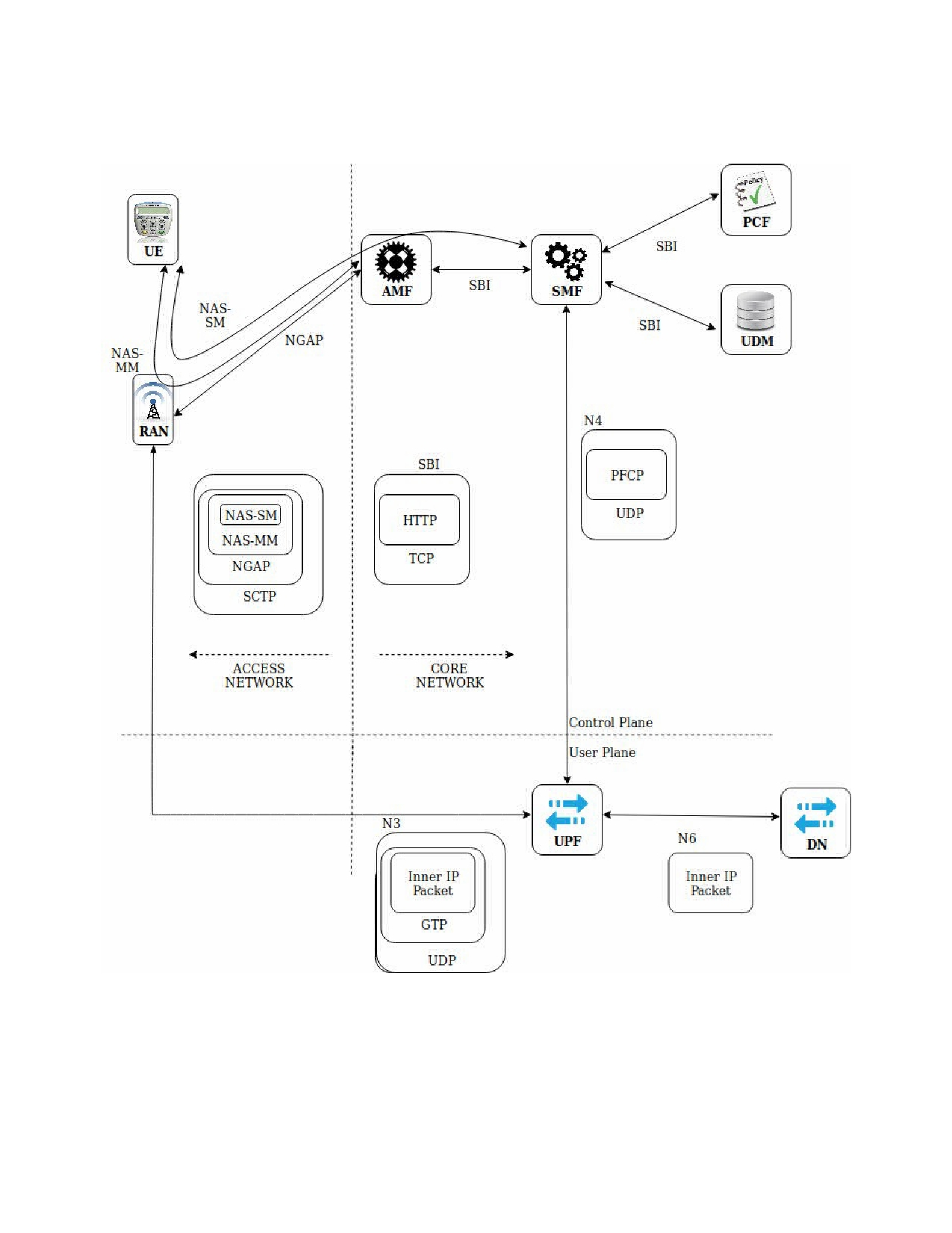
[Type here]

2. System Design

Rohan: When does SMF access PCF and UDM??

The various protocol stacks implemented are as follows. UE communicates with AMF over NAS (N1) layer. NAS messages are encapsulated within NGAP messages by the RAN and sent over SCTP. The 5G Core VNFs NRF, AMF, SMF, AUSF, UDM and UDR communicate over HTTP as per the Service Based Interface (SBI). SMF communicates with UPF over N4 interface using PFCP

[Type here]
[Type here]

protocol. The control plane part of PFCP messages (PFCP-c) are encapsulated within UDP. User plane packets are encapsulated within GTP headers and transferred between UPF and RAN.

Rohan: Does it mean GTP is PFCP-u and PFCP-c is GTP-c

3. Detailed Design
3.1 Design Guidelines

The UPF is built as a C++ software, to be run as a virtual network function (VNF) in the virtualized 5G core.
UPF has three sub-functionalities:
• It receives/sends PFCP messages from/to SMF.
• It receives/sends GTP messages from/to RAN/UPF
• It receives/sends UE's traffic from/to the Data Network (DN).
Current UPF design is to have two threads, one handling the control plane messages and one handling the data plane traffic.

Rohan: Functionalities are same as N3IWF-DP. Design is bit different, we have main thread handling the CP messages and two separate threads for uplink and downlink DP traffic respectively.

Rohan: Quick talk about PFCP and GTP, later discussed in detail

3.2 PFCP and GTP interface.

All communication to and from SMF is over PFCP. PFCP protocol divides messages into request messages and response messages. Both SMF and UPF process requests and send out responses to each other. Using sequence numbers and retries PFCP additionally provides reliability to certain extent, which have not been implemented in the current version. The PFCP library has been developed in-house, and has been described in greater detail in a later section.

The GTP interface connects RAN/UPF to UPF and facilitates the transfer of User Plane Packets. UE IP packets are encapsulated in a GTP header, within a UDP/IP header. Two NFs setup a tunnel with each end identified by a TEID (Tunnel End Point ID). The destination endpoint's TEID is filled in the GTP header.

[Type here]
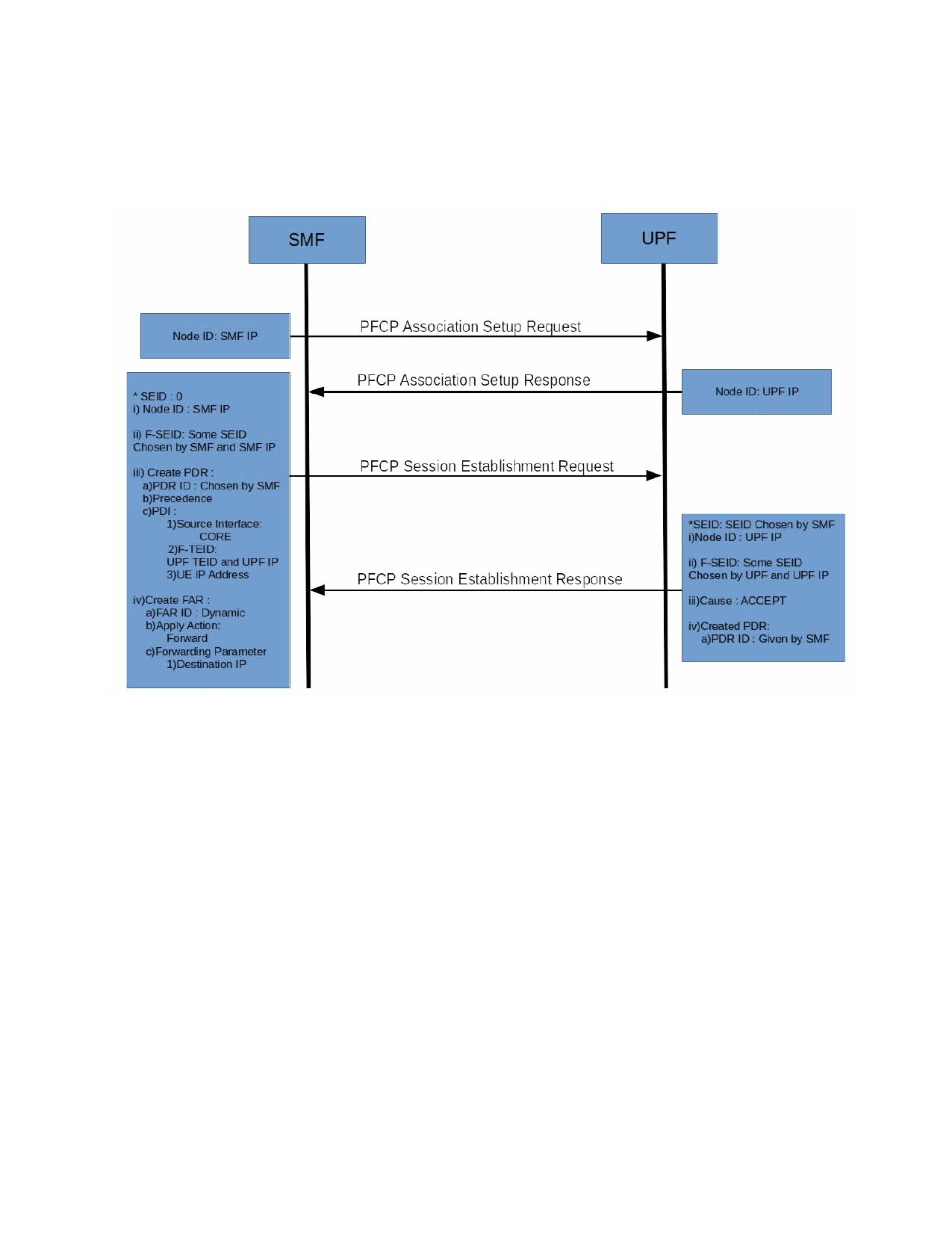
[Type here]

Rohan: Refer 3.6 for PFCP

3.3 Control Plane Procedures
In the current version the following procedures are supported.

Rohan: Association Req/Resp and Sestb Req/Resp

(a) PFCP Association Setup
SMF on discovering the UPF sends out a Association Setup Request to the UPF. The request
contains the features that SMF supports. In response, the UPF sends out a Association Setup
Response. The response contains features that UPF supports. User Plane Information, one of the
IEs in the Association Setup Response, contains the TEID range that SMF can allocate TEIDs from during session establishment procedure.

Rohan: What are more features exchanged here??

TEID, a 32 bit number, is divided into subsections using a TEDRI and TEID Range. TEDRI the value of this field indicates the number of bits in the most significant octet of a TEID that are used to partition the TEID range, e.g. if this field is set to "4", then the first 4 bits in the TEID are used to partition the TEID range. TEID Range Indication shall contain a value of the bits which are used to partition the TEID range. e.g. if the TEID Range Indication is set to "4", then Octet 6 shall be one of values between 0 and 15.
Rohan: Confused….

Each PFCP endpoint saves the peer information and peer specific information in a peer context.
UPF saves SMF specific information and vice versa. Each NF creates a peer Context Map with the

[Type here]

[Type here]

Peer Node Id as the key and the peer context as the data. Peer Node Id uniquely identifies a peer and can either be IPv4 address or IPv6 address or FQDN of the peer.
Association is done once per peer pair, after which the node id information is used to contact each
other for other node related procedures.

Rohan: So 1 SMF can be a peer to multiple UPF and 1 UPF can be a peer to multiple SMF.
Storing each others features in peer context map

(b) PFCP Session Establishment
On receiving the NAS Session Establishment Request from the UE, SMF initiates PFCP Session
Setup (steps 10a & 10b). It begins by sending out a PFCP Session Establishment Request to the UPF, which contains IEs that specify the PDRs and FARs that need to be installed. SMF picks a TEID from the TEID range allocated during association and builds the UPF FTEID.
In response to the Session Establishment request, the UPF creates a smContext, installs the rules
and sends a PFCP Session Establishment Response. If the rules were installed successfully the
cause IE is set to success, and all the PDRs that were installed are acknowledged by adding
createdPDR IEs. A failure in installing/processing the rules will return a Response with cause set to
a value based on the exact failure that occurred and if necessary specify the IE that caused the failure.
In the current design only the rules necessary to process uplink packets (from UE to DN) are
installed during the Session Establishment. RAN tunnel information is not available to install rules to process downlink packets. The set of rules necessary to process downlink packets are installed in Session Modification. Specifications of the actual rules that are being installed in the current version are described in a later section.
In Addition to installing rules during Session Establishment, both peers share the SEID (Session
Endpoint ID) that identifies the session's context within the NF. SMF shares it's FSEID (Fully Qualified SEID, i.e. IP Address and SEID) in the Session Establishment Request. Any session
related message that UPF needs to send after this point must be sent to the IP Address in the FSEID
and the SMF's SEID set in the PFCP Message header. Next, UPF shares it's FSEID in Session
Establishment Response, which the SMF needs to use in all subsequent session related messages.
Important to note that the address shared in FSEID need not be equal to the NodeID details, but for simplicity our current design has both the values set to the same IPv4 address.

Rohan: NodeID details??
Rohan: How is SEID selected? UE NAS-SM should consist something that should help SMF to select UPF

(c) PFCP Session Modification
After receiving the RAN tunnel info within NGAP PDU Session Resource Modify Request
Transfer, SMF sends a PFCP Session Modification Request to install/update rules to process
downlink packets (Steps 16a & 16b). SMF will install/modify the rules in UPF by adding
createPDR/updatePDR IEs. The UPF will respond with a PFCP Session Modification Response. If
the rules were installed successfully the cause IE is set to success, and all the PDRs that were
installed are acknowledged by adding createdPDR IEs. A failure in installing/processing the rules

[Type here]
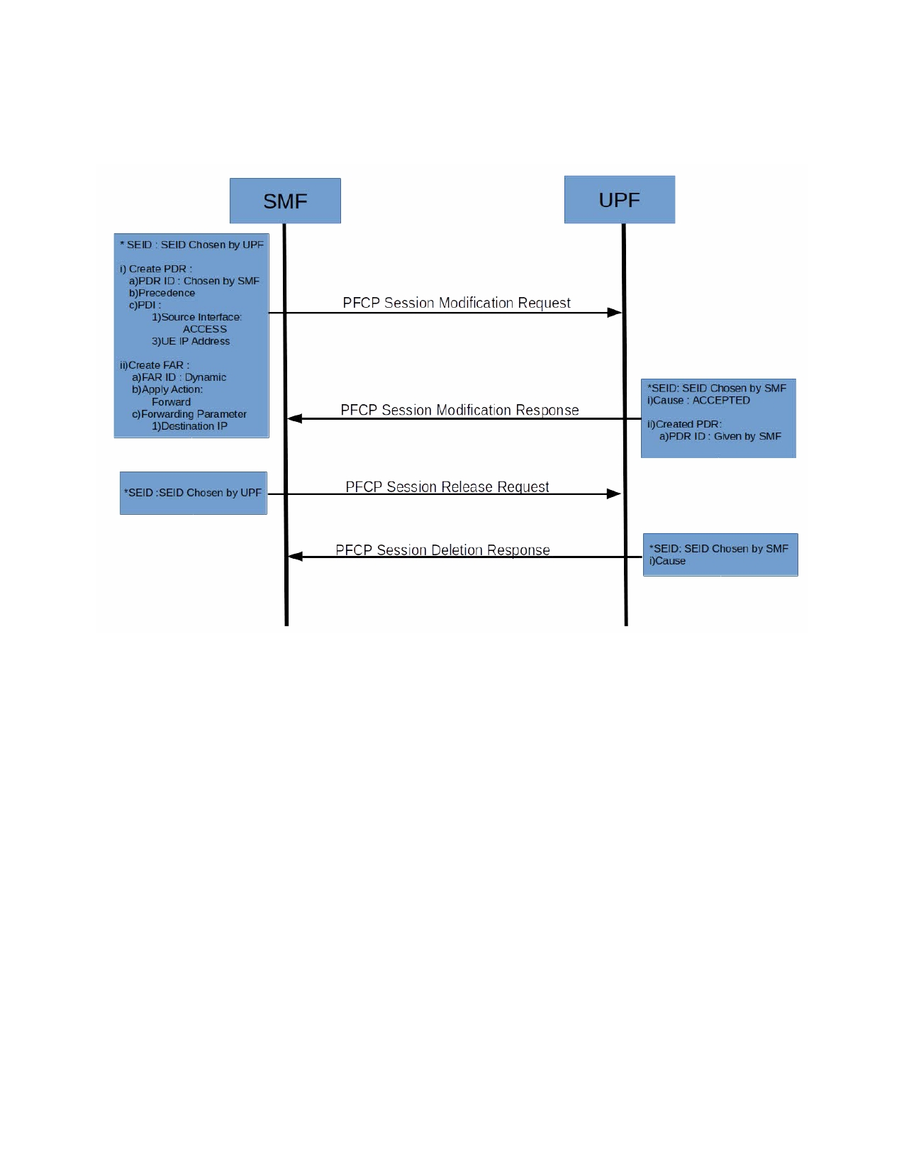
[Type here]

will return Response with cause set to a value based on the exact failure that occurred and if necessary specify the IE that caused the failure.

(d) PFCP Session Release
On receiving a release request from AMF/RAN/UE/PCF, the SMF begins PFCP Session Release by
sending a PFCP Session Release Request to the UPF. The Message just contains the PFCP header
and no IEs. The UPF on receiving the request, releases the smContext which is identified by the SEID in the request message's header. All the PDRs and FARs are released and the smContext is deleted. If the release was successful the cause IE is set to success. A failure in deleting the rules
will return a Response with cause set to a value based on the exact failure that occurred and if necessary specify the IE that caused the failure.

[Type here]
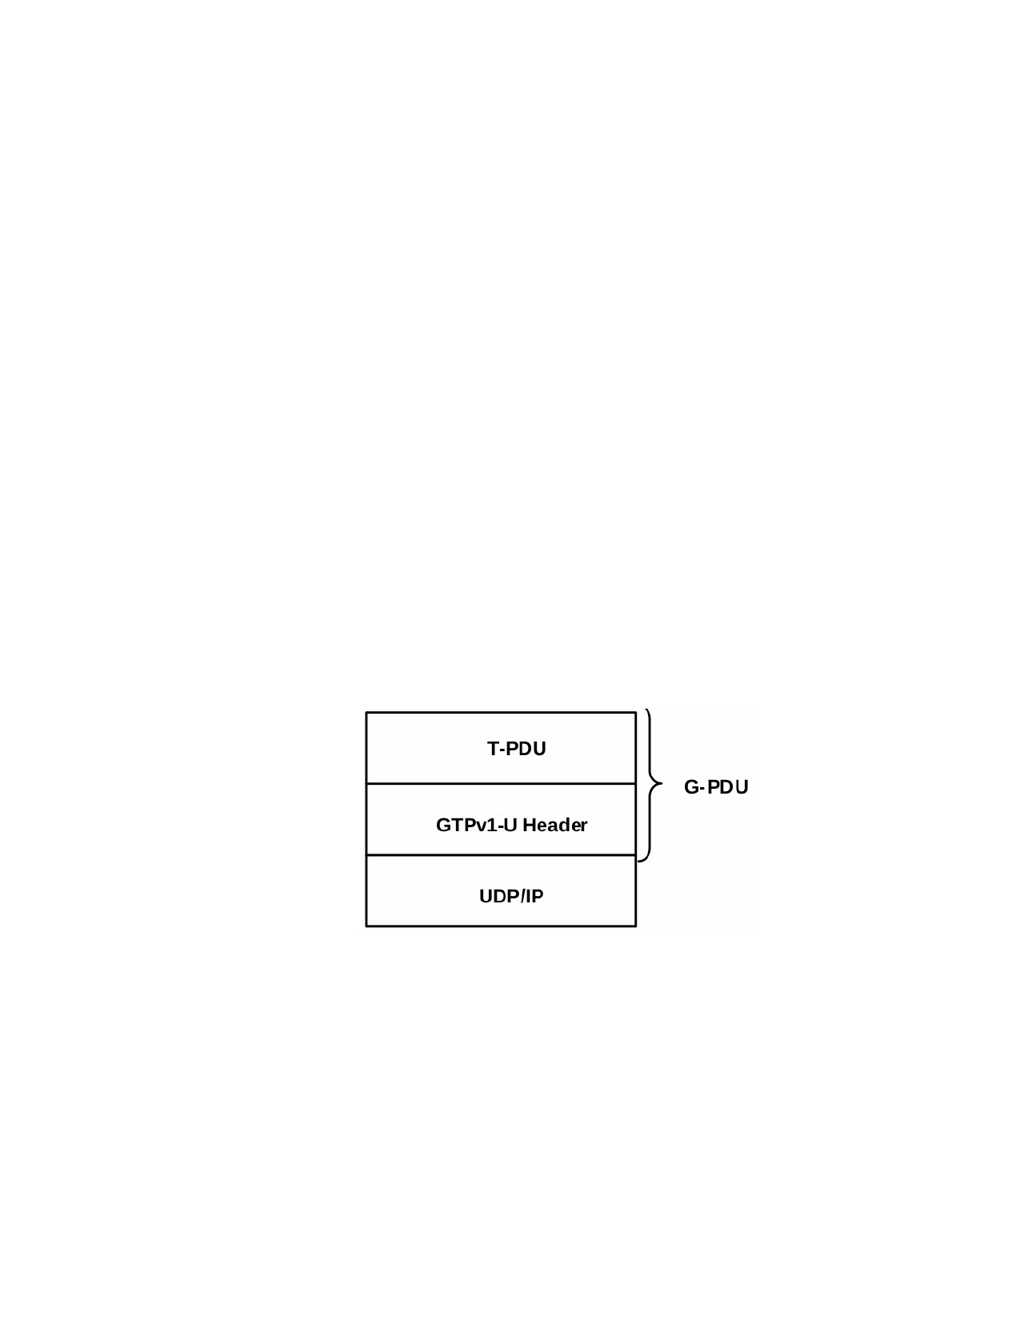
[Type here]

3.4 Data Plane Procedures

(a) GTP Tunnels
GTP-U tunnels are used to carry encapsulated T-PDUs between a pair of nodes (RAN-UPF or UPF-
UPF). Usually both endpoints have a Tunnel Endpoint ID (TEID) associated with them for both- ways communication. TEID (of the destination node) present in GTP header tells which tunnel a
particular T-PDU belongs to. This implementation uses GTP version1 (GTPv1) as per
specifications, which is an unidirectional tunnel. Hence, a pair of tunnels need to be created for duplex connections.
Rohan: T-PDU --> Payload of a G-PDU (GPRS Tunnelling Protocol PDU) which can be user data, i.e. possibly segmented IP-frames, or GTP signaling information.

GTPv1-U sending endpoint: GTP runs over UDP. So, an incoming IP packet at the sending
endpoint shall be encapsulated with a GTP header, followed by UDP and IP headers. If the outer IP packet size is more than the MTU of the link between the endpoints, necessary fragmentaion shall be done.

GTPv1-U receiving endpoint: Receiving endpoint shall reassemble all fragments to form a
complete IP packet. Then, necessary decapsulation needs to carried out to extract the inner IP packet by removing the outer IP, UDP and GTP headers. (GTP listens for incoming traffic on port 2152).

Rohan: Is reassembly and fragmentation done by our GTP stack?? => IP Layer does it
GTP protocol stack: Following is the GTP-U protocol stack (T-PDU is the inner IP packet):

Rohan: See above diagram

GTP-U header: The GTP-U header is a variable length header with minimum length 8Byte. The format of a GTP-U header is as shown below:

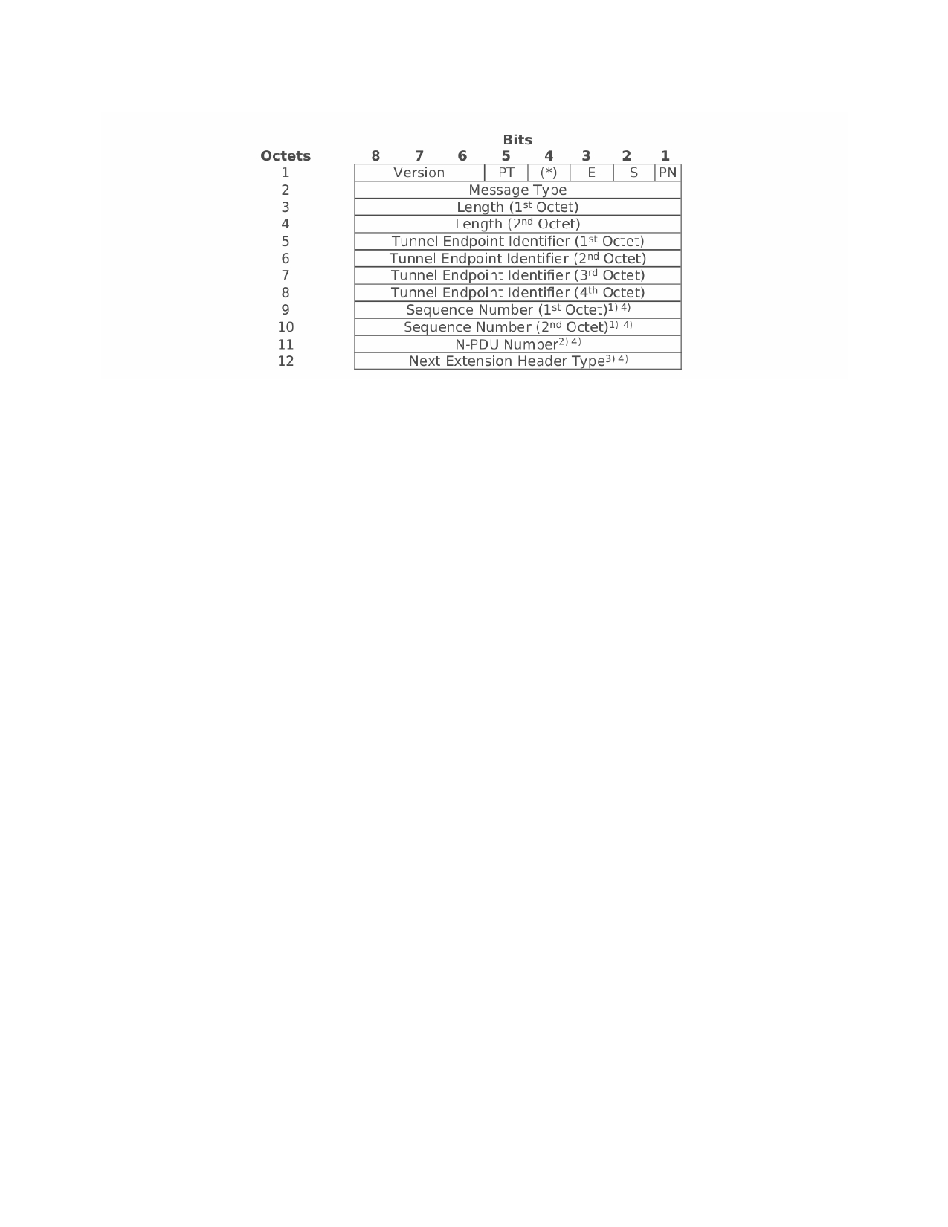
[Type here]

Following is a brief description of some of the fields in the header:
Version: Version field (Set to '1')
PT: Protocol Type (Set to '1')
E: Extension Header Flag (Set to '1' if extension header exists) S: Sequence Number Flag (Set to '1' if sequence number exists)
PN: N-PDU Number Flag (Set to '1' if N-PDU number exists)
Message Type: Indicates the type of GTP-U message
Tunnel Endpoint Identifier: Identifies TEID at the receiving GTP endpoint
Sequence Number: Indicates increasing sequence number for T-PDUs is transmitted via GTP-U
tunnels.
For more detailed description of all the header fields, please refer to TS 29.281 (Section 5).
Rohan: or gtp.h comment in next page
User payload is transmitted in G-PDU packets. A G-PDU is a packet including a GTP-U header and
a T-PDU. When a GTP-U node receives a G-PDU for which no EPS Bearer context, PDP context, MBMS Bearer context, or RAB exists, the GTP-U node shall discard the G-PDU and sends a error indication message.

Rohan: Check why above params are needed to be present in G-PDU for it to pass.

From gtp.h in utility library

/* Mandatory fields */
/*
* 0 1 2 3
* 0 1 2 3 4 5 6 7 8 9 0 1 2 3 4 5 6 7 8 9 0 1 2 3 4 5 6 7 8 9 0 1
* +-+-+-+-+-+-+-+-+-+-+-+-+-+-+-+-+-+-+-+-+-+-+-+-+-+-+-+-+-+-+-+-+
* | Ver |P|R|E|S|N| Message Type| Length |
* +-+-+-+-+-+-+-+-+-+-+-+-+-+-+-+-+-+-+-+-+-+-+-+-+-+-+-+-+-+-+-+-+
* | Tunnel Endpoint Identifier |
* +-+-+-+-+-+-+-+-+-+-+-+-+-+-+-+-+-+-+-+-+-+-+-+-+-+-+-+-+-+-+-+-+
* | Sequence Number | N-PDU Number | Next-Ext-Hdr |
* +-+-+-+-+-+-+-+-+-+-+-+-+-+-+-+-+-+-+-+-+-+-+-+-+-+-+-+-+-+-+-+-+
*
* o Ver: Version field (Set to ’1’)
* o P: Protocol Type (Set to ’1’)
* o R: Reserved bit (Set to ’0’)
* o E: Extension Header Flag (Set to ’1’ if extension header exists)
* o S: Sequence Number Flag (Set to ’1’ if sequence number exists)
* o N: N-PDU Number Flag (Set to ’1’ if N-PDU number exists)
* o Message Type: Indicates the type of GTP-U message
* o Length: Indicates the length in octets of the payload
* o Tunnel Endpoint Identifier (TEID)
* o Sequence Number: Indicates increasing sequence number for T-PDUs
* is transmitted via GTP-U tunnels
* o N-PDU Number: It is used only for inter SGSN, 2G-3G handover case,
* etc.
* o Next-Ext-Hdr: Indicates following extension header type
*
*
* 0 1 2 3
* 0 1 2 3 4 5 6 7 8 9 0 1 2 3 4 5 6 7 8 9 0 1 2 3 4 5 6 7 8 9 0 1
* +-+-+-+-+-+-+-+-+-+-+-+-+-+-+-+-+-+-+-+-+-+-+-+-+-+-+-+-+-+-+-+-+
* | Ext-Hdr Length| |
* +-+-+-+-+-+-+-+-+ |
* | Extension Header Content |
* . .
* . +-+-+-+-+-+-+-+-+
* | | Next-Ext-Hdr |
* +-+-+-+-+-+-+-+-+-+-+-+-+-+-+-+-+-+-+-+-+-+-+-+-+-+-+-+-+-+-+-+-+
*
* o No more extension headers (Next-Ext-Hdr = 00000000)
* o Service Class Indicator (Next-Ext-Hdr = 00100000)
* o UDP Port (Next-Ext-Hdr = 01000000)
* o RAN Container (Next-Ext-Hdr = 10000001)
* o Long PDCP PDU Number (Next-Ext-Hdr = 10000010)
* o Xw RAN Container (Next-Ext-Hdr = 10000011)
* o NR RAN Container (Next-Ext-Hdr = 10000100)
* o PDU Session Container (Next-Ext-Hdr = 10000101)
* o PDCP PDU Number (Next-Ext-Hdr = 11000000)
*/

Rohan: Check how Extension Header is implemented.

(b) Packet Processing
Packet Detection Rules (PDR) shall be added during PFCP Session Establishment Procedure. Each
PDR will have a Packet Detection Information (PDI) against which incoming packets will be
matched (for example, source interface, F-TEID of incoming packet will be compared with that
stored in PDI and checked if it is matching). Packets matcing the PDI will follow the Forwarding
Action Rule (FAR) stated in the PDR.
A FAR has an "apply action" parameter, indicating whether a packet is to be forwarded/buffered/dropped.

[Type here]
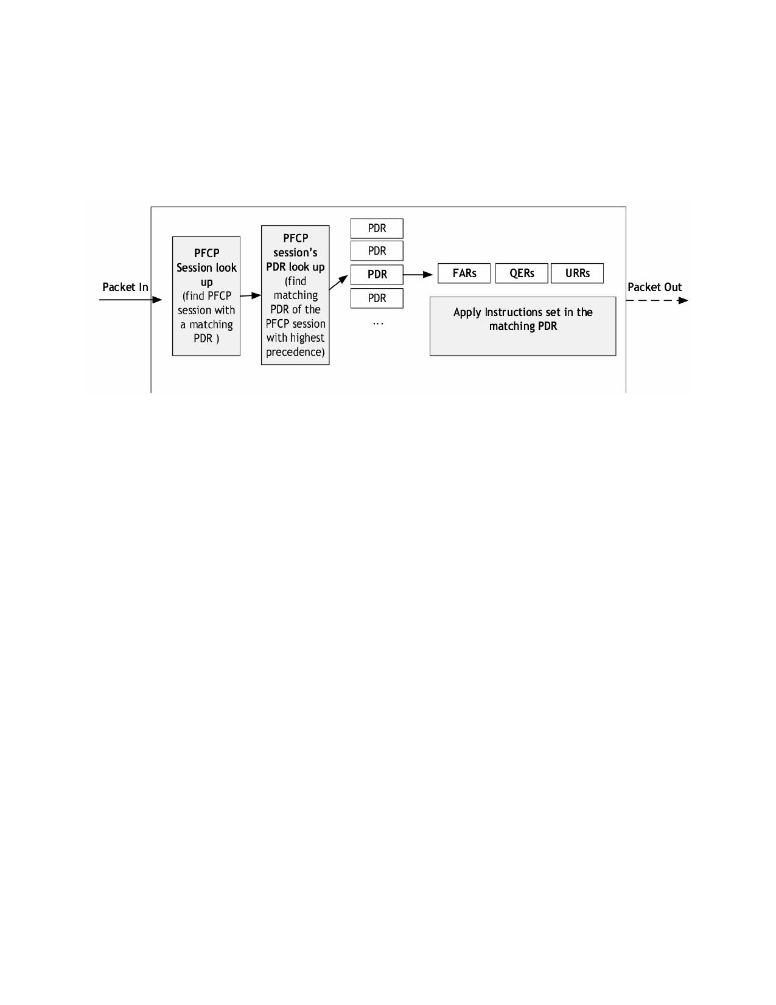
[Type here]

The following figure shows the packet processing pipeline/sequence for an incoming packet at the
UPF:

Rohan: Packet In → TEID → SessionID → Associated PDR → Matching PDI of selected PDR → Apply FAR → Packet Out

Once a UPF receives a packet, it will perform a sessionwise lookup the provisioned PDRs, in the order of decreasing PDR precedence within a PFCP session. The UPF shall stop once a matching
PDR is found (i.e., only the highest precedence PDR shall be selected). A packet matches a PDR if all the match fields with different IE type in the corresponding PDI matches with the packet header
fields. For more details, please refer to TS 29.244 (Section 5.2). If a packet does not match any of the PDRs, it will be silently discarded.
For example, suppose that the following 2 PDRs are installed for a particular session (assuming
only 1 session).
PDR-1: Src iface: CN, G-TEID: X, (Src) IP: <UE_IP>, Remove GTP header, run FAR-1
FAR-1: Dest iface: AN, Action: FORW
PDR-2: Src iface: AN, (dest) IP: <UE_IP>, run FAR-2
FAR-2: Dest iface: CN, Action: BUFF
So, when a packet arrives at the UPF, PDR-1 will be checked first (assuming PDR-1 has higher
precedence than Pdr-2). If it matches, FAR-1 will be executed. Otherwise, PDR-2 will be checked. If the packet does not match any of the PDRs, it will be dropped. Since these are non-overlapping rules precedence amongst them is not of significance.

[Type here]

[Type here]

(c) Packet Flow, Routing via UPF
Necessary routing rules and design are being explored.

Rohan: General flow for uplink and downlink data packet. Check pdf version

Uplink Path :
1) UE will write intended data to socket and send to DNN.
Data

2)Packets going to DNN will be routed to tun device .IP datagram packet will be received after reading from the tun.
UE IP DNN IP Data

3)Add GTP header with appropriate TEID' depending upon source IP and session ID.
GTP Header with TEID' UE IP DNN IP Data

4)Write this packet to UDP Socket on port 2152 from RAN Side :
RAN MAC UPF MAC RAN IP UPF IP GTP,TEID UE IP DNN IP Data

5)After Receiving Packet on UPF, normal UDP Packet read will extract till GTP Layer:
GTP Header with TEID' UE IP DNN IP Data

6)Apply PDR Rules Here.

7)Extract GTP Header.
UE IP DNN IP Data

8)Allow packet forwarding in UPF.Write the IP Datagram received in last step to Tun device.
UPF MAC DNN MAC UE IP DNN IP Data

9)DNN will accept the packet read the data and send reply back to the UE.
Data

Downlink Path :
10)The Most simplest scenario for reverse path can be illustrted by manually forwarding traffic via UPF.
DNN MAC UPF MAC DNN IP UE IP Reply

11)UPF after reception forwards packet to Tun Device
DNN IP UE IP Reply

12)Reverse path TEID are assigned depending upon UEIP and session Id .

[Type here]

[Type here]

GTP Header with TEID DNN IP UEIP Reply

13)UPF will send this message to RAN over UDP.
UPF MAC RAN MAC UPF IP RAN IP GTP ,TEID DNN IP UE IP Reply

14)After Receiving Packet on RAN , normal UDP Packet read will extract till GTP Layer:
GTP Header with TEID DNN IP UE IP Reply

15)Extract GTP Header and write the packet to TUN Device
DNN IP UE IP Reply

16)UE Interface will receive the packet and read the reply sent by DNN.
Reply

[Type here]
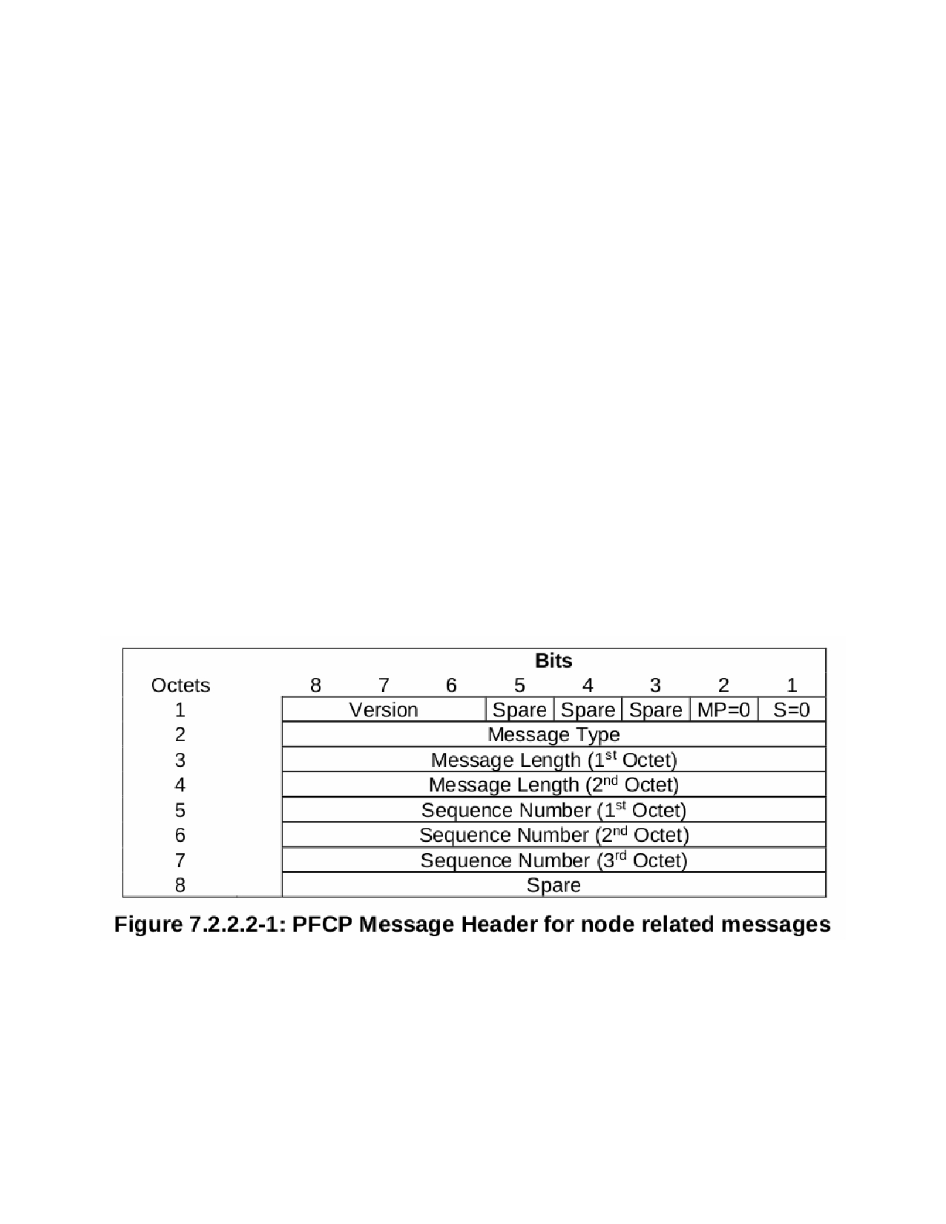
[Type here]

3.5 Threading Model
The current UPF design is to have two threads. One thread handles the control plane
messages i.e. PFCP messages. The second thread handles all the data plane traffic i.e. GTP data. UPF on startup initializes the platform to handle control plane data, spawns a separate thread for data plane processing and finally registers itself with NRF. After registration is successful, the main thread calls epoll_wait(), waiting for control plane traffic from SMF. From hereon the main thread processes control plane traffic. As session related PFCP messages are processed, rules get populated in the UPF.
The data plane thread that was initialized during init, waits for data plane traffic. On receiving any traffic, it accesses the rules within smContexts and processes the traffic. Rule matching and forwarding have been described in earlier sections.

Next steps would be to replace the data plane thread with threads that process GTP packets using DPDK. Secondly a thread pool will be added in platform that allow simultaneous processing of control plane across multiple threads.

3.6 PFCP Library

Each Message is made up of the PFCP header and a set of Information Elements (IEs). The header structure is shown below for node related and session related messages.

[Type here]
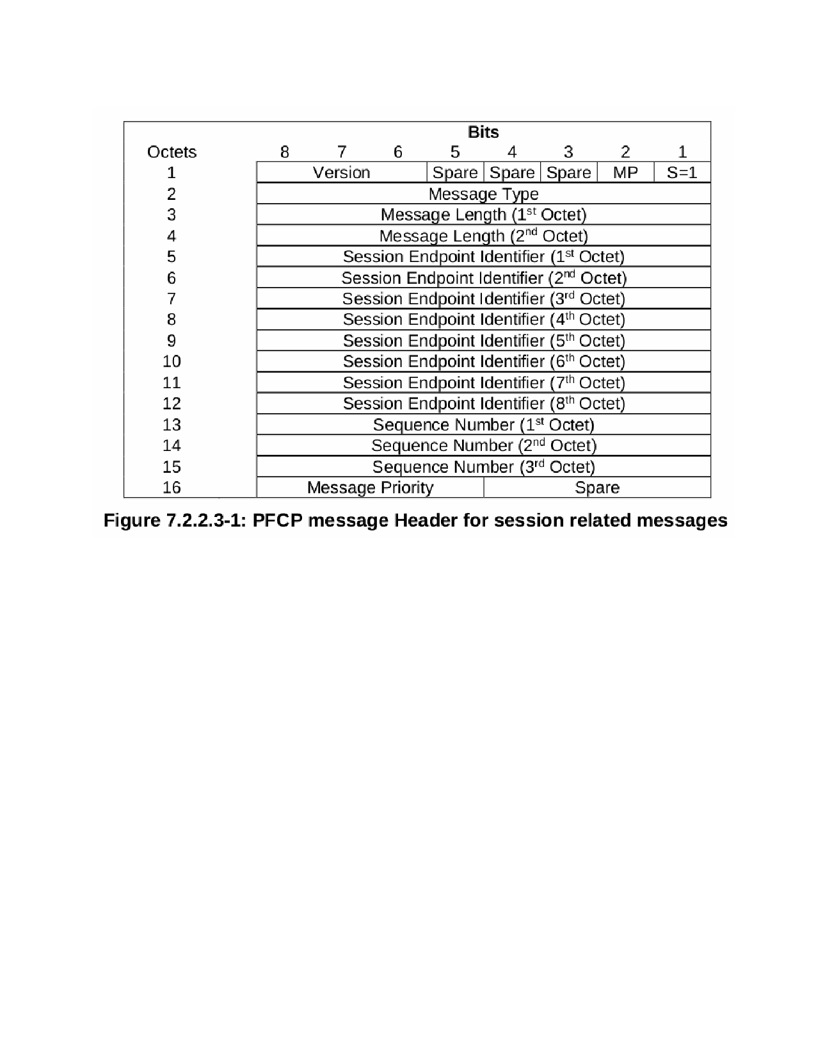
[Type here]

Version is the PFCP protocol version, which is set to 1. The S bit in the first octet will be set if the message is a session related message. The Message Type identifies the message that will follow after the header. SEID will be added to the header if it is session related message. Sequence Number is used to identify the message uniquely among the messages being sent to the peer. The response to a PFCP request must carry the same sequence number. The Message Length contains the overall message length.

Each IE is made up of an IEI, a 16bit unique Identifier assigned to each IE, the Length of the IE (excluding the IEI and Length) and the IE's contents.

Rohan: List the IE’s from below mentioned map in pfcpDefs.h

Each IE has a specific encode and decode function which are added to pfcpIEoperations, a map containing the functions of supported IEs. The map ieData contains information about Messages and the IEs within each message. Each IE also has some flags specifying whether the IE is optional, mandatory, etc.

Other than simple IEs which contain raw data, some of the IEs have complex structures and contain IEs within themselves. One such example createPDR IE, contains multiple IEs which describe the rules and rule IDs. Such IEs are handled by encoding them separately into a pfpcAny type IE and then adding the encoded buffer into the main PFCP message.

[Type here]
[Type here]

This design was chosen since the overall usage is easier, though it leads to calling encode/decode multiple times. Additional details about the function structure and style is described in the README file within the library.

Currently the library does not implement PFCP's reliability features, viz. sequence numbers and retries. These features will be implemented for a later version. The messages that the library currently supports and the IEs that are currently available can be seen in pfcpDefs.h .

3.7 UE and Test RAN Architecture

Currently, we have one thread per UE and one thread for RAN. For control plane messages, UE and RAN thread will communicate via the IPC mechanism pipes. In the uplink scenario, the UE thread encodes NAS and NGAP messages and forwards it to AMF. For data plane messages, UE will open a TCP socket to sink and write data into the socket. The kernel will add TCP/IP headers. The RAN thread will create a TUN device and set routing rules so that IP packets are captured by the TUN device. It will encapsulate the IP packet within a GTP header and write it into a UDP socket. Similarly, in the downlink scenario, RAN will decode the NGAP control plane messages and pass it to the corresponding UE thread via pipes. For data plane messages, RAN will remove the GTP header and write the inner IP packet to the TUN device. The TUN device will pass the packet to the kernel, and the data is received by UE thread on the TCP socket. We currently assume only one PDU session per UE. For multiple PDU sessions per UE, a separate thread will be spawn for each PDU session which is currently out of scope of this document. We also assume a UE life cycle in which registration, session establishment, data transfer and deregistration will be executed in a sequential manner with the flexibility to loop in any one step for a finite interval to facilitate load test.

[Type here]
[Type here]

4. Common design requirements

4.1 Software Design

The UPF is implemented as a C++ network function. The PFCP stack is built in house. GTP details will be added once the design is finalized.

4.2 Functional Requirements

Specified in the requirements document.

4.3 Performance Requirements

Specified in the requirements document.

4.4 API Design

Specified in the requirements document.

4.5 Diagnostics Design

None supported so far.

4.6 Management Interface

A configuration file is used to specify all the required parameters, details of which are in the requirements document.

[Type here]
[Type here]

5. Assumptions and Dependencies.
1. PFCP library does not have the features providing reliability.
2. UPF and SMF don't support FQDN as NodeId.

[Type here]
[Type here]

6.

7.

References
1. 3GPP TS 29244.501 V15.4.0 (2019-04) [LTE; Interface between the Control Plane and the
User Plane nodes]
2. 3GPP TS 23.502 V15.2.0 (2018-06) [Procedures for the 5G System]
3. 3GPP TS 23.501 V15.2.0 (2018-06) [System Architecture for the 5G System]
Glossary

[Type here]

