LTE for Layman (Part 1) - Introduction and Arch... https://www.linkedin.com/pulse/lte-layman-intr...

**LTE for Layman (Part 1) - Introduction and Architecture**

What is 4G and how does it actually work? Internet is filled with quality scholarly articles, and you can find numerous books explaining the various intricacies of LTE (Long Term Evolution) in detail. My personal favorite is the classic: "*LTE: The UMTS Evolution - From Theory to* *Practice*" published by Wiley. However, sometimes the complexity andterminologies get too much over our head in establishing a bare minimum idea, particularly to those who are not from technical background. This series is a humble attempt in trying to remove all the complexities associated with technology. Using power of analogy with a sprinkle of humour, readers can get a better understanding of the otherwise vast 4G technology, filled with complexity and constant developments! Objective of this article is to give readers a bird's eye view of LTE: origin from 3GPP, the underlying electronics, and the architecture components.

**A bit of history first!**

Everything that your mobile does, the kitten videos you watch on

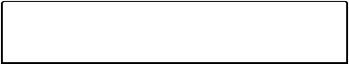

youtube, the calls you place, the call drops that happen, or those

**Messaging**

1 of 10 11/05/20, 12:31 am

LTE for Layman (Part 1) - Introduction and Arch... https://www.linkedin.com/pulse/lte-layman-intr...

awesome selfies that you share on #instagram, everything is governed by a set of rules or protocols (some say, even life). These set of rules (analogous to code) decide how to process the selfie, when you press on the upload button. It includes the complete conversion of data into digital format, travelling over the air through towers, going through some complex processing and then eventually finding itself on the internet. These rules of processing are governed by 3GPP: **3rd** **Generation Partnership Project,** which is essentially an association ofmajor telecommunication giants who work tirelessly in researching ways and means to create faster mobile internet speed! The 3GPP organizational partner releases a set of rules/protocols after meetings conducted with almost all major telecommunication players. These protocols and the associated architecture are considered

as worldwide standard, which is followed by all LTE stakeholders across the globe. Why do we need 3GPP? Well, if it had not been for them, than Airtel 4G Sims would work only on selected mobile such as the ones created by Apple only! In short, SIM cards would have had become Apple (end to end control anyone?).

The 3GPP people gave us 2G GSM, 3G UMTS, and now 4G LTE. All these terms, GSM, UMTS and LTE, they are essentially set of rules and standards developed by 3GPP, due to which we can communicate and exchange selfies worldwide! In addition, for historical context, LTE rules were released in 2008 under "release 8" of 3GPP specifications. There is also a set of advanced rules for LTE called 4G advanced, which is just an advancement on base release.

Rohan: Check Jack Ryu blog for LTE and LTE-Advance notes

**Electronics 101**

*"Behind every communication technology is a radio wave".* This holds truefor LTE, which is nothing but means to make the radio waves transfer faster and more eﬀicient. The claimed speed of LTE is approx. 300 Mbps downlink, and 75 Mbps uplink based on certain antenna conditions (actual speed and coverage diﬀers country to country). It also promises to reduce latency (or delay in data transfer) up to five ms. In order to uphold the promises; significant overhaul in the underlying radio transfer technology was done to enable the high-speed transfer.

Rohan:  
<https://www.quora.com/What-is-latency-in-telecom>  
<https://www.quora.com/Why-is-network-latency-so-high-for-3G-networks>  
<https://www.callstats.io/blog/2018/03/07/difference-between-jitter-and-latency>

While the entire listing of changes is beyond the scope of this article, one major change factors in a lot. It is called **OFDM** or *Orthogonal*

*Frequency Division Multiplexing.*

Let us start with the basics of signal communications, i.e. **Modulation**. It simply means that a radio wave is modified with another radio wave carrying information which than together, can be transferred over long distances. The combined radio wave is called "**carrier**" signal, which transmits the original signal over long distances using process of Modulation. What if we want to transmit diﬀerent information, e.g. black white, in the same "carrier" signal? We create "**sub carriers**", which are nothing but parts of the main carrier signal, carrying diﬀerent levels of additional information.

How to transmit these information on the limited bandwidth (or frequency channels) available? The traditional method (since 1870!) is by using Multiplexing, where multiple signals are clubbed together (or multiplexed) over a frequency channel. This is called *Frequency Division* *Multiplexing* **(FDM)**. However, to make the traditional approach evenfaster, OFDM came into picture. In typical FDM, the total bandwidth is divided into several non-overlapping frequency bands, each of which is used to carry signal (see diagram below). Simplest application of this is in Radio, where we tune into diﬀerent frequencies being broadcast at the same time. The extra O or "Orthogonality" is an advanced geometrical concept incorporated with FDM, which overlaps the diﬀerent sub carriers "orthogonal" to each other, hence saving bandwidth and increasing transmission capacity. In Layman terms, OFDM helps various sub carriers, carrying diﬀerent data, transmit in cost eﬀective manner, saving bandwidth (by providing orthogonality) and enabling faster transmission which is required for LTE.

Rohan:   
<https://www.quora.com/What-is-orthogonality-in-the-context-of-OFDM-and-how-Orthogonality-makes-these-sub-carriers-devoid-of-inter-carrier-interference>  
<https://www.quora.com/Why-is-OFDM-used-rather-than-FDM-in-4G>  
<https://networkengineering.stackexchange.com/questions/310/what-to-know-about-dsss-vs-ofdm>  
[https://www.quora.com/What-are-the-main-differences-between-OFDM-and-OFDMA-waveform#!n=12](https://www.quora.com/What-are-the-main-differences-between-OFDM-and-OFDMA-waveform" \l "!n=12)  
<https://www.quora.com/Why-is-OFDM-better-than-QAM>  
<https://www.quora.com/Which-comes-first-multiplexing-modulation-or-multiple-access-Why>  
<https://www.quora.com/What-are-the-advantages-and-disadvantages-of-ASK-FSK-PSK-BPSK-QPSK-MPSK-and-QAM>



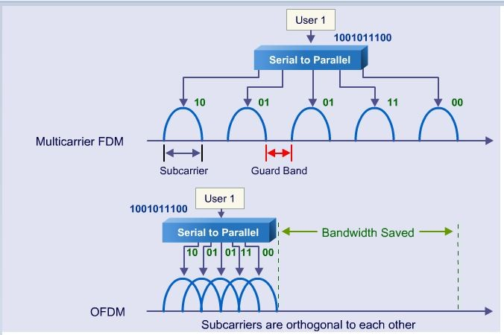

Orthogonality transmission of sub carriers saving bandwidth

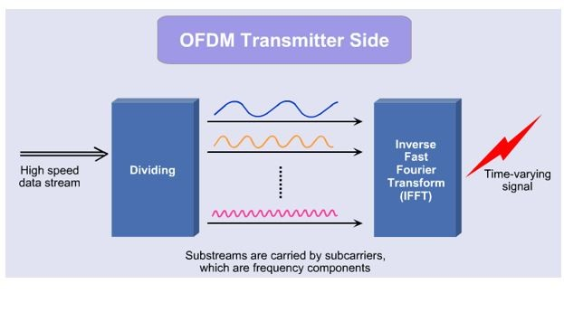Now, to transmit so many of these sub carriers (analogy of tuning into diﬀerent radio stations simultaneously), it would require several receiving and transmitting stations, one for each sub carrier. To eliminate this, **Inverse Fast Fourier Transformation** comes into rescue, which essentially transforms diﬀerent sub carrier signals of varying frequency and strength into one combined time varying signal! In Layman terms, take one signal, divide it into diﬀerent sub carriers carrying diﬀerent information, and combine it into one signal to eliminate usage of diﬀerent antennas, than reverse the steps on the receiving side! A more pictorial representation is given below:



**Messaging**

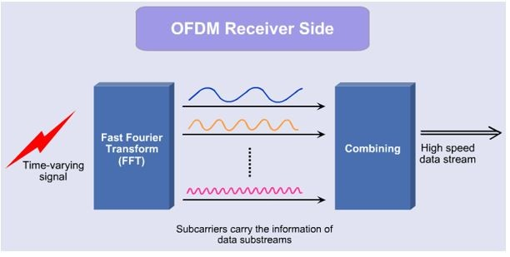4 of 10 11/05/20, 12:31 am

This is the very basics of LTE as far as electronics aspect is concerned. Please do note that there are many additional concepts related to digital signal processing of LTE. There is *cyclic prefix*, which is essentially sending out redundant information to prevent signal distortion in the forms of *Inter Signal and Inter Carrier interference*. There is *Single* *Carrier FDMA* (**SC-FDMA**), which uses an additional technology ofDiscrete Fourier Transform to eliminate *Peak to Average Power Ratio* (**PAPR**) (nonlinear distortion of radio waves combined becausesome waves have much higher magnitude). It is used extensively in uplink transmission, as vast number of cell phones generate generates their own independent radio waves, summation of which results in a distorted radio wave signal. To save us from further electronics, let us



move onto the Information Systems part of LTE!

Rohan: ??

5 of 10 11/05/20, 12:31 am

LTE for Layman (Part 1) - Introduction and Arch... https://www.linkedin.com/pulse/lte-layman-intr...

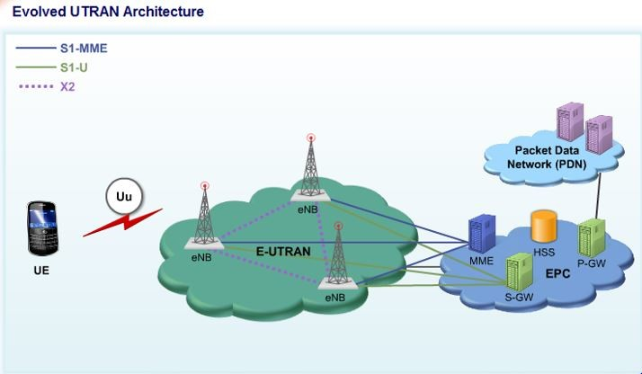

**LTE architecture, components and interfaces**

If the above diagram looks mystifying, let us approach it component-by-component, beginning from the left.

1.) **UE,** *User Equipment:* it is your mobile, or any device that allows 4G network communication. In other words, any equipment that adheres to the rules set by 3GPP, and communicates with the LTE towers, to allow your #tag tweets to reach the internet faster qualifies as UE. Examples include tablets, smartphones, dongles or Apple! It scans the frequencies when you turn it on, latches on the best LTE frequency available and the magic begins from there on. In addition, of course, it has the coveted SIM card (subscriber identification module)! This little SIM makes sure your mobile is authorized to access the network, be registered, and be billed for the services it access. UE has a host of other advanced features such as measuring channel conditions (or whether the weather is stormy or not) in the form of *Channel Quality Indicator*, providing *Scheduling Request* if it has a lot of data, and among other things trying to maintain constant connectivity with the radio tower.

Rohan CQI + SR, more ??

2.) **E-UTRAN,** *evolved UMTS (Universal Mobile Telecommunication* *System) Terrestrial Radio Access Network:* Sounds a mouthful right?Well, in essence, E-UTRAN is a network created by LTE radio towers otherwise called *Evolved Node-B* or **eNodeB**. These eNodeBs combine to form the heart of the powerful LTE network called E-UTRAN. It's the job of eNodeBs to control the otherwise dumb UEs, send them signalling messages to perform various tasks, handle their over the air signals,



**Messaging**

dynamically schedule message exchange flow based on algorithms, and forward core network signals called *Non Access Stratum* (**NAS**) messages. In the era of 3G, there were two nodes, with one being the radio network controller (RNC) and the other just a radio tower. These nodes were combined together to form eNodeB so as to enable LTE to do what it's advertised to do, reduce latency and increase the download speed! Otherwise called *Access Network*, E-UTRAN and the associated eNodeBs have no centralized controller hence having a flat architecture. They connect with the core network using an interface called **S1**, and through each other using an interface called **X2**. These interfaces, in analogical terms, are just fancy names for a gate to connect to outside world. Therefore, a gate, which connects you directly to your neighbour’s home, would be called X2, and the gate, which connects you to municipality headquarters, would be called S1.

3.) **EPC,** *Evolved Packet Core*: This is the backend, the LTE subscriber's home, Airtel 4G woman’s oﬀice. EPC handles the creation of bearers, which is the heart of data transfer. Think of bearers as tunnels in the air, carrying all your data from the Internet to your mobile. This end-to-end connectivity management through the eNodeB is the work of EPC and all of its components. Other functions include billing for the data connection, providing IP address for your cell phone, authenticating your SIM card and providing fancy ciphering techniques to secure your data flow. An all IP network, EPC is part of *System Architecture* *Evolution* (**SAE**), the core network of LTE where every magic happens.The components of EPC, otherwise called SAE Core are:

Rohan: System Architecture Evolution (SAE) is the core network architecture of 3GPP's LTE wireless communication standard.

SAE is the evolution of the GPRS Core Network, with some differences: simplified architecture, all-IP Network (AIPN), .....

Jack Ryu: Read this at the end of the Article along with

<http://www.lteandbeyond.com/2012/01/functions-of-main-lte-packet-core.html>

**SAE (Service Architecture Evolved)**

Simply put, SAE is just a terminology representing LTE network architecture. More simply put, SAE = LTE Network -:). If I represent it graphically, it looks as follows. You will find the various different type of SAE diagram from various source ranging from very simple to extremly complicated one. Following is a kind of simple presentation but it has almost everything of LTE component. The complicated diagram you would find from other source is just a combination of LTE network and other networks like UMTS, GSM etc.

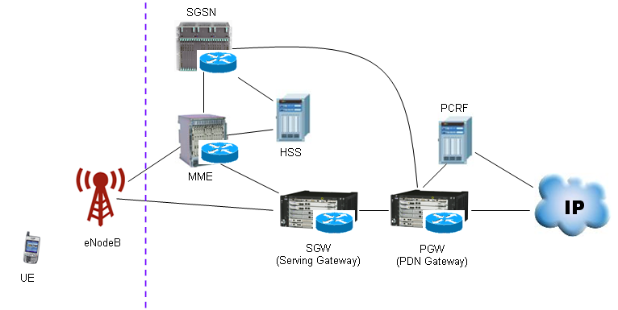

ideo Tutorials :

* [LTE Network Architecture Webinar - AIRCOM International (Strongly Recommended)](https://www.youtube.com/watch?v=Rpokj8Ysz3c)

You can extend the LET SAE as follows to interface with other technology.

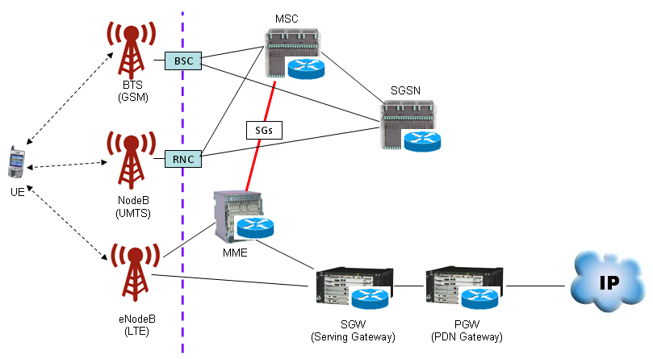

Now you'd better understand function of each node (block) in the diagram. The more you know about each of these blocks, the easier your troubleshooting, test case creation, test will be since the role of each of these nodes will be related to the information elements (IE) of RRC/NAS message. But here I would just put the brief summary of functions of each node and I leave it to you to dig into the details.

MME (Mobility Management Entity): Just remember this as the most important component of SAE which has following functionality. You can take MME as a center for all signaling message.

* Idle mode UE (User Equipment) tracking Process
* Paging Process.
* Bearer activation/deactivation process
* Choosing the SGW for a UE at the initial attach
* Core Network (CN) node relocation at time of intra-LTE handover
* Authenticating the user (by interacting with the HSS)
* Destination of NAS message
* Generation and allocation of temporary identities to UEs.
* Authorization of the UE to camp on the service provider’s Public Land Mobile Network (PLMN)
* Enforces UE roaming restrictions
* Termination Point for Ciphering/Integrity for NAS signaling
* Security key management
* Lawful interception of signaling is also supported by the MME
* Provides the control plane function for mobility between LTE and 2G/3G access networks in connection to SGSN

SGW (Serving Gateway) : Simply put, this is a center for all user data (packet data).

* Routes and forwards user data packets
* Act as the mobility anchor for the user plane during inter-eNodeB handovers
* Act as the anchor for mobility between LTE and other 3GPP technologies
* Terminates the DL data path and triggers paging when DL data arrives for the UE when UE is in Idle mode
* Manages and stores UE contexts, e.g. parameters of the IP bearer service, network internal routing information
* Performs replication of the user traffic in case of lawful interception

PGW (PDN Gateway)

* Provides connectivity from the UE to external packet data networks
* Performs policy enforcement, packet filtering for each user, charging support, lawful Interception and packet screening
* Act as the anchor for mobility between 3GPP and non-3GPP technologies such as WiMAX and 3GPP2 (CDMA 1X and EvDO)

HSS (Home Subscriber Server) : This is a central database that contains user-related and subscription-related information. It is like "HLR(WCDMA) + AuC(WCDMA) + Additional Information(LTE)"

* Mobility management
* Call and session establishment support
* User authentification and access authorization

a.) **MME,** *Mobility Management Entity*: The Mother of EPC and perhaps your cell phone, it handles the creation and destruction of the bearers that carry your data. In addition to that, it has host of other functionalities such as authentication, providing identities to UEs, selecting appropriate SGW and PGW nodes, tracking UE when it goes idle, and among other things, being the back end of all management related procedures of mobile. MME uses the functionalities of another node called **HSS** (*Home Subscriber Server*), which is essentially a comprehensive database of all the subscription and user identity information (the information you fill when getting a SIM). Analogy can be drawn in a way: if UE is the front end GUI of a software and E-UTRAN is the middleware for operations, MME + HSS would be the back end for database access, signalling and authorization. Since MME is the manager of eNodeB, the interface between MME and eNodeB is often called **Control Plane**. Analogy to how your manager controls you



**Messaging**

7 of 10 11/05/20, 12:31 am

LTE for Layman (Part 1) - Introduction and Arch... https://www.linkedin.com/pulse/lte-layman-intr...

at work by sending signals such as "what is the status"?

b.) **SGW,** *Serving Gateway*: SGW is the router of your cell phone! As simple as it gets, it routes the data from the vastness of the internet towards your sophisticated E-UTRAN network using the bearers created by MME. Although part of EPC, SGW has a direct connectivity with eNodeB. As SGW main role comprises of forwarding user traﬀic from PGWs to the UE, the interface between SGW and eNodeB is appropriately termed as **User Plane**. Apart from the routing functions, it also acts as a mobility anchor for the handover of your data to other eNodeBs in case you move out of coverage from your parent eNodeB. Same anchoring functionality is provided by SGW if you move to other networks such as 2G/3G. Other functionalities include paging your cell phone in case it becomes idle and storing context information such as bearer details.

c.) **PGW,** *Packet Data Network - Getaway*: If SGW can be considered as a router, PGW can be considered as a switch or a getaway (or gate to another world) to connect to the external network (otherwise

called **Packet Data Network**). Think of PDN as external IP based network such as internet or IP Multimedia SubSystem (eg: Skype). Now think of assigning one PGW for each of these external PDNs. Unlike other nodes, where a UE can be connected at a time to only one eNodeB, one MME and one SGW, a UE can be connected to multiple PGWs based on the type of PDN. So for example, you can browse your internet and simultaneously have a VoIP call, as your UE would be connected to two PGWs, each connected to their respective PDNs. Each PGW would be acting as a getaway between the external and internal network, forwarding data to SGW who will feed it into bearers (terminating at UE's end) created by the MME! Other functionalities of PGW include maintaining the Quality of Service (QoS) for those Skype Calls and video surfing, and providing fair billing for the same. PGW does the QoS enforcement using help from another node called **Policy** **and Charging Rules Function (PCRF)**. PCRF ensures that only theauthorized user gets the desired quality of service, with the proper billing. So for example, if you have an HD video LTE pack, it is the job of PCRF to ensure you get HD videos. Hence, no one with a SD video pack will be able to access HD videos without the subscription.

This concludes the introduction and architecture overview of LTE. So what will happen if you like this post using your LTE enabled phone?



Your UE will transmit information over the Uu interface to your parent

**Messaging**

8 of 10 11/05/20, 12:31 am

LTE for Layman (Part 1) - Introduction and Arch... https://www.linkedin.com/pulse/lte-layman-intr...

eNodeB, who will than transmit the information to MME, who will create a bearer and select the appropriate SGW and PGW. The PDN would be selected as the internet, and the associated PGW will transfer information on the bearer created by MME via SGW, all this under 5 ms!

|  |  |
| --- | --- |
| **Gaurav Dalwadi** • 3rd+ | 2y |
| Sr. Manager-I at Reliance Jio Infocom |  |



However, the reason of going for SC-FDMA in Uplink transmission to eliminate PAPR rise is correct. But reason why PAPR goes high in case of UL is wrongly mentioned. If more subcarriers in place of single carrier are used to combine and send as like in downlink transmission at eNOdeB, it combined power raises high peaks which required higher linearity of power amplifier at UE transmitter which costs high as well power consumption goes up which is not good for battery life of UE.



10 of 10 11/05/20, 12:31 am