LTE for Layman (Part 2) - Scaling the LTE! | Lin... https://www.linkedin.com/pulse/lte-layman-scali...

**LTE for Layman (Part 2) - Scaling the LTE!**

In my previous entry, we discussed at length about the various concepts and terminologies associated with the wonderful world of LTE. We learned about the history, technology behind radio towers and various components associated in establishing a LTE network. In this entry, we try to move one-step further in simplifying the complexities of LTE. Objective of this article is to help understand the protocol stack of LTE, how signal measurements are done, and the diﬀerent channels associated with LTE. Knowledge about LTE architecture is mandatory to understand the text here, so do go through the previous part in case you are unfamiliar with LTE terminologies. As always, focus is on simplicity, creating understanding, and demystifying the complex terminologies associated with LTE.

**The Yummy multi-layered Cake of LTE!**

Imagine a multi layered cake that you generally get for wedding. Imagine the various flavours that it brings. Starting with vanilla as top layer, you get delicious chocolate layer, followed by strawberry, raspberry and butter scotch! Each flavour is unique in its taste, but only

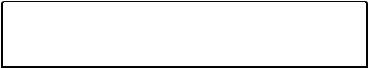

**Messaging**

1 of 11 11/05/20, 12:39 am

LTE for Layman (Part 2) - Scaling the LTE! | Lin... https://www.linkedin.com/pulse/lte-layman-scali...

when combined together they form the perfect wedding cake. Each layer has its own role, to give a distinct flavour to it. If you remove any layer, the cake would taste quite diﬀerently and guests may even start complaining over lack of their favourite flavour! Only when the savouring taste of every layer is combined together, we would get happy guests and a delicious cake. This cake, in LTE terms, is fancifully known as **LTE protocol stack**!

Consider the protocol stack as complex set of rules, layered over one another just like a wedding cake. Each layer has its own function and own protocols (rules). While layer 1 would deal with actual physical constraints such as frequency considerations with its own set of protocols, layer 4 would deal with higher level functions such as which signal to transmit with their entirely diﬀerent set of protocols. What makes protocol stack more special is the fact that each layer is inter-operable, or both vertically and horizontally aligned. This means that protocols for a particular layer on the sender side would be dealt with the same layer on the receiving side as well. This enables network operations to be done in an eﬀicient way, with the combined protocol stack essential for complete coding-decoding of data from sender to receiver. Such layered protocols are common in any network consideration, with primary example being OSI or TCP/IP model.

Coming back to LTE protocol stack, they are divided into two separate stacks. One is for control-plane signalling communication between UE and MME, another one is for user-plane data communication between UE and PGW.

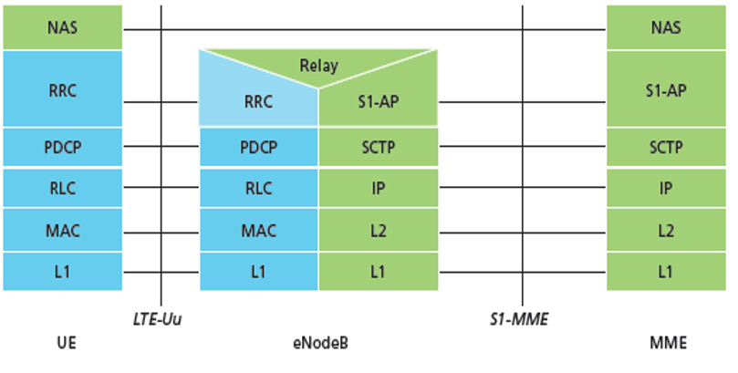

Control Plane Protocol Stack

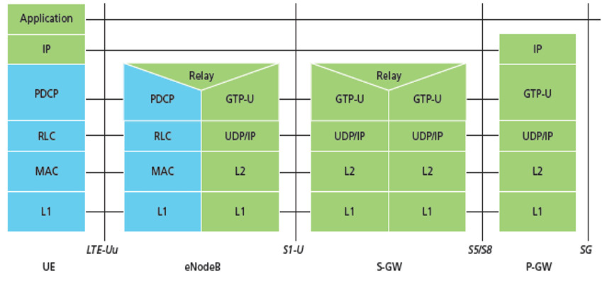

Data Plane Protocol Stack

The blue area is the one concerning the **Access Stratum** protocols, or the set of rules that dictate transfer of message between UE and eNodeB. The green area is the one concerning the **Non Access** **Stratum** protocols. These are set of rules that dictate transfer ofmessages between UE and core components of LTE network such as SGW, PGW and MME. The complete list of functionalities of each layer is



**Messaging**

2 of 11 11/05/20, 12:39 am

LTE for Layman (Part 2) - Scaling the LTE! | Lin... https://www.linkedin.com/pulse/lte-layman-scali...

beyond the scope of this article, however, a brief intro of LTE layers is mandated to understand the basic functioning of LTE protocol stack. These layers are unique for LTE. Other protocols such as GTP-U, SCTP and UDP/IP are globally used protocols whose intricate knowledge is not required to understand how your mobile connects.

1. **L1**: responsible for power control, measurement of air interface andinitial search of LTE network.
2. **Medium Access Layer (MAC)**: responsible for multiplexing ofdiﬀerent resources, priority allocation of UEs through dynamic scheduling (de facto feature of LTE) and error correction through HARQ.

Rohan: OFDM??

1. **Radio Link Control (RLC)**: responsible for reassembly offragmented packets and flow control (to handle congestion in network).
2. **Radio Resource Control (RRC)**: only found in Control Plane, thislayer is responsible for everything signalling. This includes functions such as broadcasting of system information, paging, and establishing a constant radio bearer connection between diﬀerent nodes. RRC is an important part of LTE network, as such; every UE must establish a RRC connection before communicating any data.

Rohan: Access Stratum Signalling is done by RRC

1. **Packet Data Convergence Protocol (PDCP):** Sequencing, actualtransfer of data to control or user plane, duplicate data detection, maintenance of sequence numbers of each packet, ciphering/deciphering, integrity protection/verification etc., these all are part of PDCP layer functioning.
2. **Non-Access Stratum (NAS):** It is primarily responsible formaintenance of IP address connectivity with the moving UE, along with host of other session management procedures.
3. **Relay**: More like an advanced repeater, it is essentially a minieNodeB on top of eNodeB! It carries a subset of eNodeB functions, does the basic decoding of data, and is primary connected with another donor eNodeB farther away. The main use of relaying comes when your ever-moving mobile goes to the very end of tower range. It would than need support from "relays" of other towers to continuously buﬀer your HD YouTube video!



**Messaging**

3 of 11 11/05/20, 12:39 am

LTE for Layman (Part 2) - Scaling the LTE! | Lin... https://www.linkedin.com/pulse/lte-layman-scali...

**Measurements in LTE:**

Everything in the world that can be measured has a basic unit of measurement. You have cells, which combine to form tissues, which further combine to form organs. Matter has atoms, which combine to form, well, the universe! In wireless communication systems like LTE, it is bits, which combine to form bytes, which combine to form kilobytes and so on. However, it gets a bit complicated, as LTE in essence is an electromagnetic wave! There are two dimensions to consider in LTE signalling, each with their own basic unit. In horizontal axis, representation of a LTE wireless signal is done by time. In vertical axis, it is represented by frequency. Both of these dimensions combine to give the exact location of LTE signal, which is carrying, the bits of information.

The main unit of LTE used in horizontal or time axis is a **frame**, represented by *10 ms* in length. Each frame is divided into

10 **subframes**, *1 ms* in length. Each subframe is further divided into "**time slots**", *0.5 ms* in length. Each of these time slots carry six (or seven based on certain criteria) **OFDM symbols**, *66.7 us* in length. Do recall that LTE communication happens using OFDM, and therefore uses OFDM symbols to represent time domain. Consider these OFDM symbols as the lowest element of an atom that is a frame. A pictorial representation of a FDD frame is given below:

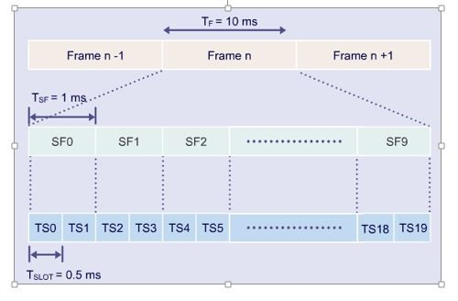

There is another representation of a frame used in Time Division Duplexing method (a type of two-way communication), in which a frame of 10 ms is divided into two half frames of 5ms. However, representation of a frame used in Frequency Division Duplexing (FDD) is most widely deployed mechanism in cellular technology since the times of GSM, and the frame structure used throughout in most of the LTE texts is of that.

Rohan: FDD = Two separte frequencies used for UL and DL  
In TDD, same freq used turn-by-turn (less popular)

Rohan: The reason for 2 Time slot in 1 Subframe is,

Falf frame is used in type 2 frame format(tdd). that means downlink and uplink data are transmited in the same frequency. The tdd system uses switching point to separate downlink and uplink signal. If the tdd system don‘t use half frame, the round trip time will be 10ms or more. Which means large system delay. In order to solve this problem, half frame is introduced.

In vertical or frequency axis, the representation of LTE signal is done by "**sub carriers**", *15 kHz* in height. No further division is needed here thankfully! Now, eNodeBs allocate resources or bits to the UEs in terms of "**Resource Blocks**" or RBs. These RBs are actual representation of "resources" used in LTE signal, carrying your bits of information! Just like water is a resource allocated by Government based on their criteria of demand and scarcity, eNodeBs allocate "RBs" or resources to your mobile (and countless others) based on their own algorithm of demand and scarcity.

Rohan:

Water = RB  
Gov = eNodeB

Ppl/Factory/Bldg = UE

RB provided based on demand and scarcity by eNodeB algo

In LTE signal terms, think of "Resource Block" as the actual 2D grid representation of signal, represented by both frequency and time, carrying the information in the form of binary bits.

RB's actual dimensions are 12 points of vertical frequency axis or subcarriers by one point of horizontal time axis or time slot (1TS = 6 OFDM Symbols). In other words, 12 sub carriers in frequency by six OFDM symbols in time comprise one Resource Block, the "water" of LTE! One subcarrier by one OFDM symbol is called "**Resource Element**", the H2O of water if analogy is drawn. These "Resource Elements" represent "**Modulation** **Symbol**", which carry one to six bits of data depending on themodulation scheme used. For example, a QPSK modulation scheme would mean 4 bits of data is transferred in one resource element. A pictorial representation is given below:

Rohan: 1F = 10SF = 10 x 2TS = 20 x 6OFDMSym = 120 Symbols

1RB = ( 12SC * 6 or 7OFDMSym ) RE’s = 72/84 RE’s

So, 1F has will have 20 RB’s (One TS holds 1RB and we have 20 TS).   
Therefore,1F will have ( 20 * 12 * 6 ) RE’s, i.e. 1440/1680 RE’s

Also 120 Symbols * 12 Subcarrier = 1440/1680 RE’s

This way there will be multiple frames (nF) on UL and DL flowing continuosly

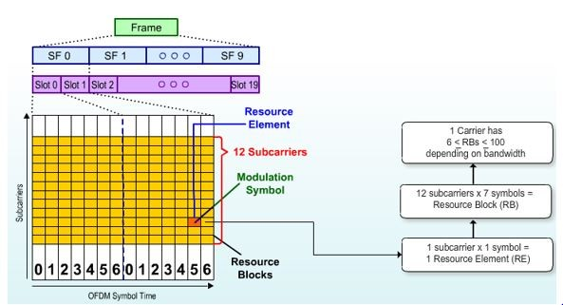

Now, given the bandwidth is 10 MHz, or in other words, you are given 10 MHz of frequency or vertical axis. How many resource blocks can you form from that? Recall that one sub carrier is 15 kHz in length (or height). Therefore, for 10 MHz, it would be 10 MHz/15 kHz = 667 sub carriers. However, in LTE, there is a concept of "usable subcarriers". In other words, some subcarriers are used as "guard" to protect against noise and distortion. According to release 8 of LTE specifications, 33 subcarriers are assigned in both front and back end of a LTE signal to act as guard. In addition, one subcarrier acts as a centre point in which no information is sent, otherwise called **DC subcarrier**. It is an important subcarrier in OFDM systems, as new mobiles trying to connect to LTE system for the first time uses the DC subcarrier to locate centre of LTE frequency band (discussed later). Therefore, this makes total of 33*2 + 1 subcarriers unusable for information transmission. This leaves 667 - 66 - 1 = 600 subcarriers usable for data transmission. Now, one resource block is 12 subcarriers. So, 600/12 = 50 resource blocks can be assigned in 10 MHz of frequency or vertical axis assigned.

Rohan: 1F = 10SF = 10 x 2TS = 20 x 6OFDMSym = 120 Symbols?

1RB = ( 12SC * 6 or 7OFDMSym ) RE’s = 72/84 RE’s

So, 1F has will have 20 RB’s (One TS holds 1RB and we have 20 TS).   
Therefore,1F will have ( 20 * 12 * 6 ) RE’s, i.e. 1440/1680 RE’s  
Also 120 Symbols * 12 Subcarrier = 1440/1680 RE’s

This way there will be multiple frames (nF) and multiple RB’s on UL and DL flowing continuosly  
But as we know BW and have calculated max RB for 10 Mhz = 50 RB

Max RE in 10 Mhz = 50 * 72 or 84 = 3600/4200 RE’s

Max Frames = 2.5 Frame as we know each frame can carry 20 RB

>> 1 subcarrier = 15 Khz

>> we have 10MHz,therefore we can have 600 subcarrier(10M/15k) max after removing guard and dc subcarrier

>> 1 RB has 12 subcarrier,therefore 600 subcarrier can have 50 RB(600/12)

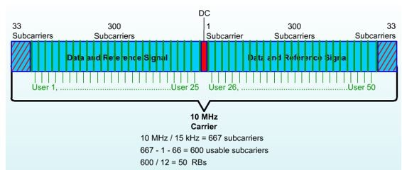

**Transportation in LTE:**

So far, we have discussed about various layers of LTE cake, and how are

resources allocated in frequency/time domain by eNodeB.

Now without a mechanism to carry these resources over all these layers, the information would lie stagnant! Just like your water is supplied by government in pipes, RBs are allocated by eNodeBs and transported through lower layers by something called "**channels**".

Think of channels as conveyor belts used in factories. So one belt or channel processes your data and signal in a diﬀerent way, than passes it along to another belt or channel and so on.

LTE system uses three diﬀerent channels, each being primarily used to segregate information processing. The three channels are:

1. **Logical Channel**: Used for communication between RLC - MAClayer interface. Denotes "*what type*" of information is carried, such as "broadcast message" or "control signal message" etc.
2. **Transport Channel**: Used for communication between MAC - PHYlayer interface. Denotes "*how is*" information carried, such as encoding options, error correction mechanism, modulation scheme etc.
3. **Physical Channel**: Used for communication between PHY - Airinterface. Denotes "*where is*" information carried, the exact location of bits in a LTE signal.

Most of the channels are mapped onto each other in following fashion, based on uplink and downlink direction:

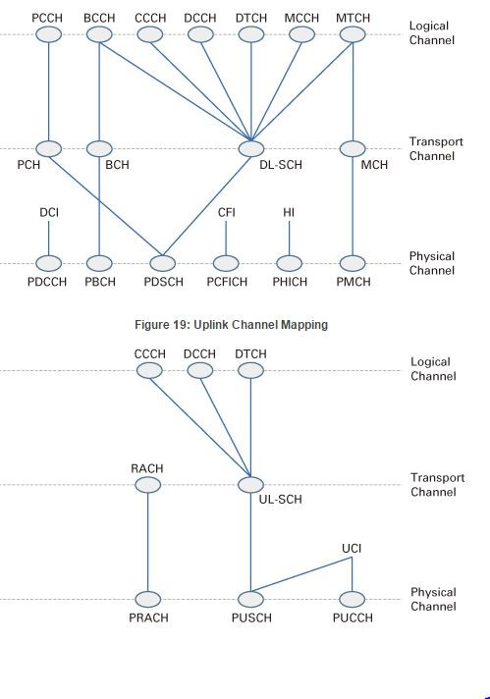

While the acronym explanation of each channel would expand this already lengthy article, an overview of critical physical channels is warranted. This is because every channel is at last mapped to Physical channel, the last conveyor belt in the cake factory of LTE. Think of Physical Channel as both provider of coordinates of your data, and the transporter of them over the air!

Rohan: Physical Channels

PDCCH/PUCCH  
PBCH  
PDSCH/PUSCH  
PCFICH  
PHICH  
PMCH  
PRACH

1. **PDCCH/PUCCH** stands for*Physical Downlink/Uplink Control**Channel*: It is used for conveying scheduling allocation information for data or RBs. These allocation information are very important, as they give functioning parameters to your mobile such as modulation scheme to be used, scheduled RBs for uplink (or where to put your #instagram selfie for upload in frequency/time grid), downlink**Messaging** data



6 of 11 11/05/20, 12:39 am

LTE for Layman (Part 2) - Scaling the LTE! | Lin... https://www.linkedin.com/pulse/lte-layman-scali...

location etc. Essentially, the coordinates of data channels PDSCH/PUSCH are provided on this channel. This channel is mapped from something called **Downlink Control Indicator** (DCI) and **Uplink Control Indicator** (UCI) of Transport Channel. PDCCH isalways mapped in first L OFDM symbols, given by PCFICH. PUCCH on the other hand occupies either ends of system bandwidth in terms of location, and size is given by something called **System** **Information Blocks** (SIB-2 in this case). SIBs carry importantchannel information, and are of diﬀerent types. We would discuss more of this in the next part. For now, think of PDCCH/PUCCH as your investment banker, one who knows exactly where your money is and how to access them, or the one who provides you the resources to invest your money.

1. **PBCH** stands for*Physical Broadcast Channel*– It carries the channelbandwidth information, antenna configuration and reference signal power that broadcast to every cell phone in the eNodeB coverage area. Think of this channel as advertiser of LTE band, one that constantly shouts to every cell phone about the critical system information needed to initiate first connection with LTE network, i.e. when mobile is switched on for the first time or when a new cell phone appears in the LTE network. eNodeB advertises this using something called “**Master Information Block**” (MIB), which carries the bandwidth information.
2. **PDSCH/PUSCH** stands for*Physical Downlink/Uplink Shared Channel*

– It is a common, big channel used for carrying both data and signalling messages. Think of it as a double decker bus, carrying control signals, system configuration messages and data towards the destination. Its size is determined by reading DCIs from PDCCH.

1. **PCFICH** stands for*Physical Control Format Indicator Channel*- Itcarries the number of OFDM symbols that can be used for control channels (PDCCH). It remains mapped in the first OFDM symbol.

Sixteen resource elements are allocated for PCFICH, whose location is determined by cell id and bandwidth. Think of it as the location provider of your investment banker!

1. **PHICH** stands for*Physical Hybrid ARQ Indicator Channel*- It carriesthe acknowledge signal of properly receiving and decoding the uplink message sent by UE. Its size is determined by MIB, and location is on first OFDM symbol, same where PCFICH resides.



**Messaging**

7 of 11 11/05/20, 12:39 am

LTE for Layman (Part 2) - Scaling the LTE! | Lin... https://www.linkedin.com/pulse/lte-layman-scali...

1. **PMCH** stands for*Physical Multicast Channel*- This channel is usedfor transmission using multicast technique, or transmitting information to some selected UEs simultaneously.
2. **PRACH** stands for*Physical Random Access Channel*- When the UEwants to make the initial request for access to LTE network, it uses this channel. As both location and identity of UE is unknown for core LTE network, PRACH is the only channel that can be used by UE for non-synchronized access to the network. Six resource blocks are allocated for this channel, with starting location communicated in SIB.

Rohan: Physical Channels

PDCCH/PUCCH : Investment Banker  
PBCH : Advertiser  
PDSCH/PUSCH : Transporter (Double Decker Bus)  
PCFICH : Info Kiosk, where to find Investment Banker  
PHICH : Uplink ka Ack (D)  
PMCH : Multicast (D)  
PRACH: UE first Message, different than sync signalling which happens at the very beginning when UE boots up

Given below is a diagram of critical uplink and downlink channel, as to how they are allocated in frequency/time grid:

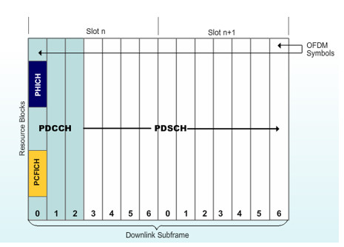

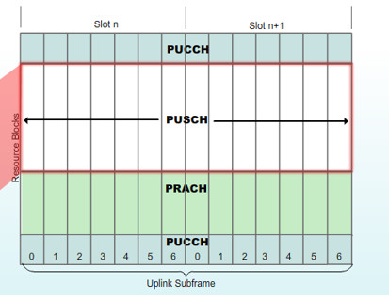

Apart from the channels, there is a concept of "Reference Signals" and

"Synchronization signals" in LTE. These signals are something that

are unique to Physical Layer, and are not aligned with other channels or

higher layers.

1.) **Reference signals**: They are used by UE to determine power level information of the downlink channel. UE uses this power level information as a "reference" to take several measurements, which aids in determining channel conditions, handover scenario and even cell selection. There are diﬀerent types of Reference signals whose location in frequency/time axis is based upon the antenna ports used for transmission of these signals. Given below is a downlink reference signal (one antenna configuration), where resource element is allocated in first and third to last OFDM symbol.

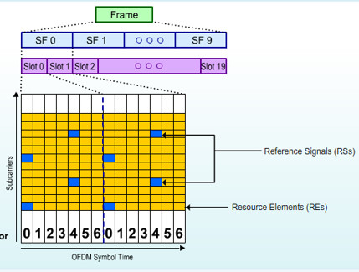

2.) Synchronization Signals: They are used by UE to have slot level and frame level synchronization with the LTE network, the very first time your UE boots up. Synchronization signals are bandwidth independent, and the UE starts to tune into sync signals from smallest frequency of 1.4 MHZ. Moreover, for every frequency, they have fixed position, occupying time slot 0th and 10th around the central slot (determined by



**Messaging**

8 of 11 11/05/20, 12:39 am

LTE for Layman (Part 2) - Scaling the LTE! | Lin... https://www.linkedin.com/pulse/lte-layman-scali...

DC subcarrier) of LTE frame. In other words, the X-axis coordinate (time location) of the first signal that the UE acquires is always fixed in every frequency station (Y-axis) that the mobile tunes in. There are two types of Synchronization signal: primary sync signal that occupies the last OFDM symbol and secondary sync signal that occupies the second last OFDM symbol. In total, 6 RBs or 72 subcarriers are allocated which are centred on the DC subcarrier, however only 62 subcarriers are actually used. Synchronization signal is the very first signal that UE acquires, and is used by UE to determine frequency/time grid of eNodeB and the Physical Cell Identity (PCI). Given below is a diagram of Sync signal:

Rohan: how?

Rohan : Read about sync channel from Synchroniztion Sequences section of [https://home.zhaw.ch/kunr/NTM1/literatur/LTE%20in%20a%20Nutshell%20-%20Physical%20Layer.pdf](https://home.zhaw.ch/kunr/NTM1/literatur/LTE in a Nutshell - Physical Layer.pdf)

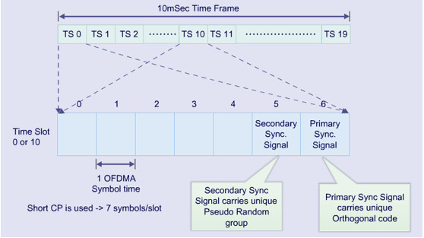

If all of this sounds confusing (it sure is!), here is a step by step logical way of deciphering channel access:

1. Your mobile, when turned on for the first time, acquires sync signal using DC subcarrier (center of any frequency band).
2. From sync signals, UE derives physical cell identity.
3. It than acquires the bandwidth using MIB broadcasted in PBCH, again using help of DC subcarrier.
4. From cell identity and bandwidth acquired earlier, it derives location of PHICH.
5. On Reading PHICH, UE knows the OFDM symbols for PDCCH that holds control location information stored in DCI.
6. Reading the DCIs, UE acquires location of critical SIBs stored in

PDSCH.

1. From the information gathered after reading SIBs, UE is ready to make the initial connection using PRACH channel.
2. After connection is established, UE transfers your data using PUSCH channel and receives on PDSCH channel.

Rohan: Also read Jack Ryu “LTE Basic Procedure”

Bottom line is that everything associated with a wireless LTE signal is located in the frequency/time grid. It is just that channels provide a means to segregate the information, and locate every information coherently!



**Messaging**

9 of 11 11/05/20, 12:39 am

LTE for Layman (Part 2) - Scaling the LTE! | Lin... https://www.linkedin.com/pulse/lte-layman-scali...

**Conclusion:**

This concludes second part of LTE for Layman series. We have discussed how entire LTE is just a series of protocols separated from one another by set of layers. We also got an overview of LTE frame structure and sub carriers, on how LTE does its measurements in frequency/time axis and forms resource blocks using it. We than dived into the world of channels, on how they are allocated and what do they carry. Now armed with this knowledge, we are ready to understand the entire lifecycle of UE, from first signal acquisition to finally uploading your #instagram selfie in next part.



Add a comment…

|  |  |
| --- | --- |
| **Varun Saini** • 3rd+ | 2y |
| Team Lead at Marquis Technologies. |  |



Hi Ayush,

in Point 4 UE will acquire PCFICH right? because you told PCFICH is location provider for Investment banker (PDCCH ) :)

Please correct me if i am missing out anything



|  |  |  |  |  |
| --- | --- | --- | --- | --- |
| · 2 Replies |  |  | | |
| **Basavaraj Hadimani** • 3rd+ | 2y |  | | |
| Web Developer at Myntra |  |  | | |
| even i have the same doubt |  |  | | |
| · 1 Like |  |  | 2y |  |
|  |  |  |  |
| **Gaurav Dalwadi** • 3rd+ |  |  | | |
| Sr. Manager-I at Reliance Jio Infocom | **Messaging** |  | | |

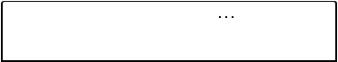

10 of 11 11/05/20, 12:39 am

LTE for Layman (Part 2) - Scaling the LTE! | Lin... https://www.linkedin.com/pulse/lte-layman-scali...

Yes. In point 4 it should derive PCFICH information from cell ID and bandwidth as PCFICH frequency location will be offseted cell by cell to minimize confusion with other cells for UE. While, PHICH is required to determine location and repetition of ACK/NAK response between eNB and UE for HARQ.



**Messaging**

11 of 11 11/05/20, 12:39 am