Real-Time Weather Anomaly Detection (Streaming + ML)

Team Number: T-001
Team Members:
- Roll 101 – Alice Smith
- Roll 102 – Bob Johnson
- Roll 103 – Carol Davis

Submission Date: 2025-11-09

Abstract
This project delivers a real-time streaming pipeline for weather telemetry, combining signal denoising (Moving Average and EWMA) with Isolation Forest-based anomaly detection. The system ingests data from a producer, optionally via Kafka, processes it in a consumer with filters and ML, and renders live visuals on a Streamlit dashboard.

Introduction
Reliable anomaly detection in environmental sensor networks is essential for early warning systems and operational monitoring. We present a modular pipeline that supports local and Kafka modes, providing robust filtering, detection, and visualization.

Project Workflow
Data Flow:
1) Producer emits weather readings (JSON/CSV).
2) Optional Kafka layer buffers and transports messages.
3) Consumer applies SDA filters (Moving Average, EWMA) to denoise.
4) Isolation Forest flags anomalies and writes to processed_stream.csv.
5) Dashboard visualizes raw trends and highlights anomalies.
End-to-End Steps:
- Configure environment variables and parameters.
- Start producer and consumer (local or Kafka mode).
- Observe dashboard updates and auto-saved images.

Streaming Denoising Filters
Streaming Denoising Filters:
- Moving Average: Smooths short-term noise via sliding window averaging.
- EWMA: Exponentially weighted smoothing that adapts to recent changes.
Implementation exposes parameters for window size and alpha to tune responsiveness.

Isolation Forest ML Algorithm
Anomaly Detection (Isolation Forest):
- Trains on baseline data to learn decision boundaries.
- Scores incoming records; negative scores indicate potential anomalies.
- Thresholding converts scores into binary status: Normal/Anomaly.
- Model is stateless per record in streaming, retrainable for drift.

Experiments and Results
No data available yet in processed_stream.csv.

Temperature Trend (Anomalies in Red)
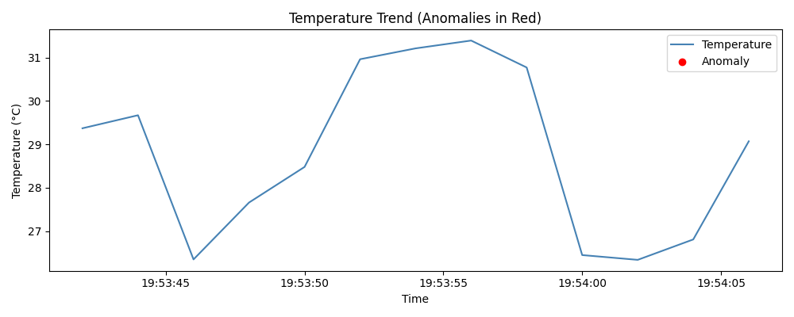

Humidity Trend (Anomalies in Red)
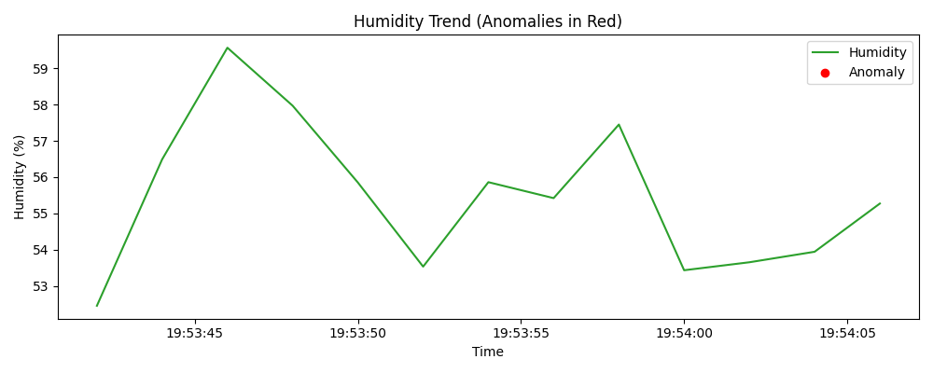

System Architecture
Producers, optional Kafka, consumer processing, and UI composition with clear data contracts.

Data Schema
Timestamped records with Temp, Humidity, Wind, Score, and Status indicating anomaly state.

Operational Modes
Local file-based streaming and Kafka-backed messaging for scalability.

Monitoring
Dashboard charts, saved PNG snapshots, and table views of latest records.

Performance
Batch sizes, refresh intervals, and throughput considerations under load.

Limitations
Static thresholds, model drift, and dependence on sensor calibration.

Future Work
Incremental learning, adaptive filters, and alerting integrations.

Conclusion
Conclusion:
The pipeline effectively detects anomalies in real time while maintaining clear, actionable visual feedback. Future work includes adaptive thresholds, concept drift handling, and enriched multisensor fusion.

References
References:
- Streamlit: https://streamlit.io/
- scikit-learn IsolationForest: https://scikit-learn.org/stable/modules/generated/sklearn.ensemble.IsolationForest.html
- Kafka: https://kafka.apache.org/
- Pandas: https://pandas.pydata.org/

