URL : <https://tourquynhon.com/combo-quy-nhon/>

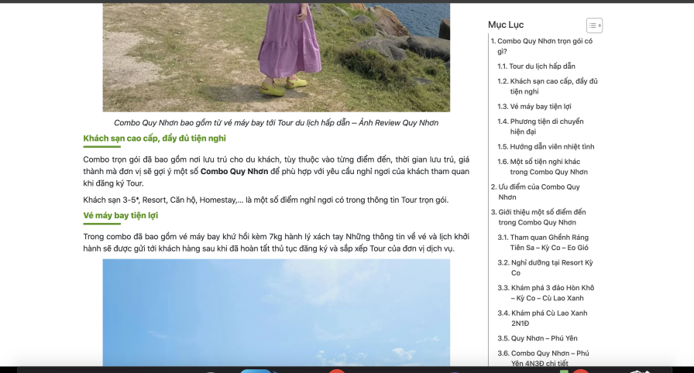

I need to fix the navbar:



When scrolling the slidebar is hidden, when I drag to the end it shows up (error). Let it show all while I haven't scrolled yet