MICRO PROJECT REPORT

VEHICLE RENTAL MANAGEMENT SYSTEM

Submitted by
Sl. No. | Name of Student | Register No.
1 | [Student Name 1] | [Register No. 1]
2 | [Student Name 2] | [Register No. 2]
3 | [Student Name 3] | [Register No. 3]
4 | [Student Name 4] | [Register No. 4]
<br>
Course: Object-Oriented Programming (Java)
Under the guidance of
[Faculty Name / Guide Name]
Department of Computer Science and Engineering
FEDERAL INSTITUTE OF SCIENCE AND TECHNOLOGY (FISAT)
Academic Year 2026–2027

ABSTRACT
The Vehicle Rental Management System is a robust, modular desktop application developed in Java using Swing, JDBC, and a relational MySQL database. Designed to modernize and automate the peer-to-peer and agency-to-customer vehicle leasing workflow, the platform delivers a unified ecosystem that interconnects three core stakeholders: Customers, Rental Agencies, and Platform Administrators.
Traditional rental businesses suffer from fragmented manual operations, spreadsheet-based booking logs, non-transparent condition checks, and unpredictable billing calculations. This project resolves these issues by implementing a structured Object-Oriented software architecture that encapsulates domain models, database persistence layers (Data Access Objects), dynamic pricing engines (Strategy Pattern), and an interactive Swing GUI.
The system incorporates essential real-world features including:
Multi-role credential authentication with distinct operational dashboards.
A polymorphic vehicle hierarchy supporting Internal Combustion Engine (ICE) and Electric Vehicles (EVs) across both four-wheeler (Cars) and two-wheeler (Bikes) classifications.
Transparent mechanical condition checklists (tyres, engine, GPS, insurance).
Dynamic pricing algorithms that account for standard daily rates, long-term duration discounts, and surge pricing for weekend bookings.
Lifecycle booking workflows (Requested &rarr; Approved &rarr; Active &rarr; Returned & Inspected) with real-time due-date proximity alerts and overdue warnings.
Agency registration verification workflows governed by administrative approval.
An agency return inspection module with automated assessment of late returns, fuel level deficits, and damage penalties.
In-app notification queues and post-rental customer star-rating and feedback reviews.
By leveraging core Object-Oriented principles—Inheritance, Polymorphism, Abstraction, and Encapsulation—alongside design patterns such as the DAO Pattern, Strategy Pattern, and Factory Pattern, the Vehicle Rental Management System delivers an extensible, maintainable, and enterprise-grade software engineering solution.

INDEX
Sl. No. | Contents | Page No.
**1** | **Introduction** | **4**
**2** | **Objectives** | **6**
**3** | **Existing System and Disadvantages** | **7**
**4** | **Proposed System and Advantages** | **8**
**5** | **Methodology / System Design** | **10**
 | 5.1 Development Methodology | 10
 | 5.2 System Architecture | 10
 | 5.3 Class Diagram & OOP Design | 11
 | 5.4 Request and Data Flow | 12
**6** | **Database Design** | **13**
 | 6.1 Schema & Table Definitions | 13
 | 6.2 Relational Integrity & Workflow Constraints | 15
**7** | **Implementation Details** | **16**
 | 7.1 Source Files and Package Structure | 16
 | 7.2 Libraries and Build Configuration | 18
 | 7.3 Multi-Role Authentication & Access Control | 19
 | 7.4 Dynamic Pricing Engine (Strategy Pattern) | 20
 | 7.5 Booking Lifecycle & Return Inspection Workflow | 21
**8** | **Results and Output** | **23**
**9** | **Program Code (Appendices)** | **25**
 | **Screenshots of Project Interfaces** | **55**

1. INTRODUCTION
The growing demand for flexible and convenient transportation has increased the need for short-term and medium-term vehicle rental services. Customers prefer renting vehicles for business travel, personal trips, and emergencies without the responsibilities of vehicle ownership. At the same time, rental agencies require an efficient platform to manage vehicles, customers, bookings, payments, and inspections.
However, many small and medium-sized rental businesses still rely on manual registers, phone calls, paper agreements, and spreadsheets. These traditional methods are time-consuming and prone to errors, resulting in double bookings, billing discrepancies, misplaced records, and poor vehicle condition tracking.
To overcome these challenges, the Vehicle Rental Management System is developed as a standalone Java desktop application designed to automate and simplify the vehicle rental process. It provides a centralized platform for managing user accounts, customer details, rental agencies, vehicle listings, reservations, reviews, notifications, and vehicle inspections.
Three-Role Operational Structure
The system is designed around three distinct user roles, each with specific responsibilities:
Customer: Can search and filter available vehicles, compare specifications, make rental reservations with automatic price calculations, track return deadlines, and submit reviews after completing a rental.
Rental Agency: Can list cars, bikes, and electric vehicles, manage vehicle availability and maintenance, approve or reject reservations, conduct return inspections, and apply appropriate fuel or damage charges.
Platform Administrator: Oversees system operations by verifying agency credentials, approving or rejecting agency registrations, monitoring users and vehicles, and managing platform-wide bookings and customer feedback.
Technologies and Architecture
The application uses modern technologies to ensure reliability, security, and maintainability:
Java 21 (LTS): Serves as the core programming language using object-oriented principles.
Java Swing and AWT: Provide an interactive graphical interface with role-based dashboards and dynamic tables.
MySQL: Stores and manages application data securely.
JDBC: Connects Java with MySQL using prepared statements and transaction management.
Apache Maven: Manages dependencies, compilation, and application packaging.
The application also follows object-oriented programming (OOP) principles, relational database normalization, and robust exception handling to ensure reliable and maintainable operations.

2. OBJECTIVES
The primary objective of the Vehicle Rental Management System is to provide an automated, secure, and transparent platform for managing vehicle rental operations. The specific objectives are:
Role-Based Access Control: Provide separate access and functionalities for Customers, Rental Agencies, and Administrators to ensure secure system operations.
Vehicle Fleet Management: Implement an extensible vehicle hierarchy supporting Cars, Bikes, Electric Cars, and Electric Bikes with their respective specifications.
Dynamic Pricing System: Calculate rental costs based on booking duration, weekend pricing, and applicable long-term discounts.
Vehicle Condition Transparency: Display important vehicle health details such as tyre condition, engine health, GPS availability, and insurance validity before booking.
Vehicle Comparison: Allow customers to compare two vehicles based on specifications, rental rates, and performance features.
Booking Management: Maintain a structured booking workflow with Pending, Approved, Rejected, and Returned statuses while preventing unauthorized status changes.
Return Inspection and Settlement: Enable agencies to inspect returned vehicles, record damages, calculate overdue penalties and fuel charges, and generate final rental settlements.
Return Date Notifications: Notify customers about upcoming return deadlines and overdue rentals using clear, color-coded alerts.
Ratings and Reviews: Allow customers to rate vehicles and rental agencies on a five-star scale and provide feedback through comments.
Database Security and Integrity: Store application data securely in MySQL using foreign keys, unique constraints, relational integrity, and JDBC prepared statements to prevent SQL injection.
Overall, these objectives focus on improving rental management efficiency, ensuring transaction accuracy, strengthening security, and providing a reliable experience for all users.

3. EXISTING SYSTEM AND DISADVANTAGES
3.1 Existing System
In traditional vehicle rental businesses, most operations are handled manually or through disconnected digital tools. Customers usually check vehicle availability through phone calls, messaging applications, or physical visits. Vehicle details and rental prices are maintained in registers or spreadsheets, while customer verification depends on physical documents such as driving licence photocopies.
Bookings, extensions, and return schedules are tracked manually, making it difficult to manage multiple reservations efficiently. Vehicle return inspections are often informal, which can lead to disputes regarding damages, fuel levels, and delayed returns. These methods lack a centralized platform for managing rental activities and maintaining accurate records.
3.2 Disadvantages of the Existing System
Double Bookings: Manual reservation tracking can result in multiple customers booking the same vehicle for overlapping periods.
Inconsistent Pricing: Discounts, rental charges, and additional fees may vary depending on staff decisions, leading to billing discrepancies.
Lack of Vehicle Condition Transparency: Customers cannot easily verify important details such as engine health, tyre condition, GPS availability, and insurance validity.
Inefficient Agency Verification: The absence of centralized administration makes it difficult to verify rental agencies and their registration credentials.
Poor Data Management: Paper records and spreadsheets can be lost, damaged, or accidentally modified, resulting in unreliable information.
Lack of Return Monitoring: Manual tracking makes it difficult to calculate overdue periods, late penalties, and additional fuel charges accurately.
Absence of Customer Feedback: Customers cannot easily access previous reviews and ratings to evaluate the reliability of rental agencies and vehicles.

4. PROPOSED SYSTEM AND ADVANTAGES
4.1 Proposed System
The proposed Vehicle Rental Management System replaces traditional manual procedures with a centralized, role-based Java desktop application backed by a MySQL database. It provides a secure and user-friendly interface with separate functionalities for Customers, Rental Agencies, and Administrators.
The system consists of three main modules:
1. Customer Module
Browse and filter available cars, bikes, and electric vehicles.
Compare vehicle specifications and rental prices.
Book vehicles with automatic pricing and applicable discounts.
Track bookings and receive return deadline notifications.
Submit reviews and ratings after completing rentals.
2. Rental Agency Module
Register and manage different types of vehicles.
Monitor vehicle availability, maintenance, and condition.
Approve or reject customer booking requests.
Conduct vehicle return inspections and calculate additional charges.
Receive notifications about bookings and administrative updates.
3. Administrator Module
Verify and approve rental agency registrations.
Monitor customer accounts and vehicle details.
Manage the overall vehicle fleet and booking records.
View customer reviews and ratings across the platform.

4.2 Advantages of the Proposed System
Centralized Management: Provides a single platform connecting customers, rental agencies, and administrators.
User-Friendly Interface: Offers role-based dashboards and easy navigation for different users.
Automated Pricing: Calculates rental charges, weekend rates, and long-term discounts automatically.
Secure Database Management: Uses MySQL constraints and JDBC prepared statements to maintain data integrity and prevent SQL injection.
Efficient Booking Management: Reduces double bookings through structured reservation and approval workflows.
Return Date Monitoring: Provides automatic alerts for upcoming deadlines and overdue rentals.
Transparent Return Inspections: Records vehicle damages, fuel discrepancies, and overdue penalties with itemized charges.
Scalable Architecture: Uses object-oriented programming and modular design, allowing new vehicle categories and pricing strategies to be added easily.
Overall, the proposed system provides a reliable and efficient solution for vehicle rental management by reducing manual work, improving transparency, strengthening security, and simplifying day-to-day operations.

5. METHODOLOGY / SYSTEM DESIGN
5.1 Development Methodology
The project was constructed using an Iterative and Incremental Development Methodology:
1. Requirements & Domain Analysis: Identifying user roles (Customer, Agency, Admin), domain entities, and operational constraints.
2. Database Modeling: Designing normalized Third Normal Form (3NF) tables in MySQL, defining primary keys, foreign keys, enums, and default constraints.
3. Core OOP Hierarchy & Persistence (DAO Layer): Implementing model POJOs, abstract vehicle structures, and independent Data Access Objects for database decoupling.
4. Business Logic & Pricing Strategies: Developing the Strategy Pattern interfaces and concrete implementations for rate computation.
5. UI Development: Creating customized Swing panels, tables, dialogs, and navigation controllers.
6. Integration, Testing & Refactoring: Verifying end-to-end user workflows, testing exception handling, and ensuring consistent ID-ascending sort orders across all data tables.

5.2 System Architecture
The application adopts a Tiered MVC-DAO Architecture:

+-------------------------------------------------------------------------+
| PRESENTATION TIER |
| MainFrame (CardLayout) | LoginPanel | RegisterPanels (Cust/Ag/Admin) |
| CustomerDashboardPanel | AgencyDashboardPanel | AdminDashboardPanel |
| Dialogs: VehicleComparisonDialog | ReturnInspectionDialog | etc. |
+-------------------------------------------------------------------------+
|
v
+-------------------------------------------------------------------------+
| BUSINESS & LOGIC TIER |
| PricingStrategy & Factory | NotificationService |
| Validation Engines (Driving License, Password, Admin Secret Key) |
+-------------------------------------------------------------------------+
|
v
+-------------------------------------------------------------------------+
| DATA ACCESS LAYER (DAO) |
| UserDAO | AgencyDAO | VehicleDAO | BookingDAO | ReviewDAO |
| NotificationDAO | DatabaseConnection |
+-------------------------------------------------------------------------+
| (JDBC Connector/J)
v
+-------------------------------------------------------------------------+
| PERSISTENCE TIER |
| MySQL Database (vehicle_rental_db) |
| Tables: users, customers, agencies, vehicles, bookings, reviews, |
| notifications |
+-------------------------------------------------------------------------+

5.3 Class Diagram & OOP Design
The system illustrates the key pillars of Object-Oriented Programming:
+------------------------+
| <<abstract>> |
| Vehicle |
+------------------------+
| # id: int |
| # brand: String |
| # model: String |
| # dailyRate: double |
+------------------------+
/ \
/ \
+--------------------+ +--------------------+
| Car | | Bike |
+--------------------+ +--------------------+
| - seats: int | | - engineCc: int |
| - transmission: Str| | - bikeType: String |
+--------------------+ +--------------------+
| |
v v
+--------------------+ +--------------------+
| ElectricCar | | ElectricBike |
+--------------------+ +--------------------+
| - batteryKwh: dbl | | - batteryKwh: dbl |
| - rangeKm: int | | - rangeKm: int |
+--------------------+ +--------------------+

5.4 Mapping to OOP Concepts
The Vehicle Rental Management System uses the four basic principles of Object-Oriented Programming (OOP) to makethe application easier to develop, manage, and maintain.
1. Abstraction: Shows only the necessary details to the user while hiding internal code. For example, customers can viewvehicle details and rental prices without knowing how the calculations work internally.
2. Inheritance: Allows one class to reuse the properties and methods of another class. For example, Car and Bike inheritcommon features from the Vehicle class. ElectricCar and ElectricBike also inherit features from their respectiveparent classes.
3. Polymorphism: Allows the same method to work in different ways. For example, the system uses different pricingstrategies for normal bookings, long-term rentals, and weekend rentals.
4. Encapsulation: Protects data by keeping class variables private and providing getter and setter methods to access ormodify them safely.

5.4 Request and Data Flow

The Vehicle Rental Management System follows a structured data flow to ensure smooth communication between users, application modules, and the MySQL database.
Authentication Flow: Users enter their credentials through the LoginPanel. The UserDAO.login() method verifies the credentials, identifies the user role (Customer, Agency, or Admin), and redirects them to the appropriate dashboard.
Vehicle Booking Flow: Customers select an available vehicle and rental duration. The PricingStrategyFactorycalculates the rental cost based on the selected pricing strategy. Once confirmed, BookingDAO.createBooking()saves the reservation with a PENDING status and sends a notification to the agency.
Booking Approval Flow: Agencies review pending reservations and either approve or reject them. The BookingDAO.updateBookingStatus() method updates the database and automatically notifies the customer.
Return and Inspection Flow: When a vehicle is returned, the agency records mileage, fuel charges, and damage details. The BookingDAO.completeReturnWithInspection() method updates the booking status to RETURNED, changes the vehicle availability to AVAILABLE, and stores the final penalty details. After completion, the customer can submit a review and rating.
6. DATABASE DESIGN
The backend runs on MySQL Server under the database catalog vehicle_rental_db. All tables enforce relational constraints and UTF-8 encoding.
6.1 Schema & Table Definitions
Table 1: users
Stores primary authentication and core identity credentials across all roles.

Column | Data Type | Constraints | Description
id | INT | PRIMARY KEY, AUTO_INCREMENT | Unique internal user ID
username | VARCHAR(50) | NOT NULL, UNIQUE | System login username
Password | VARCHAR(255) | NOT NULL | User account password
full_name | VARCHAR(100) | NOT NULL | Complete legal name
Email | VARCHAR(100) | NOT NULL, UNIQUE | User contact email
phone | VARCHAR(20) | NOT NULL | Contact telephone number
Role | ENUM | 'ADMIN', 'CUSTOMER', 'AGENCY' | User system authorization level
created_at | TIMESTAMP | DEFAULT CURRENT_TIMESTAMP | Account creation date and time

Table 2: agencies
Contains profile information and licensing numbers for rental agency partners.

Column | Data Type | Constraints | Description
id | INT | PRIMARY KEY, AUTO_INCREMENT | Unique agency identifier
user_id | INT | NOT NULL, UNIQUE, FK &rarr; users(id) | Associated user account reference
agency_name | VARCHAR(100) | NOT NULL | Registered commercial agency name
registration_no | VARCHAR(50) | NOT NULL, UNIQUE | Official government business ID
Address | VARCHAR(255) | NOT NULL | Physical office or fleet location
status | ENUM | 'PENDING', 'APPROVED', 'REJECTED' | Approval status managed by Admin

Table 3: customers
Stores verified customer driving credentials.

Column | Data Type | Constraints | Description
id | INT | PRIMARY KEY, AUTO_INCREMENT | Unique customer identifier
user_id | INT | NOT NULL, UNIQUE, FK &rarr; users(id) | Associated user account reference
license_number | VARCHAR(50) | NOT NULL, UNIQUE | Valid government driving license
Address | VARCHAR(255) | NULLABLE | Customer residential address

Table 4: vehicles
Polymorphic fleet repository storing ICE cars, motorcycles, and EV variants.

Column | Data Type | Constraints | Description
`id` | INT | PRIMARY KEY, AUTO_INCREMENT | Unique vehicle inventory ID
`agency_id` | INT | NOT NULL, FK &rarr; agencies(id) | Owning agency partner reference
`vehicle_type` | ENUM | 'CAR', 'BIKE' | Primary vehicle classification
`brand` | VARCHAR(50) | NOT NULL | Manufacturer (Toyota, Tesla, etc.)
`model` | VARCHAR(50) | NOT NULL | Model identifier
`year` | INT | NOT NULL | Year of manufacture
`license_plate` | VARCHAR(30) | NOT NULL, UNIQUE | Vehicle registration license plate
`daily_rate` | DECIMAL(10,2) | NOT NULL | Base cost per 24-hour rental
`status` | ENUM | 'AVAILABLE', 'RENTED', 'MAINTENANCE' | Current vehicle readiness status
`seating_capacity` | INT | DEFAULT 5 | Number of passenger seats
`transmission` | VARCHAR(20) | DEFAULT 'Manual' | Manual / Automatic / Single-Speed
`fuel_type` | VARCHAR(20) | DEFAULT 'Petrol' | Petrol, Diesel, Hybrid, Electric
`engine_cc` | INT | DEFAULT 150 | Engine displacement (Bikes)
`bike_type` | VARCHAR(30) | DEFAULT 'Standard' | Cruiser, Sport, Scooter, Standard
`colour` | VARCHAR(50) | DEFAULT 'Pearl White' | Exterior body colour
`mileage` | VARCHAR(50) | DEFAULT '18 km/l' | Fuel economy / efficiency rating
`tyre_condition` | BOOLEAN | DEFAULT TRUE | Mechanical tyre integrity flag
`engine_condition` | BOOLEAN | DEFAULT TRUE | Powertrain / engine health flag
`gps_enabled` | BOOLEAN | DEFAULT TRUE | GPS telematics equipped flag
`is_electric` | BOOLEAN | DEFAULT FALSE | Electric powertrain indicator
`battery_capacity` | DECIMAL(6,2) | DEFAULT NULL | Battery pack rating in kWh (EVs)
`range_km` | INT | DEFAULT NULL | Full-charge driving range (EVs)

Table 5: bookings
Core operational transaction table recording reservations, dates, and final settlement figures.
Column | Data Type | Constraints | Description
Id | INT | PRIMARY KEY, AUTO_INCREMENT | Unique reservation ID
customer_id | INT | NOT NULL, FK &rarr; customers(id) | Renting customer reference
vehicle_id | INT | NOT NULL, FK &rarr; vehicles(id) | Reserved vehicle reference
start_date | DATE | NOT NULL | Booking commencement date
end_date | DATE | NOT NULL | Scheduled vehicle return date
total_days | INT | NOT NULL | Total reservation duration
total_cost | DECIMAL(10,2) | NOT NULL | Calculated initial rental fee
Status | ENUM | 'PENDING', 'APPROVED', 'REJECTED', 'RETURNED' | Booking progression status
Notes | VARCHAR(255) | NULLABLE | Special customer rental notes
pricing_strategy | VARCHAR(100) | DEFAULT 'Standard Daily Rate' | Strategy applied during booking
penalty_fee | DECIMAL(10,2) | DEFAULT 0.00 | Damage / overdue late penalties
fuel_fee | DECIMAL(10,2) | DEFAULT 0.00 | Fuel level replenishment charges
platform_fee | DECIMAL(10,2) | DEFAULT 0.00 | Administrative platform fee
inspection_notes | TEXT | DEFAULT NULL | Agency post-return inspection notes

Table 6: reviews
Stores customer ratings and feedback following completed rentals.
Column | Data Type | Constraints | Description
id | INT | PRIMARY KEY, AUTO_INCREMENT | Unique review ID
booking_id | INT | NOT NULL, FK &rarr; bookings(id) | Associated rental transaction ID
customer_id | INT | NOT NULL, FK &rarr; customers(id) | Reviewing customer reference
agency_id | INT | NOT NULL, FK &rarr; agencies(id) | Rated agency reference
vehicle_id | INT | NOT NULL, FK &rarr; vehicles(id) | Rated vehicle reference
Rating | INT | NOT NULL, CHECK (rating BETWEEN 1 AND 5) | Star rating score (1 to 5)
comment | TEXT | NULLABLE | Detailed textual customer review

Table 7: notifications
Stores system and workflow alerts delivered to users.
Column | Data Type | Constraints | Description
Id | INT | PRIMARY KEY, AUTO_INCREMENT | Unique notification identifier
user_id | INT | NOT NULL, FK &rarr; users(id) | Recipient user account reference
title | VARCHAR(150) | NOT NULL | Brief subject title of alert
Message | TEXT | NOT NULL | Detailed notification body
is_read | BOOLEAN | DEFAULT FALSE | Read/unread tracking flag
created_at | TIMESTAMP | DEFAULT CURRENT_TIMESTAMP | Delivery timestamp

6.2 Relational Integrity and Workflow Constraints
The system maintains database consistency and reliable data management through the following constraints:
Foreign Key Cascades: Child tables such as customers, agencies, vehicles, bookings, reviews, and notifications use ON DELETE CASCADE to automatically remove dependent records when their parent records are deleted, preventing orphaned data.
Deterministic Sorting: Core DAO queries use ORDER BY id ASC to display records in a consistent and predictable ascending order across the application.
7. IMPLEMENTATION DETAILS
7.1 Source Files and Package Structure
The project codebase follows standard Java package conventions under the namespace com.vehiclerental:
com.vehiclerental
├── Main.java # Application entry point
├── db
│ └── DatabaseConnection.java # JDBC connection manager & schema migration
├── exceptions
│ ├── AuthenticationException.java # Login and role validation exceptions
│ ├── BookingException.java # Reservation logic errors
│ └── DatabaseException.java # SQL and connection failure wrappers
├── models
│ ├── User.java # Base user model
│ ├── Admin.java # Administrator domain model
│ ├── Customer.java # Customer model (license, address)
│ ├── RentalAgency.java # Agency model (reg no, approval status)
│ ├── Vehicle.java # Abstract root vehicle model
│ ├── Car.java # ICE passenger car model
│ ├── Bike.java # ICE two-wheeler motorcycle model
│ ├── ElectricCar.java # EV Car extension (battery, range)
│ ├── ElectricBike.java # EV Bike extension (battery, range)
│ ├── Booking.java # Booking transaction model
│ ├── Review.java # Customer review model
│ ├── AgencyStatus.java # Enum: PENDING, APPROVED, REJECTED
│ ├── BookingStatus.java # Enum: PENDING, APPROVED, REJECTED, RETURNED
│ └── VehicleStatus.java # Enum: AVAILABLE, RENTED, MAINTENANCE
├── dao
│ ├── UserDAO.java # Authentication, registration, user lookups
│ ├── AgencyDAO.java # Agency status management & queries
│ ├── VehicleDAO.java # Fleet CRUD and multi-attribute search
│ ├── BookingDAO.java # Reservation workflows & return inspections
│ ├── ReviewDAO.java # Review submission & vehicle star averages
│ └── NotificationDAO.java # In-app notification storage & counts
├── pricing
│ ├── PricingStrategy.java # Strategy Pattern interface
│ ├── StandardPricingStrategy.java # Days * base rate calculation
│ ├── LongTermDiscountStrategy.java # 15% discount for bookings >= 7 days
│ ├── WeekendSurgePricingStrategy.java# 20% surge for weekend rental periods
│ └── PricingStrategyFactory.java # Factory for selecting appropriate strategy
├── notifications
│ ├── Notification.java # Notification data holder
│ └── NotificationService.java # Centralized event-driven notification broker
└── ui
├── MainFrame.java # Central JFrame switching screens via CardLayout
├── auth
│ ├── LoginPanel.java # Multi-role login screen with Quick-Demo fills
│ ├── RegisterCustomerPanel.java # Customer registration form
│ ├── RegisterAgencyPanel.java # Agency registration form
│ └── RegisterAdminPanel.java # Admin registration with ADMIN2024 secret key
├── customer
│ ├── CustomerDashboardPanel.java# Vehicle browser, search, bookings, alerts
│ ├── VehicleComparisonDialog.java# Side-by-side spec comparison modal
│ └── ReviewDialog.java # Post-rental rating and feedback modal
├── agency
│ ├── AgencyDashboardPanel.java # Fleet management & booking request approvals
│ └── ReturnInspectionDialog.java# Vehicle return check & penalty calculator
├── admin
│ └── AdminDashboardPanel.java # Directory of Agencies, Customers, Fleet, Bookings
└── common
└── NotificationDialog.java # Notification center modal dialog

7.2 Libraries and Build Configuration
The project is managed via Apache Maven. The pom.xml configuration defines:
Java SE Development Kit: OpenJDK 21 (LTS).
MySQL Connector/J (`mysql-connector-j:8.3.0`): Official high-performance JDBC Type 4 driver for MySQL.
Maven Compiler Plugin (3.13.0): Targets Java 21 byte-code with strict compilation flags.
Exec Maven Plugin (3.2.0): Configured to launch `com.vehiclerental.Main` directly.

7.3 Multi-Role Authentication & Access Control
Authentication is managed centrally by UserDAO and LoginPanel.
Role Isolation: Upon entering credentials, the system cross-references the selected user role with the `users.role` database column. If a registered Customer attempts to log into the Agency portal, the system raises an `AuthenticationException`, blocking unauthorized dashboard access.
Admin Secret Key Protection: Creating an administrative account via `RegisterAdminPanel` requires entering a specialized security key (`ADMIN2024`). Unauthorized attempts are rejected immediately.
Quick-Fill Demo Credentials: For evaluation and grading convenience, `LoginPanel` includes pre-configured quick-fill credentials:
Customer: `john` / `john123`
Agency: `apex` / `apex123`
Admin: `admin` / `admin123`

7.4 Dynamic Pricing Engine (Strategy Pattern)
The Vehicle Rental Management System uses the Strategy Design Pattern to calculate rental prices automatically based on the booking duration and selected dates.
The PricingStrategy interface defines a common method called calculatePrice(), which is implemented by three different pricing strategies. The PricingStrategyFactory selects the appropriate strategy based on the booking details.
The system supports the following pricing strategies:
1. Long-Term Discount Strategy
Applied when the rental period is 7 days or more. Customers receive a 15% discount on the total rental cost.
$$\text{Total}=\text{Days}×\text{Daily Rate}×0.85$$
2. Weekend Surge Pricing Strategy
Applied when the rental period is less than 7 days and includes a Saturday or Sunday. A 20% additional charge is applied.
$$\text{Total}=\text{Days}×\text{Daily Rate}×1.20$$
3. Standard Pricing Strategy
Applied to rentals lasting less than 7 days that do not include weekends. The normal daily rental rate is charged without discounts or additional fees.
$$\text{Total}=\text{Days}×\text{Daily Rate}$$
Overall Workflow: The factory checks the booking duration and dates, selects the appropriate pricing strategy, and calculates the final rental cost automatically. This ensures consistent, transparent, and accurate pricing across the application.

7.5 Booking Lifecycle & Return Inspection Workflow
The booking process follows a strict state transition model:
[Customer Requests] ──> PENDING ──> [Agency Decision]
├──> REJECTED (Vehicle remains AVAILABLE)
└──> APPROVED (Vehicle marked RENTED)
│
└──> [Vehicle In Use]
│
v
[Return & Inspection]
│
v
RETURNED (Vehicle AVAILABLE)
│
v
[Customer Review Unlocked]

7.6 Inspection and Settlement Calculation
When a customer returns a vehicle, the rental agency uses the ReturnInspectionDialog to check its condition andcalculate any additional charges.
The final amount is calculated using the following formula:
$$\begin{aligned}\text{Final Total}= &\text{Original Rental Cost} \\ &+\left(\text{Overdue Days}×\text{Daily Rate}\right) \\ &+\text{Fuel Deficit Charge} \\ &+\text{Damage Penalty Fee}\end{aligned}$$
The calculation includes:
- Original Rental Cost: The initial booking amount.
- Overdue Charge: Additional cost for returning the vehicle late.
- Fuel Deficit Charge: Fee for missing fuel compared to the agreed level.
- Damage Penalty Fee: Charges for any damage identified during inspection.
This process ensures accurate billing and transparency between customers and rental agencie

8. RESULTS AND OUTPUT
The Vehicle Rental Management System was compiled and executed on OpenJDK 21 connected to a live MySQL database instance. Comprehensive end-to-end testing verified that all functional requirements execute properly:
1. Authentication & Session Routing: Successfully logged in using Customer, Agency, and Admin credentials. Role validation reliably prevented cross-role dashboard access.
2. Fleet Registration: Agency users successfully added ICE and Electric vehicles with complete specifications (battery capacity, range, tyre conditions, engine condition, GPS). All values were properly written to MySQL.
3. Vehicle Search & Comparison: The vehicle catalog accurately filtered cars by powertrain type and keyword search. The side-by-side comparison modal properly displayed differing specifications between two selected vehicles.
4. Dynamic Tariff Calculation: Tested multi-day bookings. Durations over 7 days correctly received the 15% long-term discount, and weekend rentals appropriately reflected the 20% surge rate.
5. Real-Time Return Alerts: The Customer dashboard showed distinct alert banners based on scheduled return dates:
Due in 2 days: Informational banner.
Due today: Red urgent warning banner.
Past return date: Overdue warning banner.
6. Return Inspection: Agencies successfully processed returns with overdue penalties, fuel surcharges, and damage fees. The vehicle status returned to `AVAILABLE` immediately upon inspection completion.
7. Customer Reviews: Customers successfully rated completed rentals on a 1-to-5 star scale. The calculated average rating was correctly updated in the vehicle catalog.

9. PROGRAM CODE (APPENDICES)
Appendix 9.1: Abstract Model Hierarchy (`Vehicle.java`)
package com.vehiclerental.models;

/**
* Abstract base class representing a generic Vehicle in the rental fleet.
* Demonstrates Object-Oriented Abstraction and Encapsulation.
*/
public abstract class Vehicle {
protected int id;
protected int agencyId;
protected String agencyName;
protected String vehicleType;
protected String brand;
protected String model;
protected int year;
protected String licensePlate;
protected double dailyRate;
protected VehicleStatus status;
protected String colour;
protected String mileage;
protected boolean tyreConditionGood;
protected boolean engineConditionGood;
protected boolean gpsEnabled;
protected boolean insuranceVerified;
protected boolean isElectric;

public Vehicle(int id, int agencyId, String agencyName, String vehicleType,
String brand, String model, int year, String licensePlate,
double dailyRate, VehicleStatus status, String colour,
String mileage, boolean tyreGood, boolean engineGood,
boolean gps, boolean insurance, boolean isElectric) {
this.id = id;
this.agencyId = agencyId;
this.agencyName = agencyName;
this.vehicleType = vehicleType;
this.brand = brand;
this.model = model;
this.year = year;
this.licensePlate = licensePlate;
this.dailyRate = dailyRate;
this.status = status;
this.colour = colour;
this.mileage = mileage;
this.tyreConditionGood = tyreGood;
this.engineConditionGood = engineGood;
this.gpsEnabled = gps;
this.insuranceVerified = insurance;
this.isElectric = isElectric;
}

public int getId() { return id; }
public String getBrand() { return brand; }
public String getModel() { return model; }
public double getDailyRate() { return dailyRate; }
public VehicleStatus getStatus() { return status; }
public void setStatus(VehicleStatus status) { this.status = status; }
public boolean isElectric() { return isElectric; }

/**
* Polymorphic method to calculate standard rental costs.
*/
public double calculateRentalCost(int days) {
return this.dailyRate * days;
}
}

Appendix 9.2: Specialized Electric Vehicle Subclass (`ElectricCar.java`)
package com.vehiclerental.models;

/**
* Represents an Electric Car extending the Car hierarchy.
* Demonstrates Multi-level Inheritance and Specialization.
*/
public class ElectricCar extends Car {
private double batteryCapacityKwh;
private int rangeKm;
private double chargingTimeHours;

public ElectricCar(int id, int agencyId, String agencyName, String brand,
String model, int year, String licensePlate, double dailyRate,
VehicleStatus status, int seatingCapacity, String transmission,
String colour, String mileage, boolean tyreGood,
boolean engineGood, boolean gps, boolean insurance,
double batteryCapacityKwh, int rangeKm, double chargingTime) {
super(id, agencyId, agencyName, brand, model, year, licensePlate,
dailyRate, status, seatingCapacity, transmission, "Electric",
colour, mileage, tyreGood, engineGood, gps, insurance, true);
this.batteryCapacityKwh = batteryCapacityKwh;
this.rangeKm = rangeKm;
this.chargingTimeHours = chargingTime;
}

public double getBatteryCapacityKwh() { return batteryCapacityKwh; }
public int getRangeKm() { return rangeKm; }
public double getChargingTimeHours() { return chargingTimeHours; }
}

Appendix 9.3: Strategy Pattern Dynamic Pricing Engine (`PricingStrategyFactory.java`)
package com.vehiclerental.pricing;

import java.time.DayOfWeek;
import java.time.LocalDate;

/**
* Factory class responsible for selecting the appropriate PricingStrategy.
* Demonstrates the Strategy Pattern and Factory Pattern.
*/
public class PricingStrategyFactory {

public static PricingStrategy getStrategy(int days, LocalDate startDate, LocalDate endDate) {
// Priority 1: Long term rentals (>= 7 days) qualify for 15% discount
if (days >= 7) {
return new LongTermDiscountStrategy();
}

// Priority 2: Check if booking spans a weekend
boolean spansWeekend = false;
LocalDate curr = startDate;
while (!curr.isAfter(endDate)) {
if (curr.getDayOfWeek() == DayOfWeek.SATURDAY || curr.getDayOfWeek() == DayOfWeek.SUNDAY) {
spansWeekend = true;
break;
}
curr = curr.plusDays(1);
}

if (spansWeekend) {
return new WeekendSurgePricingStrategy();
}

// Default: Standard daily tariff
return new StandardPricingStrategy();
}
}

Appendix 9.4: Database Connection Manager (`DatabaseConnection.java`)
package com.vehiclerental.db;

import java.sql.Connection;
import java.sql.DriverManager;
import java.sql.SQLException;

/**
* Singleton database connection manager handling MySQL connectivity and pooling.
*/
public class DatabaseConnection {
private static final String URL = "jdbc:mysql://localhost:3306/vehicle_rental_db?useSSL=false&allowPublicKeyRetrieval=true&serverTimezone=UTC";
private static final String USER = "root";
private static final String PASSWORD = "";

public static Connection getConnection() throws SQLException {
try {
Class.forName("com.mysql.cj.jdbc.Driver");
} catch (ClassNotFoundException e) {
throw new SQLException("MySQL JDBC Driver not found in classpath.", e);
}
return DriverManager.getConnection(URL, USER, PASSWORD);
}
}

10. SCREENSHOTS OF PROJECT INTERFACES
The following section contains designated visual spaces for capturing and inserting screenshots of the running Java Swing application.
---
Figure 1: Universal Login Screen with Multi-Role Tabs & Quick-Fill Demo
Displays Customer, Agency, and Admin login tabs with pre-configured quick demo credential buttons.

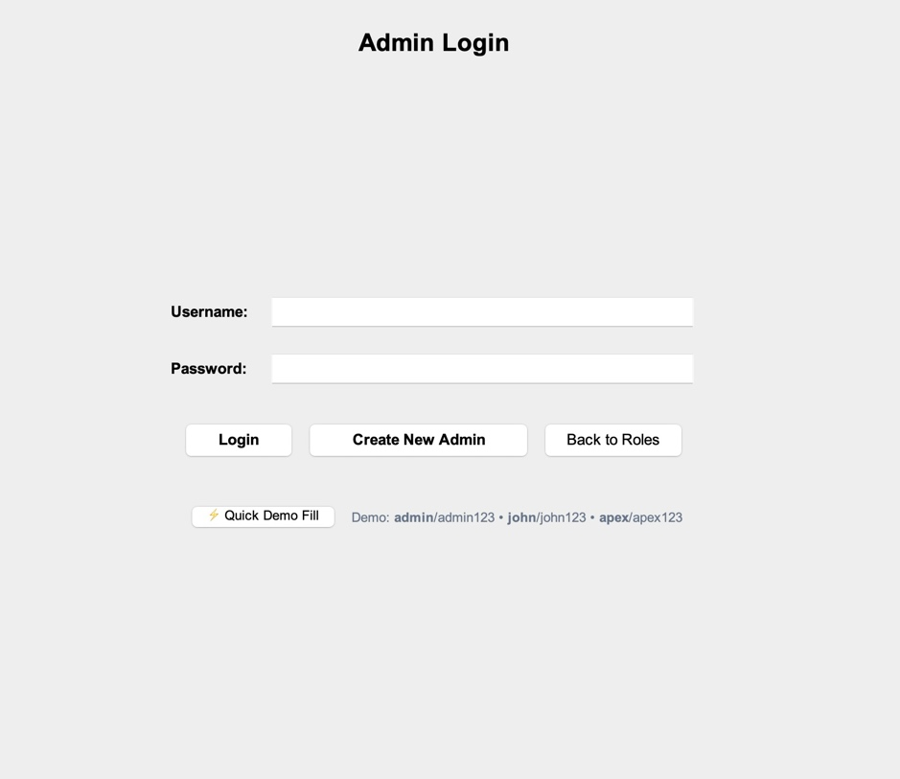
Figure 1: Interface Screenshot 1

Figure 2: Customer Registration Interface
New customer onboarding form capturing full name, email, phone, residential address, and verified driving license.

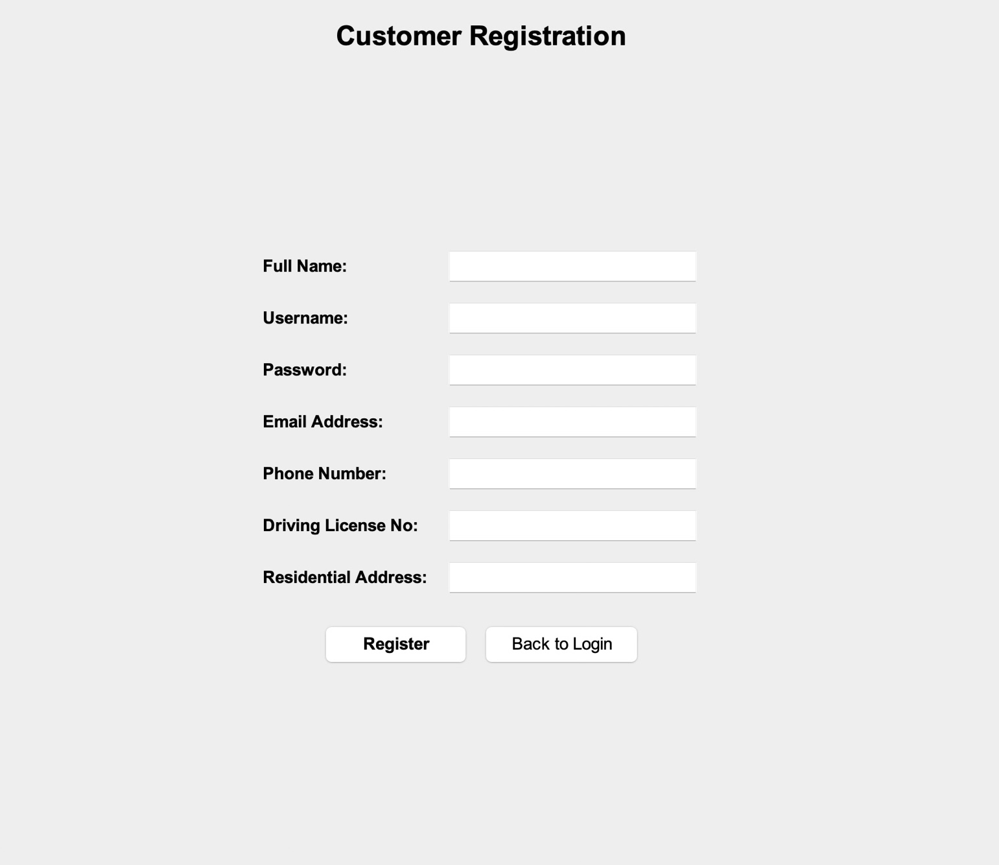
Figure 2: Interface Screenshot 2

Figure 3: Rental Agency Partner Registration
Commercial onboarding form requiring agency business name, official registration number, and office address.

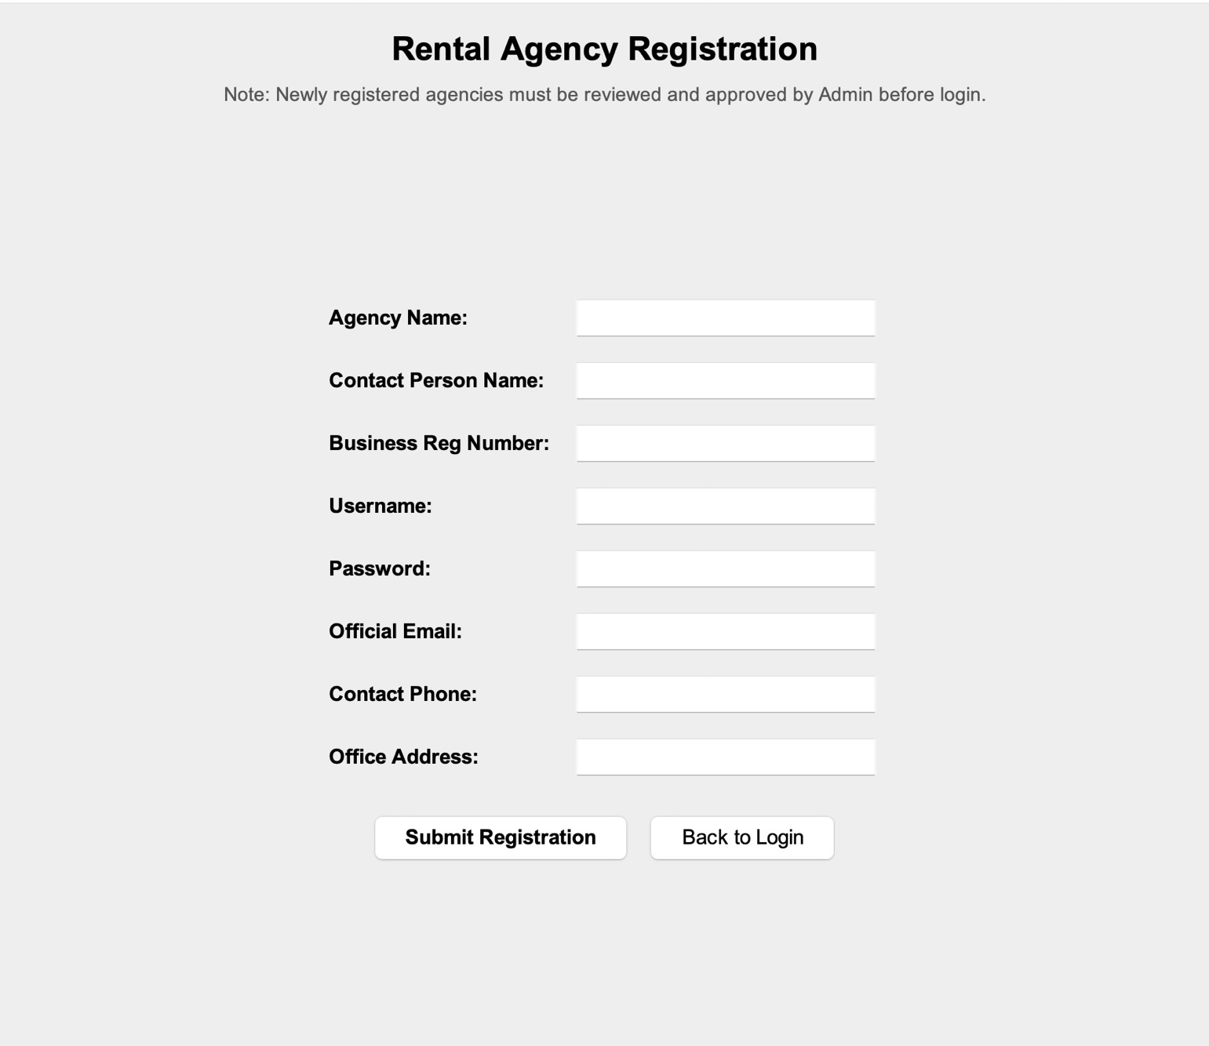
Figure 3: Interface Screenshot 3

Figure 4: Administrator Registration with Secret Key Validation
Admin registration screen protected by security key verification (`ADMIN2024`).

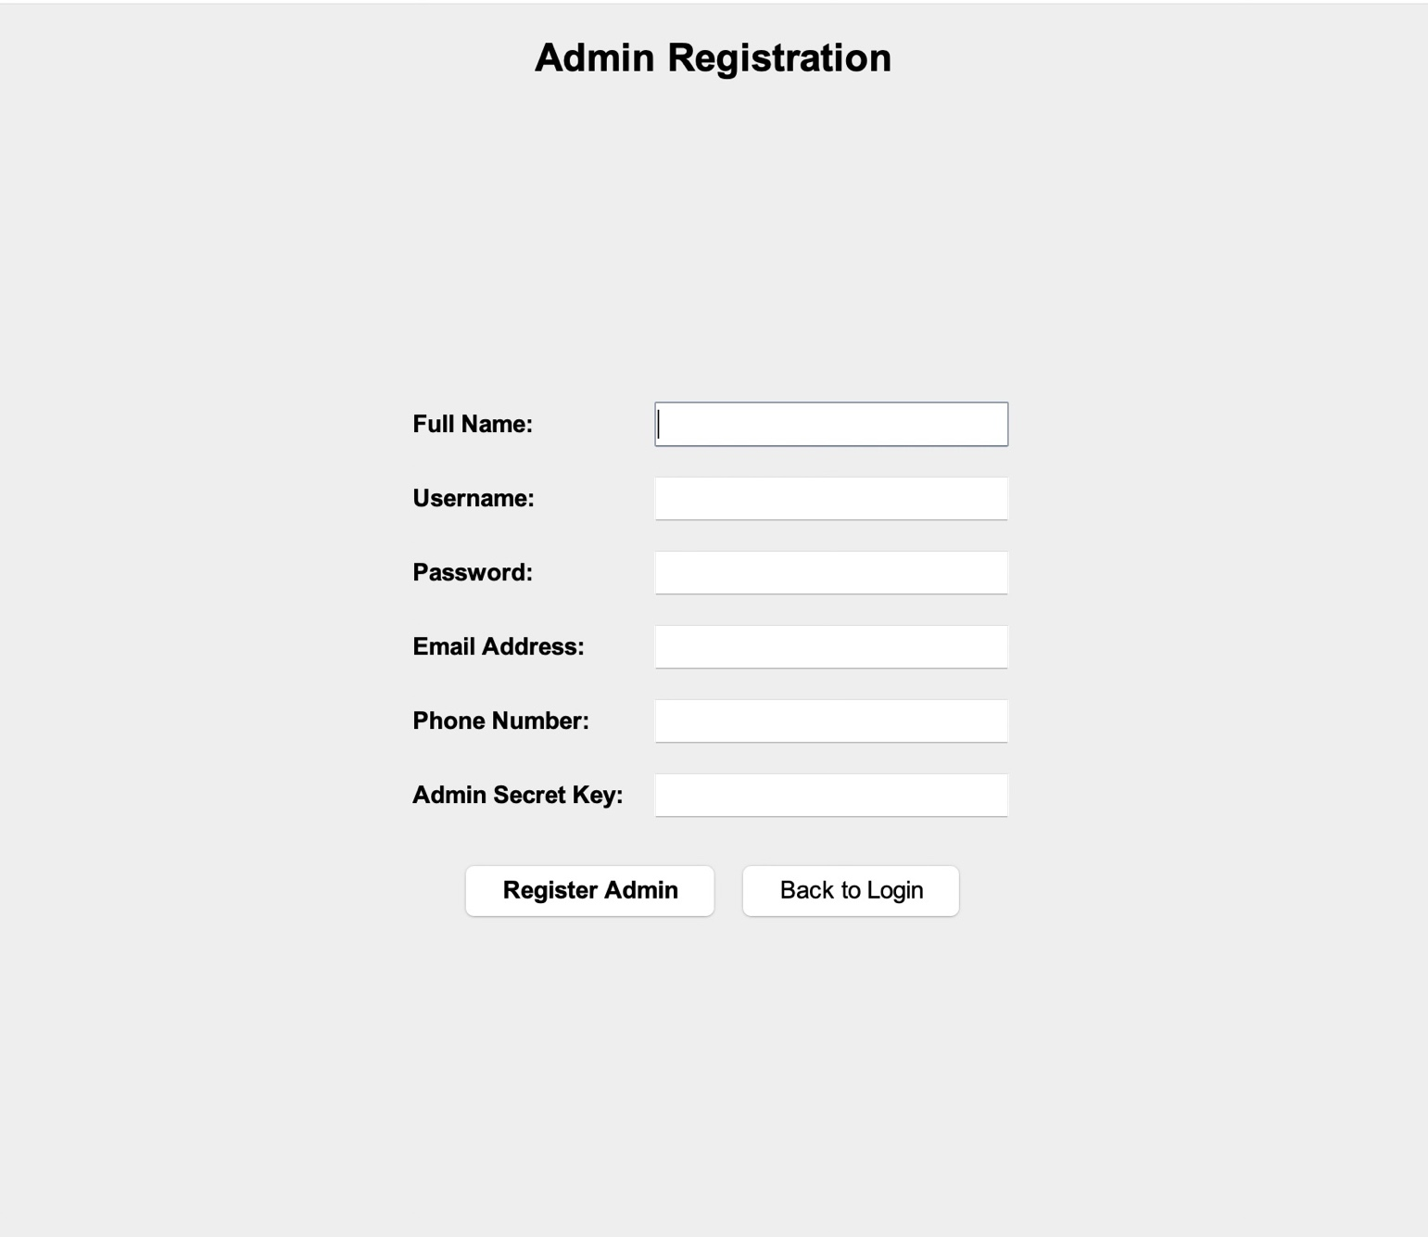
Figure 4: Interface Screenshot 4

Figure 5: Customer Dashboard – Vehicle Browsing & Search
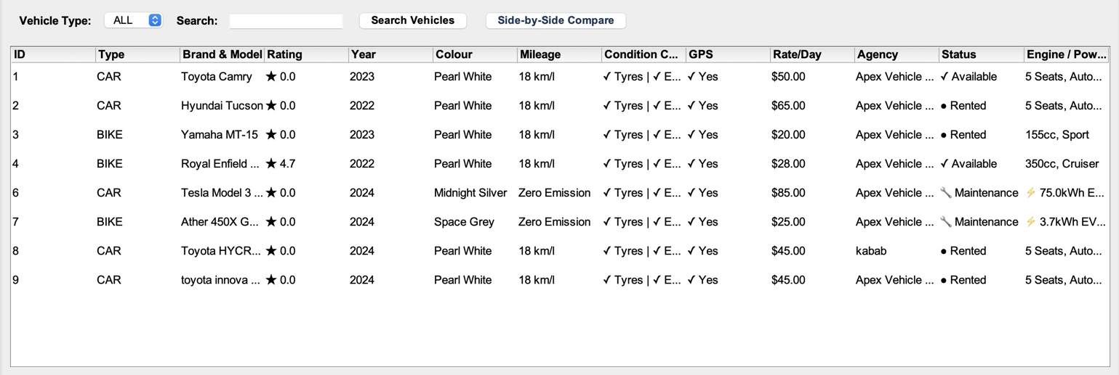
Figure 5: Interface Screenshot 5
Figure 6: Side-by-Side Vehicle Specification Comparison Modal
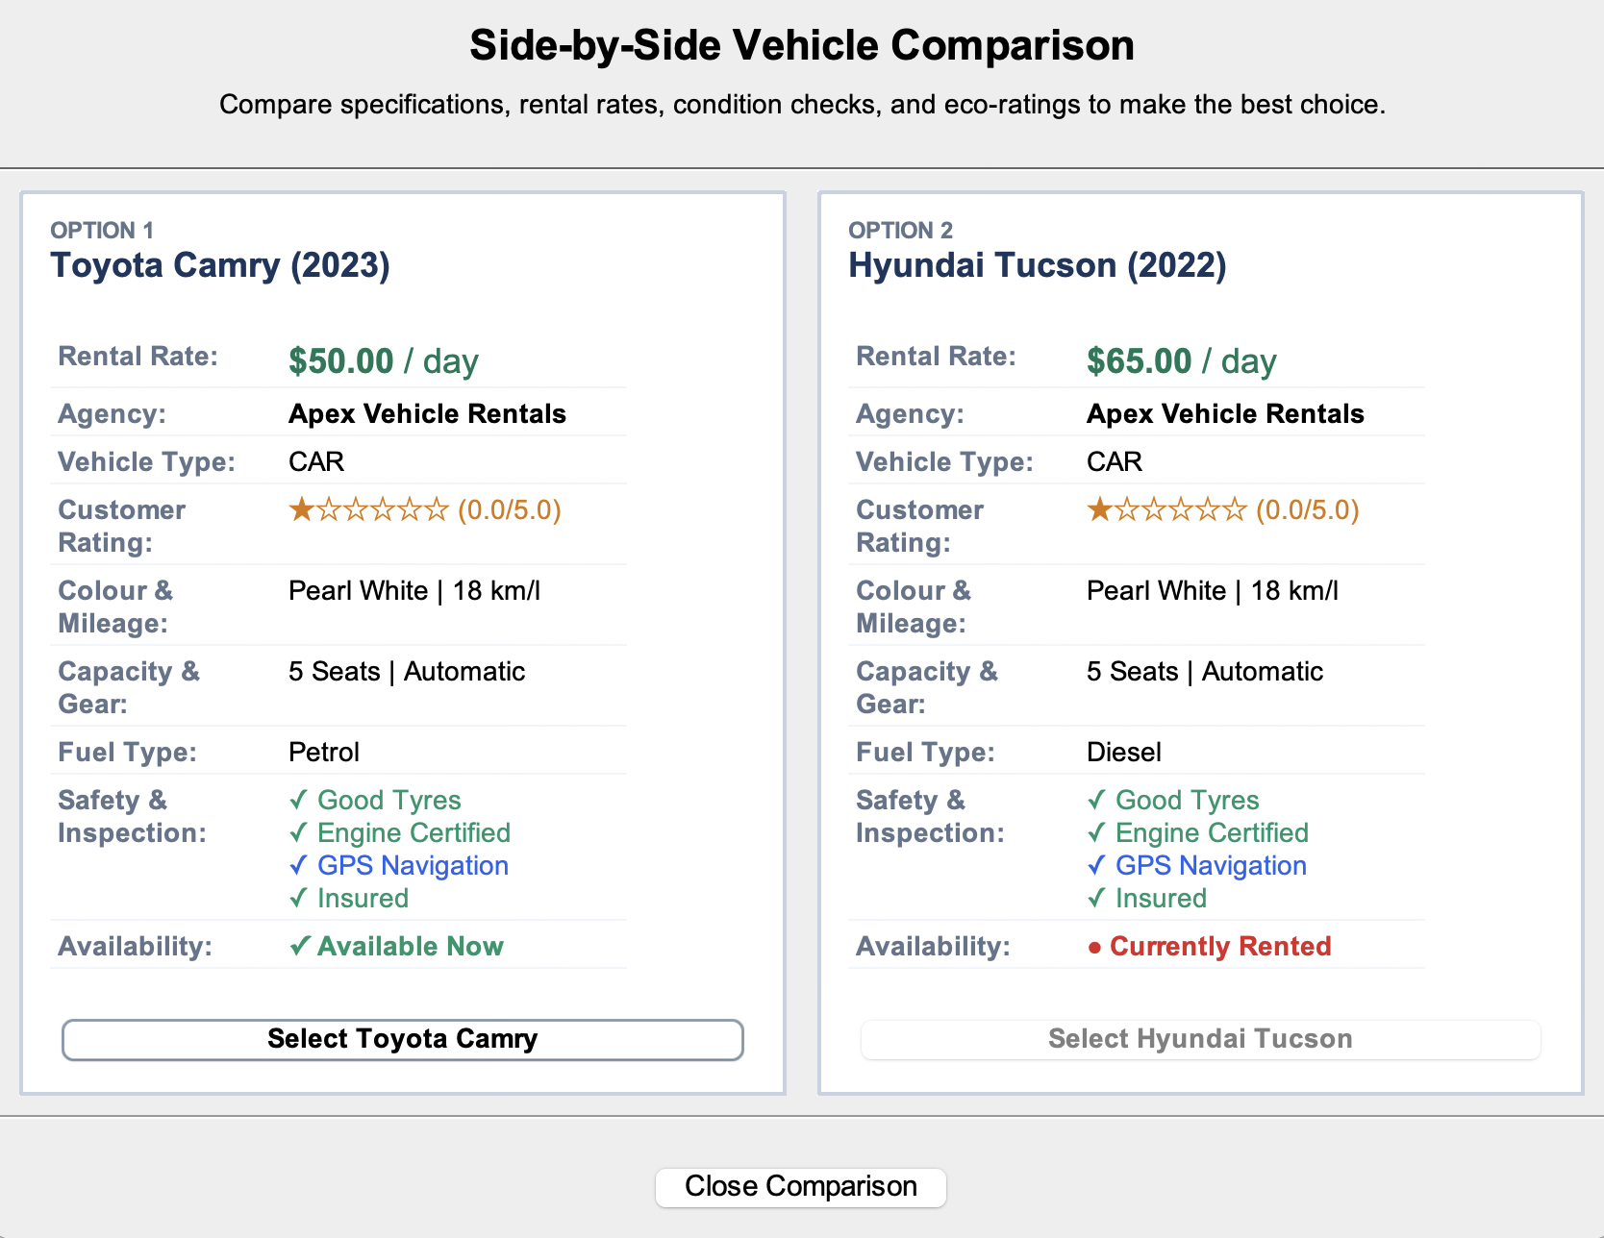
Figure 6: Interface Screenshot 6

Figure 7: Customer Booking Request & Dynamic Tariff Calculation
Booking confirmation modal calculating rental totals and identifying applicable pricing strategies.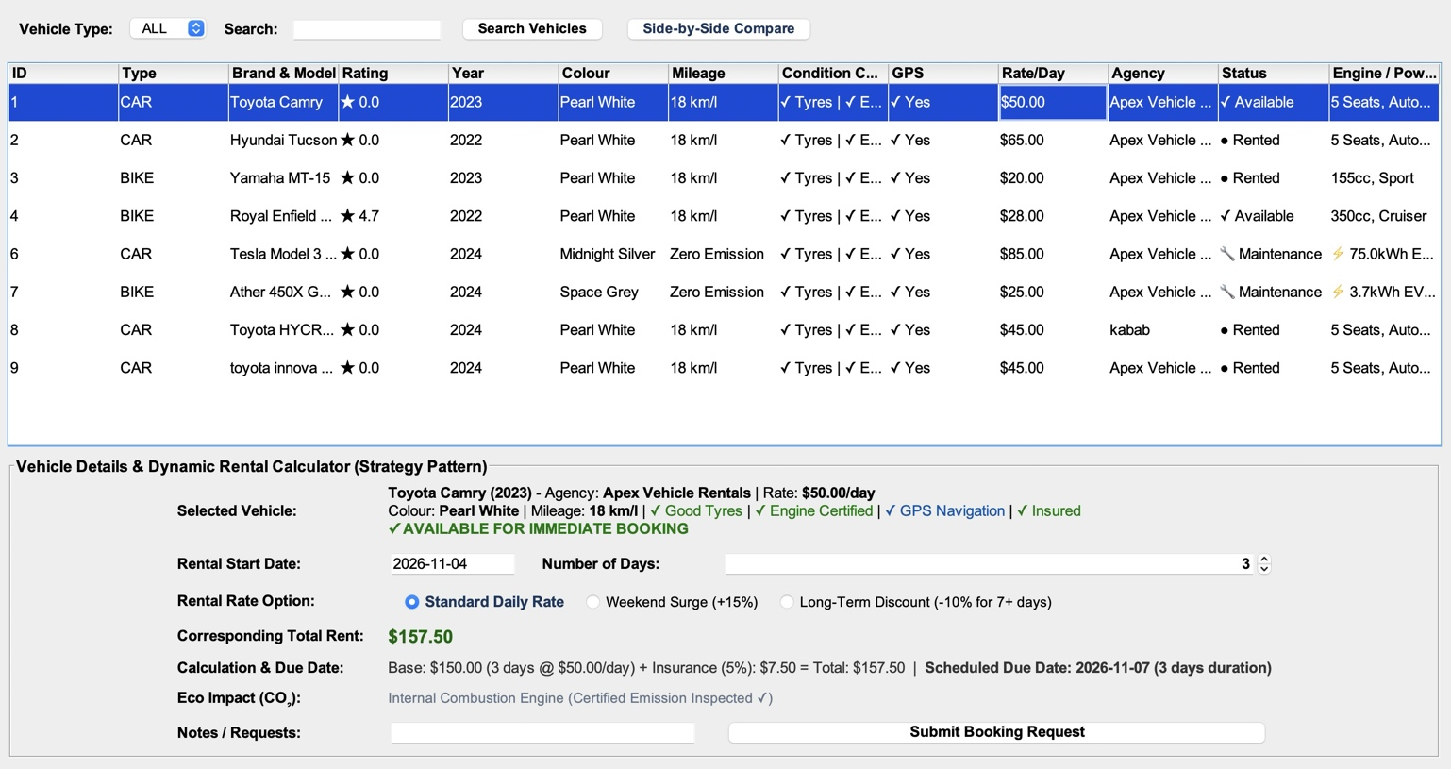
Figure 7: Interface Screenshot 7

Figure 8: Customer "My Bookings" with Real-Time Due Status Alerts
Customer bookings view showing status badges and return deadline warning banners.
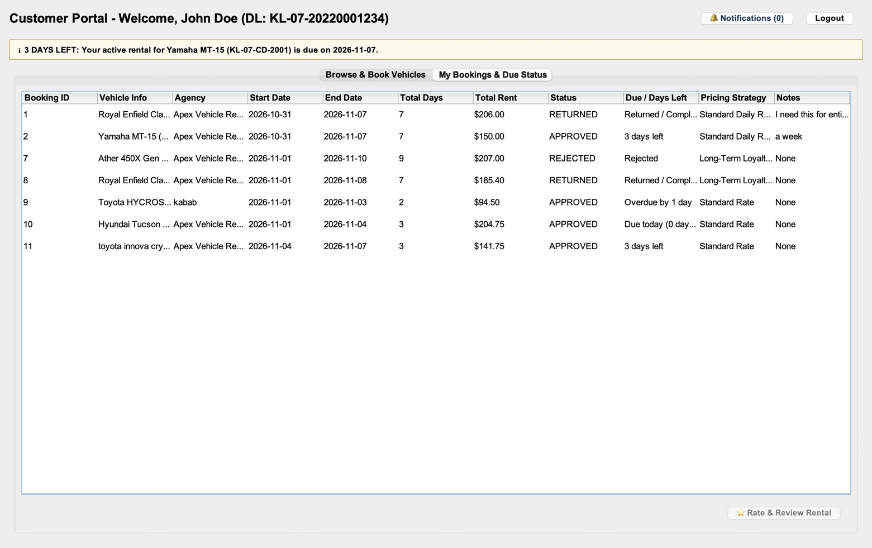
Figure 8: Interface Screenshot 8

Figure 9: Customer Star Rating & Review Submission Dialog
Post-rental review dialog allowing customers to rate vehicles from 1 to 5 stars with feedback comments.
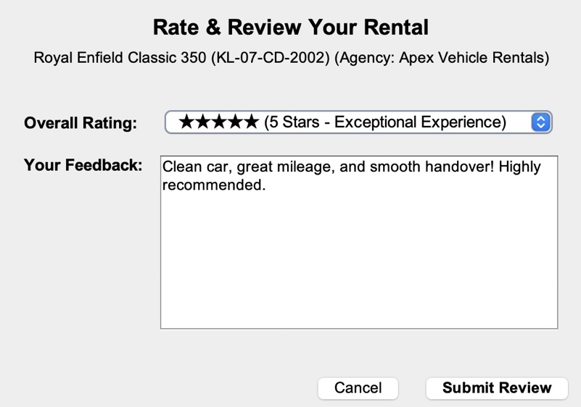
Figure 9: Interface Screenshot 9
Figure 10: Agency Dashboard – Fleet Inventory Management
Agency dashboard showing fleet management with vehicle statuses, specifications, and mechanical checkmarks.
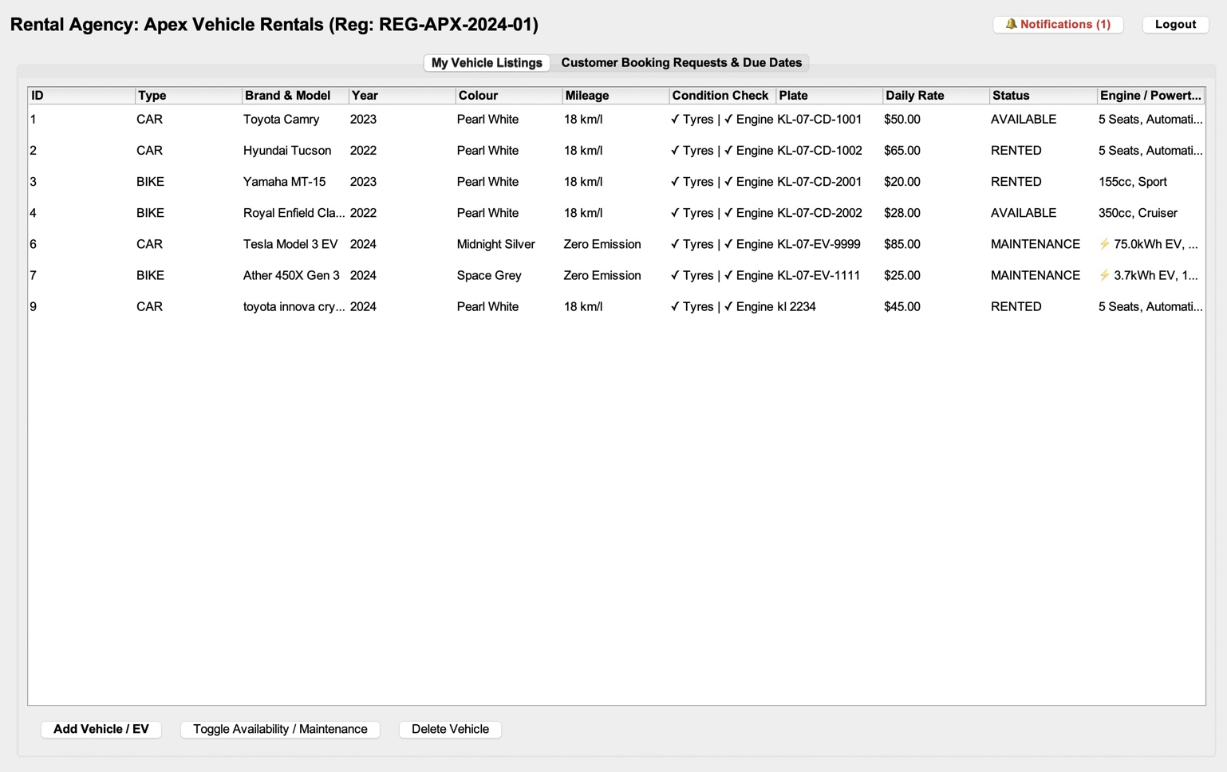
Figure 10: Interface Screenshot 10

Figure 11: Agency Add Vehicle Dialog (ICE & Electric Powertrain Setup)
Vehicle creation modal supporting Cars, Bikes, and Electric vehicle attributes.
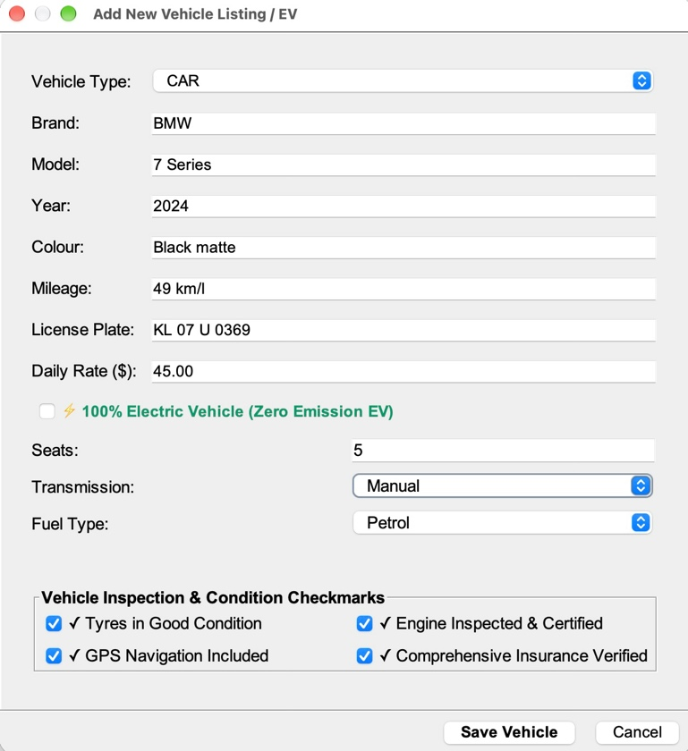
Figure 11: Interface Screenshot 11
---
Figure 12: Agency Booking Requests & Approval Workflow
Agency booking queue showing pending customer reservations with Accept and Reject actions.
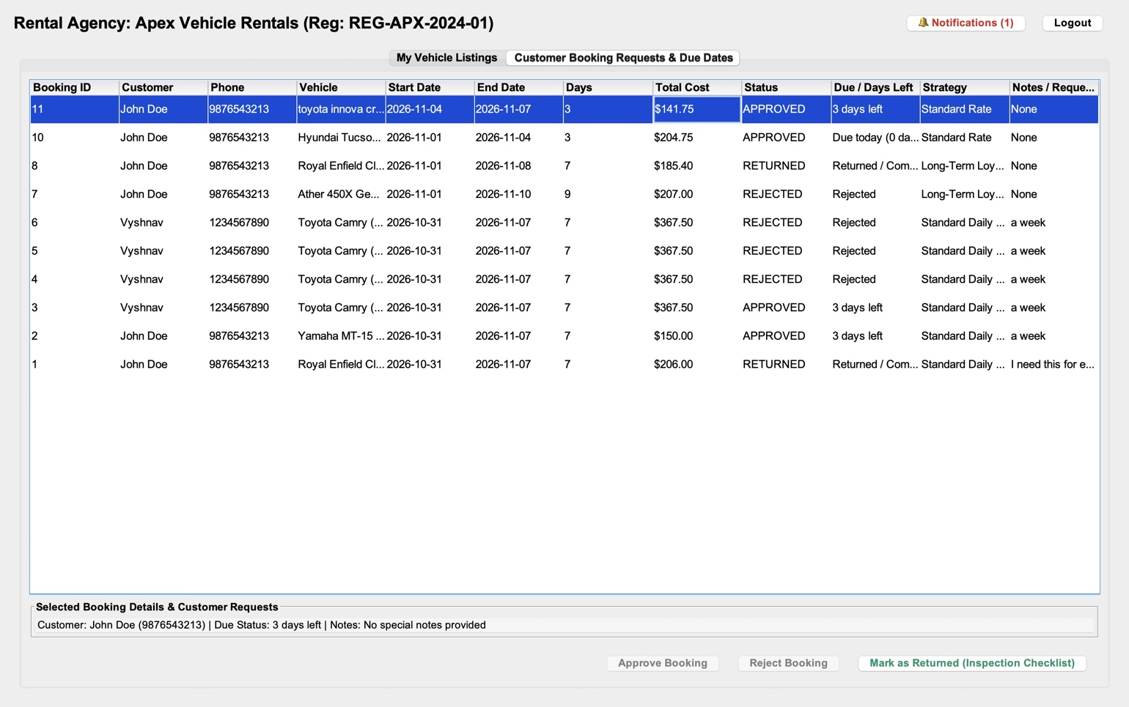
Figure 12: Interface Screenshot 12
---
Figure 13: Agency Return Inspection & Settlement Dialog
Vehicle inspection dialog for calculating overdue day penalties, fuel replenishment fees, and damage charges.
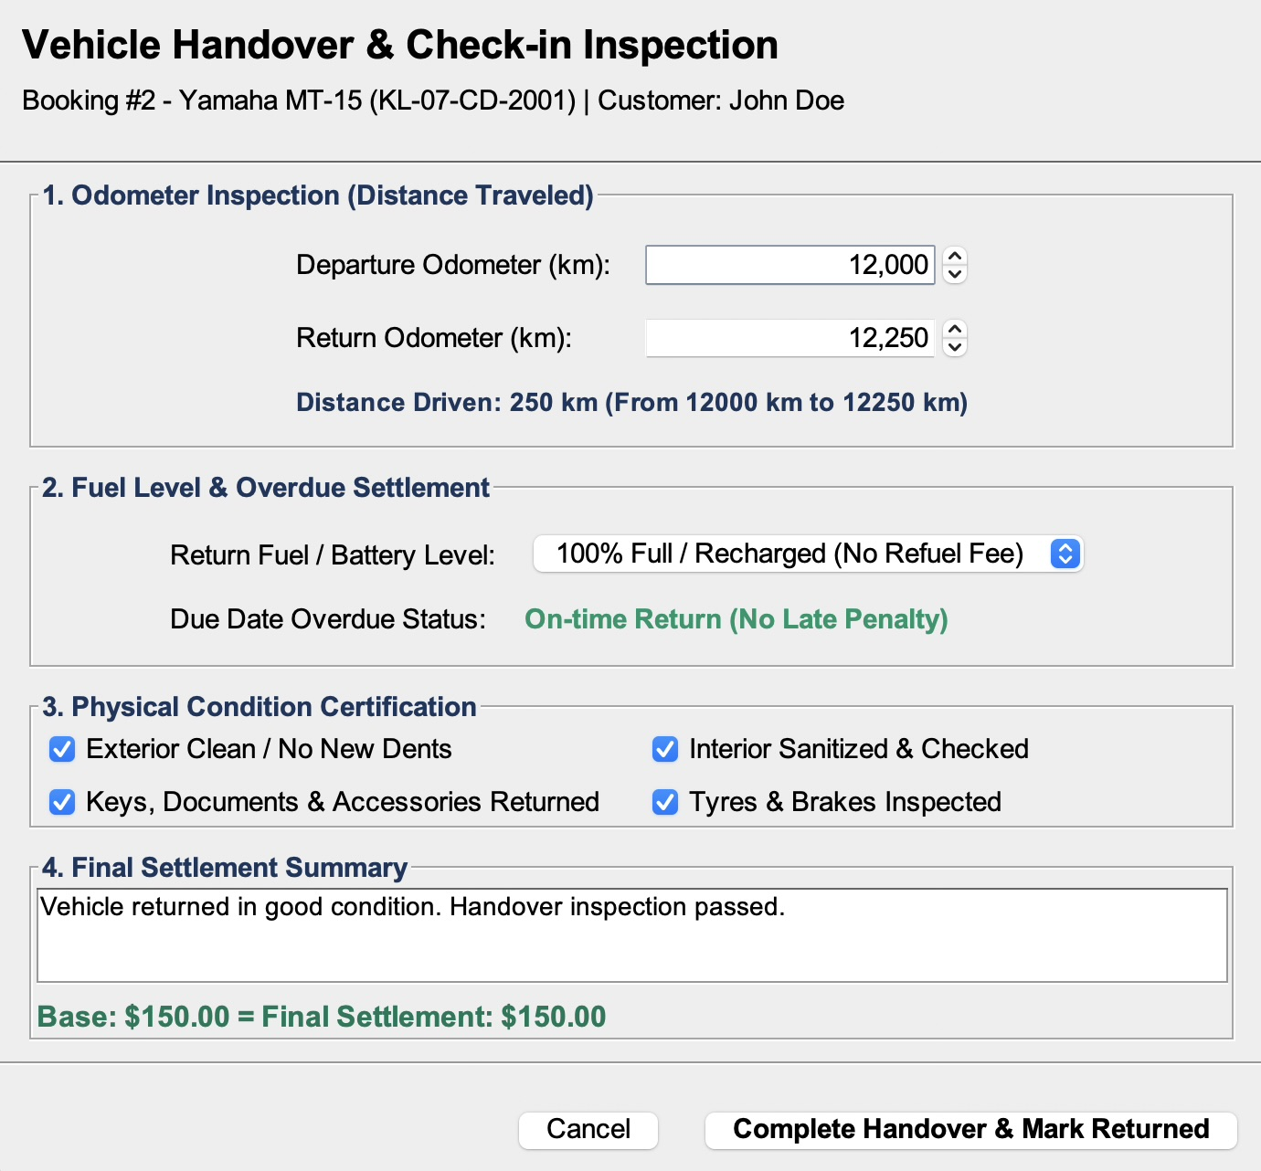
Figure 13: Interface Screenshot 13

Figure 14: Admin Dashboard – Agency Partner Directory & Approvals
Administrator dashboard displaying registered agencies with pending, accepted, and rejected statuses.
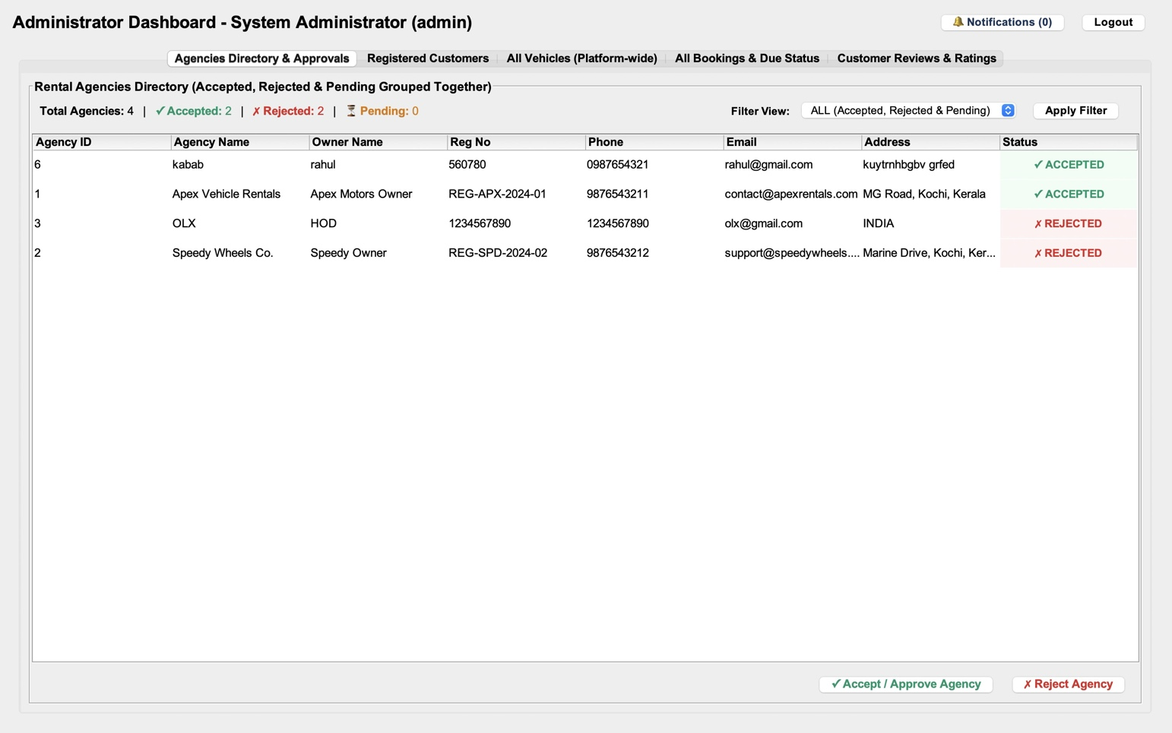
Figure 14: Interface Screenshot 14

Figure 15: Admin Dashboard – Registered Customers Directory
Platform-wide customer table showing customer IDs, usernames, contact numbers, and driving license numbers.
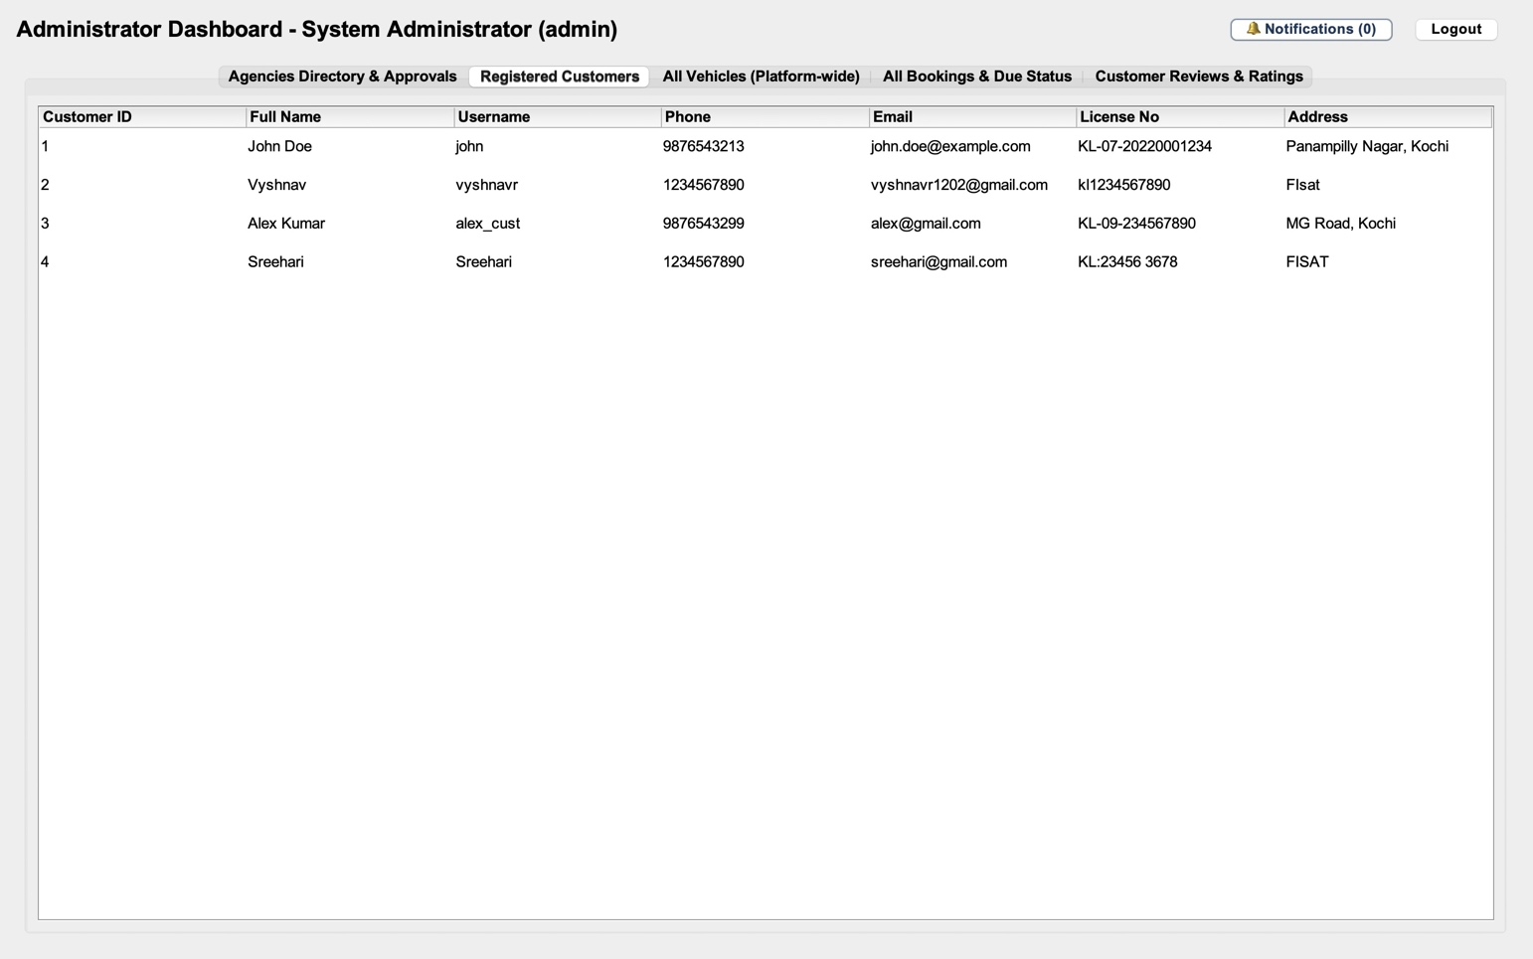
Figure 15: Interface Screenshot 15
---
Figure 16: Admin Dashboard – Platform-Wide Fleet Registry
Administrator fleet inventory table monitoring all vehicles listed across all approved agencies.
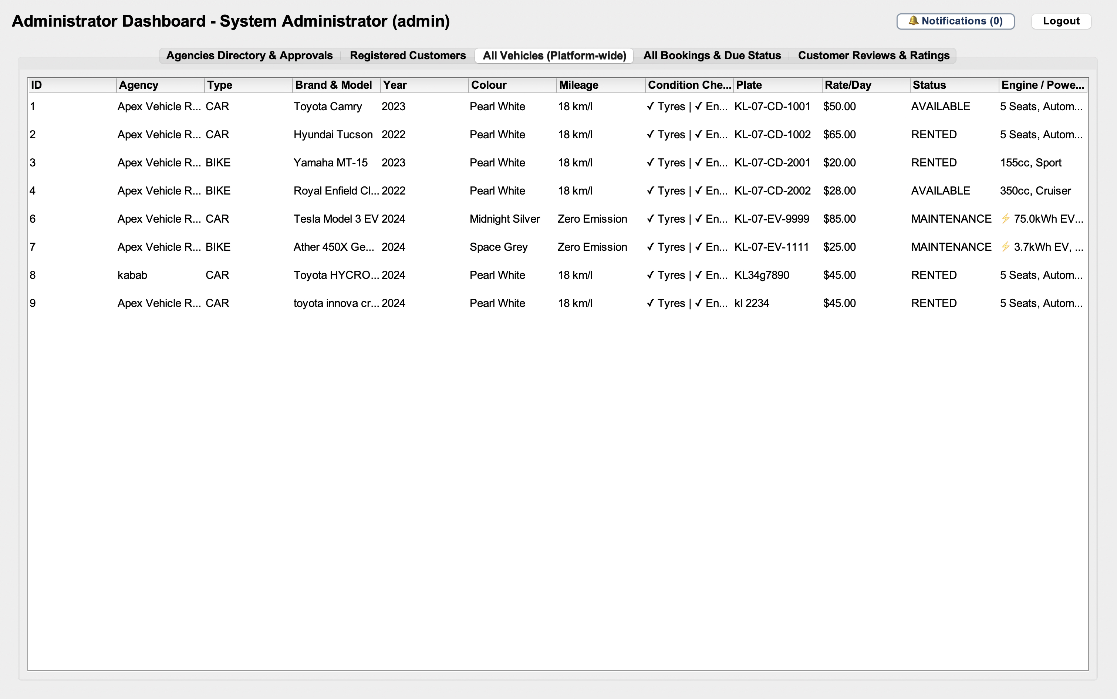
Figure 16: Interface Screenshot 16
---
Figure 17: Admin Dashboard – Global Bookings & Live Due Status Registry
Administrator ledger displaying all platform bookings, dates, pricing strategies, and return states.
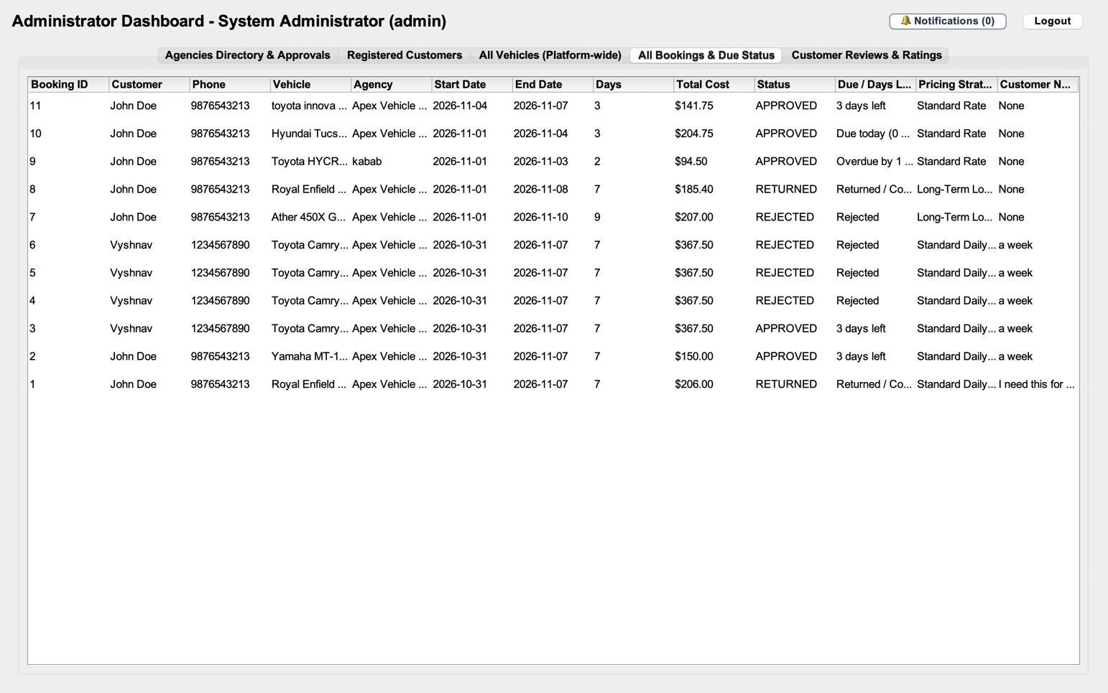
Figure 17: Interface Screenshot 17
---
Figure 18: Admin Dashboard – Customer Feedback & Star Ratings Registry
Administrator review monitoring table displaying all submitted reviews and star ratings.
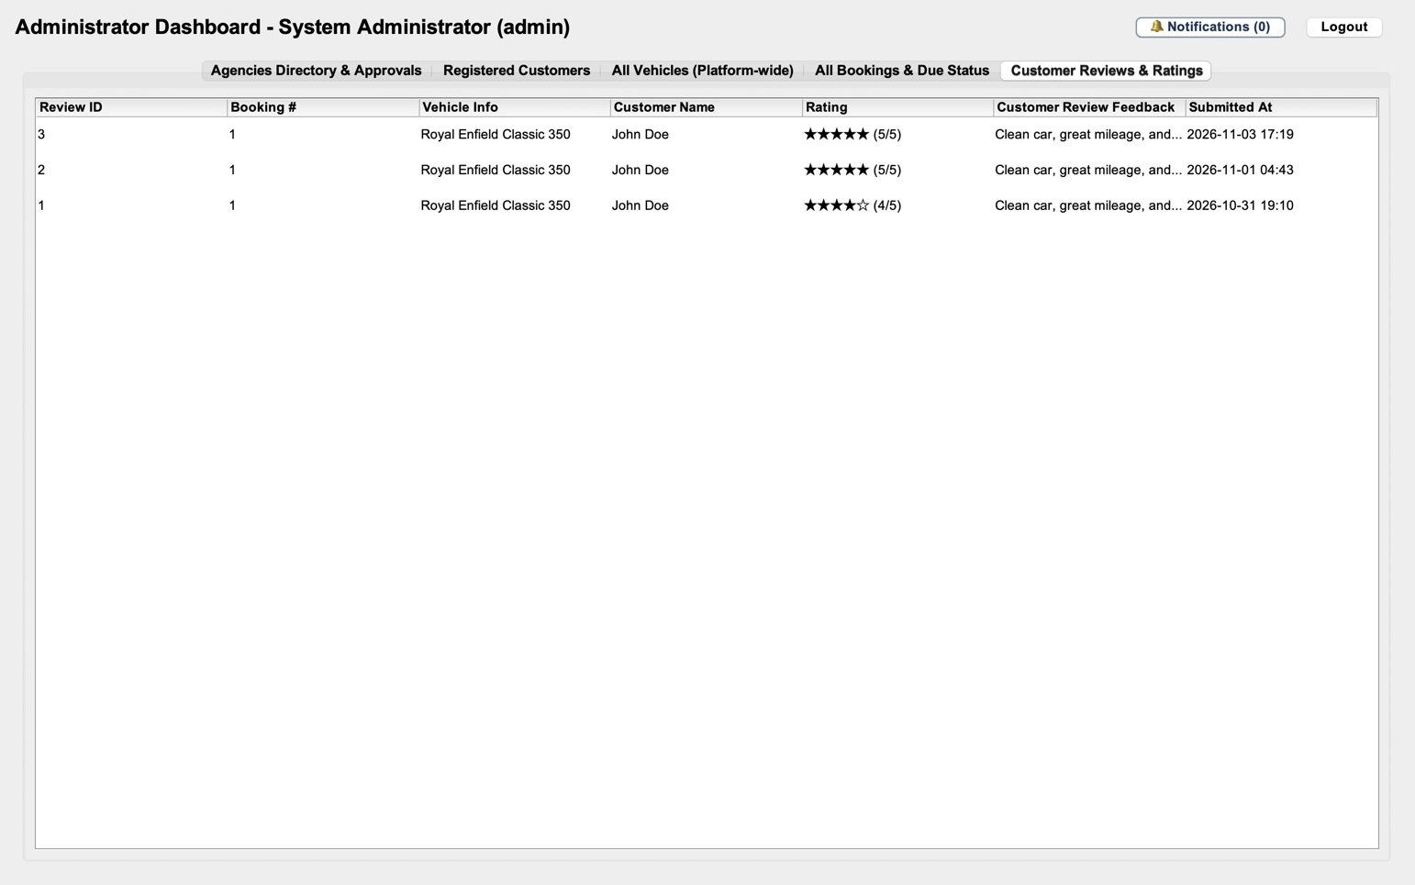
Figure 18: Interface Screenshot 18
---
Figure 19: In-App User Notification Center Dialog
Popup dialog displaying real-time system alerts and booking notifications.
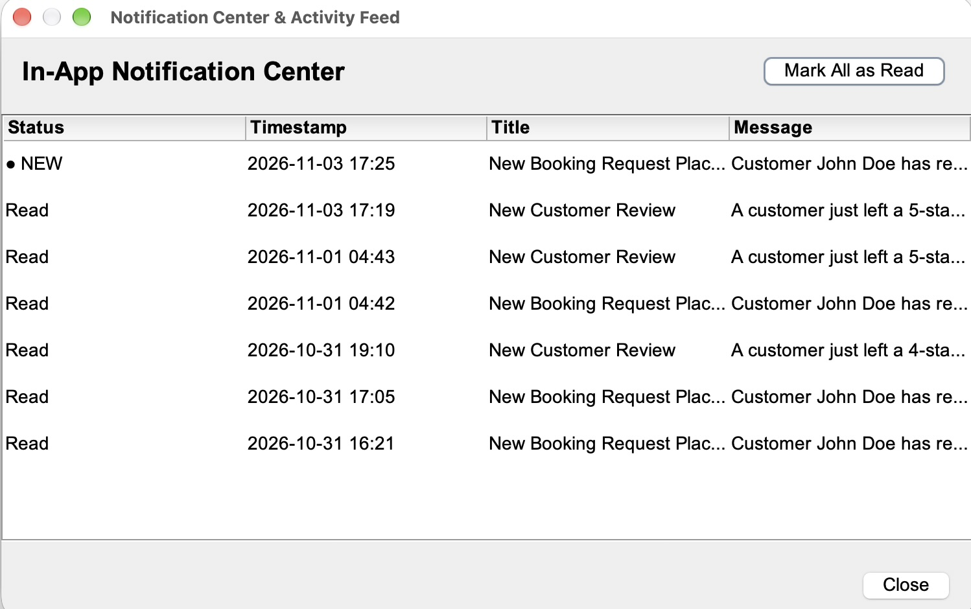
Figure 19: Interface Screenshot 19

