# Project Documentation for Advanced Notepad

By

Mr. Rohan Viraj Deshpande

Index:

1. System Study
   1. Existing System
      1. Title
      2. Platform Used
      3. Features
      4. Drawbacks
   2. Proposed System
      1. Need
      2. Features
      3. Benefits over Drawbacks of Existing System
      4. End User
   3. Analysis Phase
      1. Use Case Diagram
      2. Analysis level Class Diagram
   4. Design Phase
      1. Design level Class Diagram
      2. Activity Diagram
      3. Sequence Diagram
      4. State Diagram
      5. Deployment Diagram
      6. Collaboration Diagram
   5. Screen Shots
   6. Data Dictionary
   7. Testing Phase
      1. Form-Wise Validation
   8. Future Enhancement
   9. References

Existing System:

**Title:** Notepad

**Platform Used:** Windows

**Database Used:** None

**Features:**

1. We can align (left, center, right) a page of our document in any desired way
2. We can find any word & replace it if desired
3. We can get the current date & time
4. All the basic formatting features such as fonts (font type, font size, font style & script) can be used

Existing System:

**Drawbacks:**

1. Toolbar provided is not user-friendly
2. Uppercase to Lowercase conversion & vice-versa has to be done manually
3. Unable to open Multiple tabs in one window
4. Calculator is not provided
5. Themes are not provided
6. Programming language support not available
7. Auto-Save support not available
8. Spell check is not possible
9. Read-Only feature not possible

Proposed System:

**Title:** AdvancedNotepad

**Need:** An editor which can be useful for both programmers & non – programming background people.

**Features:**

1. User-friendly Toolbar provided
2. Multiple Tabs can be opened in a single window
3. Auto-Save feature provided
4. Programming language support like keyword coloring & parenthesis matching provided
5. Uppercase to lowercase conversion & vice versa possible
6. Spell-check feature provided
7. Various Themes provided
8. Read-Only feature provided
9. Inbuilt Calculator provided

Proposed System:

**Benefits over Drawbacks of Existing System:**

1. Toolbar provided to simplify usability of the interface/application
2. Multiple Tabs can be opened in a single window. So simplicity and ease of access for comparison if related documents are opened
3. Auto-Save feature provided for overcoming data loss due to various reasons
4. Programming language support like keyword coloring & parenthesis matching for budding programmers to differentiate between keywords & variables
5. Spell-check feature provided to avoid spelling mistakes
6. Read-Only feature provided, to stop anyone from modifying your document in your absence

**End User:** Any Computer User

Analysis Phase: Use Case Diagram

Modify contents of the File

Open File

Create File

Open Notepad

Save the File

Print the File

Acquire Help

Closes the Notepad

**Process Name:** Advanced Notepad

1. **Actor:** User
2. **Pre-condition:** For opening a file it has to be a text file
3. **Post-condition:** We can save only text files
4. **Flow of Events:**

* User opens the Notepad application
* User opens or creates a File
* User modifies the contents of the File
* User saves the contents of the File
* User changes the theme if desired
* User closes the file
* User closes the Notepad application

**Exceptions:**

* File already exists
* File cannot be opened because it is not of specific data type
* Invalid File-name or File-Type
* File could not be found
* File cannot be saved because it is not of specific data type
* Cannot close any tab after all the tabs have been closed
* Cannot perform undo/redo operation after a specified value
* Arithmetic Exceptions have been handled

Analysis Level Class Diagram

Notepad

User

*

1

Design Phase:

Class Diagram (Design Level)

USER

NOTEPAD

FILE_ID: INTEGER

_

_

U_ID: INTEGER

U_NAME: String

FILE_NAME: STRING

#

*

8

_

1

modify()

open()

print()

save()

getHelp()

close()

Activity Diagram

N

Y

OPEN NOTEPAD

OPEN / CREATE FILE

UNABLE TO OPEN

MODIFY FILE

SAVE FILE

CLOSE NOTEPAD

CHANGE THEME

OPEN CALCULATOR

EDIT FILE

Sequence Diagram

SUCCESSFUL?

State Diagram

NOTEPAD: APPLICATION

APPLICATION CLOSED

CLOSE NOTEPAD

SEND HELP

ACQUIRE HELP

SAVE THE FILE

FILE SENT TO SERVER

IF CONFIRMED

CONFIRMATION

AUTO - SAVE REQUEST

MODIFY THE FILE

AUTO-SAVE CONFIRMED

REQUEST TO FILE SERVER

OPEN/CREATE FILE

OPEN NOTEPAD

IF CONFIRMED

FILE SERVER

USER

IDLE

USE CALCULATOR TO DO THE DESIRED OPERATIONS

CREATE A NEW FILE

CLOSE

FILE

OPEN NOTEPAD

OPEN NOTEPAD

WANT TO USE THE CALCULATOR?

WANT TO APPLY THEMES?

APPLY THEMES

OPEN FILE FOR WRITING / READING THE FILE

IDLE

Collaboration Diagram

1: OPEN NOTEPAD

2: OPEN / CREATE FILE

3: MODIFY THE FILE

5: SAVE THE FILE

6: ACQUIRE HELP

2.1: FILE REQUESTED

4: AUTO - SAVE

5.1: FILE SENT TO SERVER

5.2: AFTER CONFIRMATION

4.1: AUTO - SAVE

2.2: IF CONFIRMED

5.3: CONFIRMATION

7: CLOSE THE NOTEPAD

USER

**NOTEPAD APPLICATION**

**FILE SERVER**

Deployment Diagram

NOTEPAD APPLICATION

<< APPLICATION

SERVER >>

<< FILE SERVER >>

Screen Shots:

**Main** **Screen:**

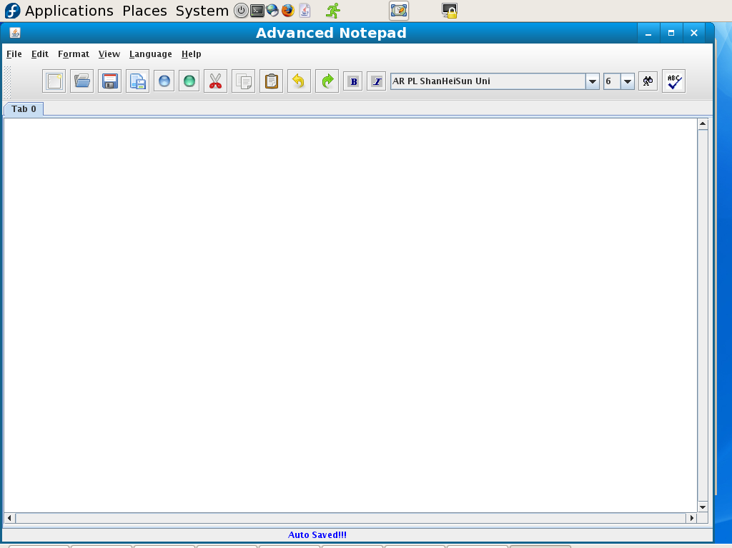

# C Language:

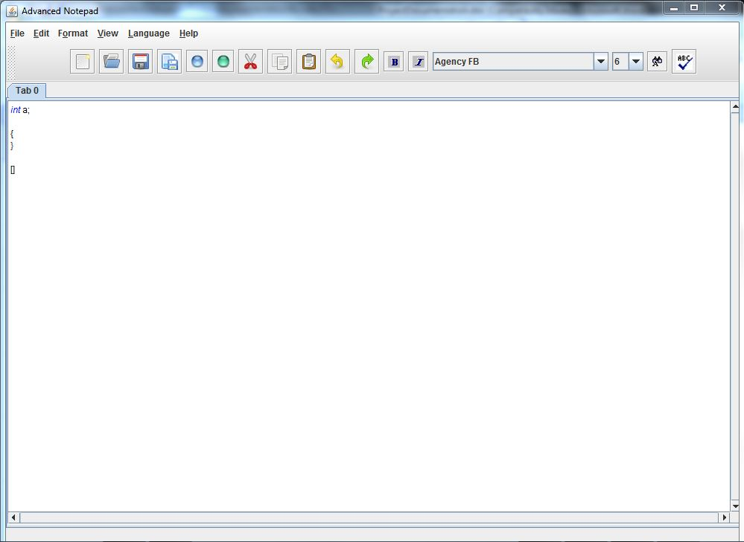

# Java Language:

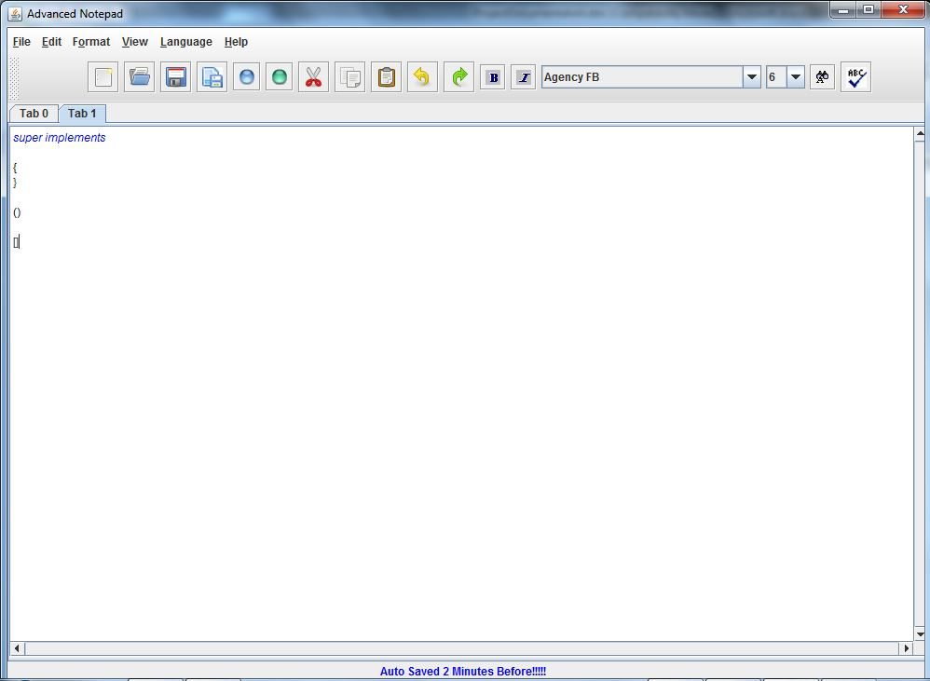

**Spell Check:**

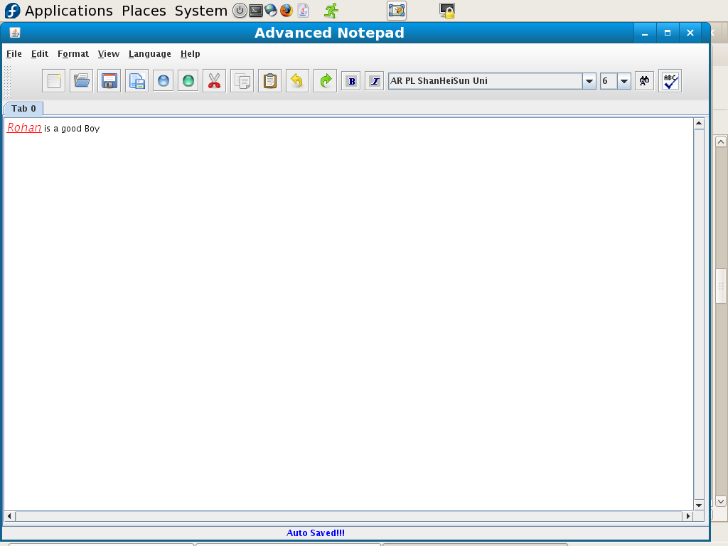

Themes

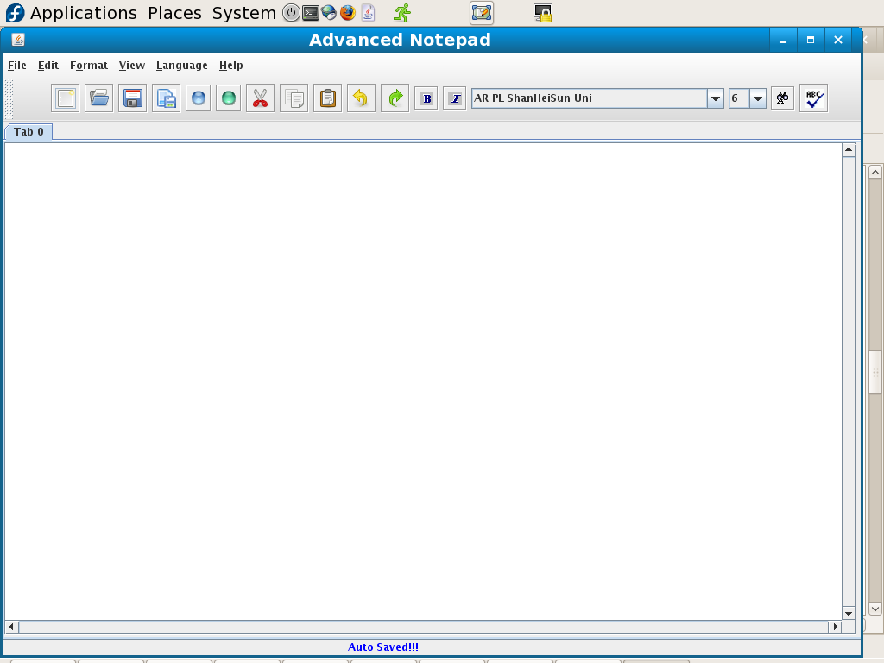**Metal:**

**Motif:**

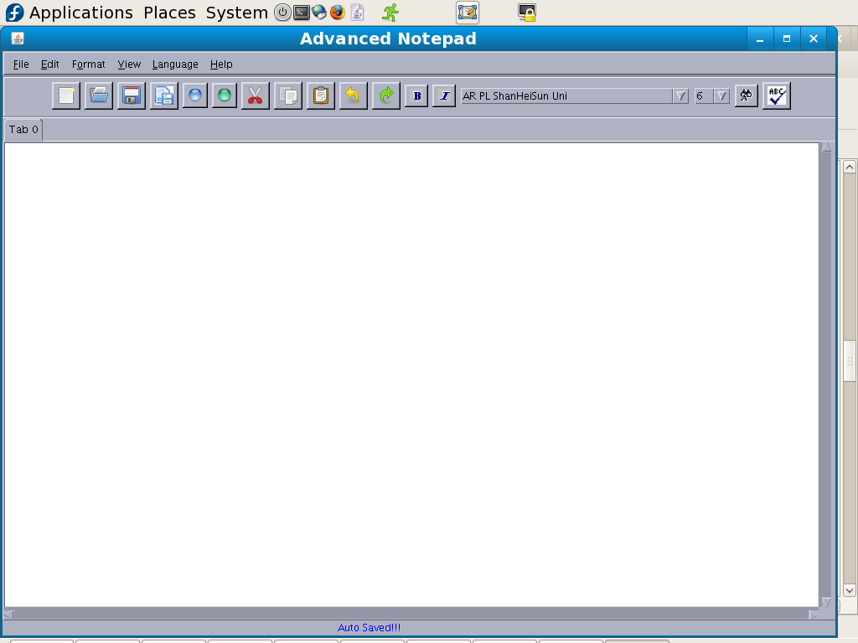

**Nimbus:**

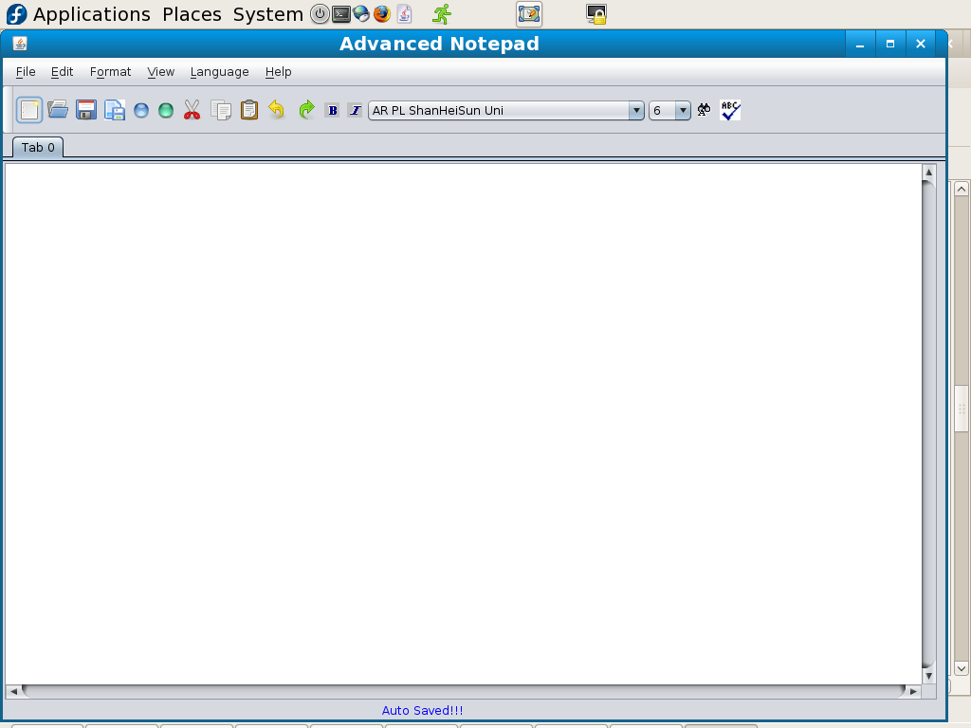

Testing Phase: Form–wise Validation

**While Opening a File:**

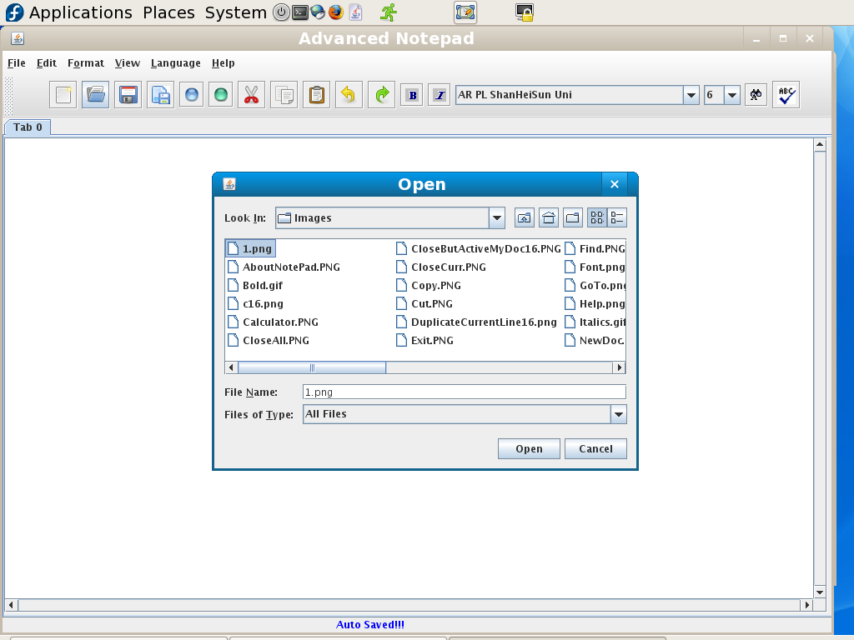

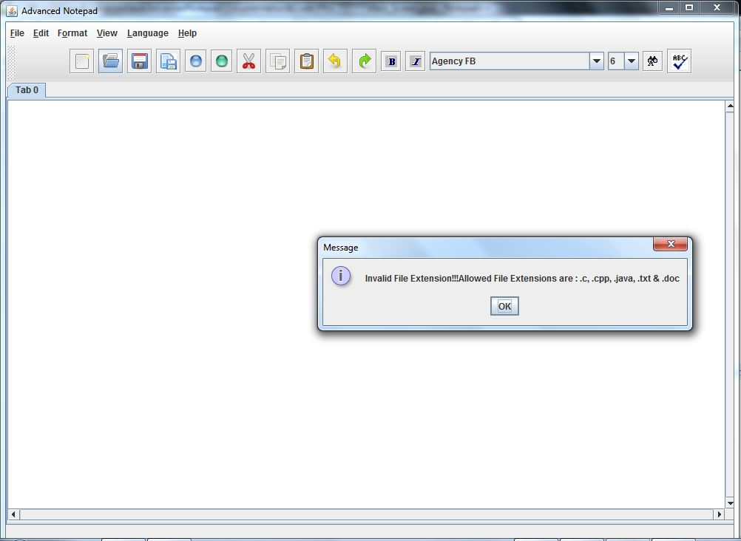

**While Saving a File:**

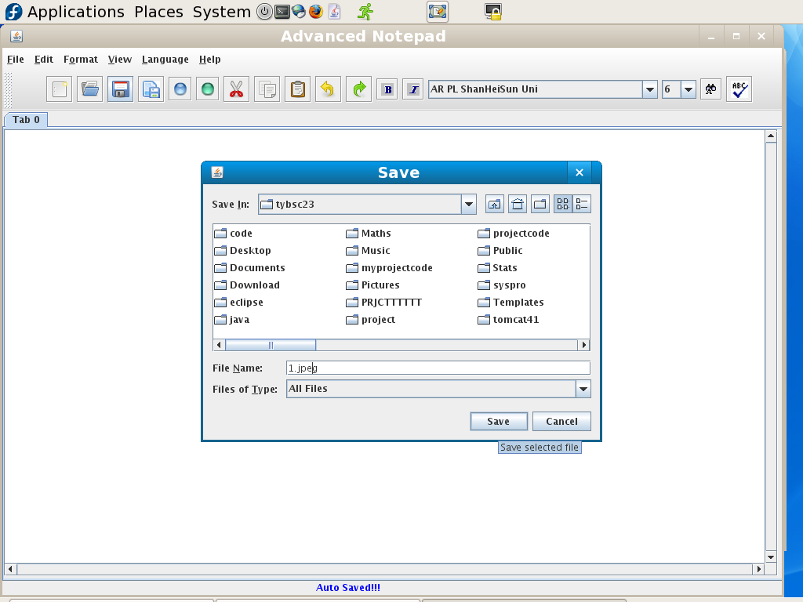



**Undo:**

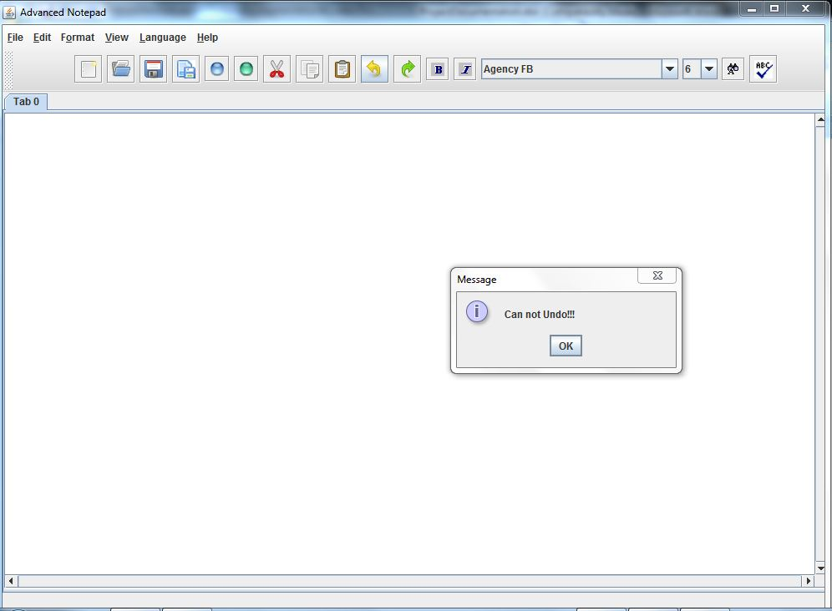

**Redo:**

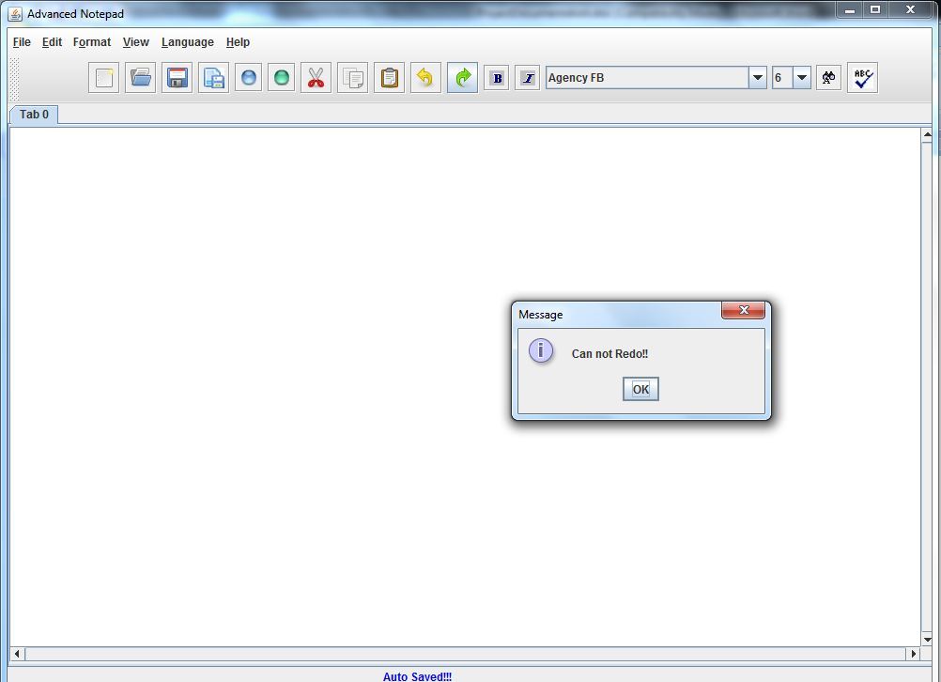Testing Phase Validations:

1. While opening a file or while saving a file, the file has to compulsorily be a text file i.e. it can have any one of the following extensions only otherwise an exception message is thrown:

* .txt
* .c
* .cpp
* .java

1. We cannot perform undo or redo beyond a certain limit

Future Enhancements:

1. To add a C/C++ Compiler & Java Compiler to our project to create it into an independent Integrated Development Environment (i.e. an IDE)
2. Auto-Indentation feature will be provided
3. Offer two options during installation:
   1. Standard Package: Regular installation for the normal user
   2. Custom Package: Advanced installation for programmers
4. Complete interactive document support for images, charts, tables etc.
5. User lock to protect/restrict modification of files
6. Incorporating & Supporting Hyperlinks
7. Text narrator – read out onscreen contents
8. Scientific Calculator
9. Virtual Keyboard

References:

1. [www.stackoverflow.com](http://www.stackoverflow.com)
2. en.wikipedia.org
3. [www.java-examples.com](http://www.java-examples.com)
4. [www.docs.oracle.com](http://www.docs.oracle.com)