SQL – Relational DB’s

Relational DB’s – Data is stored in rows & columns

We have a pre-defined data structure:



But if we want to add new emails, we have to overwrite or add new columns:



This is what will happen if we have to add multiple email addresses or addresses or phone numbers and not everyone has multiples of everything so specifies

users not having multiple values, so they will be blank. So the RDBMS is getting bloated with multiple empty or NULL fields.

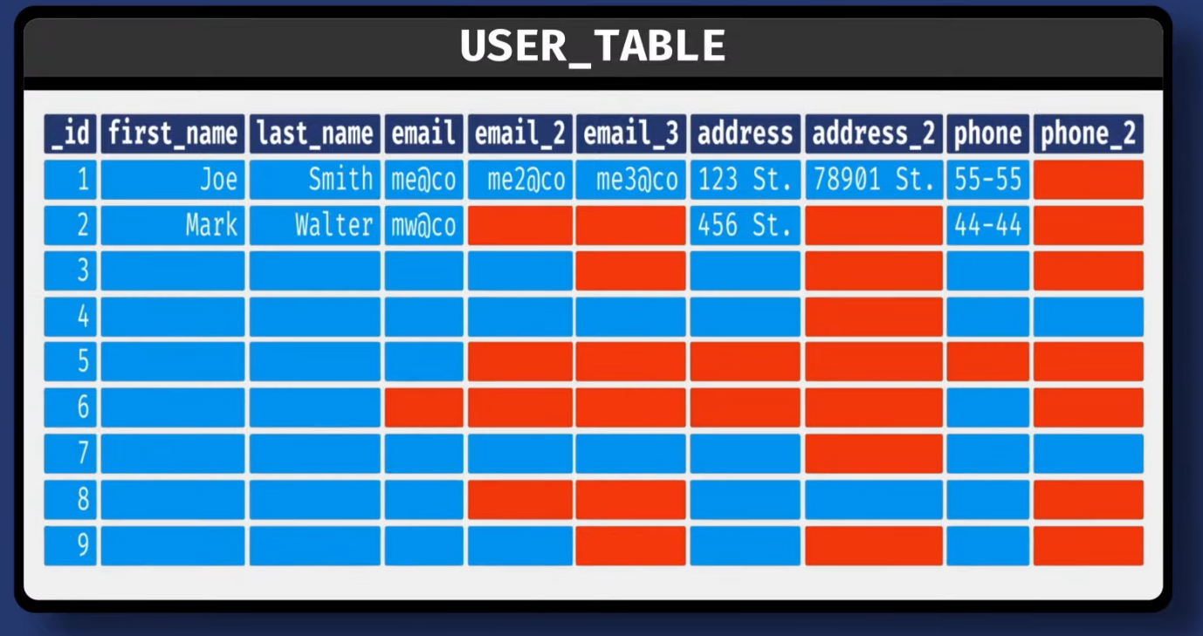

So to overcome this we can create multiple tables for Email-Address, Address and Phone and then Join them based on the UserID. So, to access information about a Single User, we need to traverse three tables based on the join and then get the Data.

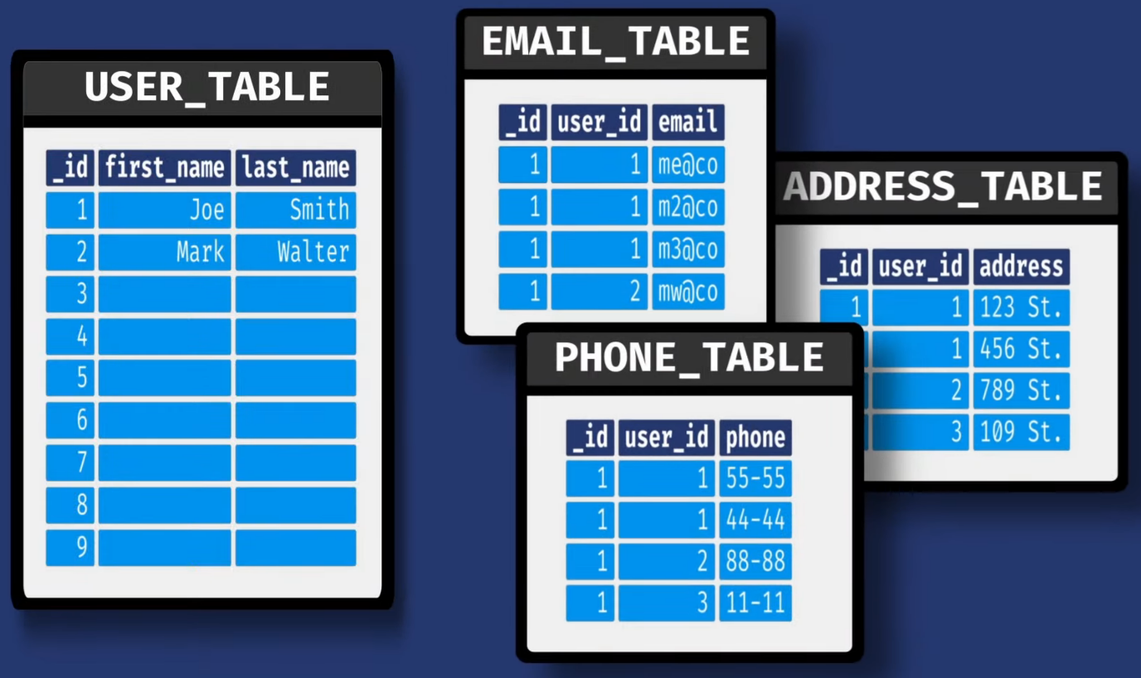

Schema Structure has to be Pre-defined and the Values it contains are rigid.

We have to store particular values in particular columns and if we want to save some different type we have to alter the entire column’s datatype or handle from Programming Language end.

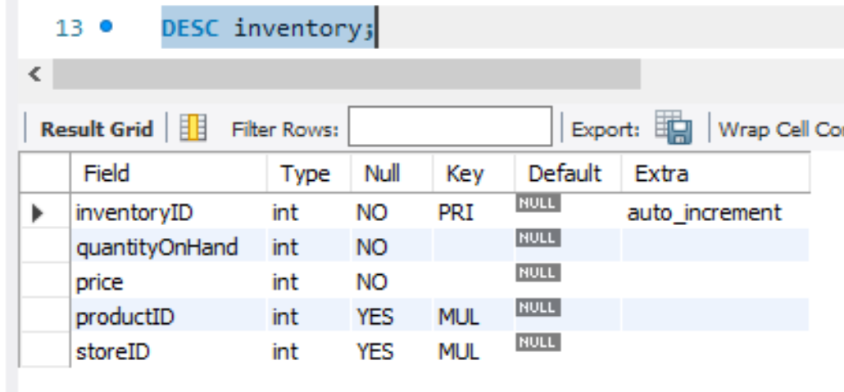

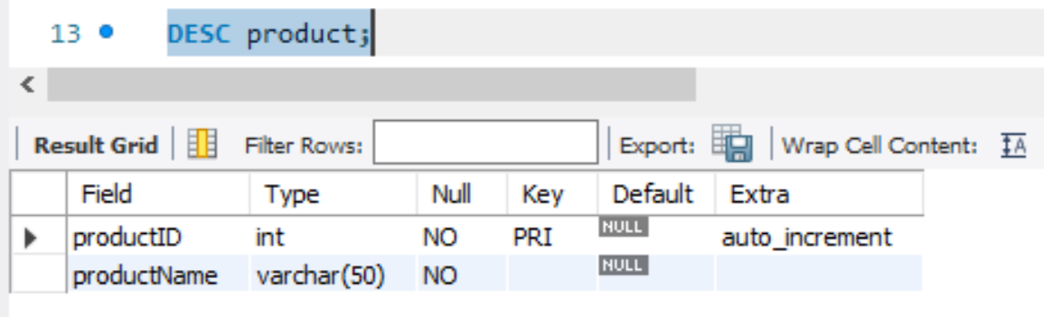

To Scale your RDBMS, you have to do either Vertical Scaling or Horizontal Scaling, both of which have their own Cost and Issues.

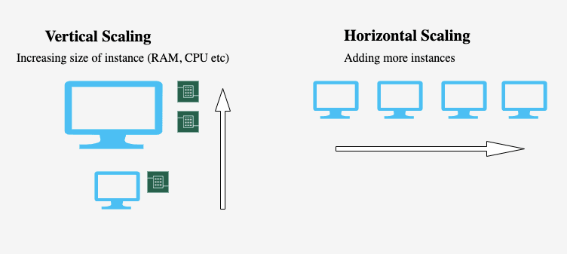

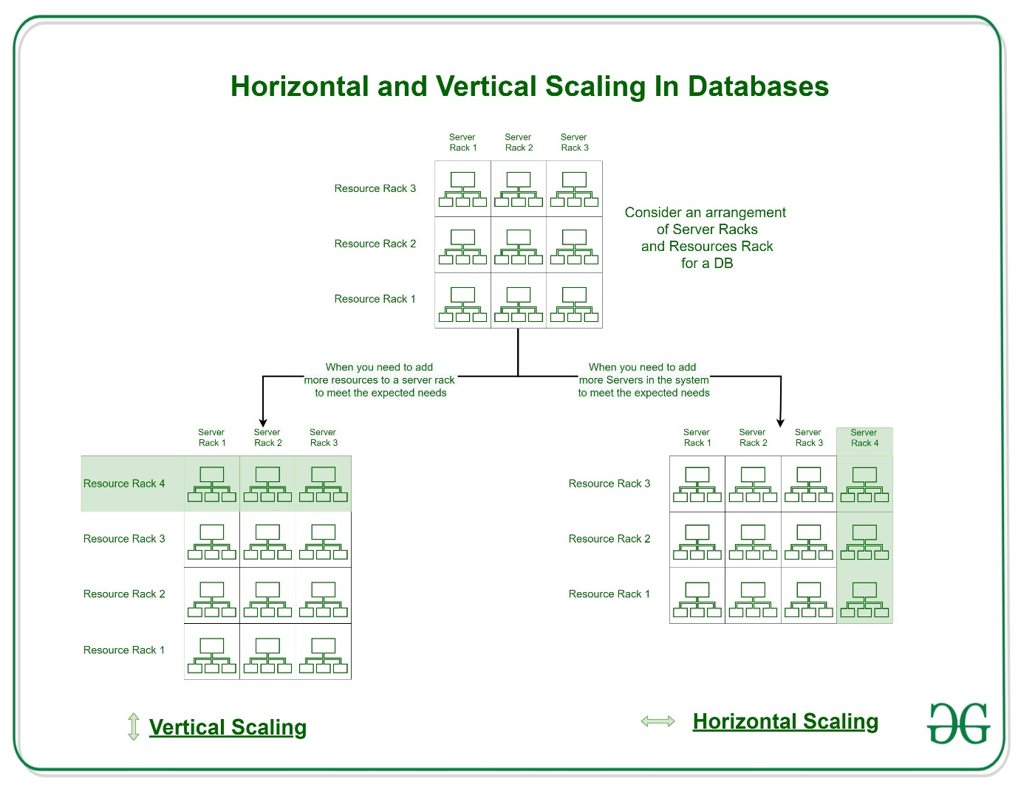

NoSQL – Not Only SQL Databases

We can Store Data differently, based on the NoSQL Implementation.

Types of NoSQL DB’s

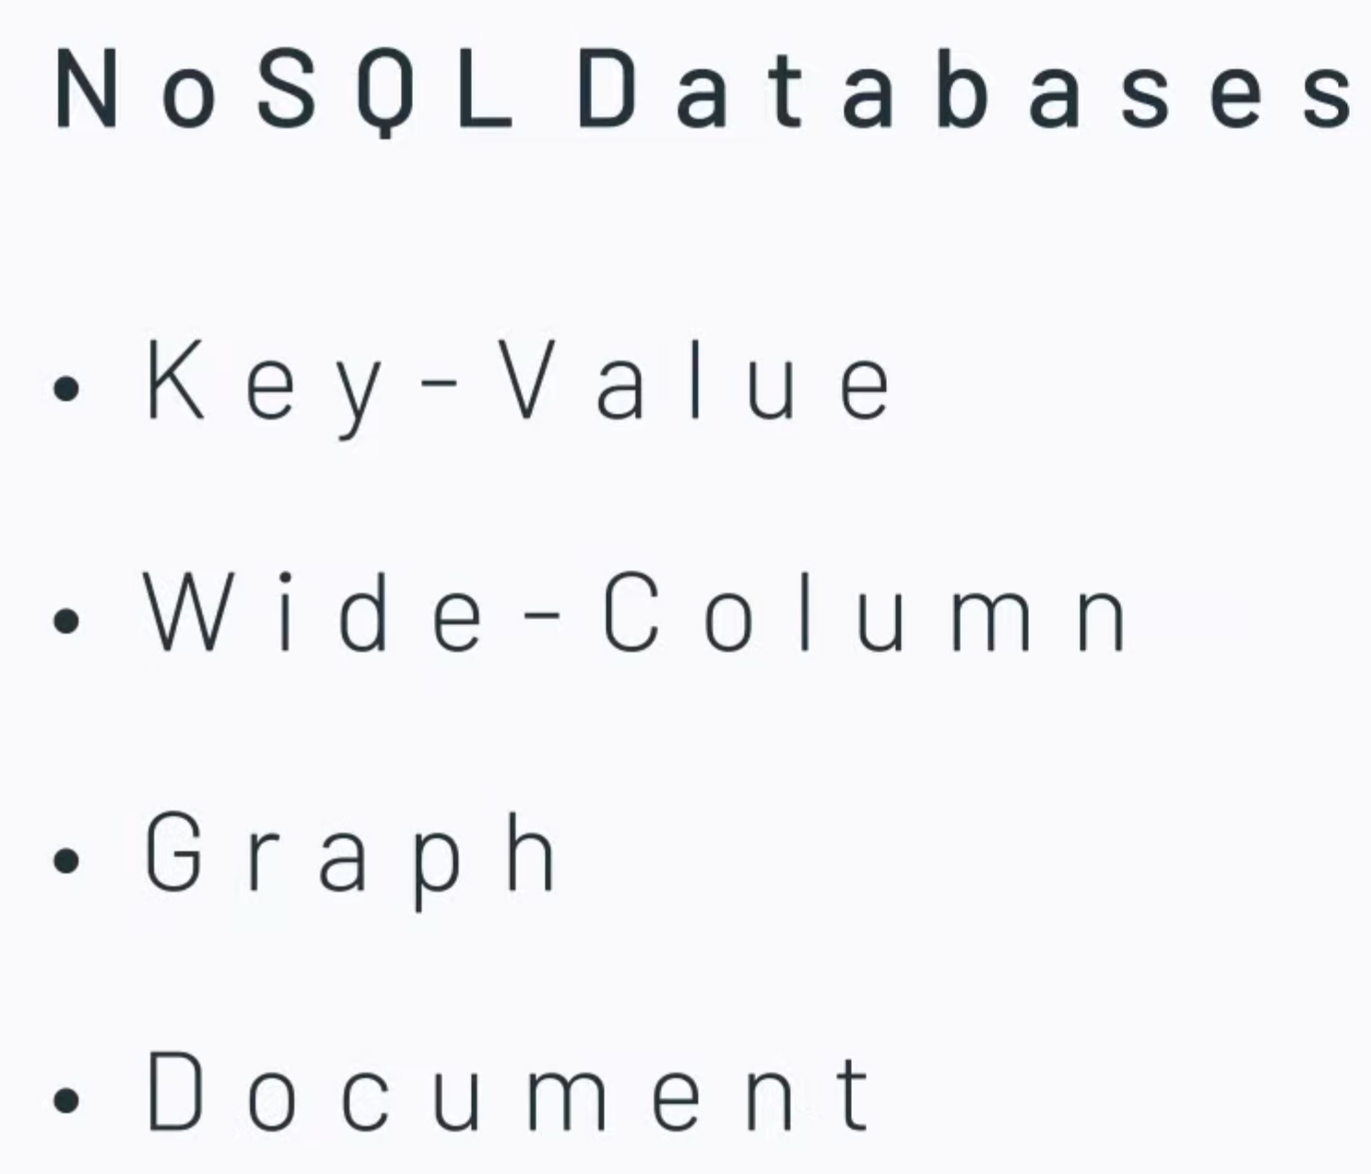

MongoDB is a Document DB where data is Stored in Documents instead of Rows & Columns.

So Instead of Storing values in Multiple Columns or Multiple Tables and then Joining Them Document DB’s Store them as JSON Arrays s we can easily Add Multiple Values For Address, Phone and Email-Address as below:

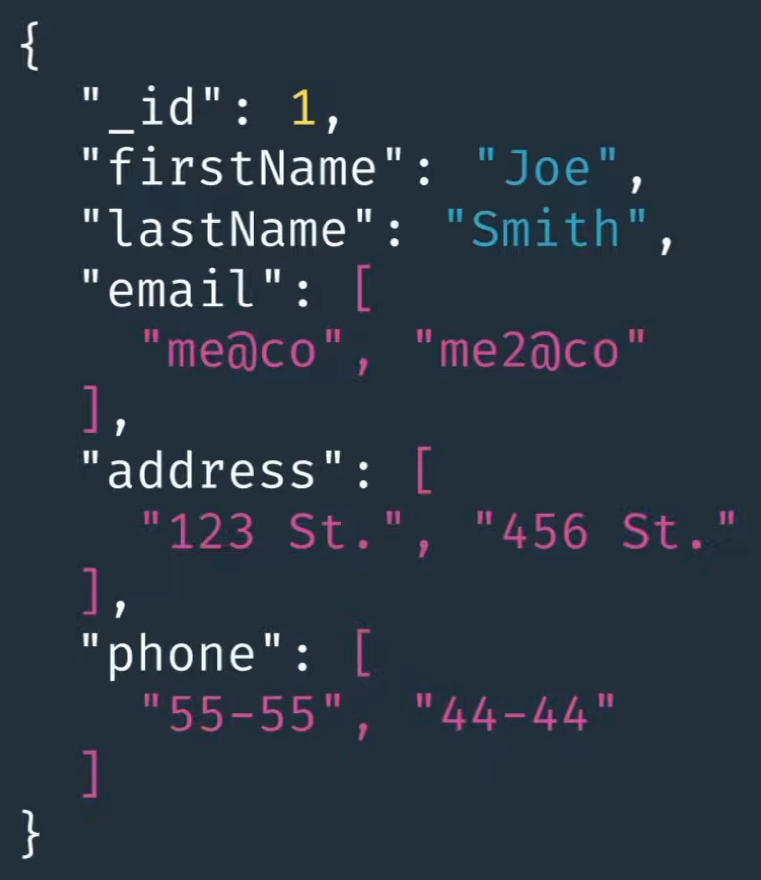

**Single Document Stores the Data in a Single Object instead of Splitting it into multiple Columns/Values – Thus, this makes the Data-Retrieval faster.**

Data is Stored as Binary JSON or BSON format, which provides added advantage to Store multiple Data-types.

Schema has no Rules so you can Store any Values in Any Format as needed.

MongoDB documents scale Horizontally so instead of having a single machine, Data can be distributed among multiple cheap servers.

SQL v/s NoSQL:

