# **SQL Assignment Cohort #2**

1. Identify the foreign key on [HumanResources].[EmployeePayHistory] table :
   1. SELECT TC.CONSTRAINT_SCHEMA, TABLE_NAME, TC.CONSTRAINT_NAME AS ForeignKey, CONSTRAINT_TYPE, UNIQUE_CONSTRAINT_NAME AS ParentKey FROM INFORMATION_SCHEMA.TABLE_CONSTRAINTS TC, INFORMATION_SCHEMA.REFERENTIAL_CONSTRAINTS RC  WHERE TC.CONSTRAINT_NAME = RC.CONSTRAINT_NAME AND TC.TABLE_NAME = 'EmployeePayHistory' AND TC.CONSTRAINT_TYPE = 'FOREIGN KEY';

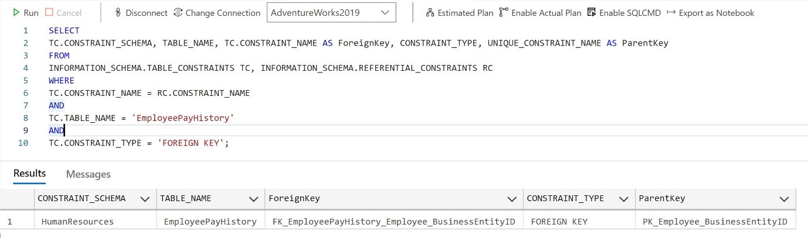

OR

SELECT CONSTRAINT_SCHEMA, TABLE_NAME, CONSTRAINT_NAME, CONSTRAINT_TYPE FROM INFORMATION_SCHEMA.TABLE_CONSTRAINTS

WHERE TABLE_NAME = 'EmployeePayHistory' AND CONSTRAINT_TYPE = 'FOREIGN KEY';

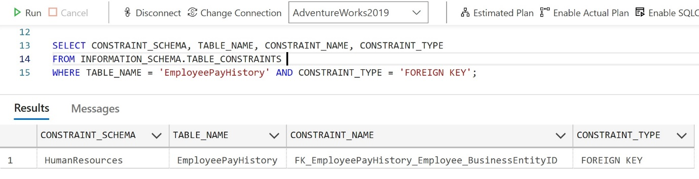

From the above queries it was clear that “BusinessEntityID” was the Primary Key in “Employee” Table which became a Foreign Key in “EmployeePayHistory” table.

1. Show all person from the person.person table with firstname Rob or Roberto: SELECT * from Person.Person where FirstName ='Rob' OR FirstName = 'Roberto';

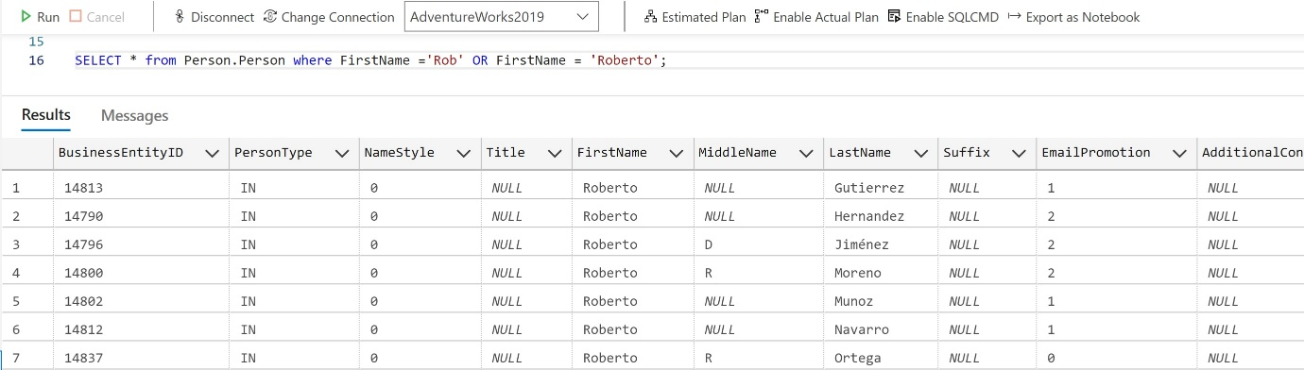

A total of 76 Users were displayed.

1. Show the first 10 records from [Sales].[SalesOrderDetail]: SELECT TOP(10) * FROM Sales.SalesOrderDetail;

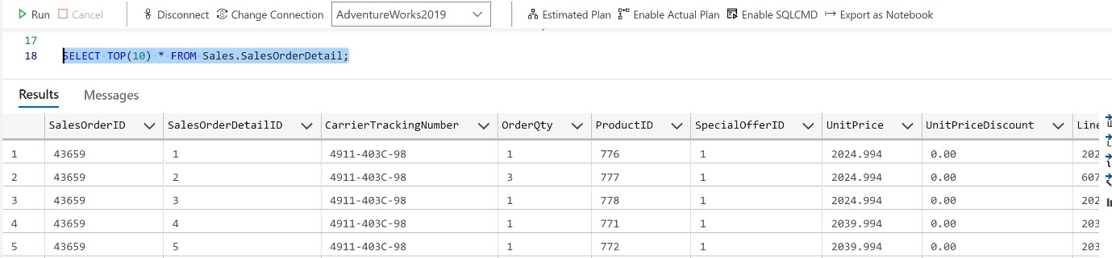

Top returned the first 10 Records from “SalesOrderDetail” table.

1. List the databases on your server: EXEC sp_databases;

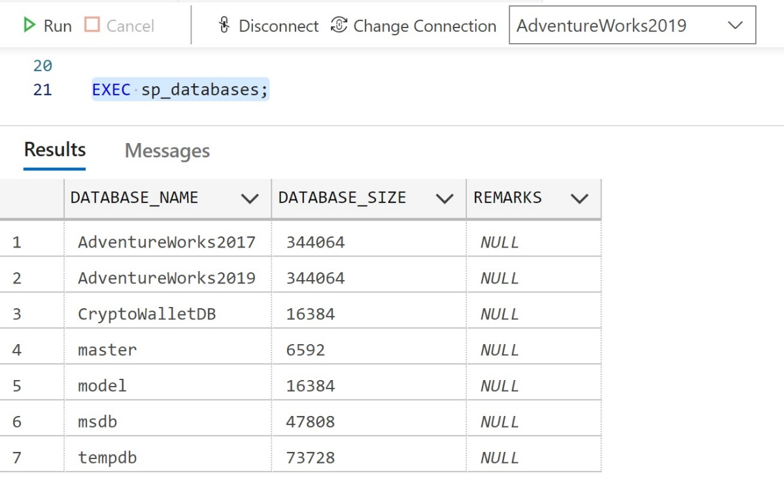

List of all the Databases in my SQL Server Instance.

1. Count how many rows in [HumanResources].[EmployeePayHistory] : SELECT COUNT(*) AS recordCnt FROM HumanResources.EmployeePayHistory;

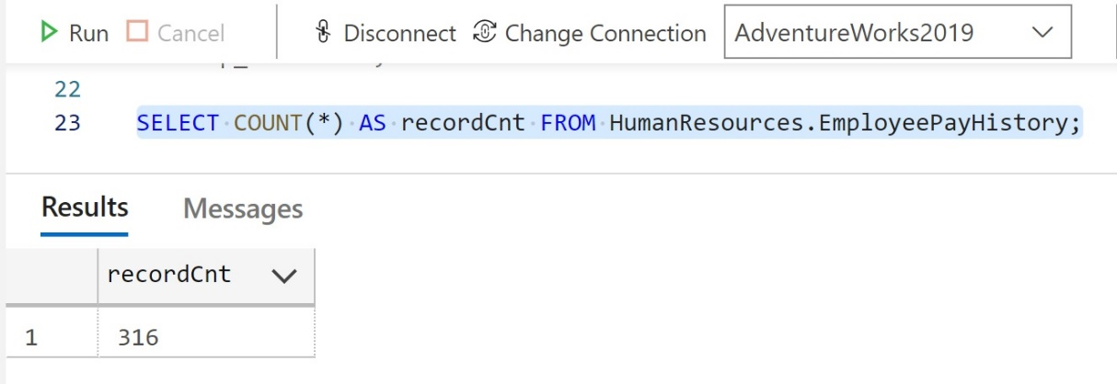

Total Records Count = 316

1. Name three relational databases: MySQL, SQL Server, SQLite and PostgreSQL

Reference Links –

* <https://devathon.com/blog/mysql-vs-postgresql-vs-sqlite/>
* <https://www.datacamp.com/blog/sql-server-postgresql-mysql-whats-the-difference-where-do-i-start>