# **SQL Assignment #3 for Cohort #2**

1. How many entities do not have an email address?

Way #1: temp variable

SELECT COUNT(*) AS Entities_Without_Email FROM

(

SELECT BusinessEntityID AS Entities_Without_Email FROM Person.BusinessEntity

EXCEPT

SELECT BusinessEntityID FROM Person.EmailAddress

) temp;

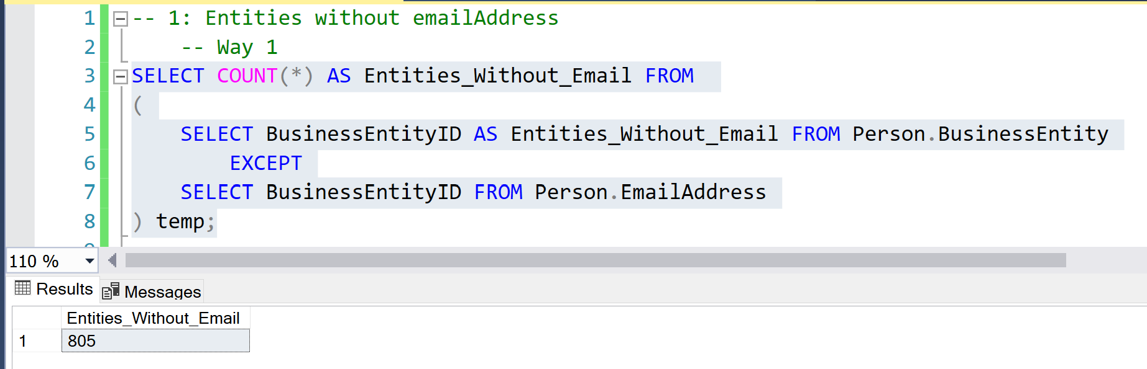

Way #2: NOT IN clause

SELECT COUNT(BusinessEntityID) AS Entities_Without_Email FROM Person.BusinessEntity

WHERE BusinessEntityID NOT IN (SELECT BusinessEntityID FROM Person.EmailAddress);

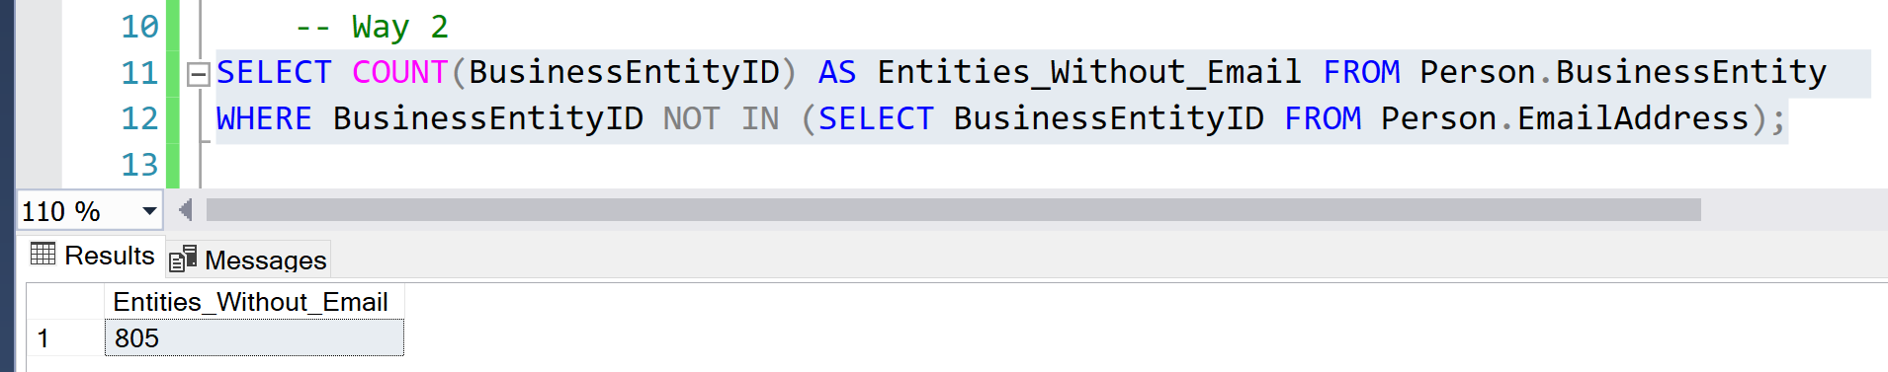

1. I want the name of the products, how much they are sold, the standard cost of manufacture, and calculate the profit margin. Show results according to those with more profit margins.

Way #1: INNER JOIN

SELECT prd.Name, prd.ListPrice, prd.StandardCost, (prd.ListPrice-prd.StandardCost) as profit_margin FROM Production.Product prd

INNER JOIN Production.ProductCostHistory pch

ON prd.ProductID = pch.ProductID order by profit_margin DESC;

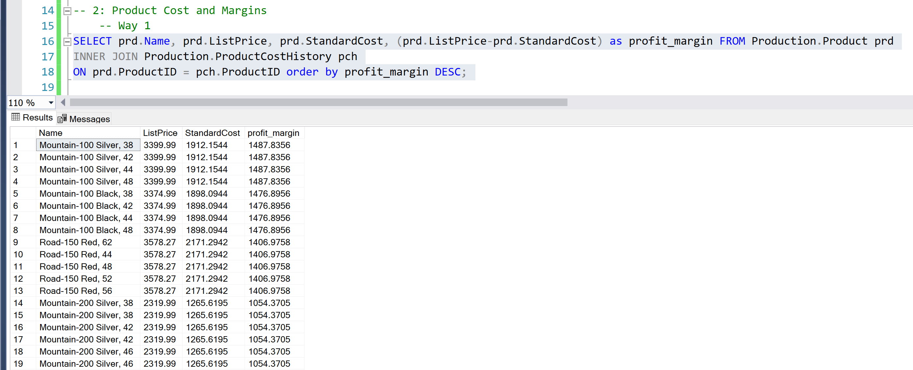

I Didn't Understand the significance of Join, Query works fine without it.

Way #2: WITHOUT THE INNER JOIN

SELECT Name, ListPrice, StandardCost, (ListPrice-StandardCost) as Profit_Margin from Production.Product order by Profit_Margin DESC;

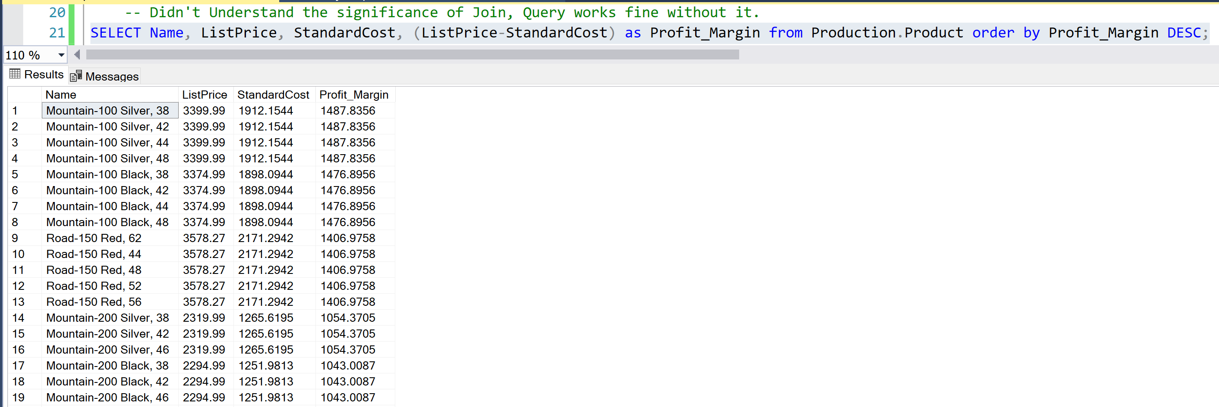

Way #3: Getting the Cost Difference between Historic Product Cost and New Cost along with the Profit Margin

SELECT prd.Name, prd.ListPrice, prd.StandardCost as newCost, pch.StandardCost as oldCost, (prd.StandardCost-pch.StandardCost) as product_cost_difference,

(prd.ListPrice-prd.StandardCost) as profit_margin

FROM Production.Product prd

INNER JOIN Production.ProductCostHistory pch

ON prd.ProductID = pch.ProductID order by profit_margin DESC;

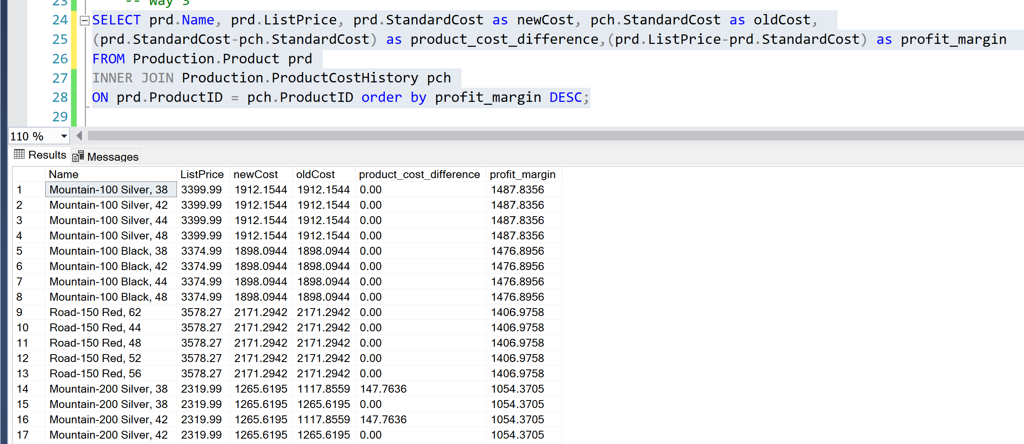

1. Get Complete Client List – Person as well as Store:

We Use the Union Operator

SELECT BusinessEntityID, (FirstName + ' ' + LastName) as name FROM Person.Person

UNION

SELECT BusinessEntityID, Name FROM Sales.Store;

