# A Project Report on

# Student Admission System

by

**Mr. Rohan Viraj Deshpande**

Introduction

The project “**Student Admission System”** is developed for the purpose of managing fees of students’ enrolled for different courses.

This project consists of various input screens like Student Admission Screen, Fees Challan Entry Screen, Student & Course Masters Entry and various reports like Fees Collection Report, Balance Fees Report, Advance Fees Report etc.

Scope of Work

The scope of the project includes Concession-wise Student Entry, Student Fees Receipt Entry, Balance/Advance payment of fees & Master Entries used for Student Fee Receipt Entry.

Feasibility Study

In this document we will talk about the feasibility part of implementing the **“Student Admission System”**.This system will reside on the Client Terminal & will work as a typical ‘Console Application’.

The Feasibility parameters are as follows:

**Technical Feasibility Study:**

H/W used in this project is Pentium Core i5 4th Generation Processor, 4GB RAM, 200MB HDD Space on existing Computer System, created with the Help of IDE’s (Integrated Development Environment) like Eclipse & MySQL Workbench. While hosting the actual Application No Special H/W is required, just MySQL setup will need to be installed along with the Project’s JAR File.

**Technical Requirement of the System:**

* Platform: Independent
* OS: Windows XP & Above/ RHEL 6 & Above/ Ubuntu 13 & Above
* Database: MySQL version 5 (WorkBench v6.3) & Above
* License: Open – Source

**Economical Feasibility Study:**

* The proposed System is economically feasible because No Special H/W or S/W needs to be purchased.
* The operating environment cost are marginal, the less time involved for the operations also help in Economical Feasibility.

**Operational Feasibility Study:**

* + Generally people are inherently resistant to change & Computers have been to know to facilitate Change.
  + Due to Automation of the System, increased Security & have considerably reduced the Human Efforts done by Office Staff during the Admission Process.

Need for System

Due to the Manual Entries during the Admission Process, extra efforts were needed by the Office Staff; also there were chances of Manual Errors & Difficulty in Accounting of Fees Receipt.

Automated System will provide increased Security & in turn reduce Human Efforts and Errors made during Admission Process & the different reports generated by the system will show the exact Status of Fees Collection on a Day, List of Students with Outstanding/Excess Fees.

The System also provides the Additional Facility to Give Scholarship Concession to Selective Students, on entering the eligibility percentage; the payable fees will be automatically displayed on the Challan Entry Screen.

Operating Environment: Hardware & Software

**Hardware:**

* Processor: Pentium Dual Core & Above
* RAM: 1GB & Above
* HDD Space: 1GB or Above

**Software:**

* Platform: Independent
* OS: Windows XP & Above/ RHEL 6 & Above/ Ubuntu 13 & Above
* Database: MySQL version 5 & above
* IDE’s (Integrated Development Environment): Eclipse & MySQL Workbench (WorkBench v6.3)
* Licence: Open – Source (as No Third Party Tools/Libraries were used)

Proposed System

**Objectives to be fulfilled:**

* + To Automate the System, increase Security & reduce the Human Efforts done by Office Staff during the Admission Process
  + To aid the Placement Officer with a Report of Students’ satisfying specified criteria

**User Requirements:**

An Automated System which will reduce manual efforts & errors & will provide reports about Fees Receipt Status, Outstanding/Advance Fees Status.

Design of Input/output Screens

**Login Screen:**

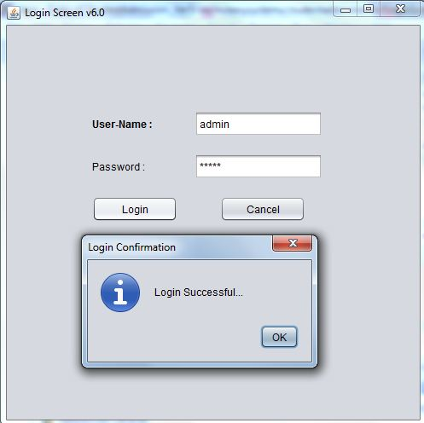

**Main Screen: Select Student Status**

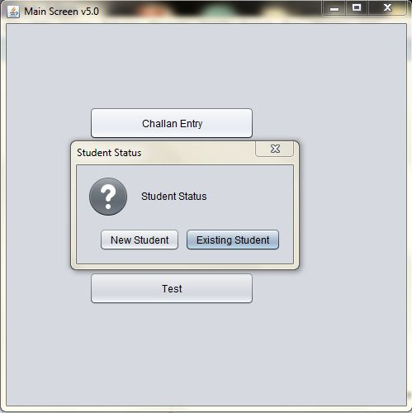

**Select Existing Student depending on course:**

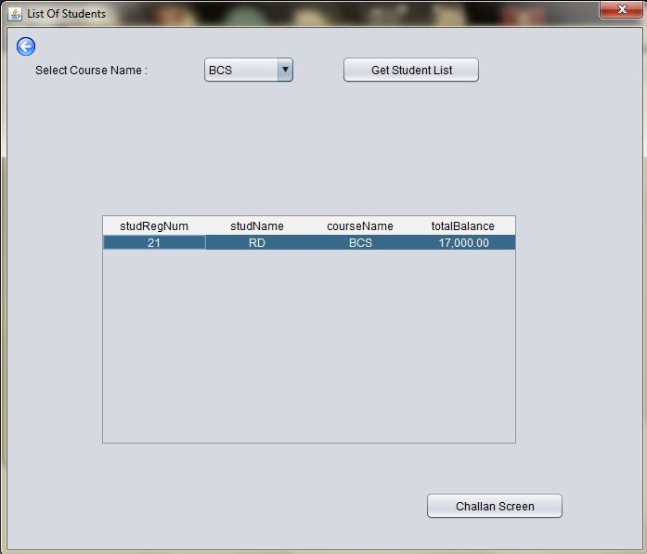

**Challan Screen Entry:**

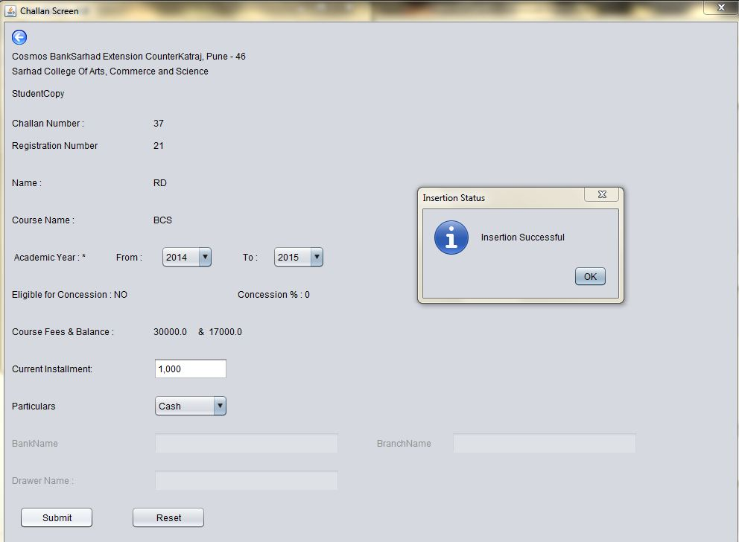

**Student Entry Form:**

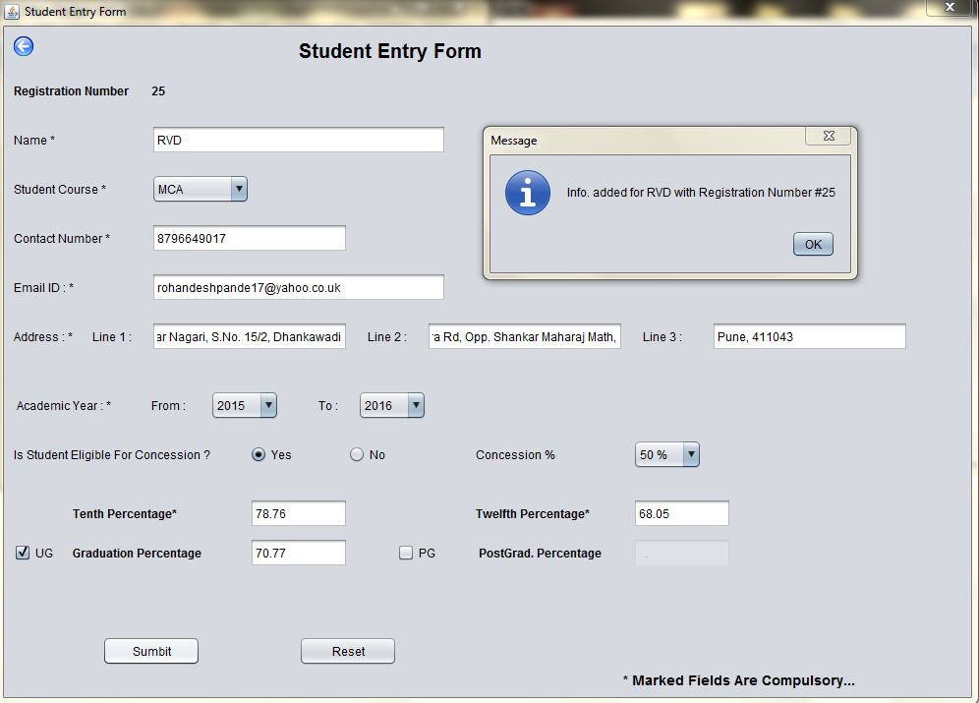

Reports

**Student Fees Collection Report: Single Date**

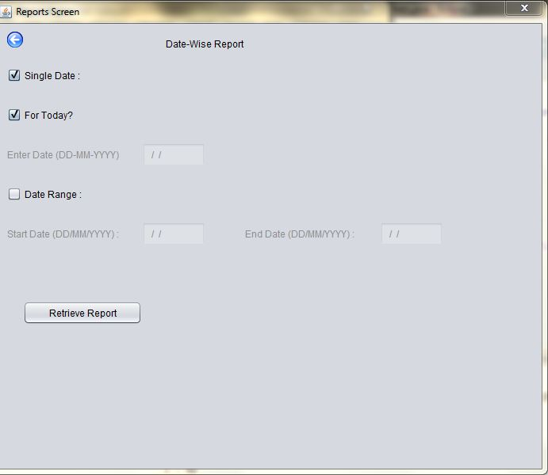

**Student Fees Collection Report: Date Range**

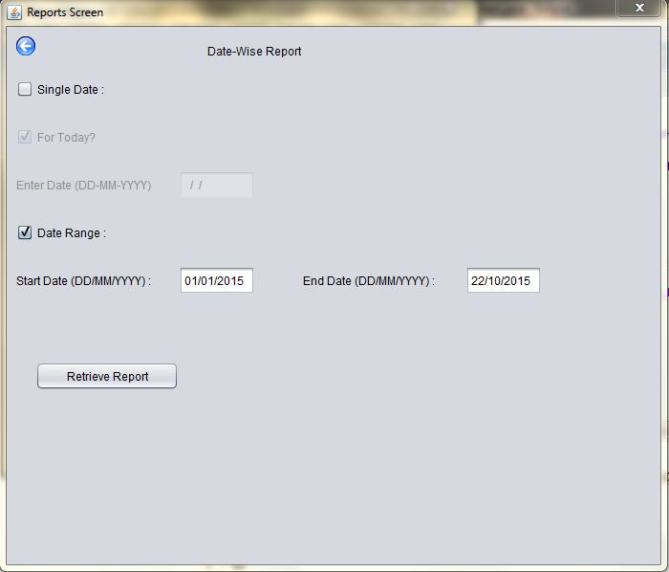

**Date Report Format:**

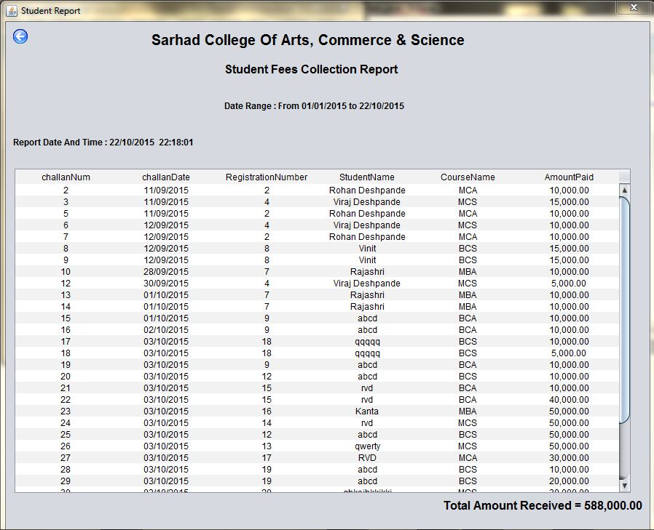

**Advance Fees Paid Student List:**

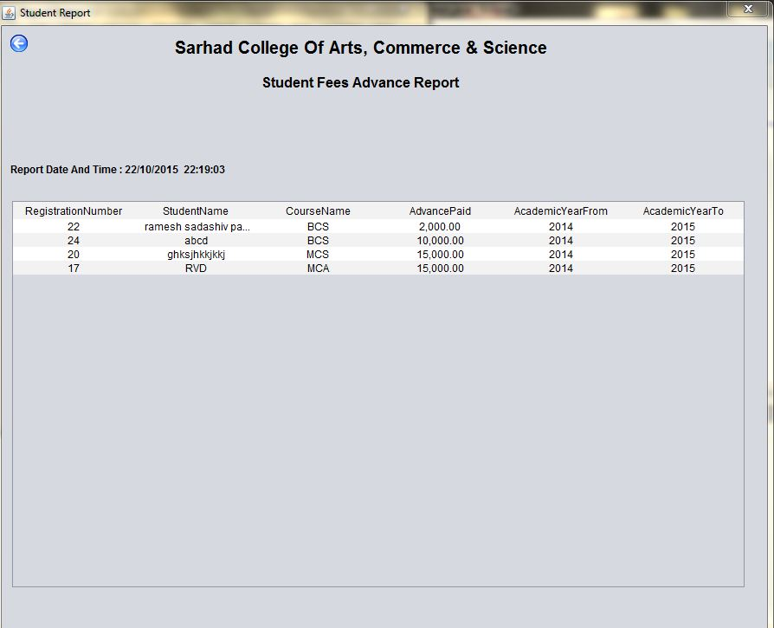

**List of Students having Outstanding Fees:**

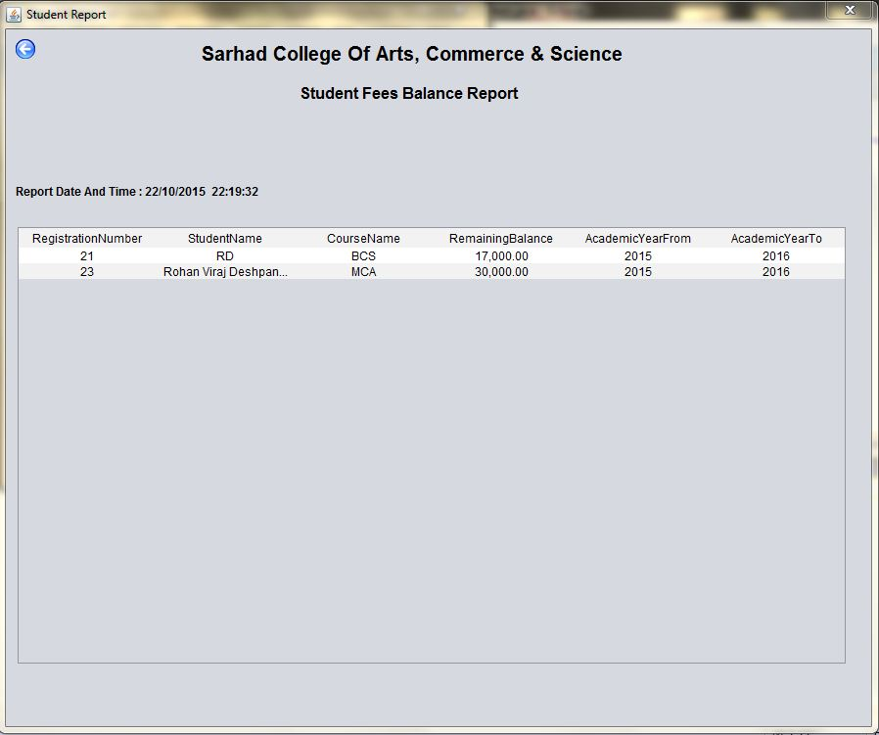

**Course-wise Student List:**

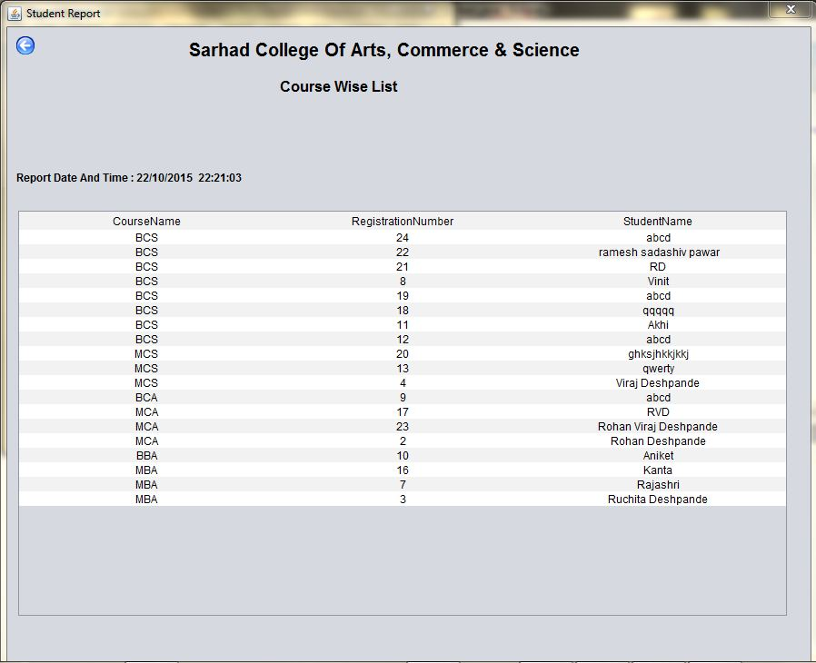

**Registration No. wise Student List:**

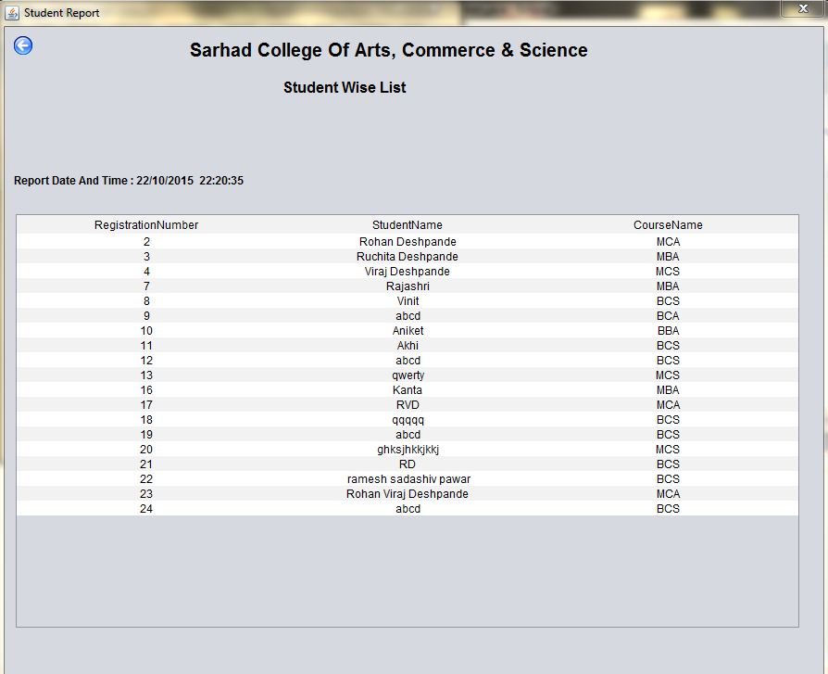

Testing: Exception Screenshots

**Incorrect Login:**

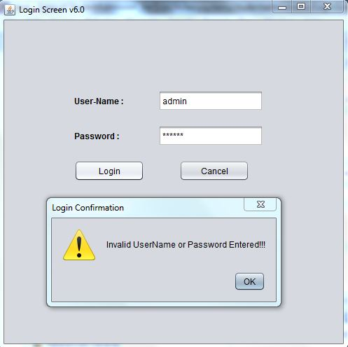

**Student Entry: No Input**

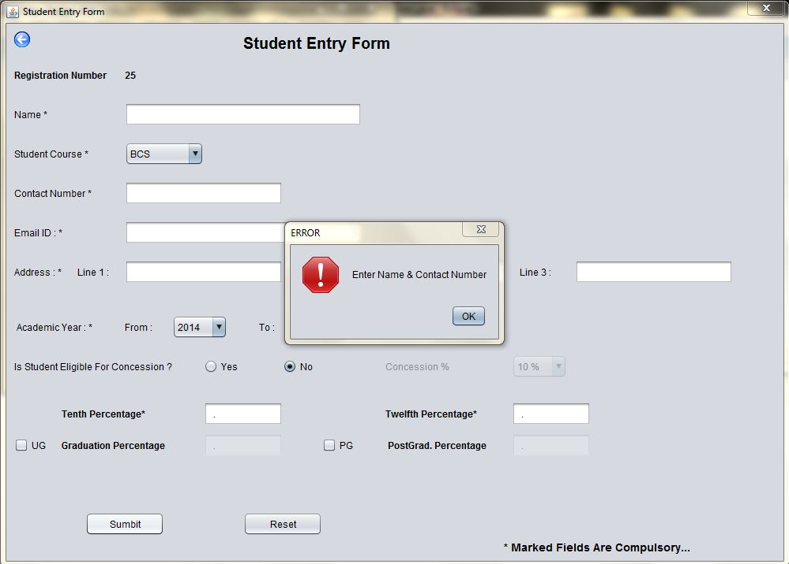

**Student Entry: Invalid Email-ID**

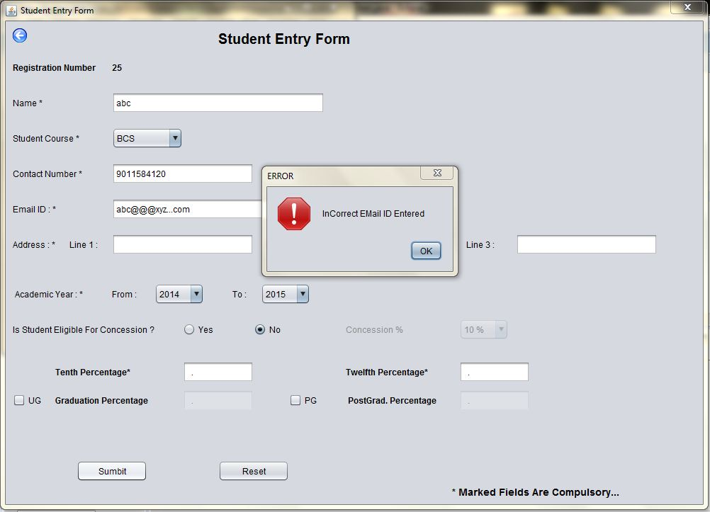

**Student List: If Student Not Selected**

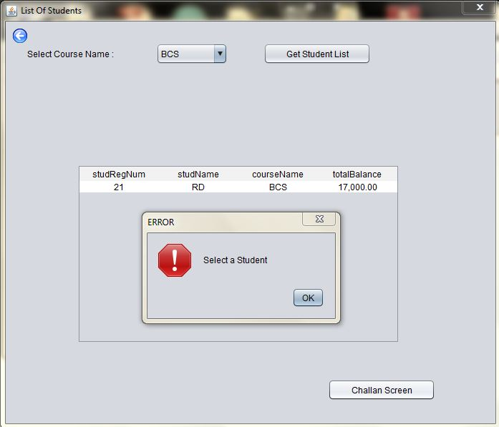

**Challan Entry: If Installment Not Entered**

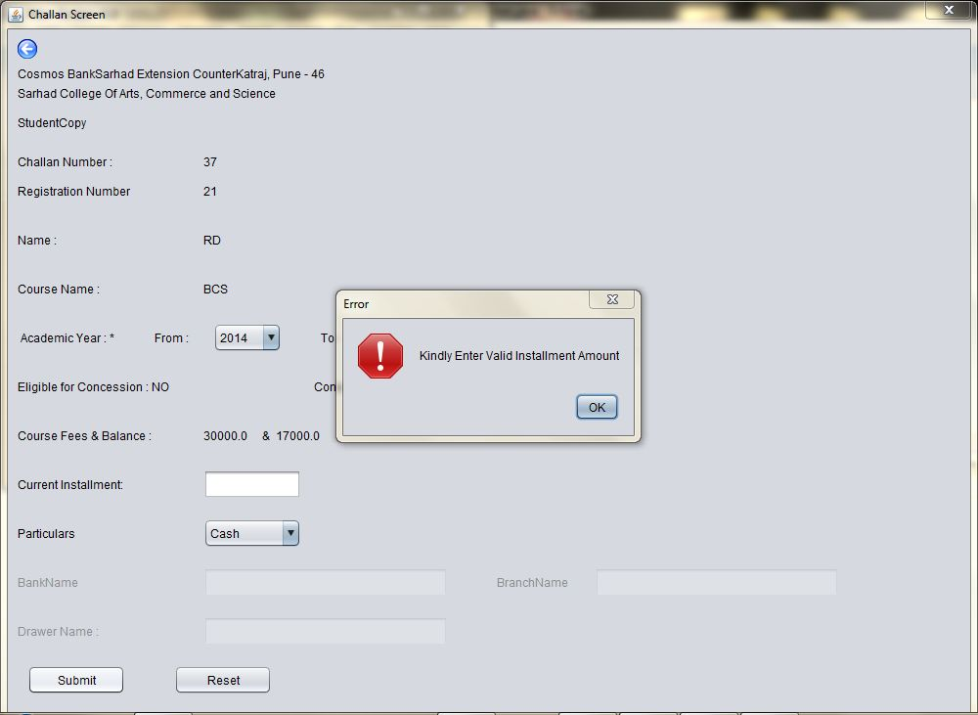

**Date Report: If No Option is Selected**

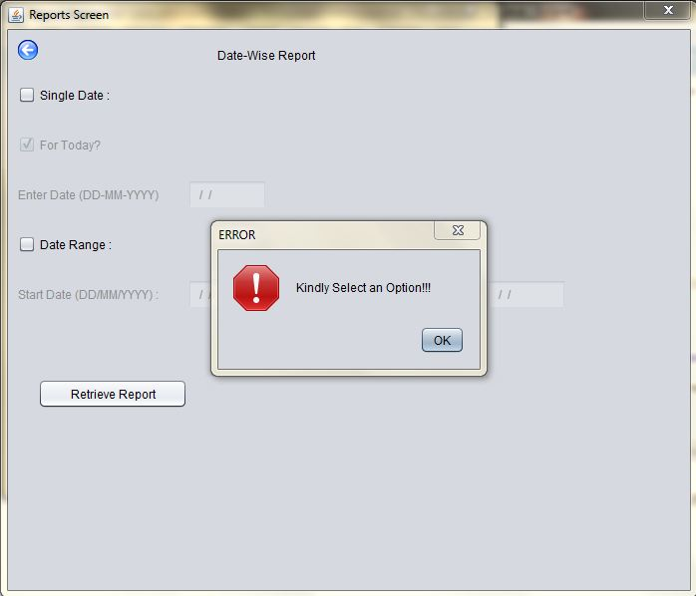

Limitations & Drawbacks

As it is a Console-Based Application, a few limitations persist:

* + No facilities provided for NEFT/RTGS Payment
  + Online Payment through PayPal or similar third-party services is not possible

Future Enhancements

* To add the Exam Fees Receipt facility into the application
* To add the School & Junior College Student’s Admission process into the application
* To provide the TPO (i.e. the Training & Placement Officer) with Percentage-wise StudentList

Conclusion

**To conclude, let me give you an overview of the functionalities provided by my Project:**

* To facilitate automation & easy monitoring of the every aspect of the Students’ Admission Process
* To track down, important aspects like Balance and Advance Fees per Student. (In other words, book-keeping becomes **easy** and **accurate**)
* To aid the Placement Process by providing student profile

Bibliography

* http://www.javatpoint.com/
* http://java4s.com/
* https://docs.oracle.com/javase/tutorial/
* http://tutorialspoint.com/
* http://stackoverflow.com/
* YouTube Tutorials
* Thinking in Java