Unveiling Insights and Elevating Employee Performance: The Power of Annual Performance Reviews

Let us embark on an exciting Journey into the world of HR Analytics leveraging the power of a Dynamic and Interactive Data Visualization Platform known as Tableau. In this blog, you will get a complete overview of the Data presented with the help of Graphs and Charts which showcase important information about HR Metrics and Insights to present to multiple Stakeholders.

In today’s competitive business landscape, a company’s success is highly reliant on Performant Employees, so it is important to understand the key factors which influence and play a pivotal role in an employee’s performance.

Structured Annual Performance Reviews are crucial to every employee’s growth as well as organizational excellence. They allow both parties to asses their performance, recognize achievements and find areas for improvement.  
  
To understand this is a better way, I took help of a Dataset from Kaggle: <https://www.kaggle.com/datasets/adityaab14/employee-performance-and-satisfaction-metrics>  
  
https://bit.ly/empDataset  
  
**Data-Wrangling and Cleaning:**  
The first thing I realized after watching the Data was the lack of an Employee ID column, which will be crucial, especially when running any aggregate functions like Count or Average:  


So, I made use of Python’s inbuilt “uuid” module and ran a loop to generate 200 random UUID’s corresponding to each employee:

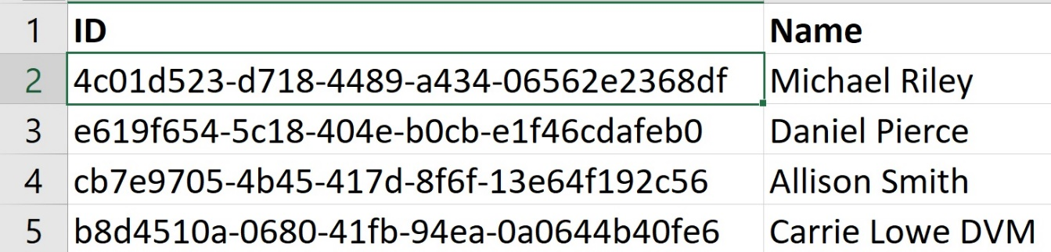

Since these are Annual performance reviews, I saw the JoiningDate Column had repetitive String Values like Jan-20 (January 2020) or Jan-98 (January 1998) so I converted them into Year format:  
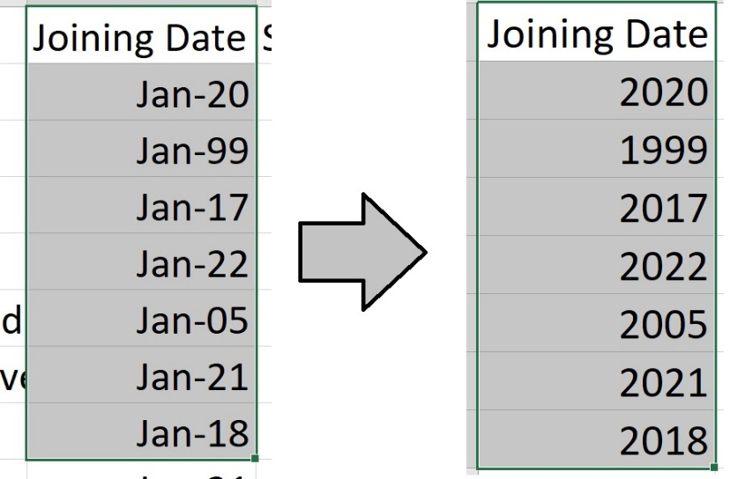

A link to the Tableau Dashboard: <https://public.tableau.com/app/profile/rohan.deshpande4178/viz/HR-Analytics-Dashboard/empDashboard>  
  
https://tabsoft.co/476cQUf  
  
This HR Analytics Dashboard is an intricately designed Visualization Tool which would help foster a culture of excellence and achieve sustainable success and enable the Stakeholders, Decision-Makers to make Proper changes in the Team as well as in the Company, if required.

Let Us Dive into its main components and understand the key Insights it offers:

1. Pay Disparity: Based on multiple factors like Gender, Education or Position, we can find Pay Disparity in most of the companies but here I found very little Pay Disparity based on the Gender or Position in this Company, which can be found in the graph specified below:

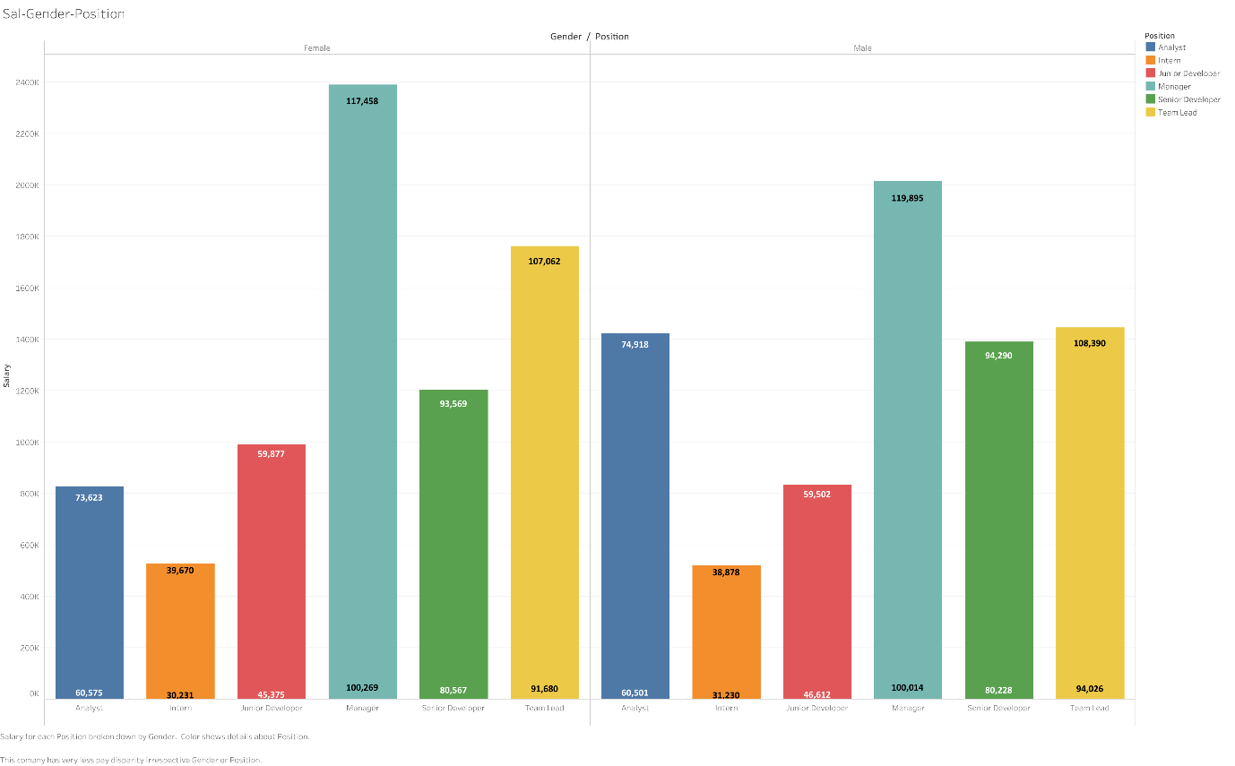

1. The Salary in this company is based upon experience which can be seen here as only the Senior Roles like Senior Developer, Manager or Team Lead have salaries greater than the average salary of 75K, which can be seen in the below mentioned Graph:  
   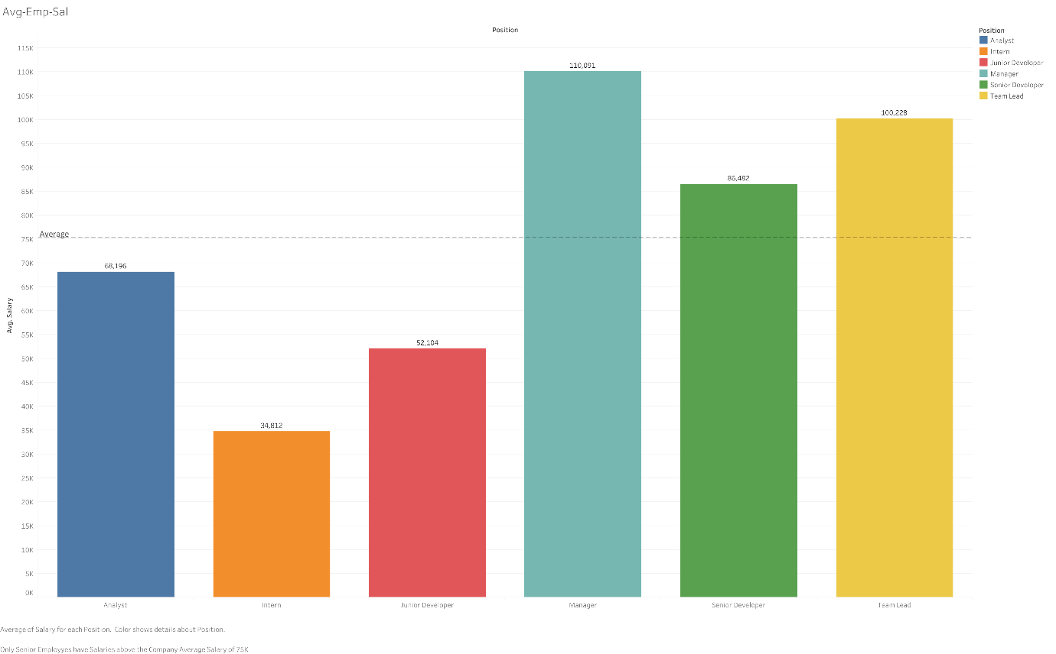
2. The Company Started hiring Senior Employees initially so they could get the ground running fast effectively which can be evident since only Managers were employed before 2003. Moreover Since 2019 onwards, Only Interns or Junior Developers were employed. No new Leads, Managers or Senior Developers employed after 2018.

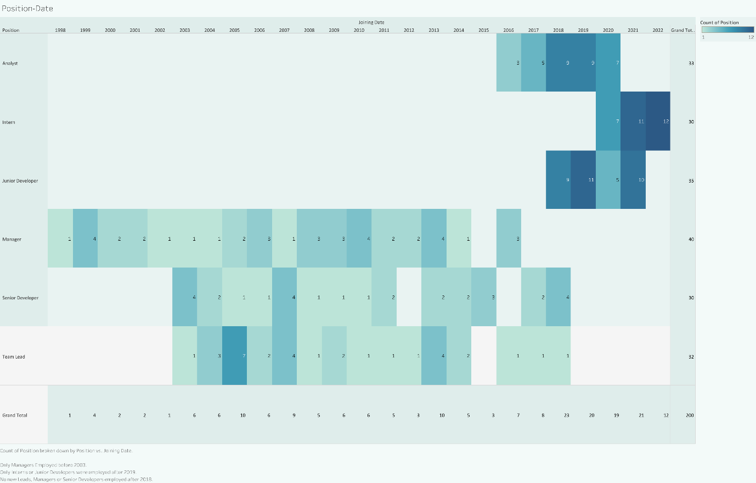

1. The number of Projects completed is based upon the Role the employee performs. Number of Projects completed is directly proportional to the Employee's Seniority, the senior the employee the greater number of projects they complete and vice versa. This can be evident since Senior Employees complete Projects more than the Average of 11 Projects.

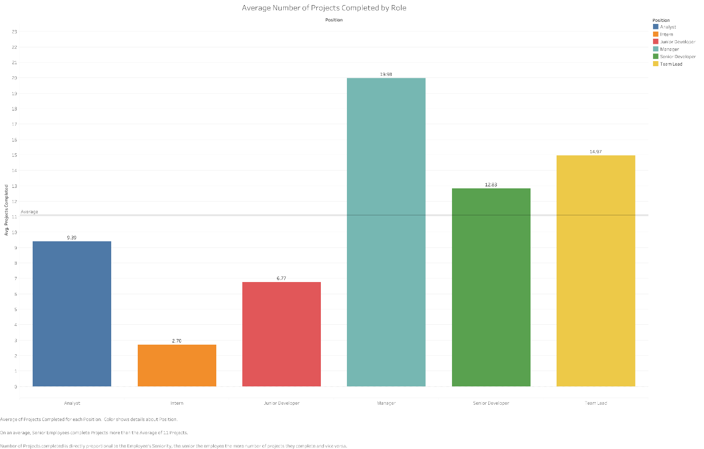

1. Productivity and Satisfaction Rate:  
   When I mapped Average Productivity Percentage and Average Satisfaction Rate to Department-Gender, I had the below mentioned inferences:  
   On an Average Male Employees have a better Productivity Percentage above the Average Value of 46.755  
     
   On an Average Male Employees have a better Satisfaction Rate as well above the Average of 49.935 except in the IT and Sales Department where females have a better Satisfaction Rate

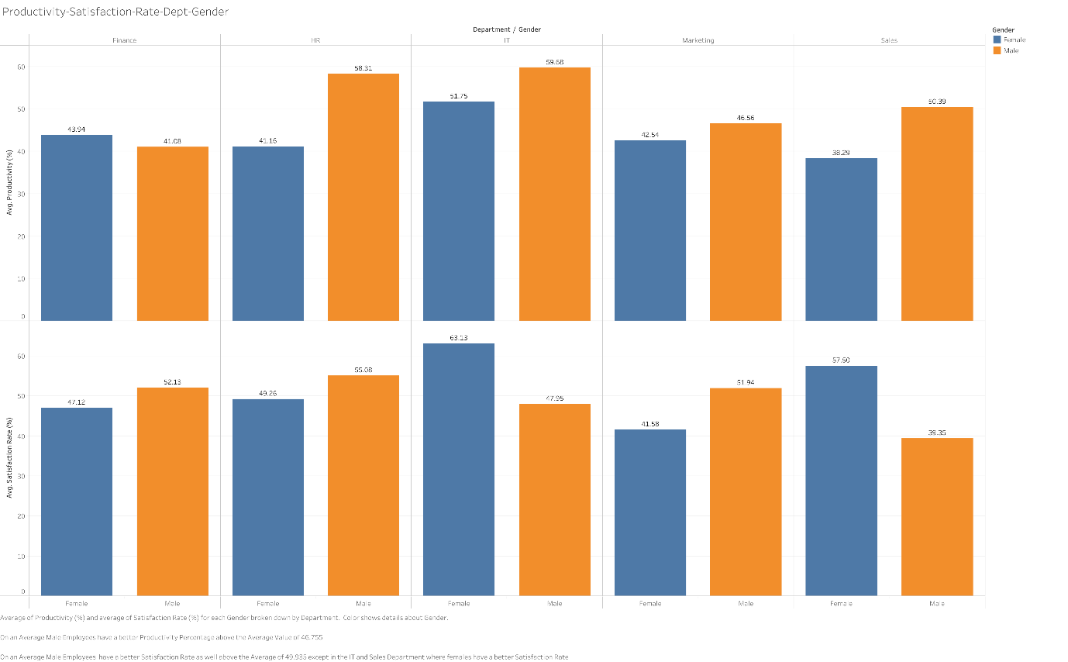

But when I mapped Average Productivity Percentage and Average Satisfaction Rate to Department-Position I found out a few things:  
a. In Marketing, till Team Lead Level, Satisfaction & Productivity are on par with each other. There is a Higher Deviation between Intern & Manager where their Average Satisfaction is higher than their Productivity.  
b. To Hypothesize, to check Managers have a Higher Pay so Satisfaction is Higher & the Productivity might be lower because their Task Productivity might be low because they are spending a part of their workday in People and Project Management.

c. We Hypothesize that the Intern Productivity is lower than their Satisfaction because they do not have much of an experience or context of why they are doing certain things, part of their workday would be spent in correcting their mistakes or redoing their assignments or researching or learning to build context about the task they are doing.

d. In the HR Department, Managers have a High Productivity but their Satisfaction Rate is lower this could happen because since they are HR, they must deal with people and processes on an everyday basis but if the volume of such work is more, then it is bound to reduce the Satisfaction rate.

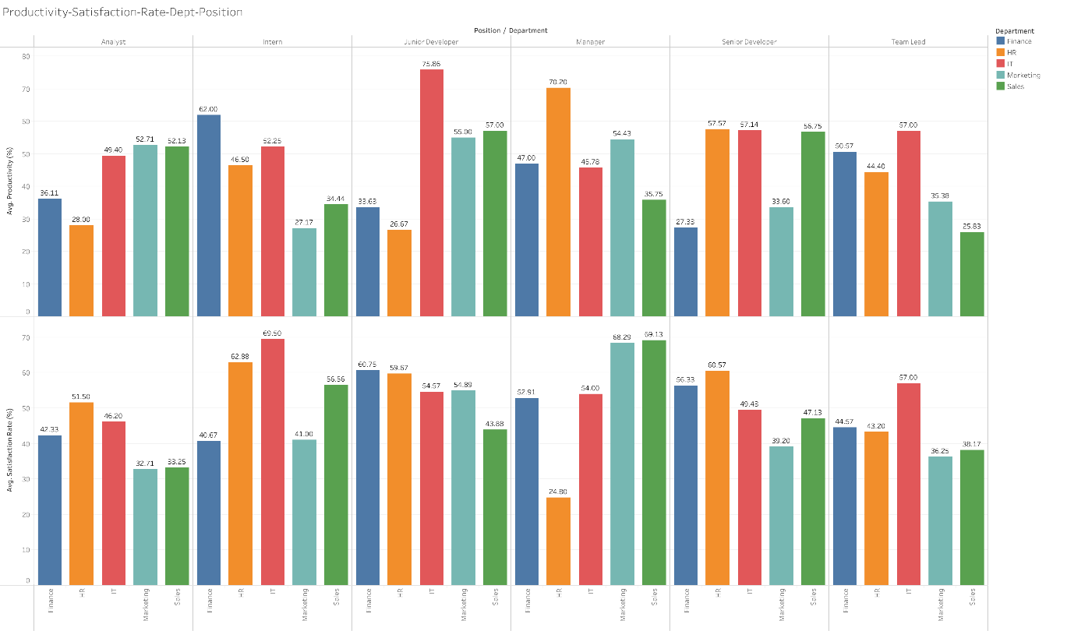

1. Average Age mapped Against Gender and Position:  
   From the below mentioned Chart we find out that a majority of the Senior Team members like Managers, Senior Developers, Team Leads and Analysts are above 28 Years old while The Junior team members like the Junior Developers and Interns Generally are between the Age of 22 and 28 with one outlier employee of 30 years old which is generally true in most Enterprise organizations we can see today.

