VISVESVARAYA TECHNOLOGICAL UNIVERSITY
“Jnana Sangama”, Belgaum -590014, Karnataka.



Full Stack Web Development Report
On

“Project Title”

Submitted by

NAME1 (USN1)
NAME2 (USN2)
NAME3 (USN3)
NAME4 (USN4)

Under the Guidance of
Faculty-in-Charge Name
Designation

in partial fulfillment for the award of the degree of
BACHELOR OF ENGINEERING
in
COMPUTER SCIENCE AND ENGINEERING



B.M.S. COLLEGE OF ENGINEERING
(Autonomous Institution under VTU)
BENGALURU-560019
Sep 2025 – Jan 2026
B. M. S. College of Engineering,
Bull Temple Road, Bangalore 560019
(Affiliated to Visvesvaraya Technological University, Belgaum)
Department of Computer Science and Engineering

CERTIFICATE
This is to certify that the project work entitled “Project Title” carried out by NAME1(USN1), NAME2(USN2), NAME3(USN3), NAME4(USN4) who are bonafide students of B. M. S. College of Engineering. It is in partial fulfillment for the award of Bachelor of Engineering in Computer Science and Engineering of the Visveswaraiah Technological University, Belgaum during the year 2025-2026. The project report has been approved as it satisfies the academic requirements in respect of Full Stack Web Development(23CS3AEFWD) work prescribed for the said degree.

Signature of the Guide Signature of the HOD
************* Dr. Kavitha Sooda
Assistant Professor Prof & Head of Dept of CSE
BMSCE, Bengaluru BMSCE, Bengaluru

External Viva
Name of the Examiner Signature with date
1)
2)

B.M.S. College of EngineerinG
DEPARTMENT OF COMPUTER SCIENCE AND ENGINEERING



DECALARATION

We, NAME1(USN1), NAME2(USN2), NAME3(USN3), NAME4(USN4) students of 3rd Semester, B.E, Department of Computer Science and Engineering, BMS College of Engineering, Bangalore, hereby declare that, this Full Stack Web Development entitled "Project Title" has been carried out by us under the guidance of ***********, Assistant Professor, Department of CSE, BMS College of Engineering, Bangalore during the academic semester Sep 2025 - Dec 2026.
We also declare that to the best of our knowledge and belief, the development reported here is not from part of any other report by any other students.

Signature

NAME1 (USN1)
NAME2 (USN2)
NAME3 (USN3)
NAME4 (USN4)

TABLE OF CONTENTS

Serial  No. | TITLE | PAGE NO.
1 | Introduction | 1
1.1 | Overview | 1
1.2 | Motivation | 1
2 | Software Requirement Specification | 2
2.1 | Hardware Requirements | 2
2.2 | Software Requirements | 2
3 | ER diagram of the project | 3
4 | Schema of project | 4
5 | User Interface Design | 5
6 | Back End Design | 5
7 | Conclusion and Future work | 6
8 | References | 7

INTRODUCTION
  - Overview

1.2 Motivation

SOFTWARE REQUIREMENTS
2.1 Hardware Requirements:
- A PC with the following or greater specifications:
  - Intel Core i3 or higher
  - 8 GB RAM
  - 500 GB Hard Drive
- A stable internet connection (2Mbps or higher)
2.2 Software Requirements:

- Operating system : Windows, Linux
- Front end technologies are : HTML, CSS, JavaScript
- IDE : VS Code,Sublime text
- Back end requirement : PHP/Node.js
- Server : XAMPP server/Node.js
(This is just a sample for reference only)

3. ER DIAGRAM OF THE PROJECT
EQUIP_NAME

EQUIP_NO
PASSWORDD
EQUIPMENT_INFO
EMAIL
SKILL
ADDS
EQUIP_QTY

TRAINER_ID
TRAINER_INFO
PASSWORDDDD

ADMIN M N
ADDS
TRAINER_NAME
USERNAME
USERNAME
TEACHESS
ADDS
ATTENDED
PASSWORD
CLASS_ID

M N
M
TRAINER_ID
FIRST
LAST
M
AGE
CLASSES

CLASS_NAME
GENDERR
MEMBER_INFO

N
DOB
TRAINER_NAME
USERNAMEE
CONTACTT
ATTENDED
EMAIL
M

M
CLASS_NAME
PAYS
USERNAME
SLNO
DAYS
FEE
N
FIRST
MUSER
ATTENDANCE
LAST
TUSER
PAYMENT
4. SCHEMA OF THE PROJECT

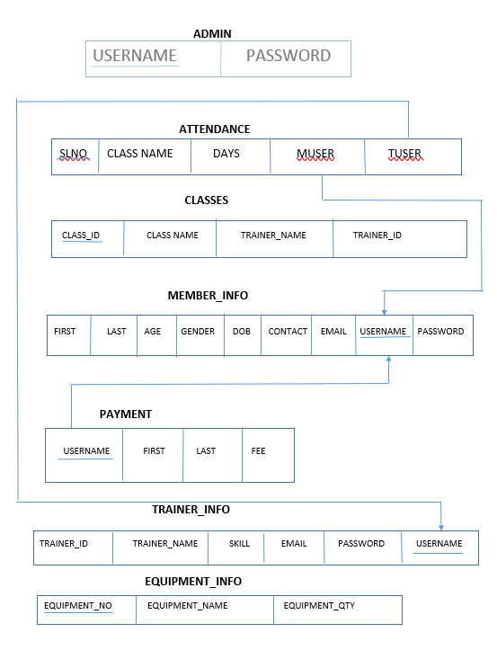
USER INTERFACE DESIGN

Attach various screenshots of each page along with a brief discussion. Please give Figure numbers and names to each of the screenshot attached.

BACK END DESIGN

Attach various screenshots of each page along with a brief discussion. Please give Figure numbers and names to each of the screenshot attached.

CONCLUSION AND FUTURE WORK

REFERENCES
Please provide all the website links you used as reference to build the project

