Name: Rohan Singh

Reg. No: 20bcs113

Subject: DBMS

Q1.

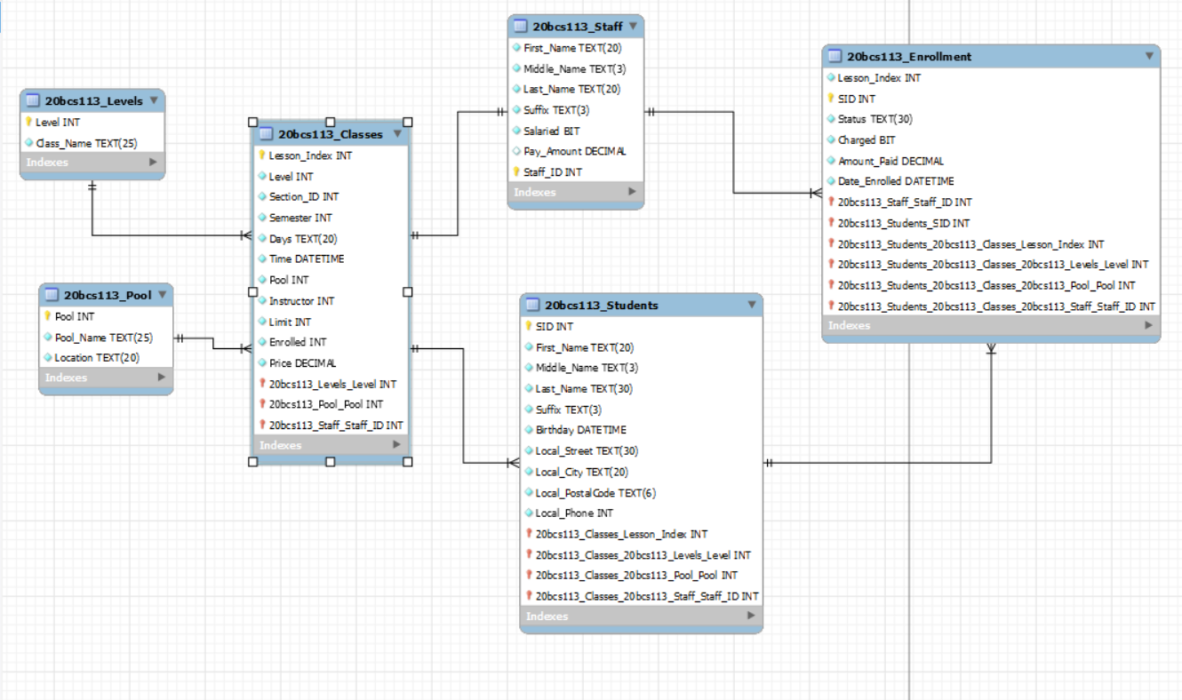

**Schema:**

20BCS113_Levels (Level, Class_Name)

20BCS113_Pool (Pool, Pool_Name, Location)

20BCS113_Staff (Staff, First_Name, Middle_Name, Last_Name, Suffix, Salaried, Pay_Amount)

20BCS113_Classes (Lesson_Index, Level, Pool, Instructor, Section_ID, Days, Time, Limit, Enrolled, Price)

20BCS113_Enrollment (Lesson_Index, SID, Status, Charged, Amount_Paid, Date_Enrolled)

20BCS113_Students (SID, First_Name, Middle_Name, Last_Name, Suffix, Birthday, Local_Street, Loca_lCity, Local_PostalCode, Loca_lPhone)

Q2. Degree and Cardinality

|  |  |  |
| --- | --- | --- |
| 20bcs113_Levels | Mandatory 1 - Mandatory Many | 20bcs113_Classes |
| 20bcs113_Pool | Mandatory 1 - Optional Many | 20bcs113_Classes |
| 20bcs113_Classes | Mandatory 1 - Mandatory Many | 20bcs113_Enrollment |
| 20bcs113_Enrollment | Mandatory Many - Mandatory 1 | 20bcs113_Students |
| 20bcs113_Enrollment | Optional Many – Optional 1 | 20bcs113_Staffs |

Q3. Data Model

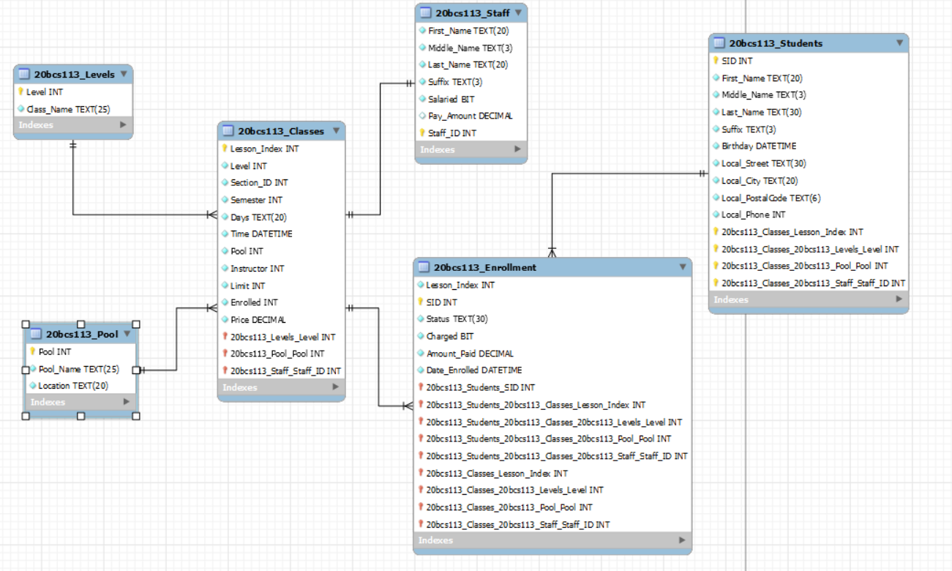

Q4.

20bcs113_Enrollment is a weak entity. **I**t's an associative entity because it doesn't have a primary key, and it's actually a weak entity. We can't make it a powerful entity because you add a primary key and defeat its purpose acts as an m: n relationship (associative entity) between the class table and the student table.

Q5.

There is no data redundancy in this scheme. We can say because there are no equal dates Attributes that exist in two separate tables.