**2.Develop a PHP program that facilitates the addition, multiplication of two matrices. Utilize HTML for the user interface and PHP for the backend logic. Dynamically generate the required number of textboxes based on the specified number of rows and columns. Implement three distinct buttons to perform each matrix operation For instance, consider the addition of two matrices as an example.**

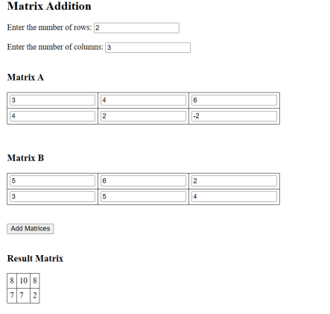

**\*\*\*\*\*\*\*\*\*\*\*\*\*\*\*\*\*\*\*\*\*\*\*\*\*\*\*\*\*\*\*\*\*\*\*\*\*\*\*\*\*\*\*\*\*\*\*\*\*\*\*\*\*\*\*\*\*\*\*\*\*\*\*\*\*\*\*\*\*\*\*\*\*\*\*\*\*\*\*\*<?**php session_start(); ?>

<!DOCTYPE html>

<html>

<head>

<meta charset="UTF-8">

<title>Matrix Operations</title>

</head>

<body>

<?php

$m = 0;

$n = 0;

if(isset($_REQUEST["M"]) && isset($_REQUEST["N"])) {

$m = $_REQUEST["M"];

$n = $_REQUEST["N"];

session_unset();

$_SESSION["m"] = $m;

$_SESSION["n"] = $n;

}

if(isset($_SESSION["m"]) && isset($_SESSION["n"])) {

$m = $_SESSION["m"];

$n = $_SESSION["n"];

}

?>

<form method="post">

Enter the number of rows: <input type="number" name="M" value="<?= $m ?>"><br><br>

Enter the number of columns: <input type="number" name="N" value="<?= $n

?>"><br><br>

<input type="submit" name="createMatrixBtn" value="Create Matrix">

</form>

<?php

function CreateMatrix($strTitle, $arName) {

$m = $_SESSION["m"];

$n = $_SESSION["n"];

echo "<h3>$strTitle</h3>";

echo "<table border=\"2\">";

for ($i = 0; $i < $m; $i++) {

echo "<tr>";

for ($j = 0; $j < $n; $j++) {

echo "<td>";

?>

<input type="number" name="<?= $arName ?>[]">

<?php

echo "</td>";

}

echo "</tr>";

}

echo "</table>";

}

function showMatButton() {

echo "<br>";

echo "<input type=\"submit\" name=\"addMat\" value=\"Add Matrice\">";

echo "&nbsp; &nbsp;";

echo "<input type=\"submit\" name=\"mulMat\" value=\"Multiply Matrice\">";

}

function GenerateMatrix($strTitle, $arName, $matName, $a) {

$m = $_SESSION["m"];

$n = $_SESSION["n"];

echo "<h3>$strTitle</h3>";

echo "<table border=\"2\">";

$k = 0;

for ($i = 0; $i < $m; $i++) {

echo "<tr>";

for ($j = 0; $j < $n; $j++) {

echo "<td>";

$$matName[$i][$j] = $a[$k];

$k++;

?>

<input type="number" name="<?= $arName ?>[]" value="<?= $$matName[$i][$j]

?>">

<?php

echo "</td>";

}

echo "</tr>";

}

echo "</table>";

$_SESSION[$matName] = $$matName;

}

if(isset($_REQUEST["createMatrixBtn"])) {

echo "<form method=\"post\">";

CreateMatrix("Matrix A", "a");

CreateMatrix("Matrix B", "b");

showMatButton();

echo "</form>";

}

if(isset($_REQUEST["addMat"])) {

echo "<form method=\"post\">";

$a = $_REQUEST["a"];

$b = $_REQUEST["b"];

GenerateMatrix("Matrix A", "a", "ma", $a);

GenerateMatrix("Matrix B", "b", "mb", $b);

$ma = $_SESSION["ma"];

$mb = $_SESSION["mb"];

echo "<h3>Result Matrix </h3>";

echo "<table border=\"1\" width=\"20%\">";

for ($i = 0; $i < $m; $i++) {

echo "<tr>";

for ($j = 0; $j < $n; $j++) {

echo "<td align=\"center\">";

$mc[$i][$j] = $ma[$i][$j] + $mb[$i][$j];

echo $mc[$i][$j];

echo "</td>";

}

echo "</tr>";

}

echo "</table>";

echo "</form>";

}

if(isset($_REQUEST["mulMat"])) {

if ($m != $n) {

echo "<h3>wrong dimension, cannot multiply</h3>";

} else {

echo "<form method=\"post\">";

$a = $_REQUEST["a"];

$b = $_REQUEST["b"];

GenerateMatrix("Matrix A", "a", "ma", $a);

GenerateMatrix("Matrix B", "b", "mb", $b);

$ma = $_SESSION["ma"];

$mb = $_SESSION["mb"];

echo "<h3>Product Matrix </h3>";

echo "<table border=\"1\" width=\"20%\">";

for ($i = 0; $i < $m; $i++) {

echo "<tr>";

for ($j = 0; $j < $n; $j++) {

echo "<td align=\"center\">";

$mc[$i][$j] = 0;

for ($k = 0; $k < $n; $k++) {

$mc[$i][$j] += $ma[$i][$k] * $mb[$k][$j];

}

echo $mc[$i][$j];

echo "</td>";

}

echo "</tr>";

}

echo "</table>";

echo "</form>";

}

}

?>

</body>

</html>