Lab Manual
Practical and Skills Development

CERTIFICATE

THE ASSIGNMENT ENTERED IN THIS REPORT HAVE BEEN
SATISFACTORILY PERFORMED BY
Registration No : 25BSA10063
Name of Student : Rohan raj
Course
Course Name Faculty
: Introduction to Problem Solving and Programming ^{Name}
Course Code : CSE1021
School Name : VIT BHOPAL
Slot : B11+B12+B13
Class ID : BL2025260100796
: FALL 2025/26
Semester

: Dr. Hemraj S. Lamkuche Signature:

Practical Index

S. No. | Title of Practical | Date of Submission | Signature of Faculty
1 | Implement the probabilistic Miller-  Rabin  test is_prime_miller_rabin(n, k) with k rounds. | 23-11-2025
2 | Implement pollard_rho(n) for integer factorization using Pollard's rho algorithm. | 23-11-2025
3 | Write a function zeta_approx(s, terms) that approximates  the Riemann zeta function ζ(s) using the first 'terms' of the series. | 23-11-2025
4 | Write a function Partition Function p(n) partition_function(n) that calculates the number of  distinct ways to write n as a sum of positive integers. | 23-11-2025

5
6
7

8
9
10
11
12
13
14
15

Practical No: 1
Date: 23-11-2025

TITLE: probabilistic Miller–Rabin

AIM/OBJECTIVE(s) : Implement the probabilistic Miller-Rabin test is_prime_miller_rabin(n, k) with k rounds.

METHODOLOGY & TOOL USED:

- Use modular exponentiation to compute power efficiently.
- Decompose n-1 into 2^r * d.
- Perform k rounds of testing with random bases.
- Check the conditions of strong probable prime.

Tool Used:
Programming Language: Python
IDE / Environment: IDLE (Python 3.x) or any Python-supported IDE
such as Jupyter Notebook

BRIEF DESCRIPTION:
This function performs a randomized test to check whether a number n is prime. It repeatedly tests n using randomly selected bases, reducing the probability of error with each round.

RESULTS ACHIEVED:
Example Output:
Enter number: 6
Enter rounds k: 5
Probably Prime? False
Execution Time: 0.003022909164428711 seconds
Memory Used: 56.2578125 KB
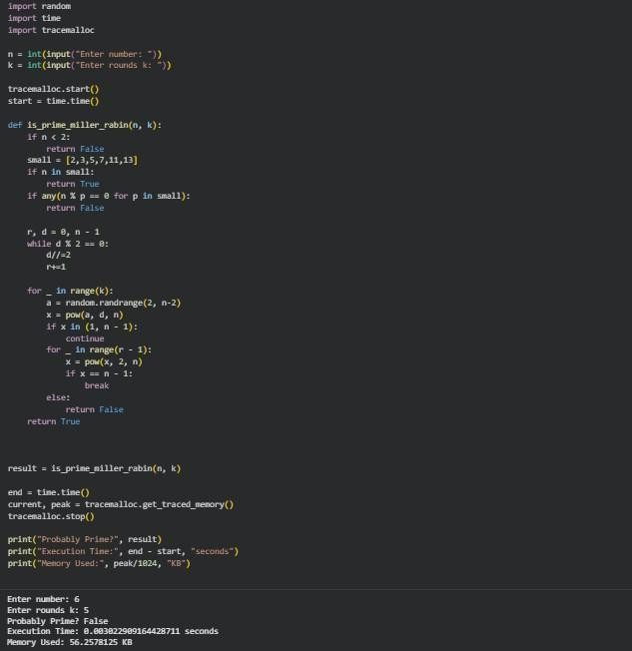

DIFFICULTY FACED BY STUDENT:
- Understanding decomposition of n-1 into factors of 2.
- Handling modular exponentiation correctly.
- Ensuring that all edge cases (n < 2, even numbers) work properly.
- Logic complexity of multiple checks in each iteration.

SKILLS ACHIEVED:

. Strong understanding of primality testing algorithms.
. Implementation of modular arithmetic and fast exponentiation.
. Ability to convert mathematical algorithms into working Python code.
. Improved debugging and logical reasoning skills.

Practical No: 2
Date: 23-11-2025

TITLE: Pollard’s Rho Algorithm
AIM/OBJECTIVE(s): To implement Pollard’s Rho integer factorization algorithm, which finds non-trivial factors of large composite numbers
efficiently.

METHODOLOGY & TOOL USED:
Select a pseudo-random polynomial function f(x) = x^2 + c mod n.

Use Floyd’s cycle-finding method (tortoise–hare).
Keep computing gcd(|x - y|, n) until a non-trivial factor is found.
Tools used: Python built-ins (gcd), random number generation.

Tool Used:
Programming Language: Python
IDE / Environment: IDLE (Python 3.x) or any Python-supported IDE
such as Jupyter Notebook

BRIEF DESCRIPTION:
The algorithm uses pseudo-random sequences to discover a factor of a composite number. It is fast, efficient, and widely used in cryptanalysis and number theory.

RESULTS ACHIEVED:
Example Output:
Enter number: 4
Factor Found: 2
Execution Time: 0.0005011558532714844 seconds
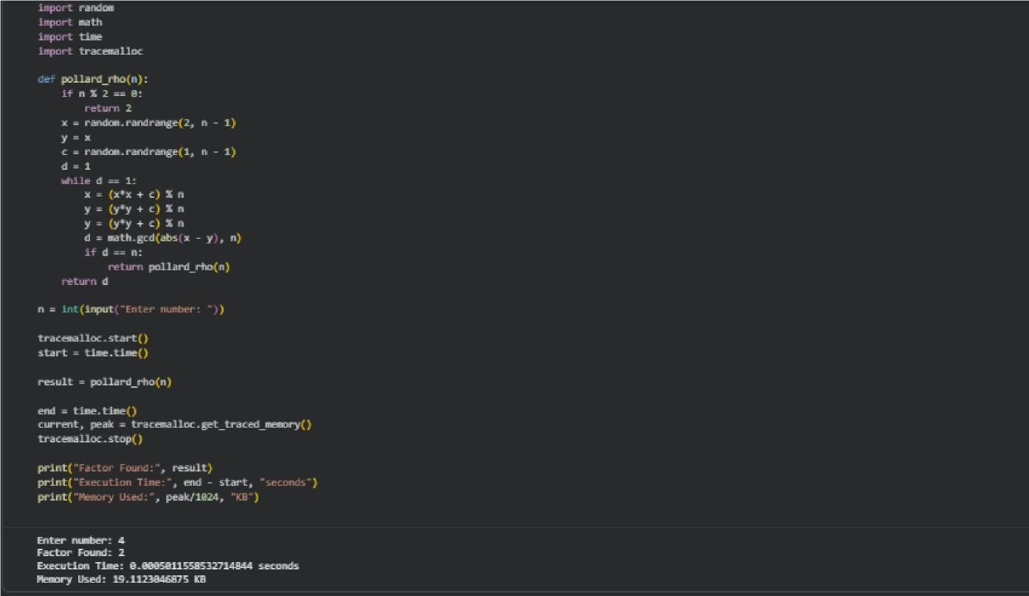
Memory Used: 19.1123046875 KB

DIFFICULTY FACED BY STUDENT:

- Hard to understand cycle detection (tortoise and hare method).
- Managing infinite loops when factor is not found quickly.
- Selecting good values of c and initial seeds.
- Handling cases when the algorithm returns n again instead of a factor.

SKILLS ACHIEVED:
• Understanding of probabilistic factorization algorithms.
• Use of GCD, modular arithmetic, and random functions.
• Learning cycle detection techniques used in algorithms.
• Improved algorithmic thinking and use of mathematical functions.

Practical No: 3
Date: 23-11-2025

TITLE: Approximate Riemann Zeta Function (zeta_approx(s, terms))

AIM/OBJECTIVE(s):
Write a function zeta_approx(s, terms) that approximates the Riemann zeta function ζ(s) using the first 'terms' of the series.

METHODOLOGY & TOOL USED:
• Use a loop to compute summation:
𝑘
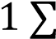
𝑛 𝑠
𝑛=1

• Ensure precision for fractional powers using Python’s floating-point arithmetic.
• Tool used: Python (** operator, loops).

Tool Used:
Programming Language: Python
IDE / Environment: IDLE (Python 3.x) or any Python-supported IDE
such as Jupyter Notebook

BRIEF DESCRIPTION:
The function calculates an approximate value of the zeta function by summing the first terms in the infinite series. Increasing terms improves accuracy.

RESULTS ACHIEVED:
Example Output:
Enter s: 4
Enter number of terms: 2

Zeta Approx: 1.0625
Execution Time: 0.0003490447998046875 seconds
Memory Used: 19.0419921875 KB
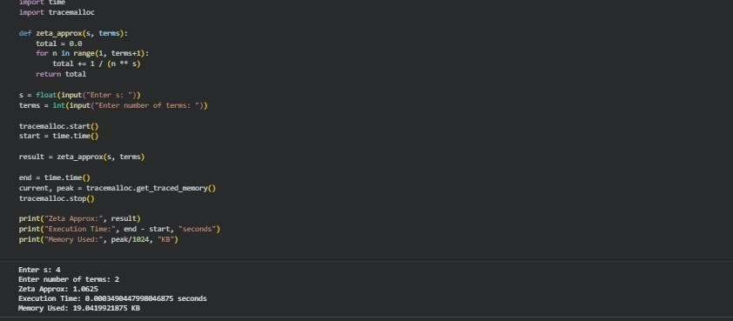

DIFFICULTY FACED BY STUDENT:
- Handling floating-point precision issues.
- Slow computation for large terms.
- Understanding convergence behavior of series.
- Implementing exponent and summation efficiently.

SKILLS ACHIEVED:

- Knowledge of infinite series approximation.

- Use of loops with mathematical expressions.
- Understanding numerical precision.
- Improved mathematical programming skills.

Practical No: 4
Date: 23-11-2025

TITLE: Partition Function (partition_function(n))

AIM/OBJECTIVE(s): Write a function Partition Function p(n) partition_function(n) that calculates the number of distinct ways to write n as a sum of positive integers.

METHODOLOGY & TOOL USED:
• Use dynamic programming or recursive memoization.
• Generate partitions using previously computed values.
• Tool used: Python (recursion, lists, memoization dictionary).

Tool Used:

Programming Language: Python

IDE / Environment: IDLE (Python 3.x) or any Python-supported IDE
such as Jupyter Notebook

BRIEF DESCRIPTION:
The partition function grows rapidly and cannot be computed by brute force for large n. Using dynamic programming, the function calculates p(n) using already-known values for smaller integers.

RESULTS ACHIEVED:
Example Output:

Enter n: 3
Partition p(n): 3
Execution Time: 0.0002810955047607422 seconds
Memory Used: 19.0419921875 KB

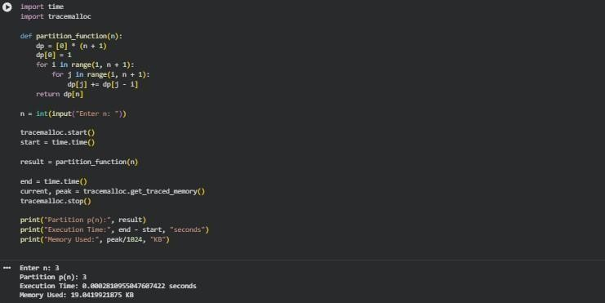

DIFFICULTY FACED BY STUDENT:
Understanding recurrence relation for partition numbers.
High time complexity for naïve implementations.
Handling large values of n without overflow or excessive recursion depth.
Designing efficient memoization.

Skills Achieved:
Understanding of combinatorics and number theory.
Ability to implement dynamic programming.
Handling recursive problems with optimization.
Experience with mathematically intensive algorithms.

