DATATHON PROJECT REPORT
MANDI MARKET
SUPPLY CHAIN OPTIMIZER
Problem Statement 4 — AgriTech
An integrated data analytics solution for understanding
agricultural arrivals, market prices, MSP, transport logistics, and weather.
TEAM MEMBERS
Annamika • Niya • Rohan • Bhavani
Submitted as part of the Datathon / Hackathon Project

1. Executive Summary
Agricultural markets generate large volumes of information related to mandi arrivals, commodity prices, Minimum Support Price (MSP), transport movement, and local weather conditions. When these datasets are maintained separately or contain inconsistent formats, it becomes difficult to identify market patterns, compare prices with MSP, understand logistics performance, and obtain a consolidated view of mandi operations.
The Mandi Market Supply Chain Optimizer project addresses this challenge through a data-driven analytics workflow. Five synthetic agricultural datasets—Mandi Master, Arrivals, Prices and MSP, Transport, and Weather—were processed, validated, and brought into an analysis-ready structure. Python, pandas, and NumPy were used for data cleaning and validation; SQL was used for database-level querying, aggregation, filtering, joining, and analysis; and Microsoft Power BI and HTML were used to transform the processed information into interactive, accessible visualizations.
The resulting dashboard provides a consolidated view of market operations across 57 mandis in Punjab, Haryana, and Uttar Pradesh for the Jan–Sep 2026 period represented in the dashboard. It brings together arrival volumes, modal prices and MSP comparisons, transactions below MSP, mandi-level performance, transit time, farmer counts, and regional weather trends. Interactive filters allow users to explore the information by state, district, crop, and time period.
The project demonstrates how structured data preparation and visualization can convert fragmented agricultural records into decision-support information for understanding market supply, price conditions, and logistics performance.

2. Project Overview
Item | Description
Domain | AgriTech / Agricultural Market Supply Chain
Problem Statement | 4 — AgriTech: Mandi Market Supply Chain Optimizer
Core Focus | Data integration, cleaning, SQL analysis, and interactive visualization
Geographic Coverage | Punjab, Haryana, and Uttar Pradesh in the presented dashboard
Dashboard Period | January–September 2026
Main Technologies | Python, pandas, NumPy, SQL, Microsoft Power BI, HTML
Primary Output | Interactive mandi operations analytics dashboard

3. Problem Statement
The mandi ecosystem involves multiple connected factors: agricultural arrivals determine market supply; prices and MSP indicate market conditions; transport affects movement from mandis to warehouses or terminals; and weather can influence agricultural operations and supply conditions. However, these factors are often represented in different datasets with inconsistent identifiers, units, date formats, missing values, and data-quality issues.
The project problem is therefore to create a practical analytical view of mandi market operations by integrating these datasets, preserving data quality information, and presenting useful insights through an interactive dashboard. The intended outcome is not simply a collection of charts, but a unified decision-support interface that makes important relationships and patterns easier to investigate.

4. Objectives
- Clean and standardize heterogeneous agricultural datasets without silently replacing missing or unreliable values.
- Validate identifiers and relationships across mandi, arrival, price, transport, and weather records.
- Prepare structured data suitable for SQL analysis and business-intelligence visualization.
- Compare commodity modal prices with MSP and identify the share of transactions below the benchmark.
- Analyze arrival volumes by crop, month, and mandi type.
- Examine transport transit time across destinations and identify logistics patterns.
- Present regional weather trends alongside market information.
- Provide interactive filters and dashboard views that allow users to explore the data without inspecting raw datasets.

5. Proposed Data Analytics Workflow
The project follows a pipeline in which raw synthetic datasets are first cleaned and validated, then loaded into a structured SQL environment for analysis. The resulting measures and relationships are used in Power BI and HTML-based presentation components to create the final user-facing dashboard.
- Raw synthetic datasets
- Data cleaning and standardization using Python, pandas, and NumPy
- Quality flags, validation checks, and preservation of source values
- SQL table preparation and analytical queries
- Aggregation and comparison of market, logistics, and weather measures
- Power BI dashboard development with KPI cards, charts, tables, slicers, and filters
- HTML-based organization/presentation of visualization content
- Final review, consistency checks, report preparation, and project assembly

6. Datasets Used
Dataset | Purpose | Key information
Mandi Master | Reference/master data | Mandi identifiers, district, state, mandi type, area and related reference fields
Arrivals | Market supply | Crop, mandi, date, quantity, farmer counts and arrival-related fields
Prices and MSP | Price benchmarking | Crop prices, MSP, mandi/reporting location and related price fields
Transport | Logistics | Mandi movement, destination, vehicle information, timestamps and duration fields
Weather | Environmental context | Sensor readings, temperature, rainfall, humidity and timestamps

7. Data Cleaning and Validation
The data-cleaning stage was designed to preserve the source information while creating standardized fields suitable for downstream SQL and Power BI analysis. Instead of replacing uncertain values with arbitrary estimates, quality flags were retained so that downstream users could distinguish usable values from missing, ambiguous, or unreliable records.
Dataset | Cleaning / validation performed | Result
Mandi Master | Removed exact duplicates; standardized text; validated IDs; recovered states using consistent district mappings. | 60 → 57 rows; 4 states recovered; 4 districts, 11 mandi types, and 6 areas remain missing.
Arrivals | Standardized multilingual crop names into six reporting groups; normalized mandi IDs; parsed dates; converted quantities to quintals; validated farmer counts. | 25,750 → 25,000 rows; all mandi IDs matched; 23,767 valid quantities; 1,233 negative quantities flagged; valid volume 6,077,460.14 quintals.
Prices and MSP | Removed currency formatting; converted prices to numeric values; checked price ordering; standardized crops and IDs; resolved reporting districts using the master. | 12,000 rows; no conversion failures or price-order contradictions; 1,235 missing mandi IDs; 2,004 unresolved reporting districts.
Transport | Removed duplicates; standardized IDs; converted miles to kilometres; parsed timestamps and durations; normalized vehicle registrations. | 10,400 → 10,000 rows; all mandi IDs matched; 7,359 calculated durations; 2,356 reported fallbacks; 285 unavailable/invalid.
Weather | Converted Fahrenheit to Celsius and inches to millimetres; converted explicit UTC timestamps to IST; validated humidity; cleaned sensor IDs. | 15,000 readings; 50 known sensors; 1,518 negative rainfall readings flagged; 715 unknown sensor IDs; 2 conflicting sensor–timestamp readings flagged.

7.1 Key Data-Quality Decisions
- Missing values were not replaced with zero or guessed averages. Exported missing values are represented as NA for downstream import as NULL/null.
- Negative quantities and rainfall values were retained in source columns but excluded from cleaned numeric fields.
- Ambiguous dates were parsed using documented format conventions and flagged: 4,703 arrival records and 2,262 price records.
- Price districts conflicted with the master in 8,366 records. The master was used as the reporting reference while source districts and conflict information were preserved.
- Missing source arrival IDs were retained, with a separate technical row key used to support SQL processing.
- Date-only transport records were not interpreted as midnight timestamps. Reported duration fallbacks remained separately labelled.
- Weather timestamps without timezone labels were assumed to be IST and flagged. Sensor-to-district mapping remained unresolved.

7.2 Validation and Limitations Identified During Cleaning
Validation covered row counts, identifier uniqueness, master relationships, numeric validity, date parsing, and measurement consistency. Of the price observations, 9,131 had both modal price and supplied MSP; 3,667 (40.16%) were below that benchmark. This comparison uses the common basis implied by the challenge, while noting that the price quantity unit is unspecified.
Weather rainfall totals and district-level weather comparisons require further source clarification. Confirmed transport delays cannot be calculated without a defined service-level agreement (SLA). The final project therefore treats these as limitations rather than presenting unsupported conclusions.

8. SQL Analysis and Database Processing
The SQL stage provided the database-level foundation for structured analysis. The cleaned datasets were organized into database tables while maintaining relevant columns, identifiers, data types, and relationships. SQL queries were used to retrieve, filter, sort, group, aggregate, compare, and join records.
The analysis included operations such as COUNT, SUM, AVG, MIN, MAX, WHERE, GROUP BY, ORDER BY, and JOIN. These operations supported measures and summaries later used in the dashboard, including arrival totals, average prices, price–MSP gaps, transactions below MSP, transport measures, and category-level comparisons.
- Aggregation of arrival quantities by crop, mandi, mandi type, and month.
- Price and MSP comparisons by crop and market.
- Identification of records below the MSP benchmark.
- Mandi-level summaries combining market and logistics measures.
- Validation of related records through mandi identifiers and matching fields.
- Preparation of summarized outputs for Power BI and HTML visualization.

9. Data Visualization and Dashboard Development
The visualization stage converted the processed and analyzed datasets into an interactive dashboard. Microsoft Power BI was used to create KPI cards, bar and column charts, line charts, a donut chart, tables, slicers, filters, and other graphical elements. The visualization choices were based on the analytical question represented by each measure.
HTML was also used to structure and present visualization-related content through a browser-oriented interface. Sections, headings, cards, tables, and visualization containers were organized to provide a clear presentation of project results.
The dashboard was reviewed for readability, consistency, alignment, labels, chart functionality, filter behavior, and agreement with the processed data. The layout was designed to keep high-value summary information visible while allowing deeper exploration through filters.

9.1 Dashboard Components
Dashboard component | Purpose
KPI cards | Provide at-a-glance totals and averages such as arrivals, modal price, price–MSP gap, below-MSP share, transit time, and farmers served.
Regional Weather Trend | Shows monthly average temperature and rainfall trends from the sensor network.
Arrival Volume by Mandi Type | Shows the distribution of arrival volume across Private, Direct, APMC, and Unknown mandi types.
Share of Transactions Below MSP | Compares the percentage of transactions below MSP across crops.
Average Transit Time by Destination | Compares average movement time from mandi dispatch to warehouse/terminal arrival.
Mandi-Level Summary | Provides a detailed table of mandi, district, state, type, arrivals, price–MSP gap, below-MSP percentage, transit time, and trips.
Monthly Arrivals by Crop | Shows monthly stacked arrival volume by the six reporting crop groups.
Modal Price vs. MSP | Compares average modal price with MSP for each reporting crop.
Interactive slicers | Allow exploration by state, district, crop, and selected time range.

10. Dashboard and Analytical Results
The following figures are screenshots supplied by the project team. They are included as evidence of the implemented analytics dashboard and are accompanied by interpretations based on the displayed values.
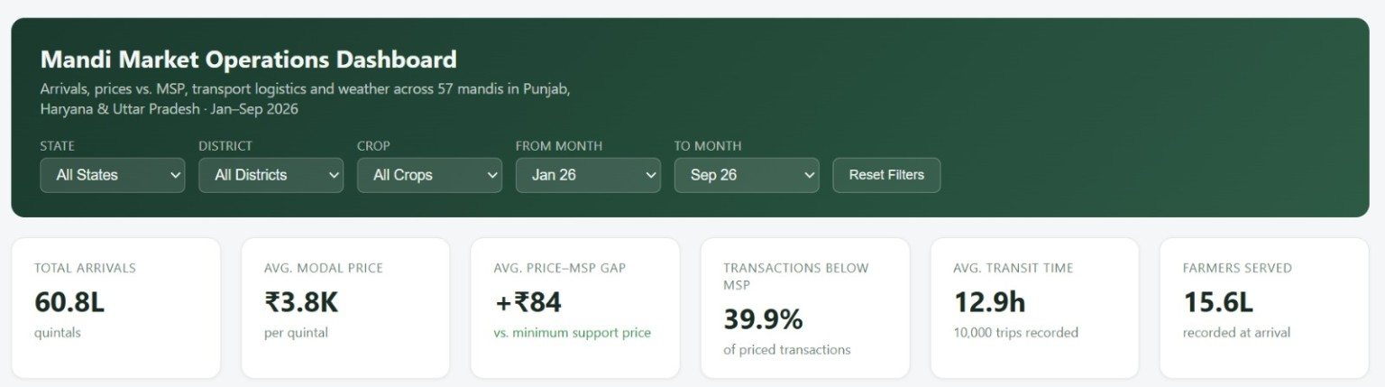
Figure 1. Main Mandi Market Operations Dashboard with filters and KPI cards.
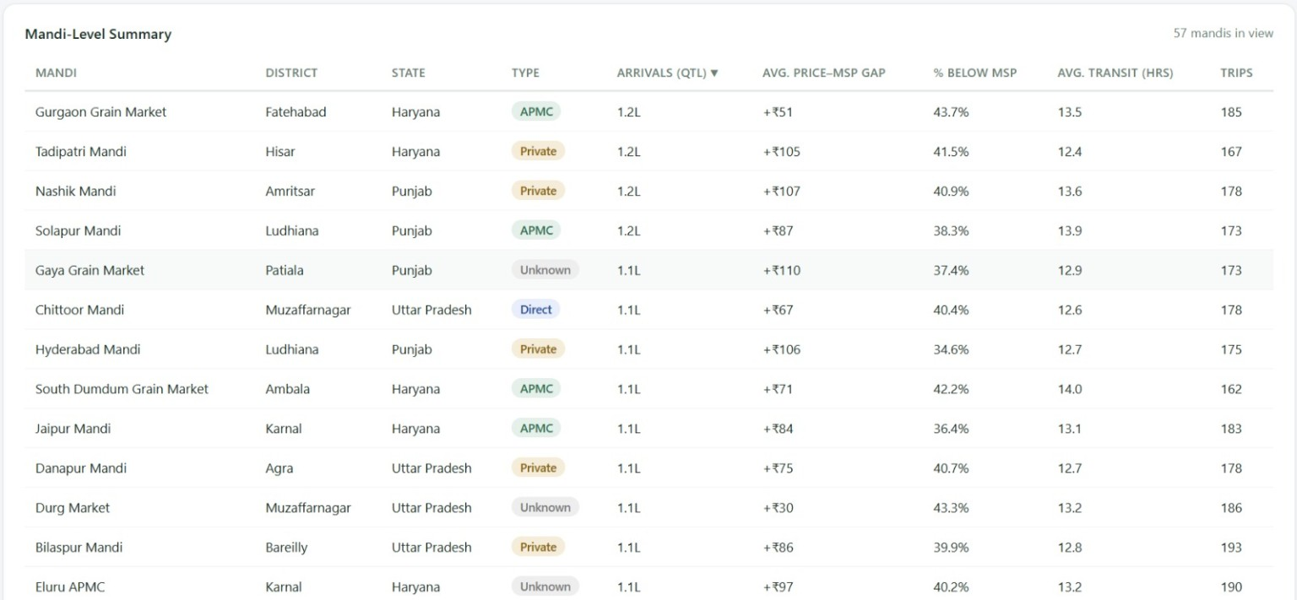
Figure 2. Mandi-level summary showing market, price, MSP, transit, and trip measures.
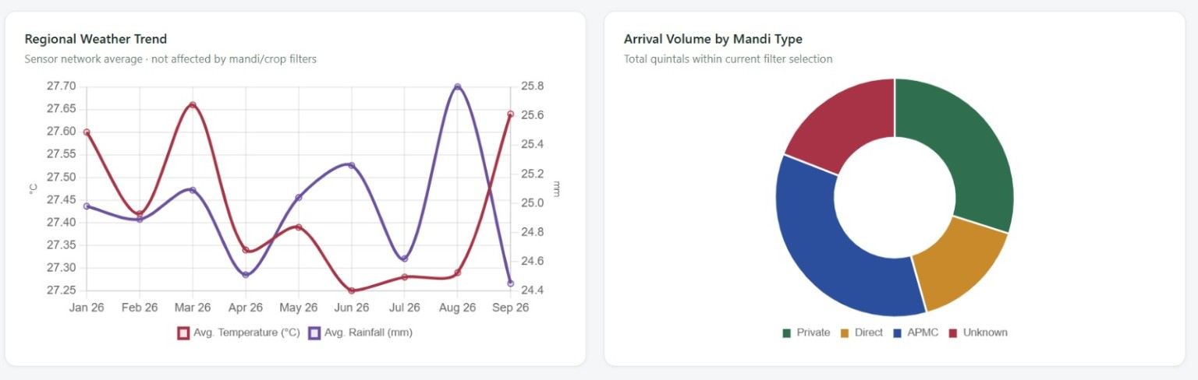
Figure 3. Regional weather trend and arrival volume by mandi type.
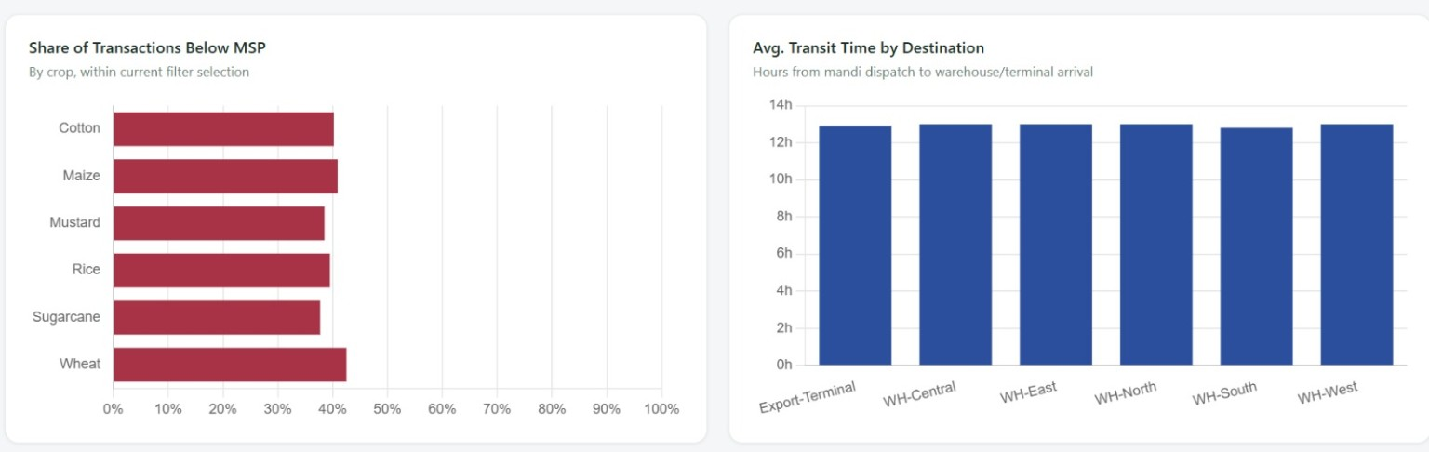
Figure 4. Share of transactions below MSP and average transit time by destination.
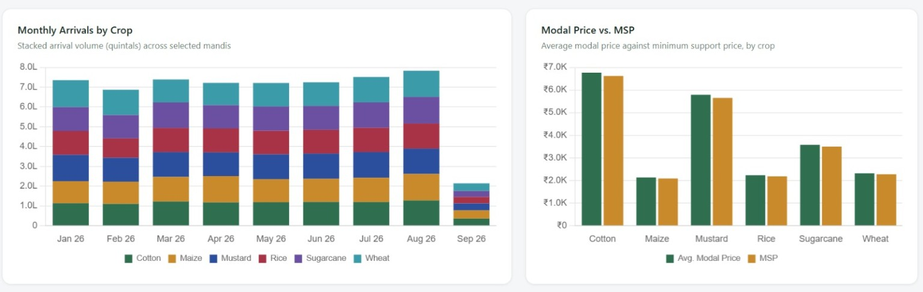
Figure 5. Monthly arrivals by crop and modal price versus MSP.

11. Key Findings from the Dashboard
The dashboard provides several high-level observations. These findings are intended as descriptive analytics of the synthetic project data and should not be interpreted as real-world agricultural statistics.
Area | Displayed / derived observation | Interpretation
Overall arrivals | 60.8L quintals | The dashboard indicates a large aggregate arrival volume across the selected mandis and period.
Average modal price | ₹3.8K per quintal | Provides a high-level market price reference across the current filter selection.
Average price–MSP gap | +₹84 | The aggregate average modal price is displayed above the MSP benchmark by ₹84.
Transactions below MSP | 39.9% | A substantial share of priced transactions is displayed below the MSP benchmark, making this an important area for monitoring.
Average transit time | 12.9 hours | The dashboard provides a consolidated view of movement time, with 10,000 trips recorded.
Farmers served | 15.6L recorded at arrival | Indicates the aggregate farmer-count measure represented in the dashboard.
Crop comparison | Cotton, maize, mustard, rice, sugarcane, wheat | The dashboard enables crop-level comparison of arrivals and price performance.
Mandi type | Private, Direct, APMC, Unknown | Arrival volume is distributed across different mandi types, with Unknown retained rather than silently discarded.

The crop-level below-MSP visualization shows that all six displayed crop categories have a sizeable share of transactions below the benchmark, with the chart indicating values broadly in the mid-30% to low-40% range. The modal-price-versus-MSP chart also shows that average modal prices are generally above the displayed MSP values for the selected crops, illustrating why aggregate price–MSP gaps and below-MSP transaction shares should be interpreted as complementary measures rather than as contradictory indicators.

12. Interpretation of Major Visualizations

12.1 Regional Weather Trend
The weather chart presents monthly average temperature and rainfall from the sensor network. The two measures use separate axes, allowing temperature and rainfall to be viewed together without treating them as the same unit. The visualization is useful for identifying monthly changes, although district-level conclusions require reliable sensor-to-district mapping.

12.2 Arrival Volume by Mandi Type
The donut chart summarizes arrival volume across Private, Direct, APMC, and Unknown mandi types. Retaining the Unknown category makes data quality visible and prevents missing classification information from being mistaken for a zero-volume category.

12.3 Transactions Below MSP
The crop-level bar chart highlights the proportion of priced transactions below the MSP benchmark. This is an important monitoring measure because a high below-MSP share can indicate that a significant portion of observed transactions occurred below the supplied benchmark. The project's data-quality notes should be considered because the price quantity unit is unspecified.

12.4 Transit Time by Destination
The destination chart compares average transit time in hours from mandi dispatch to warehouse or terminal arrival. The values shown are close to one another, indicating relatively similar average movement times among the displayed destinations. However, a confirmed delay metric cannot be calculated without an SLA.

12.5 Monthly Arrivals by Crop
The stacked monthly chart shows how total arrival volume is distributed across six reporting crop groups over time. It helps identify changes in total volume and the relative contribution of different crops.

12.6 Modal Price vs. MSP
The grouped bar chart compares average modal price against MSP for each crop. This provides a simple benchmark view of price positioning and supports further investigation of the below-MSP transaction measure.

13. Technical Architecture
Layer | Tools / methods | Role in the project
Data preparation | Python, pandas, NumPy | Cleaning, standardization, unit conversion, date parsing, quality flags, and validation.
Database analysis | SQL | Table organization, querying, filtering, aggregation, joins, and validation.
Visualization | Microsoft Power BI | Interactive charts, KPI cards, tables, slicers, filters, and dashboard design.
Web presentation | HTML | Structured browser-oriented presentation of visualization-related content.
Documentation | Project report / screenshots | Communication of methodology, results, limitations, and team contributions.

14. Team Contributions
Team member | Primary contribution
Niya | Data visualization using Microsoft Power BI and HTML; creation of KPI cards, charts, tables, slicers, filters, dashboard layout, readability checks, and visualization validation.
Rohan | Data cleaning and validation using Python, pandas, and NumPy; standardization, identifier validation, unit conversion, date parsing, quality flags, and documentation of data-quality limitations.
Annamika | Power BI and HTML visualization support, report preparation, formatting, documentation, compilation of team outputs, and final project assembly.
Bhavani | SQL analysis and database-level processing; table structuring, querying, aggregation, filtering, joins, validation, and preparation of analytical outputs for visualization.

15. Limitations
- The datasets are synthetic and therefore the results are intended for project demonstration and analytical methodology, not as real-world agricultural estimates.
- Some mandi reference fields remain missing, including district, mandi type, and area fields.
- Price data contain missing mandi identifiers and unresolved reporting districts; source conflicts were preserved rather than hidden.
- The price quantity unit is unspecified, so price-versus-MSP comparisons assume the common basis implied by the challenge.
- Weather sensor-to-district mapping remains unresolved, limiting district-level weather analysis.
- Negative rainfall and quantity observations were flagged rather than treated as valid measurements.
- Transport records include reported-duration fallbacks, and no confirmed delay calculation is possible without a defined SLA.
- The final status of transport export/validation should be confirmed before claiming that the transport dataset is fully production-ready.

16. Future Scope
- Establish a formal data dictionary defining every field, unit, allowed range, and quality flag.
- Resolve remaining mandi, district, and sensor mappings through an authoritative master reference.
- Obtain or define the exact price quantity basis so modal prices and MSP can be compared unambiguously.
- Introduce an explicit transport SLA by destination or route to calculate confirmed delays and on-time performance.
- Add automated data-quality monitoring so new files can be validated before entering the database.
- Develop predictive models for arrival volume, price movement, transport demand, or supply risk once sufficient historical data are available.
- Add alerting for unusually high below-MSP shares, abnormal arrival changes, invalid measurements, or logistics delays.
- Expand the dashboard with role-specific views for farmers, mandi operators, logistics teams, and decision-makers.

17. Conclusion
The Mandi Market Supply Chain Optimizer demonstrates how agricultural market data can be transformed from heterogeneous records into a structured analytics solution. The project combines systematic data cleaning and validation, SQL-based analysis, and interactive Power BI and HTML visualization to provide a consolidated view of mandi operations.
The final dashboard makes it easier to examine arrival volumes, crop patterns, mandi types, prices relative to MSP, below-MSP transactions, transport movement, farmer counts, and weather trends. The project also emphasizes an important principle of responsible analytics: uncertain or missing information should be preserved and flagged rather than silently replaced.
With stronger master-data mapping, clarified units, defined logistics SLAs, and additional historical data, the solution could be extended from descriptive analytics toward monitoring, forecasting, and decision support for agricultural supply-chain operations.

Appendix A — Selected Data-Quality Statistics
Metric | Value
Mandi master rows after cleaning | 57
Arrivals rows after cleaning | 25,000
Valid arrival quantities | 23,767
Negative arrival quantities flagged | 1,233
Valid arrival volume | 6,077,460.14 quintals
Price/MSP rows | 12,000
Price observations with both modal price and MSP | 9,131
Price observations below benchmark | 3,667 (40.16%)
Transport rows after cleaning | 10,000
Calculated transport durations | 7,359
Reported duration fallbacks | 2,356
Weather readings | 15,000
Known weather sensors | 50
Negative rainfall readings flagged | 1,518
Unknown sensor IDs | 715
Price district conflicts with master | 8,366
Ambiguous arrival dates | 4,703
Ambiguous price dates | 2,262

— End of Report —

