**ESE-3014 Lab 3**

**Interfacing communication – I2C**

**Submitted by: Group 6**

**Rohan yadav - C0773871**

**Shahrukh Padaniya - C0769542**

**Swapnil Sevak - C0777195**

**Khaja Faraz Ahmed C0765504**

**Step1:**

Connect ADXL345 Board to Beaglebone black as shown in figure:

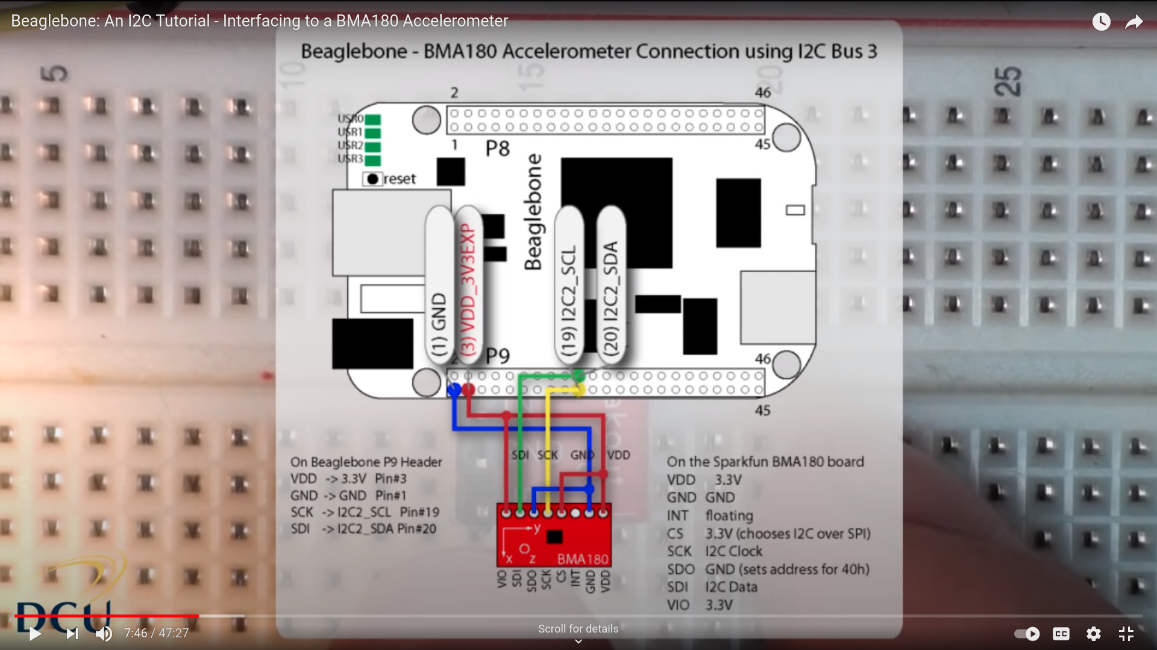

ADXL --------> Beaglebone

GND Pin1(GND)

VCC Pin3(VDD_3.3V)

CS Pin3(VDD)

SCL Pin19(I2C_2_SCL)

SDA Pin20(I2C_2_SDA)

Warning: Do not merge Vcc and Gnd line on Breadboard!!!

Step2:

Install i2ctool package on your beaglebone:

Command: sudo apt-get install i2c-tools

Output:

Here I have already installed i2c-tools

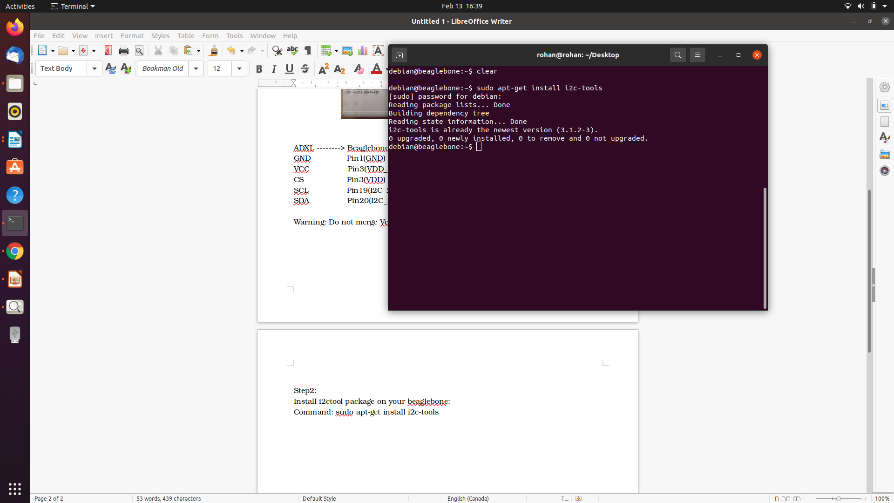

Step 3:

We have to find which i2c buses are available to us and how many are available.

Command: i2cdetect -l

Output:

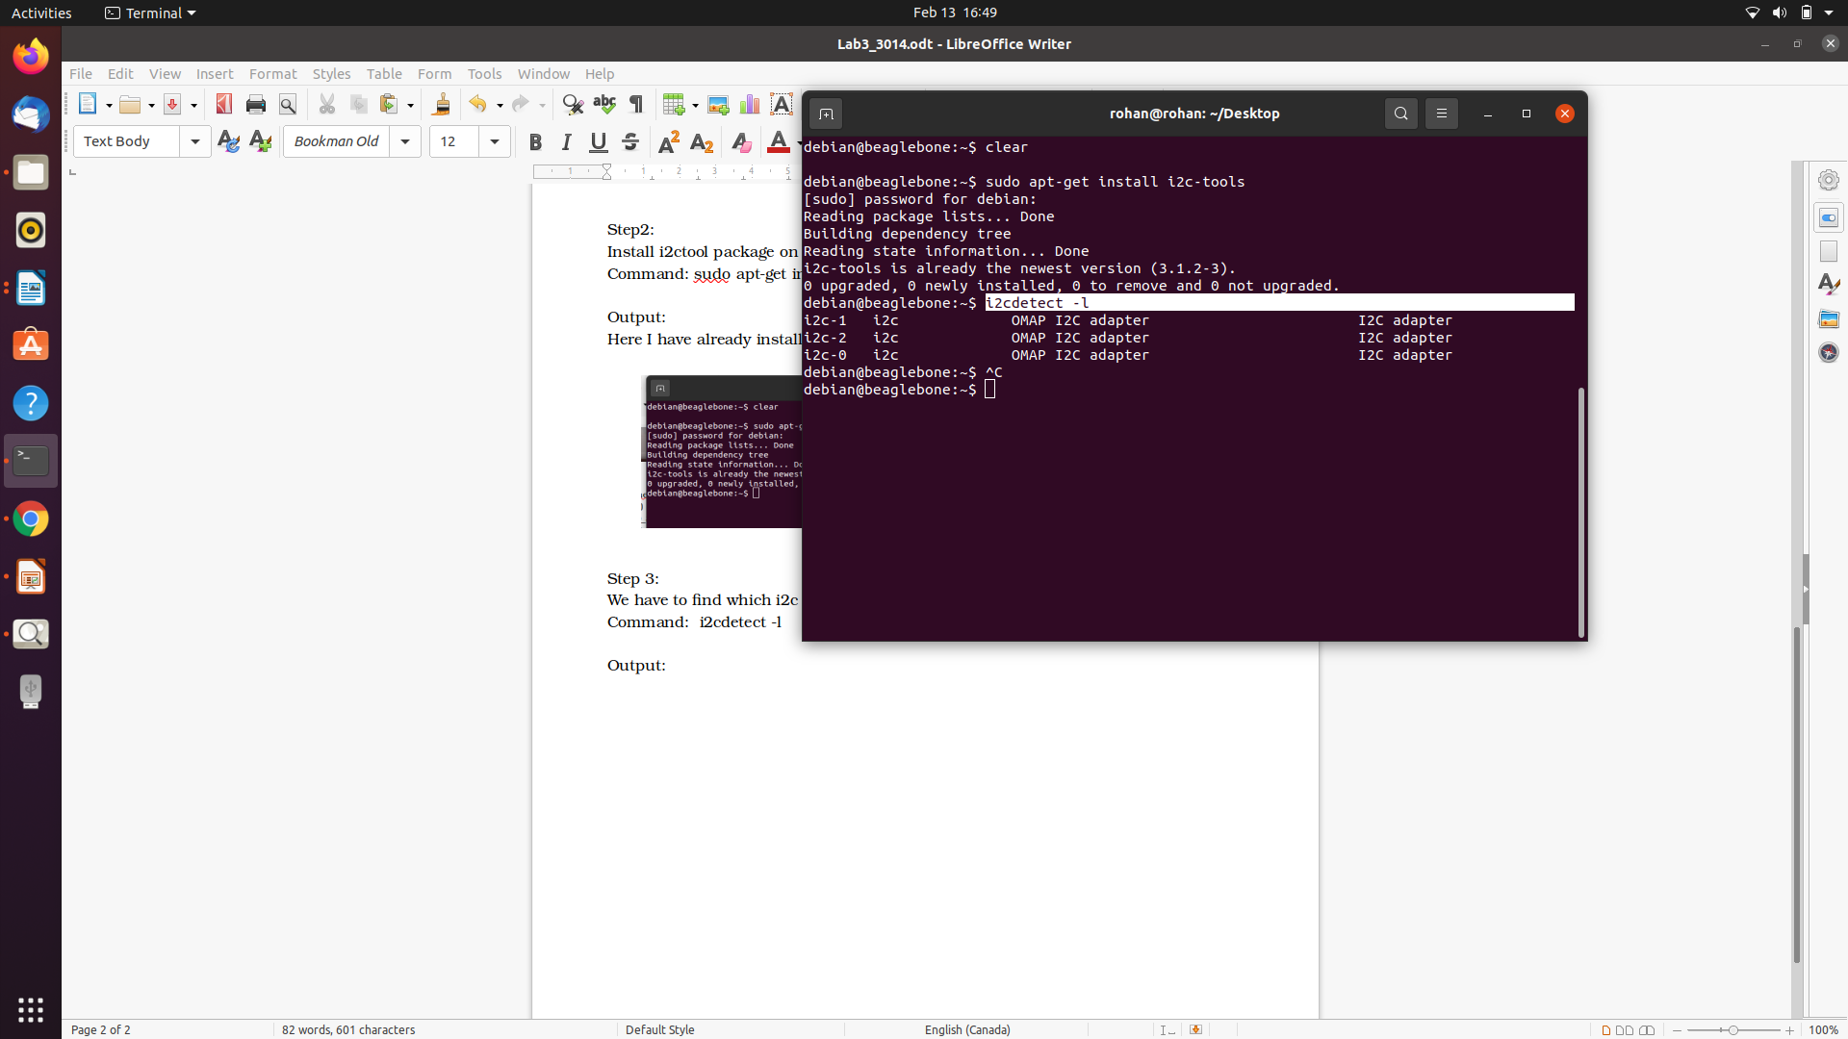

Here, we can see that 3 i2c-buses are available to use.

1. i2c-0

2. i2c-1

3. i2c-2

We can identify pin-configuration for different bus from data sheet:

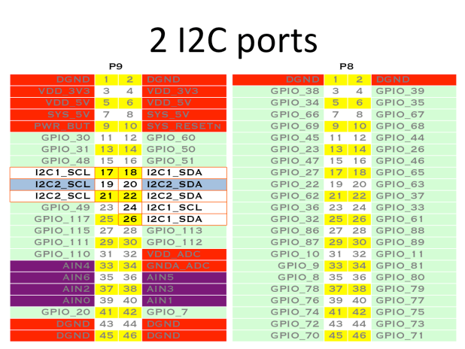

i2c-0 is internally used for HDMI cable by default, so we can not use it. So we have 2 option to choose. For this practicle, we have used i2c-2 bus. So, pin19 will be used for SCL(Serial clock) and 20 for SDA(Serial data)

Step 4:

Command: sudo i2cdetect -F 2

Output:

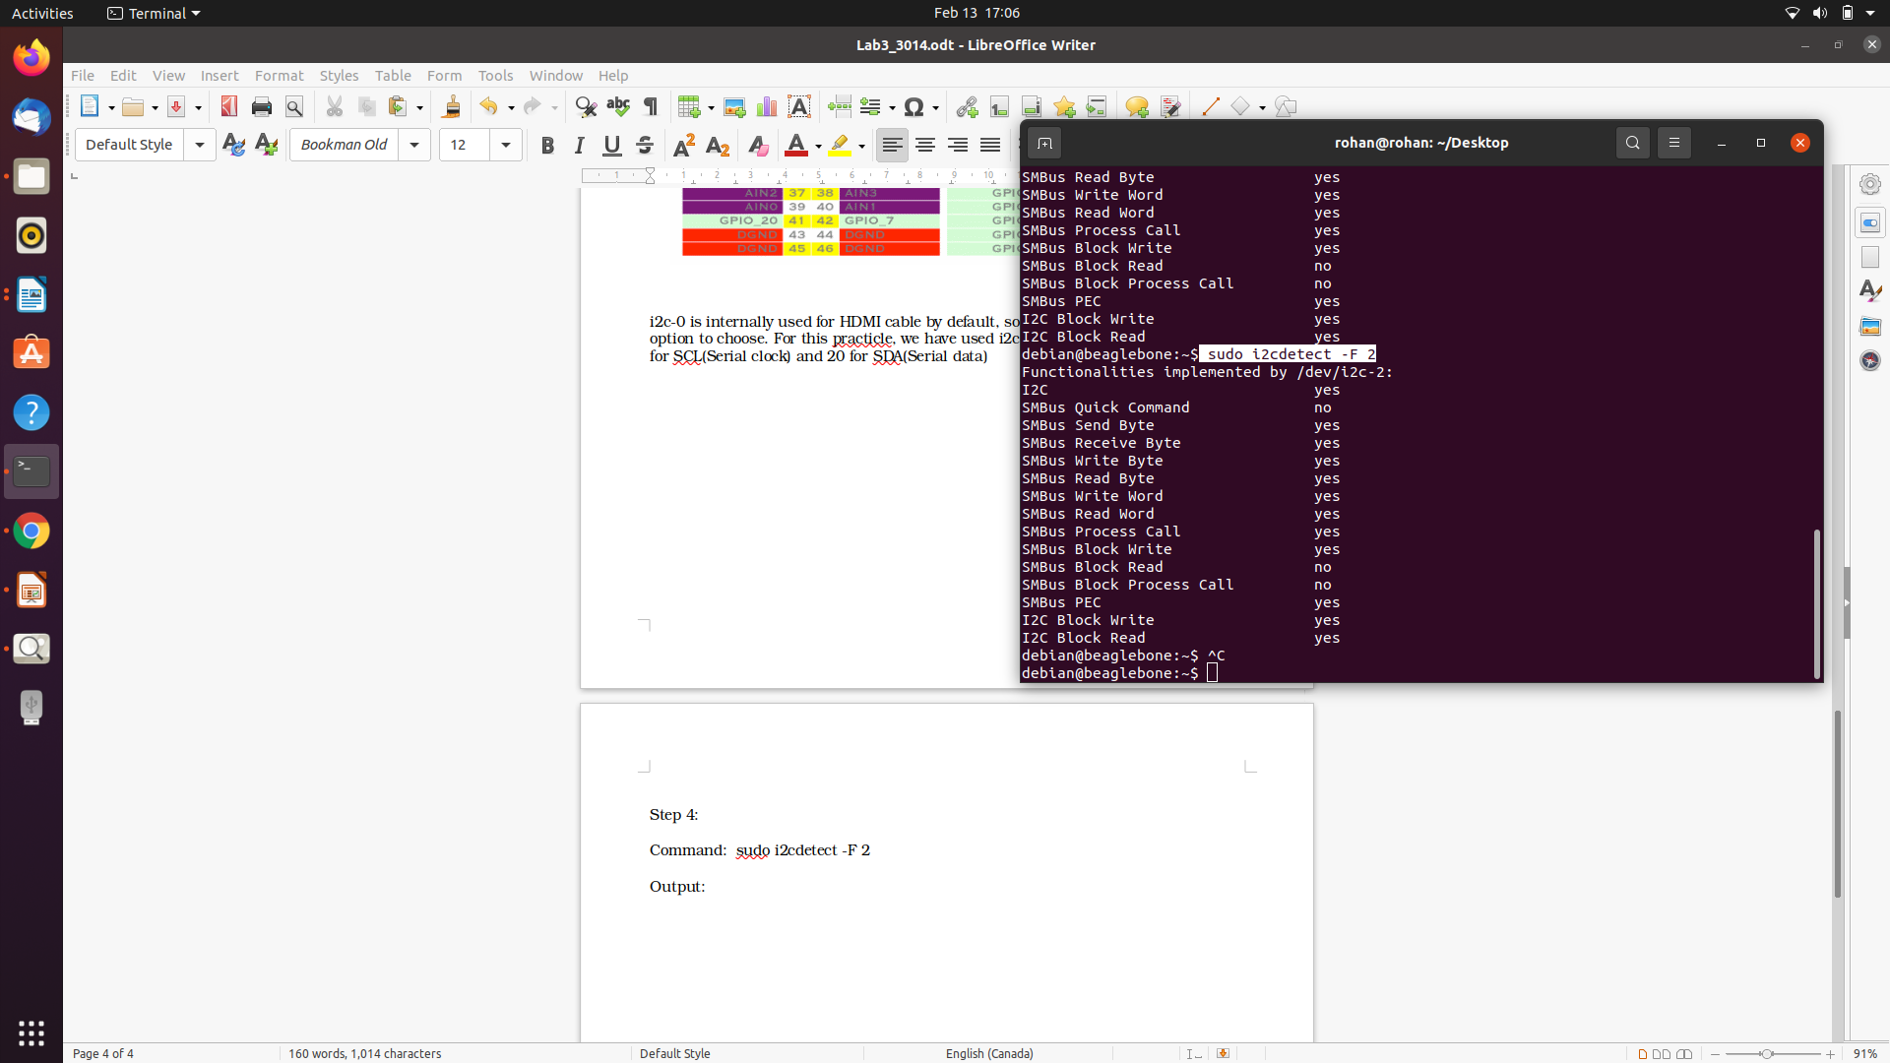

This command gives information about functionality of i2c-2 bus. We can see that, it is possible to read and write data through this bus.

Step 5:

Command: sudo i2cdetect -r 2

After connecting accelerometer to beglebone, we need to know device is allocated to which address. This command will give address where Accelerometer data will be dumped using i2c protocol.

Output:

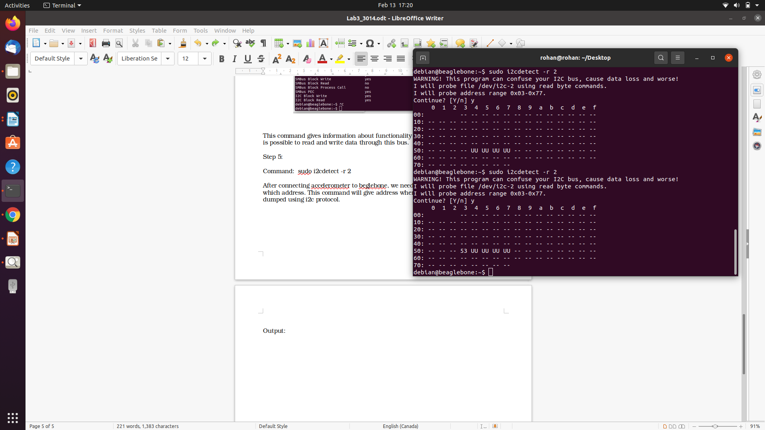

Here we can see that, our device is allocated to 0x53 address . UU is allocated address of other device drivers, which we can ignore.

Step 6:

Command: i2cdump 2 0x53

Output:

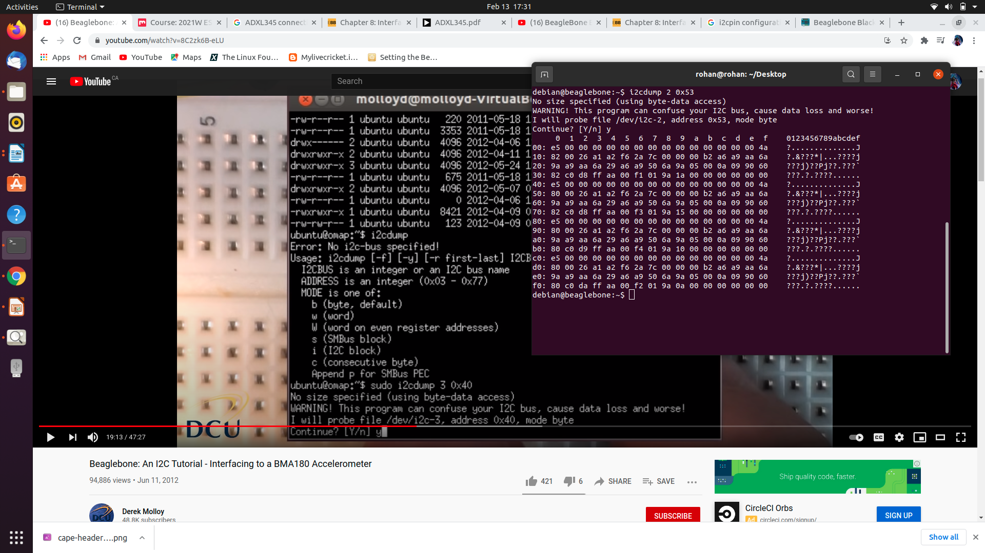

Here, by using this command we get data of 0x53 address which is generated by ADXL345 chip. As we move the chip data will be changed according to chip position.

Because as we move chip, accelerometer senses the movement and give output in terms of acceleration.

Step 7:

Command: sudo i2cget -y 2 0x53 50

Output:

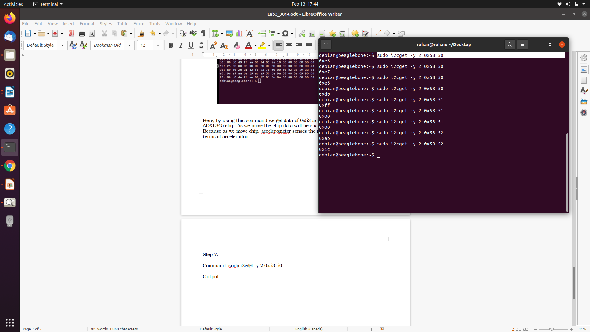

This command gives value of particular register in Accelerometer. We can know which register is associated to which data by datasheet of ADXL-345.

Here, I have used no. 50 register which is associated to x-axis data,

We can see that each time value is changing which prooves that our beaglebone successfully reading data form accelerometer.

Here is information about register (collected from data sheet page-23):

