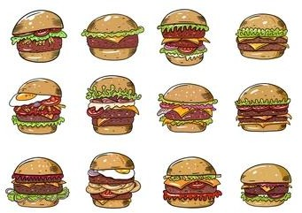**SQL Project : Burger Bash Case Study**

**INTRODUCTION:**

I have a started a new business of selling burger because I read on my Instagram feed that „Burger Is the Future!

But I knew that burger alone was not going to help me get seed funding to expand my new Burger Empire - so I had one more genius idea to combine with it - I was going to Uberize it - and so Burger Runner was launched!

I started by recruiting “runners” to deliver fresh burger from Burger Runner Headquarters and also maxed out my credit card to pay freelance developers to build a mobile app to accept orders from customers.

**SCHEMA USED**

**burger_runner** runner_id int registration_date date

**customer_orders**

order_id int

customer_id int

burger_id int

exclusions varchar

extras varchar

order_time timestamp

|  |  |
| --- | --- |
| **runner_orders** | |
| order_id | int |
| runner_id | int |
| pickup_time | timestamp |
| distance | varchar |
| duration | varchar |
| cancellation | varchar |

|  |  |
| --- | --- |
| **burger_names** | |
| burger_id | int |
| burger_name | varchar |

**QUESTIONS**

1. How many burgers were ordered?
2. How many unique customer orders were made?
3. How many successful orders were delivered by each runner?
4. How many of each type of burger was delivered?
5. How many Vegetarian and Meatlovers were ordered by each customer?
6. What was the maximum number of burgers delivered in a single order?
7. For each customer, how many delivered burgers had at least 1 change and how many had no changes?
8. What was the total volume of burgers ordered for each hour of the day?
9. How many runners signed up for each 1 week period?
10. What was the average distance travelled for each customer?

Burger_name .csv - https://internal-cohort-owner-db.s3.ap-south-1.amazonaws.com/Data_Science/Projects/DA+Projects/SQL/Burger+Bash/burger+name.csv

Burger_runner_order.csv - <https://internal-cohort-owner-db.s3.ap-south-1.amazonaws.com/Data_Science/Projects/DA+Projects/SQL/Burger+Bash/burger+runner_orders.csv>

Customers_order.csv - <https://internal-cohort-owner-db.s3.ap-south-1.amazonaws.com/Data_Science/Projects/DA+Projects/SQL/Burger+Bash/customer_orders.csv>

