**AquaVision: Enhancing Underwater Imagery**

**Capstone Project Report**

**MID SEMESTER EVALUATION**

**Submitted by:**

102283008 Anirudh Bansal

102283007 Rajneesh Bansal

102103142 Divyam Malik

102103108 Rohan Gulati

102103110 Abhinandan Sharma

**BE Fourth Year, COE**

**CPG No: 138**

Under the Mentorship of

Dr. Chinmaya Panigrahy

(Assistant Professor)



**Computer Science and Engineering Department**

**Thapar Institute of Engineering and Technology, Patiala**

**August 2024**

**ABSTRACT**

The AquaVision is an innovative solution aimed at enhancing underwater photos with the help of neural network algorithms as well as custom adjustment. Some of the problems identified include color shift, poor contrast and loss of resolution to optimize underwater photography. This system applies deep learning and specific image processing approaches that allow it to cope with the issues, such as loss of light, color shift, and noise in underwater environment. It is as if, through continuous experimentation, AquaVision achieves a reasonable compromise between the temporal and the spatial rates. Some of the fields that can apply this technology include fields like marine biology, oceanography, underwater history, and archaeology, industrial surveys, search and rescue, and military & naval operations. Helping us see underwater in a better way, AquaVision creates brand new possibilities of ocean discoveries, seascape conservation, and broader understanding of marine life.

**DECLARATION**

We hereby declare that the design principles and working prototype model of the project entitled Aqua Vision is an authentic record of our work carried out in the Computer Science and Engineering Department, TIET, Patiala, under the guidance of Dr. Chinmaya Panigrahy during the 6th semester (2024).

Date: 23-08-2024

|  |  |  |  |
| --- | --- | --- | --- |
| **Roll No.** | **Name** |  | **Signature** |
| 102283008 | Anirudh Bansal |  | Anirudh |
| 102283007 | Rajneesh Bansal |  | Rajneesh |
| 102103142 | Divyam Malik |  | Divyam |
| 102103108 | Rohan Gulati |  | Rohan |
| 102103110 | Abhinandan Sharma |  | Abhinandan |

*Counter Signed By:*

Faculty Mentor:

Dr. _________________________

Assistant Professor

CSED,

TIET, Patiala

**ACKNOWLEDGEMENT**

We would like to express our thanks to our mentor Dr. Chinmaya Panigrahy. He has been of great help in our venture and an indispensable resource of technical knowledge. He is truly an amazing mentor to have.

We are also thankful to Dr. Shalini Batra Head, Computer Science and Engineering Department, the entire faculty and staff of the Computer Science and Engineering Department, and also our friends who devoted their valuable time and helped us in all possible ways towards successful completion of this project. We thank all those who have contributed either directly or indirectly towards this project.

Lastly, we would also like to thank our families for their unyielding love and encouragement.

They always wanted the best for us, and we admire their determination and sacrifice.

Date: 23-08-2024

|  |  |  |  |
| --- | --- | --- | --- |
| **Roll No.** | **Name** |  | **Signature** |
| 102283008 | Anirudh Bansal |  | Anirudh |
| 102283007 | Rajneesh Bansal |  | Rajneesh |
| 102103142 | Divyam Malik |  | Divyam |
| 102103108 | Rohan Gulati |  | Rohan |
| 102103110 | Abhinandan Sharma |  | Abhinandan |

**TABLE OF CONTENTS**

**ABSTRACT…………………………………………………………………………… i**

**DECLARATION………………………………………………………………………ii**

**ACKNOWLEDGEMENT……………………………………………………………iii**

**LIST OF FIGURES……………………………………………………………………iv**

**LIST OF TABLES……………………………………………………………………...v**

**LIST OF ABBREVIATIONS…………………………………………………..……..vi**

**CHAPTER………………………………………………………………………Page No.**

|  |  |  |  |
| --- | --- | --- | --- |
| **1.** | **Introduction**  10 | |  |
|  | 1.1 | Project Overview 10 |  |
|  | 1.2 | Need Analysis 11 |  |
|  | 1.3 | Research Gaps 13 |  |
|  | 1.4 | Problem Definition and Scope 14 |  |
|  | 1.5 | Assumptions and Constraints 15 |  |
|  | 1.6 | Standards 16 |  |
|  | 1.7 | Approved Objectives 16 |  |
|  | 1.8 | Methodology 17 |  |
|  | 1.9 | Project Outcomes and Deliverables 19 |  |

1.10 Novelty of Work 20

1. **Requirement Analysis 21**
   1. Literature Survey 21

2.1.1 Theory Associated With Problem Area 21

2.1.2 Present Systems and Solutions 21

2.1.3 Research Findings for Existing Literature 22

2.1.4 Problem Identified 22

2.1.5 Survey of Tools and Technologies Used 23

2.2 Software Requirement Specification 24

2.2.1 Introduction 24

2.2.1.1 Purpose 24

2.2.1.2 Intended Audience and Reading Suggestions 24

2.2.1.3 Project Scope 24

2.2.2 Overall Description 26

2.2.2.1 Product Perspective 26

2.2.2.2 Product Features 26

2.2.3 External Interface Requirements 26

2.2.3.1 User Interfaces 26

2.2.3.2 Hardware Interfaces 27

2.2.3.3 Software Interfaces 28

2.2.4 Other Non-functional Requirements 28

2.2.4.1 Performance Requirements 28

2.2.4.2 Safety Requirements 28

2.2.4.3 Security Requirements 28

2.3 Risk Analysis 29

* 1. **Methodology Adopted 31**

3.1 Investigative Techniques 31

3.2 Proposed Solution 36

3.3 Work Breakdown Structure 39

3.4 Tools and Technology 40

1. **Design Specifications 42**

4.1 System Architecture 42

4.2 Design Level Diagrams 43

4.3 User Interface Diagrams 44

4.4 Snapshots of Working Prototype 45

1. **Conclusions and Future Scope 47**

5.1 Work Accomplished 47

5.2 Conclusions 47

5.3 Environmental Benefits 48

5.4 Future Work Plan 48

**APPENDIX A: References 49**

**APPENDIX B: Plagiarism Report**

**LIST OF TABLES**

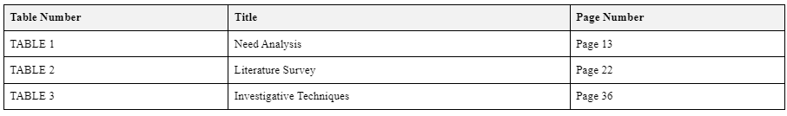

**LIST OF FIGURES**

­-­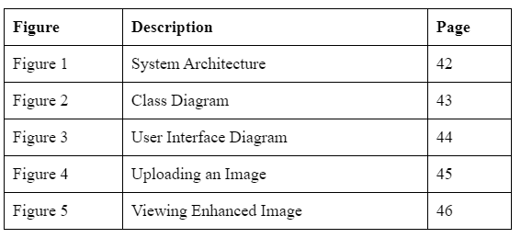

**LIST OF ABBREVIATIONS**

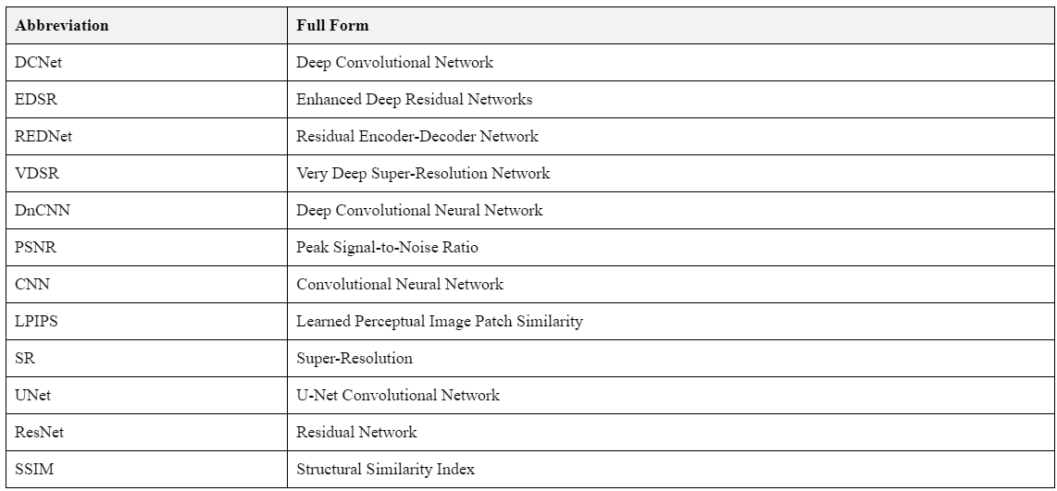

**INTRODUCTION**

* 1. **Project Overview**

Our project will try to revolutionize underwater photography by establishing better techniques to improve the quality of images taken underwater through the use of neural network algorithms. Scene acquisition is another issue in underwater photography, colors are distorted, clarity is compromised, and fine detail is hard to discern, meaning scenes are often captured inaccurately.

It is a complicated task to solve these problems and return the ‘real’ look to underwater scenes with the help of modern artificial intelligence combined with small hand-tempered corrections using neural networks.

The goals set for this work are:

* Significantly improve image quality.
* Improve processing speed.
* Keep images as realistic as possible.
* Design a freeware that operates in various underwater environments.

Our algorithms are built in accordance with the principles of modern neural network design; however, we apply appropriate tuning by hand, combining the best aspects of artificial intelligence and human expertise.

Key parts of our approach include:

* **Neural Network Integration:** We optimize modifying techniques, including Convolutional Neural Networks (CNNs) for image improvement.
* **Deep Learning-Based Image Processing:** We create techniques for color correction, haze reduction, contrast enhancement, and noise reduction specific to underwater conditions.
* **Manual Adjustment Integration:** We provide options for further adjustment of parameters, image enhancement after processing, and user feedback to improve future results.
* **Iterative Experimentation and Validation:** We conduct tests and compare our methods with existing ones to ensure superior performance.

Potential applications include Marine Biology, Oceanography, Underwater Archaeology, Scuba Diving, Movies & Documentaries, and Industrial Surveys.

Our main motivation in enhancing underwater scene understanding is to improve research, conservation, and industrial operations in underwater spaces. Our work involves marine biologists, oceanographers, software engineers, computer vision specialists, and professional underwater photographers. Such teamwork helps ensure that the solution meets practical requirements and contributes to technological progress.

Through this project, we seek to make a breakthrough in marine research, exploration, and management of underwater ecosystems for protection. By addressing the challenges of underwater photography, we strive to expand our aesthetic and intellectual understanding of the underwater world.

* 1. **Need Analysis**

Enhancing the Unseen: Overcoming Underwater Imaging Challenges with Aqua Vision

**Scientific Exploration and Research:**

* Challenge: Underwater photography is all the more important for the purpose of understanding the marine environment, oceanography, and aquatic organisms. The current limitations in the quality of the images obtained make it difficult to achieve an extensive analysis and research on these fields.
* Solution: Aqua Vision facilitates boost up of image sharpness and can therefore assist in gathering of clearer and more informative visions by the scientists. This enhancement will help in the understanding of complex ecosystems in seas and oceans, aids in the identification of new species and enhance the overall research conducted in underwater contexts.

**Underwater Inspection and Maintenance:**

* Challenge: Some important sectors which require underwater inspection are offshore drilling sector, underwater construction companies, and maintenance of marine structures. Bad picture quality can hide important elements, and therefore, issues, and potential risks.
* Solution: Aqua Vision increases the contrast of underwater structures so that the inspectors can effectively find the issues out. This enhancement improves safety and service life of the marine structures and cuts maintenance expenses by proposing timely and accurate work.

**Search and Rescue Operations:**

* Challenge: Underwater search and rescue typically depends on the precise picture of the particular object, wreckage, or lost persons. In traditional imaging, the required resolution for effective recoveries is usually missing which in turns slows down the operations and puts the possibility of a positive result in jeopardy.
* Solution: Aqua Vision greatly improves the resolution of locations in underwater search and rescue operations, thereby allowing the rescue team to identify important points as soon as possible. The capability incidentally results in quicker recovery, higher Survival Rates and successful operations in difficult underwater environments.

**Environmental Monitoring and Conservation:**

* Challenge: A successful monitoring of environment entails having clear images to evaluate the ecosystem heath in the ocean, any changes, and new threats. Inability to access detailed information is one of the issues experienced in the current imaging systems undermines the affords to protect marine biodiversity.
* Solution: Aqua Vision affords improved observational acuity or clarity of the sea environments as seen by investigators. This improvement assists in measuring alterations in the coral reefs, measuring the effects of pollution, and in determining which areas must be conserved to support the sustainable conservation of the seas and seascape.

**Military and Defense Operations:**

* Challenge: Military tasks such as reconnaissance, surveillance, and underwater defense rely on clear underwater imagery. Poor visibility can compromise missions, making it difficult to detect threats or gather critical intelligence.
* Solution: Aqua Vision delivers enhanced imaging capabilities that improve the detection of underwater threats, support reconnaissance missions with greater accuracy.

TABLE 1: Need Analysis

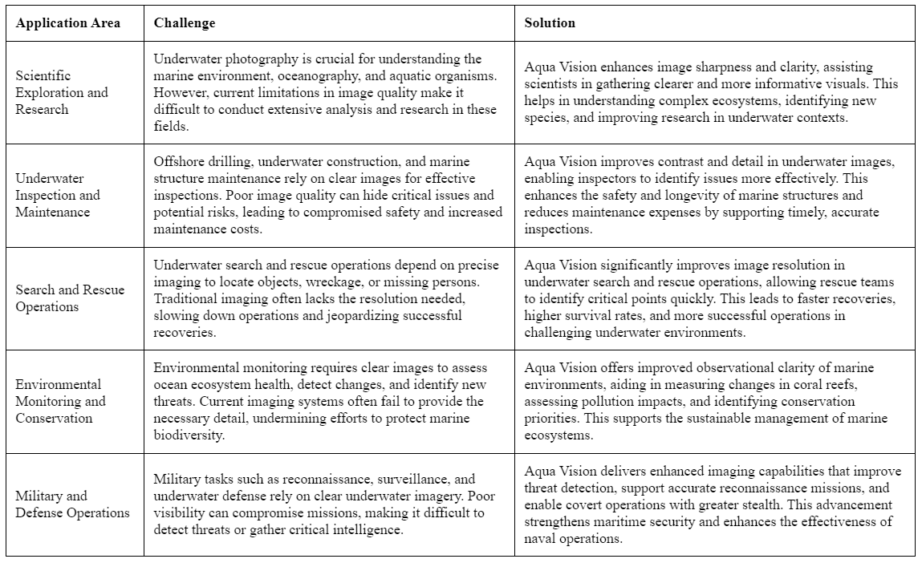

* 1. **Research Gaps**
* **Adaptive Color Correction for Varying Underwater Conditions:** Existing color correction algorithms often struggle with the diverse and dynamic nature of underwater environments. We need adaptive models that can adjust to different water conditions and depths.
* **Integration of Manual and Automated Adjustments:** Most current approaches rely on either fully automated or fully manual enhancement techniques. We should explore how to optimally combine neural network algorithms with manual adjustments to improve the overall enhancement process.
* **Underwater-Specific Neural Network Architectures:** While neural networks have been used for image enhancement, we lack architectures specifically designed for the unique challenges of underwater imagery, such as color distortion, reduced clarity, and loss of detail.
* **Standardized Evaluation Metrics for Underwater Image Quality:** We currently lack universally accepted metrics for assessing the quality of enhanced underwater images across different applications. Existing methods often inadequately use color space, leading to poor feature extraction and inaccurate representation of the relationship between underwater image quality and subjective perception
  1. **Problem Definition and Scope**

Our project tackles the challenges of underwater image enhancement by addressing the following key issues -

* Color Distortion: We resolve the unnatural color transitions in underwater images due to water’s ability to absorb particular wavelengths of light.
* Reduced Clarity: We deal with blurred images, which are the outcome of the dispersion of light with the particles that are dispersed in fluids.
* Loss of Detail: We actively contribute to the enhancement of visibility of the finer details which may be masked by the fall off of light in water.
* Varying Environmental Conditions: Thus we create means of enhancing to fit the different types of water forms and depths of the water.
* Integration of Automated and Manual Processes: In order to handle the control intricacies, we propose a further combination of automatic enhancements and manual changes.

The scope of our project includes:

* Developing Custom Neural Network Architectures: We design proper neural networks for reprocessing of underwater images.
* Implementing Adaptive Color Correction: To enhance the color correction particularly, we utilize methods that involves fusion of multiple feature scales.
* Creating a Hybrid Framework: It consists of automated improvements that employ essential higher-level variance and manual fine-tuning changes in a single approach.
* Establishing a Comprehensive Evaluation Protocol: We provided the procedures to establish the quality performance of underwater images.
* Designing Multi-Factor Enhancement Models: We develop models that mitigate all the above mentioned underwater imaging problems at the same time.

That is why we want to create a universally applicable and rather stable underwater image enhancement system. This system will help amass better assessment and recordation across various academic disciplines including marine biology, oceanography, underwater archeology, and industrial surveys.

* 1. **Assumptions and Constraints**

Our underwater image enhancement project operates under the following key assumptions and constraints -

**Assumptions:**

* Availability of Diverse Datasets: As a form of standard work, we assume to have a wide number of underwater image datasets for both training and testing.
* Computational Resources: We anticipate should be able to have enough computation and programming platform to help us to in our development.
* Domain Expert Support: For getting the evaluation about the utility and effectiveness of proposed approach, we depend on the feedback from the domain experts.
* Minimum Image Quality: We assume that input images will be of a minimum quality.
* Varied Underwater Conditions: For a moments we understand that the conditions post water differ immensely depending on the environment that it is in.

**Constraints:**

* Computational Efficiency: They require that the algorithms that will be developed should perform their tasks on regular hardware with standard processing power.
* Model Size Limitations: The models should also be designed so as to be compatible with size constraints that may be integral to deployment in different platforms such as the mobile.
* Ethical Considerations: We want to save the truthfulness of scenes shot underwater, and don’t want to deceive the audience.
* Processing Times: Real-time processing is not entirely a priority for us, but we do endeavor to make processing time feasible for real application use.
* Dataset Biases: We discuss about the bias when it comes to the data collection.
* Regulatory Compliance: We abide by legal requirements that apply to our activity.
* System Interpretability: To embrace system interpretability, we keep our system comprehensible so as to keep information transparency.
* Generalization Limitations: We know about the problems of extending our system to extremely adverse underwater environment.
  1. **Standards**

We will adhere to the following standards and guidelines in our development process -

* Image Quality Standards: For resolution, we will use the ISO 12233 standard and for noise the ISO 15739 standard but with modifications for the underwater conditions.
* Color Management: ICC profile will be used to enhance colour reproduction on screen devices to help match the actual real-life world.
* Image File Formats: JPEG, TIFF, and RAW formats will be provided by our system, guaranteeing the compatibility with several devices and applications.
* Metadata Standards: To maintain information regarding the imaging conditions and the enhancement processes applied we will use Exif metadata.
* Data Protection and Privacy: To the extent we do process underwater images and they originate from protected marine areas, we shall fully respect the GDPR.
* Software Development Standards: We will adhere to the best standards like using a version control system (Git), writing comments and documenting our code and testing our code.
* Machine Learning Model Standards: We will apply proper approach to model develop – we will use proper ways of splitting the data sets, using cv, having proper metrics for evaluation.
* Ethical AI Guidelines: In the case of this work, we commit to IEEE’s ethical guidelines on AI development and usage to avoid adverse consequences.
  1. **Approved Objectives**

Here are the objectives for the capstone project on underwater image enhancement that we will achieve:

* Develop and Implement: For image improvement underwater images we will develop and implement one deep learning algorithm which will be beneficial for all our work.
* Evaluate Performance: As it pertains the performance of the algorithm we will use quantitative measurements including PSNR, SSIM, and Color Difference measurements.
* Investigate Generalization: Lastly, we will evaluate the efficiency of the algorithm by performing different experiments under water environment.
* Validate Real-World Applicability: To make the algorithm practical we will test it in different real-world applications and in various domains.
* Gather Feedback: For better and efficient results, we will capture feedback from domain specialists and users to improve the algorithm.
* Design User Interface: For input and output, we will build a friendly for users web interface for using the image enhancement system.
* Implement Web Features: In the process we shall implement features that enable users to upload, work on and view improved underwater images.
* Ensure Compatibility: The web application will be made cross-platform compatible with the devices of use and the browsers in use.
* Integrate Backend and Frontend: To provide the linkage between the deep learning model and the web application the optimized image processing and enhancement services will be provided to the users.
* Conduct User Testing: Lastly, we will conduct an accessibility test, which is a test of the web interface as a means of proving it is usable to the target users.
  1. **Methodology**

Algorithm Development:

* Research and Implement: In order to conduct this research, we will investigate on the use of deep learning architectures with emphasis is put on underwater image enhancement.
* Address Key Issues: We will address issues of color calibration, improve on contrast and details of underwater image.
* Enhance Robustness: To increase robustness of the models we will incorporate data augmentation and transfer learning strategies.

Performance Evaluation:

* Collect Datasets: Different datasets of underwater images for benchmarking will be accumulated.
* Calculate Metrics: We will also calculate quantitative measures including PSNR, SSIM and colour difference.

Generalization Analysis:

* Test Across Conditions: Using cross-validation on the dataset, we shall evaluate the algorithm under different underwater environment.
* Analyze Impact: We will also discuss about the impact which environment has on performance.
* Identify Improvements: We shall identify areas of application for increases and areas that require alterations when used in other settings.

Web Development:

* Design Interface: For enhanced usability of the image enhancement system, we will develop an easy to use graphical user interface, residing on the world wide web.
* Develop Backend: The following backend mechanisms for requesting image processing will be established:
* Ensure Responsiveness: There is the development of a responsive design since the service will also be usable on any device.

Refinement and Iteration:

* Incorporate Feedback: We shall also accumulate and incorporate the feedback of managers and other people.
* Fine-Tune Parameters: It is noted that more parameters will be tuned according to requirements of specific applications.
* Continuous Improvement: The given algorithm will be constantly tested and updated to have a practical applicability in the real world.
  1. **Project Outcomes and Deliverables**

Our underwater image enhancement project aims to achieve the following key outcomes and deliverables -

**Advanced Underwater Image Enhancement Algorithm:**

* Design a complex deep-learning based algorithm that has to solve the issues of color distortion, contrast, and details in the underwater images.
* It is required to submit a document stating the architecture of the algorithm, training, and implementation protocol.

**Comprehensive Performance Evaluation Report:**

* Test the algorithm under different underwater environments using the simulation.
* Perform a comparative analysis with existing techniques with the help of basic parameters (PSNR, SSIM, Color Difference).
* Display the improvement outcome in order to gain a better qualitative quality.

**Web-Based Enhancement Platform:**

* Design an easily navigable web page for image uploading and post-processing of underwater photographs.
* Make preparations at the backend to enable it address cases of image enhancement.
* Use good user authentication and make good management of data.
* Always make the site responsive specifically for mobile devices so that visitors can accessibility easily.

**Dataset and Benchmarks:**

* Collect a wide selection of underwater images which can be used for the learning and validation of the algorithm.
* Set reference standards that can be used to assess methods that aim to augments underwater images.

**Technical Documentation and User Guide:**

* Ensure that all aspects of the algorithm implementation, as well as all the ways in which the algorithm is being used, are well-documented .
  1. **Novelty**
* Customized Neural Networks for Underwater Imagery
* Design special structures of neural networks for enhancing underwater images.
* Modify model to fit such problems as color shift and lower resolution.
* Design a way of operating that would allow processing to be varied according to the condition under water.
* Work with regard to marine biology, oceanography, as well as underwater architecture.
* Integrate user feedback to guarantee use in practice and applicability in various disciplines.
* Innovative Web-Based Enhancement Platform.
* Design a web application that can utilize enhanced submerged picture examination.
* Link customized Neural Network algorithms to the product’s graphical user interface for real-time image illumination enhancement.
* Use adaptive processing techniques in order to balance results of the session in regards to the underwater conditions.
* Ensure it has features for group work with regard to fine – tuned image analysis and improved picture sharing.

**Requirement Analysis**

**2. 1 Literature Survey**

**2. 1. 1 Theory that can be linked to the Problem Area**

Underwater image degradation results from two main factors: transmittance and reflectance of light in water.

Contrary to other materials, water has distinct transmittances for different wavelengths of the light. High magnitude causes selective absorption of light, and this result in hue shift in underwater images hence distorting color. Red is the lowest frequency and as such is absorbed quickly normally within the initial meters when in water. The next light spectrum regimes are orange and yellow leaving mainly the blue and green light to enter deeper water. As such, the underwater images show a certain degree of blue-green image appearance; more so for the deeper regions of the water body.

Particulate matter to include planktons, silt and organic mattes float and cause light scatter hence lower image resolution and contrast. This scattering gives a blurry look, or more precisely, a foggy look to the environment it transmits, and objects cannot easily be made out, especially if they are relatively far away from the receiver.

It is hence possible to mathematically model the underwater image formation as a linear combination of three factors.Brightest rays of light that are coming from the source are set on the object, then they are not scattered while getting to the camera.A part of light reflected off the object which gets slightly diffused before reaching the lens of a camera.Reflection whose path does not reach the object: light reflected back toward the camera by water and particles.

This model is fundamental in many physics driven image enhancement paradigms.

**2. 1. 2 Present Systems and other Responses**

* Color Correction methods colour blast to restore natural shades. White balance operation controls color temperaure. Channel adjustment adjusts each channel to make up for the gone color. Histogram equalization simply distributes pixel intensities so as to improve contrast.
* Contrast Enhancement: Histogram equalisation and Contrast Limited Adaptive Histogram Equalisation (CLAHE) increases the contrast by redistributing pixel intensities. CLAHE helps in avoiding over enhancement in regions which have same intensity levels.
* Physics-Based Methods quantify and compensate for the clear convolution of light absorption and scattering. Of them, the parameters estimation consists of background light, transmission maps, and helps the construction of the initial image.
* Deep Learning Approaches handle multiple degradation factors simultaneously and adapt to various underwater conditions. However, they face challenges with limited annotated data and high computational requirements.

### 2.1.3 Research Findings from Existing Literature

### TABLE 2: Literature Survey

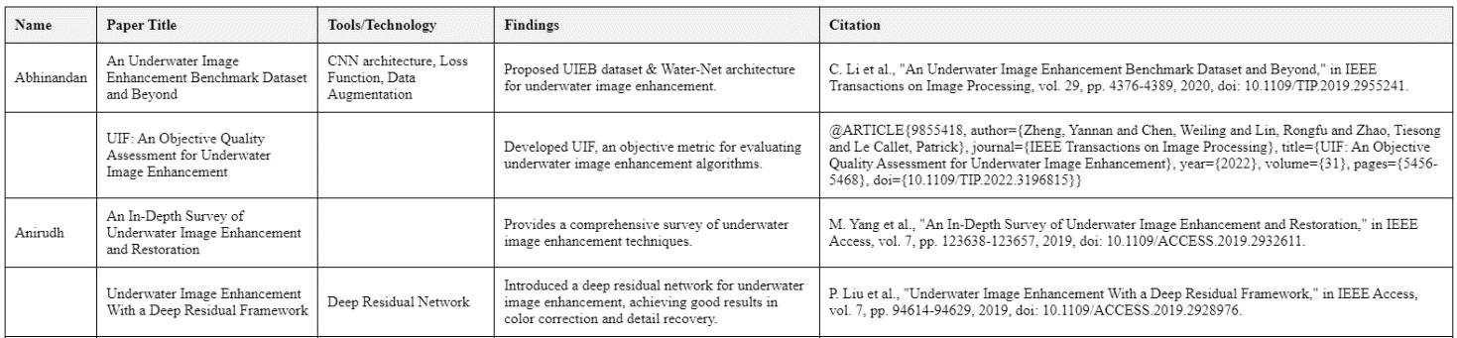

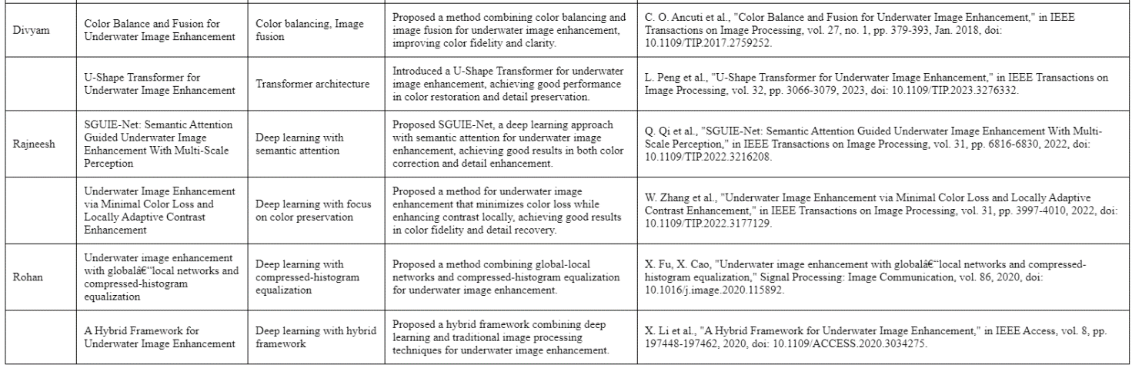

**2. 1. 4 Problem Identified**

* Color Distortion: Such kind of selective absorption of light by the water wavelength dependent results to color shift particularly in red color at deeper parts of the water.
* Reduced Clarity and Contrast: Particle movements cause light to scatter which in turn affects the clarity as well as the contrast.
* Varying Underwater Conditions: Various types of waters, water depth, and so forth, influence image quality, and thus it is difficult to have a universal product.
* Limited Datasets: There is a scarcity of large and diverse underwater image dataset with adequate annotations limiting the use and training of deep learning models.
* Computational Efficiency: Some of the enhanced enhancement schemes especially the deep learning based ones consume massive amount of computational power making real-time processing cumbersome.
* Generalization: It remains a challenge to improving the approaches that would work on a range of underwater settings and imaging factors.

**2. 1. 5 Self-Assessment of Tools and Technologies Employed**

* OpenCV: Implements conventional image processing functions that may be missing in other programming languages.
* scikit-image: Is richer in technologies for image processing compared to OpenCV.
* TensorFlow and PyTorch: These libraries are used for implementing and training neural network models, as well as allowing the programmer a certain degree of control on their workings.
* Hardware: GPUs (Graphics Processing Units): Scales deep learning computations faster and reduce the time taken to train and make inferences on complex model.
* Manually Annotated Background Lights (MABLs) Database: Employed in estimation of optical characteristics in physics-based techniques.
* Clear and High-Resolution Underwater Image Datasets: Critic for training and evaluation of enhancement algorithms.
* Peak Signal-to-Noise Ratio (PSNR): A measurement of the ranges between the maximal sign strength as well as the strength of disturbance.
* Structural Similarity Index (SSIM): allows measurement of similarity in terms of luminance, contrast, and structural similarity.
* Color Difference: Measures the actual change in colour between the enhanced and the original pictures.
* Subjective Evaluation: Whereas technology luminaries rate the pragmatic worth of improved pictures of various oddities.

**2. 2 Software Requirement Specification**

**2.2.1 Introduction**

This Software Requirement Specification (SRS) document outlines the requirements for the Underwater Image Enhancement System. This web-based platform uses advanced neural network algorithms to improve the quality of underwater images, addressing issues like color distortion, reduced clarity, and loss of detail in underwater photography.

**2.2.1.1 Purpose**

* Comprehensive Description: Provide a detailed description of the Underwater Image Enhancement System.
* Functionality: Outline system functionality, performance requirements, design constraints, and user interface specifications.
* Development Blueprint: Serve as a blueprint for the development team.
* Stakeholder Reference: Ensure the final product meets intended goals and user needs.

**2.2.1.2 Intended Audience and Reading Suggestions**

* Development Team: Software engineers, web developers, and machine learning specialists who will implement the system.
* Project Managers: To plan and oversee the development process.
* Quality Assurance Team: For developing test plans and conducting system testing.
* Stakeholders: Marine biologists, oceanographers, underwater photographers, and other potential end-users.
* Clients and Sponsors: To understand the project scope and capabilities.

**Reading Suggestions:**

* High-Level Overview: Focus on sections 2.2.1 (Introduction) and 2.2.1.3 (Project Scope).
* Developers: Pay attention to detailed functional and non-functional requirements (not included in this excerpt).
* Stakeholders and End-Users: Review user interface specifications and system features.

**2.2.1.3 Project Scope**

Key Components and Features:

1. **Web-Based User Interface:**
   * User registration and authentication system
   * Image upload functionality
   * Enhancement parameter selection
   * Results visualization and comparison tools
2. **Image Enhancement Algorithm:**
   * Custom neural network architecture for underwater image processing
   * Color correction module
   * Contrast enhancement module
   * Detail preservation techniques
3. **Backend Processing System:**
   * Image processing pipeline
   * Task queue management for handling multiple requests
   * Result storage and retrieval system
4. **Performance Optimization:**
   * GPU acceleration for neural network computations
   * Caching mechanisms for improved response times
5. **Data Management:**
   * Secure storage of user images and enhanced results
   * User profile and preferences management
6. **API for Integration:**
   * API for potential integration with third-party applications

**Out of Scope:**

* Real-time video processing
* Mobile application development (initially web-based only)
* Hardware-specific optimizations for underwater cameras

**System Goals:**

* Provide a user-friendly, efficient, and effective solution for enhancing underwater images.
* Cater to both professional and amateur users in fields such as marine biology, underwater archaeology, and recreational diving.
* Leverage advanced machine learning techniques and a web-based platform to make high-quality underwater image enhancement accessible to a wide range of users.

**2.2.2 Overall Description**

**2.2.2.1 Product Perspective**

* **Web-Based Platform**: The system is a web-based platform designed to enhance underwater images using advanced neural network algorithms.
* **Integration**: It integrates with existing web technologies and leverages GPU acceleration for performance optimization.
* **User Interaction**: Users interact with the system through a web interface, uploading images and selecting enhancement parameters.

**2.2.2.2 Product Features**

* **User Interface**: Registration, authentication, image upload, enhancement parameter selection, and result visualization.
* **Enhancement Algorithms**: Custom neural network for color correction, contrast enhancement, and detail preservation.
* **Backend**: Image processing pipeline, task queue management, and secure result storage.
* **Performance**: GPU acceleration and caching for faster processing.
* **Data Management**: Secure image and result storage with user profile management.
* **API**: API for third-party integration.

**2.2.3 External Interface Requirements**

**2.2.3.1 User Interfaces**

The Underwater Image Enhancement System will provide a web-based user interface accessible through standard web browsers. The interface will be designed with the following considerations:

**1. Responsive Design:**

* + Compatible with desktop, tablet, and mobile devices
  + Adapts to different screen sizes and resolutions

**2. Main Dashboard:**

* + Clear navigation menu for accessing different features
  + Quick access to image upload and enhancement tools
  + Display of recently enhanced images and user statistics

**3. Image Upload Interface:**

* + Drag-and-drop functionality for easy image uploading
  + Support for multiple file selection
  + Progress bar for upload status

**4. Enhancement Interface:**

* + Side-by-side display of original and enhanced images
  + Slider controls for adjusting enhancement parameters
  + Real-time preview of enhancement effects

**5. Results Gallery:**

* + Grid view of enhanced images with thumbnail previews
  + Sorting and filtering options
  + Detailed view with zooming capabilities

**6. User Profile and Settings:**

* + Interface for managing account information
  + Customization options for default enhancement settings

**7. Help and Documentation:**

* + Integrated user guide and tooltips
  + FAQ section and tutorial videos

**2.2.3.2 Hardware Interfaces**

The system does not require specific hardware interfaces on the client side beyond standard computing devices. However, the server-side infrastructure will include:

**1. Server Hardware:**

* + High-performance CPU for handling image processing tasks
  + Sufficient RAM to manage multiple concurrent user sessions
  + GPU acceleration for neural network computations

**2. Storage Systems:**

* + High-capacity, fast-access storage for image data and user files
  + Backup and redundancy systems for data protection

**3. Network Interface:**

* + High-bandwidth network connection to handle large image file transfers

**2.2.3.3 Software Interfaces**

The Underwater Image Enhancement System will interact with the following software interfaces:

**1. Web Server:**

* + HTTPS protocol for secure communication

**2. Image Processing Libraries:**

* + OpenCV for basic image manipulation
  + TensorFlow or PyTorch for neural network-based enhancement algorithms

**3. Version Control System:**

* + Git for source code management and version control

**4. Application Programming Interface (API):**

* + API for potential integration with external applications
  + JSON for data exchange format

These interfaces are designed to ensure smooth operation, scalability, and integration capabilities of the Underwater Image Enhancement System, providing a robust and user-friendly experience for enhancing underwater imagery.

**2.2.4 Other Non-functional Requirements**

**Performance:**

* The system should process images efficiently.
* The model should be optimized for speed without compromising image quality.

**Accuracy:**

* The model should accurately enhance underwater images to improve visibility and quality.
* The system should achieve high accuracy in image enhancement tasks.

**Scalability:**

* The system should be scalable to handle large volumes of image data.
* It should support adding new features and capabilities in the future**.**

**Usability:**

* The user interface should be intuitive and easy to use.
* Users should be able to upload, process, and visualize underwater images with minimaleffort**.**

**Reliability:**

* The system should be reliable and stable under varying conditions.
* It should be resilient to failures and errors.

**Security:**

* The system should ensure the confidentiality and integrity of user data.
* Access to sensitive information should be restricted to authorized users.

**Documentation:**

* The project should be well-documented, including technical details, user manuals, and maintenance procedures.
* Documentation should be comprehensive and easy to understand for both developers and users

### 2.3 Risk Analysis

The Underwater Image Enhancement System faces several potential risks, categorized as follows:

* **Technical Risks:**
  + **Algorithm Performance:** The neural network may not perform optimally, leading to poor image quality. Mitigation includes extensive testing and manual adjustment options.
  + **Computational Efficiency:** High processing demands could slow down the system. GPU optimization and caching will be employed to address this.
  + **Integration Issues:** Compatibility problems with third-party applications may arise. Robust API development and thorough testing are planned.
* **Operational Risks:**
  + **Server Downtime:** Unexpected traffic or hardware failures could cause downtime. Load balancing and redundancy strategies will mitigate this.
  + **Data Security:** There is a risk of data breaches. Strong encryption, access controls, and regular security audits will ensure data protection.
  + **User Adoption:** Non-technical users may struggle to adopt the system. An intuitive interface and comprehensive support will be provided.
* **Project Management Risks:**
  + **Scope Creep:** Expanding project scope could delay timelines. Strict change control and clear communication with stakeholders will help manage this.
  + **Resource Allocation:** Inadequate resources could hinder progress. Detailed planning and regular reviews will ensure proper allocation.
  + **Regulatory Compliance:** Non-compliance with standards could lead to legal issues. Regular compliance checks and expert consultation will prevent this.

**METHODOLOGY ADOPTED**

**3.1 Investigative Techniques**

The core objective of our project is to develop an underwater image enhancement system that can significantly improve the quality of underwater photography by addressing issues such as poor visibility, color distortion, and loss of detail. To achieve this, we employed a diverse range of investigative techniques that span traditional image processing methods and cutting-edge neural network algorithms. Our approach is rooted in the principles of computational efficiency, aesthetic fidelity, and the ability to restore the natural appearance of underwater scenes. This section details the investigative techniques we adopted and provides a justification for their selection, along with a comprehensive explanation of the methodologies employed.

**Selection and Justification of Investigative Techniques**

Underwater environments present a unique set of challenges for imaging, primarily due to the water's inherent properties, such as light absorption, scattering, and the presence of particulate matter. These factors result in degraded images that are often murky, color-shifted, and lacking in detail. To counteract these effects, we strategically selected investigative techniques that are well-suited to address each of these issues while maintaining a focus on real-time processing capabilities. Our selection was guided by a thorough review of existing literature, an understanding of underwater imaging challenges, and the need to produce results that are both scientifically valuable and visually appealing.

**Traditional Image Processing Techniques**

Our investigative approach began with the application of traditional image processing techniques using OpenCV, a powerful library that provides a wide range of tools for enhancing images. The following techniques were selected for their ability to improve image quality in various ways:

**1. Histogram Equalization:**

**Purpose:**

* To improve the contrast of underwater images by redistributing the intensity values across the entire image.

**Justification:**

* Underwater images often suffer from low contrast due to the scattering of light. Histogram equalization effectively addresses this by enhancing the visibility of features within the image, making it easier to distinguish objects and details.

**Implementation:**

* We applied histogram equalization using the `histogram_equalization(img)` function. This technique adjusts the intensity distribution of the image, spreading out the most frequent intensity values and enhancing overall contrast.

**2. CLAHE (Contrast Limited Adaptive Histogram Equalization):**

**Purpose:**

* To provide localized contrast enhancement, avoiding the pitfalls of global histogram equalization, which can amplify noise.

**Justification:**

* Underwater images often exhibit varying lighting conditions across different regions. CLAHE adapts to these variations, enhancing contrast in localized areas without introducing excessive noise or artifacts.

**Implementation:**

* The `clahe(img)` function was used to apply CLAHE, which limits the amplification of contrast in regions with homogeneous areas, thereby preserving detail while avoiding noise amplification.

**3. Sharpening:**

**Purpose**:

* To enhance the clarity of underwater images by accentuating edges and fine details.

**Justification:**

* The scattering of light underwater tends to blur the edges and reduce the sharpness of images. Sharpening techniques counteract this effect, making the details more prominent and improving overall image clarity.

**Implementation:**

* We employed the `sharpening(img)` function to apply a sharpening filter that enhances edge contrast and restores the sharpness of underwater features.

**4. Adaptive Thresholding:**

**Purpose:**

* To accurately separate objects from the background, especially in underwater images with uneven lighting conditions.

**Justification:**

* Underwater environments often have complex lighting due to water currents and varying depths. Adaptive thresholding adjusts the threshold value dynamically, providing better segmentation of objects from the background.

**Implementation:**

* The `adaptive_thresholding(img)` function was utilized to apply adaptive thresholding, which calculates a threshold for small regions of the image, allowing for more precise object detection in challenging underwater conditions.

**5. Dehazing:**

**Purpose:**

* To remove the haze caused by the scattering of light in water, which often results in washed-out, foggy images.

**Justification:**

* Haze is a common issue in underwater images, caused by the scattering of light by water particles. Dehazing techniques restore visibility and true colors by reducing the scattering effect.

**Implementation**:

* We used the `dehaze_image(img)` function to apply dehazing algorithms that counteract the scattering effects, restoring the image’s clarity and color fidelity.

**6. Gamma Correction:**

**Purpose:**

* To adjust the brightness levels in the image to match human visual perception, enhancing the natural appearance of the image.

**Justification:**

* Gamma correction is crucial for adjusting the brightness of an image, especially in underwater environments where lighting is uneven. By correcting the gamma, we can ensure that the image's brightness levels are more visually appealing and realistic.

**Implementation:**

* The `gamma_correction(img)` function was applied to perform gamma correction, adjusting the luminance levels in the image to enhance visual perception and improve overall appearance.

**7. Retinex Algorithm:**

**Purpose:**

* To maintain color constancy and improve contrast in underwater images, which often suffer from color distortion.

**Justification:**

* The Retinex algorithm is particularly effective in environments with poor lighting, such as underwater. It enhances contrast and restores natural colors, making it ideal for underwater image enhancement.

**Implementation:**

* We applied the Retinex algorithm using the `retinex(img)` function, which processes the image to maintain consistent color representation and enhance contrast, resulting in more natural-looking underwater scenes.

**Advanced Neural Network Models**

In addition to traditional image processing techniques, we integrated advanced neural network models to further enhance the quality of underwater images. One of the key models we employed is the Deep Convolutional Enhancement Network (DCENet). This model was selected for its ability to handle the complex distortions and noise inherent in underwater images through deep learning techniques.

**Deep Convolutional Enhancement Network (DCENet):**

**Purpose**:

* To perform comprehensive image enhancement, including color correction, noise reduction, and detail enhancement, by leveraging deep learning.

**Justification:**

* DCENet’s deep convolutional architecture is specifically designed for image enhancement tasks. It excels in learning from large datasets to correct complex distortions that traditional methods may not fully address. Its application is particularly beneficial for real-time enhancement scenarios, where both speed and quality are critical.

**Implementation**:

* The DCENet model was trained on a large dataset of underwater images, learning to correct common issues such as color distortion, noise, and loss of detail. By applying this model, we achieved significant improvements in the quality of underwater images, surpassing the capabilities of traditional methods.

**Iterative Experimentation and Validation**

Our investigative techniques were not static; they involved iterative experimentation and continuous validation to refine our methods. We conducted numerous tests using different underwater images, applying the selected techniques and analyzing the results. This iterative process allowed us to fine-tune the algorithms, ensuring that they not only enhanced image quality but also preserved the natural characteristics of underwater scenes

To validate our approach, we collaborated with experts in marine biology, oceanography, and related fields. Their feedback was instrumental in assessing the practical utility of our enhanced images for real-world applications. Additionally, we conducted user studies to evaluate the aesthetic appeal of the images, ensuring that our enhancements met the expectations of both scientific and recreational users.

**Conclusion**

The investigative techniques employed in our project represent a comprehensive approach to addressing the unique challenges of underwater image enhancement. By combining traditional image processing methods with advanced neural network models, we developed a robust framework capable of significantly improving image clarity, color accuracy, and detail preservation. The careful selection and justification of these techniques, supported by iterative experimentation and expert validation, ensure that our system is both effective and versatile, ready to be applied across various applications in underwater imaging. This multi-faceted approach not only enhances the visual quality of underwater images but also contributes to the broader goal of advancing research, conservation, and exploration in underwater environments.

TABLE 3: Investigative Techniques

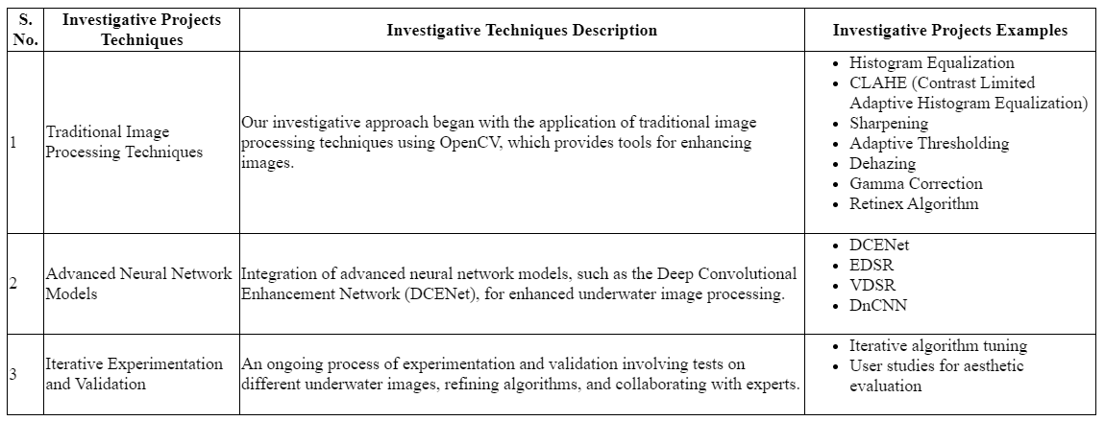

**3.2 Proposed Solution**

The complexity of underwater imaging requires a tailored approach that addresses the specific challenges of color distortion, reduced visibility, and detail loss. To effectively enhance underwater images, our proposed solution involves selecting a diverse set of image enhancement models and training them on a specialized dataset composed of underwater images. This solution is designed to leverage the strengths of both traditional image processing techniques and advanced neural networks, ensuring that our system can deliver high-quality results across a range of underwater conditions.

**Selection of Enhancement Models**

The first step in our proposed solution is the careful selection of image enhancement models that are best suited to address the unique challenges posed by underwater photography. We plan to utilize a combination of traditional image processing algorithms and deep learning-based models. Each model is chosen for its specific capabilities in improving aspects such as contrast, color accuracy, sharpness, and noise reduction.

The models we will employ include:

1. **Histogram Equalization and CLAHE:** These traditional techniques will be used to enhance the contrast of underwater images. Histogram Equalization improves global contrast, while CLAHE focuses on enhancing local contrast, ensuring that fine details are preserved without amplifying noise.
2. **Sharpening:** This technique will be applied to enhance the sharpness of underwater images, making edges and small details more prominent.
3. **Adaptive Thresholding:** Adaptive thresholding will be utilized to effectively separate objects from the background, particularly in images where lighting conditions are uneven.
4. **Dehazing:** To counteract the effects of light scattering and haze in underwater environments, dehazing algorithms will be applied to restore visibility and true colors.
5. **Gamma Correction:** This technique will be employed to adjust the brightness levels of the images, ensuring they are more in line with human visual perception.
6. **Retinex Algorithm:** The Retinex algorithm will be used to maintain color constancy and enhance contrast in underwater images, which often suffer from color shifts due to varying light absorption.
7. **DCENet (Deep Convolutional Enhancement Network):** As an advanced neural network model, DCENet will be crucial in our approach. Its deep learning architecture is specifically designed for image enhancement, capable of correcting complex distortions, reducing noise, and enhancing details in underwater images.

**Training on a Specialized Underwater Dataset**

The core of our proposed solution lies in the training of these selected models on a curated dataset specifically designed for underwater image enhancement. This dataset will include a wide variety of underwater scenes, capturing the diverse conditions encountered in underwater environments—ranging from shallow, well-lit waters to deeper, murkier settings. The dataset will include images affected by common underwater issues such as color distortion, low contrast, and high levels of noise.

The training process will involve:

1. **Data Augmentation:** To ensure that our models generalize well across different underwater conditions, we will apply data augmentation techniques. These techniques will include rotations, flips, and varying levels of brightness and contrast to simulate the wide range of conditions found underwater.
2. **Supervised Learning:** The models will be trained using a supervised learning approach, where they will learn from labeled examples of enhanced and unenhanced underwater images. This will enable the models to learn the specific transformations needed to improve image quality.
3. **Iterative Refinement:** Throughout the training process, we will iteratively refine the models by adjusting hyperparameters, testing different architectures, and evaluating their performance on validation sets. This iterative approach will help us identify the optimal configuration for each model, ensuring that they deliver the best possible enhancement results.
4. **Cross-Model Integration:** After training each model individually, we will explore the possibility of integrating multiple models to leverage their complementary strengths. For example, we may combine the outputs of traditional image processing techniques with those from neural networks to create a hybrid model that maximizes image quality.

**Implementation and Real-Time Application**

Once trained, these models will be integrated into our underwater image enhancement system. The system will be designed to process images in real-time, applying the trained models to enhance visibility, correct color distortions, and preserve fine details in underwater images. The system will also be adaptable, allowing users to select specific enhancement techniques based on their needs or the particular challenges presented by their underwater environment.

In conclusion, our proposed solution is a comprehensive approach to underwater image enhancement that leverages the power of both traditional image processing techniques and advanced neural networks. By training these models on a specialized dataset, we aim to develop a robust system capable of addressing the unique challenges of underwater imaging, ultimately providing clearer, more accurate, and aesthetically pleasing images for a wide range of applications.

**3.3 Work Breakdown Structure (WBS)**

The Work Breakdown Structure (WBS) for our underwater image enhancement project is designed to ensure that all aspects of the project are comprehensively covered, with each team member contributing to specific tasks that align with their expertise. The WBS is divided into multiple modules, each representing a crucial component of the project. These modules are structured to facilitate the systematic development, testing, and deployment of the underwater image enhancement system.

**Modules and Tasks:**

1. **User Requirements and System Objectives:**
   * **Task 1.1:** Conduct user interviews and gather insights into user requirements.
   * **Task 1.2:** Define project objectives, scope, and system requirements based on user feedback and project goals.
   * **Task 1.3:** Conduct a feasibility study to assess the technical and resource requirements necessary for successful project execution.
2. **Research and Development:**
   * **Task 2.1:** Research existing solutions and techniques for underwater image enhancement, focusing on traditional and deep learning approaches.
   * **Task 2.2:** Develop traditional image enhancement techniques such as color correction, contrast enhancement, and image preprocessing.
   * **Task 2.3:** Preprocess underwater image datasets, including noise reduction and data augmentation, to prepare for model training.
   * **Task 2.4:** Develop and train deep learning models, including convolutional neural networks (CNNs) and other advanced neural network architectures, for tasks such as image denoising, detail enhancement, and color correction.
3. **System Integration and Testing:**
   * **Task 3.1:** Integrate the traditional image enhancement techniques and deep learning models into a cohesive system architecture.
   * **Task 3.2:** Conduct comprehensive system testing, including functional testing, performance evaluation, and validation of image enhancement results against standardized metrics.
   * **Task 3.3:** Assist in system testing, ensuring that all components work seamlessly together and that the system meets the defined objectives.
4. **System Deployment and Documentation:**
   * **Task 4.1:** Prepare system documentation, including user manuals, technical specifications, and system architecture diagrams.
   * **Task 4.2:** Deploy the system for real-world application, ensuring that it is ready for use by the target audience.
   * **Task 4.3:** Provide user training and support, ensuring that end-users are equipped to utilize the system effectively.

The work breakdown structure ensures that each aspect of the project is addressed systematically, with clearly defined responsibilities and tasks that contribute to the overall success of the project.

**3.4 Tools and Technology**

The tools and technologies selected for this project are chosen based on their ability to support the various tasks involved in underwater image enhancement, including data preprocessing, model development, system integration, and deployment. The selection of tools and technology reflects the need for both traditional image processing capabilities and advanced deep learning frameworks.

**Tools and Technologies:**

1. **Programming Languages and Frameworks:**
   * **Python:** The primary programming language for this project, chosen for its versatility and extensive support for both traditional image processing and deep learning libraries.
   * **OpenCV:** A comprehensive library used for implementing traditional image enhancement techniques such as histogram equalization, CLAHE, sharpening, adaptive thresholding, dehazing, and gamma correction.
   * **TensorFlow/Keras:** Deep learning frameworks that will be used to develop and train convolutional neural networks (CNNs) and other neural network models tailored for underwater image enhancement tasks.
2. **Data Management and Processing:**
   * **NumPy and Pandas:** Libraries for handling data manipulation and preprocessing tasks, including noise reduction, data augmentation, and preparing datasets for model training and validation.
   * **MATLAB:** Used for advanced mathematical modeling and analysis, particularly in the preprocessing and evaluation phases.
3. **System Integration and Testing:**
   * **Git:** Version control system to manage the development process, ensuring that code is efficiently tracked, merged, and maintained across different modules of the project.
   * **Docker:** Containerization technology to streamline system integration and ensure consistent environments for testing and deployment.
   * **Jupyter Notebooks:** Used for iterative development and testing of code, particularly for experimenting with different models and enhancement techniques.
4. **Deployment and User Support:**
   * **AWS (Amazon Web Services):** Cloud platform selected for deploying the final system, providing scalability and reliability for real-time underwater image enhancement tasks.
   * **Flask/Django:** Web frameworks for developing the user interface and backend services that will allow users to interact with the system, upload images, and receive enhanced outputs.
   * **REST APIs:** To facilitate communication between different components of the system, particularly in integrating the enhancement models with the user interface and data storage solutions.

The combination of these tools and technologies ensures that our project is built on a robust foundation capable of handling the complexities of underwater image enhancement, from development and testing to deployment and real-world application.

**DESIGN SPECIFICATIONS**

This section outlines the design specifications for our underwater image enhancement system. It includes system architecture, design level diagrams, user interface diagrams, and snapshots of the working prototype, each accompanied by detailed discussions.

**4.1 System Architecture**

The system architecture for our underwater image enhancement project follows a multi-tier structure that incorporates a combination of traditional image processing techniques and advanced deep learning models. The architecture is designed to handle the entire pipeline, from data preprocessing and model training to real-time image enhancement and user interaction.

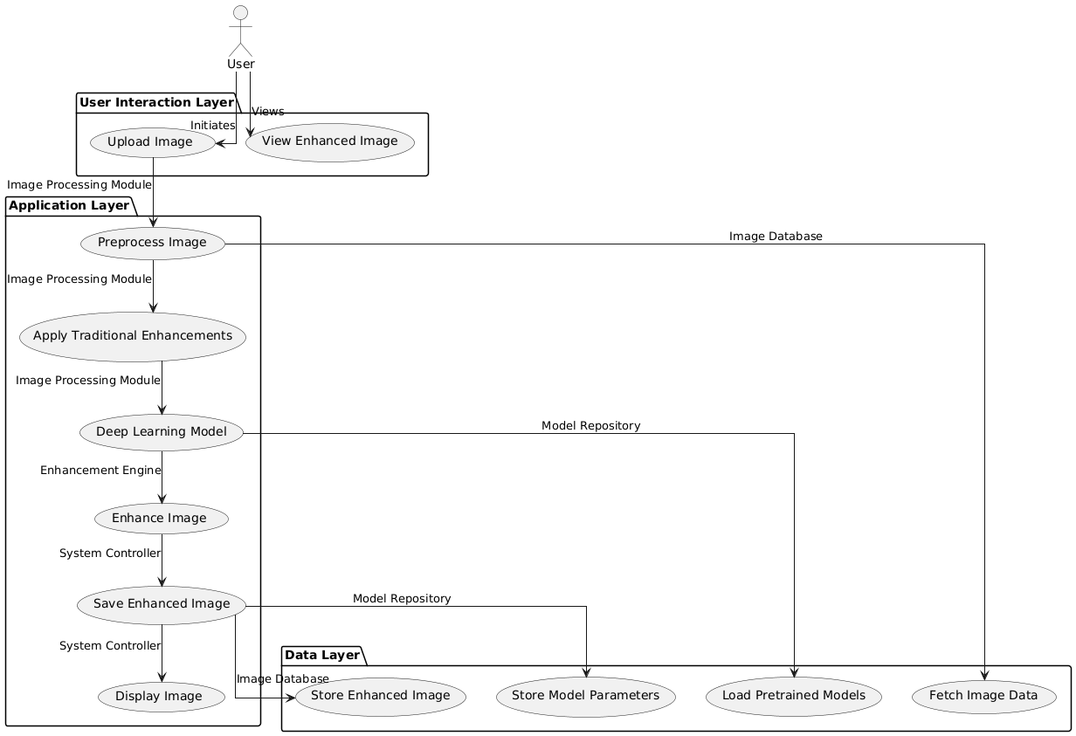

Figure 1: System Architecture

**Discussion:**

The architecture is divided into three main layers:

1. **User Interaction Layer:** This layer provides the user interface, allowing users to upload underwater images, apply enhancements, and view the enhanced results. It includes web interfaces developed using Flask/Django, which interact with the underlying system components.
2. **Application Layer:** This is the core of the system, where image processing and enhancement take place. The Image Processing Module handles initial preprocessing, while the Enhancement Engine applies deep learning models to enhance the images. The System Controller manages the workflow, ensuring that images are processed, enhanced, and stored correctly.
3. **Data Layer:** The Data Layer consists of the Image Database and Model Repository. The Image Database stores both raw and enhanced images, while the Model Repository holds the trained models and their parameters. This layer ensures data persistence and access across the system.

**4.2 Design Level Diagrams**

Design level diagrams provide a detailed look at the individual components of the system, focusing on the interaction between the modules and how they contribute to the overall workflow.

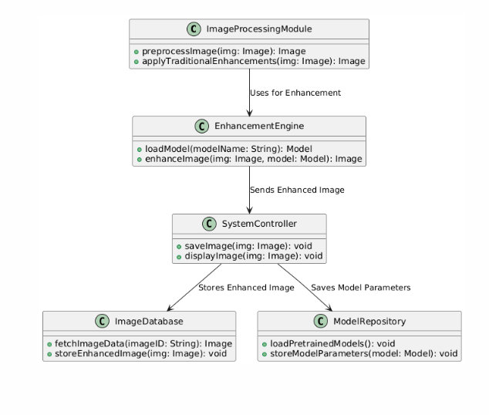

Figure 2: Class Diagram

**Discussion:**

This class diagram represents the core components of the system and their relationships. The ImageProcessingModule is responsible for preprocessing images and applying traditional enhancements. The EnhancementEngine loads pretrained models and applies them to the images. The SystemController manages saving and displaying the final enhanced images, interacting with both the ImageDatabase and ModelRepository.

**4.3 User Interface Diagrams**

The user interface is designed to be intuitive and user-friendly, allowing users to easily upload images, apply enhancements, and view results.

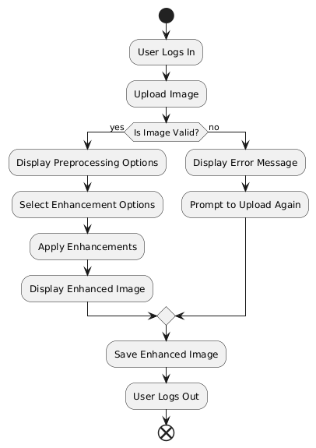

Figure 3: User Interface Diagram

**Discussion:**

This flow diagram illustrates the user journey through the system. After logging in, the user can upload an image, select preprocessing and enhancement options, apply those enhancements, and view the enhanced image. The system provides feedback at each step and allows the user to save the enhanced image.

**4.4 Snapshots of Working Prototype**

Below are the snapshots of the working prototype, along with a step-by-step discussion of its functionality.

**Snapshot 1: Uploading an Image**

* **Description:** The user interface allows the user to upload an underwater image by selecting it from their device. The system validates the image format and size before proceeding to the next step.

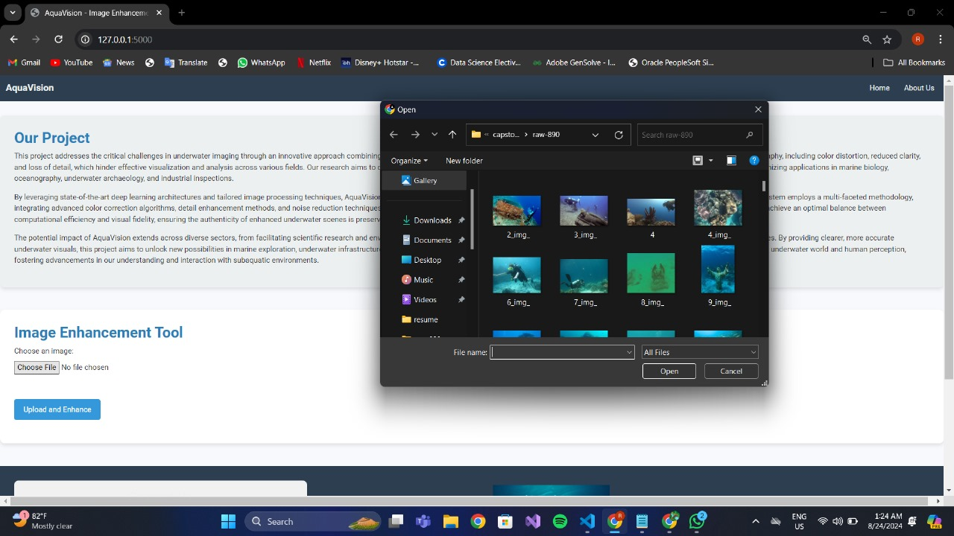

Figure 4: Uploading an Image

**Snapshot 2: Viewing Enhanced Image**

* **Description:** After selecting the desired enhancements, the system processes the image and displays the enhanced result. The user can compare the original and enhanced images side by side to evaluate the improvements.

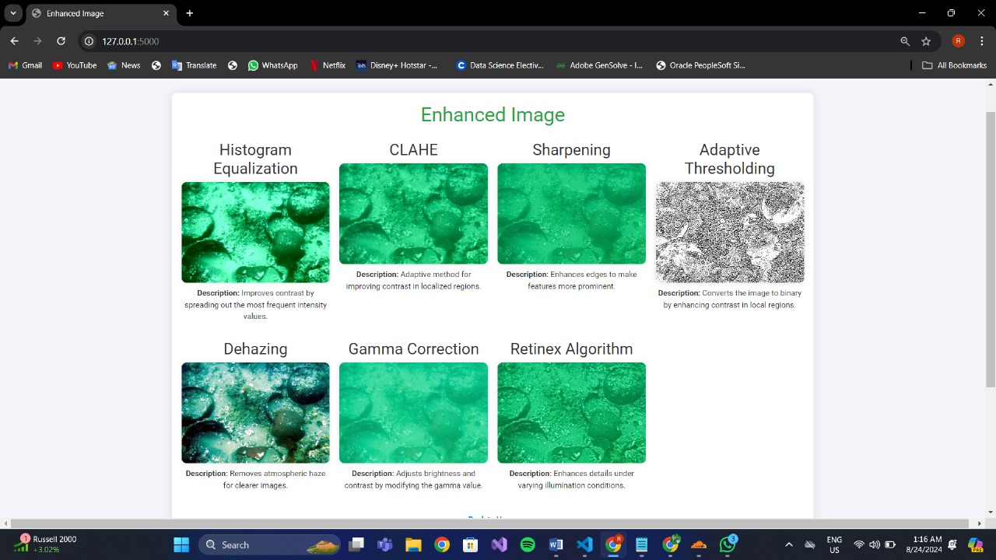

Figure 5: Viewing Enhanced Image

**Discussion:**

The working prototype demonstrates the entire workflow, from image upload to enhancement and saving. The interface is designed to be simple yet powerful, offering a range of enhancement options while ensuring that the process is seamless and user-friendly. The prototype effectively showcases the system's capabilities, providing a solid foundation for further development and refinement.

These design specifications lay the groundwork for a robust and effective underwater image enhancement system, ensuring that all aspects of the project are well-documented and thoughtfully planned.

**CONCLUSIONS AND FUTURE SCOPE**

**5.1 Work Accomplished**

In this project, we have made significant progress in the area of underwater image enhancement using both traditional image processing techniques and advanced neural network models. The primary datasets used for our research include:

1. **LSUI (UIE)**
2. **UIEB (UIE)**
3. **SQUID (UIE)**
4. **UFO (SESR)**
5. **USR (SR)**

We explored various traditional image enhancement methods, including histogram equalization, dehazing, retinex, and adaptive thresholding, to understand their effectiveness in improving underwater images. Additionally, we examined the fusion of these techniques to evaluate how different underwater scenes impact the performance of enhancement models.

Our work extended to deep learning models such as Dense Convolutional Network (DCNN), Basic Deep Super-Resolution Network (BDSR), Enhanced Deep Super-Resolution Network (EDSR), and Residual Encoder-Decoder Network (RedNet). We applied transfer learning techniques to these models, optimizing them specifically for underwater image enhancement and evaluating their performance metrics.

Furthermore, we developed both the frontend and backend of the application, integrating these models under development. Testing and deployment were conducted using the Scrum model for iterative and incremental development.

**5.2 Conclusions**

The results of our study demonstrate that combining traditional image processing techniques with deep learning models provides a substantial improvement in underwater image quality. The optimized models were able to enhance image clarity, reduce noise, and improve color accuracy, leading to more realistic and detailed images. Our approach of integrating neural networks with manual adjustments offers flexibility and allows users to tailor enhancements according to specific requirements. This project lays the groundwork for future development of more sophisticated underwater imaging solutions.

**5.3 Environmental Benefits**

Enhanced underwater imaging has significant environmental benefits. Clearer and more accurate images allow for better monitoring of marine ecosystems, aiding in the conservation of biodiversity. This technology supports environmental research by providing detailed visual data, crucial for analyzing the health of coral reefs, detecting pollution, and monitoring changes in marine habitats. By improving underwater imagery, our project contributes to more effective conservation efforts, enabling timely intervention to protect endangered species and ecosystems.

**5.4 Future Work Plan**

Future work will focus on developing custom neural network architectures tailored specifically for underwater image enhancement. These new models will aim to further improve accuracy, processing speed, and adaptability to various underwater environments. We plan to enhance the robustness of our algorithms to handle diverse underwater conditions, such as varying light levels, turbidity, and water depth. Additional efforts will be made to integrate real-time processing capabilities, allowing for instant image enhancement during underwater exploration missions.

Moreover, we will explore collaborations with marine research institutes and industries to refine our models based on real-world feedback. The potential development of a user-friendly interface that incorporates machine learning-driven suggestions for image enhancement will also be considered. Finally, we aim to expand the application scope of our technology to include augmented reality (AR) systems for underwater navigation, further broadening the impact of our research in fields such as marine biology, archaeology, and industrial inspection.

**REFERENCES**

1) Khurana, Khushboo. (2020). A Review of Image Enhancement Techniques for Underwater Images. Bioscience Biotechnology Research Communications. 13. 40-44. 10.21786/bbrc/13.14/10.

2) BANERJEE, J., RAY, R., VADALI, S.R.K. et al. Real-time underwater image enhancement: An improved approach for imaging with AUV-150. Sadhana 41,225–238 (2016). <https://doi.org/10.1007/s12046-015-0446-7>

3) Y. Guo, H. Li and P. Zhuang, "Underwater Image Enhancement Using a Multiscale Dense Generative Adversarial Network," in IEEE Journal of Oceanic Engineering, vol. 45, no. 3, pp. 862-870, July 2020, doi: 10.1109/JOE.2019.2911447. keywords:{Gallium nitride;Image color analysis;Generators;Image restoration;Feature extraction;Training;Image enhancement;Dense concatenation;generative adversarial network (GAN);multiscale;residual learning underwater image enhancement}

4) J. Li, K. A. Skinner, R. M. Eustice and M. Johnson-Roberson, "WaterGAN: Unsupervised Generative Network to Enable Real-Time Color Correction of Monocular Underwater Images," in IEEE Robotics and Automation Letters, vol. 3,no. 1, pp. 387-394, Jan. 2018, doi: 10.1109/LRA.2017.2730363. keywords: {Image color analysis;Attenuation;Image restoration;Generators;Gallium nitride;Pipelines;Training;Marine robotics;visual learning}

**PLAGIARISM REPORT**

**Authors:**

102283008 Anirudh Bansal

102283007 Rajneesh Bansal

102103142 Divyam Malik

102103108 Rohan Gulati

102103110 Abhinandan Sharma

**Institution:** Thapar Institute of Engineering and Technology, Patiala

**Date:** 24/08/2024

**Plagiarism Declaration:**

We, the undersigned authors of the project report titled "Smart Farming for Precision Fruit Cultivation," hereby declare that this report is a product of our own independent work, conducted under the supervision and guidance of Dr. Rajendra Roul.

We affirm that :

The contents of this report are original and have not been copied from any other source.

All references, citations, and acknowledgments have been duly provided where required, and proper credit has been given to the authors of any external material used.

The project has been checked for plagiarism using [mention any plagiarism detection software or method used], and the similarity index is within the acceptable range as per the academic standards of Thapar Institute of Engineering and Technology.

We have adhered to the academic integrity guidelines set forth by the institution, and this report is free from any form of plagiarism.

By signing this declaration, we confirm that the work presented in this report is genuine and has not been submitted for assessment or publication elsewhere.