**HOUSE RENTALS**



Submitted to the

Department of Computer Applications

in partial fulfillment of the requirements of

Topics in Web Programming (MCA16)

**by**

**KUMAR ROHAN**

**1MS17MCA21**

**Ramaiah Institute of Technology**

**(Autonomous Institute, Affiliated to VTU)**

**Bangalore – 54**

**2017 - 2018**

## RAMAIAH INSTITUTE OF TECHNOLOGY

**(Autonomous Institute, Affiliated To VTU)**

**Bangalore-54**

**DEPARTMENT OF**

**COMPUTER APPLICATIONS**



CERTIFICATE

This is to certify that the project entitled **HOUSE RENTALS** is carried out by

**1) KUMAR ROHAN 1MS17MCA21**

Students of 1st semester, in partial fulfillment for the Topics in Web Programming course (MCA16), during the academic year 2017-2018.

**Faculty In-charge Head of the Dept.**

**(Dr. Madhu Bhan) (Dr. T V Suresh Kumar)**

**Name of Examiners Signature with Date**

**LIST OF CONTENTS**

1) Abstract

1.1) Problem Definition

2) Introduction

3) Functional Requirements

3.1) Hardware Requirements

3.2) Software Requirements

4) Implementation

5) Screenshots

6) Conclusions

7) Future Scope and Enhancements

8) Bibliography

**1. ABSTRACT**

This project is useful for the individuals looking for the properties for Rent, Buying or selling. Using these website users can the properties in all of Bangalore for the properties they are required to find. The project is about enabling people to search the Ideal house to live in. Many people don’t have the knowledge or the idea for a right place to look in or what’s profitable or just a bargain. The system will be managed by a single person only (Superuser). Users can register to the account and get 40% off on first purchase. Thus, user can access this site for a better choice. The website provides a smart, simple and user-friendly interface to accomplish the above-mentioned functions.

**1.1 Problem Definition**

By implementing a computerized system, the limitation in the present system will be reduced. Manpower can be reduced to a great extent and efficiency and accuracy can be increased to manifold. More over consumption of time can be reduced to far greater extend by the implementation of the proposed system.

The problem definition computer-based information system is aimed at eliminating the limitations of the existing system via increasing speed of information retrieval, by increasing processing speed, data security and hence give accurate reports. The proposed system fully satisfies user needs. All most all the limitations of the existing system are reduced in a great manner.

Some of the problem solutions for this web application are as follows: -

* A lot of manual work which is time consuming and tedious can be reduced.
* Reduce paper work and extra cost.
* Flexibility.
* User friendliness.
* Data security.
* There are sections provided for User Requirement/Resource.
* Can get to know about other riders who are interested in travelling.

**2. INTRODUCTION**

The Indian housing sector is just out of its infancy. Its history as a mass market product, where a consumer has a choice to look around and purchase a unit he or she desires

The roller coaster ride for property buyers in the past few years was because of the clouded vision of the new generation of buyers. When housing finance to retail buyers at affordable rates began during 1998-2001, end users purchasing for self-use were the beneficiaries. The need was so great and the yearning so high that they would not default on loans, for fear of losing the house.

However, this need was replaced by greed – both of the buyer and the seller. As policy was unable to keep pace the effort floundered. Unlike the early buyers, investors looking for quick returns were driving the property market. While end-users wanted quick construction, good quality structure, social and physical infrastructure and most importantly, live ability, investors sought stretched timelines, slow delivery, with no concern for live ability, and wanted easy exit strategies. While the end user put pennies together, the investor, flush with cash became a developer’s friend.

The developers, too, made money out of multiple investors who bought into and exited the project during the construction cycle, after which the end-user would buy into the almost complete project, to live in. Money paid by investors was used to purchase more land and completion of projects were replaced by more launches.

Whether you are an end user or an investor, a secure, fully functional housing market gives good returns. It is second only to systematic investments in equity markets in terms of returns. However, unlike other asset classes, this investment is a usable asset

As jobs make the workforce mobile, the attachment to cities and houses also fades away. It makes sense to sell and purchase afresh in the next city. However, there are very few buyers who lose money exiting a good property. The only drawback is that the property market is cyclical and therefore the investment is not as liquid as other asset classes. Having said this, the smallest and most affordable property is an asset that yields big dividends long-term.

Indian housing was benchmarked against global markets. Should one enter it as an end user or an investor? The more information and analysis tools there are for buyers, the more scientific the process and the safer the purchase will be.

The government, on its part, has already started fixing policy to facilitate the marginalized end users with a real estate regulator, affordable housing policy to dovetail into the Pradhan Mantri Awas Yojana and the Credit Linked Subsidy Scheme for those who cannot afford to buy. With this umbrella of policy protection, go ahead, read the analysis and contribute to your asset wealth creation and managing it as well.

There is a lot more research that needs to be done in this eminently investible asset class. Here a significant beginning has been made.

**3. FUNCTIONAL REQUIREMENTS**

**3.1 HARDWARE REQUIREMENTS**

Any PC, mobile or tablet computer that can run a web browser and is capable of connecting to the internet.

**3.2 SOFTWARE REQUIREMENTS**

**For users:**

Browser: Any modern web browser.

Ideal when viewed on Firefox.

**For developers:**

Operating System: Microsoft Windows XP

Front End: HTML, JAVASCRIPT & CSS

Tools: Sublime Text

Browser: Mozilla Firefox.

**4. IMPLEMENTATION**

**Code of Index page**

<html>

<head>

<title>Home Web page</title>

<link rrel="stylesheet" href="https://maxcdn.bootstrapcdn.com/bootstrap/3.3.7/css/bootstrap.min.css"> <!-- Intialize the bootstrap CSS -->

<script src="https://ajax.googleapis.com/ajax/libs/jquery/3.2.1/jquery.min.js"></script> <!-- Add 2 more scripts for further funcitionlaity -->

<script src="https://maxcdn.bootstrapcdn.com/bootstrap/3.3.7/js/bootstrap.min.js"></script>

<style>

.put

{

background-image:url("title_RentalsRings.png"); padding-top: 135px;padding-right: 30px; padding-bottom: 40px; padding-left: 60px; background-repeat: no-repeat; }

.alter

{

background-image:url("dfs_olympics.jpg");background-repeat: no-repeat; +

}

p

{

font-family:Abel-Regular; src: url(sansation_light.woff); font-size:18px; color:white;

}

article

{

font-family:Verdana; font-size:18px; color:black;

}

a

{

color:white;

text-decoration:none;

}

.disc_pop{

position: absolute;

top: 10px;

right: 10px;

}

</style>

</head>

<body class="alter"> <!-- For the background image -->

<div class="container"> <!-- 1st Container class -->

<div class="alert alert-info alert-dismissable fade in disc_pop"> <!-- cutting tht tooltip -->

<a href="#" class="close" data-dismiss="alert" aria-label="close">&times;</a>

<h1 class="display-4" style="float:right;"> Become A Member</h1> </br> </br> </br> </br>

<p style="float:right; color:black;"> Get 40% off on your 1st Transaction </br><a class="btn btn-lg btn-success" href="login.html" role="button">Sign up today</a></p>

</div> <!-- alert closed -->

</div> <!-- Container closed -->

<div class="put"> <!-- For title image -->

</div> <!-- div closed -->

</br>

<!-- NAVBAR STARTS -->

<nav class="navbar navbar-inverse" style="background-color:#49484b;"> <!-- navbar class -->

<div class="container-fluid"> <!-- navbar style –

<div class="navbar-header"> <!-- Navbar header -->

</div> <!-- Navbar header closed -->

<ul class="nav navbar-nav" style="font-family:Abel-Regular;"> <!-- Listing of menu -->

<li class="active" style="color:white;"><a href="#">Home</a></li>

<li><a href="es.html" target="_blank">Essentials</a></li>

<li><a href="contact.html" target="_blank">Contact</a></li>

<li><a href="links.html" target="_blank">Links</a></li>

<li><a href="maps.html" target="_blank">Locate Us</a></li>

<li><a href="login.html" target="_blank">Sign up</a></li>

<form class="navbar-form navbar-left">

<div class="form-group"> <!-- FORM GROUP -->

<input type="text" class="form-control" placeholder="Search">

</div> <!-- FORM GROUP CLOSED -->

<button type="submit" class="btn btn-default btn-success">Submit</button>

</form>

</ul>

</div> <!-- Container Closed -->

</nav> <!-- nav closed -->

<center>

<h3 style="font-family:Trebuchet MS; font-size:40px;" class="text text-alert"><b> Welcome to Rentals </b> </h3> <!-- HEADER -->

<article>

Although you may want a real estate agent to help you complete the purchase of a rental property, you should start searching for your investment on your own.<span style="font-weight:bold;"> Having an agent can bring unnecessary pressure to buy before you have found a property that suits you</span>. The most important thing is to take an unbiased approach to all the properties and neighborhoods within your investing range.Your investing range will be limited by whether you intend to actively manage the property (be a landlord) or hire someone else to manage it. If you intend to actively manage, you should not get a property that's too far away from where you live. If you are going to get a company to look after it for you, your proximity to the property will be less of an issue.

</article>

</center> </br></br></br>

<div class="container"> <!-- container opened -->

<div class="col-md-4"> <!-- column class -->

<div class="thumbnail"> <!-- THUMBNAIL -->

<a href="es.html" target="_blank">

**Code of contact Us page(only validation)**

<html>

<head>

<title>Home Web page</title>

<link rel="stylesheet" href="https://maxcdn.bootstrapcdn.com/bootstrap/3.3.7/css/bootstrap.min.css">

<script type="text/javascript">

function validateName() {

var name = document.getElementById('contact-name').value;

if(name.length == 0) {

producePrompt('Name is required', 'name-error' , 'red')

return false;

}

if(name.match(/^[0-9]*$/)) {

producePrompt('Only charachters please.' ,'name-error', 'red');

return false;

}

producePrompt('Valid', 'name-error', 'green');

return true;

}

function validatePhone() {

var phone = document.getElementById('contact-phone').value;

if(phone.length == 0) {

producePrompt('Phone number is required.', 'phone-error', 'red');

return false;

}

if(phone.length <= 10) {

producePrompt('Length less than 10.No alphabets', 'phone-error', 'red');

return false;

}

if(phone.length >= 10) {

producePrompt('Length more than 10.', 'phone-error', 'red');

return false;

}

if(!phone.match(/^[0-9]{10}$/)) {

producePrompt('Only digits, please.' ,'phone-error', 'red');

return false;

}

producePrompt('Valid', 'phone-error', 'green');

return true;

}

function validateEmail () {

var email = document.getElementById('contact-email').value;

if(email.length == 0) {

producePrompt('Email is required','email-error', 'red');

return false;

}

if(!email.match(/^[A-Za-z\._\-[0-9]*[@][A-Za-z]*[\.][gG]{2,4}$/)) {

producePrompt('Email Invalid', 'email-error', 'red');

return false;

}

producePrompt('Valid', 'email-error', 'green');

return true;

}

function validateMessage() {

var message = document.getElementById('contact-message').value;

var required = 30;

var left = required - message.length;

if (left > 0) {

producePrompt(left + ' more characters required','message-error','red');

return false;

}

producePrompt('Valid', 'message-error', 'green');

return true;

}

function producePrompt(message, promptLocation, color) {

document.getElementById(promptLocation).innerHTML = message;

document.getElementById(promptLocation).style.color = color;

</script>

**Code of Search Page**

<div class="row">

<div class="col-sm-4" style="height:20px;">

<div class="search-form alert alert-success">

<h4><span class="glyphicon glyphicon-search"></span> Search for</h4>

<form action="#" method="post">

<input class="form-control" placeholder="Search of Properties in Banglore" type="text">

<div class="row">

<div class="col-lg-5">

<select class="form-control">

<option>Buy</option>

<option>Rent</option>

<option>Sale</option>

</select>

</div>

<div class="col-lg-7">

<select class="form-control">

<option>Price</option>

<option>1,50,000 - 2,00,000</option>

<option>2,00,000 - 2,50,000</option>

<option>2,50,000 - 3,00,000</option>

<option>3,00,000 - above</option>

</select>

</div>

</div>

<div class="row">

<div class="col-lg-12">

<select class="form-control">

<option>Property Type</option>

<option>Budget Houses</option>

<option>Apartments</option>

<option>Luxury Houses</option>

</select>

</div>

</div>

</br>

<button class="btn btn-primary">Find Now</button>

</form>

</div>

</div>

<div class="row">

<div class="col-sm-6 alert alert-danger">

<h3 style="font-family:monospace;"><b>Facilities(Range- 1,50,000 - 2,00,000)</h3></b>

<article>

<i style="font-family:Verdana;">Global Techies Town by GM Infinite</i> </br>

Price Range: Rs 1.5 Lakh to Rs 2.5 Lakh </br>

Spanning over an area of 28 acres, Global Techies Town is situated at Electronic City phase 1 within the bustling suburb of Hosur Road. **<button type="button" class="btn btn-info" data-toggle="collapse" data-target="#new2">More</button>**

<div id="new2" class="collapse">

It has a total of 2,844 apartments of 2BHK and 3BHK configurations and the sizes vary between 900 sq ft and 1,750 sq ft.

</div>

</div>

</div>

<div class="col-sm-4 container"></div>

<div class="col-sm-6 container alert alert-danger">

<h3 style="font-family:monospace;"><b>Facilities(Range- 2,00,000 - 2,50,000)</h3></b>

<article>

<i style="font-family:Verdana;">Lugaano by Ajmera Group</i> </br>

Price Range: Rs 2 Lakh to Rs 2.5 Lakh </br>

Developed by a leading real estate player, Ajmera Group, Lugaano is a premium residential project located at Yelahanka in north Bengaluru.

<button type="button" class="btn btn-info" data-toggle="collapse" data-target="#new">More</button>

<div id="new" class="collapse "> Covering an area of 11 acres, the project offers 468 units of 1, 2 and 3BHK apartments sized between 594 sq ft and 1,359 sq ft. Presently under pre-launch stage, the project is well-located. Yelahanka is a locality with important infrastructural facilities like schools, hospitals, shopping complexes as well as breathtaking lakes (Kere and Puttenhalli lakes). The area has good public transportation along with a proposed metro connectivity.

</div>

</div>

<div class="col-sm-4 container"></div>

<div class="col-sm-6 container alert alert-danger">

<h3 style="font-family:monospace;"><b>Facilities(Range- 2,50,000 - 3,00,000)</h3></b>

<article>

<i style="font-family:Verdana;">Breeze by Unidus Projects</i></br>

Price Range: Rs 2.5 Lakh to Rs 3 Lakh </br>

Breeze is an affordable housing property launched in January 2017 and is presently under construction.

<button type="button" class="btn btn-info" data-toggle="collapse" data-target="#new1">More</button>

<div id="new1" class="collapse ">Developed by Unidus Projects, the property is situated at Marathahalli within the suburbs of Old Airport Road. The project has 120 units of 1, 2 and 3BHK homes sized between 607 sq ft and 1,305 sq ft. The neighbourhood has all the required social amenities like supermarkets, cloth stores and shopping malls. It is well-connected to HAL Airport, Whitefield, Electronic City and Sarjapur.

</div>

</div>

<div class="col-sm-4 container"></div>

<div class="col-sm-6 container alert alert-danger">

<h3 style="font-family:monospace;"><b>Facilities(Range- 3,00,000 and above)</h3></b>

<article>

<i style="font-family:Verdana;">Here and Now by Assetz Homes</i></br>

Price Range: Rs 3 Lakh and above </br>

Here and Now is a three-acre residential property situated at Thanisandra in north Bengaluru.

<button type="button" class="btn btn-info" data-toggle="collapse" data-target="#new3">More</button>

<div id="new3" class="collapse "> Developed by the popular developer Assetz Homes, the project is presently under pre-launch stage and comprises 248 studio apartments of 1 and 2BHK layout sized between 385 sq ft and 995 sq ft. In addition, there are a host of modern amenities which include mini-theatre, sports facility, organic waste convertor, BBQ area and much more.

</div>

</div>

</br></br></br> </br></br></br> </br></br></br> </br></br></br> </br></br></br> </br></br></br>

<div class="container" align="bottom">

<ul class="pagination">

<li ><a href="home.html" target="_self">1</a></li>

<li class="active"><a href="#" target="_blank">2</a></li>

<li><a href="contact.html" target="_blank">3</a></li>

<li><a href="links.html" target="_blank">4</a></li>

<li><a href="maps.html" target="_blank">5</a></li>

</ul>

</div>

</body>

</html>

**Code of Locate Us page**

<html>

<head>

<title>Home Web page</title>

<link rel="stylesheet" href="https://maxcdn.bootstrapcdn.com/bootstrap/3.3.7/css/bootstrap.min.css">

<script src="https://ajax.googleapis.com/ajax/libs/jquery/3.2.1/jquery.min.js"></script>

<script src="https://maxcdn.bootstrapcdn.com/bootstrap/3.3.7/js/bootstrap.min.js"></script>

<style>

.put

{

background-image:url("title_RentalsRings.png"); padding-top: 135px; padding-right: 30px; padding-bottom: 40px; padding-left: 60px; background-repeat: no-repeat;

}

.alter

{

background-image:url("dfs_olympics.jpg");background-repeat: no-repeat;

}

p

{

font-family:Abel-Regular; font-size:20px; color:white;

}

article

{

font-family:Abel-Regular; font-size:16px; color:black;

}

a

{

color:white;

text-decoration:none;

}

.search-form

{

margin-bottom: 50px;

}

#map

{

height: 400px;

width: 100%;

}

</style>

</head>

<body class="alter">

<div class="put">

<center>

</center>

</div>

<nav class="navbar navbar-inverse" style="background-color:#49484b;">

<div class="container-fluid">

<div class="navbar-header">

</div>

<ul class="nav navbar-nav" style="font-family:Abel-Regular;">

<li><a href="C:\Users\Rohan\Desktop\Wireshark Files\Project/home.html" target="_self">Home</a></li>

<li><a href="C:\Users\Rohan\Desktop\Wireshark Files\Project/es.html" target="_blank">Essentials</a></li>

<li><a href="C:\Users\Rohan\Desktop\Wireshark Files\Project/contact.html" target="_blank">Contact</a></li>

<li><a href="C:\Users\Rohan\Desktop\Wireshark Files\Project/links.html" target="_blank">Links</a></li>

<li class="active"><a href="#">Locate Us</a></li>

<form class="navbar-form navbar-left">

<div class="form-group">

<input type="text" class="form-control" placeholder="Search">

</div>

<button type="submit" class="btn btn-default btn-success">Submit</button>

</form>

</ul>

</div>

<div class="jumbotron">

<button onclick="getLocation()">Locate US</button>

<p id="demo"></p> </br></br></br></br>

<div id="map"></div>

<script>

var longi, lati;

var x = document.getElementById("demo");

function getLocation() {

if (navigator.geolocation) {

navigator.geolocation.getCurrentPosition(showPosition);

} else {

x.innerHTML = "Geolocation is not supported by this browser.";

}

}

function showPosition(position) {

x.innerHTML = "Latitude: " + position.coords.latitude +

"<br>Longitude: " + position.coords.longitude;

lati= position.coords.latitude;

longi= position.coords.longitude;

initMap();

}

function initMap() {

var u = {lat: lati, lng: longi};

var map = new google.maps.Map(document.getElementById('map'), {

zoom: 10,

center: u

});

var marker = new google.maps.Marker({

positimap: map

**5. FLOWCHART**

HOME

ESSENTIALS

LOCATE US

LINKS

DISCOUNT

SEARCH

SIGN-IN

BUY

RENT

SALE

**6. SCREEN SHOTS**

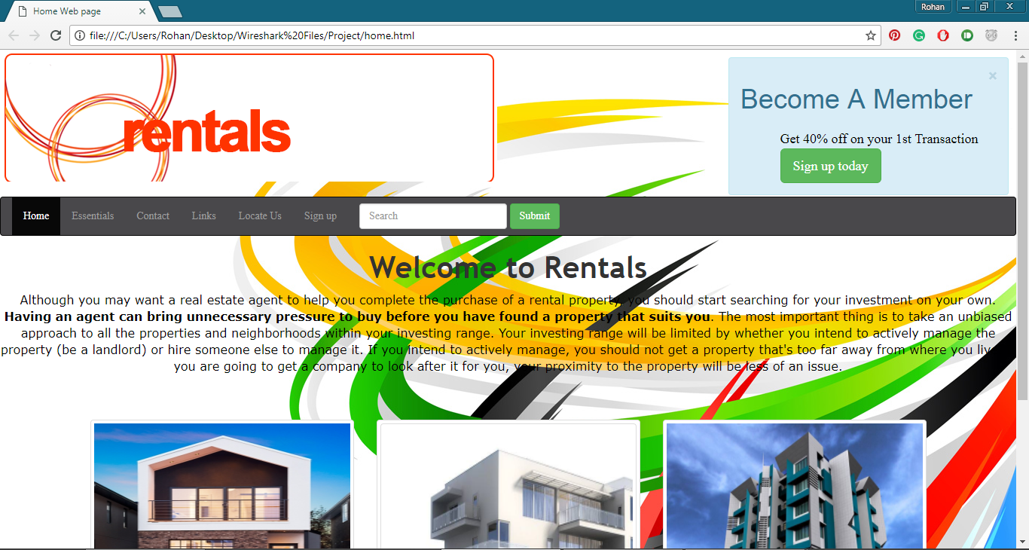

**F**ig 1: Screenshot of the Index page.

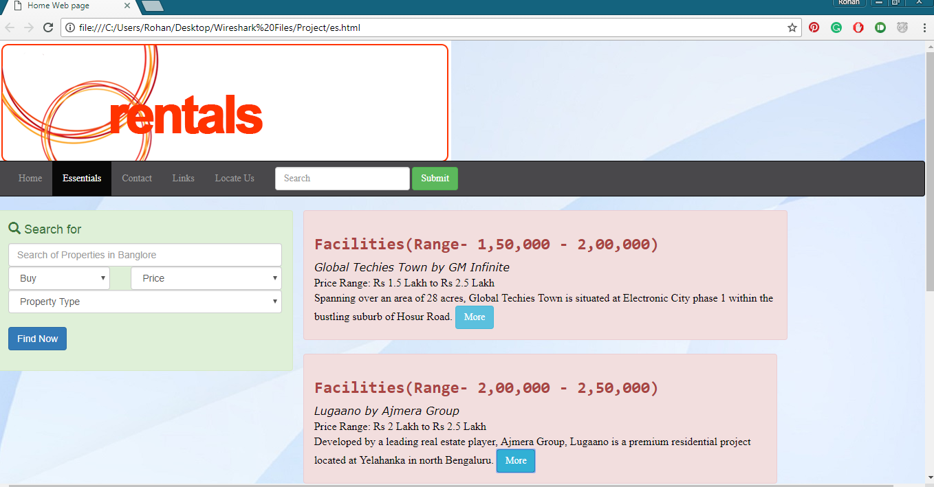

Fig 2: Screenshot of the Search page.

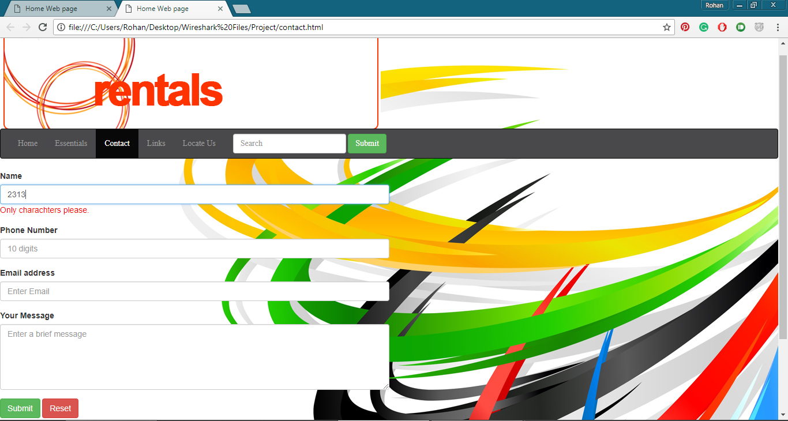

Fig 3: Screenshot of the Contact Us page.

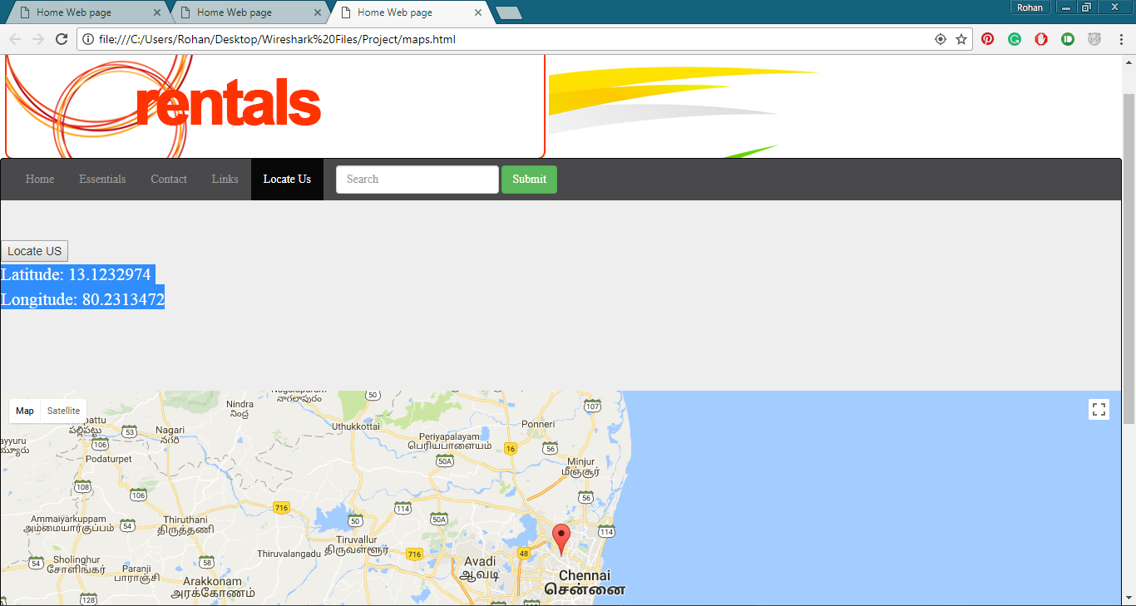

Fig 4: Showing Locate Us page

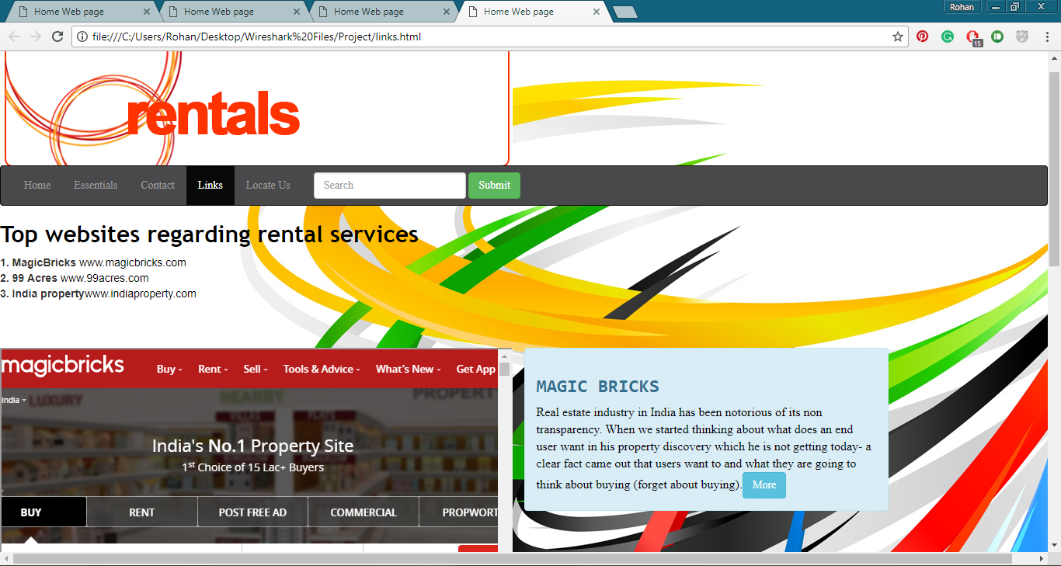

Fig 5-Showing Links Page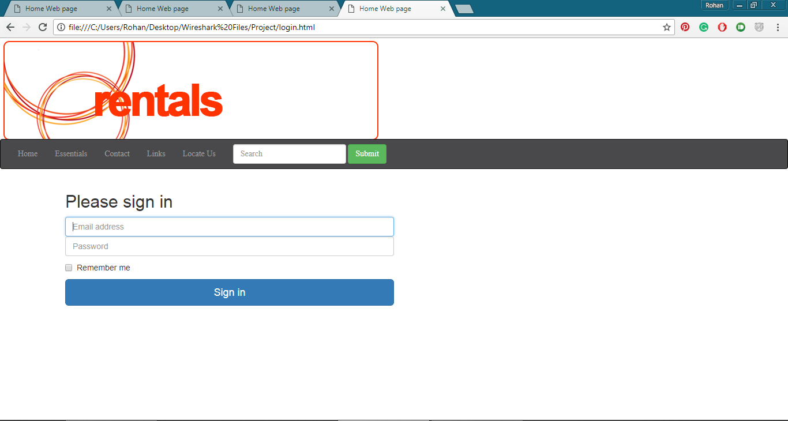

Fig 6: Showing Sign-in page

**7. CONCLUSION**

What role does the housing sector play in our lives and the economic development of a nation? Housing is considered as one of the most important basic necessities of living. For some nations, the housing sector can be an engine of economic growth, owing to its linkages to over 250 ancillary industries, providing opportunities of growth, which can have a multiplier effect on the economy. For a nation like India, which has been witnessing rapid urbanization over the past decade with an addition of over 10 million people to its urban population annually, the need for housing becomes even more important. India is the second-largest urban community in the world, after China, with an urban population of over 420 million, which is growing rapidly.

Overall, India holds a strong potential for residential property market growth as there would be a significant price appreciation over the next decade, with property market fundamental drivers, such as the GDP, urbanization, income growth, savings rate, mortgage growth and affordability, expected to improve going forward. Purchasing a house entails large amount of investment by an individual, for which a majority of the population utilize their lifetime savings

A web project for managing House rentals. This is just cursory website that allows user to search and execute their best ideas to find an ideal place. Across internet categories, leading players are making impact which change the dynamics of the industry itself. The way e-commerce has changed the contours of retail, or the way cab aggregators are changing the car transport industry are evidences that point to this trend. The Online Property Portal business too has come a long way. There has been an opportunity to evolve from being a listings platform to a full stack service provider.

Now that you have finalized a home on rent, there are certain essential checks which certainly you might be aware of as a tenant. However, it is equally essential to check the rental agreement for some of the most important points before you sign it in order to avoid that any disputes once you start living on rent in the desired house. Investing in property without analyzing the market dynamics may sometimes erode a large proportion from the investment for a certain period of time and can also entail other associated risks. Hence, it becomes important to critically understand the property market dynamics and thus the creation of **HOUSE RENTALS**.

**8. FUTURE SCOPE AND ENHANCEMENT**

**Clear and smooth navigation.** This is a matter of course for any solid website, from a landing page to a large database-driven website with a customize back-end and content management system. So in future a Simple navigation is easy people access, find what they need and more enjoyable their experience will be. If your website users cannot find the information they are interested in without being irritated, why do you think they would want to buy a house from your company?

**Meaningful content.** Strong content always wins. But what make it so special?

Content builds trust - through content, you tell your potential clients who you are and why you differ from others while clients’ reviews and ratings establish themselves in thought that you can be trusted. It establishes your company as an expert in the industry - by providing real estate-focused information, you say people that you know what you deal with. It gives users something to share. And finally, it drives organic traffic through SEO and social media.

**Responsive design.** Today’s consumers do their research online. Over 60% of users visit real estate websites via their smartphones first.

It is crucial to establish a mobile-responsive website. This means that users could find all necessary information quickly and easily no matter what device they use - laptop, desktop, tablet or smartphone - without being redirected to another website. Let people a chance to see your beautiful apartments.

No matter what kind of website you need to design - for elite mansions, middle-class houses or affordable apartments - it must inspire clients’ confidence and immerse them into how a property will look like. So, forget about cheap renders and so-and-so content - they will not just help you but fear your clients away. Only well-designed 3D renders and only professional photo gallery.

Secondly, define your client. Your client has a portrait and your goal is to draw it. Do not be fooled into thinking that you provide real estate services to everyone. At the very least, you probably business with buyers and sellers within a specific financial bracket.

Create email subscription. The consumer buying-decision process is long-term, so it makes sense to remind users of yourself from time to time. Otherwise, your client may just forget about you.

**Mobile-friendly websites are the need of the hour. Also, database connection enabled stand-alone applications can be devised.**

**As per email-subscription goes OTP verification can be added in the future.**

**9. BIBLIOGRAPHY**

1. HTML <http://www.tutorialspoint.com/html/>
2. Bootstrap <http://www.bootstrap.com/js.html>