PRN : 2019BTECS00056

Name : Rohan Pramod Bondre

Batch: T2 Date:22.02.2022

--------------------------------------------------------------------------------------------

Third Year B. Tech., Sem VI 2021-22

Software Engineering Tools Lab

Assignment: 3

Question :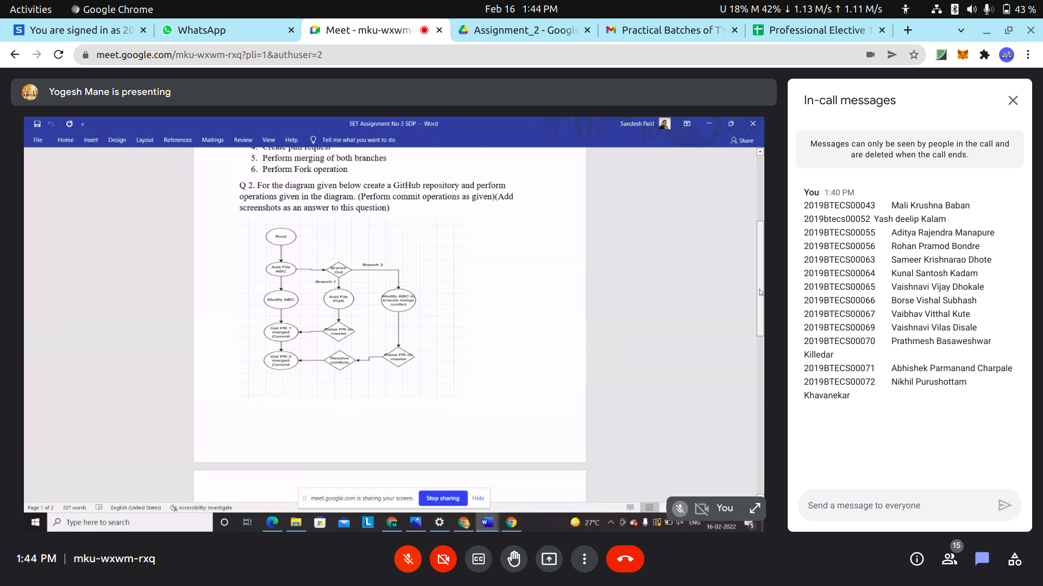

Creating repo : (<https://github.com/Rohan1710/Assignment3> )

Initialized git.

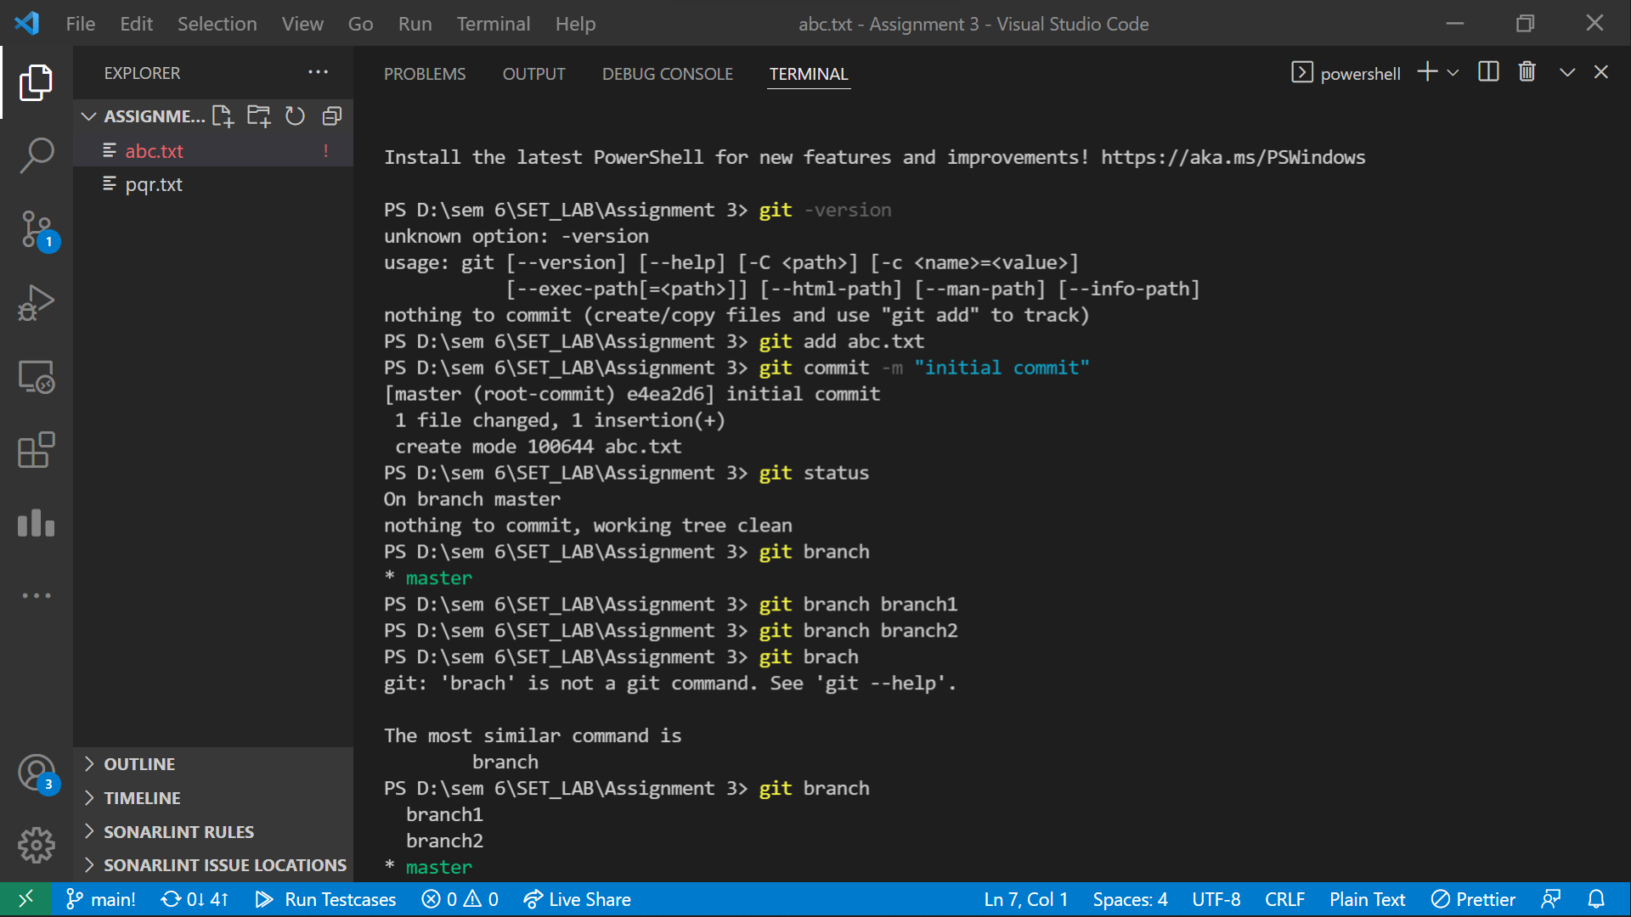

Firstly in main branch, created branch 1 and branch 2:

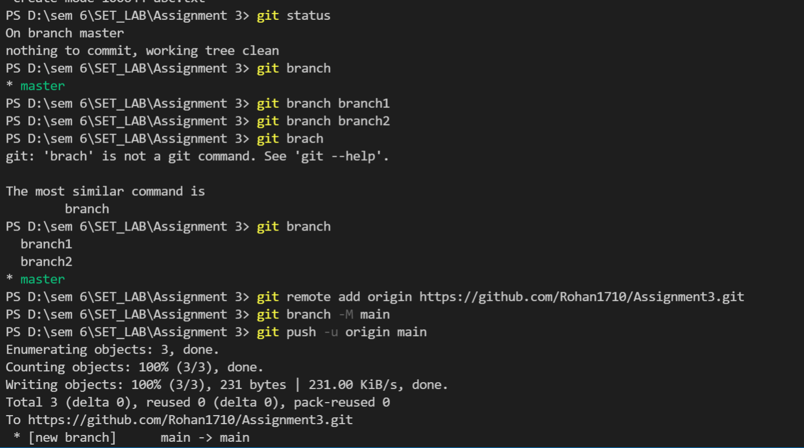

Modifying file ABC in main branch:

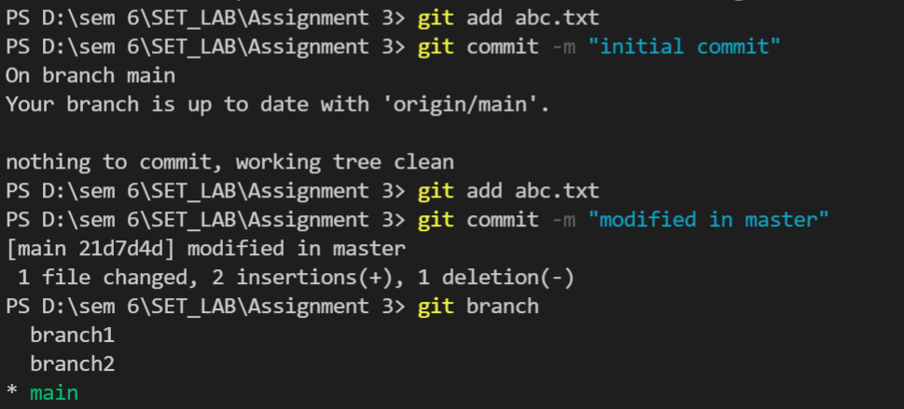

Switching to branch_2 and added pqr.txt :

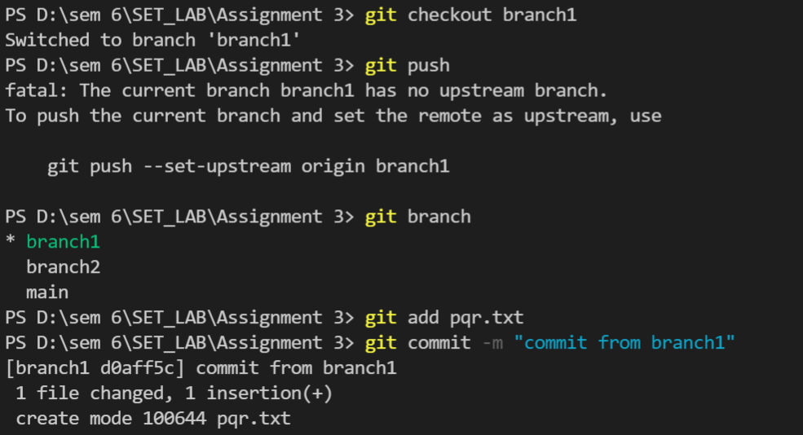

Raising pull request to main:

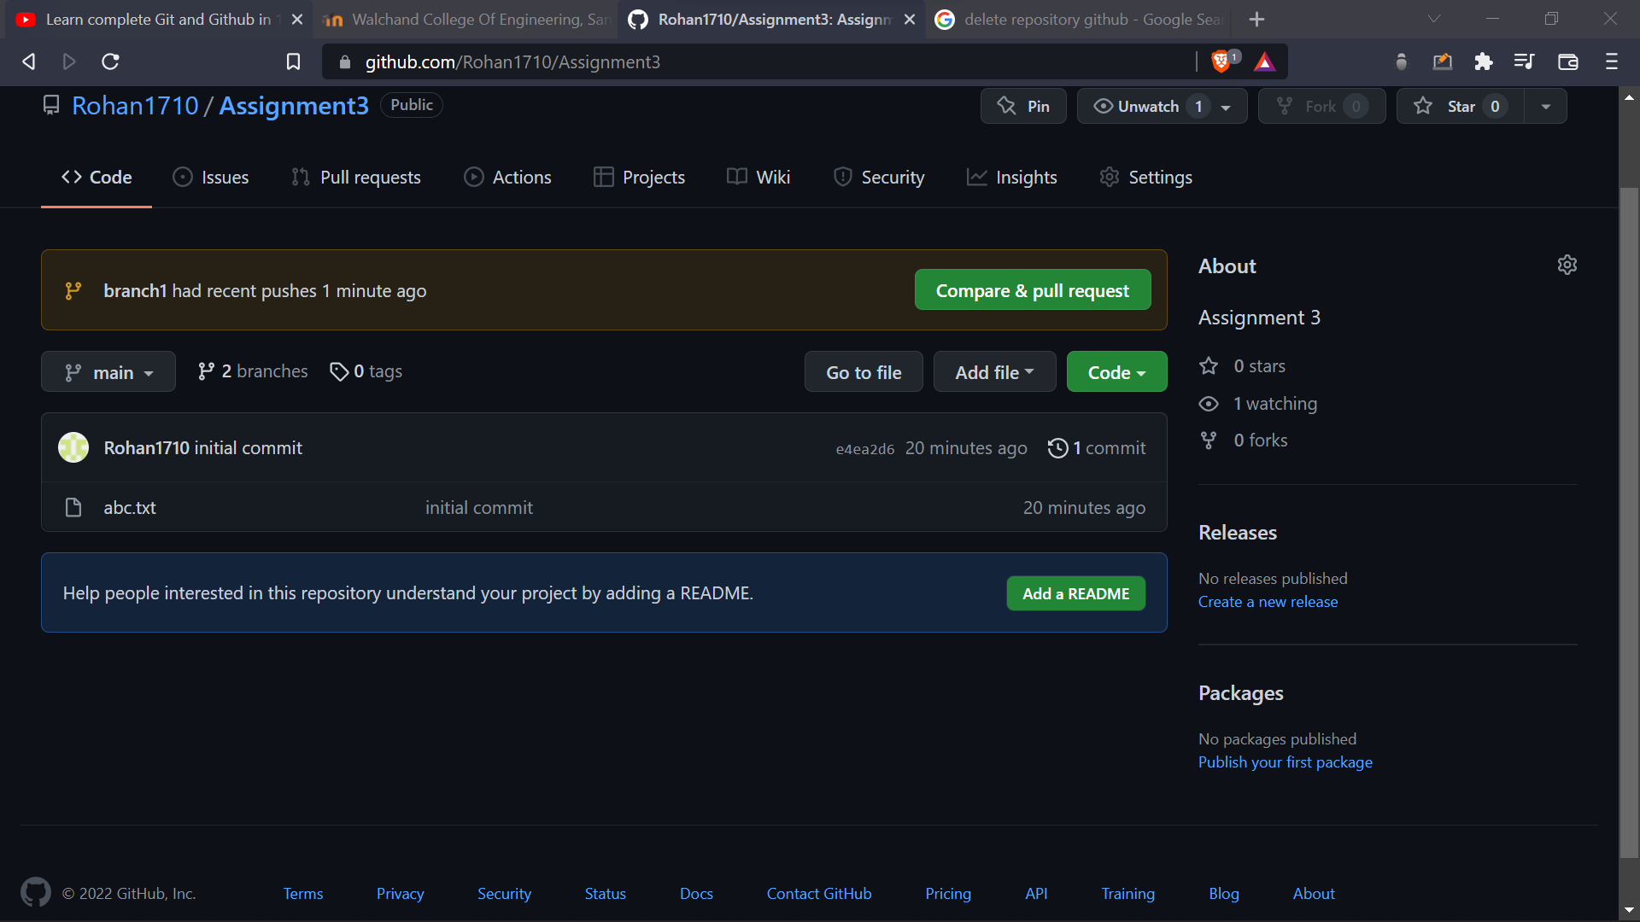

Pull request Merging :

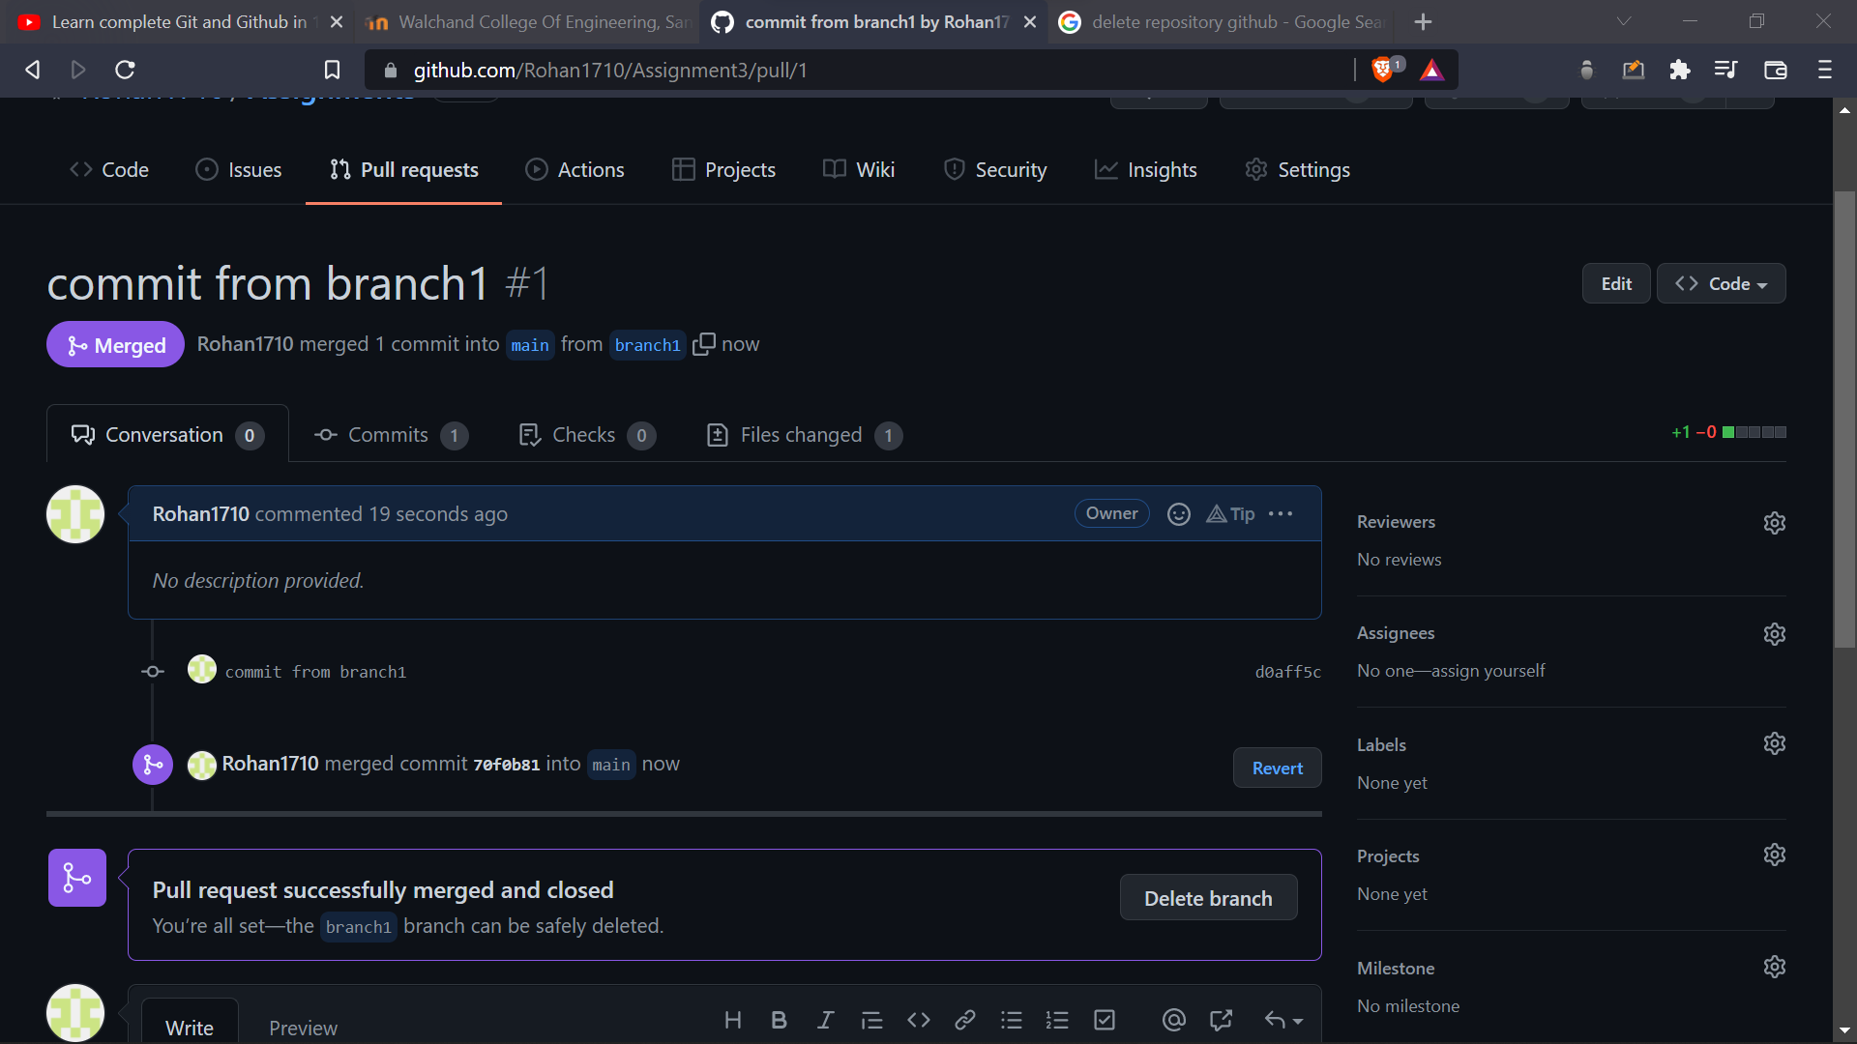

Switching to branch_3

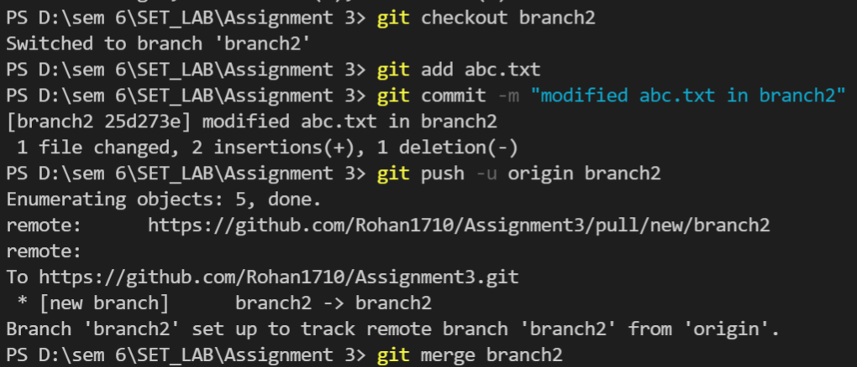

Raising Pull request to main:

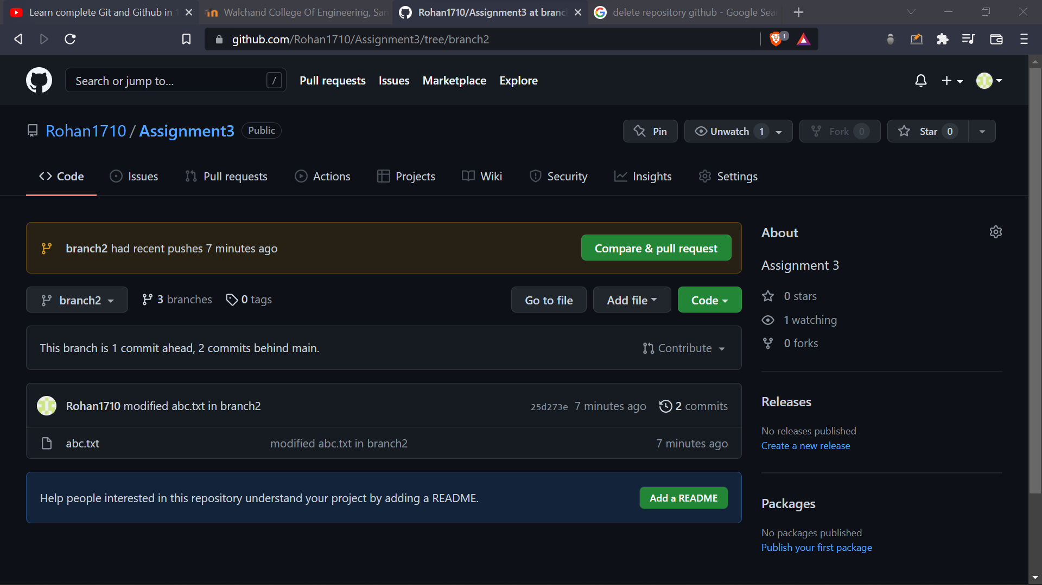

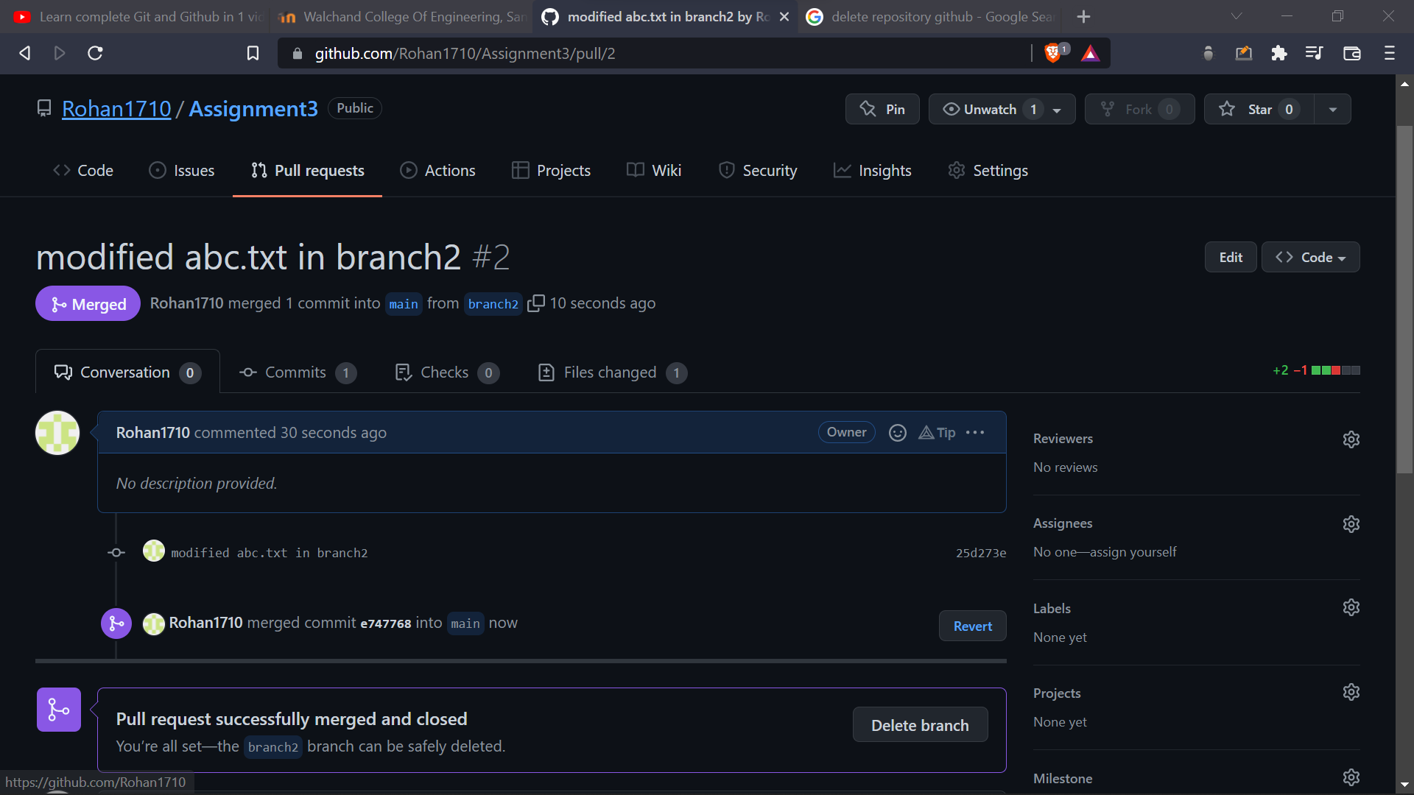

After merging both branches :



