**Roll No : 04**

**Practical No : 4**

**Practical Name : Demonstrate Importing and exporting data.**

**#IMPORT**

getwd()

#Importing csv file.

path<-"C:/Users/Leena/OneDrive/Documents/candidate-elimination.csv"

content<-read.csv(path)

print(content)

#Importing Text file.

x<-read.table("C:/Users/Leena/OneDrive/Documents/file.txt",header=FALSE)

print(x)

#Importing CSV file using csv2.

x<-read.csv2("C:/Users/Leena/OneDrive/Documents/candidate-elimination.csv")

print(x)

**OUTPUT**

SKY TEMP HUMID WIND WATER FOREST OUTPUT

1 sunny warm normal strong warm same yes

2 sunny warm high strong warm same yes

3 rainy cold high strong warm change no

4 sunny warm high strong cool change yes

SKY.TEMP.HUMID.WIND.WATER.FOREST.OUTPUT

1 sunny,warm,normal,strong,warm,same,yes

2 sunny,warm,high,strong,warm,same,yes

3 rainy,cold,high,strong,warm,change,no

4 sunny,warm,high,strong,cool,change,yes

SKY.TEMP.HUMID.WIND.WATER.FOREST.OUTPUT

1 sunny,warm,normal,strong,warm,same,yes

2 sunny,warm,high,strong,warm,same,yes

3 rainy,cold,high,strong,warm,change,no

4 sunny,warm,high,strong,cool,change,yes

**EXPORT**

**1).Export a data frame to a text file using write.table().**

df=data.frame(

"Name"=c("Leena","Roshani","Komal"),

"Language"=c("R","Python","Java"),

"Age"=c(22,25,24)

)

write.table(df,

file="Demo.txt",

sep = "\t",

row.names = TRUE,

col.names = NA)

**OUTPUT :**

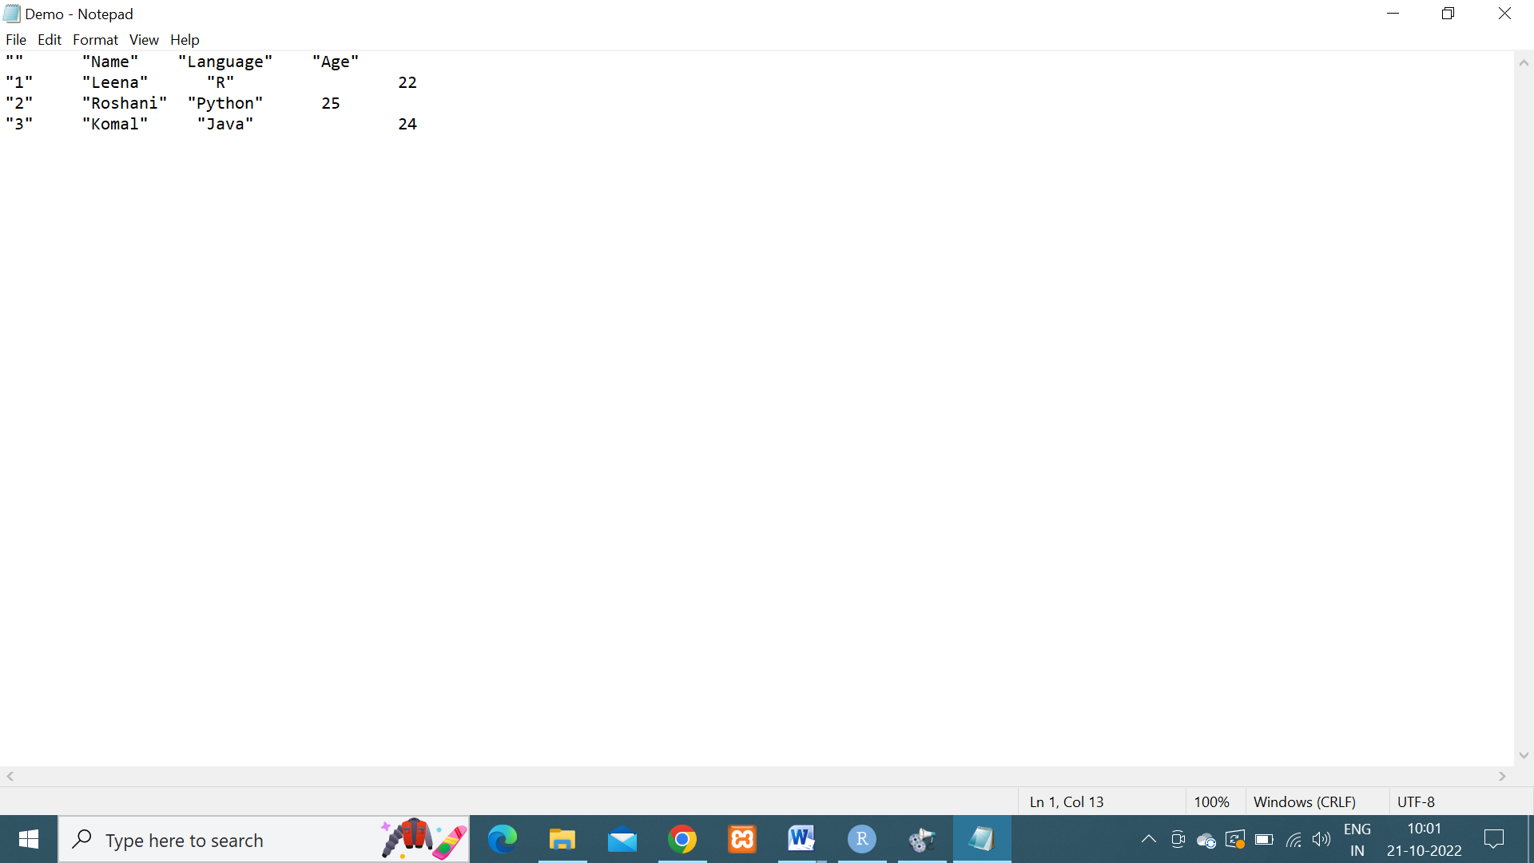

2).**Exporting Data to a csv file.**

df=data.frame(

"Name"=c("Ankit","Manthan","Pranav"),

"Language"=c("C Programming","Java","HTML"),

"Age"=c(28,27,29)

)

write.table(df,

file="myFile.csv",

sep = "\t",

row.names = FALSE)

**OUTPUT :**

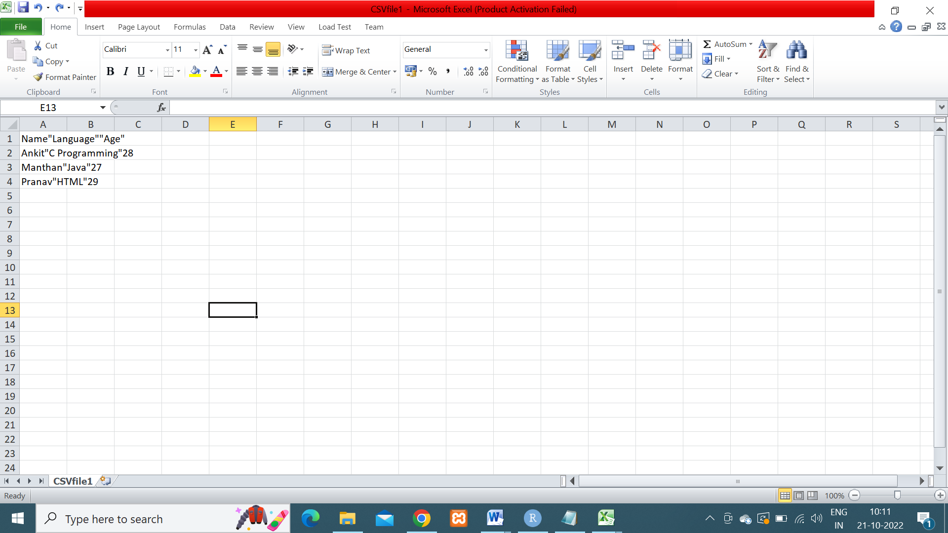

**3)Exporting data to a csv2 file**

library(readr)

df2=data.frame(

"Name"=c("Swati","Anushka","Ashish","Kalpesh"),

"Language"=c("R","Python","Java","PHP"),

"Age"=c(22,25,45,23),

"class"=c("SYMCA","SYMCA","FYMCA","FYMCA")

)

write_csv(df2,path="Demo2.csv")

write_csv2(df2,path="Demo3.csv")

**OUTPUT**

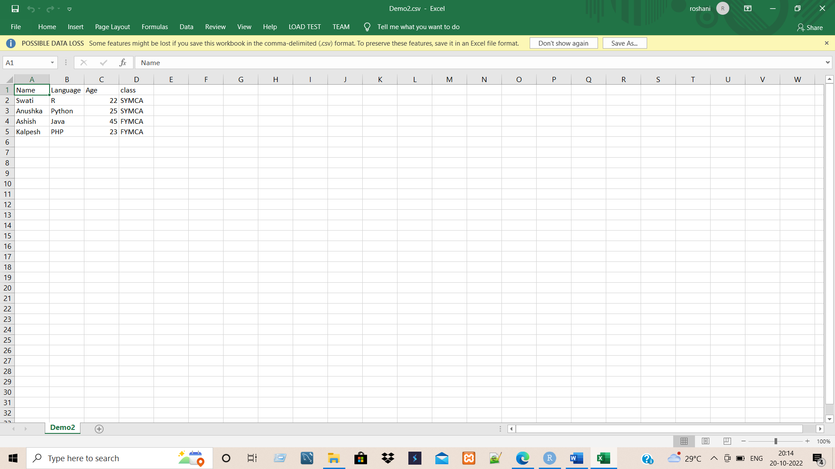

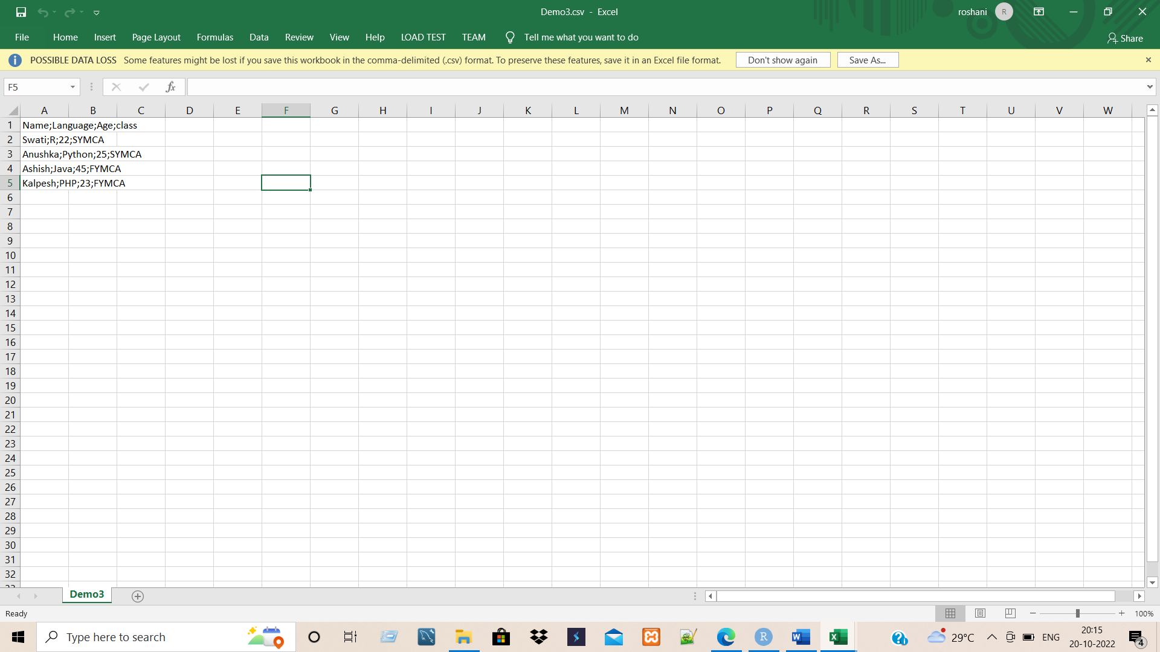

**4)Exporting data using write_tsv()function**

getwd()

#library(readr)

df2=data.frame(

"Name"=c("Swati","Anushka","Ashish","Kalpesh"),

"Language"=c("R","Python","Java","PHP"),

"Age"=c(22,25,45,23),

"class"=c("SYMCA","SYMCA","FYMCA","FYMCA")

)

write_tsv(df2,path="pract5.txt")

**OUTPUT**

