Experiment No. Date:
KICAD Individual Project
Objective:
- To design the schematic layout.
- To simulate the schematic for verification.
- To design the PCB layout.
- To generate Gerber and Excellon drill files.

Equipment:

Sr. No | Resources
 | Desktop/Laptop System
 | External Mouse
 | KiCAD

Procedure:
- Study the working of the circuits, download the component datasheets, and find the dimensions of the components.
- Design the schematic layout:
a. Open Schematic Editor. Set grid and page settings.
b. Add symbols to the sheet according to the circuit.
c. Arrange, wire, and annotate symbols; add textual information ensuring readability.
d. Perform Electrical Rules Check (ERC), fix errors, and repeat as necessary.
e. Assign footprints for each symbol according to finalized datasheets.
f. Attach datasheets to the schematic symbols.
g. Export the Bill of Materials (BOM) file.
h. Export the netlist.
- Design the PCB layout:
a. Open PCB Layout Editor. Set grid and page settings.
b. Import the generated netlist.
c. Arrange footprints by functional blocks and user interface needs, ensuring airwires do not intersect and the ‘Ratsnest’ is resolved.
d. Route the tracks; add textual info (your name, PCB type abbreviation) ensuring readability; avoid acute angles in tracks to prevent acid traps during etching.
e. Add the edge cuts layer defining PCB boundaries; keep PCB size minimal within constraints.
f. Perform zone fill connecting ground terminals.
g. Perform Design Rules Check (DRC), fix errors, and repeat.
h. Create, verify, and export Gerber and Excellon drill files.
- Perform a simulation:
a. Search and assign suitable SPICE models for unassigned components.
b. Open the simulator.
c. Select the signals whose waveforms you wish to view from the available list.
d. Click the Run button.

Circuit Diagram:
IC555 based sequential timer circuit
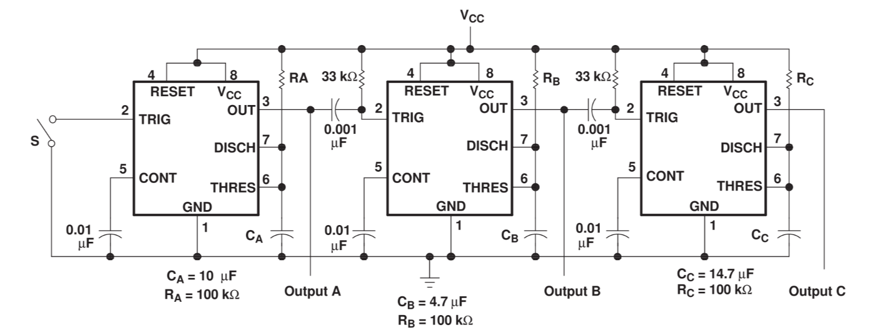
Implementation:
Sequential Timer Schematic Circuit:
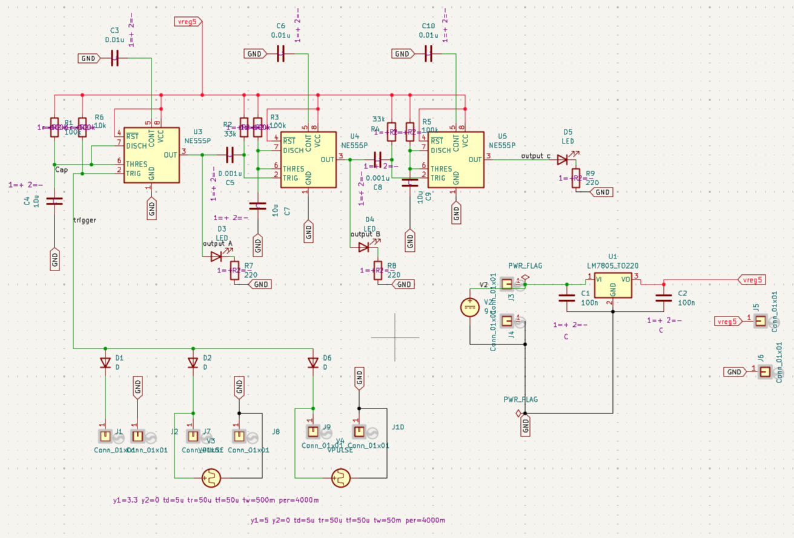
Schematic Circuit after ERC

Bill of Materials:
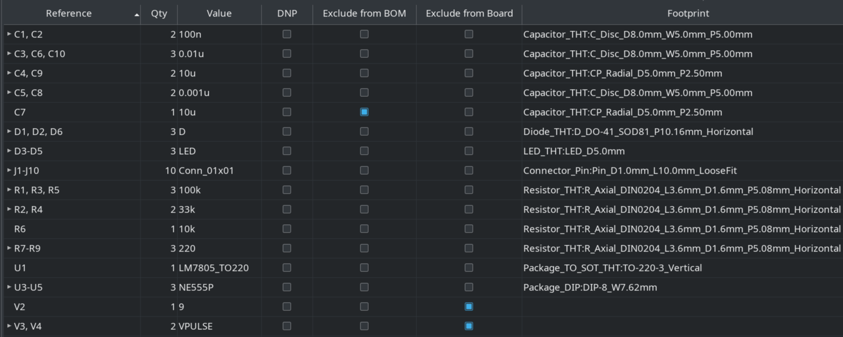

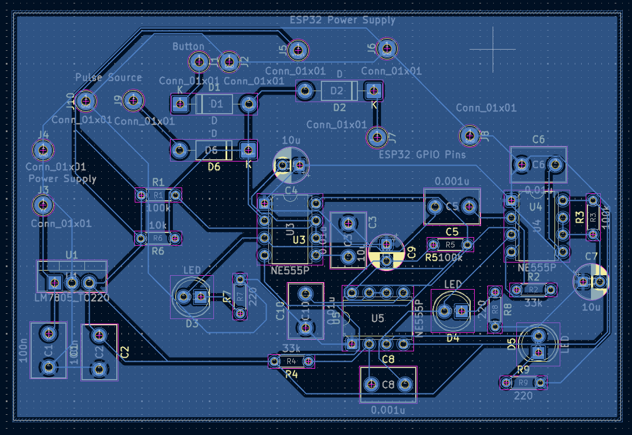
PCB Layout after DRC
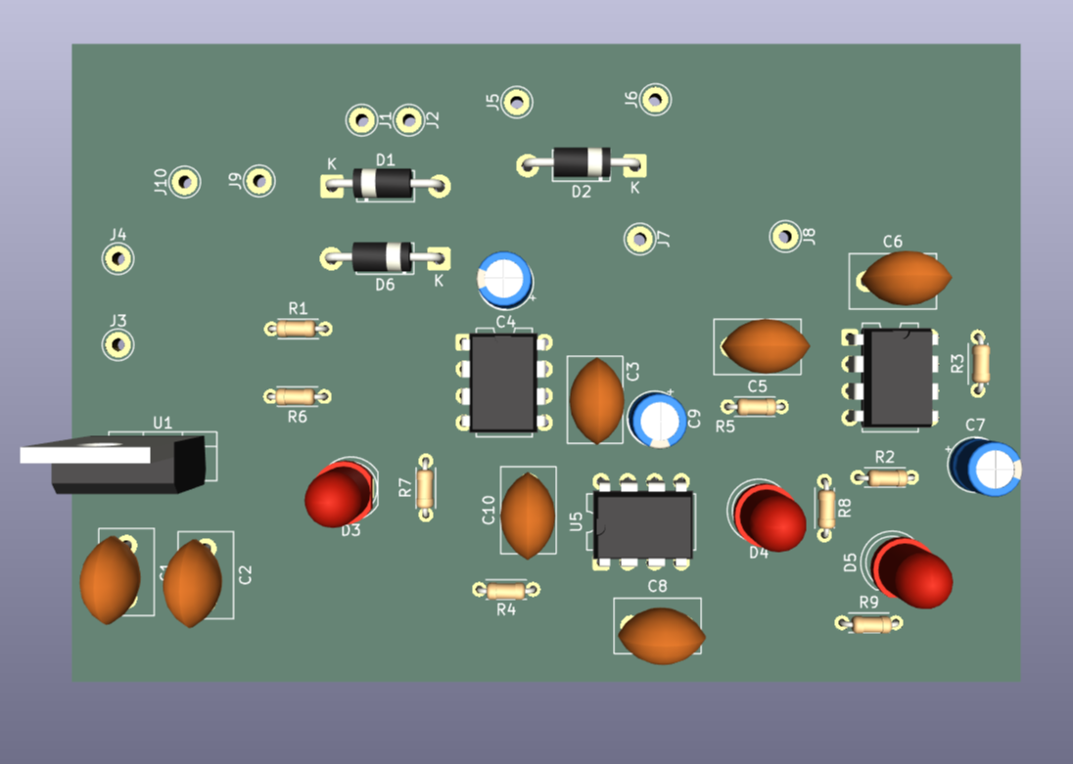
Component-side 3D view
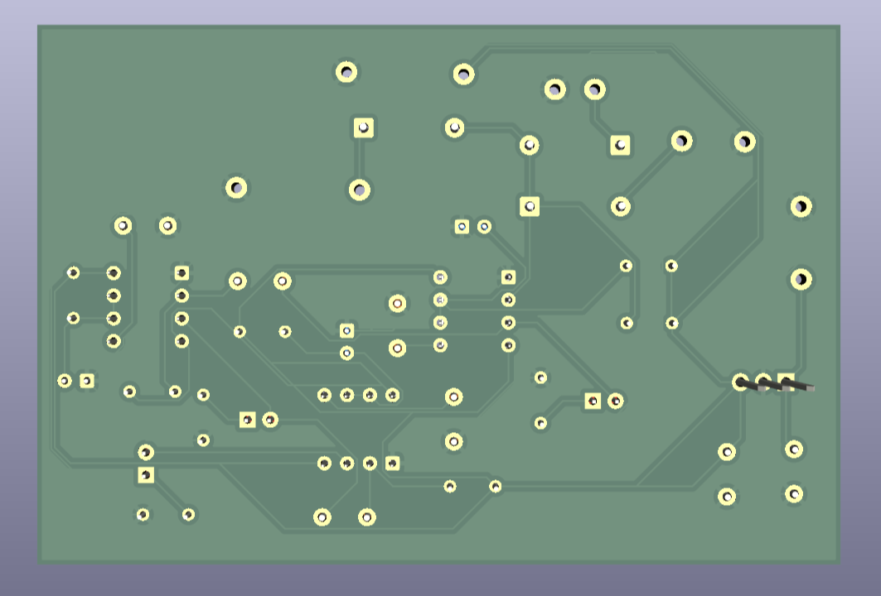
Solder-side 3D view

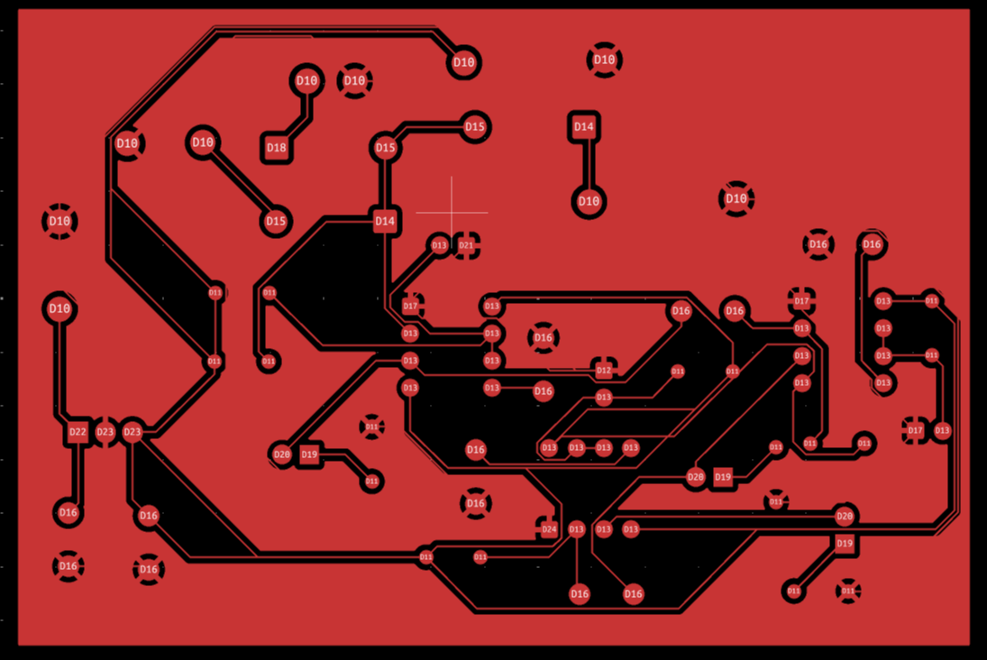
Back Copper Gerber and Excellon Drill Files in Gerber Viewer
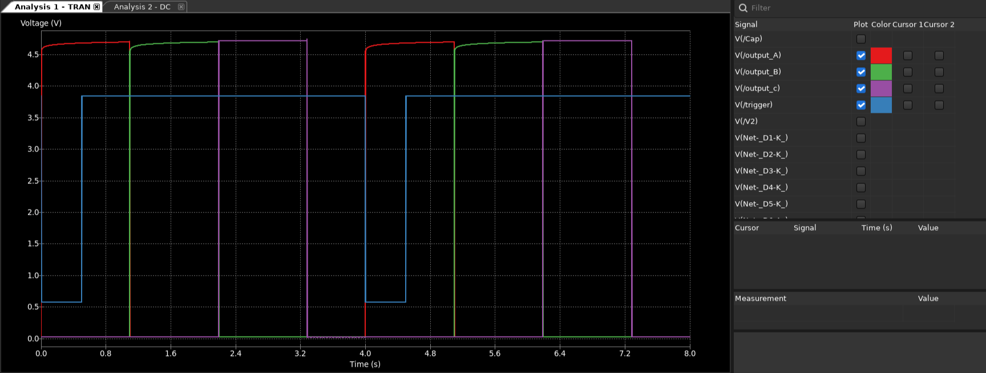
Output Waveform

