PROJECT REPORT

Problem Statement
Design and Development of a Flexible Two-Digit Counter Module Using CD4026 Decade Counter IC
Group Members
Pooja Dinesh Vengurlekar —— 23B-ET-043
Riya Rupesh Naik —— 23B-ET-054
Rohan Ravi Hulli —— 23B-ET-055
Hazarat Ali —— 22B-ET-080
Abstract
This project presents the design and implementation of a flexible two-digit digital counter module using CD4026 decade counter ICs and seven-segment displays. The module is capable of counting pulses received from any external clock source and displaying the count from 00 to 99.
Unlike application-specific counters, this design can be integrated with various sensor systems and electronic modules. Depending on the source connected to the clock input, the circuit can function as an object counter, event counter, timed counter, pulse counter, or microcontroller-based counting system.
The complete design process included schematic creation, PCB layout design, component selection, simulation, PCB fabrication planning, and hardware implementation considerations.
Components Used
2x CD4026 Decade Counter IC
2x HDSP-7803 Seven Segment Display
14x 330 Ω Resistors
1x LM7805 Voltage Regulator
2x 100 nF Capacitors
1x Clock Input Connector 1
1x Power Input Connector 1
1x Button
2x PCB
Connecting Wires —— As Required

Applications
This module can be used in:
- Object Counting —— using IR Sensors,Ultrasonic sensors(Example: Production line item counting, Visitor counting)
- Time-Based Counting —— using timer IC like 555 Timer IC(Example: Frequency demonstration, Event timing,
- Microcontroller Interfacing —— using Arduino, ESP32, Raspberry Pi(Example: Event monitoring, Educational Laboratories, Counter demonstration)
Design Challenges Faced
1. PCB Trace Routing
Routing all connections on a single-layer PCB proved challenging because several signal traces intersected. To overcome this:
- Components were repositioned multiple times.
- Routing paths were optimized manually.
- Trace lengths were adjusted where necessary.
2. Component Availability
Some components available locally differed from those used in the original design. For example:
A compatible 10-pin seven-segment display was available. However, its pin arrangement was vertically aligned instead of horizontally aligned. To overcome this:
- Alternative footprints were evaluated.
- The PCB layout was modified to support available components.
3. PCB Fabrication Constraints
Originally, the PCB design was intended for fabrication on a double-sided PCB. However, due to the unavailability of double-sided copper-clad boards, an alternative approach had to be adopted.
To overcome this limitation:
- The PCB layout was reorganized to suit single-layer routing constraints.
- Routing paths were carefully planned to minimize trace intersections.
- In locations where direct routing was not feasible, wire jumpers were used to establish connections and replace vias that would normally be implemented on a double-sided PCB.
- Additional effort was required to maintain signal continuity and proper component connectivity.

Figures
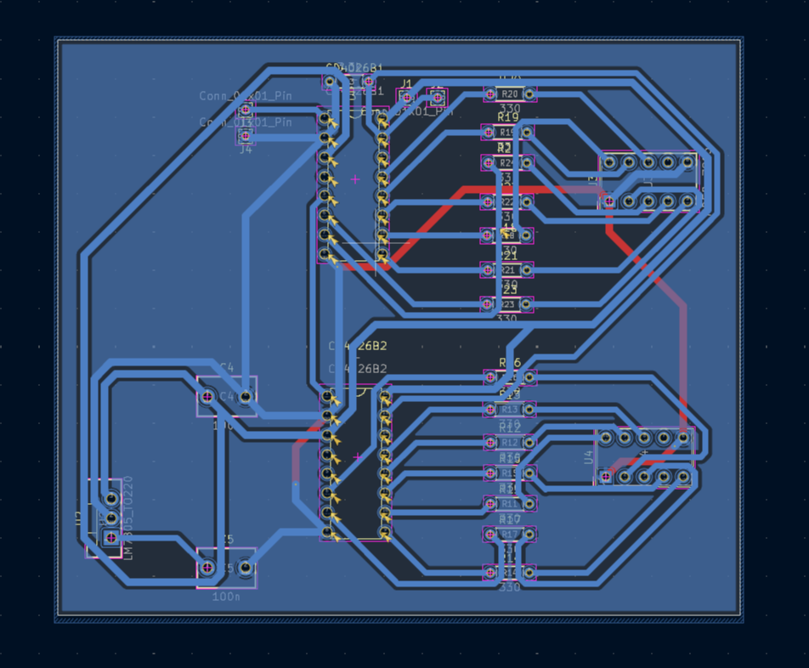
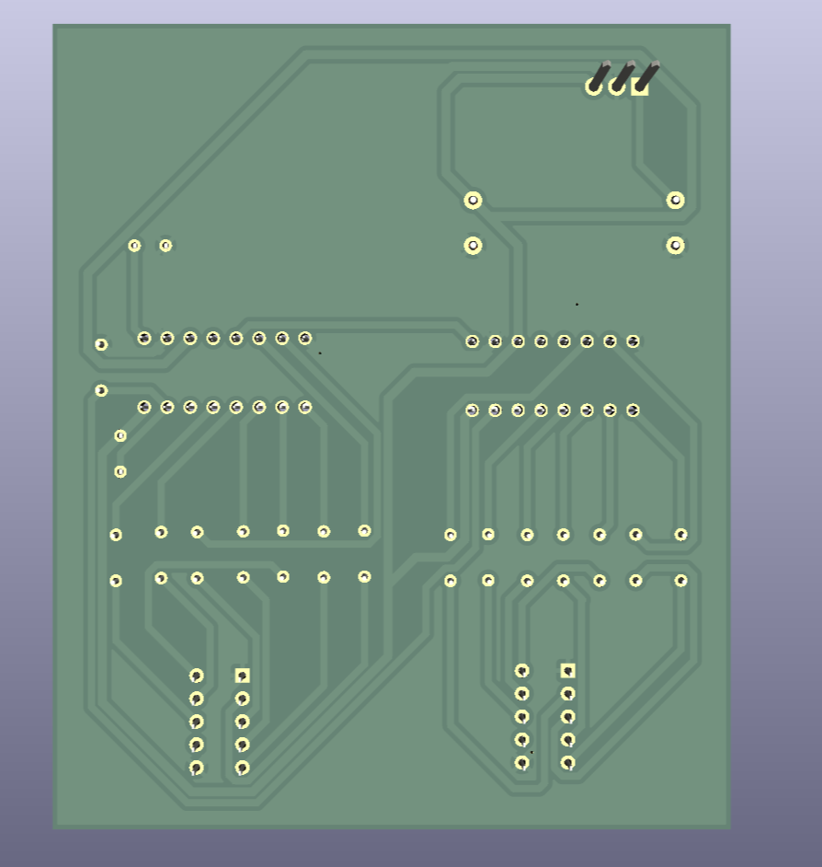
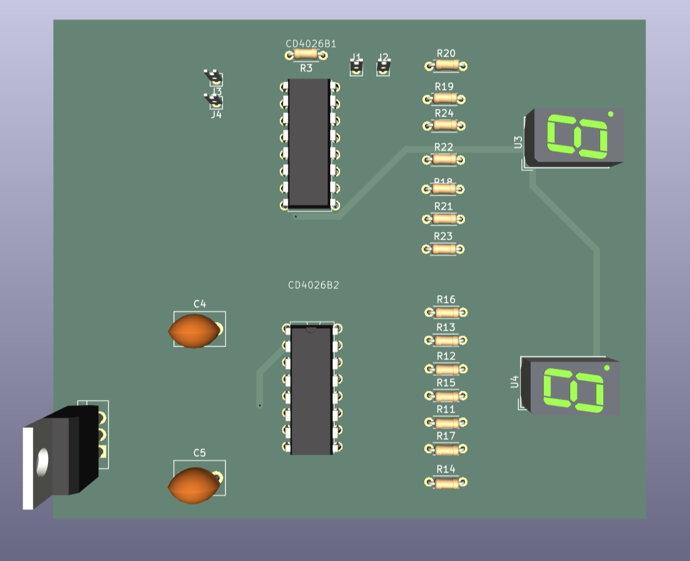
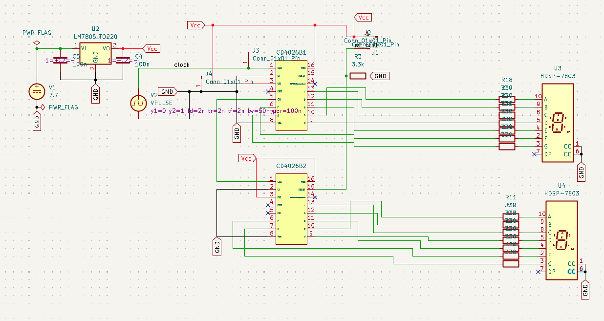
Figure 4: PCB Solder Side
Figure 3: PCB 3D model
Figure 1: Circuit Schematic
Figure 2: PCB Layout

Conclusion
The project successfully demonstrates the design and implementation of a flexible two-digit counter module using CD4026 decade counter ICs. The module can accept clock signals from a wide range of external sources, making it suitable for numerous applications such as object counting, pulse monitoring, timing systems, and educational demonstrations.
The project also provided practical experience in schematic design, PCB layout creation, component selection, and hardware implementation. The resulting design serves as a reusable digital counter platform that can be integrated into future electronics and embedded systems projects.

