PROPOSED MODEL / SYSTEM DESIGN
(Flowcharts / Block Diagrams / Algorithms / DFD / ER Diagrams)
and Implementation of Code
Project Title
HireSense AI
An AI-Based Resume Screening and Recruitment Assistant
Submitted in partial fulfilment of the requirements for the degree of
[Bachelor of Technology in Computer Science and Engineering]
Submitted by
[Student Name] – [Enrollment / Roll No.]
[Student Name] – [Enrollment / Roll No.]
Under the guidance of
[Guide Name]
[Designation, Department]
[Department of Computer Science and Engineering]
[Name of College / University]
Academic Year 2026 – 2027

TABLE OF CONTENTS
1. Introduction 3
2. Proposed Model 3
3. System Architecture (Block Diagram) 4
4. Flowcharts 6
5. Algorithms 7
6. Data Flow Diagrams (DFD) 9
7. Entity-Relationship (ER) Diagram and Database Design 12
8. Implementation of Code 14
9. User Interface and Running Model 17
10. Testing 19
11. Conclusion 20
12. References 21
List of figures: Block diagram (Fig. 3.1), Recruiter flowchart (Fig. 4.1), Candidate flowchart (Fig. 4.2), DFD level 0 (Fig. 6.1), DFD level 1 (Fig. 6.2), ER diagram (Fig. 7.1).

1. Introduction
This document presents the proposed model and the system design of the project “HireSense AI – An AI-Based Resume Screening and Recruitment Assistant”, together with the implementation of the code that realises the design. It follows the project synopsis and describes how the system is organised, how data flows through it, how the main algorithms work and how the running application is built and operated.
HireSense AI is a role-based web application for three kinds of users: candidates, recruiters and administrators. It extracts structured information from resumes, matches candidates with job descriptions using a language model, shows explainable scores, supports interview scheduling and gives candidates feedback to improve their resumes. The human recruiter always makes the final decision.

1.1 Scope of this Document
- Proposed model and overall design approach.
- System architecture as a block diagram.
- Flowcharts of the recruiter and candidate processes.
- Algorithms in pseudocode.
- Data Flow Diagrams (level 0 and level 1).
- ER diagram and database design.
- Implementation details: technology, project structure, key code, API endpoints and security.
- User interface, instructions to run the model and test cases.

2. Proposed Model
The proposed model combines a conventional three-tier web application with a language-model service. A resume is treated as unstructured text; the model converts it into structured data and a match assessment, and a verification step makes sure that nothing in the result is invented. The recruiter or candidate then works with explainable results instead of a bare score.

2.1 Model Overview
- Input: resumes in PDF or text format and job descriptions with required and optional skills.
- Text extraction: the file is converted to plain text.
- AI analysis: the language model returns a fixed JSON structure with the candidate profile, per-skill match, sub-scores (skills, experience, domain, education), reasons and a recommendation.
- Verification: each extracted item is checked against the resume text; unsupported items are removed (hallucination control).
- Decision support: scores, matched and missing skills and reasons are shown; the recruiter shortlists, reviews or rejects.
- Feedback loop: recruiter decisions are compared with AI recommendations and used to suggest a better shortlisting threshold.

2.2 Users and Their Functions
User | Main functions
Candidate | Register/login, manage profile, upload resume versions, ATS report, improvement suggestions, skill gap analysis, version comparison, job recommendations, apply to jobs, track applications, generative career assistant.
Recruiter | Company profile, create and publish jobs with required/optional skills, batch resume screening, ranked and explainable candidate reports, candidate comparison, shortlist/reject, interview questions, interview scheduling, HR chatbot, analytics, blind screening and fairness audit.
Administrator | Manage users and job postings, platform statistics, skills demand analytics, shortlisting statistics, API usage and error monitoring, audit logs, shortlist threshold and feedback learning.
Table 2.1: Users and functions

2.3 Design Principles
- Explainability: every score is accompanied by reasons and skill-level evidence.
- Verification before trust: AI output is validated against the source document.
- Human in the loop: AI recommends, a person decides.
- Least privilege: each API route checks the role of the logged-in user.
- Simplicity: one Next.js project contains both frontend and backend, and one MySQL database stores all data.

3. System Architecture (Block Diagram)
The system is organised in four layers. The browser-based presentation layer talks to server-side API routes in the application layer. The application layer reads and writes the MySQL database, extracts text with the pdf-parse library and calls the AI service through one wrapper function that logs usage and errors.
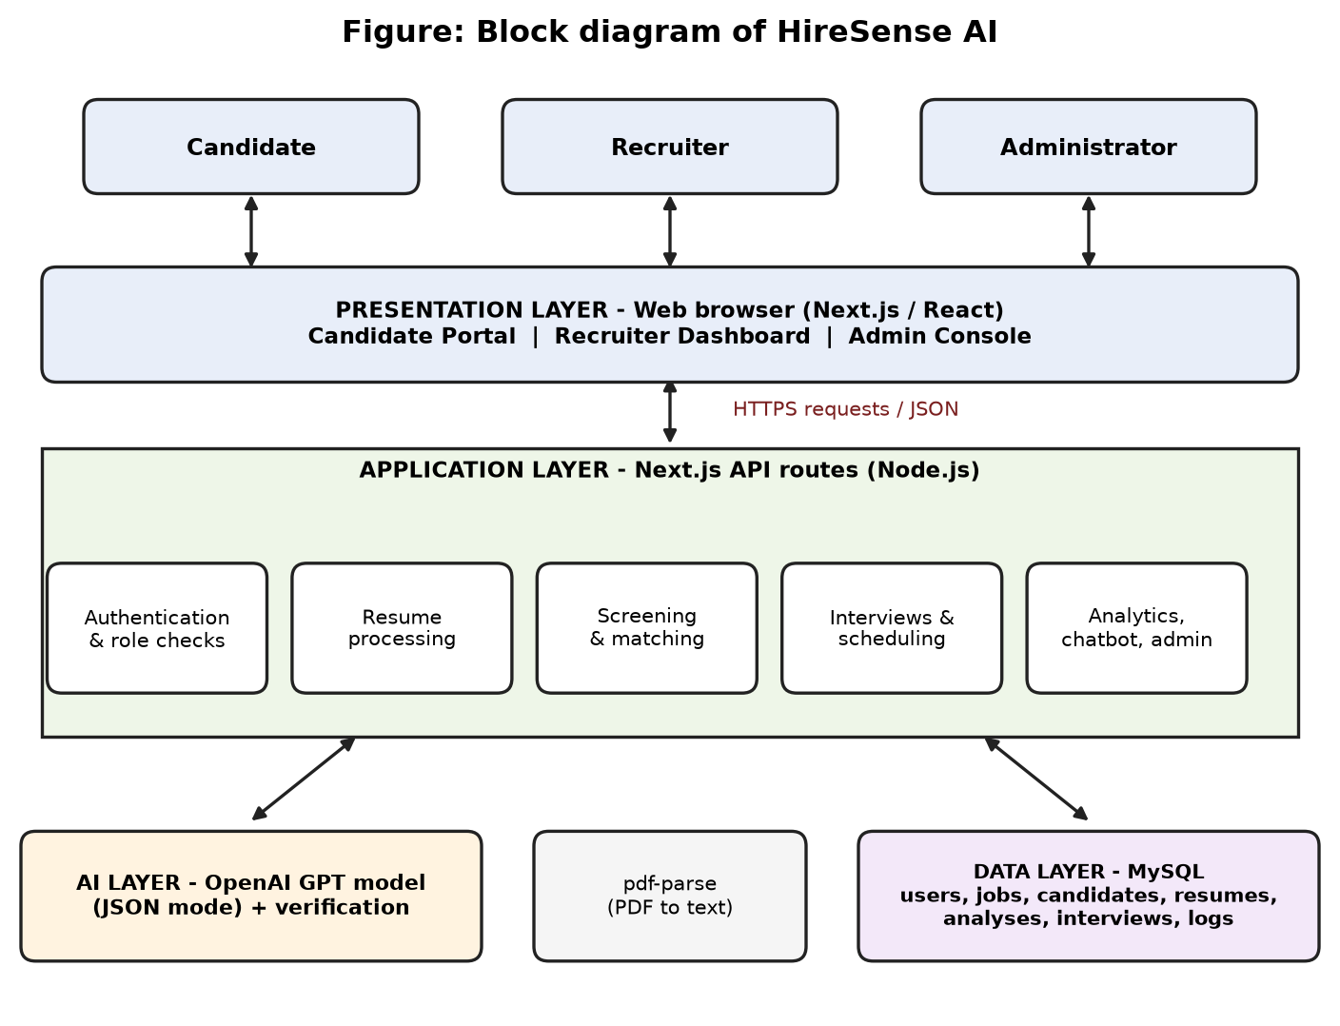
Figure 3.1: Block diagram of HireSense AI
Layer | Components | Responsibility
Presentation | Next.js / React pages: candidate portal, recruiter dashboard, admin console; SVG charts | User interface, form validation, calls to the API.
Application | Next.js API routes on Node.js: authentication and role checks, resume processing, screening and matching, interviews, analytics, chatbot, administration | Business logic, access control, orchestration of AI and database.
AI | OpenAI GPT model in JSON mode, verification functions | Parsing, semantic matching, explanations, ATS and skill gap analysis, question generation, career assistant.
Data | MySQL 8 with JSON columns | Persistent storage of users, jobs, resumes, candidates, analyses, interviews, feedback and logs.
Table 3.1: Layers of the architecture

4. Flowcharts

4.1 Recruiter Flow
Flowchart 1 shows how a recruiter creates a job and screens resumes. Unreadable files and duplicate resumes are skipped with a message. Accepted resumes are analysed by the AI, verified against the text, stored and ranked; the recruiter then reviews the explainable report and decides.
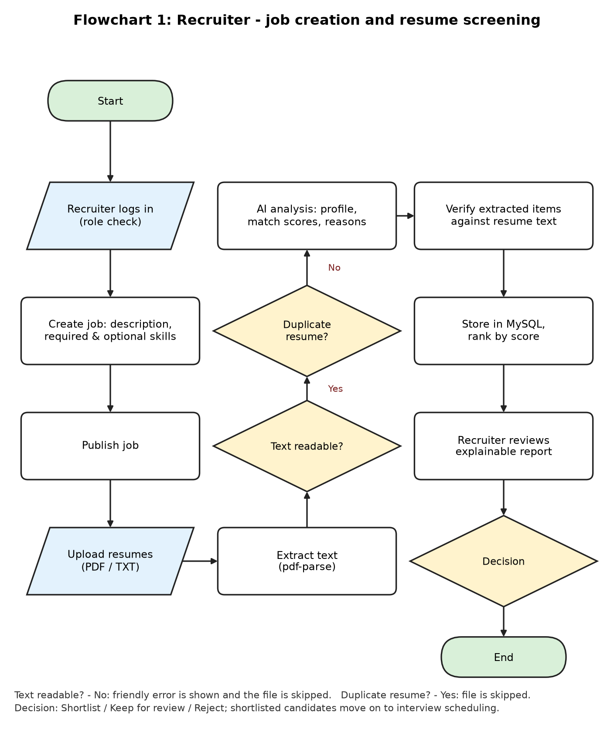
Figure 4.1: Flowchart of recruiter job creation and resume screening

4.2 Candidate Flow
Flowchart 2 shows the candidate journey: upload and validate a resume, receive the structured profile and improvement reports, compare versions, apply to a recommended job and track the result.
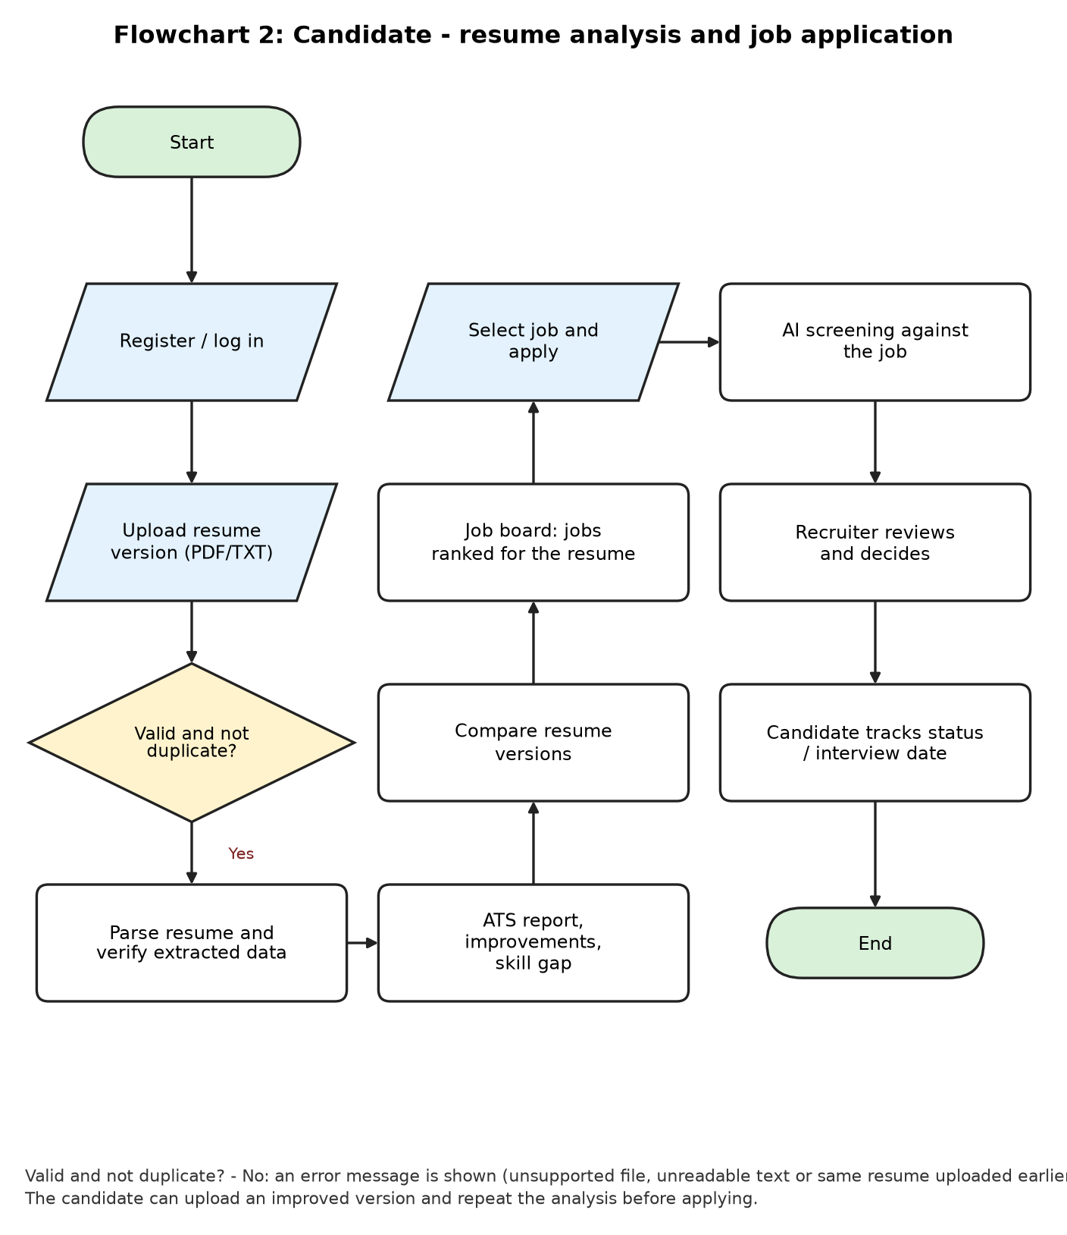
Figure 4.2: Flowchart of candidate resume analysis and job application

5. Algorithms
The main algorithms of the system are given below in pseudocode. They correspond to functions in the implemented code.
Algorithm 1: Batch resume screening
Input : job J (required skills R, optional skills O), resume files F1..Fn
Output: scored and ranked candidate records stored in the database
1. threshold <- shortlist threshold from settings (default 80)
2. seen <- empty set of resume hashes
3. for each file f in F (in parallel):
4. text <- extract_text(f) // pdf-parse or plain text
5. if text is empty or file type unsupported: report error; continue
6. h <- SHA256(normalise(text))
7. if h already stored for job J or h in seen: report duplicate; continue
8. add h to seen
9. result <- LLM(J, text) // JSON: scores, overlap, reasons, profile
10. result.profile <- VERIFY(result.profile, text) // Algorithm 2
11. if score >= threshold then status <- Shortlisted
else if score >= threshold-20 then status <- Review
else status <- Rejected
12. store candidate (scores, profile, hash, status)
13. rank the candidates of J by score in descending order

Algorithm 2: Hallucination control (verification of extracted data)
Input : extracted profile P, resume text T
Output: verified profile P', counts (checked, removed)
1. H <- lower-case(T) with whitespace collapsed
2. checked <- 0; removed <- 0
3. for each item x in education, experience, projects, certifications, skills:
4. checked <- checked + 1
5. if no key field of x (institution/degree, company/role, name, text)
occurs as a substring of H:
6. remove x from P; removed <- removed + 1
7. keep e-mail only if it occurs in T; keep phone only if its digits occur in digits(T)
8. return P', (checked, removed)

Algorithm 3: Job recommendation for a candidate
Input : resume text T, published jobs
1. for each job j:
2. R <- required skills of j; O <- optional skills of j
3. foundR <- number of skills in R that occur in T (case-insensitive)
4. foundO <- number of skills in O that occur in T
5. total <- 2*|R| + |O|
6. match(j) <- round(100 * (2*foundR + foundO) / total) if total > 0
7. sort jobs by match(j) in descending order

Algorithm 4: Interview slot conflict check
Input : start time S, duration d (minutes), candidate c
1. end <- S + d
2. if there is an interview I with I.start < end AND I.start + I.duration > S:
3. reject the booking (overlap)
4. else store the interview and draft the invitation e-mail

Algorithm 5: Feedback learning (shortlist threshold)
1. whenever a recruiter changes a candidate status, store
(AI recommendation, final status, score)
2. agreement <- (number of decisions equal to the AI recommendation) / total
3. H <- scores of candidates finally shortlisted by recruiters
4. if |H| >= 3: suggested <- max(50, floor(min(H) / 5) * 5)
5. the administrator may apply the suggestion (or any value from 50 to 95)
as the new shortlist threshold used in Algorithm 1

Algorithm 6: Fairness (selection-rate) audit
1. group candidates by experience band and by city (groups with >= 2 candidates)
2. rate(g) <- shortlisted(g) / total(g)
3. best <- maximum rate over all groups
4. ratio(g) <- rate(g) / best
5. flag group g when ratio(g) < 0.80 // four-fifths rule

Algorithm 7: Resume version comparison
Input : resume versions A and B of one candidate
1. get the ATS score and the technical skills of A and B
2. delta <- ATS(B) - ATS(A)
3. added <- skills(B) minus skills(A); removed <- skills(A) minus skills(B)
4. report delta, added, removed, word counts and number of sections

6. Data Flow Diagrams (DFD)

6.1 DFD Level 0 (Context Diagram)
At level 0 the whole system is one process that exchanges data with three kinds of users and with the external AI service.
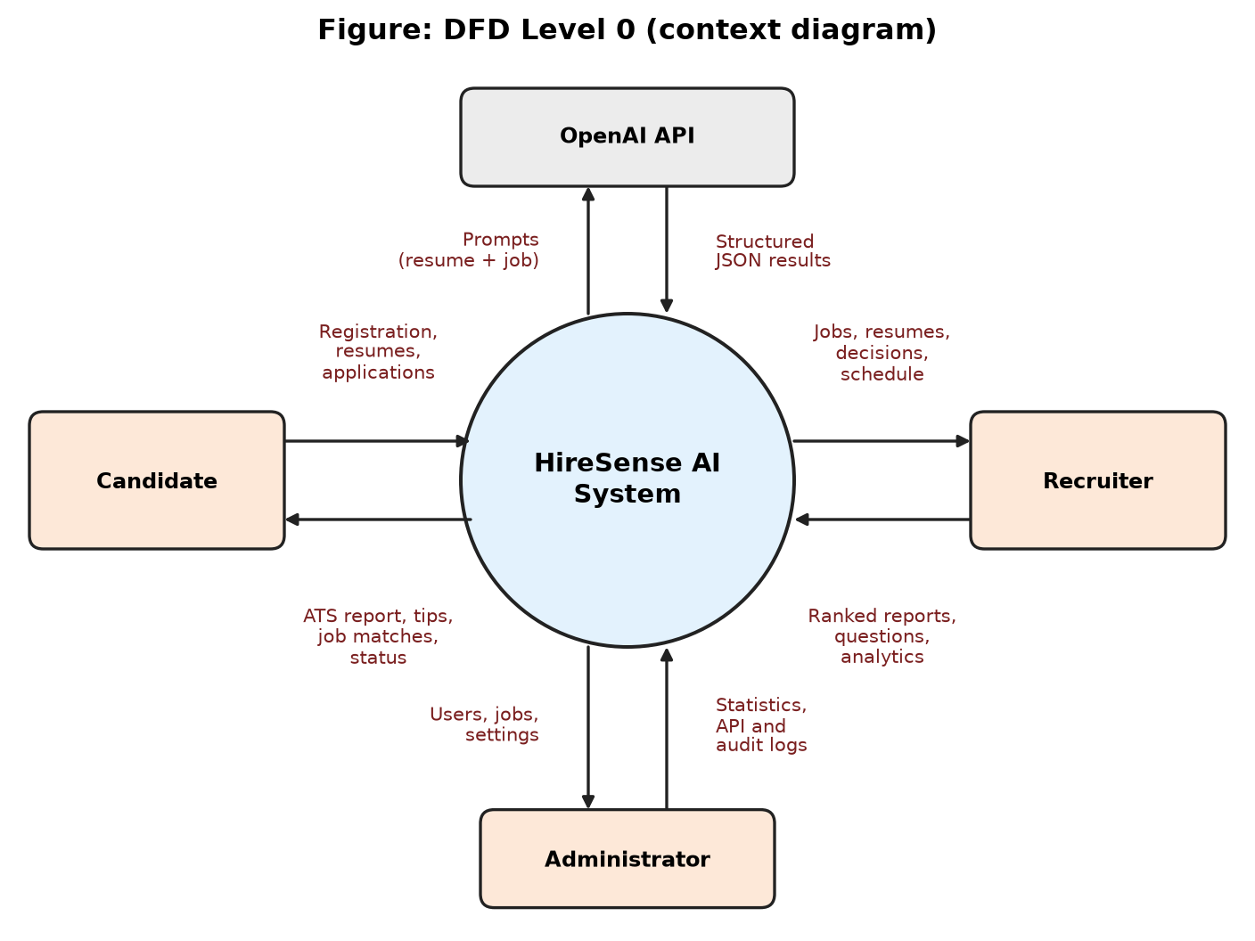
Figure 6.1: DFD level 0

6.2 DFD Level 1
At level 1 the system is divided into six processes that use five data stores. All users log in through process 1.0.
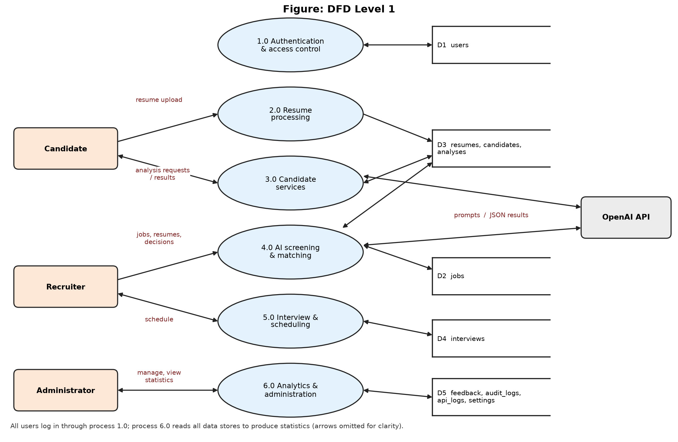
Figure 6.2: DFD level 1

7. Entity-Relationship (ER) Diagram and Database Design
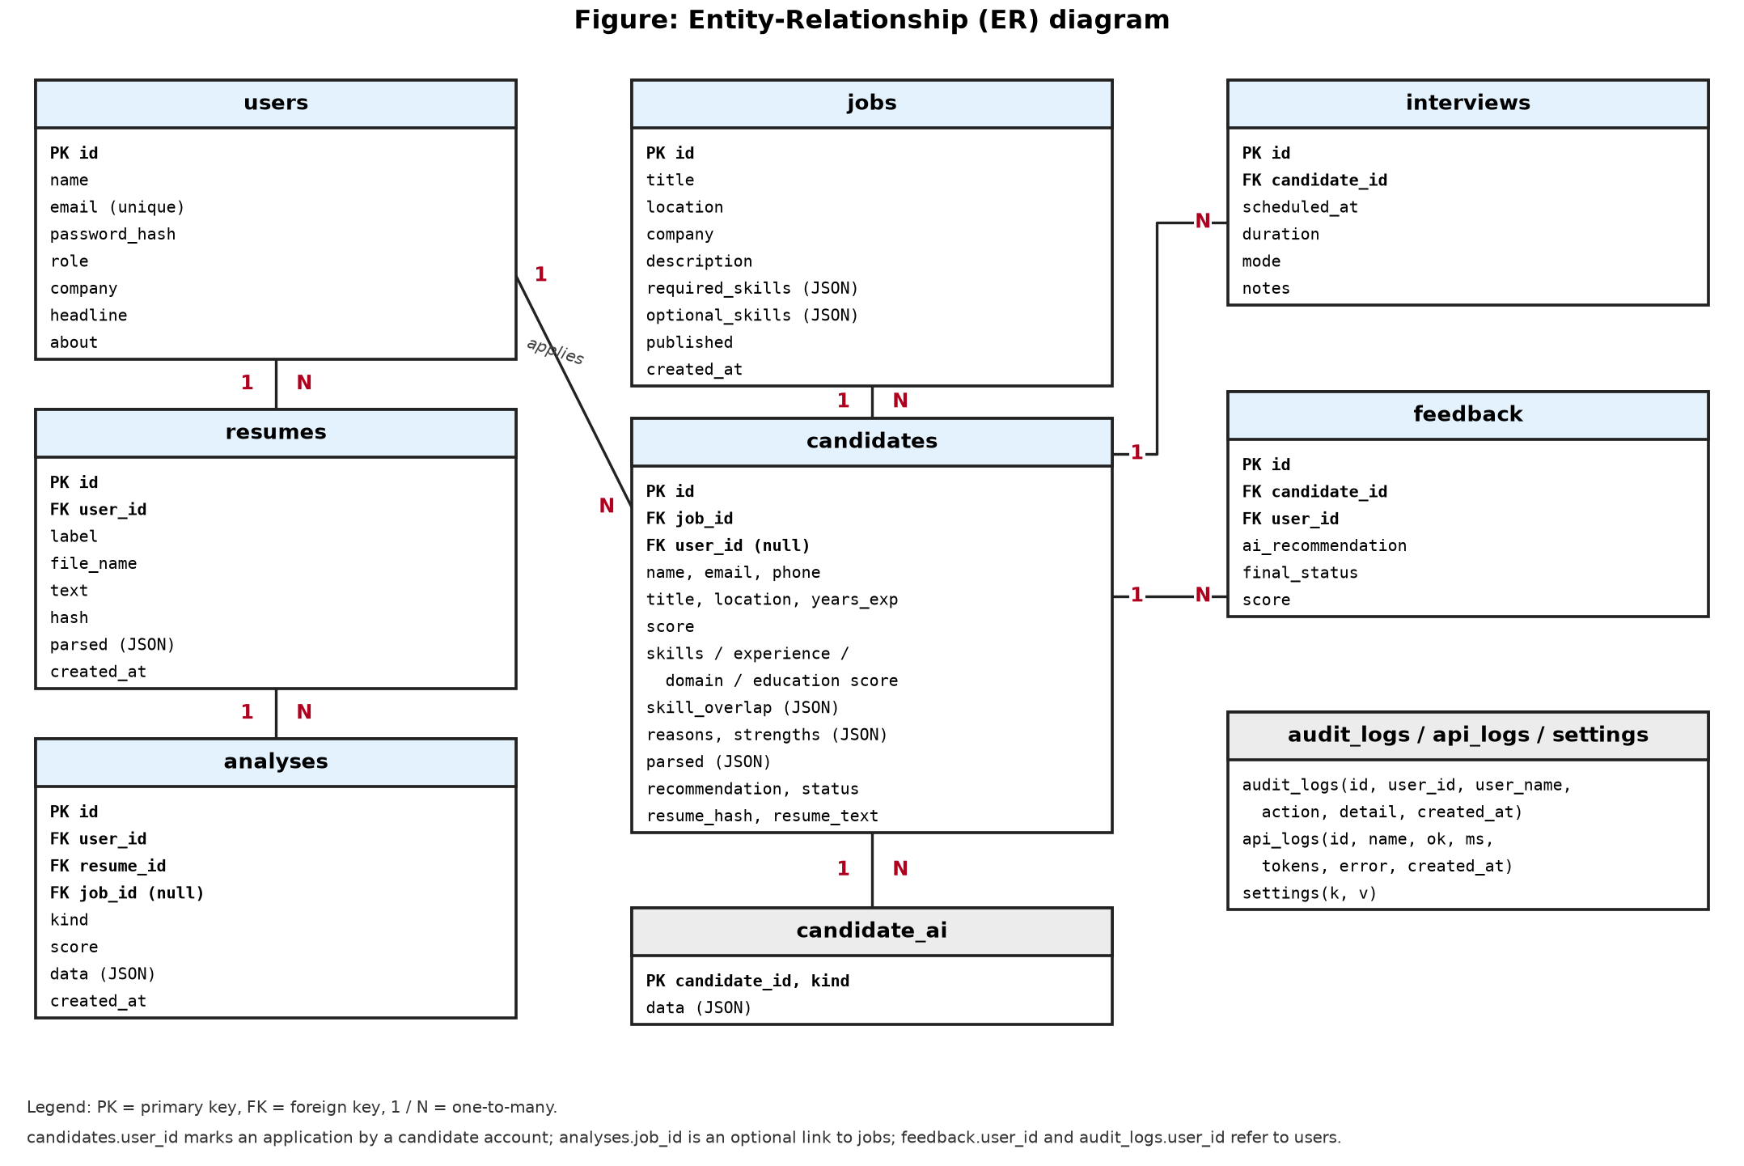
Figure 7.1: ER diagram of the HireSense AI database

6.3 Description of Processes and Data Stores
No. | Process | Description
1.0 | Authentication and access control | Registers users, verifies passwords, creates the session and checks the role on every request.
2.0 | Resume processing | Accepts uploads, extracts text, detects duplicates and stores resume text and structured profiles.
3.0 | Candidate services | ATS report, improvement suggestions, skill gap analysis, version comparison, job board, applications and career assistant.
4.0 | AI screening and matching | Compares resumes with jobs, produces scores, reasons and recommendations, verifies the output and ranks candidates.
5.0 | Interview and scheduling | Generates interview questions, books slots without overlap and drafts invitations.
6.0 | Analytics and administration | Statistics, skills demand, fairness audit, user and job management, API monitoring and audit logs.
Table 6.1: Processes of DFD level 1
Store | Contents
D1 users | Accounts, roles, company and profile details.
D2 jobs | Job descriptions, required and optional skills, publication status.
D3 resumes, candidates, analyses | Resume versions, screened candidates with scores and structured profiles, analysis history.
D4 interviews | Scheduled interviews.
D5 feedback, audit_logs, api_logs, settings | Recruiter feedback, audit trail, AI usage and errors, shortlist threshold.
Table 6.2: Data stores

7.1 Relationships
Relationship | Cardinality | Meaning
users – resumes | 1 : N | A candidate account owns many resume versions.
resumes – analyses | 1 : N | Each resume has many saved analyses (ATS, improvement, skill gap).
jobs – candidates | 1 : N | A job has many screened or applied candidates.
users – candidates | 1 : N (optional) | A candidate account can apply to many jobs; recruiter-screened resumes have no user.
candidates – interviews | 1 : N | A candidate can have scheduled interviews.
candidates – feedback | 1 : N | Every recruiter decision is stored as feedback.
candidates – candidate_ai | 1 : N | Cached AI outputs (skill gap, ATS, questions) per candidate.
Table 7.1: Relationships between entities

7.2 Main Tables
Table | Key columns | Notes
users | id, name, email, password_hash, role, company, headline, about | Roles: admin, recruiter, candidate. Passwords stored as scrypt hashes.
jobs | id, title, location, company, description, required_skills, optional_skills, published | Skill lists are JSON arrays.
candidates | id, job_id, user_id, name, email, score, skills/experience/domain/education score, skill_overlap, reasons, strengths, parsed, recommendation, status, resume_hash | status is Shortlisted, Review or Rejected; resume_hash supports duplicate detection.
resumes | id, user_id, label, file_name, text, hash, parsed | Multiple versions per candidate.
analyses | id, user_id, resume_id, job_id, kind, score, data | Analysis history; kind is ats, improve or gap.
interviews | id, candidate_id, scheduled_at, duration, mode, notes | Overlap check before insert.
feedback | id, candidate_id, user_id, ai_recommendation, final_status, score | Used for feedback learning.
audit_logs, api_logs, settings | action/detail; name/ok/ms/tokens/error; k/v | Monitoring, audit trail and shortlist threshold.
Table 7.2: Main database tables

8. Implementation of Code

8.1 Development Environment
Item | Details
Language / runtime | JavaScript (ES2020+), Node.js 18 or later
Framework | Next.js 14 (App Router) with React 18; frontend and backend in one project
Database | MySQL 8 using the mysql2 driver; database name hireai, tables created automatically
AI service | OpenAI Chat Completions API, model gpt-4o-mini, JSON response format
Libraries | pdf-parse (PDF text extraction), openai, mysql2, next, react, react-dom
Tools | VS Code, Git/GitHub, MySQL Workbench / command-line client, web browser
Table 8.1: Development environment

8.2 Project Structure
AI-Based Recruitment/
├── app/
│ ├── page.js app shell, dashboard, candidate list, match details
│ ├── portal.js candidate portal (resumes, job board, applications, career assistant)
│ ├── admin.js recruiter jobs page and admin console
│ ├── features.js skill gap, ATS view, questions, compare, scheduling, chatbot, analytics
│ ├── ui.js fetch helpers and SVG charts
│ ├── layout.js, globals.css
│ └── api/ login, register, profile, jobs, screen, candidates, ai, chat,
│ interviews, report, blind, resumes, resume-ai, career, board,
│ applications, admin (one route.js each)
├── lib/
│ ├── server.js database, auth, role checks, AI wrapper, parsing, verification
│ ├── prompts.js AI prompts
│ └── sample.js sample data
├── database/sample-data.sql
├── package.json, .env.example, README.md

8.3 Key Parts of the Code
The following excerpts (shortened) show the core logic. They are taken from lib/server.js and from the API routes.
Code 8.1: Hallucination control (lib/server.js)
export function verifyProfile(p, text) {
const hay = text.toLowerCase().replace(/\s+/g, " ");
const has = (s) => !!s && hay.includes(String(s).toLowerCase().trim());
let checked = 0, removed = 0;
const keep = (arr, test) => (Array.isArray(arr) ? arr : []).filter((x) => {
checked++; const ok = test(x); if (!ok) removed++; return ok;
});
return {
profile: {
education: keep(p.education, (e) => has(e?.institution) || has(e?.degree)),
experience: keep(p.experience, (e) => has(e?.company) || has(e?.role)),
technicalSkills: keep(p.technicalSkills, has),
/* projects, certifications, softSkills handled the same way */
},
verification: { checked, removed },
};
}

Code 8.2: Duplicate detection and screening (app/api/screen/route.js)
const h = hashText(text);
const [dup] = await pool.query(
"SELECT name FROM candidates WHERE job_id = ? AND resume_hash = ?", [jobId, h]);
if (dup.length || seen.has(h)) throw new Error("Duplicate resume - skipped");
seen.add(h);
const r = await analyze(job, text);
await insertCandidate(pool, { jobId, fileName, text, r,
status: statusFor(r.score, threshold) });

Code 8.3: Status from threshold and role check (lib/server.js)
export const statusFor = (score, th) =>
score >= th ? "Shortlisted" : score >= th - 20 ? "Review" : "Rejected";

export async function getStaff() {
const u = await getUser();
return u && (u.role === "admin" || u.role === "recruiter") ? u : null;
}

Code 8.4: Job recommendation score (app/api/board/route.js)
const total = req.length * 2 + opt.length;
const got = req.filter(has).length * 2 + opt.filter(has).length;
match = hay && total ? Math.round((got / total) * 100) : null;

Code 8.5: Interview overlap check (app/api/interviews/route.js)
const [clash] = await pool.query(
`SELECT id FROM interviews
WHERE scheduled_at < DATE_ADD(?, INTERVAL ? MINUTE)
AND DATE_ADD(scheduled_at, INTERVAL duration MINUTE) > ?`,
[start, mins, start]);
if (clash.length) return Response.json(
{ error: "That time overlaps another interview." }, { status: 409 });

Code 8.6: Single wrapper for AI calls with usage/error logging (lib/server.js)
export async function callOpenAI(name, params) {
const t = Date.now();
try {
const client = new OpenAI({ apiKey: process.env.OPENAI_API_KEY });
const r = await client.chat.completions.create({ model: "gpt-4o-mini", ...params });
/* log name, duration and tokens to api_logs */
return r;
} catch (e) {
/* log the error to api_logs */
throw e;
}
}

8.4 API Endpoints
Endpoint | Methods | Access | Purpose
/api/login, /api/register | GET, POST, DELETE / POST | Public | Session check, login, logout; sign-up.
/api/profile | PUT | All roles | Update profile / company profile.
/api/jobs | GET, POST, PATCH | Staff | List, create, publish/unpublish jobs.
/api/screen | POST | Staff | Batch screening of resumes for a job.
/api/candidates | GET, PATCH | Staff | Filtered list, details, status change (feedback stored).
/api/ai | POST | Staff | Skill gap, ATS analysis, interview questions per candidate.
/api/chat | POST | Staff | HR chatbot answering from the candidate database.
/api/interviews | GET, POST, DELETE | Staff | Schedule, list and cancel interviews; invitation draft.
/api/report, /api/blind | GET / GET, POST | Staff | CSV report; blind screening switch.
/api/resumes | GET, POST, DELETE | Candidate | Resume versions.
/api/resume-ai | GET, POST | Candidate | ATS report, improvements, skill gap, history.
/api/career | POST | Candidate | Generative career assistant.
/api/board, /api/applications | GET, POST / GET | Candidate | Job recommendations, apply, application status.
/api/admin | GET, PATCH, DELETE | Admin | Statistics, users, jobs, API monitor, audit logs, threshold.
Table 8.2: API endpoints

8.5 Security Measures
- Passwords are hashed with scrypt and a random salt; the session is a signed HttpOnly cookie.
- Every API route verifies the role; candidates cannot call recruiter or admin routes.
- The OpenAI key and database password live only in the server-side .env.local file, which is excluded from Git.
- SQL statements use parameters (prepared values) to prevent SQL injection.
- Blind screening removes names and contact details on the server before data reaches the browser.
- Important actions are written to the audit log.

9. User Interface and Running Model

9.1 How to Run the Model
- Install Node.js 18+ and MySQL 8 and start the MySQL server.
- Copy .env.example to .env.local and set OPENAI_API_KEY and the MYSQL_* values.
- Open a terminal in the project folder and run npm install.
- Run npm run dev and open http://localhost:3000. The database, tables and sample data are created automatically on the first request.
- Sign in with a demo account (below) or register a new candidate or recruiter account.
Role | Email | Password
Administrator | admin@hireai.com | admin123
Recruiter | recruiter@hireai.com | recruiter123
Candidate | candidate@hireai.com | candidate123
Table 9.1: Demo accounts (for local use only; change before any public deployment)

9.2 Application Screens
The screens below show the running model. Paste the screenshots taken from the running application in the marked boxes.
[ Paste screenshot here ]
Figure 9.1: Login and registration screen
[ Paste screenshot here ]
Figure 9.2: Recruiter dashboard with best-match card and statistics
[ Paste screenshot here ]
Figure 9.3: Candidate match details with explainable scores
[ Paste screenshot here ]
Figure 9.4: Skill gap analysis (radar chart) and ATS analysis
[ Paste screenshot here ]
Figure 9.5: Candidate portal – resume versions and job board
[ Paste screenshot here ]
Figure 9.6: Admin console – API monitoring and audit logs

10. Testing
The following test cases are used to verify the running model. The Result column is to be completed with Pass or Fail after executing the tests on the running application.
ID | Test case | Input / action | Expected result | Result
TC1 | Login with wrong password | Valid email, wrong password | Error “Invalid email or password”
TC2 | Access recruiter page as candidate | Candidate session calls /api/jobs | Request refused (401)
TC3 | Upload unsupported file | A .docx or image file | Friendly error; nothing stored
TC4 | Upload same resume twice for a job | Identical PDF | Second copy skipped as duplicate
TC5 | Batch screening | 5 resumes, 1 job | 5 ranked candidates with reasons
TC6 | Hallucination control | Resume lacking a skill the model reports | Unsupported item removed; count shown
TC7 | Overlapping interviews | Two bookings at the same time | Second booking rejected
TC8 | Blind screening | Switch on and open the candidate list | Names/contact details not shown
TC9 | Job application | Candidate applies with a resume | Application appears for the recruiter; status visible to candidate
TC10 | Admin monitoring | Trigger an AI error | Error visible in API monitor and audit log
Table 10.1: Test cases

11. Conclusion
The proposed model and system design of HireSense AI have been described using a block diagram, flowcharts, algorithms, data flow diagrams and an ER diagram, and implemented as a single Next.js application with a MySQL database. The design keeps AI output explainable and verified against the source text, separates the three user roles with access control, and leaves the final hiring decision with a human. The running model, its code and the test cases are submitted for approval by the guide.
Approval by Guide
The proposed model / system design, the implementation of the code and the running model have been reviewed and approved.
Guide name
Signature
Date
Remarks

12. References
[1] Next.js Documentation, Vercel Inc. [Online]. Available: https://nextjs.org/docs
[2] MySQL 8.0 Reference Manual, Oracle Corporation. [Online]. Available: https://dev.mysql.com/doc/
[3] OpenAI API Documentation. [Online]. Available: https://platform.openai.com/docs
[4] pdf-parse package, npm registry. [Online]. Available: https://www.npmjs.com/package/pdf-parse
[5] Equal Employment Opportunity Commission et al., “Uniform Guidelines on Employee Selection Procedures,” 29 C.F.R. Part 1607, 1978.
[6] Project synopsis: “HireSense AI – An AI-Based Resume Screening and Recruitment Assistant” (Synopsis.docx), including the literature references listed there.

