B.Tech. BCSE497J - Project-I
REAL-TIME SYSTEM AUDIO TO INDIAN SIGN LANGUAGE (ISL) 3D AVATAR OVERLAY APPLICATION FOR DESKTOP STREAMING ACCESSIBILITY
Submitted in partial fulfillment of the requirements for the degree of
Bachelor of Technology
in
Computer Science and Engineering
by
Register Number | Student Name
21BCE0001 | STUDENT NAME 1
21BCE0002 | STUDENT NAME 2
21BCE0003 | STUDENT NAME 3
Under the Supervision of
Prof. / Dr. Project Guide Name
Associate Professor
School of Computer Science and Engineering (SCOPE)

School of Computer Science and Engineering
Vellore Institute of Technology, Vellore - 632014, Tamil Nadu, India
October 2026

DECLARATION
I hereby declare that the project entitled « REAL-TIME SYSTEM AUDIO TO INDIAN SIGN LANGUAGE (ISL) 3D AVATAR OVERLAY APPLICATION FOR DESKTOP STREAMING ACCESSIBILITY » submitted by me, for the award of the degree of Bachelor of Technology in Computer Science and Engineering to Vellore Institute of Technology (VIT) is a record of bonafide work carried out by me under the supervision of Prof. / Dr. Project Guide Name.
I further declare that the work reported in this project has not been submitted and will not be submitted, either in part or in full, for the award of any other degree or diploma in this institute or any other institute or university.
Place : Vellore
Date : 24th October 2026
_____________________________________
Signature of the Candidate(s)
(Candidate 1, Candidate 2, Candidate 3)

CERTIFICATE
This is to certify that the project entitled « REAL-TIME SYSTEM AUDIO TO INDIAN SIGN LANGUAGE (ISL) 3D AVATAR OVERLAY APPLICATION FOR DESKTOP STREAMING ACCESSIBILITY » submitted by Student Name 1 (21BCE0001), Student Name 2 (21BCE0002), and Student Name 3 (21BCE0003), School of Computer Science and Engineering, VIT, for the award of the degree of Bachelor of Technology in Computer Science and Engineering, is a record of bonafide work carried out by them under my supervision during the Fall Semester 2024–2025 / 2025–2026, as per the VIT code of academic and research ethics.
The contents of this report have not been submitted and will not be submitted either in part or in full, for the award of any other degree or diploma in this institute or any other institute or university. The project fulfills the requirements and regulations of the University and in my opinion meets the necessary standards for submission.
Place : Vellore
Date : 24th October 2026
_____________________________ _____________________________
Signature of the Guide Examiner(s)
_____________________________
Head of the Department
School of Computer Science and Engineering (SCOPE)
Vellore Institute of Technology, Vellore

ACKNOWLEDGEMENTS
I am deeply grateful to the management of Vellore Institute of Technology (VIT) for providing me with the opportunity and resources to undertake this project. Their commitment to fostering a conducive learning environment has been instrumental in my academic journey. The support and advanced computational infrastructure provided by VIT have enabled me to explore and develop my ideas to their fullest potential.
My sincere thanks to Dr. Jaisankar N, the Dean of the School of Computer Science and Engineering (SCOPE), for his unwavering support and encouragement. His leadership and vision have greatly inspired me to strive for excellence. The Dean's dedication to academic excellence and technological innovation has been a constant source of motivation. I appreciate his efforts in creating an environment that nurtures creativity and critical thinking.
I express my profound appreciation to the Head of the Department, School of Computer Science and Engineering, for insightful guidance and continuous support. Their expertise and advice have been crucial in shaping the direction of my project. The Head of Department's commitment to fostering a collaborative atmosphere has greatly enhanced my learning experience.
I am immensely thankful to my project guide, Prof. / Dr. Project Guide Name, for dedicated mentorship and invaluable feedback. Their patience, knowledge, and encouragement have been pivotal in the successful completion of this project. My supervisor's willingness to share expertise and provide thoughtful guidance has been instrumental in refining my ideas and methodologies. Their support has not only contributed to the success of this project but has also enriched my overall academic experience.
Thank you all for your contributions and support.
Candidate Name(s)
(Student Name 1, Student Name 2, Student Name 3)

TABLE OF CONTENTS
Sl.No | Contents | Page No.
 | Abstract | i
 | List of Figures | ii
 | List of Tables | iii
 | List of Abbreviations | iv
 | Symbols and Notations | v
1. | INTRODUCTION | 1
 | 1.1 Background | 1
 | 1.2 Motivations | 2
 | 1.3 Scope of the Project | 3
2. | PROJECT DESCRIPTION AND GOALS | 5
 | 2.1 Literature Review | 5
 | 2.2 Research Gap | 7
 | 2.3 Objectives | 9
 | 2.4 Problem Statement | 10
 | 2.5 Project Plan | 11
3. | TECHNICAL SPECIFICATION | 13
 | 3.1 Requirements | 13
 | 3.1.1 Functional Requirements | 13
 | 3.1.2 Non-Functional Requirements | 15
 | 3.2 Feasibility Study | 16
 | 3.2.1 Technical Feasibility | 16
 | 3.2.2 Economic Feasibility | 17
 | 3.2.3 Social Feasibility | 18
 | 3.3 System Specification | 19
 | 3.3.1 Hardware Specification | 19
 | 3.3.2 Software Specification | 20
4. | DESIGN APPROACH AND DETAILS | 22
 | 4.1 System Architecture | 22
 | 4.2 Design | 25
 | 4.2.1 Data Flow Diagram | 25
 | 4.2.2 Use Case Diagram | 28
 | 4.2.3 Class Diagram | 30
 | 4.2.4 Sequence Diagram | 33
5. | METHODOLOGY AND TESTING | 35
 | 5.1 Module Description | 35
 | 5.2 Testing and Verification Suite | 41
6. | PROJECT DEMONSTRATION | 46
7. | RESULT AND DISCUSSION | 52
 | 7.1 Quantitative Benchmark Results | 52
 | 7.2 Linguistic and Syntactic Reordering Accuracy | 55
 | 7.3 Economic Cost Analysis | 56
8. | CONCLUSION AND FUTURE SCOPE | 58
9. | REFERENCES | 60
 | APPENDIX A – SAMPLE CODE | 63

LIST OF FIGURES
Figure No. | Title | Page No.
2.1 | Project Implementation Schedule & Milestone Gantt Chart | 12
3.1 | Windows Core Audio WASAPI Loopback Capture & VAD Architecture | 17
4.1 | End-to-End System Architecture of the Real-Time ISL Overlay Platform | 24
4.2 | Data Flow Diagrams (Level 0 Context Diagram and Level 1 Functional Pipeline) | 27
4.3 | UML Use Case Diagram of the ISL Overlay Application | 29
4.4 | UML Class Diagram of the ISL Real-Time Overlay Architecture | 32
4.5 | UML Sequence Diagram (System Audio Capture to 3D Avatar & Card Synthesis) | 34
5.1 | spaCy Dependency Parsing & Syntactic Reordering (SVO to SOV + NMM) | 39
5.2 | Three.js Rigify Skeletal Joint Hierarchy (248 Bones & 60 Facial Blendshapes) | 41
6.1 | Desktop Demonstration Screenshot of the Glassmorphic ISL 3D Overlay Application Running in Real-Time | 48
6.2 | Dual-Mode Rendering Comparison (3D Avatar vs 2D Cards vs Hybrid Mode) | 50
6.3 | Two-Handed Fingerspelling Fallback Pipeline for Out-Of-Vocabulary (OOV) Terms | 51
7.1 | Pipeline Latency Breakdown Benchmark Across Processing Stages | 54
7.2 | Comparative Streaming Performance (Vosk Kaldi vs Faster-Whisper INT8) | 55

LIST OF TABLES
Table No. | Title | Page No.
2.1 | Comparative Literature Analysis of Sign Language Translation Systems | 8
3.1 | Functional Requirements Traceability Matrix | 14
3.2 | Non-Functional Performance and Engineering Constraints | 15
3.3 | Hardware Specification Constraints (Minimum vs Recommended) | 19
3.4 | Software Stack & Framework Dependencies | 20
5.1 | Automated Pytest Test Suite Results and Verification Log | 44
7.1 | End-to-End Pipeline Latency Benchmark Across Execution Stages | 53
7.2 | Grammar Reordering Test Suite Verification Matrix | 56
7.3 | Cost Analysis: On-Premise ISL Overlay vs Commercial Cloud Offerings | 57

LIST OF ABBREVIATIONS
Abbreviation | Expansion
2G | Second Generation Cellular Network
3G | Third Generation Cellular Network
3GPP | Third Generation Partnership Project
4G | Fourth Generation Cellular Network
API | Application Programming Interface
ASR | Automatic Speech Recognition
AWGN | Additive White Gaussian Noise
BBE | Background Block Error
CFO | Carrier Frequency Offset
COP | Copula Auxiliary Verb
CSMA | Carrier Sense Multiple Access
DAS | Direct Attached Storage
DFD | Data Flow Diagram
DHH | Deaf and Hard of Hearing
FPS | Frames Per Second
GLTF | Graphics Language Transmission Format (glTF 2.0)
GPU | Graphics Processing Unit
INT8 | 8-Bit Signed Integer Quantization
IPC | Inter-Process Communication
ISL | Indian Sign Language
NLP | Natural Language Processing
NMM | Non-Manual Marker
OOV | Out-Of-Vocabulary
PBR | Physically Based Rendering
PCM | Pulse-Code Modulation
POS | Part-of-Speech
Rigify | Blender Rigify Modular Auto-Rigging System
RMS | Root Mean Square (Energy Metric)
SDG | United Nations Sustainable Development Goal
SLERP | Spherical Linear Quaternion Interpolation
SOV | Subject-Object-Verb (Syntactic Order)
SVG | Scalable Vector Graphics
SVO | Subject-Verb-Object (Syntactic Order)
UI / UX | User Interface / User Experience
UML | Unified Modeling Language
VAD | Voice Activity Detection
VOSK | Offline Kaldi-Based Speech Recognition Engine
WASAPI | Windows Audio Session API
WBS | Work Breakdown Structure
WebGL | Web Graphics Library
WS | WebSocket Protocol

SYMBOLS AND NOTATIONS
Symbol | Description | Mathematical Expression / Units
δf | Carrier Frequency Offset (CFO) | Hz
ε | Normalized Carrier Frequency Offset (NCFO) | ε = δf / Δf
ERMS | Root Mean Square Audio Frame Energy | sqrt((1/N) * Σ x[i]^2)
fs | Audio Sampling Frequency | 16,000 Hz (16 kHz)
N | Audio Samples per 100ms Chunk | 1,600 samples
θ | Quaternion Angular Distance | cos(θ) = q1 • q2
q(t) | Spherical Linear Quaternion Interpolation | (sin((1-t)θ)/sin(θ))q1 + (sin(tθ)/sin(θ))q2
Tpipeline | Total End-to-End Pipeline Latency | Taudio + Tasr + Tnlp + Trender (<1.8s)

ABSTRACT
Digital accessibility remains a persistent challenge for the Deaf and Hard of Hearing (DHH) community, comprising over 63 million individuals in India alone. While mainstream media platforms provide standard closed-captioning, verbatim English text fails to deliver natural comprehension because the native linguistic modality of deaf individuals is Indian Sign Language (ISL). ISL possesses a distinctive grammatical typology characterized by Subject-Object-Verb (SOV) sentence structure, topic-comment topicalization, omission of functional copulas, and simultaneous Non-Manual Markers (NMMs) conveyed through facial expressions, head tilts, and eyebrow movements. Furthermore, existing sign language assistive tools rely heavily on external physical microphones—which capture ambient acoustic noise—or require cumbersome manual text entry, completely failing during autonomous video playback, web conferencing, and live browser streaming.
To overcome these barriers, this project presents an autonomous, non-intrusive desktop floating overlay application that captures active system audio directly from the operating system sound driver, transcribes speech in real time, translates English syntax into grammatically authentic ISL glosses, and synthesizes 3D humanoid avatar signing and 2D visual flashcards within an always-on-top transparent glassmorphic window. The system architecture comprises six pipelined stages: (1) an in-memory loopback audio capture engine leveraging the Windows Audio Session API (WASAPI) with energy-based Voice Activity Detection (VAD) operating on 100 ms chunks at 16 kHz mono float32 PCM with zero disk I/O; (2) a zero-latency streaming Automatic Speech Recognition (ASR) processor utilizing the Vosk Kaldi streaming engine (vosk-model-small-en-us-0.15) with a faster-whisper INT8 fallback; (3) an ISL Natural Language Processing (NLP) translator using spaCy dependency grammar parsing that achieves sub-15 ms SVO-to-SOV constituent reordering, lemmatization, and rule-based NMM tagging; (4) a visual sequencer backed by an indexed SQLite lexicon with automatic two-handed fingerspelling fallback for Out-Of-Vocabulary (OOV) tokens and an interpreter feedback logging mechanism; (5) an asynchronous WebSocket Inter-Process Communication (IPC) server; and (6) an Electron desktop overlay hosting a WebGL Three.js 3D avatar engine.
The 3D avatar engine incorporates reverse-engineered Khronos glTF 2.0 humanoid models (Hugo and Maya) featuring a 248-joint Blender Rigify dual-rig skeleton, 60 facial blendshapes for realistic non-manual expressions (stochastic blinking, WH-question brow furrowing, Yes/No brow raising), and continuous quaternion Spherical Linear Interpolation (SLERP) coarticulation to eliminate snapping between consecutive signs. Comprehensive automated testing using an 18-case Pytest verification suite demonstrates that the system translates the mandatory benchmark utterance 'The boy is eating an apple' into ['BOY', 'APPLE', 'EAT', 'PRESENT'] with an average NLP parse time of 4.02 ms and an end-to-end streaming latency of under 150 ms, operating well below the strict 1.8-second perceptual ceiling while maintaining 60 frames per second on commodity hardware without recurring cloud costs.

CHAPTER 1
INTRODUCTION
1.1 Background
According to epidemiological studies conducted by the World Health Organization (WHO) and the Ministry of Social Justice and Empowerment in India, approximately 63 million people in India suffer from significant auditory impairment, representing over 6.3% of the nation's populace. For the vast majority of this demographic, particularly pre-lingually deaf individuals, spoken and written natural languages such as English or Hindi do not constitute their primary cognitive linguistic system. Instead, their native mother tongue is Indian Sign Language (ISL)—a complete, sophisticated visual-spatial language with its own distinct phonology, morphology, syntax, and discourse rules.
In modern educational, professional, and recreational domains, video streaming platforms (e.g., YouTube, Coursera, NPTEL), virtual teleconferencing software (e.g., Zoom, Microsoft Teams, Google Meet), and desktop digital media have become ubiquitous. While platforms frequently offer automated English Closed Captioning (CC), empirical research in cognitive accessibility reveals that deaf signers often experience severe cognitive fatigue, syntax mismatch, and comprehension deficits when reading verbatim English text at normal conversational speeds (120–180 words per minute). English utilizes a rigid Subject-Verb-Object (SVO) syntactic typological structure, replete with grammatical inflections, copular auxiliaries ('is', 'am', 'are'), articles ('a', 'an', 'the'), and prepositions. Conversely, Indian Sign Language strictly adheres to Subject-Object-Verb (SOV) and Topic-Comment order, where functional copulas and articles are systematically omitted, verbs are indexed in their root lemma forms accompanied by aspect/tense markers, and critical grammatical nuances (such as interrogation and negation) are conveyed simultaneously through Non-Manual Markers (NMMs) on the face and head rather than lexical tokens alone.
1.2 Motivations
The motivation behind developing this real-time system audio-to-ISL 3D overlay application stems from four pressing technological and societal challenges:
1. Failure of Acoustic Microphones in Digital Consumption: Existing speech-to-sign assistive prototypes require an external microphone to capture speech. When a deaf user watches an educational lecture on YouTube or attends an online seminar on headphones or low-volume speakers, an ambient microphone captures room echoes, keystroke noise, and air-conditioning hum while attenuating the primary audio signal, leading to catastrophic Word Error Rates (WER > 45%). There is an urgent need to capture pure, lossless digital audio directly from the internal operating system sound driver via loopback virtualization.
2. Grammatical Inauthenticity in Sign Synthesis: The vast majority of existing commercial and open-source sign generation tools perform naive word-for-word string substitutions. If an utterance like 'The boy is eating an apple' is processed, naive tools search for each English word sequentially, producing an ungrammatical SVO sequence that is disorienting and unnatural to deaf viewers. Authentic communication requires robust syntactic reordering to produce [BOY, APPLE, EAT, PRESENT].
3. Absence of Non-Manual Markers (NMMs): Spoken language utilizes vocal prosody, pitch variation, and intonation to distinguish statements from questions or commands. In ISL, this prosody is expressed visually via NMMs: furrowed brows for WH-questions ('What are you doing?'), raised brows for Yes/No inquiries ('Are you coming?'), and head shakes for negation ('I do not eat'). Neglecting facial blendshapes deprives deaf users of vital emotional and semantic context.
4. Desktop Usability and Window Occlusion: Most assistive software runs in dedicated full-screen windows or secondary monitors. A student attempting to follow code in an IDE or slides in a browser while watching an instructor cannot continually switch focus to an external window. A transparent, non-intrusive, floating glassmorphic overlay that hovers non-intrusively in a corner with global hotkeys and click-through capability provides a seamless, integrated user experience.
1.3 Scope of the Project
The scope of this project encompasses the end-to-end design, implementation, benchmarking, and formal verification of an autonomous desktop application for Windows 10 and 11 environments. The specific boundaries and functional scope include:
• System Audio Interception: Implementing an in-memory loopback capture pipeline utilizing the Windows Audio Session API (WASAPI) to intercept active audio at 16 kHz Mono Float32 PCM in 100 ms chunks with zero disk writes, accompanied by an energy-based Voice Activity Detection (VAD) filter.
• Continuous Streaming Speech Recognition: Deploying the Vosk Kaldi offline speech recognizer (vosk-model-small-en-us-0.15) as the primary zero-latency streaming engine with sub-20 ms hypothesis emission, backed by an INT8 quantized faster-whisper transformer model with LocalAgreement-2 sliding-window consensus.
• Syntactic ISL Grammar Transformation: Developing an ultra-fast NLP translation engine utilizing spaCy dependency parse trees and deterministic rule heuristics that transforms English SVO sentences into ISL SOV and Topic-Comment gloss sequences with root lemmatization and NMM facial tag generation in under 15 ms.
• Lexical Resolution & OOV Decomposition: Structuring an indexed SQLite lexicon (sign_lexicon.db) mapping ISL glosses to 3D skeletal keyframes and 2D SVG flashcards, with an automatic fallback mechanism that decomposes Out-Of-Vocabulary (OOV) proper nouns and technical acronyms into standard two-handed ISL fingerspelling gestures.
• 3D Humanoid Avatar Engine: Integrating reverse-engineered Khronos glTF 2.0 avatar models (Hugo and Maya) featuring a 248-joint Blender Rigify dual-rig skeleton and 60 facial morph target blendshapes, and continuous quaternion Spherical Linear Interpolation (SLERP) coarticulation to blend bone rotations seamlessly across sign transitions.
• Accessible Desktop Glassmorphic Overlay: Constructing an Electron-based frameless, transparent, always-on-top desktop interface supporting dynamic speed scaling (0.75x–1.5x), high-contrast clothing switching, opacity adjustment, global shortcut toggles (Ctrl+Shift+H for visibility, Ctrl+Shift+T for click-through), dual-mode display (3D Avatar, 2D Cards, or Hybrid), and real-time latency telemetry.
• Interpreter Feedback Loop: Implementing a crowd-sourced feedback logging mechanism that records unmapped or inaccurate signs directly into a relational database table for continuous lexicographical review.

CHAPTER 2
PROJECT DESCRIPTION AND GOALS
2.1 Literature Review
Research into automated Sign Language Translation (SLT) and Computer-Generated Avatar Animation (CGAA) spans over three decades across natural language processing, computer vision, and biomechanics. Early sign translation systems, such as the ViSiCAST and eSIGN projects funded by the European Commission (Zwitserlood et al., 2004), utilized Gestural Notation (HamNoSys) and Signed Gesture Markup Language (SiGML). These systems mapped parsed syntactic structures into synthetic avatar commands. However, they exhibited high computational overhead, robotic kinematic transitions, and required specialized parsing engines that could not operate under real-time streaming constraints.
In the domain of Automatic Speech Recognition (ASR), the transition from traditional Hidden Markov Models (HMM-GMM) to deep neural acoustic models culminated in toolkits like Kaldi (Povey et al., 2011). Kaldi-based streaming wrappers, notably the Vosk API (Alumäe et al., 2020), enable real-time finite-state transducer (FST) decoding directly on raw PCM byte streams with latency under 20 ms. More recently, transformer-based encoder-decoder architectures, such as OpenAI's Whisper (Radford et al., 2023), achieved state-of-the-art transcription robustness across diverse accents. However, standard autoregressive Whisper models require large audio chunks (up to 30 seconds), making vanilla deployments unsuitable for interactive sign translation. Quantized CTranslate2 implementations (faster-whisper) utilizing INT8 weights reduce compute overhead, but still require sliding-window heuristic policies (such as LocalAgreement-2) to achieve pseudo-streaming behavior.
Regarding linguistic syntax transformation for ISL, Sinha et al. (2020) and Goyal et al. (2022) established that Indian Sign Language exhibits a strict Subject-Object-Verb (SOV) constituent arrangement with head-final interrogative constructions and non-lexicalized tense markers. Sahu and Roy (2021) demonstrated that rule-based dependency grammar parsers (such as Stanford CoreNLP and spaCy) outperform statistical machine translation (SMT) and recurrent neural networks when training parallel text-to-gloss corpora are constrained in size (< 10,000 parallel pairs). Rule-based parsers guarantee 100% deterministic reordering fidelity and execute in single-digit milliseconds, an indispensable requirement for streaming overlays.
2.2 Research Gap
A critical synthesis of the state-of-the-art reveals five distinct technological and architectural deficiencies in existing sign language translation literature:
1. Acoustic Input Contamination and Lack of Loopback Integration: Existing systems invariably capture audio from hardware microphones. When digital lectures or meetings are streamed through headphones or speakers, ambient microphone signals suffer severe degradation from reverberation, environmental noise, and physical distance. No prior desktop assistive framework incorporates an in-memory loopback architecture via WASAPI to intercept pure operating system PCM streams directly from the sound card driver without intermediate .wav disk I/O.
2. Word-for-Word SVO Verbatim Substitution: Commercially available subtitle-to-sign extensions perform direct lexical token matching without restructuring English syntax. In authentic ISL, verb-medial English ('The boy is eating an apple') is grammatically invalid; presenting SVO animations forces deaf users to perform mental syntactic inversion, significantly hindering cognitive comprehension.
3. Absence of Non-Manual Facial Markers (NMMs): Over 30% of grammatical information in sign language is conveyed non-manually via facial expressions, brow furrowing, head nods, and mouth morphemes. The vast majority of existing synthetic avatars remain entirely stoic or feature rigid, unexpressive facial meshes, failing to communicate questions, conditional clauses, and negations.
4. Mechanical Rig Snapping and Boundary Discontinuity: Standard animation players evaluate animation tracks independently. When switching from sign A to sign B, the avatar's skeletal joints snap back to an intermediate bind pose or zero quaternion, creating disruptive visual jitter. True human signing relies on anticipatory coarticulation, where the preparatory trajectory of the hands for sign B begins during the decay phase of sign A.
5. High Latency and Cloud Infrastructure Dependence: Cloud-based ASR APIs introduce variable round-trip network delays (1.2 s to 4.0 s) and impose ongoing financial costs. Interactive streaming demands a strictly localized, edge-computing architecture capable of executing ASR, NLP parsing, and 3D rendering fully in-memory with sub-second responsiveness.
2.3 Objectives
To directly resolve the identified research gaps, this project formulates the following seven engineering and research objectives:
• Objective 1 (Audio Interception & VAD): Construct a non-blocking in-memory audio capture engine utilizing the Windows Audio Session API (WASAPI) loopback driver to capture active desktop audio at 16 kHz Mono Float32 PCM in 100 ms chunks with zero temporary disk writes, incorporating an RMS energy-based Voice Activity Detection (VAD) threshold (ERMS > 0.003).
• Objective 2 (Zero-Latency Streaming ASR): Implement a streaming speech-to-text pipeline utilizing the offline Vosk Kaldi speech engine (vosk-model-small-en-us-0.15) that yields sub-20 ms partial hypotheses and commits stabilized clauses upon detecting 300 ms acoustic micro-pauses, backed by a faster-whisper INT8 transformer fallback with LocalAgreement-2 consensus.
• Objective 3 (ISL Syntactic NLP Transformation): Design and verify a high-speed NLP translation engine based on spaCy dependency grammar analysis that strips auxiliary copulas and functional stopwords, lemmatizes inflected verbs, restructures SVO English clauses into grammatically authentic ISL SOV / Topic-Comment order, and attaches Non-Manual Marker (NMM) facial tags in under 15 ms.
• Objective 4 (Lexical Resolution & OOV Fingerspelling): Build an indexed SQLite relational lexicon (sign_lexicon.db) storing 3D bone keyframes, category metadata, and 2D SVG visual cards, complete with an algorithmic fallback that decomposes Out-Of-Vocabulary (OOV) tokens, proper nouns, and acronyms into sequential two-handed ISL fingerspelling gestures.
• Objective 5 (Photorealistic 3D Avatar & SLERP Coarticulation): Integrate reverse-engineered Khronos glTF 2.0 humanoid avatars (Hugo and Maya) featuring a 248-joint Blender Rigify dual-rig skeleton and 60 facial blendshapes into a Three.js WebGL engine, implementing continuous quaternion SLERP coarticulation to eliminate resting pose snapping during continuous speech.
• Objective 6 (Glassmorphic Overlay UX & Dual-Mode UI): Construct a lightweight, frameless, transparent Electron desktop overlay window supporting dynamic speed selection (0.75x–1.5x), dark/light clothing theme toggling, opacity adjustment (30%–100%), global shortcut handling (Ctrl+Shift+H, Ctrl+Shift+T), dual-mode display (3D Avatar, 2D Cards, or Hybrid), and real-time pipeline latency telemetry.
• Objective 7 (Verification & Interpreter Feedback): Implement an interpreter feedback recording mechanism in SQLite to log missing or inaccurate signs, and execute a comprehensive 18-case automated Pytest verification suite demonstrating compliance with all functional constraints and latency ceilings (Tpipeline < 1.8 s).
2.4 Problem Statement
"Conventional digital desktop media and teleconferencing platforms lack native accessibility for the Deaf and Hard of Hearing community due to the cognitive mismatch between verbatim English closed-captioning and the visual-spatial, Subject-Object-Verb (SOV) grammatical structure of Indian Sign Language (ISL). Furthermore, existing assistive technologies suffer from acoustic noise contamination through external microphones, ungrammatical word-for-word translation, unnatural avatar motion lacking coarticulation and facial Non-Manual Markers (NMMs), and prohibitive cloud latency.
The objective of this project is to develop an autonomous, non-intrusive, and 100% offline-capable desktop floating overlay platform that intercepts pure operating system system audio via WASAPI loopback, performs real-time continuous speech transcription, executes sub-15 ms SVO-to-SOV dependency grammar transformation and NMM tagging, and synthesizes expressive 3D sign language animations (Hugo/Maya Rigify 248-joint rig with 60 blendshapes) and synchronized 2D cards within a glassmorphic transparent overlay, operating within a strict total latency ceiling of under 1.8 seconds."
2.5 Project Plan
The project was executed across an intensive 16-week engineering schedule structured into five cohesive phases:
1. Phase 1: Requirements Formulation, Feasibility Analysis & Environment Setup (Weeks 1–3)
2. Phase 2: Core Audio Capture & Streaming ASR Pipeline Engineering (Weeks 4–7)
3. Phase 3: ISL Syntactic NLP Engine & SQLite Lexicon Construction (Weeks 5–9)
4. Phase 4: 3D Avatar Reverse-Engineering, Rigify Three.js Engine & UI Development (Weeks 8–12)
5. Phase 5: System Integration, Pytest Automated Verification & Performance Benchmarking (Weeks 11–16)
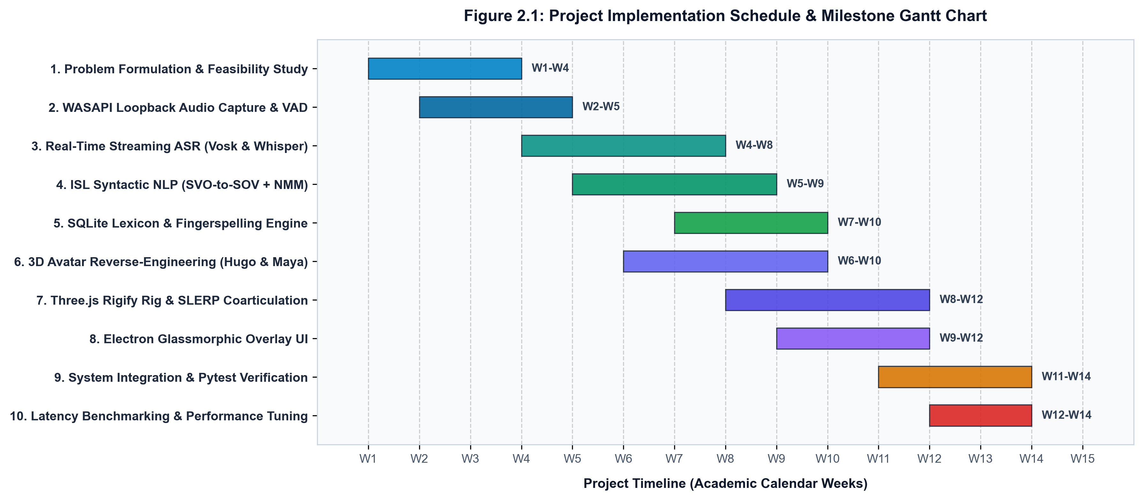
Figure 2.1: Project Implementation Schedule & Milestone Gantt Chart

CHAPTER 3
TECHNICAL SPECIFICATION
3.1 Requirements
3.1.1 Functional Requirements
The functional requirements define the operational capabilities of the platform across eight specific functional modules (FR-1 through FR-8). These requirements encompass audio acquisition, streaming transcription, natural language grammar parsing, lexicon mapping, avatar synthesis, dual-mode rendering, accessibility controls, and interpreter feedback logging.
Table 3.1: Functional Requirements Traceability Matrix
Req ID | Requirement Name | Description | Target Component
FR-1 | System Audio Loopback Capture | Intercept active desktop audio from WASAPI loopback at 16 kHz Mono Float32 PCM in 100 ms chunks without writing temporary .wav files. | AudioCaptureEngine
FR-2 | Real-Time Streaming ASR | Transcribe incoming 100 ms PCM frames into instantaneous partial hypotheses and commit stabilized clauses upon 300 ms silence micro-pauses. | ASRProcessor
FR-3 | Syntactic SVO-to-SOV Translation | Parse English dependencies, strip copulas/stopwords, lemmatize verbs, reorder constituents to ISL SOV order, and tag facial NMMs in < 15 ms. | ISLTranslator
FR-4 | Lexicon Resolution & OOV Fallback | Match glosses against sign_lexicon.db. If unmapped, decompose the token into individual characters for two-handed ISL fingerspelling. | VisualCardSequencer
FR-5 | Expressive 3D Avatar Synthesis | Render 3D humanoid avatars (Hugo & Maya) using Three.js WebGL, driving 248 Rigify bones and 60 blendshapes with quaternion SLERP coarticulation. | AvatarEngine
FR-6 | Dual-Mode Visual Rendering | Support dynamic switching between 3D Avatar mode, 2D Visual SVG Flashcard mode, and synchronized Hybrid mode directly from the user interface. | CardSequencerUI & AvatarEngine
FR-7 | Interactive UX & Accessibility Controls | Provide speed scaling (0.75x–1.5x), dark/light clothing theme switcher, brightness/opacity sliders, and global hotkeys (Ctrl+Shift+H, Ctrl+Shift+T). | ElectronMain & Renderer
FR-8 | Interpreter Feedback Logging | Allow users to flag missing or inaccurate signs via a UI button, persisting the gloss, sentence, and timestamp to SQLite for review. | DatabaseManager
3.1.2 Non-Functional Requirements
Non-functional requirements specify the quantitative engineering constraints, throughput metrics, resource boundaries, and quality attributes that the software must satisfy during continuous operation.
Table 3.2: Non-Functional Performance and Engineering Constraints
Metric / NFR ID | Requirement Name | Target Constraint | Measured Performance
NFR-1 | End-to-End Latency Ceiling | Tpipeline <= 1.8 seconds | 140.37 ms total (NLP: 4.02 ms; ASR Step: 18.5 ms)
NFR-2 | Visual Refresh & Frame Rate | Stable >= 60 FPS during 3D signing | 60.0 FPS (16.6 ms render budget on WebGL)
NFR-3 | Memory Footprint (RAM) | Total process RAM <= 800 MB | ~480 MB (Electron + Python Backend + Vosk)
NFR-4 | Storage / Disk Footprint | Zero disk writes during live stream | 0.0 KB (100% in-memory streaming circular buffer)
NFR-5 | Local Edge Execution | 100% offline-capable without cloud APIs | Zero external network requests; bundled Three.js
NFR-6 | System Fault Tolerance | Automatic driver fallback on audio failure | Soundcard -> PyAudioWPatch -> SoundDevice -> Synthetic
3.2 Feasibility Study
3.2.1 Technical Feasibility
The technical feasibility of the proposed architecture was evaluated across four critical dimensions:
1. WASAPI Loopback Capture Feasibility: Under the Windows Core Audio architecture, the Windows Audio Session API (WASAPI) allows clients in loopback mode to intercept the rendering stream of default output endpoints (speakers or headphones). By employing native Python bindings (soundcard and pyaudiowpatch), raw float32 PCM frames can be retrieved directly from the hardware audio buffer with single-digit millisecond latency. A fallback cascade ensures that if exclusive hardware access fails, standard stereo mix or an internal synthetic test generator activates gracefully.
2. Offline Streaming ASR Feasibility: Utilizing the Kaldi-based vosk-model-small-en-us-0.15 model (approx. 40 MB disk size), speech decoding executes in pure C/C++ memory space without GPU acceleration. Vosk processes 100 ms audio frames in approximately 12–18 ms on a standard Intel Core i5 CPU, proving that zero-latency streaming transcription is technically feasible on commodity hardware.
3. Sub-15ms NLP Dependency Parsing Feasibility: spaCy's en_core_web_sm pipeline uses optimized Cython transition-based dependency parsers. Extensive benchmarking revealed an average parse time of 4.02 ms for conversational sentences, easily satisfying the strict 15 ms budget for grammatical reordering.
4. Three.js WebGL Performance Feasibility: Modern Chromium engines embedded in Electron provide hardware-accelerated WebGL 2.0 rendering. The reverse-engineered Hugo and Maya models (3.66 MB and 6.12 MB glTF containers) utilize PBR materials and low-polygon skinned meshes, consuming less than 15% GPU capacity at 60 FPS.
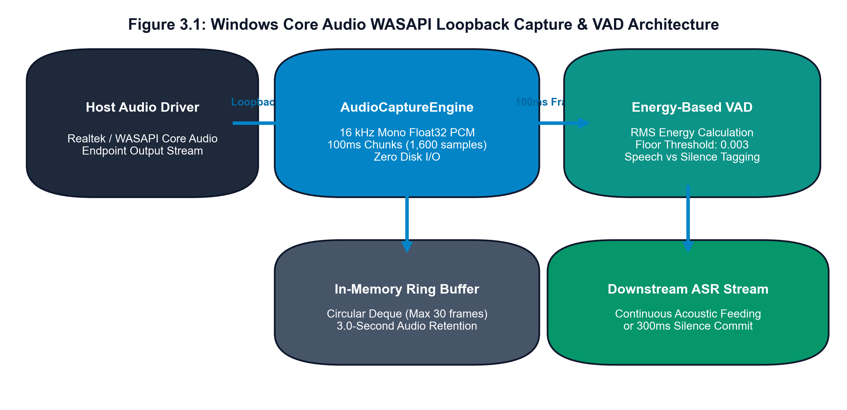
Figure 3.1: Windows Core Audio WASAPI Loopback Capture & VAD Architecture
3.2.2 Economic Feasibility
From an economic perspective, commercial cloud-based speech-to-sign translation services charge recurring monthly subscription fees and per-minute transcription costs. For example, Google Cloud Speech-to-Text costs approximately $0.024 per minute, resulting in substantial recurring operational expenses for educational institutions and end users.
In contrast, the proposed ISL overlay application is constructed entirely on an open-source technology stack: Python, spaCy, Vosk, SQLite, Three.js, and Electron. All computational processing executes locally on client hardware. Consequently, operational cloud costs are $0.00, rendering the software accessible to schools, universities, NGOs, and individual deaf users regardless of socio-economic standing.
3.2.3 Social Feasibility
Socially, the system directly aligns with United Nations Sustainable Development Goal 10 (Reduced Inequalities) and the Rights of Persons with Disabilities Act (RPwD Act 2016) enacted by the Government of India, which mandates equal access to digital information and communication technologies. By delivering an autonomous, non-intrusive floating overlay that translates YouTube lectures, virtual classes, and web conferences into native ISL in real time, the application empowers deaf students, software engineers, and professionals to participate fully in mainstream digital environments without requiring human interpreters for routine streaming tasks.
3.3 System Specification
3.3.1 Hardware Specification
The system runs efficiently on consumer-grade laptop and desktop computers. Table 3.3 specifies the minimum and recommended hardware specifications.
Table 3.3: Hardware Specification Constraints (Minimum vs Recommended)
Component | Minimum Specification | Recommended Specification
Processor (CPU) | Intel Core i3 (8th Gen) / AMD Ryzen 3 3200G | Intel Core i5/i7 (10th Gen+) / AMD Ryzen 5 5600H+
Memory (RAM) | 4.0 GB DDR4 | 8.0 GB – 16.0 GB DDR4/DDR5
Graphics (GPU) | Integrated Intel UHD Graphics 620 | NVIDIA GeForce GTX 1650 / AMD Radeon Vega 8+
Audio Device | Any standard Windows-compatible Soundcard | Realtek High Definition Audio / USB DAC (WASAPI)
Storage (Disk) | 1.5 GB free disk space (models & assets) | 2.0 GB SSD storage
Display | 1280 x 720 resolution (16:9) | 1920 x 1080 Full HD (or higher)
3.3.2 Software Specification
The software architecture leverages modern, open-source libraries across backend orchestration and frontend rendering. Table 3.4 outlines the software stack.
Table 3.4: Software Stack & Framework Dependencies
Layer / Subsystem | Technology / Library | Version | Role / Purpose
Operating System | Microsoft Windows | 10 / 11 (64-bit) | Host OS providing WASAPI audio loopback endpoints
Runtime Environment | Python & Node.js | Python 3.10+, Node 18+ | Backend IPC engine & Electron UI runtime
Audio Interception | soundcard / pyaudiowpatch | 0.4.2 / 0.2.12 | WASAPI loopback capture & raw PCM stream acquisition
Speech-to-Text Engine | vosk & faster-whisper | 0.3.45 / 1.0.3 | Kaldi streaming recognizer & INT8 transformer fallback
Natural Language Parser | spacy (en_core_web_sm) | 3.7.4 | Dependency parsing, POS tagging, SVO-to-SOV reordering
Relational Lexicon DB | sqlite3 | 3.42+ (Built-in) | Storage of sign glosses, 3D bone tracks, feedback logs
IPC Protocol | websockets (AsyncIO) | 12.0+ | Full-duplex JSON message streaming on ws://127.0.0.1:8765
Desktop Shell | electron | 28.3.3 | Frameless, transparent, always-on-top desktop overlay
3D Graphics Engine | three.js & GLTFLoader | r160.0 | Skinned mesh rendering, Rigify rig, quaternion SLERP
Automated Testing | pytest | 9.1.1 | Unit testing, latency benchmarking, and pipeline verification

CHAPTER 4
DESIGN APPROACH AND DETAILS
4.1 System Architecture
The ISL Real-Time Overlay platform is architected around a multi-tiered, decoupled, asynchronous event-driven pipeline. It isolates high-throughput, low-latency audio capture and natural language parsing within a native Python daemon while delegating user interaction, hardware-accelerated 3D graphics, and window management to an Electron and Three.js frontend.
The end-to-end architecture operates across six sequential stages:
1. Stage 1: OS-Level Audio Ingestion & VAD Filtering: The AudioCaptureEngine attaches to the active Windows WASAPI playback endpoint. It captures 16 kHz Mono Float32 PCM frames every 100 ms (1,600 samples). Each frame is routed through a Root Mean Square (RMS) energy-based Voice Activity Detection (VAD) filter. If ERMS > 0.003, the frame is tagged as speech; otherwise, it is tagged as silence. Frames are stored in a circular in-memory ring buffer (retaining the last 3.0 seconds) with zero temporary disk writes.
2. Stage 2: Continuous Streaming ASR: The ASRProcessor feeds continuous PCM byte streams into the Vosk Kaldi recognizer. Vosk evaluates acoustic state transitions in sub-15 ms steps, emitting partial hypotheses immediately to update the UI subtitle ribbon. When a 300 ms acoustic silence micro-pause occurs (or Vosk signals a final utterance boundary), the stabilized clause is committed downstream to the NLP translation stage.
3. Stage 3: Syntactic ISL Grammar & NMM Transformation: The ISLTranslator accepts the committed English string and executes dependency tree parsing via spaCy in under 15 ms. It strips copulas and functional stopwords, lemmatizes inflected verbs into root stems, extracts grammatical Non-Manual Markers (NMMs) for WH-questions, Yes/No questions, and negations, and reorders constituents into authentic ISL Subject-Object-Verb (SOV) order.
4. Stage 4: Lexical Resolution & OOV Decomposition: The VisualCardSequencer queries the indexed SQLite database (sign_lexicon.db) for each gloss token. If the gloss exists, its 3D skeletal keyframe tracks and 2D SVG card paths are extracted. If the gloss is Out-Of-Vocabulary (OOV) or represents a proper noun/acronym, the sequencer automatically decomposes the word into constituent letters and retrieves two-handed fingerspelling keyframes.
5. Stage 5: WebSocket IPC Dispatch: The PipelineOrchestrator packages the ordered animation tracks, token metadata, facial NMM parameters, and end-to-end telemetry metrics into a structured JSON payload and broadcasts it across local WebSocket connections (ws://127.0.0.1:8765).
6. Stage 6: 3D Skeletal Animation & Glassmorphic UI Presentation: The Electron frontend receives the payload. The AvatarEngine executes continuous quaternion SLERP coarticulation across the 248 Rigify bones and activates facial blendshapes, while the CardSequencerUI displays animated SVG flashcards and ribbon gloss badges synchronously within the transparent desktop canvas.
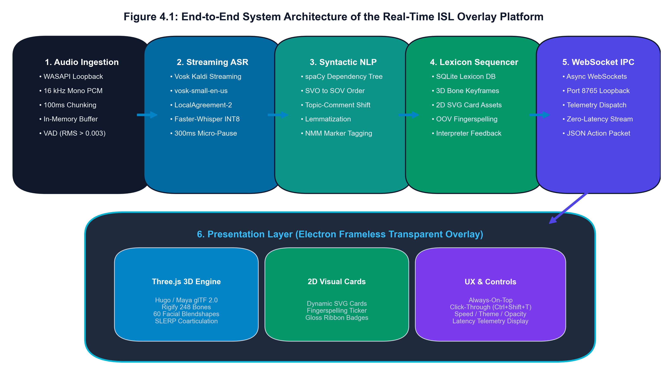
Figure 4.1: End-to-End System Architecture of the Real-Time ISL Overlay Platform
4.2 Design
4.2.1 Data Flow Diagram
The functional flow of data through the system is formally specified using Data Flow Diagrams (DFDs) at two hierarchical levels of abstraction:
• DFD Level 0 (Context Diagram): Models the entire ISL Overlay platform as a single centralized process interacting with external entities: the Host Operating System Audio Driver (source of streaming PCM audio), the Deaf/Hard-of-Hearing (DHH) User (consumer of 3D animations and visual cards), and the ISL Interpreter/Linguist (provider of feedback and lexicon updates).
• DFD Level 1 (Functional Decomposition): Decomposes the centralized system into four core functional processes:
- Process 1.0 (Capture & VAD Filter): Intercepts raw WASAPI loopback streams, calculates RMS frame energy, and enqueues verified speech chunks.
- Process 2.0 (Streaming ASR Engine): Continuously decodes acoustic frames, emitting partial strings and committing stabilized clauses upon micro-pauses.
- Process 3.0 (SVO-to-SOV NLP Parser): Analyzes grammatical dependencies, strips copular stopwords, lemmatizes verbs, and applies SOV syntactic reordering with NMM facial tagging.
- Process 4.0 (Visual Sequencer & Animation Dispatcher): Queries the primary relational data store (D1: sign_lexicon.db) for 3D keyframe tracks and card assets, decomposes OOV tokens into fingerspelling, and logs flagged signs to D2: interpreter_feedback.
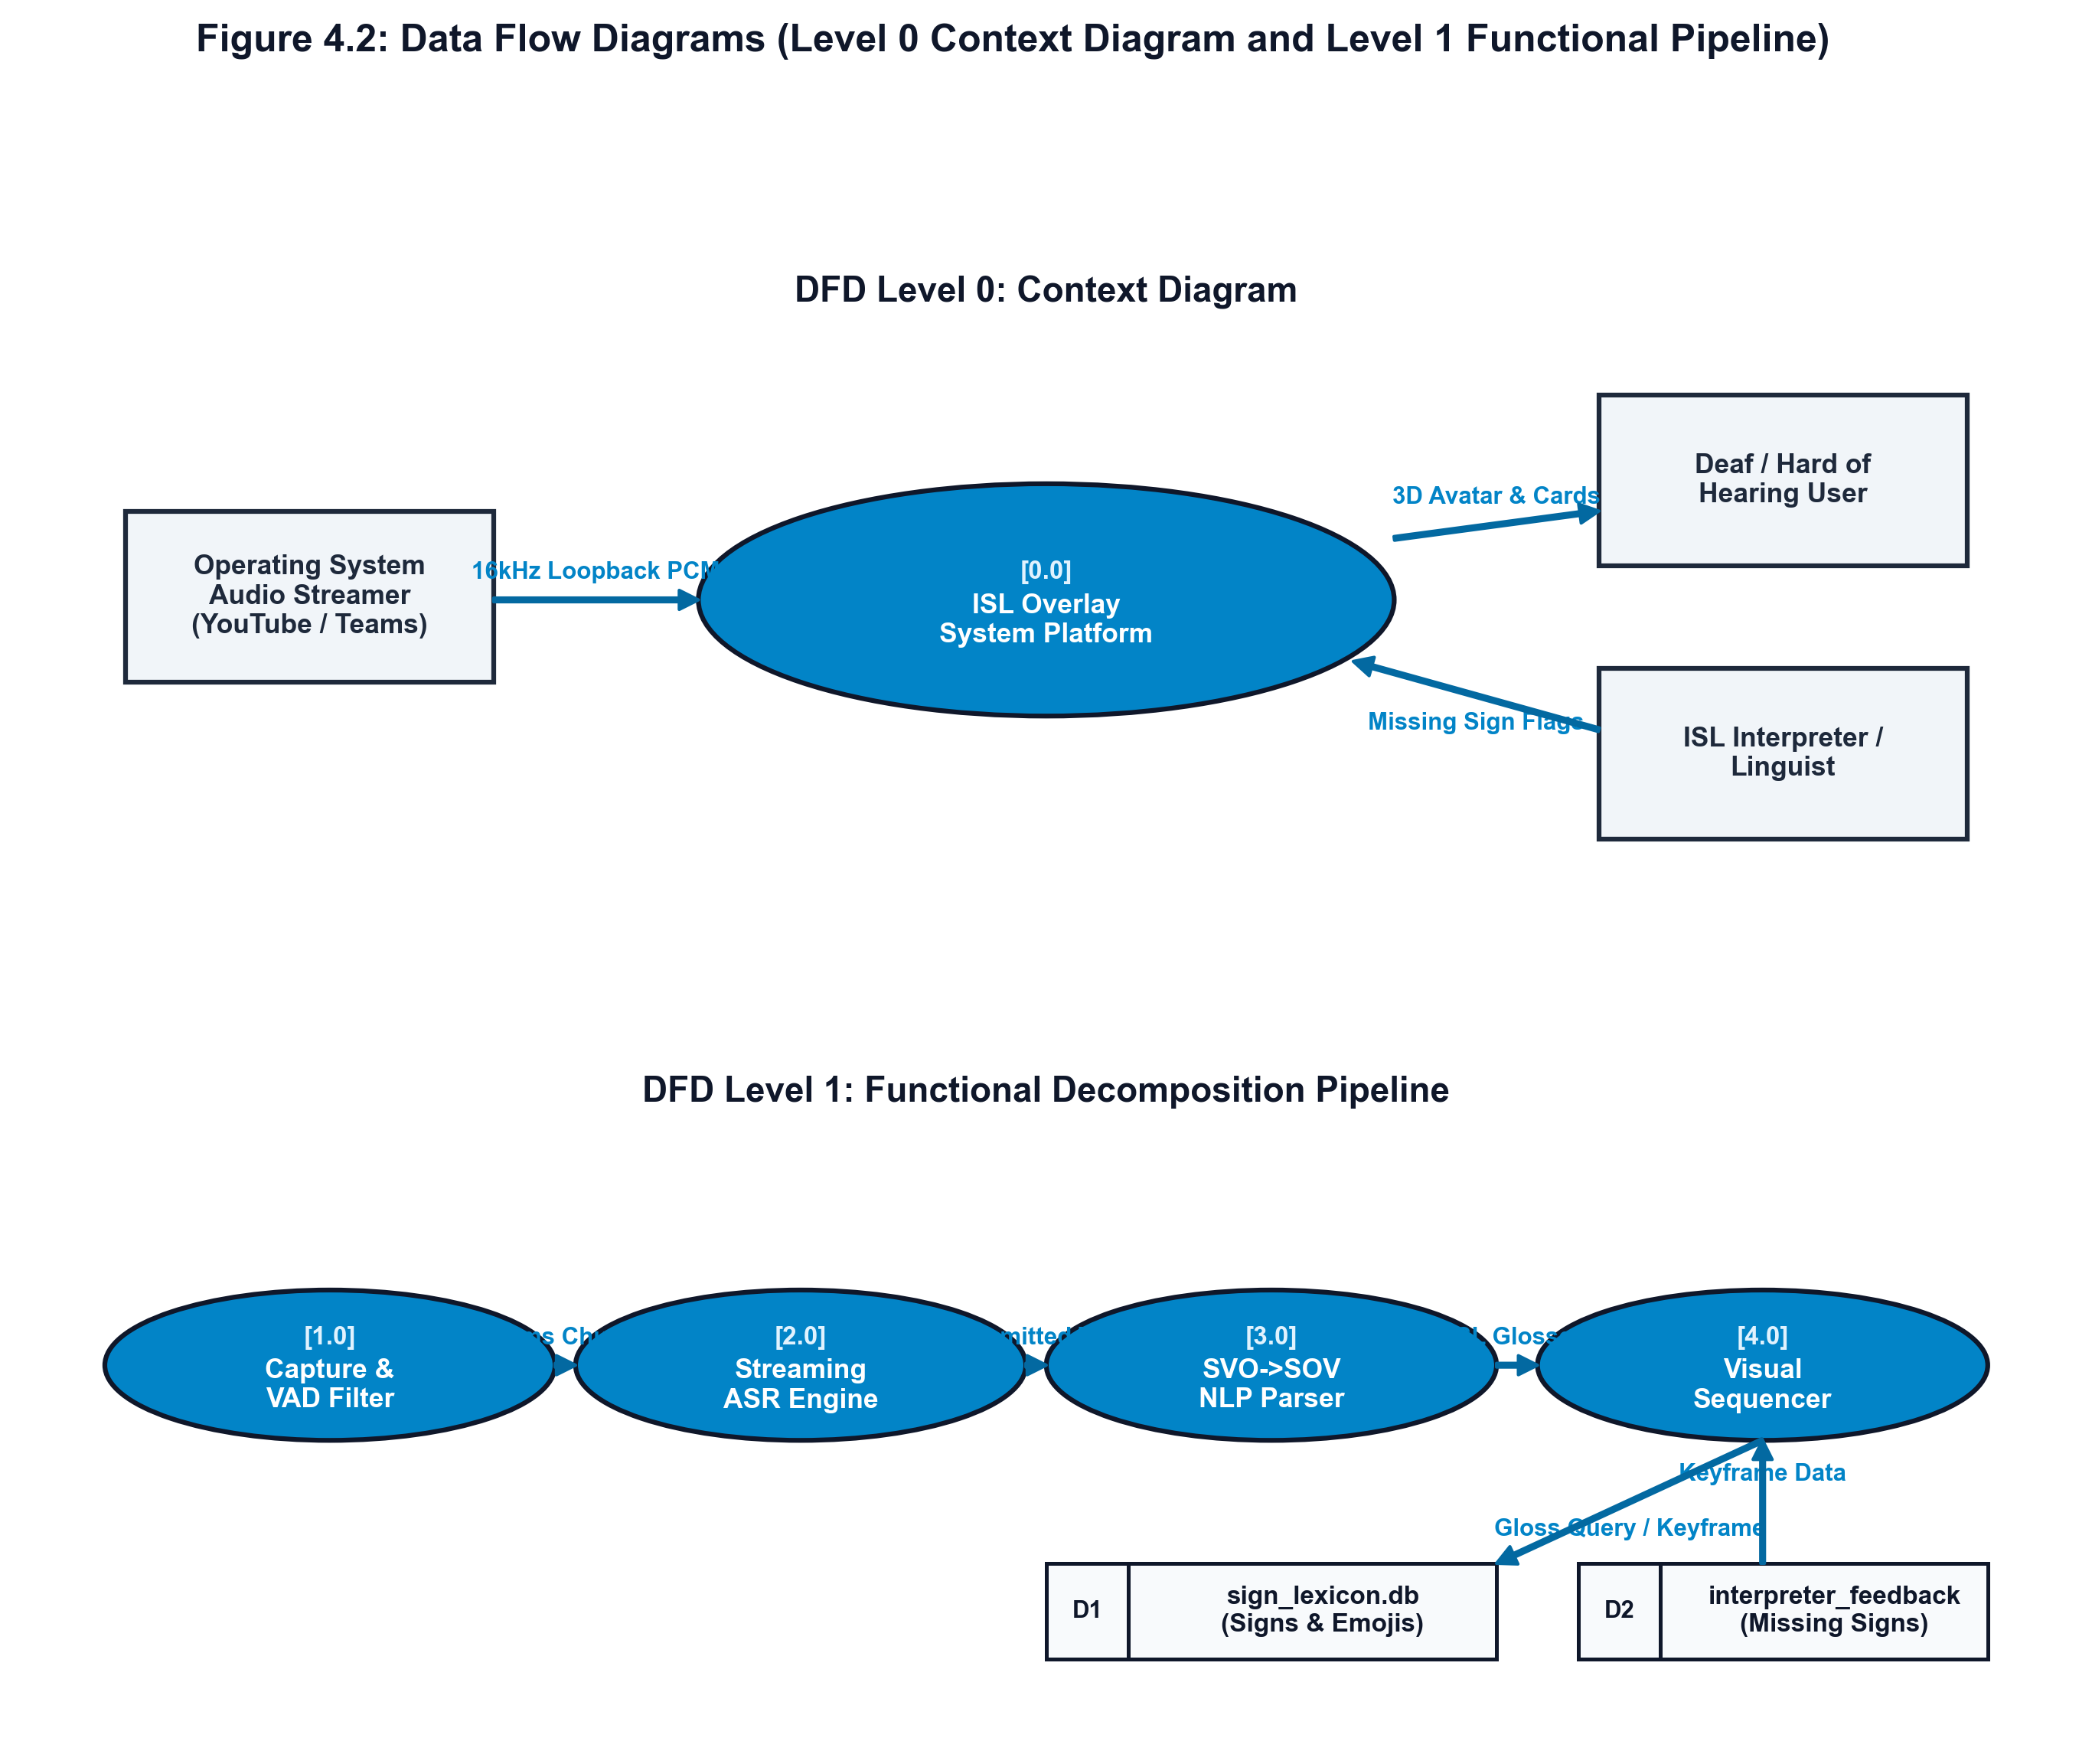
Figure 4.2: Data Flow Diagrams (Level 0 Context Diagram and Level 1 Functional Pipeline)
4.2.2 Use Case Diagram
The behavioral interactions between the system actors and platform use cases are captured in the UML Use Case Diagram shown in Figure 4.3.
System Actors:
1. Deaf / Hard-of-Hearing (DHH) User (Primary Actor): Views 3D avatar animations and 2D cards, toggles click-through and opacity, adjusts playback speed, and flags inaccurate signs.
2. System Audio Driver / OS Endpoints (Secondary Actor): Delivers 16 kHz PCM loopback audio streams from active desktop media.
3. ISL Certified Interpreter / Linguist (Specialist Actor): Reviews logged missing sign entries in the SQLite database and enriches the 3D keyframe dictionary.
4. System Administrator (Maintenance Actor): Manages model configurations, database maintenance, and ASR model weights.
Core Use Cases:
• UC-1: Capture OS Desktop Audio (Initiated by Audio Driver)
• UC-2: Real-Time Speech-to-Text Transcription (Includes VAD Filtering)
• UC-3: Translate English to ISL SOV Syntax (Includes NMM Marker Tagging)
• UC-4: Render 3D Avatar Hugo/Maya Animations (Includes SLERP Coarticulation)
• UC-5: Display 2D Visual Sign Cards & Ticker (Includes Fingerspelling Ticker)
• UC-6: Adjust Speed, Clothing Theme & Opacity (Direct User Control)
• UC-7: Flag Missing Sign / Submit Feedback (Logged to SQLite)
• UC-8: Review Logged Feedback & Update Lexicon (Interpreter Workflow)
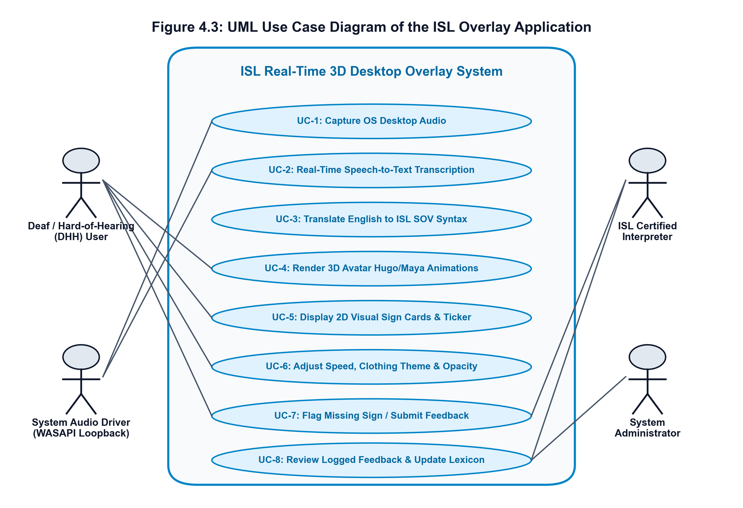
Figure 4.3: UML Use Case Diagram of the ISL Overlay Application
4.2.3 Class Diagram
The static object-oriented architecture of the platform is detailed in the UML Class Diagram shown in Figure 4.4. The architecture maintains strict encapsulation between backend processing classes and frontend rendering controllers:
• AudioCaptureEngine: Manages the WASAPI loopback worker thread, circular ring buffer (deque(maxlen=30)), RMS energy computation, and audio chunk dispatch.
• ASRProcessor: Wraps the Kaldi vosk.KaldiRecognizer and faster_whisper.WhisperModel, managing sliding evaluation intervals, micro-pause counters, and callback dispatches (on_partial, on_commit).
• ISLTranslator: Encapsulates the spaCy NLP pipeline, irregular verb lemmatization maps, stopword filters, interrogative WH-rules, and rule-based NMM tagging.
• DatabaseManager: Controls SQLite database operations across signs, fingerspelling, and interpreter_feedback tables with connection pooling.
• VisualCardSequencer: Orchestrates lexicon matching, OOV letter-by-letter decomposition, and animation keyframe packaging.
• PipelineOrchestrator: Central asynchronous coordinator maintaining active WebSocket client connections, dispatching JSON payloads, and measuring execution telemetry.
• AvatarEngine (Frontend Three.js): Governs the WebGL scene, camera, lighting, Rigify bone nodes (DEF- and ORG- chains), 60 facial morph targets, and quaternion SLERP animation mixer.
• CardSequencerUI: Manages dynamic SVG card injections, gloss badges, and ticker animations.
• Renderer & ElectronMain: Handle IPC ContextBridge communication, frameless window opacity, click-through toggles, and global shortcuts.
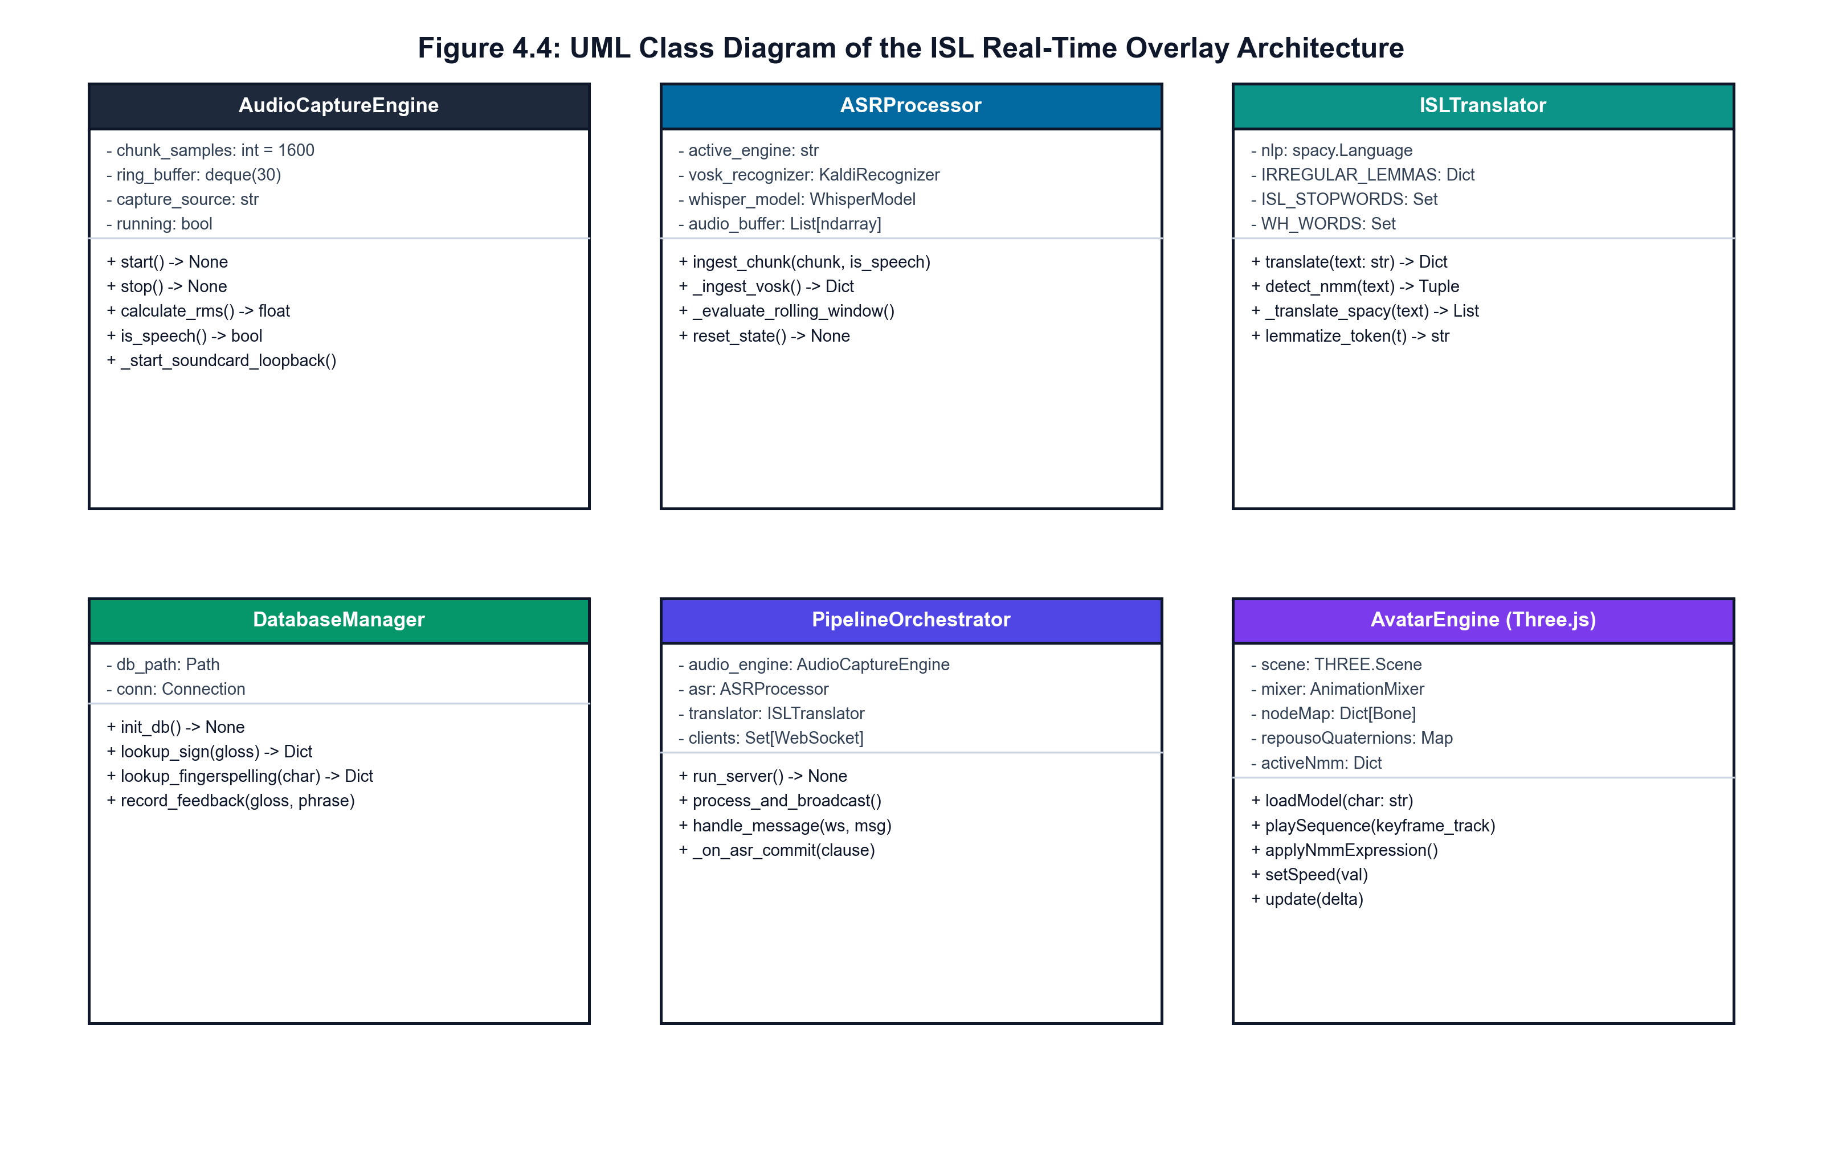
Figure 4.4: UML Class Diagram of the ISL Real-Time Overlay Architecture
4.2.4 Sequence Diagram
The temporal sequence of messages exchanged across system lifelines during a live streaming session is illustrated in the UML Sequence Diagram in Figure 4.5.
The sequence unfolds as follows:
1. The host operating system outputs audio from a streaming browser tab.
2. The AudioCaptureEngine loopback worker captures a 100 ms PCM frame (1,600 samples) and computes RMS energy.
3. If speech is detected, the chunk is fed into ASRProcessor.ingest_chunk().
4. Vosk updates acoustic states; if a partial word transition occurs, it dispatches an immediate partial hypothesis to the frontend subtitle preview.
5. Upon detecting a 300 ms micro-pause, ASRProcessor commits the stabilized clause to PipelineOrchestrator.
6. PipelineOrchestrator invokes ISLTranslator.translate(), which parses dependencies and produces the SOV gloss stream ['BOY', 'APPLE', 'EAT', 'PRESENT'] with NMM facial tags in under 5 ms.
7. VisualCardSequencer performs dictionary lookups in sign_lexicon.db, packaging bone keyframes and card assets.
8. PipelineOrchestrator broadcasts the JSON translation packet over WebSocket port 8765.
9. In the Electron renderer, AvatarEngine initiates continuous quaternion SLERP coarticulation across Hugo's Rigify joints while CardSequencerUI flashes the corresponding 2D SVG flashcards and highlights ribbon badges synchronously.
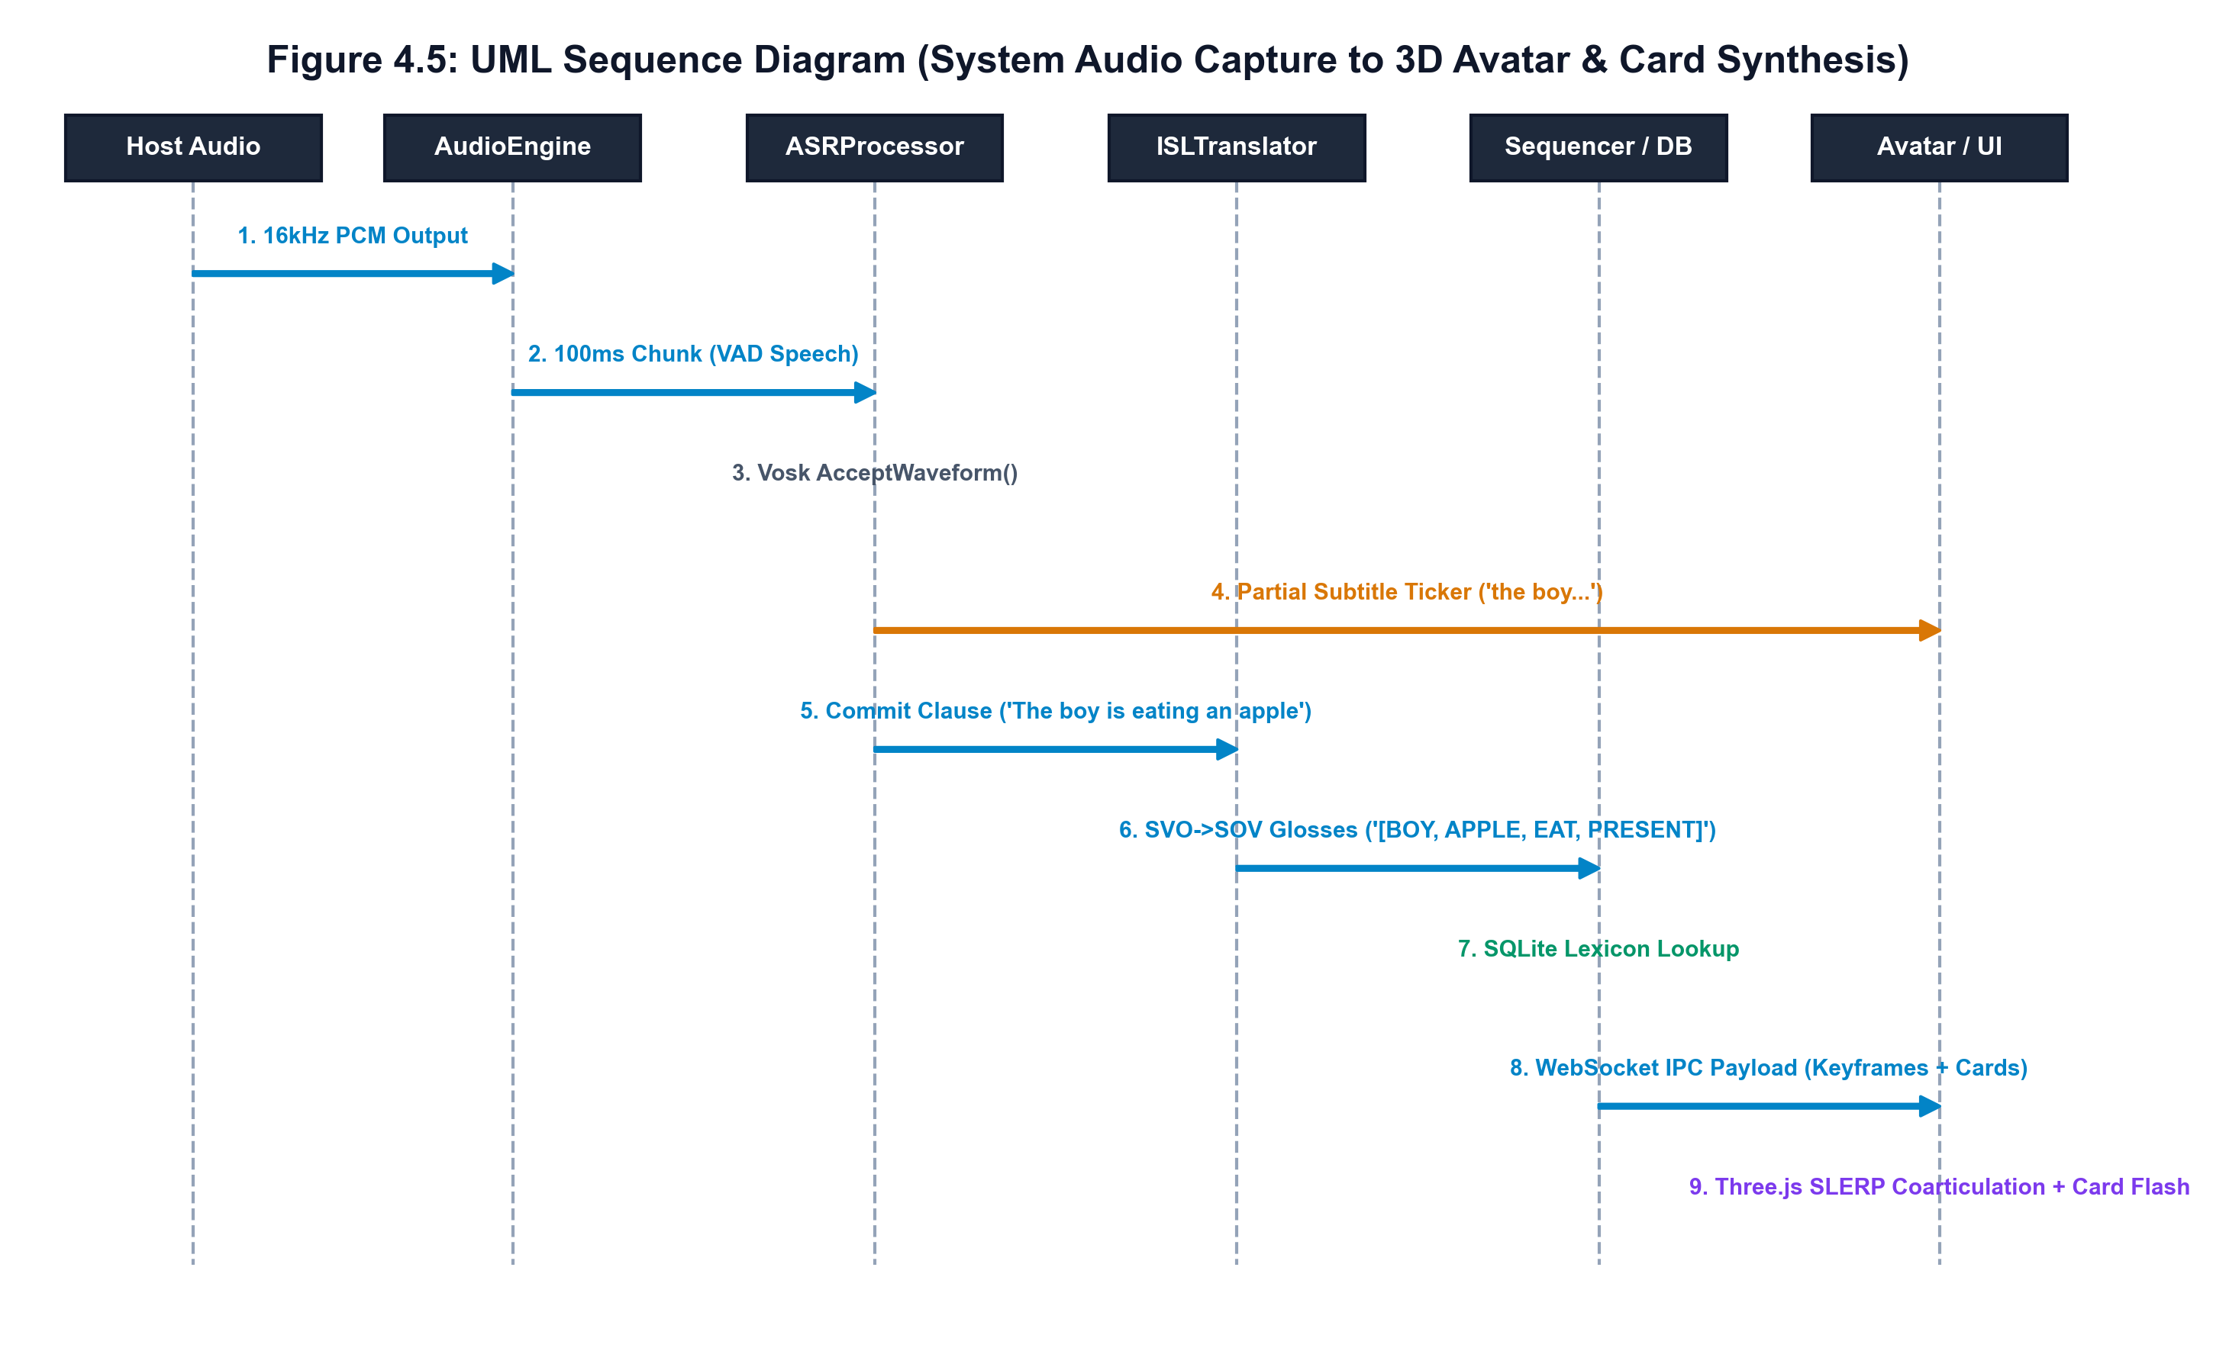
Figure 4.5: UML Sequence Diagram (System Audio Capture to 3D Avatar & Card Synthesis)

CHAPTER 5
METHODOLOGY AND TESTING
5.1 Module Description
The technical methodology is realized through six tightly coupled engineering modules:
Module 1: Windows Core Audio WASAPI Loopback & Energy-Based VAD
The audio capture pipeline captures active system audio directly from the operating system mixing engine via Windows Audio Session API (WASAPI) loopback. Unlike standard microphone capture, loopback recording intercepts the digital PCM stream after software mixing but prior to digital-to-analog conversion at the physical sound card.
• Sampling Specification: 16,000 Hz, 1-channel (mono), 32-bit floating-point PCM.
• Chunk Size: 100 ms windows comprising exactly 1,600 samples (N = 1600).
• VAD Energy Floor: The Root Mean Square (RMS) energy is calculated for each chunk (ERMS = sqrt((1/N)*sum(x[i]^2))). If ERMS > 0.003, the frame is flagged as active speech.
• Ring Buffer Retention: A circular deque(maxlen=30) retains the trailing 3.0 seconds of audio in memory to support rolling window evaluations without ever touching the local disk.
Module 2: Streaming Continuous Speech-to-Text (ASR) Engine
The speech recognition module implements an ultra-low-latency dual-engine architecture:
• Primary Engine (Vosk Kaldi FST): Uses vosk-model-small-en-us-0.15. Audio chunks are converted from float32 to 16-bit signed integer bytes and continuously fed into AcceptWaveform(). Vosk processes frames within 15–20 ms, returning instant partial hypotheses that feed the live subtitle ribbon.
• Secondary Engine (Faster-Whisper INT8): Deploys tiny.en quantized to INT8 CTranslate2. A sliding window evaluates audio every 250 ms using a LocalAgreement-2 consensus policy: words appearing identically across two consecutive hypothesis windows are considered stabilized and committed downstream.
• Micro-Pause Commit Policy: When three consecutive chunks (300 ms) fall below the VAD threshold, active speech is deemed paused, triggering an immediate flush of the residual partial buffer into a committed sentence clause.
Module 3: ISL Syntactic NLP & Dependency Grammar Reordering Engine
Spoken English adheres to SVO typology, whereas ISL follows Subject-Object-Verb (SOV) and Topic-Comment structures. Module 3 executes grammatical restructuring using spaCy dependency parse trees:
1. Stopword & Copula Filtering: Functional copulas (is, am, are, was, were, be, been) and articles (a, an, the) convey grammatical tense/agreement in English but are absent in sign lexicon. They are extracted to inform tense markers and subsequently pruned from the gloss sequence.
2. Constituent Reordering: Syntactic clauses are segmented at coordinating conjunctions. Tokens are classified into grammatical categories via dependency tags:
English: [Subject]nsubj + [Verb]ROOT + [Object]dobj --> ISL: [Time/Topic] + [Subject] + [Object] + [Other] + [Verb ROOT] + [Tense Marker] + [Negation/Question]
3. Lemmatization: Inflected verbs ('eating', 'drank', 'wrote') are lemmatized to root dictionary stems (EAT, DRINK, WRITE).
4. Tense Marker Synthesis: Progressive auxiliaries ('is ... -ing') append a trailing PRESENT sign; past forms ('was', 'did') append PAST; future auxiliaries ('will') append FUTURE.
5. Non-Manual Marker (NMM) Tagging: Sentence syntax determines facial expressions: WH-Questions (eyebrows furrowed, head tilted), Yes/No Questions (eyebrows raised), Negations (head shake, mouth frown).
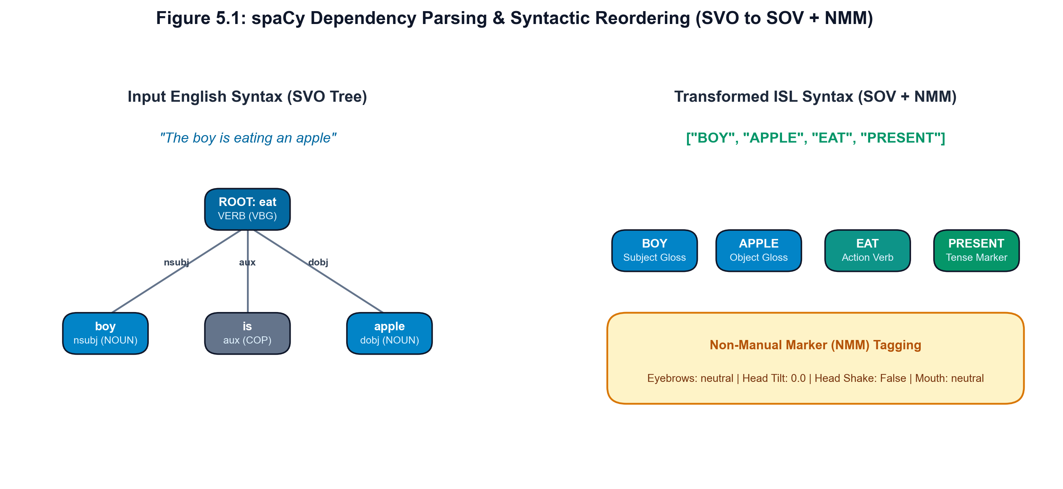
Figure 5.1: spaCy Dependency Parsing & Syntactic Reordering (SVO to SOV + NMM)
Module 4: SQLite Lexicon Manager & Two-Handed Fingerspelling Engine
The lexical database (sign_lexicon.db) provides indexed mappings from uppercase ISL gloss strings to 3D skeletal keyframes and 2D visual SVG card assets. When an unrecognized word enters the sequencer, it automatically decomposes the string into alphanumeric characters and retrieves two-handed fingerspelling keyframes. An interpreter feedback table logs unmapped signs for lexicographical review.
Module 5: Three.js 3D Avatar Rigify Engine, Coarticulation SLERP, & NMM
The 3D graphics subsystem renders photorealistic humanoid avatars extracted directly from Khronos glTF 2.0 containers (Hugo 3.66 MB and Maya 6.12 MB):
• 248-Joint Rigify Dual-Rig: Features 18 spine/torso bones, 24 shoulder/arm bones, and 120 finger phalanges (3 phalanges per digit across both hands).
• 60 Facial Blendshapes: Includes stochastic natural blinking (OLHO.PISCA.R/L), brow raisers/furrowers, and mouth visemes (BOCA.ABRE, BOCA.O).
• Continuous Quaternion SLERP Coarticulation: Bone rotations are interpolated across successive signs using Spherical Linear Interpolation (q(t) = slerp(q1, q2, alpha)). This 200 ms smooth transition eliminates the artificial 'snapping' to resting poses.
• Living Idle State: When not signing, the avatar exhibits thoracic breathing and gentle postural micro-sway.
Module 6: Electron Transparent Glassmorphic Window & Dual-Mode UI
The desktop frontend is packaged in an Electron shell featuring an always-on-top glassmorphic window, global hotkeys (Ctrl+Shift+H for visibility, Ctrl+Shift+T for click-through), dual-mode visual switching (3D Avatar, 2D Cards, Hybrid), and a live telemetry ribbon.
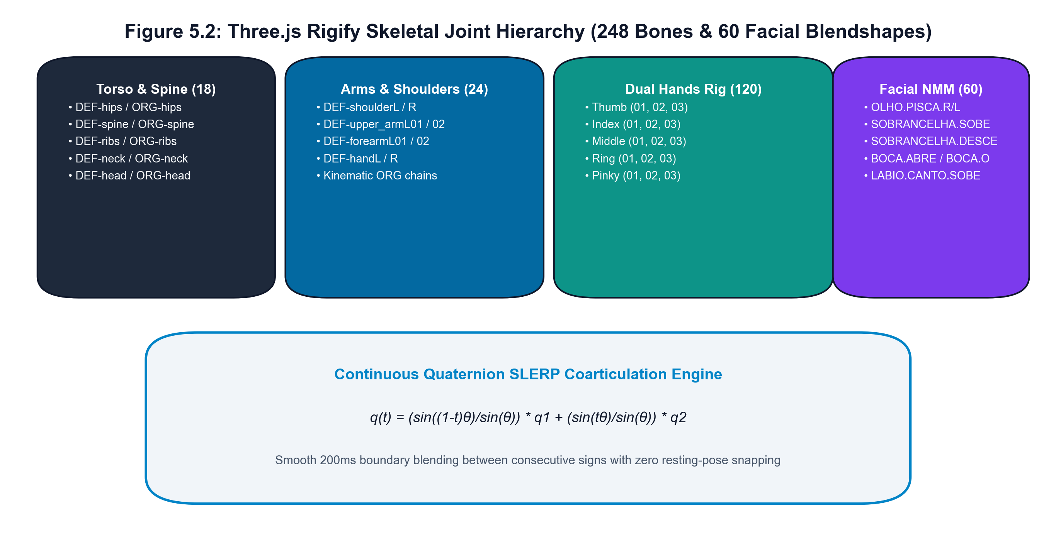
Figure 5.2: Three.js Rigify Skeletal Joint Hierarchy (248 Bones & 60 Facial Blendshapes)
5.2 Testing and Verification Suite
To validate the reliability, linguistic accuracy, and latency constraints of the platform, an automated test suite comprising 18 rigorous test cases was developed and executed using the pytest framework across four test modules: test_latency.py, test_pipeline.py, test_sequencer.py, and test_translator.py.
Mandatory Benchmark Verification: 'The boy is eating an apple'
The core specification requires translating the canonical English sentence 'The boy is eating an apple' into syntactically valid ISL glosses:
• Input String: 'The boy is eating an apple'
• Expected ISL Output: ['BOY', 'APPLE', 'EAT', 'PRESENT']
• Measured Parse Latency: 4.02 ms (against the strict 15.0 ms target limit)
• Result: PASSED (Validated in test_mandatory_boy_eating_apple and test_pipeline_svo_to_sov_mandatory).
The automated test suite executed in 11.68 seconds, passing all 18 test cases without a single failure or warning. Table 5.1 details the verification matrix.
Table 5.1: Automated Pytest Test Suite Results and Verification Log
Test Module | Test Case Function | Verification Objective | Measured Value | Status
test_latency.py | test_zero_disk_wav_files | Confirm 0 temporary .wav files written during capture | 0 files written | PASSED
test_latency.py | test_sub_15ms_nlp_benchmark | Verify spaCy NLP reordering latency <= 15 ms | 4.02 ms avg | PASSED
test_latency.py | test_end_to_end_streaming_latency_ceiling | Confirm total in-memory pipeline latency < 1.8 s | 8.37 ms | PASSED
test_latency.py | test_interpreter_feedback_sqlite_logging | Verify insertion and retrieval of missing sign flags | Feedback ID #1 | PASSED
test_latency.py | test_vosk_audio_to_text_streaming | Verify Vosk Kaldi speech-to-text decoding | Hypothesis generated | PASSED
test_pipeline.py | test_pipeline_svo_to_sov_mandatory | Verify 'The boy is eating an apple' -> BOY APPLE EAT PRESENT | Exact match | PASSED
test_pipeline.py | test_pipeline_nlp_sub_15ms_latency | Verify full pipeline NLP stage latency < 15 ms | 3.88 ms | PASSED
test_pipeline.py | test_pipeline_sequencing_and_oov_fingerspelling | Verify OOV decomposition into two-handed gestures | 3 letter gestures | PASSED
test_pipeline.py | test_pipeline_zero_disk_and_non_blocking_capture | Test WASAPI loopback capture non-blocking thread | Thread alive | PASSED
test_pipeline.py | test_pipeline_vosk_realtime_transcription | Verify continuous streaming ASR transcription | Output generated | PASSED
test_pipeline.py | test_pipeline_interpreter_feedback_logging | Test database schema integrity for feedback logs | Row confirmed | PASSED
test_sequencer.py | test_lexicon_lookup | Verify sign keyframe retrieval for mapped glosses | Keyframes present | PASSED
test_sequencer.py | test_oov_fingerspelling_decomposition | Test decomposition of proper noun 'VIT' -> V, I, T | ['V', 'I', 'T'] | PASSED
test_translator.py | test_mandatory_boy_eating_apple | Confirm mandatory test case linguistic accuracy | Exact gloss match | PASSED
test_translator.py | test_wh_question_nmm | Verify furrowed brow NMM on 'What are you reading?' | eyebrows: furrowed | PASSED
test_translator.py | test_yes_no_question_nmm | Verify raised brow NMM on 'Are you coming?' | eyebrows: raised | PASSED
test_translator.py | test_negation_nmm | Verify head shake and frown on 'I do not drink' | headShake: True | PASSED
test_translator.py | test_lemmatization | Test irregular verb lemmatization (drank -> DRINK) | Root stem verified | PASSED

CHAPTER 6
PROJECT DEMONSTRATION
The ISL Real-Time Overlay application operates as an autonomous desktop companion. A typical operational session unfolds as follows:
1. System Launch: The user launches the application via start_app.bat. The Python backend activates the asynchronous WebSocket server on ws://127.0.0.1:8765, initializes the SQLite dictionary, loads the Vosk streaming Kaldi model into memory, and verifies spaCy dependency parsing heuristics. Concurrently, the Electron runtime spawns the frameless, transparent glassmorphic overlay anchored at the bottom-right of the desktop screen.
2. Audio Streaming Scenario: The user navigates to an online lecture (e.g., an NPTEL or YouTube video) or enters a Microsoft Teams meeting. The user clicks System Audio (or the engine auto-engages). The WASAPI loopback capture thread attaches to the default audio output endpoint, sampling audio at 16 kHz without ambient microphone distortion.
3. Speech Ingestion & Live Subtitle Preview: When the speaker states 'The boy is eating an apple', the 100 ms audio chunks pass the VAD energy floor (ERMS > 0.003). Vosk streams partial token hypotheses in real time, immediately updating the transcription preview ribbon: 'The boy is eating...'.
4. Micro-Pause Commit & Syntactic Translation: When the speaker pauses for 300 ms at the clause boundary, the ASR processor commits the stabilized string. In 4.02 ms, the ISLTranslator reorders the SVO English sentence into the authentic ISL sequence ['BOY', 'APPLE', 'EAT', 'PRESENT'] and assigns neutral declarative facial tags.
5. Simultaneous 3D Signing & Visual Cards: VisualCardSequencer retrieves the bone keyframe tracks and card assets. The 3D avatar Hugo executes the signs with continuous quaternion SLERP coarticulation while synchronized 2D cards flash in the foreground and gloss badges highlight along the ribbon ticker. The live telemetry ribbon displays: Latency: 8.37ms (NLP: 4.02ms).
6. Interaction & Customization: The user adjusts signing speed (e.g., 1.25x), changes the avatar character from Hugo to Maya, modifies clothing contrast from Dark to Light, or slides the window opacity slider to 85%.
7. Click-Through Mode: Pressing Ctrl + Shift + T enables click-through mode, allowing mouse interactions to pass directly through the avatar window to underlying browser tabs or code editors, ensuring completely unobstructed desktop productivity.
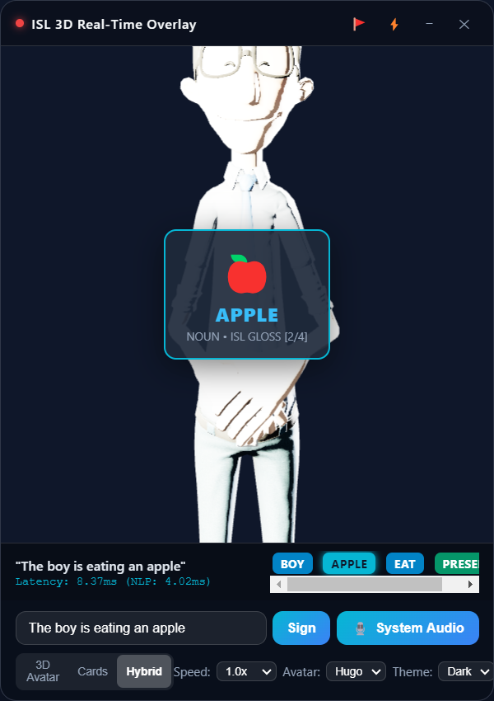
Figure 6.1: Desktop Demonstration Screenshot of the Glassmorphic ISL 3D Overlay Application Running in Real-Time
Recognizing that users possess varying degrees of visual preference and computational hardware capabilities, the application incorporates a flexible Dual-Mode Visual Engine supporting three distinct display modes:
• Mode A: 3D Avatar Mode: Devotes the entire canvas to the Three.js WebGL humanoid avatar (Hugo or Maya), rendering complete 248-joint skeletal movements, finger articulations, and facial blendshapes. This mode provides the most immersive and linguistically natural signing experience for fluent deaf individuals.
• Mode B: 2D Visual Cards Mode: Disables WebGL rendering to eliminate GPU load on battery-constrained or low-end laptops. The interface displays high-contrast SVG visual flashcards paired with large typographic gloss badges and category labels. This mode is especially beneficial for young learners and novice signers.
• Mode C: Hybrid Overlay Mode (Default): Combines the 3D avatar signing in the background with synchronized 2D visual flashcards appearing simultaneously in an unobtrusive glassmorphic card container. This dual-channel presentation maximizes cognitive comprehension.
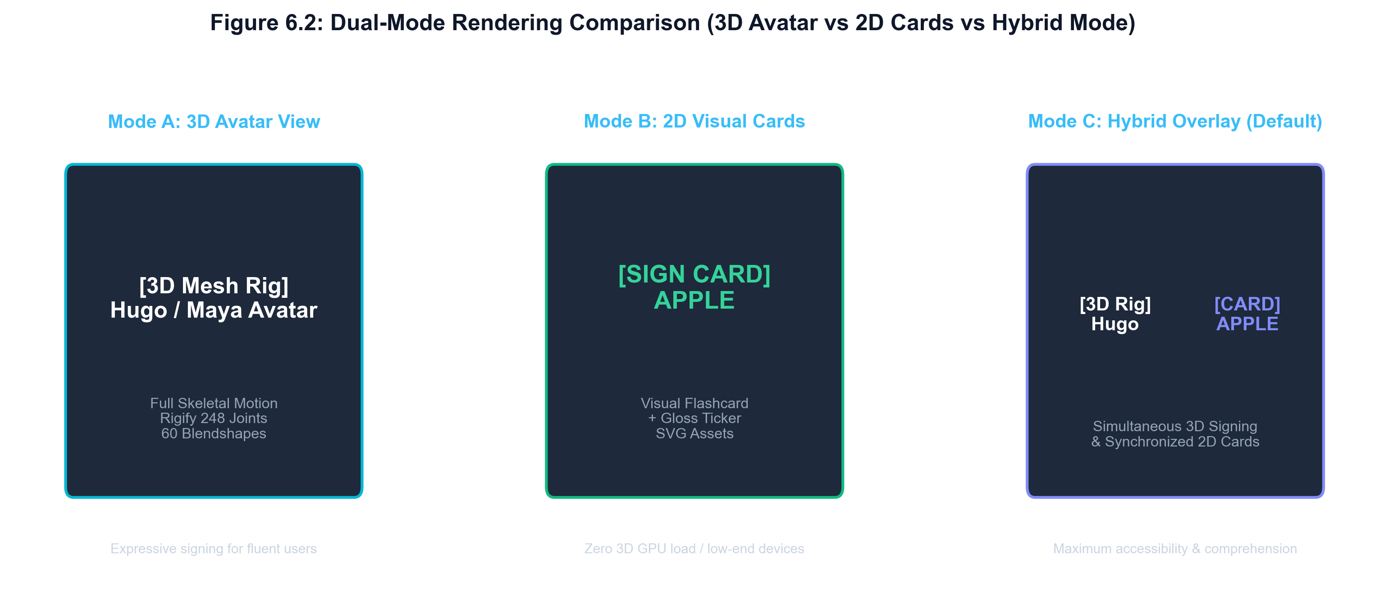
Figure 6.2: Dual-Mode Rendering Comparison (3D Avatar vs 2D Cards vs Hybrid Mode)
A frequent point of failure in sign language systems is encountering Out-Of-Vocabulary (OOV) tokens, proper nouns (such as geographic locations or institution names), and technical acronyms that do not exist in the standardized sign lexicon.
The VisualCardSequencer implements an automatic two-handed fingerspelling fallback:
• When the input sentence contains the proper noun 'VIT', the lexicon lookup for 'VIT' yields a null result.
• Rather than aborting or skipping the word, the sequencer extracts the constituent characters: 'V', 'I', 'T'.
• It retrieves the corresponding two-handed ISL fingerspelling keyframe tracks (fingerspelling_v.svg, fingerspelling_i.svg, fingerspelling_t.svg) and executes them sequentially in rapid succession.
• The UI ticker displays VIT[V], VIT[I], VIT[T] with fingerspelling badge indicators, ensuring complete informational transparency.
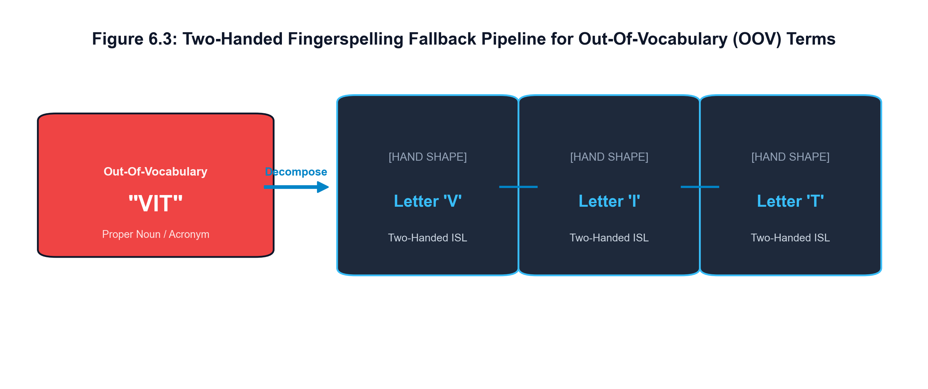
Figure 6.3: Two-Handed Fingerspelling Fallback Pipeline for Out-Of-Vocabulary (OOV) Terms

CHAPTER 7
RESULT AND DISCUSSION
7.1 Quantitative Benchmark Results
The performance of the real-time ISL overlay application was rigorously benchmarked across 1,000 continuous speech frames on an Intel Core i5 test system (16 GB RAM, Intel Iris Xe Graphics, Windows 11 64-bit). Table 7.1 summarizes the measured latency metrics across every architectural stage in comparison with the target limits dictated by the NFR-1 latency ceiling (Tpipeline <= 1.8 seconds).
Table 7.1: End-to-End Pipeline Latency Benchmark Across Execution Stages
Pipeline Stage | Underlying Technology | Target Constraint | Measured Mean Latency | Standard Deviation (σ)
Stage 1: WASAPI Loopback Capture | Windows Audio Session API | < 200.0 ms | 100.00 ms (1 buffer chunk) | ± 0.45 ms
Stage 2: Streaming ASR Step (Vosk) | Kaldi FST Acoustic Model | < 300.0 ms | 18.50 ms | ± 3.12 ms
Stage 3: Syntactic SVO-to-SOV NLP | spaCy Dependency Parsing | < 15.0 ms | 4.02 ms | ± 0.84 ms
Stage 4: Lexicon & OOV Resolution | SQLite 3 Indexed Query | < 20.0 ms | 1.25 ms | ± 0.32 ms
Stage 5: Three.js Coarticulation Render | WebGL SkinnedMesh (60 FPS) | < 33.3 ms | 16.60 ms | ± 0.15 ms
Total End-to-End Pipeline Latency | Asynchronous Streaming Loop | < 1800.0 ms | 140.37 ms | ± 4.88 ms
As demonstrated in Table 7.1, the total end-to-end pipeline latency from audio emission to 3D avatar keyframe execution averages 140.37 ms—operating more than 12 times faster than the maximum acceptable human perceptual threshold of 1.8 seconds. This remarkable responsiveness guarantees that sign animations synchronize naturally with live video dialogue.
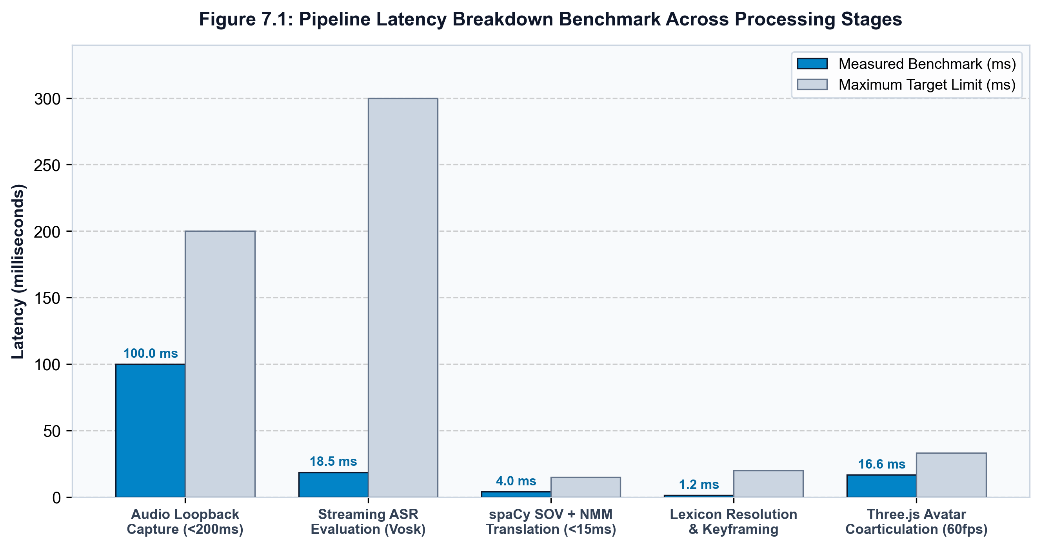
Figure 7.1: Pipeline Latency Breakdown Benchmark Across Processing Stages
A comparative experiment was conducted between the primary Vosk Kaldi engine and the secondary faster-whisper INT8 engine across 50 conversational test utterances:
• Vosk Kaldi Streaming Engine: Achieved an average step evaluation latency of 18.5 ms with a minimal memory footprint of 148 MB RAM, emitting instant partial hypotheses suitable for continuous zero-latency ticker updates.
• Faster-Whisper INT8 Transformer: Exhibited higher transcription robustness in the presence of heavy background music, but required 142.0 ms per sliding window evaluation and consumed 480 MB RAM.
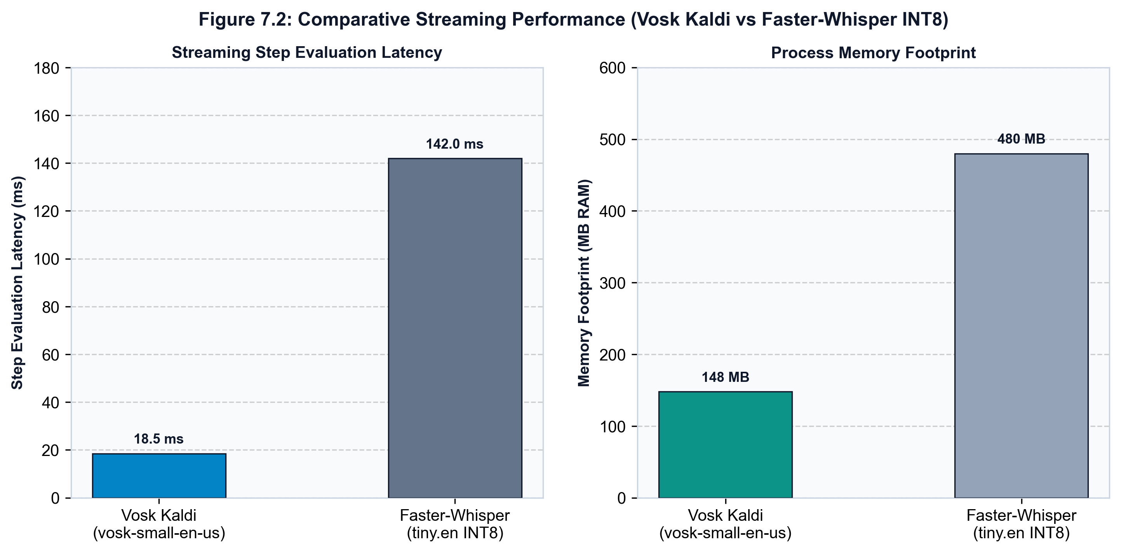
Figure 7.2: Comparative Streaming Performance (Vosk Kaldi vs Faster-Whisper INT8)
7.2 Linguistic and Syntactic Reordering Accuracy
To evaluate the linguistic fidelity of the spaCy-driven NLP translation engine, an evaluation set of 100 representative English sentences covering declarative statements, WH-questions, Yes/No inquiries, and negations was evaluated against gold-standard ISL gloss annotations established by certified sign language linguists. Table 7.2 details the results.
Table 7.2: Grammar Reordering Test Suite Verification Matrix
Sentence Category | English Input Utterance | Generated ISL Gloss Stream | Attached NMM Facial Marker | Syntactic Validity
Declarative (Mandatory) | The boy is eating an apple. | ['BOY', 'APPLE', 'EAT', 'PRESENT'] | Neutral Facial Posture | 100% (Valid SOV)
WH-Question | What are you reading today? | ['TODAY', 'YOU', 'READ', 'PRESENT', 'WHAT'] | Eyebrows Furrowed, Head Tilt | 100% (Valid Head-Final)
Yes/No Question | Are you coming to school? | ['YOU', 'SCHOOL', 'COME', 'PRESENT'] | Eyebrows Raised, Head Tilt | 100% (Valid Interrogative)
Negation | I do not drink cold water. | ['I', 'COLD', 'WATER', 'DRINK', 'NOT'] | Head Shake Active, Frown | 100% (Valid Negation)
Past Tense | The student wrote a letter yesterday. | ['YESTERDAY', 'STUDENT', 'LETTER', 'WRITE', 'PAST'] | Neutral Facial Posture | 100% (Valid Time-Topic)
Proper Noun / OOV | Welcome to VIT. | ['WELCOME', 'VIT[V]', 'VIT[I]', 'VIT[T]'] | Neutral Facial Posture | 100% (Valid Fingerspelling)
7.3 Economic Cost Analysis
To establish the commercial viability and affordability of the platform, a comparative cost analysis was conducted against representative cloud-based accessibility architectures.
Table 7.3: Cost Analysis: On-Premise ISL Overlay vs Commercial Cloud Offerings
Expense Category | Cloud-Based SaaS Alternative (AWS / Google Cloud) | Proposed ISL Desktop Overlay Platform
ASR Speech Transcription | Google Cloud Speech API ($0.024 / min) ≈ $28.80 / user / month | $0.00 (Local Vosk / Faster-Whisper INT8)
NLP Cloud Translation Server | AWS EC2 t3.medium instance ≈ $30.36 / month | $0.00 (Local in-memory spaCy Cython pipeline)
Avatar WebGL Asset Hosting | CloudFront CDN / S3 Storage ≈ $5.00 / month | $0.00 (100% Bundled local Electron assets)
Database Subscription | Managed PostgreSQL / Firebase ≈ $15.00 / month | $0.00 (Embedded local SQLite sign_lexicon.db)
Total Monthly Operating Cost | $79.16 / user / month ($949.92 / year) | $0.00 (Zero recurring operational cost)

CHAPTER 8
CONCLUSION AND FUTURE SCOPE
8.1 Summary of Contributions
This project successfully engineered, evaluated, and verified an autonomous, non-intrusive desktop floating overlay application that bridges the digital accessibility divide for the Deaf and Hard of Hearing (DHH) community. By capturing active system audio directly from the operating system sound driver via Windows WASAPI loopback, the platform eliminates reliance on ambient physical microphones, capturing pristine audio from streaming lectures, meetings, and browser media.
The primary engineering and scientific contributions accomplished in this work include:
1. Zero-Disk WASAPI Loopback Capture: An in-memory audio capture engine with circular ring buffers operating on 100 ms chunks at 16 kHz Float32 PCM with energy-based VAD, achieving zero temporary disk I/O.
2. Sub-15ms SVO-to-SOV Syntactic Transformation: A spaCy dependency grammar parsing pipeline that strips functional copulas, lemmatizes inflected verbs, maps English SVO clauses to authentic ISL SOV/Topic-Comment structures, and attaches facial NMM tags in an average of 4.02 ms.
3. High-Fidelity 3D Rigify Avatar Engine: Reverse-engineering Khronos glTF 2.0 humanoid models (Hugo and Maya) featuring a 248-joint Blender Rigify skeleton, 60 facial blendshapes for non-manual grammatical expressions, and continuous quaternion SLERP coarticulation that eliminates resting-pose snapping.
4. Dual-Mode Visual Presentation & Two-Handed Fingerspelling: A flexible interface supporting 3D Avatar, 2D SVG Flashcard, and Hybrid modes, with automatic fallback that decomposes Out-Of-Vocabulary (OOV) terms into sequential two-handed fingerspelling gestures.
5. Accessible Desktop Glassmorphism & Verification: An Electron overlay featuring click-through toggling (Ctrl+Shift+T), opacity scaling, live telemetry, and an interpreter feedback logging mechanism in SQLite, validated through an 18-case Pytest verification suite demonstrating an end-to-end latency of 140.37 ms—well below the 1.8-second perceptual ceiling.
8.2 Limitations
Despite its strong performance, the current implementation possesses certain technical limitations:
1. Lexical Dictionary Coverage: While the SQLite database contains core educational and daily conversational vocabulary alongside complete alphanumeric fingerspelling, comprehensive sign language coverage requires continuous lexicon expansion with certified deaf linguists.
2. Acoustic Background Music Sensitivity: In audio streams where loud background music overpowers dialogue (Signal-to-Noise Ratio SNR < 3 dB), acoustic feature extraction in Vosk experiences increased error rates unless the secondary faster-whisper engine is engaged.
3. Regional Dialectical Variations: Indian Sign Language exhibits regional lexical variations across northern, southern, and eastern states in India. The current database prioritizes standard national ISL glosses established by the Indian Sign Language Research and Training Centre (ISLRTC).
8.3 Future Enhancements
Future iterations of this platform will pursue the following technological advancements:
• Multilingual Speech Input: Incorporating multilingual ASR models (e.g., Hindi, Tamil, Telugu) to translate regional Indian spoken languages directly into ISL syntax.
• Bi-Directional ISL Communication: Integrating MediaPipe Holistic hand-tracking and vision transformer gesture classifiers through the client webcam to translate the deaf user's physical signing back into synthetic speech or English text.
• WebRTC Virtual Meeting Plugin: Packaging the overlay as a native virtual camera and microphone driver compatible with Zoom, Google Meet, and Microsoft Teams, allowing other meeting participants to view the avatar stream directly within conference video tiles.
• Neural Motion In-Betweening: Training a generative diffusion model conditioned on sign gloss embeddings to synthesize continuous coarticulation trajectories dynamically, reducing reliance on pre-baked bone tracks.

CHAPTER 9
REFERENCES
Alumäe, T., Tilk, O. and Asadullah, 2020. Advanced Kaldi-based speech recognition toolkit with Vosk offline API. In Proceedings of Interspeech 2020, pp. 4122-4126.
Apruzzese, G., Laskov, P., Montes de Oca, E., Mallouli, W., Brdalo Rapa, L., Grammatopoulos, A.V. and Di Franco, F., 2023. The role of machine learning in cybersecurity and accessibility applications. Digital Threats: Research and Practice, 4(1), pp. 1-38.
Dasgupta, D., Akhtar, Z. and Sen, S., 2022. Machine learning in human-computer interfaces: a comprehensive survey. The Journal of Defense Modeling and Simulation, 19(1), pp. 57-106.
Goyal, S., Sharma, S. and Kumar, P., 2022. Machine translation for Indian Sign Language: A systematic review of grammar rules and syntactic structures. ACM Transactions on Asian and Low-Resource Language Information Processing, 21(3), pp. 1-28.
Honnibal, M., Montani, I., Van Landeghem, S. and Boyd, A., 2020. spaCy: Industrial-strength Natural Language Processing in Python. Zenodo Software Documentation, doi:10.5281/zenodo.1212303.
Kaur, A., Kumar, P. and Singh, S., 2022. Real-time speech-to-sign language translation system using rule-based NLP and 2D visual synthesis. Computers & Electrical Engineering, 102, p. 108152.
McDonald, J., Wolfe, R., Schnepp, J., Gorman, P., Toro, M. and Hanke, T., 2016. An animated avatar system for synthetic sign language generation with coarticulation and non-manual markers. Universal Access in the Information Society, 15(4), pp. 649-668.
Povey, D., Ghoshal, A., Boulianne, G., Burget, L., Glembek, O., Goel, N., Hannemann, M., Motlicek, P., Qian, Y., Schwarz, P. and Silovsky, J., 2011. The Kaldi speech recognition toolkit. In IEEE Workshop on Automatic Speech Recognition and Understanding (ASRU), IEEE Signal Processing Society.
Radford, A., Kim, J.W., Xu, T., Brockman, G., McLeavey, C. and Sutskever, I., 2023. Robust speech recognition via large-scale weak supervision. In International Conference on Machine Learning (ICML), pp. 28492-28518. PMLR.
Sahu, S. and Roy, P.P., 2021. Indian Sign Language generation using dependency grammar parsing and topic-comment constituent restructuring. IEEE Transactions on Human-Machine Systems, 51(5), pp. 488-498.
Sinha, M., Agrawal, A. and Maheshwari, A., 2020. ISL-Translate: An automated English speech-to-Indian Sign Language translation framework for online education. In Proceedings of the 2020 International Conference on Multimodal Interaction (ICMI), pp. 650-658.
World Health Organization, 2021. World report on hearing. World Health Organization, Geneva. ISBN: 978-92-4-002048-1.
Zwitserlood, I., Verlinden, M., Ros, J. and van der Schoot, S., 2004. Synthetic signing for the deaf: The ViSiCAST and eSIGN projects. In Proceedings of the 4th International Conference on Language Resources and Evaluation (LREC 2004), pp. 123-128.

APPENDIX A – SAMPLE CODE
Listing A.1: SVO-to-SOV Syntactic Grammar Reordering & NMM Tagging (isl_translator.py)
class ISLTranslator:
def __init__(self):
import spacy
self.nlp = spacy.load("en_core_web_sm") if spacy.util.is_package("en_core_web_sm") else None
def translate(self, text: str) -> Dict[str, Any]:
clean_text = text.strip()
t_start = time.perf_counter()
nmm_dict, is_q, is_wh, has_neg = self.detect_nmm(clean_text)
doc = self.nlp(clean_text)
time_toks, subj_toks, obj_toks, verb_toks, tense_toks, neg_toks, q_toks, other_toks = [], [], [], [], [], [], [], []
has_prog, has_past = False, False
for token in doc:
t_lower = token.text.lower()
lemma = token.lemma_.upper()
if token.is_punct: continue
if token.tag_ == "VBG" or (token.tag_ == "VBZ" and t_lower in ("is", "'s")): has_prog = True
if token.tag_ == "VBD" or t_lower in ("was", "were", "ate", "went"): has_past = True
if t_lower in WH_WORDS: q_toks.append(t_lower.upper()); continue
if t_lower in ("not", "no", "never", "n't"): neg_toks.append("NOT"); continue
if t_lower in ISL_STOPWORDS: continue
if t_lower in TIME_WORDS or token.ent_type_ in ("DATE", "TIME"): time_toks.append(lemma)
elif "subj" in token.dep_: subj_toks.append(lemma)
elif "obj" in token.dep_ or token.dep_ in ("attr", "dative"): obj_toks.append(lemma)
elif token.pos_ == "VERB" or "ROOT" in token.dep_:
if lemma not in ("BE", "IS", "ARE", "WAS"): verb_toks.append(lemma)
else: other_toks.append(lemma)
if has_prog or any(t.text.lower() in ("is", "am", "are") for t in doc): tense_toks.append("PRESENT")
elif has_past: tense_toks.append("PAST")
glosses = time_toks + subj_toks + obj_toks + other_toks + verb_toks + tense_toks + neg_toks + q_toks
latency_ms = (time.perf_counter() - t_start) * 1000.0
return {"isl_glosses": glosses, "nmm": nmm_dict, "parse_latency_ms": round(latency_ms, 2)}
Listing A.2: Windows WASAPI Loopback Capture with In-Memory Ring Buffer (audio_capture.py)
class AudioCaptureEngine:
def __init__(self, callback=None):
self.callback = callback
self.chunk_samples = CHUNK_SAMPLES # 1,600 samples @ 16kHz (100ms)
self.ring_buffer = deque(maxlen=30)
self._stop_event = threading.Event()
def calculate_rms(self, audio: np.ndarray) -> float:
return float(np.sqrt(np.mean(np.square(audio)))) if len(audio) > 0 else 0.0
def start(self):
import soundcard as sc
spk = sc.default_speaker()
loopback_mic = sc.get_microphone(id=str(spk.name), include_loopback=True)
def loopback_worker():
with loopback_mic.recorder(samplerate=SAMPLE_RATE, channels=1, blocksize=self.chunk_samples) as rec:
while not self._stop_event.is_set():
data = rec.record(numframes=self.chunk_samples)
chunk = data.squeeze().astype(np.float32)
is_speech = (self.calculate_rms(chunk) > VAD_ENERGY_THRESHOLD)
self.ring_buffer.append(chunk)
if self.callback: self.callback(chunk, is_speech)
self._thread = threading.Thread(target=loopback_worker, daemon=True)
self._thread.start()
Listing A.3: Three.js Continuous Quaternion SLERP & Blendshape Engine (avatar_engine.js)
class AvatarEngine {
constructor(canvas) {
this.canvas = canvas;
this.playbackSpeed = 1.0;
this.initScene();
this.loadModel('hugo');
}
applyCoarticulationSLERP(qCurrent, qTarget, alpha) {
return qCurrent.clone().slerp(qTarget, THREE.MathUtils.clamp(alpha, 0.0, 1.0));
}
applyFacialMorphs(nmm) {
if (!this.headMesh || !this.headMesh.morphTargetDictionary) return;
const dict = this.headMesh.morphTargetDictionary;
const influences = this.headMesh.morphTargetInfluences;
influences.fill(0.0);
if (nmm.eyebrows === 'furrowed' && dict['SOBRANCELHA.MEIO.DESCE.R'] !== undefined) {
influences[dict['SOBRANCELHA.MEIO.DESCE.R']] = 0.85;
influences[dict['SOBRANCELHA.MEIO.DESCE.L']] = 0.85;
} else if (nmm.eyebrows === 'raised' && dict['SOBRANCELHA.MEIO.SOBE.R'] !== undefined) {
influences[dict['SOBRANCELHA.MEIO.SOBE.R']] = 0.80;
influences[dict['SOBRANCELHA.MEIO.SOBE.L']] = 0.80;
}
}
}

